B.Tech. BCSE497J - Project-I

OBJECT-CENTRIC EVENT LOG MINING FOR ACADEMIC CAPSTONE PROCESSES: A NATIVE OCEL 2.0 APPROACH
Submitted in partial fulfillment of the requirements for the degree of

Bachelor of Technology

in

Computer Science and Engineering

by

23BCE0434 | MITISHA SHARMA
23BCE0498 | TANMAY KHAMBETE
23BCE0500 | AAKAASH SATHYA SARAVANAN

Under the Supervision of
Dr. Kalyanaraman P.
Professor Grade 1
School of Computer Science and Engineering (SCOPE)


October 2026

DECLARATION

We hereby declare that the project entitled Object-Centric Event Log Mining for Academic Capstone Processes: A Native OCEL 2.0 Approach submitted by us, for the award of the degree of Bachelor of Technology in Computer Science and Engineering to VIT is a record of bonafide work carried out by us under the supervision of Dr. Kalyanaraman P.
We further declare that the work reported in this project has not been submitted and will not be submitted, either in part or in full, for the award of any other degree or diploma in this institute or any other institute or university.

Place : Vellore Date :
Signature: ______________________ Mitisha Sharma
Signature: ______________________ Tanmay Khambete
Signature: ______________________ Aakaash Sathya Saravanan

CERTIFICATE

This is to certify that the project entitled Object-Centric Event Log Mining for Academic Capstone Processes: A Native OCEL 2.0 Approach submitted by Mitisha Sharma (23BCE0434), Tanmay Khambete (23BCE0498) and Aakaash Sathya Saravanan (23BCE0500), School of Computer Science and Engineering, VIT, for the award of the degree of Bachelor of Technology in Computer Science and Engineering, is a record of bonafide work carried out by them under my supervision during Fall Semester 2026-2027, as per the VIT code of academic and research ethics.

The contents of this report have not been submitted and will not be submitted either in part or in full, for the award of any other degree or diploma in this institute or any other institute or university. The project fulfills the requirements and regulations of the University and in my opinion meets the necessary standards for submission.

Place : Vellore
Date :

Signature of the Guide

Examiner(s)
Dr. Boominathan P
Computer Science and Engineering
ACKNOWLEDGEMENTS

We are deeply grateful to the management of Vellore Institute of Technology (VIT) for giving us the opportunity and the resources to take up this project. Their commitment to a conducive learning environment has been important to our academic journey, and the support and infrastructure provided by VIT let us explore and develop our ideas.

Our sincere thanks to Dr. Jaisankar N, the Dean of the School of Computer Science and Engineering (SCOPE), for the Dean's unwavering support and encouragement. The Dean's leadership and vision have inspired us to strive for excellence, and the dedication to academic excellence and innovation has been a constant source of motivation. We appreciate the effort that goes into creating an environment that nurtures creativity and critical thinking.

We express our profound appreciation to Dr. Boominathan P, the Head of the Department of Computer Science and Engineering, for their insightful guidance and continuous support. Their expertise and advice shaped the direction of our project, and the collaborative, supportive atmosphere they keep made learning easier for us.

We are immensely thankful to our project guide, Dr. Kalyanaraman P., for their dedicated mentorship and valuable feedback. Their patience, knowledge and encouragement carried us through this project, and the time they spent sharing expertise and giving thoughtful guidance helped us refine our ideas and methods.

Thank you all for your contributions and support.

Mitisha Sharma
Tanmay Khambete
Aakaash Sathya Saravanan

TABLE OF CONTENTS
Sl.No | Contents | Page No.
 | Abstract | x
1. | INTRODUCTION | 1
 | 1.1 Background | 1
 | 1.2 Motivations | 2
 | 1.3 Scope of the Project | 2
2. | PROJECT DESCRIPTION AND GOALS | 3
 | 2.1 Literature Review | 3
 | 2.2 Research Gap | 4
 | 2.3 Objectives | 4
 | 2.4 Problem Statement | 5
 | 2.5 Project Plan | 5
3. | TECHNICAL SPECIFICATION | 7
 | 3.1 Requirements | 7
 | 3.1.1 Functional | 7
 | 3.1.2 Non-Functional | 7
 | 3.2 Feasibility Study | 7
 | 3.2.1 Technical Feasibility | 7
 | 3.2.2 Economic Feasibility | 8
 | 3.2.3 Social Feasibility | 8
 | 3.3 System Specification | 8
 | 3.3.1 Hardware Specification | 8
 | 3.3.2 Software Specification | 9
4. | DESIGN APPROACH AND DETAILS | 10
 | 4.1 System Architecture | 10
 | 4.2 Design | 10
 | 4.2.1 Data Flow Diagram | 10
 | 4.2.2 Use Case Diagram | 11
 | 4.2.3 Class Diagram | 12
 | 4.2.4 Sequence Diagram | 13
 | 4.3 OCEL 2.0 Model of the Capstone Lifecycle (Design Only) | 13
5. | METHODOLOGY AND TESTING | 15
 | 5.1 Module Description | 15
 | 5.1.1 M1: Acquire and Verify | 15
 | 5.1.2 M2: Convert and Load | 15
 | 5.1.3 M3: Distortion Metrics | 16
 | 5.1.4 M4: Consequence Analysis | 16
 | 5.1.5 M5: Predicate Engine (Appendix-Level) | 17
 | 5.1.6 M6: Validation | 18
 | 5.1.7 M7: Summaries | 18
 | 5.2 Testing | 18
6. | PROJECT DEMONSTRATION | 20
 | 6.1 Step 1: Check that the data is present | 20
 | 6.2 Step 2: Run the self-check | 20
 | 6.3 Step 3: Distortion of the Enron log | 20
 | 6.4 Step 4: Consequences for the Enron log | 21
 | 6.5 Step 5: The cross-log summary | 21
7. | RESULT AND DISCUSSION | 22
 | 7.1 The Seven Logs | 22
 | 7.2 Distortion by Flattening | 22
 | 7.3 Consequences for Standard Outputs | 24
 | 7.4 Process Discovery on Flat Logs | 26
 | 7.5 Discussion | 27
 | 7.5.1 Threats to Validity | 28
 | 7.6 Cost Analysis | 28
8. | CONCLUSION | 29
 | 8.1 Limitations | 29
 | 8.2 Future Work | 30
9. | REFERENCES | 31
 | APPENDIX A - SAMPLE CODE | 33

LIST OF FIGURES
Figure No. | Title | Page No.
2.1 | Project calendar, August to December 2026 (grey bars are not part of the delivered work) | 5
4.1 | System architecture of the flattening study | 10
4.2 | Data flow diagram, level 0 | 11
4.3 | Data flow diagram, level 1 | 11
4.4 | Use case diagram | 12
4.5 | Class diagram of the main structures | 12
4.6 | Sequence diagram of one end-to-end run | 13
4.7 | Object types, relations and events of the capstone lifecycle | 14
7.1 | Duplication and dropped events for the seven logs, by regime | 23
7.2 | Object-type pairs that share more than half of their objects across cases | 23
7.3 | Activity ranking agreement: duplication alone versus the whole process | 25
7.4 | Entity ranking agreement from a denormalised flat export | 25
7.5 | Spurious directly-follows edges, worst case notion per log | 26
7.6 | Replay fitness against the share of the process's activities in the discovered model, one dot per case notion | 27

LIST OF TABLES
Table No. | Title | Page No.
1.1 | Scope of the project | 2
2.1 | Summary of the reviewed literature | 3
2.2 | Work packages and status | 5
3.1 | Functional requirements | 7
3.2 | Non-functional requirements | 7
3.3 | Cost items | 8
3.4 | Hardware used | 8
3.5 | Software used | 9
4.1 | Object types of the capstone model | 14
5.1 | Sources of the seven logs | 15
5.2 | Distortion metrics for a case notion T | 16
5.3 | Verification checks | 18
6.1 | Demonstration steps | 20
7.1 | Profile of the seven logs | 22
7.2 | Flattening distortion per log (analysed case notions) | 22
7.3 | Consequences of flattening per log | 24
7.4 | Process discovery on the flat logs (Inductive Miner, noise threshold 0.2) | 26
7.5 | Cost of producing and reproducing the study | 28

LIST OF ABBREVIATIONS
AGPL | GNU Affero General Public Licence
AoE2 | Age of Empires II
CC BY | Creative Commons Attribution
COOC | Cross-Object Observability Coverage
CROP | Code Review Open Platform (Gerrit code-review dataset)
CSV | Comma-Separated Values
DF | Directly-Follows
DFD | Data Flow Diagram
E2O | Event-to-Object
HTTP | Hypertext Transfer Protocol
JSON | JavaScript Object Notation
MD5 | Message-Digest Algorithm 5
MSR | Mining Software Repositories
O2O | Object-to-Object
OCEL | Object-Centric Event Log
OULAD | Open University Learning Analytics Dataset
SCOPE | School of Computer Science and Engineering
SDG | Sustainable Development Goal
SHA-256 | Secure Hash Algorithm, 256-bit
SQL | Structured Query Language
TRL | Technology Readiness Level
UCI | University of California, Irvine
UML | Unified Modeling Language
VIT | Vellore Institute of Technology
XML | Extensible Markup Language

SYMBOLS AND NOTATIONS
T | Object type chosen as the case notion
U | Another object type, the entities being ranked or nested inside T
δ(T) | Deficiency: share of events with no T-object
κ(T) | Convergence share: share of covered events related to two or more T-objects
c(T) | Copies per event: flat rows divided by covered events
ρ | Spearman rank correlation coefficient

ABSTRACT
When a student leader submits a report on a capstone portal, that single event concerns a project, a team, three students, a guide and a report version. Process mining, however, requires every event to belong to exactly one case. When the event is flattened to one case notion, it can be copied into several cases (convergence), dropped altogether (deficiency) or merged with repeated events that belong to other objects (divergence). Object-centric event logs, in the OCEL 2.0 standard, keep the many-to-many links instead.
We began this project to study capstone review processes with OCEL 2.0, but portal logs could not be obtained. We also found no public capstone or thesis-management event log. We therefore narrowed our claims. The capstone is presented as a documented OCEL 2.0 design, and we measured flattening on seven real public logs: Gerrit code review (CROP), Open University learning analytics (OULAD), Angular commits, German Bundestag procedures, Enron e-mail, an Ethereum window and Age of Empires II matches. No synthetic or simulated data was used anywhere.
We built a reproducible pipeline that downloads and checks each source, converts the Gerrit and OULAD data to OCEL 2.0, computes flattening distortion for 38 case notions, and compares what an analyst would read off a flat view against the object-centric one: activity rankings, directly-follows edges, process variants, entity rankings and the process model a miner discovers.
The logs fall into three groups. In star logs (CROP, OULAD) every event touches one object of each type, so flattening copies nothing. In partitioned logs (Bundestag, Age of Empires II, Ethereum) one case notion drops 69% to 91% of the events in the median. In fan-out logs (Angular, Enron) flattening does duplicate events, up to 81.65 copies of one event in Angular. Duplication alone rarely changes an activity ranking, since only 2 of 38 case notions fall below a rank correlation of 0.95. The bigger effect is narrowing: in 20 of 38 case notions the flat log shows fewer than half of the process's activities, and 2 of the 15 case notions that cover at least half of their log are among them. A model discovered from a narrowed flat log still reaches a replay fitness of 0.955 or more, so the usual quality check gives no warning. Counting rows in a denormalised flat export can also invert an entity ranking, with worst-case rank correlations of 0.16 (Enron), -0.01 (Ethereum) and -0.41 (Age of Empires II).
We checked parts of the pipeline with an independent SQL implementation, a brute-force self-check, an independent recomputation of the OULAD counts and byte-identical re-runs. A plain-Python re-implementation reproduces the distortion metrics exactly on all seven full logs. Those checks caught three bugs of our own, which we fixed. No one outside the team has labelled the findings, and the capstone model is still a design that has not met portal data. The measurement work is under review at the Journal of Intelligent Information Systems.

CHAPTER 1

INTRODUCTION

1.1 Background
Consider what happens when a student leader submits a capstone report; that single event concerns the project, the team, three students, the guide who will, in practice, confirm it and the report version being submitted. A process-mining tool, however, needs to know which one of these is the case.
The project is motivated by this question. Against this backdrop, classic process mining starts from an event log in which every event has a case identifier, an activity name and a timestamp; the methods built on top of it (discovery, conformance checking, bottleneck analysis) assume that each event belongs to exactly one case.
If the project is chosen as the case, each project's history stays together, but the guide's workload across all projects disappears; if the student is chosen, the same submission appears three times, once per team member. One useful comparison is a group photograph. A flat view cuts one person out of the picture, and every person can be cut out in turn, but the resulting set of cut-outs no longer reveals who was standing next to whom.
The literature names these distortions. When one event is copied into several cases, the result is convergence, and when repeated events that belong to different objects of another type are merged into one case, the result is divergence [1]. Events that have no object of the chosen type are dropped from the flat log altogether, which is called deficiency.
Object-centric event logs avoid this choice. One event can refer to any number of objects, each with a type, and objects can also be linked to each other. OCEL 2.0 [2] standardises this structure, with JSON, XML and SQLite formats, a qualifier on every link, and object attributes that can change over time.
Several studies reveal why this structure matters. Keeping the object graph improves machine-learning tasks on process data in comparison to flattened features [3], and Adams and van der Aalst [4] tackle convergence, divergence and deficiency together. In parallel, one-to-many links yielded false directly-follows relations in a food-company case study [5], and object-centric data has quality problems of its own [6]. In education, Miri et al. [7] converted Moodle activity into OCEL and found that group and resource links remain invisible in a student-centric log.
What we could not find was a study that measures these effects across several real logs. The problem is generally acknowledged; nonetheless, its size has not been reported. Suitable public data does exist: the Open University Learning Analytics Dataset (OULAD) [8] covers students, courses and assessments, and CROP [9] links Gerrit code reviews to code changes, a process closely related to report review.
A capstone has the same structure. Hassani et al. [10] describe a department supervising more than 250 final-year computing projects, and Premchaiswadi and Porouhan [11] mined an online peer-review process and found bottlenecks and rule violations in reviewer handling. The Educational Capstone Portal, whose architecture is documented in our project repository, handles registration, team formation, report compilation, three review stages, faculty decisions and scoring; it writes an audit-log row for every state change. Its process is therefore strongly object-centric.
We set out to study that process directly, yet portal logs could not be obtained, and no public capstone or thesis-management event log was found. We therefore narrowed what we claim: the capstone is offered as a documented OCEL 2.0 design, and the measurements are made on seven real public logs [16]. This report keeps the two parts clearly separate.

1.2 Motivations
First, flattening happens without notice. Tools apply it by default and rarely report how many events were copied, dropped or merged.
Second, the evidence is thin. Convergence and divergence are ordinarily explained with small examples or a single case study, and we found no work that reports how often and how strongly they occur across several real logs.
Third, capstones are coordination work. The questions that matter in practice (whether one guide is overloaded, or which team resubmits repeatedly) cut across cases, so a case-centric view does not fit them.
Fourth, our claims are restricted to the data we can access. Portal data is not available to us, so a re-runnable measurement on public logs is the strongest evidence we can offer.

1.3 Scope of the Project
Table 1.1 states what the project covers and what it does not, so that its limits are clear from the start.
Table 1.1: Scope of the project
In scope | Out of scope
An OCEL 2.0 model of the capstone lifecycle, designed from the portal documentation | Any claim about how real capstone teams behave; no portal data was used
A re-runnable pipeline: download, verify, convert, load, analyse | Predictive monitoring on flat versus object-centric logs
Flattening distortion for 38 case notions on seven real public logs | Independent human labelling of the findings by a second rater
A consequence analysis: activity rankings, directly-follows edges, variants, entity rankings and discovered models, flat versus object-centric | Integrating a portal adapter; this is future work
Independent checks of our own code, and a documented list of bugs they found | Synthetic or simulated data of any kind

Two further points apply. A rule-based engine from our earlier work is kept at appendix level, since eleven rules on two logs cannot support a conclusion. In addition, a Moodle log from the University of Cádiz was downloaded as an eighth source but is not used in any result.
The report is organised as follows. Chapter 2 covers the literature and the plan, Chapter 3 the requirements and feasibility, Chapter 4 the design, Chapter 5 the modules and testing, Chapter 6 the demonstration, Chapter 7 the results and cost, Chapter 8 the conclusion and Chapter 9 the references. Appendix A includes sample code.
CHAPTER 2

PROJECT DESCRIPTION AND GOALS

2.1 Literature Review
The literature falls into four groups: the flattening problem itself, the OCEL format, what flattening does to results and to data quality, and the education and capstone papers. Table 2.1 sums up the ones that matter most for our questions, and the full list is in Chapter 9.
Table 2.1: Summary of the reviewed literature
Ref. | Objective | Method | Strength and limitation | Finding
van der Aalst (2019) [1] | Name the problems of one-case-per-event logs | Conceptual analysis with worked examples | Defines convergence and divergence. No measurement on real logs | Flattening copies events across cases or mis-orders them
Berti et al. (2024) [2] | A standard exchange format for object-centric data | OCEL 2.0 specification: JSON, XML, SQLite, qualifiers, O2O links | Expressive, with tool support. Extraction still needs domain decisions | One event can relate to many typed objects
Adams, Park, van der Aalst (2023) [3] | Keep object-centric graph structure for machine learning | Compare graph encodings with flattened features on predictive tasks | Shows the value of structure. Focus is prediction, not analysis outputs | Structure-preserving encodings are favoured over flattening
Waibel et al. (2022) [5] | Causal structure from relational data | Causal event graph on one food-company case | Avoids false edges. Only one case study | One-to-many and many-to-many links give spurious directly-follows relations
Kabierski et al. (2026) [6] | Classify quality issues in object-centric data | Classification checked on real logs and practitioner interviews | Practitioner-validated. Classifies issues but gives no distortion rates | Object-centric data has quality problems of its own, e.g. wrong object relations
Miri et al. (2026) [7] | Object-centric educational process mining | Moodle to OCEL conversion, real course case study | First educational use. One course, not a transactional lifecycle | Group and resource links are invisible in student-centric logs
Premchaiswadi, Porouhan (2015) [11] | Mine a peer-review process in an online system | Event log from review handling; discovery and conformance | Real review workflow. One case notion | Bottlenecks and rule violations found in reviewer handling
Hassani et al. (2018) [10] | Manage more than 250 computing final-year projects | Case study of supervision, panels and rubrics | Real capstone practice. No event data | Capstones need coordinated supervision, submission and assessment

On the flattening problem itself, van der Aalst [1] explained why one-case-per-event logs misrepresent processes with several interacting entities, and Adams and van der Aalst [4] went on to cover convergence, divergence and deficiency together. Both papers are conceptual, and neither reports how often these effects take place in real data.
OCEL 2.0 [2] is the format we build on; it stores events, objects, event-to-object (E2O) links and object-to-object (O2O) links, each with qualifiers, in JSON, XML or SQLite. Our own converters write the SQLite form, and we read the JSON and XML forms of the public logs.
On consequences, Waibel et al. [5] applied a causal event graph to reveal that one-to-many links yield false directly-follows edges, but only on one company's data. Kabierski et al. [6] classified the quality issues of object-centric data; they outline the kinds of problems but do not count them. Adams et al. [3] showed that keeping the object graph helps predictive tasks.
In education, Miri et al. [7] is the closest related work, since they applied object-centric mining to Moodle data; this project is therefore not the first use of OCEL in education. Premchaiswadi and Porouhan [11] mined an online peer-review process with a single case notion, and Hassani et al. [10] outline how a department supervises many final-year projects, with no event data.

2.2 Research Gap
Taken together, the reviewed work leaves three gaps.
First, flattening is described but not measured. Convergence, divergence and deficiency are defined conceptually [1], [4] and shown on single case studies [5], but no study we found reports how often they occur across several real logs from different domains. We address this with distortion metrics for 38 case notions on seven real public logs, which sort the logs into three regimes.
Second, the effect of flattening on what an analyst reads is unknown. Earlier work compares machine-learning performance [3] or classifies data-quality issues [6], but none measures, across logs, whether flattening changes activity rankings, process paths or discovered models, or separates duplication, which can be fixed, from narrowing, which cannot. We address this by comparing five standard outputs (C1 to C5) with an object-centric reference, with bootstrap intervals on the headline numbers.
Third, review workflows have no object-centric model. Object-centric educational mining uses learning-platform activity [7], and review processes have been mined with a single case notion only [11]. A lifecycle of submit, review, reject, resubmit and score has no object-centric model that we could find, and no public capstone or thesis-management event log exists. We address this with an OCEL 2.0 model of the capstone lifecycle, and by measuring on real logs that have a review shape (code review and student assessment).
Our approach is therefore to measure first, on real data only, and to check every number with independent code.

2.3 Objectives
The project has five objectives, listed in the order we worked on them.
- O1. Model the capstone lifecycle as OCEL 2.0 from the documented portal behaviour.
- O2. Build a reproducible pipeline: download, verify, convert, load and analyse.
- O3. Measure flattening distortion on seven real logs without hand-picked rules.
- O4. Compare standard outputs (activity rankings, directly-follows edges, variants, entity counts and discovered process models) between flat and object-centric views.
- O5. Verify every result with independent checks and keep the code re-runnable.
The work touches two of the United Nations Sustainable Development Goals: Goal 4, Quality Education, since it concerns how academic review processes are recorded and understood, and Goal 9, Industry, Innovation and Infrastructure, since it adds open tooling for object-centric process data. On the Technology Readiness Level scale the pipeline is placed at TRL 4 (validated in the laboratory, on seven public logs) and portal integration at TRL 2 to 3; those levels are our own estimate.

2.4 Problem Statement
We have an object-centric event log with several object types, and one type is picked as the case notion. Two questions follow. How much does the flat log differ from the object-centric one, that is, how many events are copied, dropped or merged? And do those differences change what an analyst reads from the standard outputs: activity rankings, directly-follows edges, process variants, entity rankings and discovered models? Both questions must be answered on real data only, with checks that do not depend on our own code; also, even though no portal data exists, the capstone lifecycle must be specified in OCEL 2.0.

2.5 Project Plan
Figure 2.1 shows the project calendar. At Review 2 we presented a prototype that was evaluated on synthetic data; the team then decided to use real data only, so that prototype and its results are excluded from this work. The plan below reflects the work done after that decision.
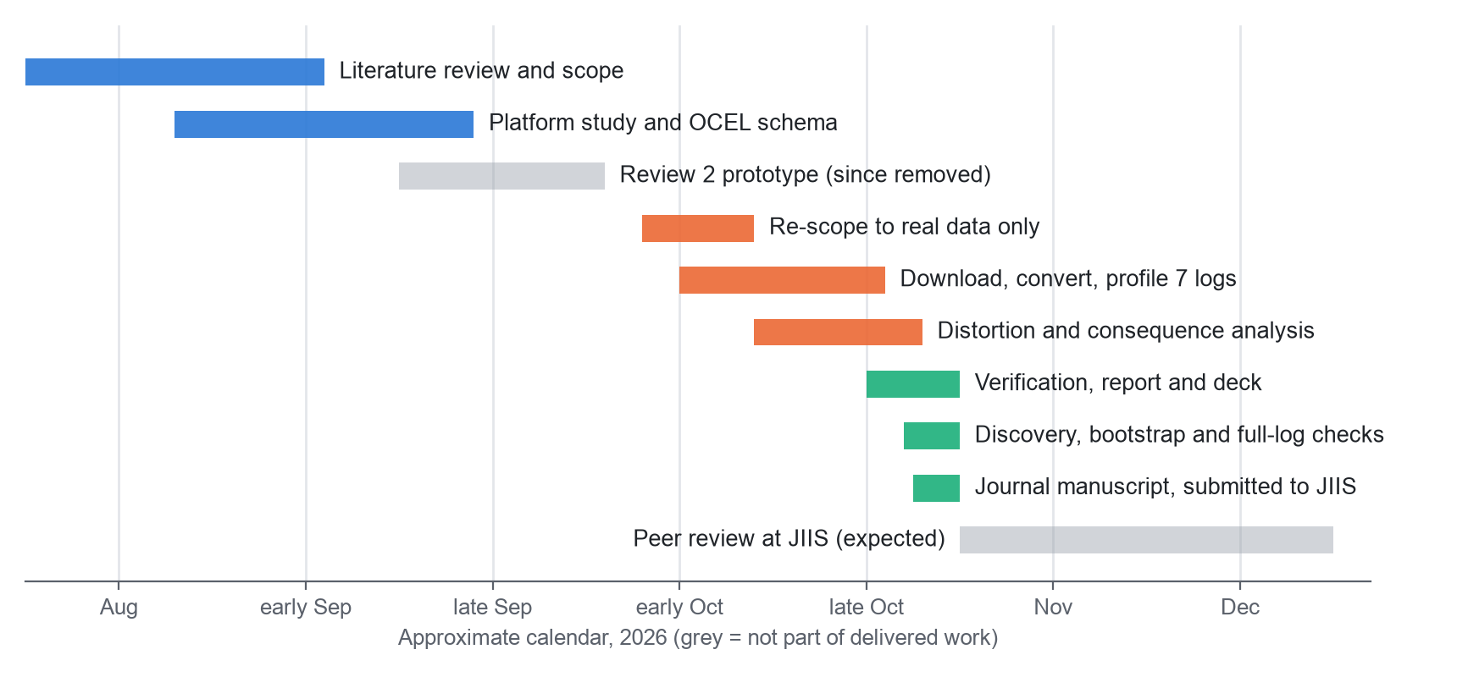
Figure 2.1: Project calendar, August to December 2026 (grey bars are not part of the delivered work)
Table 2.2: Work packages and status
Work package | Content | Status
WP1 | Literature review and scope | Completed
WP2 | Platform study and OCEL 2.0 schema of the capstone lifecycle | Completed (design only)
WP3 | Re-scope to real data only; locate and download public logs | Completed
WP4 | Convert CROP and OULAD to OCEL 2.0; profile all seven logs | Completed
WP5 | Distortion metrics and consequence analysis | Completed
WP6 | Independent verification, report and presentation | Completed
WP7 | Process-discovery comparison, bootstrap intervals and full-log verification | Completed
WP8 | Journal manuscript | Submitted to the Journal of Intelligent Information Systems (Springer), October 2026; under review
WP9 | Independent labelling of the findings | Planned

CHAPTER 3

TECHNICAL SPECIFICATION

3.1 Requirements

3.1.1 Functional
Table 3.1 lists the functional requirements and the module that covers each one; the modules are described in Chapter 5.
Table 3.1: Functional requirements
ID | The system shall | Module
FR1 | Download datasets from a manifest; check size and MD5 where the publisher provides them, and record a SHA-256 for every file | M1
FR2 | Extract archives without trusting member paths | M1
FR3 | Convert Gerrit code reviews (CROP) and OULAD into OCEL 2.0 SQLite | M2
FR4 | Load OCEL from SQLite, JSON, XML and bundled formats, with hashed identifiers for personal data | M2
FR5 | Compute flattening distortion for every object type of every log | M3
FR6 | Compare flat and object-centric outputs: rankings, edges, variants and entities | M4
FR7 | Validate results with independent implementations | M6
FR8 | Export CSV, JSON and Markdown tables; re-run the whole study with one command | M7

3.1.2 Non-Functional
Table 3.2: Non-functional requirements
ID | Requirement | How we meet or check it
NFR1 | Reproducibility: the same input gives the same bytes | Tracked result files were byte-identical after a re-run
NFR2 | Privacy: personal identifiers are not published | E-mail addresses and names are hashed on load; no VIT student data is used
NFR3 | Resource limit: runs on an ordinary laptop | Developed on an 8 GiB machine; the Ethereum log is analysed as a 300,000-event window
NFR4 | Licensing: only openly licensed data | All seven logs are CC BY 4.0; the licence is recorded per source
NFR5 | Integrity and safety of data handling | Size and MD5 checked against the Zenodo record; SHA-256 recorded for all files; archives with unsafe member paths rejected
NFR6 | Transparency of limits | Every result table states what was and was not checked

3.2 Feasibility Study

3.2.1 Technical Feasibility
The pipeline is written in Python with open-source libraries and runs on a single laptop. The only memory constraint was the Ethereum log, whose 3.2 million events do not fit in 8 GiB of memory, so we analyse a contiguous window of 300,000 events and state this wherever that log appears. For Enron, the distortion analysis took about 9.5 seconds and the consequence analysis about 4. Run time was not a risk; correctness was, which is why Chapter 5 devotes most of its space to verification.

3.2.2 Economic Feasibility
No data, software or cloud time was bought; Table 3.3 lists the items. The only cost that cannot be quantified is the team's own time.
Table 3.3: Cost items
Item | Source | Incremental cost
Datasets (seven logs) | Zenodo and UCI repositories, CC BY 4.0 | Nil
Analysis software | Python and open-source libraries (see Section 3.3.2) | Nil
Hardware | A laptop the team already owned | Nil
Storage | About 1.3 GB of downloaded and extracted files and 132 MB of derived OCEL files | Nil
Cloud or paid services | None used | Nil

One licensing point needs attention. The pm4py library is released under AGPL-3.0, and we use it as a reference implementation of flattening and for process discovery. The code is public on GitHub and is released under AGPL-3.0, which is compatible with pm4py.

3.2.3 Social Feasibility
Two logs contain data about people: Enron has real e-mail addresses, and CROP has developer names that its authors had already pseudonymised. We hash identifiers again when a log loads and never print raw values, and no VIT student, guide or portal record was used. This method lets anyone who analyses multi-entity workflows, including academic review, see in advance what a flat view will hide.

3.3 System Specification

3.3.1 Hardware Specification
Table 3.4: Hardware used
Item | Specification
Machine | Apple silicon laptop (arm64)
Memory | 8 GiB
Storage used | 1.3 GB raw (downloaded and extracted), 132 MB derived OCEL files; the one-time download is about 350 MB

3.3.2 Software Specification
Table 3.5: Software used
Component | Version | Use
Python | 3.14.5 | All analysis code
pandas, NumPy, SciPy | 3.1.0, 2.5.4, 1.18.1 | Tables, vectorised metrics, Spearman correlation
lxml | 6.1.3 | XML OCEL loading
pm4py | 2.7.23.11 | Reference flattening implementation (AGPL-3.0)
DuckDB | 2.0.0 | Reads the parquet OCEL bundles (Enron, Ethereum) without extra libraries
Matplotlib | 3.11.2 | Figures
SQLite | 3.54.0 | OCEL 2.0 storage and the independent SQL cross-check
macOS, Git, Make | - | Operating system, version control, one-command re-run

CHAPTER 4

DESIGN APPROACH AND DETAILS

4.1 System Architecture
Figure 4.1 reads from left to right. Against this backdrop, the seven public logs enter on the left. The first stage downloads each file, checks it against the publisher's record where one exists, and records a SHA-256 checksum. A second stage extracts archives safely, and then the conversion stage turns CROP and OULAD into OCEL 2.0; every log ends up in the same four tables: events, objects, event-to-object links and object-to-object links.
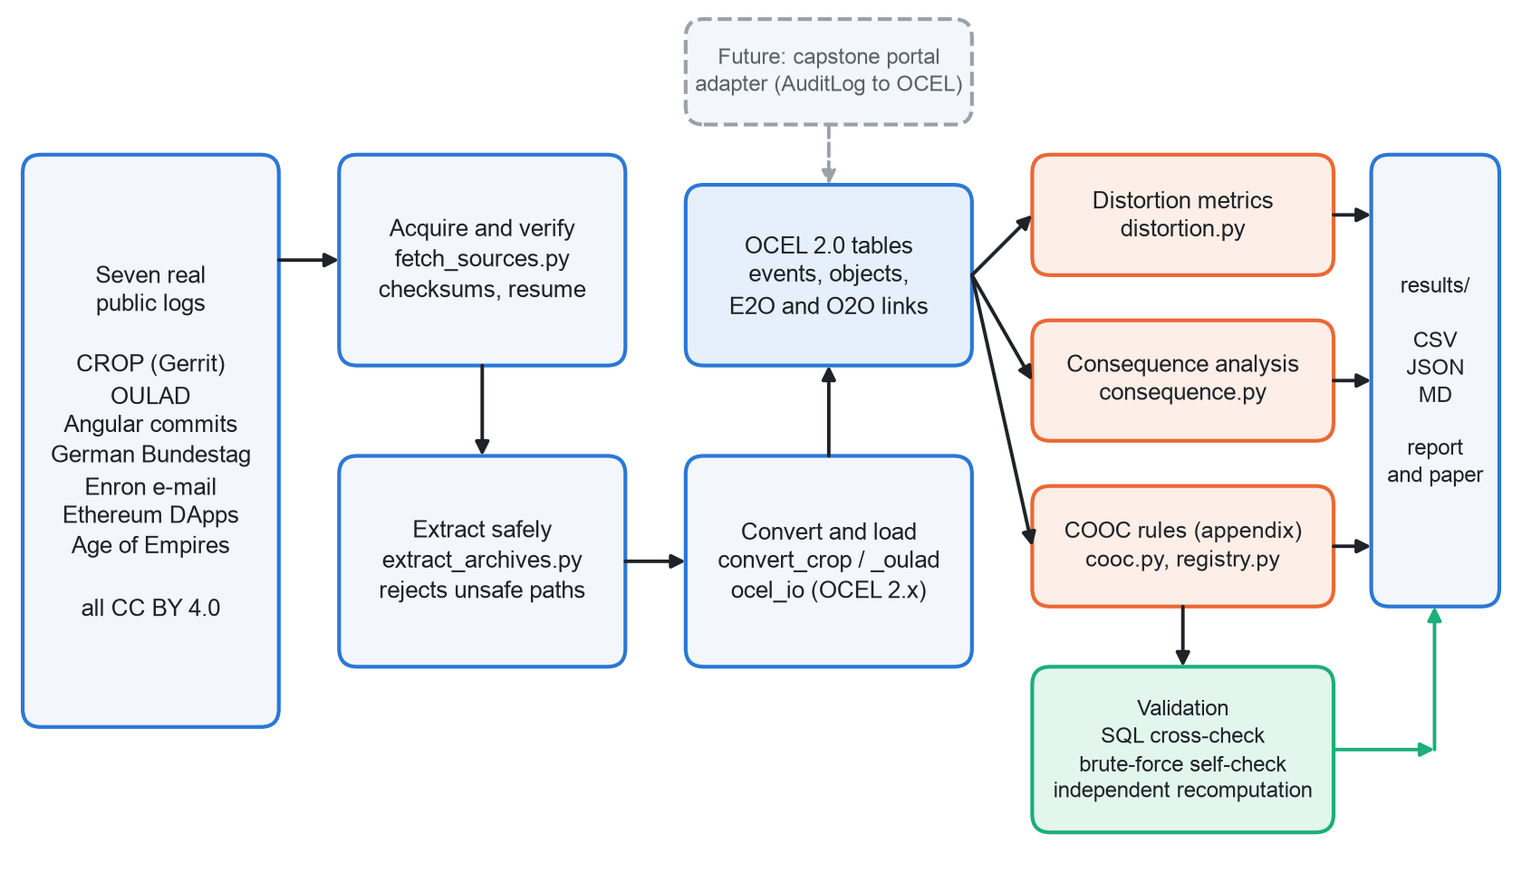
Figure 4.1: System architecture of the flattening study
Those tables are read by three engines. Deficiency, convergence, divergence and coupling for each case notion are computed by the distortion engine, and flat and object-centric outputs are compared by the consequence engine; the rule-based engine is the appendix-level part. A validation stage re-implements the key computations independently, and all results are written as CSV, JSON and Markdown files from which the report and the paper are produced. The dashed box at the top has not been built; it marks where an adapter for the portal's audit log would connect, should de-identified logs be approved.

4.2 Design

4.2.1 Data Flow Diagram
Figure 4.2 is the level-0 diagram, with one process and two external entities. Dataset archives and licences are supplied by public data publishers. The researchers and the guide supply run commands and settings, and receive tables, figures and validation status.
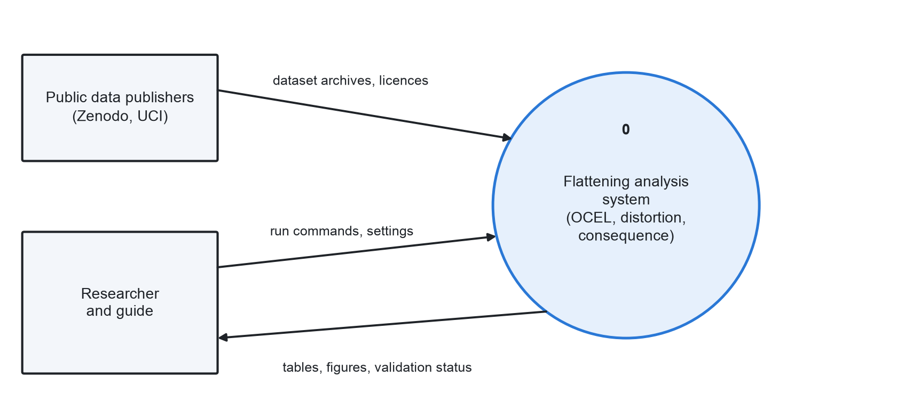
Figure 4.2: Data flow diagram, level 0
Figure 4.3 decomposes that process into six sub-processes. Process 1.0 acquires and verifies archives into store D1, and process 2.0 extracts and converts them into the OCEL logs of store D2. D2 is read by processes 3.0 (distortion metrics) and 4.0 (consequence analysis), which write the metric tables of store D3. Process 5.0 validates, and process 6.0 summarises the results for the researchers.
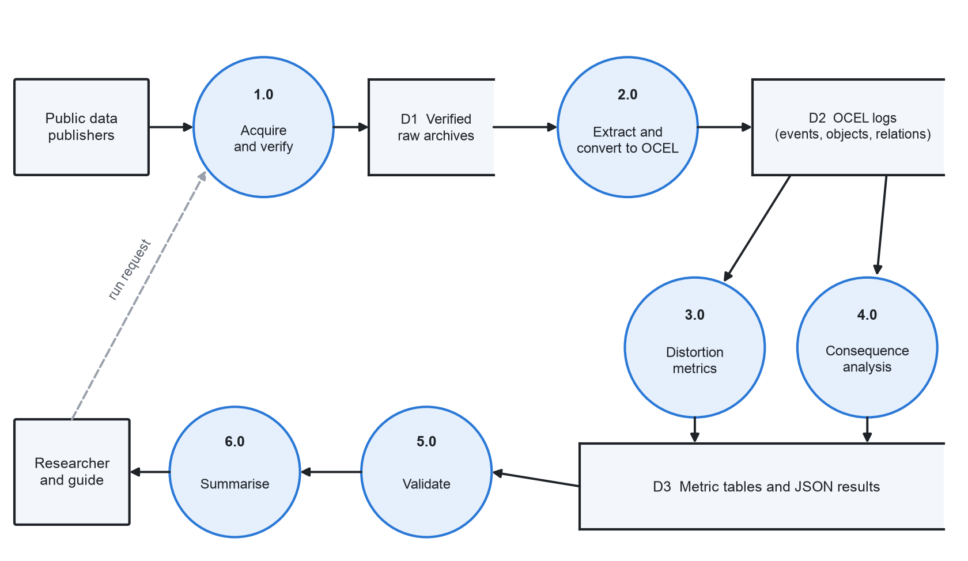
Figure 4.3: Data flow diagram, level 1

4.2.2 Use Case Diagram
Figure 4.4 has two actors. The researcher (the team) downloads and verifies datasets, converts a source to OCEL 2.0, computes distortion metrics, runs the consequence analysis, validates against independent code and exports tables. The results are reviewed and approved by the guide or panel.
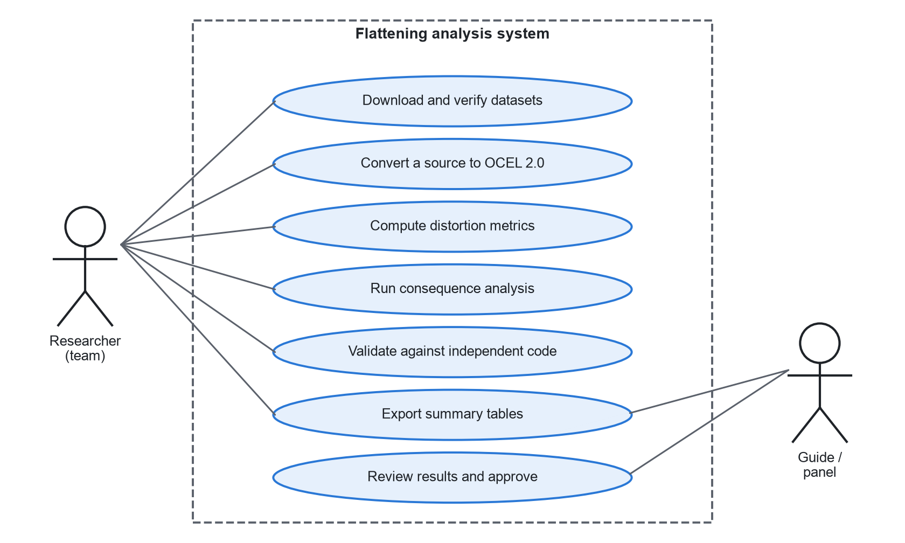
Figure 4.4: Use case diagram

4.2.3 Class Diagram
The main data structures are shown in Figure 4.5. Ocel holds the four tables of a loaded log, and Prepared wraps an Ocel with integer-coded arrays, which makes the rankings and directly-follows counts fast to compute. View and Predicate belong to the rule-based engine, where a predicate is evaluated on a view of the log (native, flat or denormalised flat). Note that in the code the loader and the registry are modules of functions, not classes; they are drawn as classes to make their roles clear.
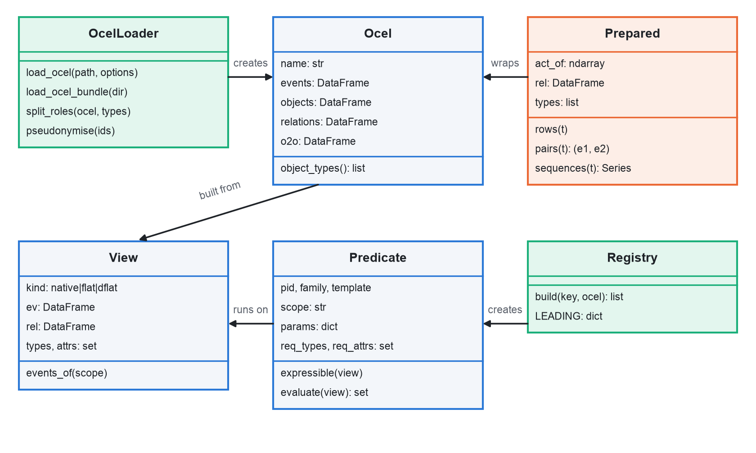
Figure 4.5: Class diagram of the main structures

4.2.4 Sequence Diagram
One full run is followed in Figure 4.6. The researcher starts the download, which verifies and records each file, and conversion writes OCEL 2.0 SQLite. The distortion engine asks the loader for an Ocel and writes its JSON results, and the consequence engine does the same. The self-check recomputes the directly-follows pairs and the entity ranking in plain Python, and the summaries come last.
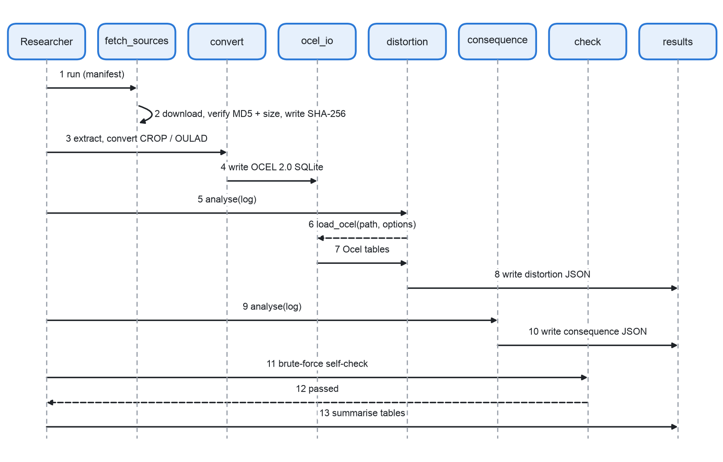
Figure 4.6: Sequence diagram of one end-to-end run

4.3 OCEL 2.0 Model of the Capstone Lifecycle (Design Only)
This section outlines the model we designed for the portal; it is a design, not a result. We derived it from the portal's documentation (the audit-trail, submission-system and scoring-system documents in the repository), and because no portal data is available, it has not been populated with portal data.
Table 4.1: Object types of the capstone model
Object type | Meaning | Example relations (qualifiers)
Student | A team member; the leader may submit | member-of (team)
Team | Group executing one project | executes (project)
Project | The capstone project | has-report, guides
Faculty (guide) | Guide who approves ideas, opens reviews and decides | guides (project), reviews (stage)
Report | The report for a project | has-version
Report version | One compiled version; incremented on each rejection | has-score
Review stage | R1, R2 or R3 | at-stage
Score | Similarity and AI percentages; written once, then locked | has-score (from version)

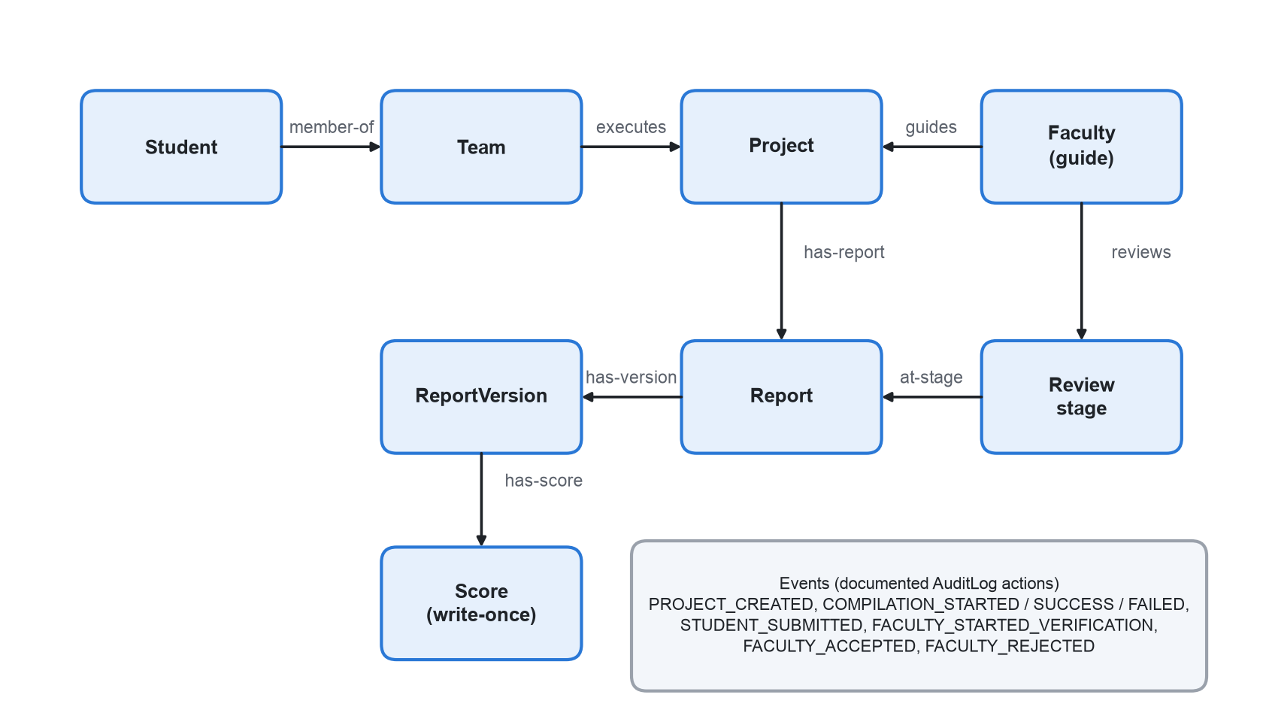
Figure 4.7: Object types, relations and events of the capstone lifecycle
The portal writes an audit-log row for every state transition, and the documented action vocabulary gives eight event types: PROJECT_CREATED, COMPILATION_STARTED, COMPILATION_SUCCESS, COMPILATION_FAILED, STUDENT_SUBMITTED, FACULTY_STARTED_VERIFICATION, FACULTY_ACCEPTED and FACULTY_REJECTED. Each row carries a project identifier, the acting student or faculty member and a timestamp. In the model, an event relates to its project, to the acting student or faculty member, and, through joins on the project, to the team, the report version and the stage.
The model is shaped by a few documented facts. A score is written once and then locked. A rejection uses up one of three attempts and increments the report version, while compilation failures are free retries and do not use an attempt. The documentation lists the automatic move from stage R1 to R2 to R3 as a known gap, so the stage relation is part of the design, yet the current system does not fully populate it.
CHAPTER 5

METHODOLOGY AND TESTING

5.1 Module Description
There are seven modules, M1 to M7. Each one is a small Python script in the realdata/src directory, each reads what the one before it wrote, and Figure 4.1 shows how they connect.

5.1.1 M1: Acquire and Verify
fetch_sources.py reads a manifest (sources.json) that lists each source with its record number, licence and expected files. For a Zenodo record it asks Zenodo for the file list, downloads each file, and compares the size and MD5 checksum with the record; a mismatch deletes the file and stops the run. OULAD comes from the UCI mirror and has no published checksum, so there we cap the download size and record the SHA-256. Every file gets a SHA-256 in a SOURCE.md next to it. If a download stalls, the script resumes from the partial file with an HTTP Range request; this was needed once during the study.
extract_archives.py unpacks each archive into a new, empty directory next to it, and it refuses any archive with an absolute path or a parent-relative (..) member path.
Table 5.1 lists the sources, and Table 7.1 gives the sizes of the logs.
Table 5.1: Sources of the seven logs
Log | Publisher and record | Authors of the dataset
CROP (Gerrit) | Zenodo 3599150 | Paixao, Krinke, Han, Harman
OULAD | UCI repository, DOI 10.24432/C5KK69 | Kuzilek, Hlosta, Zdrahal
Angular commits | Zenodo 8430332 | Pegoraro
German Bundestag (20th period, filtered) | Zenodo 16811928 | Diers, Peeva, Rennert, van der Aalst
Enron e-mail (top 100,000 mails) | Zenodo 21989732 | Berti
Ethereum DApps (300,000-event window) | Zenodo 21989580 | Berti
Age of Empires II (10-match filter) | Zenodo 13365584 | Liss, Elbert, Flath

5.1.2 M2: Convert and Load
Five logs already come in an OCEL format: Angular and Bundestag as JSON, Age of Empires as SQLite, Enron and Ethereum as parquet bundles. For the other two, convert_crop.py and convert_oulad.py build OCEL 2.0 SQLite files. CROP becomes three object types (change, person, project) with events like upload, comment, approve, merge and abandon, and OULAD becomes four (student, enrollment, presentation, assessment) with events like register, submit and unregister.
ocel_io.py loads every format into the same four pandas tables. It hashes personal identifiers with a salted hash (the Enron e-mail addresses and the CROP names), splits the Enron e-mail address type by role (sender, recipient, copied) so each role can be a case notion, and for Ethereum cuts a contiguous window of 300,000 events. The flattening function used throughout the study is also defined there.

5.1.3 M3: Distortion Metrics
A case notion is an object type we choose as the case. Flattening on type T gives one row for every distinct pair of an event and a T-object, equivalent to the flattening function in pm4py; events with several T-objects are repeated, events with none are dropped, and only event-level attributes survive. A case notion counts as analysed when it covers at least 1,000 events, which leaves 38 case notions over the seven logs. Table 5.2 defines the metrics.
Table 5.2: Distortion metrics for a case notion T
Metric | Definition | How to read it
Deficiency | Share of events with no T-object | Events a flat view drops
Convergence share | Share of covered events related to two or more T-objects | Events copied into several cases
Copies per event | Flat rows divided by covered events | Inflation of event counts (1.0 means none)
Divergence share | Share of (case, activity) pairs with two or more events whose other-object sets differ | Repeated events that belong to different objects
Nested child | Another type U whose objects are almost exclusive to one case (95% or more), have their own lifecycle (two or more events) and a fan-out of at least 1.5 per case | Items of an order, for example
Cross-instance adjacency | Among directly-follows pairs in cases with two or more nested children, the share whose two events concern disjoint children | Events adjacent in the flat log but unrelated in the data
Coupling | For an ordered pair of types (T, U), the share of U-objects that touch two or more T-objects | How much the cases share objects
Variants per case | Distinct activity sequences divided by cases | How scattered the flat behaviour looks

The thresholds (95% exclusivity, fan-out of 1.5, 1,000 events) are our own choices. They sit at the top of distortion.py and consequence.py, and none of them was tuned to improve a result.

5.1.4 M4: Consequence Analysis
Distortion metrics tell us how much a flat view differs; the consequence analysis asks what an analyst would read differently. The reference is the object-centric view: every event counted once, plus the object-centric directly-follows relation, which is the union of consecutive-event pairs over the lifecycle of every object of every type. For each case notion we compare four outputs against that reference, and then we look at the process model an analyst would discover from the flat log.
- C1, activity ranking: Spearman rank correlation of the flat activity counts with (a) the counts of the whole process, each event once, and (b) the counts of the same covered events each counted once, which isolates the effect of duplication. We also report the share of activities visible at all.
- C2, directly-follows edges: duplication of event pairs (flat pairs divided by distinct pairs), rank agreement of edge frequencies with and without duplicates, the largest inflation among the ten most frequent reference edges, and, when nested children exist, the share of flat edge instances whose edge type never occurs inside any child (the spurious edge mass).
- C3, variants: distinct activity sequences, variants per case, and the share of cases covered by the ten most frequent variants.
- C4, entity ranking: for every other object type with at least 30 objects, the rank correlation between the true number of events per object and the row count that a denormalised flat export of T would give, over the objects that appear in the export at all.
- C5, discovered model: the Inductive Miner with infrequent-behaviour filtering [12] (noise threshold 0.2, as implemented in pm4py [15]) runs on each flat log. The model is scored on the same flat log with token-based replay fitness [13] and token-based precision [14], and we record the size of the process tree, its loop share (the share of its visible activities that sit under a loop operator) and the share of the process's activities that the model contains at all.
Precision replays every prefix of every case, so its cost grows with the square of case length; we compute it only when the squared case lengths add up to at most 20 million, and each case notion gets an hour in total. The Inductive Miner copies its process tree with Python's deepcopy while simplifying it, and on cases of several thousand events that nests deeper than Python's default limit of 1,000 calls. Two Age of Empires II case notions failed on this account in our first runs, so discovery.py raises the limit inside the mining process.
Two details matter for fairness. Events are coded by sorted event identifier, so ties in time always break the same way, and the analysis keeps duplication (the same event counted several times) apart from narrowing (events or activities a case notion never sees). An analyst can undo the first by de-duplicating on the event identifier; the second, however, cannot be recovered from a flat log.
Some object types would never be chosen as a case notion. A farm in Age of Empires II, as an illustration, takes part in only a handful of activities. To separate this structural narrowing from narrowing that an analyst could plausibly encounter, we also look at the widest case notion of each log (the one covering the most events) and at plausible case notions, meaning those that cover at least half of the log's events. Both views were introduced after the first results were seen, so we report them over a range of thresholds rather than at 50% only.
Every number is computed on the full data, so the remaining uncertainty is about which events and which items happen to be in a log. bootstrap.py estimates it with 200 bootstrap replicates and a fixed seed. For counts of case notions it gives every event a Poisson(1) weight and recomputes coverage and visibility; for rank correlations it resamples the ranked items themselves (activities, or visible entities). An earlier version also applied event weights for the correlations and generated intervals that did not contain their own estimates: an entity with a single event receives the same weight in its true count and in its row count, which creates artificial agreement. The unweighted replicate reproduces every published value, and the script checks that before it starts.

5.1.5 M5: Predicate Engine (Appendix-Level)
A rule-based engine is kept from earlier work, cooc.py with registry.py; it evaluates eleven natural rules (as an illustration, a change is merged only after an approval vote, or no submission after the assessment deadline) on native, flat and denormalised-flat views of CROP and OULAD. Two logs and eleven rules are too few to support a conclusion, so the engine is excluded from the main results.

5.1.6 M6: Validation
sql_crosscheck.py re-implements four CROP rules in plain SQL on the OCEL SQLite file, opened read-only. check_consequence.py compares the fast consequence code with a slow plain-Python version on a real slice of the Enron log, and check_distortion.py does the same for the distortion metrics, using only dictionaries and sets. By default it runs on 6,000-event slices of Enron, Bundestag and Age of Empires II; with --full (part of make study) it recomputes every metric on all seven full logs and compares the result with the published files. Finally, the OULAD counts are recomputed independently from the raw CSV files. Section 5.2 reports the results.

5.1.7 M7: Summaries
summarize_distortion.py, summarize_log_level.py, summarize_consequence.py and summarize_discovery.py combine the per-log JSON files into the CSV and Markdown tables used in Chapter 7. make study runs the main sequence and the full-log check, and make extended runs the bootstrap and the process-discovery comparison, which take much longer.

5.2 Testing
The project was tested as we would test an external piece of work; Table 5.3 lists each check, what it establishes and its outcome.
Table 5.3: Verification checks
Check | What it proves | Result
Download integrity | Zenodo files match the published size and MD5 | Verified for the Zenodo sources; SHA-256 recorded for every file, including OULAD
Reproducibility | Re-running gives the same outputs | Tracked result files were byte-identical after a re-run (checked with Git)
SQL cross-check | The predicate code matches independent SQL | 4 of 4 CROP rules match exactly: 522, 19,109, 164 and 423 flagged changes
Brute-force self-check | The fast consequence code equals plain Python | Directly-follows pairs identical on 4 case notions; entity ranking identical
Distortion self-check | The pandas distortion metrics equal a plain-Python version | Identical on all seven full logs: 87 case notions (every object type) and 294 type pairs
Bootstrap reproduction | The resampling code computes the same statistics as the analysis | The unweighted replicate matches all 38 case notions exactly
Independent recomputation | OULAD counts match the raw CSV files | 15,348 enrolments with a late submission, 415 submissions after unregistration, 29 flagged by the stage-order rule: all exact
Bugs found by our own checks | The checks detect real errors | Three bugs found and fixed (see below)

The checks caught three bugs of our own, and we fixed all three before producing the results in this report.
- Duplicate events: duplicate event rows were written by the CROP converter, about 17% of them. They are removed.
- A missed abandon form: the converter did not recognise one phrasing of the Gerrit abandon message ("Patch Set N: Abandoned"). It does now.
- Tie-breaking: events with the same timestamp could be ordered differently in two code paths, so events are now ordered by timestamp and then by event identifier.
Some checks were not carried out. No one outside the team labelled the findings. We reviewed a stratified sample of classified CROP comments by hand and found no further misclassification, but the reviewer was one of us, so it is not an independent label set. The converters are checked by us, not by a second team, and the SQL cross-check tests the predicate code, not the CROP converter. The activity-ranking numbers are recomputed only by the bootstrap code, which loads the data the same way as the analysis it checks.
CHAPTER 6

PROJECT DEMONSTRATION
The live demonstration runs five commands from the realdata directory. We ran them for this report and saved the output under docs/review-3/demo/, so that the same output can be shown if network or hardware issues arise during the review. Table 6.1 lists the steps and the measured times.
Table 6.1: Demonstration steps
Step | Command | What the panel sees | Time
1 | python3 -I src/fetch_sources.py | All eight sources already present; nothing is downloaded again | 0.1 s
2 | .venv/bin/python -I src/check_consequence.py | Self-check against the plain-Python version | 3.7 s
3 | .venv/bin/python -I src/distortion.py enron | Distortion table for the Enron log | 9.5 s
4 | .venv/bin/python -I src/consequence.py enron | Rankings, edges, variants and entities for Enron | 4.1 s
5 | head -4 results/consequence_by_log.md | The cross-log summary table | instant

6.1 Step 1: Check that the data is present
Command: python3 -I src/fetch_sources.py
[T1e_angular_commits] already present, skipping
[T2a_oulad] already present, skipping
[T2b_moodle_cadiz] already present, skipping
[T3a_crop] already present, skipping
[T4a_bundestag] already present, skipping
[T4b_enron] already present, skipping
[T4c_ethereum] already present, skipping
[T4d_aoe2] already present, skipping
python3 -I src/fetch_sources.py 0.04s user 0.02s system 58% cpu 0.109 total

The manifest lists eight sources, and all of them are already on disk with a SOURCE.md, so the script skips them. On a clean machine the same command downloads about 350 MB.

6.2 Step 2: Run the self-check
Command: .venv/bin/python -I src/check_consequence.py
consequence self-check passed: DF pairs identical for 4 case notions; entity ranking
identical
.venv/bin/python -I src/check_consequence.py 1.70s user 0.41s system 57% cpu 3.664 total

The fast consequence code and a plain-Python version agree on a real Enron slice; the directly-follows pairs are identical for four case notions, and so is the entity ranking.

6.3 Step 3: Distortion of the Enron log
Command: .venv/bin/python -I src/distortion.py enron

=== enron: events=96,175 e2o/event=3.498
flat[EMAILADDRESS:CC] def=0.778 conv=0.667 copies= 2.114 maxActInfl= 3.286 div=0.769
var/case=0.241 kids=[] CAS=None
flat[EMAILADDRESS:FROM] def=0.046 conv=0.000 copies= 1.000 maxActInfl= 1.000 div=0.802
var/case=0.2079 kids=[] CAS=None
flat[EMAILADDRESS:TO] def=0.060 conv=0.334 copies= 1.572 maxActInfl= 2.345 div=0.778
var/case=0.2526 kids=[] CAS=None
flat[MESSAGEID ] def=0.401 conv=0.000 copies= 1.000 maxActInfl= 1.000 div=0.715
var/case=0.0046 kids=[] CAS=None
coupling EMAILADDRESS:TO objs in >=2 EMAILADDRESS:CC cases: 0.81 (mean 6.369)
coupling EMAILADDRESS:FROM objs in >=2 EMAILADDRESS:CC cases: 0.79 (mean 5.277)
coupling EMAILADDRESS:CC objs in >=2 EMAILADDRESS:TO cases: 0.75 (mean 5.878)
coupling EMAILADDRESS:TO objs in >=2 MESSAGEID cases: 0.69 (mean 11.962)
coupling MESSAGEID objs in >=2 EMAILADDRESS:CC cases: 0.67 (mean 2.173)
coupling EMAILADDRESS:CC objs in >=2 MESSAGEID cases: 0.66 (mean 7.222)
.venv/bin/python -I src/distortion.py enron 9.18s user 0.29s system 99% cpu 9.502 total

Four case notions get flattened: the three e-mail roles and the message identifier. With the copied-in recipients as the case (EMAILADDRESS:CC), 77.8% of the events drop out, while the remaining events are copied 2.11 times on average. The message identifier drops 40.1% of the events and copies nothing. The coupling lines show how strongly the cases are interlinked: 81% of the "to" addresses take part in events that belong to two or more different "cc" cases (6.4 on average).

6.4 Step 4: Consequences for the Enron log
Command: .venv/bin/python -I src/consequence.py enron

=== enron: events=96,175 reference DF pairs=157,258 edge types=48
EMAILADDRESS:CC act: visible=0.7778 rho(all)=0.8656 rho(dup)=1.0 | DF:
dup=1.5675 rho(dup)=0.9844 top10(dup)=9 maxInfl10=0.357 spur=None | var/case=0.241
top10cov=0.5653 | entity rho min/med=0.0832/0.473
EMAILADDRESS:FROM act: visible=1.0 rho(all)=1.0 rho(dup)=1.0 | DF: dup=1.0
rho(dup)=1.0 top10(dup)=10 maxInfl10=0.669 spur=None | var/case=0.2079 top10cov=0.623
| entity rho min/med=0.3863/0.962
EMAILADDRESS:TO act: visible=1.0 rho(all)=0.9333 rho(dup)=0.9333 | DF:
dup=1.3065 rho(dup)=0.9792 top10(dup)=9 maxInfl10=1.161 spur=None | var/case=0.2526
top10cov=0.5419 | entity rho min/med=0.1591/0.887
MESSAGEID act: visible=1.0 rho(all)=1.0 rho(dup)=1.0 | DF: dup=1.0014
rho(dup)=1.0 top10(dup)=10 maxInfl10=0.035 spur=None | var/case=0.0046 top10cov=0.9917
| entity rho min/med=0.8327/0.863
.venv/bin/python -I src/consequence.py enron 3.06s user 0.35s system 82% cpu 4.133 total

Each line is one case notion. For the copied-recipient notion only 77.8% of the activities are visible, and the activity ranking agrees with the whole process at a rank correlation of 0.87. Measured for duplication alone, the correlation is exactly 1.0, so nearly all of that gap is owing to narrowing.

6.5 Step 5: The cross-log summary
Command: head -4 results/consequence_by_log.md
The command prints a Markdown table with one row per log; the lines are too wide for a printed page, so we do not copy them here. The saved output is in docs/review-3/demo/5_table.txt, and Table 7.3 in Chapter 7 shows the same numbers.
make study re-runs everything. When we ran it for this report it finished without error in 6 minutes 6 seconds and left every tracked result file unchanged (checked with Git).
CHAPTER 7

RESULT AND DISCUSSION
Every number in this chapter comes from the files in realdata/results and regenerates with make study; these are measurements on seven real public logs, so they say nothing about the capstone portal.

7.1 The Seven Logs
Table 7.1: Profile of the seven logs
Log | Domain | Events | Objects | Object types | Objects per event | Analysed case notions
CROP (Gerrit) | Code review | 306,716 | 55,323 | 3 | 3.0 | 3
OULAD | Education | 216,532 | 61,577 | 4 | 3.8 | 4
German Bundestag | Legislation | 62,719 | 37,665 | 44 | 1.1 | 9
Age of Empires II | Game play | 34,860 | 5,054 | 25 | 4.3 | 11
Ethereum (window) | Blockchain | 300,000 | 17,773 | 5 | 1.6 | 5
Angular commits | Software commits | 27,842 | 28,317 | 2 | 88.0 | 2
Enron e-mail | E-mail | 96,175 | 70,541 | 4 | 3.5 | 4

The logs cover code review, education, legislation, e-mail, blockchain and game play, which gives 38 analysed case notions. The Ethereum figures are for a contiguous window of 300,000 events from a log with 3.2 million.

7.2 Distortion by Flattening
Table 7.2: Flattening distortion per log (analysed case notions)
Log | Regime | Median share of events dropped | Median copies per event | Largest copies per event | Notions with over 5% duplication | Type pairs sharing 50% or more
CROP (Gerrit) | Star | 0.0% | 1.00 | 1.00 | 0 of 3 | 4 of 6
OULAD | Star | 0.0% | 1.00 | 1.00 | 0 of 4 | 7 of 12
German Bundestag | Partitioned | 90.8% | 1.00 | 1.27 | 2 of 9 | 2 of 13
Age of Empires II | Partitioned | 86.3% | 1.01 | 1.76 | 4 of 11 | 50 of 137
Ethereum (window) | Partitioned | 68.9% | 1.04 | 1.09 | 2 of 5 | 10 of 20
Angular commits | Fan-out | 0.1% | 44.06 | 81.65 | 2 of 2 | 2 of 2
Enron e-mail | Fan-out | 23.1% | 1.29 | 2.11 | 2 of 4 | 8 of 12

The logs fall into three groups, laid out in Figure 7.1.
In the star logs (CROP and OULAD) every event touches exactly one object of each type. Flattening copies nothing (1.00 copies per event) and, in the median, drops nothing; on these two measures the distortion is zero.
The partitioned logs (Bundestag, Age of Empires II, Ethereum) copy little, at most 1.27, 1.76 and 1.09 copies per event. Yet different object types cover different parts of the log, so the median case notion drops between 69% and 91% of the events.
In the fan-out logs (Angular commits and Enron) one event relates to many objects of the same type. The largest duplication is 81.65 copies per event in Angular (the branch case notion) and 2.11 in Enron.
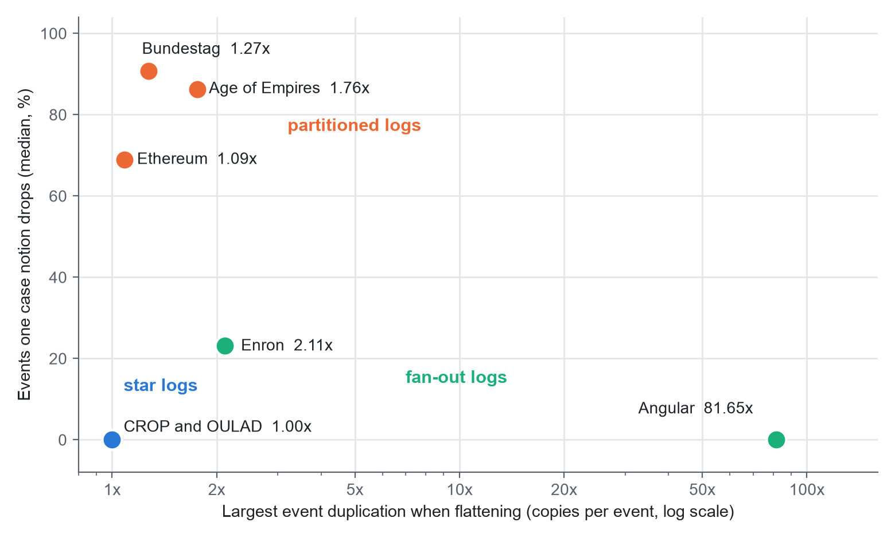
Figure 7.1: Duplication and dropped events for the seven logs, by regime
Coupling adds a second perspective. Figure 7.2 shows the share of object-type pairs where the objects of one type are shared across the cases of the other. In every log except the Bundestag and Age of Empires, at least half the type pairs share more than half of their objects, and in Angular both of the two pairs do.
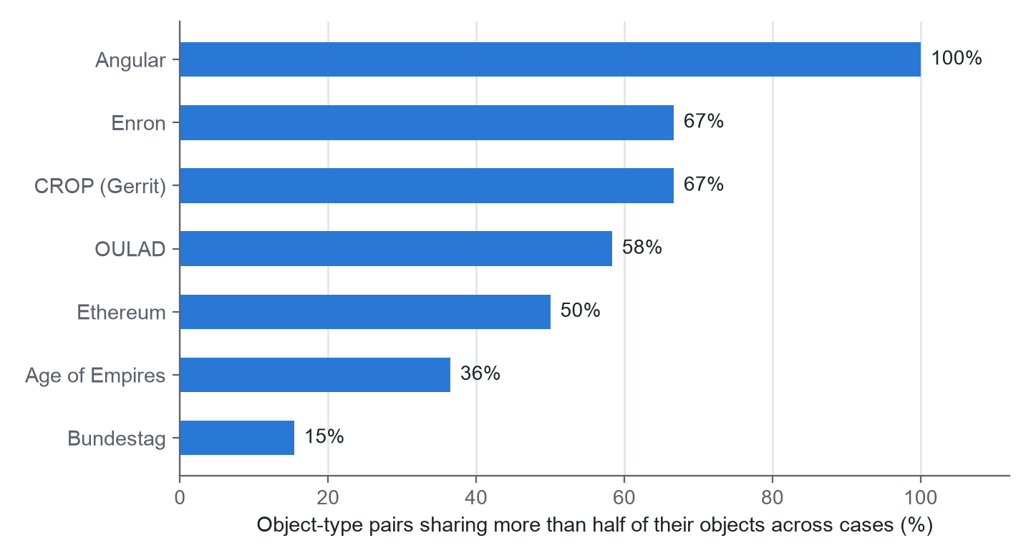
Figure 7.2: Object-type pairs that share more than half of their objects across cases

7.3 Consequences for Standard Outputs
Table 7.3: Consequences of flattening per log
Log | Notions | Activities visible (median) | Activity rank correlation, whole process (median / lowest) | Lowest, duplication only | Largest edge duplication | Lowest entity-rank correlation
CROP (Gerrit) | 3 | 1.00 | 1.00 / 1.00 | 1.00 | 1.00 | 1.00
OULAD | 4 | 1.00 | 1.00 / 0.87 | 1.00 | 1.00 | 0.98
German Bundestag | 9 | 0.10 | 0.17 / 0.00 | 1.00 | 1.26 | 0.34
Age of Empires II | 11 | 0.12 | 0.21 / -0.05 | 1.00 | 1.69 | -0.41
Ethereum (window) | 5 | 0.79 | 0.64 / 0.02 | 1.00 | 1.02 | -0.01
Angular commits | 2 | 0.98 | 0.88 / 0.81 | 0.81 | 74.05 | 0.88
Enron e-mail | 4 | 1.00 | 0.97 / 0.87 | 0.93 | 1.57 | 0.16

Three findings follow from this table.
First, duplication alone rarely changes a ranking. When the activity ranking from flat rows is compared with the ranking of the same events counted once, only 2 of the 38 case notions fall below a rank correlation of 0.95 (bootstrap interval 1 to 3): Angular files (0.81, interval 0.66 to 0.90) and the Enron "to" role (0.93). The Enron value is less certain: with only nine activities, its interval runs from 0.53 to 1.00. Where a log has no duplication, as in the star logs, the correlation is exactly 1.0.
Second, narrowing is the bigger effect. In 20 of the 38 case notions the flat log shows fewer than half of the activities of the whole process. The activity rank correlation with the whole process has a median of only 0.17 in the Bundestag (interval 0.14 to 0.29) and 0.21 in Age of Empires II (0.15 to 0.29). A flat view of those logs is therefore not a distorted picture of the whole process but a small part of it.
Much of this narrowing is structural. Eighteen of the 20 narrowed case notions come from the Bundestag and Age of Empires II, where an object type such as a written parliamentary question or a farm is in effect a sub-process of its own, and a farm cannot be expected to see the rest of the game. We therefore also inspected the case notions an analyst would plausibly choose. Fifteen of them cover at least half of their log, and 2 of those are still narrowed. Villager, in Age of Empires II, covers 52.8% of the events but shows 17% of the activities. OULAD's Assessment case notion covers 80% of the events and shows one activity in three: every submission is present, while every registration and withdrawal is lost. More importantly, two logs have no plausible case notion at all: the widest case notion covers 32.8% of the Bundestag events (and 3% of its 148 activities) and 37.4% of the Ethereum window. In the other five logs the widest case notion covers at least 95% of the events.
These counts do not depend on a single threshold. With the narrowing threshold at 0.3, 0.4, 0.5, 0.6 and 0.7, the number of narrowed case notions is 17, 18, 20, 20 and 20. With the coverage threshold at 30% to 70%, there are 21, 16, 15, 13 and 13 plausible case notions, of which 5, 3, 2, 1 and 1 are narrowed, and OULAD Assessment is narrowed every time. Raising the 1,000-event cut-off to 2,000 or 5,000 leaves 15 of 33 and 10 of 28 narrowed, and in all 200 bootstrap replicates the counts remain at 20 narrowed, 15 plausible and 2 both.
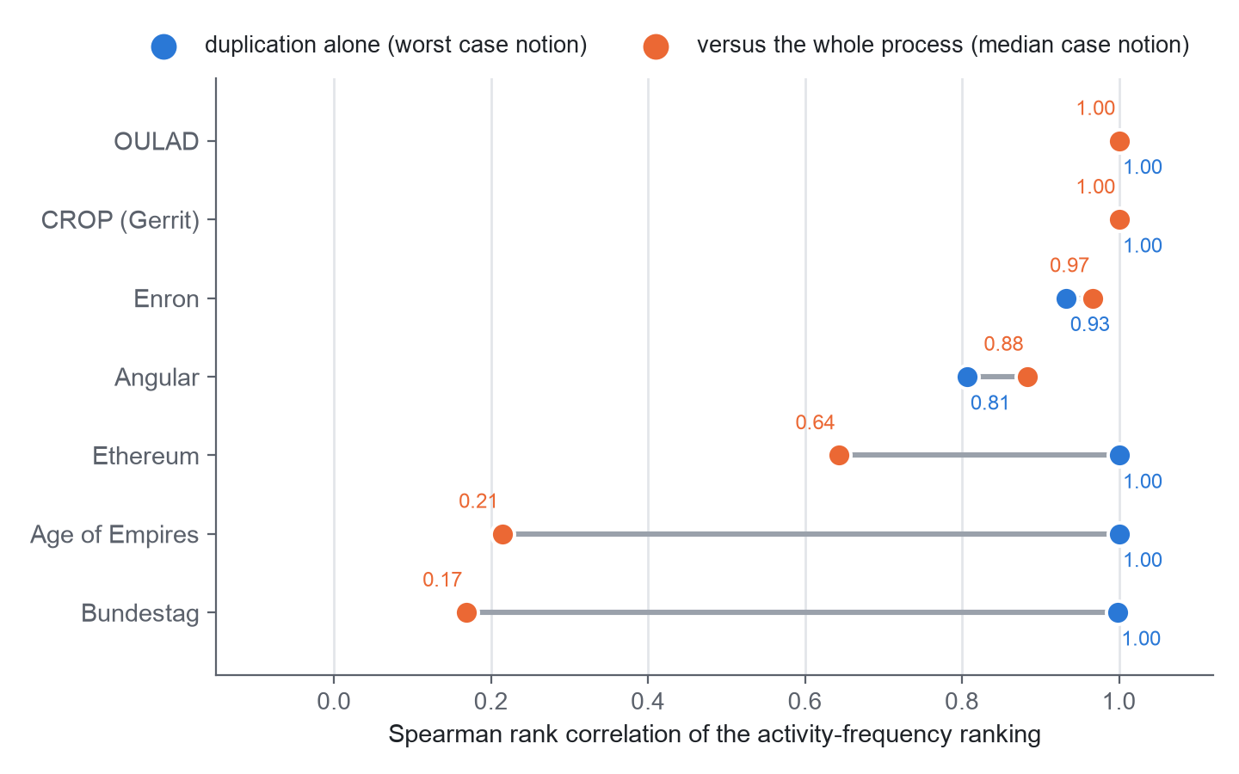
Figure 7.3: Activity ranking agreement: duplication alone versus the whole process
Third, careless counting can mislead. Suppose an analyst ranks entities (people, as an illustration) by counting rows in a denormalised flat export. Among the entities that appear in the export, the worst-case rank correlations with the true number of events per entity are 0.16 in Enron (interval 0.14 to 0.18), -0.01 in Ethereum (-0.03 to 0.02) and -0.41 in Age of Empires II (-0.67 to -0.26). An analyst who de-duplicates on the event identifier would avoid this, so this result is a warning about careless counting rather than an unavoidable loss.
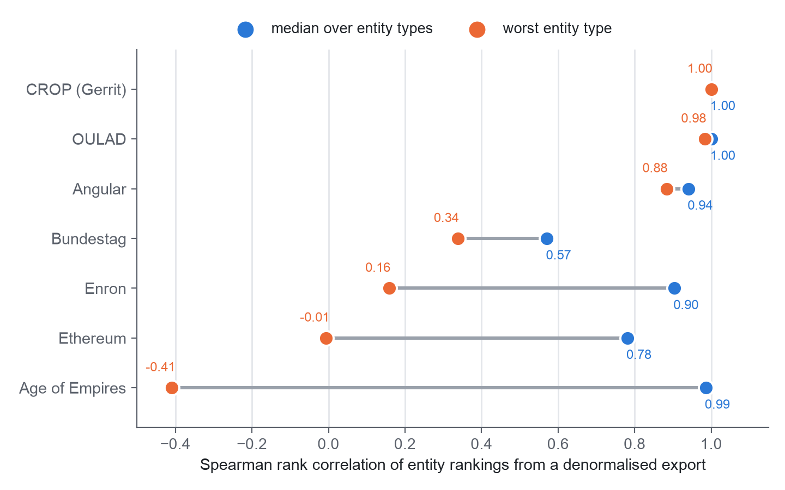
Figure 7.4: Entity ranking agreement from a denormalised flat export
Directly-follows edges show a smaller but measurable effect. Angular has the largest duplication of event pairs (74 copies for the branch case notion). Where nested children exist, some flat edges join events that are adjacent in the flat log but unrelated in the data; these spurious edges account for at most 27.7% in Age of Empires II and 16.6% in OULAD.
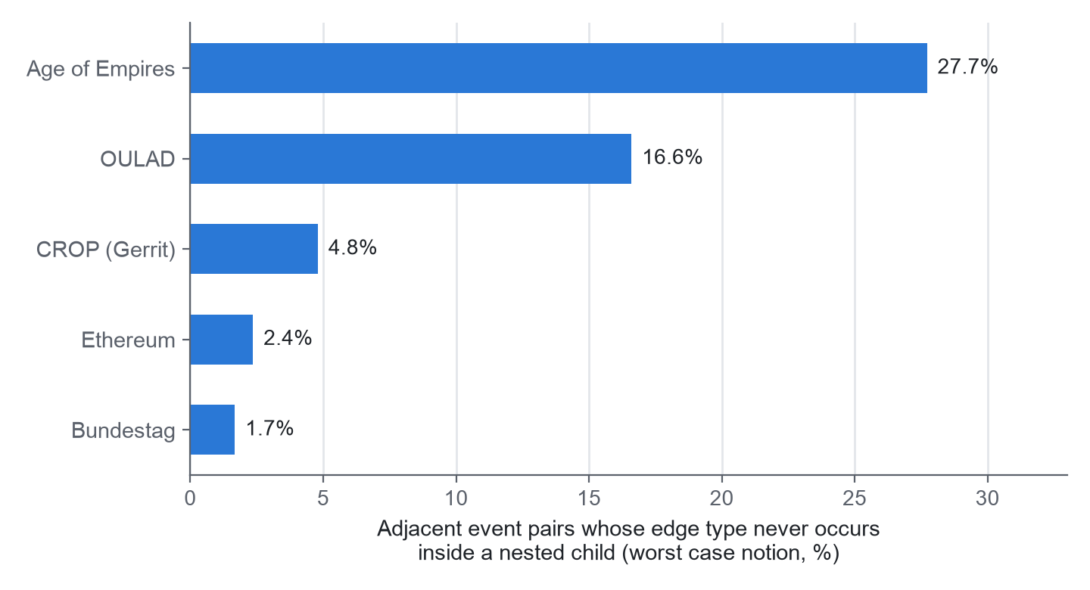
Figure 7.5: Spurious directly-follows edges, worst case notion per log

7.4 Process Discovery on Flat Logs
Process discovery is the most typical use of process mining, so we discovered a model from every flat log (C5 in Section 5.1); it finished for 37 of the 38 case notions, and Table 7.4 summarises the results per log. One case notion did not finish: Angular commits branches (it exceeded the time budget).
Table 7.4: Process discovery on the flat logs (Inductive Miner, noise threshold 0.2)
Log | Mined | Lowest fitness | Median precision (notions) | Models with 90% or more of activities in loops | Models with under half of the activities
CROP (Gerrit) | 3 of 3 | 0.975 | 0.65 (1) | 3 | 0
OULAD | 4 of 4 | 0.980 | 0.98 (2) | 3 | 1
German Bundestag | 9 of 9 | 0.955 | 0.79 (9) | 1 | 9
Age of Empires II | 11 of 11 | 0.977 | 0.30 (9) | 4 | 9
Ethereum (window) | 5 of 5 | 0.979 | 0.07 (1) | 5 | 1
Angular commits | 1 of 2 | 0.987 | 0.60 (1) | 0 | 0
Enron e-mail | 4 of 4 | 0.984 | 0.99 (2) | 2 | 0

First, every model appears to be of high quality. Replay fitness runs from 0.955 to 1.000, with a median of 0.994, and all 20 narrowed case notions are in that range; yet 20 of the models contain fewer than half of the process's activities. Fitness is measured against the flat log from which the model was discovered, so it cannot reflect what flattening removed. Figure 7.6 reveals this: the points on the left represent models of a small fraction of the process, and they score as well as the complete ones.
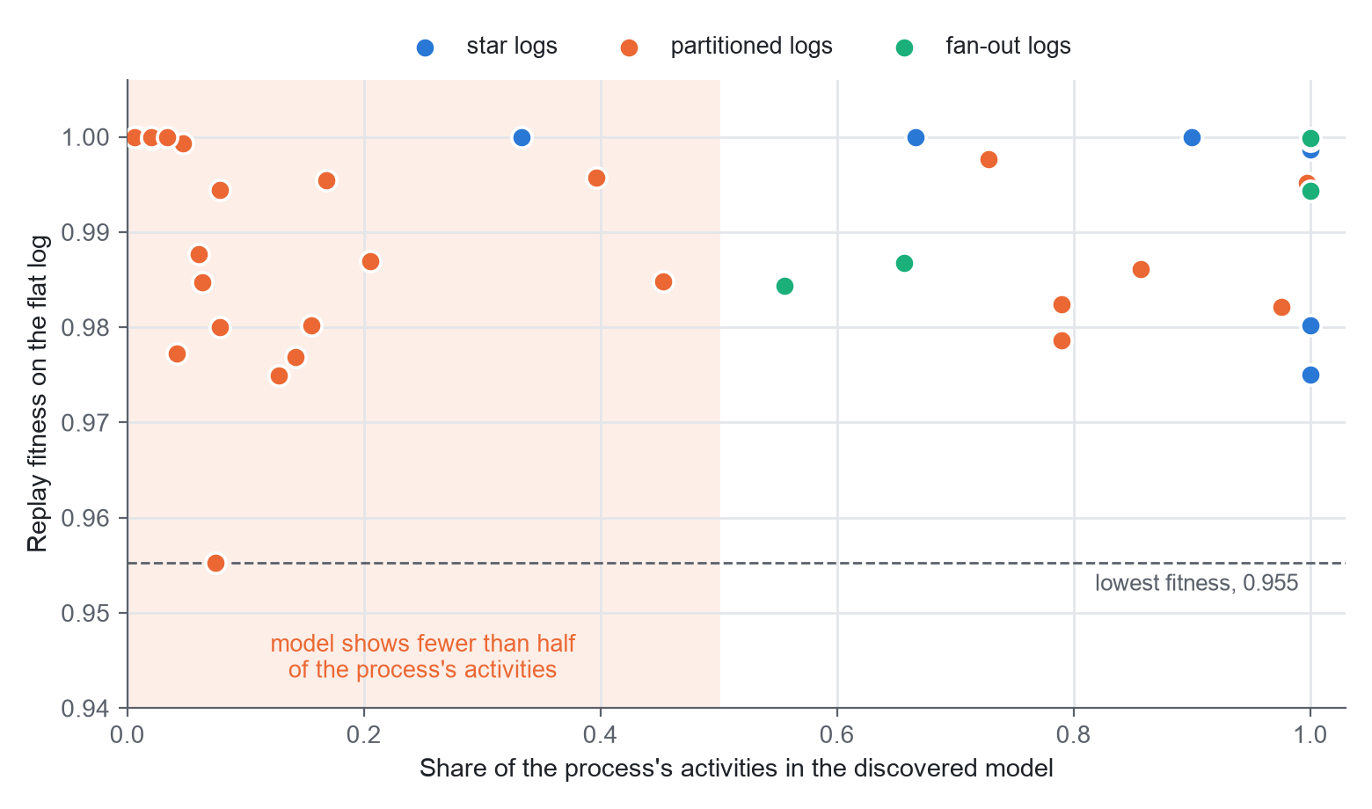
Figure 7.6: Replay fitness against the share of the process's activities in the discovered model, one dot per case notion
Second, divergence appears as loops. Across case notions the loop share rises with the divergence share (Spearman rank correlation 0.69), and at least 90% of the activities sit under a loop in 14 of the 19 case notions with a divergence share of 0.5 or more, and in only 4 of the rest. When a flat case collects repeated events that belong to different objects, the miner tends to place them inside a loop. Precision, which could be computed for 25 case notions, reveals the result: its median is 0.67, and the lowest values (0.04 for Age of Empires II player, 0.07 for Ethereum orders (ORDER), 0.09 for German Bundestag legislation (Gesetzgebung)) all come from models in which nearly every activity is inside a loop, so the models accept almost any order of events.
Given the number of case notions and the seven logs, we interpret these correlations as tendencies rather than general laws.

7.5 Discussion
Our initial expectation was that flattening mainly duplicates events, and the data did not support this. Duplication is large in only two of the seven logs; the common pattern is that a case notion sees only part of the process, and the flat log gives no indication of what is missing. The usual quality check does not reveal this either: a model discovered from a narrowed flat log still replays that log almost perfectly, so fitness remains high precisely when the view is most partial.
For the capstone, only a hypothesis can be stated, since no portal data is available. The portal's documented audit log relates each action to one project and to the person who acted. If real data has that shape, flattening on the project would copy few events, but it would hide how one guide's reviews spread across many projects, and it would hide the people; that is the narrowing pattern, not the duplication pattern. The next step is to test this on a de-identified portal log; until then, no claim about the portal is made.

7.5.1 Threats to Validity
- Seven logs from several domains: the three regimes are descriptive, and we do not claim that they are exhaustive.
- Our choices: case notions are object types (and roles for Enron), and the thresholds for nested children and for the minimum case-notion size are ours, written in the code.
- A window of Ethereum: those results come from a contiguous window of 300,000 events.
- A data-quality flag in Enron: about 0.1% of the events (72) have timestamps before 1990, which is unusual for a corpus from 1998 to 2002. They were kept.
- Checks by us: the independent implementations are independent of the code under test, not of the team, and the findings were labelled by no one outside the team.
- One miner: the discovery comparison applies one algorithm with one noise threshold, and other miners may well give different models.

7.6 Cost Analysis
By cost we mean the money and effort to produce or reproduce the study. Table 7.5 summarises it.
Table 7.5: Cost of producing and reproducing the study
Item | Producing the study | Reproducing it
Data | Nil (open data, CC BY 4.0) | About 350 MB download for the core set
Software | Nil (open-source libraries; pm4py is AGPL-3.0) | Python 3.14 and the pinned packages in requirements.txt
Hardware | A laptop the team already owned (8 GiB memory) | Any laptop with 8 GiB of memory or more
Cloud or paid services | None | None
Run time | Seconds to minutes per log | About 4 to 10 seconds for the Enron log; make study for all seven logs took 6 minutes 6 seconds

The principal cost is the team's time, much of it spent on verification; the monetary cost is nil.
CHAPTER 8

CONCLUSION
We set out to study capstone review processes with OCEL 2.0. Portal logs were not available, so the project turned into two things: a documented OCEL 2.0 design of the capstone lifecycle, and a measurement of the effects of flattening on seven real public logs. The main conclusions are as follows.
First, a reproducible and verified pipeline has been built; it downloads and verifies seven public logs, converts two of them to OCEL 2.0, computes distortion metrics for 38 case notions and compares standard outputs between flat and object-centric views. A second, plain-Python implementation reproduces the distortion metrics exactly on all seven full logs, other independent checks agree with the parts they cover, and the checks caught three bugs of our own, which we fixed.
Second, flattening does not mainly duplicate events. Duplication is large only in the fan-out logs, up to 81.65 copies of an event in Angular, and only 2 of 38 case notions fall below a rank correlation of 0.95 on account of duplication alone.
Third, the larger effect is narrowing. In 20 of 38 case notions the flat log shows fewer than half of the process's activities. Most of that comes from the structure of the logs; yet 2 of the 15 case notions that cover at least half of their log are narrowed too, and in two logs no case notion covers half of the events. The counts hold across every threshold we tried and in every bootstrap replicate.
Fourth, the usual quality checks do not detect narrowing: a model discovered from a narrowed flat log still replays that log with a fitness of 0.955 or more, and divergence turns into loops that accept almost any order of events.
Fifth, careless counting from a flat export can be seriously misleading: worst-case entity rankings reach a rank correlation of 0.16 (Enron), -0.01 (Ethereum) and -0.41 (Age of Empires II), and none of the bootstrap intervals exceeds 0.2.
Sixth, the capstone model remains a design. We could not test it on portal data, and nothing is claimed about how real capstone teams behave.
The measurement part of this work is written up as a journal paper, What Does Flattening Hide? Measuring Case-Notion Distortion and Its Consequences on Seven Real Object-Centric Event Logs, which we submitted to the Journal of Intelligent Information Systems (Springer) in October 2026; it is under review.

8.1 Limitations
We have seven logs from five domains, and one of them is a window. The thresholds are ours, and the idea of a plausible case notion came after we had seen the first results. The checks are independent of the code under test but not of the team, no one outside the team has labelled the findings, and the activity-ranking numbers are re-computed only by the bootstrap code. The discovery comparison applies one miner, and the rule-based engine covers eleven rules on two logs, which we use for no conclusion.

8.2 Future Work
- Get independent two-rater labelling of the real-data findings.
- Compare predictive monitoring between flat and object-centric logs, and repeat the discovery comparison with other miners.

REFERENCES
The references follow the IEEE numeric style, numbered in the order in which they are first cited.
[1] W. M. P. van der Aalst, "Object-centric process mining: Dealing with divergence and convergence in event data," in Software Engineering and Formal Methods (SEFM), Lecture Notes in Computer Science. Springer, 2019, pp. 3-25.
[2] A. Berti et al., "OCEL (Object-Centric Event Log) 2.0 specification," arXiv:2403.01975, 2024.
[3] J. N. Adams, G. Park, and W. M. P. van der Aalst, "Preserving complex object-centric graph structures to improve machine learning tasks in process mining," Engineering Applications of Artificial Intelligence, vol. 125, p. 106764, 2023.
[4] J. N. Adams and W. M. P. van der Aalst, "Addressing convergence, divergence, and deficiency issues," Lecture Notes in Business Information Processing. Springer, 2024.
[5] P. Waibel, L. Pfahlsberger, K. Revoredo, and J. Mendling, "Causal process mining from relational databases with domain knowledge," arXiv:2202.08314, 2022.
[6] M. Kabierski et al., "Data quality in object-centric event data: Issues classification and evaluation," Process Science, vol. 3, 2026.
[7] N. Miri, S. Khayatbashi, J. Zdravkovic, and A. Jalali, "An object-centric approach to multi-entity educational process mining," Decision Analytics Journal, vol. 19, p. 100724, 2026.
[8] J. Kuzilek, M. Hlosta, and Z. Zdrahal, "Open University Learning Analytics dataset," Scientific Data, vol. 4, p. 170171, 2017.
[9] M. Paixao, J. Krinke, D. Han, and M. Harman, "CROP: Linking code reviews to source code changes," in Proc. Mining Software Repositories (MSR), 2018.
[10] H. Hassani et al., "Supervision of undergraduate final year projects in computing: A case study," Education Sciences, vol. 8, no. 4, p. 210, 2018.
[11] W. Premchaiswadi and P. Porouhan, "Process modeling and bottleneck mining in online peer-review systems," SpringerPlus, vol. 4, p. 441, 2015.
[12] S. J. J. Leemans, D. Fahland, and W. M. P. van der Aalst, "Discovering block-structured process models from event logs containing infrequent behaviour," in Business Process Management Workshops (BPM 2013), Lecture Notes in Business Information Processing, vol. 171. Springer, 2014, pp. 66-78.
[13] A. Berti and W. M. P. van der Aalst, "Reviving token-based replay: Increasing speed while improving diagnostics," in Proc. Algorithms and Theories for the Analysis of Event Data (ATAED 2019), CEUR Workshop Proceedings, vol. 2371, 2019, pp. 87-103.
[14] J. Munoz-Gama and J. Carmona, "A fresh look at precision in process conformance," in Business Process Management (BPM 2010), Lecture Notes in Computer Science, vol. 6336. Springer, 2010, pp. 211-226.
[15] A. Berti, S. van Zelst, and D. Schuster, "PM4Py: A process mining library for Python," Software Impacts, vol. 17, p. 100556, 2023.
[16] Datasets used (all CC BY 4.0): German Bundestag, Zenodo record 16811928 (H. Diers, V. Peeva, C. Rennert, W. M. P. van der Aalst); Enron e-mail OCEL, Zenodo 21989732 (A. Berti); Ethereum execution data, Zenodo 21989580 (A. Berti); Age of Empires II, Zenodo 13365584 (L. Liss, N. Elbert, C. M. Flath); Angular commits, Zenodo 8430332 (M. Pegoraro); CROP, Zenodo 3599150 (M. Paixao, J. Krinke, D. Han, M. Harman); OULAD, UCI Machine Learning Repository, doi:10.24432/C5KK69.

APPENDIX A - SAMPLE CODE
The listings are copied from the repository by a script, so they are the code that produced the results. Long lines are wrapped for printing, and file names are relative to the realdata/src directory.
A.1 Case-centric flattening (ocel_io.py)
def flatten(ocel: Ocel, case_type: str) -> pd.DataFrame:
"""Case-centric flattening: one row per (event, object of ``case_type``).

Mirrors pm4py's ``ocel_flattening``: events related to several objects of the
case type are repeated (convergence); events with none are dropped (deficiency);
only event-level attributes survive, never attributes or identities of other
objects.
"""
rel = ocel.relations[ocel.relations["otype"] == case_type][["eid",
"oid"]].drop_duplicates()
flat = rel.merge(ocel.events, on="eid", how="left").rename(columns={"oid":
"case_id"})
return flat.sort_values(["case_id", "timestamp", "eid"],
kind="stable").reset_index(drop=True)

A.2 Deficiency, convergence and divergence (ocel_io.py)
def flattening_stats(ocel: Ocel, case_type: str) -> dict:
"""Deficiency, convergence and divergence for one case notion."""
n_events = len(ocel.events)
rel_t = ocel.relations[ocel.relations["otype"] == case_type][["eid",
"oid"]].drop_duplicates()
covered = rel_t["eid"].nunique()
per_event = rel_t.groupby("eid")["oid"].nunique()
stats = {
"case_type": case_type,
"cases": int(rel_t["oid"].nunique()),
"events": n_events,
"flat_rows": int(len(rel_t)),
"row_multiplier": round(len(rel_t) / n_events, 3) if n_events else None,
"deficiency_share": round(1 - covered / n_events, 4) if n_events else None,
"convergence_share": round(float((per_event > 1).mean()), 4) if covered else
0.0,
}
# Divergence: within a case, the same activity occurs >= 2 times and the repeated
# events differ in the set of objects of at least one other type.
other = ocel.relations[ocel.relations["otype"] != case_type][["eid", "otype",
"oid"]].drop_duplicates()
if other.empty or rel_t.empty:
stats["divergence_share"] = 0.0
return stats
act = ocel.events[["eid", "activity"]]
case_events = rel_t.merge(act, on="eid")
reps = case_events.groupby(["oid", "activity"])["eid"].transform("count") > 1
case_events = case_events[reps]
if case_events.empty:
stats["divergence_share"] = 0.0
return stats
total_pairs = case_events[["oid", "activity"]].drop_duplicates().shape[0]
sig = (other.sort_values(["eid", "otype", "oid"]).groupby(["eid",
"otype"])["oid"].agg(lambda s: "|".join(s)).reset_index())
merged = case_events.merge(sig, on="eid", how="left")
diverging = merged.groupby(["oid_x", "activity", "otype"])["oid_y"].nunique()
diverging_pairs = diverging[diverging > 1].reset_index()[["oid_x",
"activity"]].drop_duplicates().shape[0]
stats["divergence_share"] = round(diverging_pairs / total_pairs, 4)
return stats

A.3 Rank agreement helpers (consequence.py)
def spearman(a: np.ndarray, b: np.ndarray) -> float | None:
if len(a) < 3 or np.ptp(a) == 0 or np.ptp(b) == 0:
return None
return round(float(spearmanr(a, b).statistic), 4)

def topk_overlap(ref: np.ndarray, other: np.ndarray, k: int) -> int:
"""Size of the intersection of the top-k index sets (ties broken by index,
deterministic)."""
k = min(k, len(ref))
top = lambda x: set(np.lexsort((np.arange(len(x)), -x))[:k]) # noqa: E731
return len(top(ref) & top(other))

def variant_summary(seqs: pd.Series) -> dict:
vc = seqs.value_counts()
return {"cases": int(len(seqs)), "variants": int(len(vc)), "variants_per_case":
round(len(vc) / len(seqs), 4),
"top10_variant_coverage": round(float(vc.head(10).sum() / len(seqs)), 4)}

A.4 Integrity check on a Zenodo download (fetch_sources.py)
def fetch_zenodo(src: dict, out_dir: Path) -> list[dict]:
rec = get_json(f"https://zenodo.org/api/records/{src['record']}")
index = {f["key"]: f for f in rec.get("files", [])}
rows = []
for name in src["files"]:
meta = index.get(name)
if meta is None:
raise SystemExit(f"{src['id']}: {name} not listed in record
{src['record']}")
url = meta.get("links", {}).get("self") or f"https://zenodo.org/api/records/{src
['record']}/files/{urllib.parse.quote(name)}/content"
dest = out_dir / name
print(f"[{src['id']}] {name} ({meta['size'] / 1e6:.1f} MB) ...", flush=True)
md5, sha, size = stream(url, dest)
expected = meta.get("checksum", "").split(":", 1)[-1]
if size != meta["size"] or (expected and md5 != expected):
dest.unlink(missing_ok=True)
raise SystemExit(f"{src['id']}: {name} failed integrity check (size {size}
vs {meta['size']}, md5 {md5} vs {expected})")
rows.append({"file": name, "bytes": size, "sha256": sha, "md5_verified":
bool(expected)})
return rows

A.5 Safe extraction of archives (extract_archives.py)
def main() -> None:
for archive, (target, skip) in JOBS.items():
src, dst = RAW / archive, RAW / target
if not src.exists():
print(f"missing: {archive}")
continue
if dst.exists():
print(f"exists, skipping: {target}")
continue
with zipfile.ZipFile(src) as z:
bad = [i.filename for i in z.infolist() if i.filename.startswith("/") or
".." in i.filename.split("/")]
if bad:
raise SystemExit(f"{archive}: unsafe member paths {bad[:3]}")
dst.mkdir(parents=True)
for info in z.infolist():
if info.filename not in skip:
z.extract(info, dst)
print(f"extracted {archive} -> {target}")

