Educational Capstone Portal Research Program
Three-Paper Proposal — Execution Blueprint & Technical Architecture (v1)
3 teams · 9 researchers · 12-week timeline
Grounded in the Educational Capstone Portal architecture and audit-trail data model
Prepared July 27, 2026

Contents
1. Program Foundations
2. Paper 1 (Team 1) — Educational Capstone Portal as a Native OCEL 2.0 Educational Event Engine
3. Paper 2 (Team 2) — Grounding AI-Augmented Feedback in an Immutable Score Ledger
4. Paper 3 (Team 3) — Traceability-Gap Detection Between Student Code and Thesis Claims
5. Twelve-Week Timeline
6. Risk Register
7. Venue & Submission Strategy
8. Immediate Next Steps

Executive Summary
This document consolidates two rounds of literature verification into a final three-paper research program for the Educational Capstone Portal capstone-portal dataset. Each paper is anchored on a documented educational capstone data asset and must be evaluated against the closest current baselines: Team 1 uses the immutable per-transition audit ledger to build a native object-centric event log and a lightweight digital twin of the capstone lifecycle; Team 2 uses the immutable, write-once, multi-draft score ledger as ground truth for a controlled study of AI-augmented feedback; Team 3 uses grade-linked, faculty-adjudicated code-and-thesis pairs to validate a structural traceability-gap detector.
None of the three requires the planned chatbot or Git-hosting products to exist first — all three run directly against data Educational Capstone Portal already produces. The chatbot and code-repository ideas remain available as optional demo layers on top of Team 1's and Team 3's pipelines, not as prerequisites for publication.

Paper Snapshot
# | Team | Paper title (working) | Core novel claim | Primary venue
1 | Team 1  (3 people) | Educational Capstone Portal as a Native OCEL 2.0 Educational Event Engine | Capstone-specific multi-object observability study using a documented audit ledger, case-centric projection baselines, and a cautiously scoped digital-twin prototype. | ICPM
2 | Team 2  (3 people) | Grounding AI-Augmented Feedback in an Immutable Score Ledger | A controlled AI-vs-traditional feedback study validated against real, tamper-evident institutional grades — not a synthetic post-test. | AIED / LAK
3 | Team 3  (3 people) | Traceability-Gap Detection Between Student Code and Thesis Claims | A structural code↔thesis mismatch signal validated against real accept/reject decisions and grades, not simulated cases. | MSR / ICSE-SEET

1. Program Foundations

1.1 Why These Three
Two earlier candidate lineups were checked against the live literature as of July 2026 and dropped or merged where a close published system already existed — among them a voice-AI oral-exam system already deployed for capstone-style project defense, several 2025–26 randomized trials on AI-vs-human writing feedback, and multiple LLM-as-reviewer / GraphRAG evaluation papers. The three below survived that check because each leans on a Educational Capstone Portal-specific asset — the audit trail, the immutable score ledger, or grade-linked code/thesis pairs — rather than on a general-purpose technique any dataset could reproduce.

1.2 Ethics / IRB Approval — Blocking Prerequisite
Team 2 runs a live, randomized intervention on real students; Team 3 uses real code, theses, and grading decisions; Team 1 uses de-identified process logs. All three need institutional approval before any data leaves the Educational Capstone Portal database. File the IRB/ethics application in week 1 — this is the single most common cause of a 3-month research timeline slipping, and Team 2 specifically cannot begin its intervention without it.

1.3 Shared Data Pipeline
Build one export pipeline that feeds all three teams so nobody hand-rolls their own database access or re-derives their own anonymization logic. A single, read-only, scheduled export job pulls from the Educational Capstone Portal production database, passes through one IRB-approved anonymization/pseudonymization layer, and lands in an access-controlled shared store that each team draws its own extract from. Build this in weeks 1–2, before any team-specific work starts.
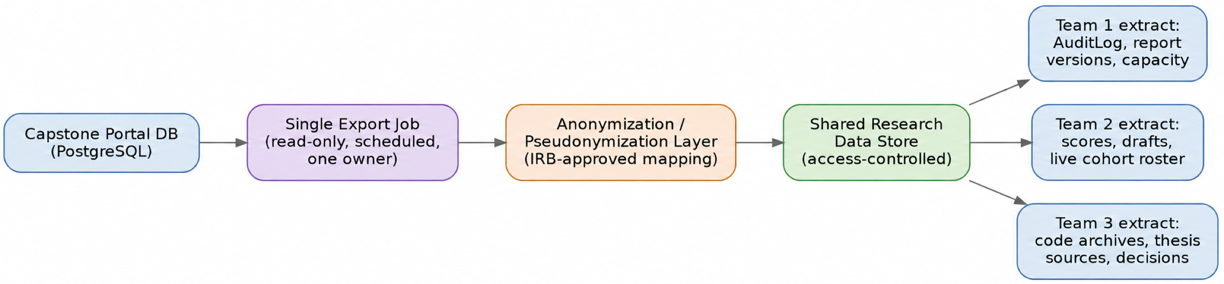
Figure 1. Shared data pipeline — one export path feeds all three teams.

1.4 Suggested Team Roles (3 people per team)
- Data / infra engineer — owns extraction, parsing, and pipeline plumbing specific to that paper.
- ML / NLP engineer — owns the core model or algorithm (OCEL analysis, feedback generation, alignment model).
- Analysis & writing lead — owns statistics, evaluation design, and drafting from week 1, not brought in during week 11.
Adjust to each team's actual skills — the important constraint is that analysis and writing are staffed from the start, not treated as a week-11 activity.

2. Paper 1 (Team 1) — Educational Capstone Portal as a Native OCEL 2.0 Educational Event Engine

2.1 Problem Statement
Flattening Educational Capstone Portal's AuditLog to a single case ID (Student, or Team, or Report) to run conventional process mining loses the other objects a single event actually touches — a guide accepting a submission simultaneously changes Student, Team, Faculty, Project, ReportVersion, and Score state. Object-centric process mining (OCEL 2.0) removes this constraint by letting one event relate to many objects of many types. Team 1 exports Educational Capstone Portal's AuditLog natively to OCEL 2.0 and uses it to (a) discover and conformance-check the multi-object process, testing which bottlenecks become unobservable or incorrect in case-centric projections, and (b) build a minimal digital twin capable of simulating interventions.

2.2 Novelty Positioning
Educational process mining includes extensive case-centric work, and Miri et al. (2026) demonstrate direct object-centric prior art through Moodle-to-OCEL extraction. Educational Capstone Portal's transactional, multi-object ledger is a structurally different and richer substrate. This is a study-specific contribution that requires comparison with the closest educational object-centric baseline and validation on approved real logs before it can be presented as generalizable.

2.3 Data
Production event logs are not yet available to Team 1. The current prototype uses deterministic synthetic events derived from documented AuditLog, ReportVersion, Score, and FacultyGuideCapacity concepts. An empirical submission requires ethics approval, de-identification, extraction-quality checks, recalibration, and grouped validation on approved operational records.

2.4 Method
- Schema mapping: define Educational Capstone Portal's Event-to-Object / Object-to-Object relationships (which objects each AuditLog event type touches) and export to OCEL 2.0's relational SQLite format.
- Discovery: run object-centric process discovery (PM4Py) to build object-centric directly-follows graphs (OC-DFGs) spanning Student, Team, Faculty, ReportVersion, and Score.
- Conformance: check the discovered process against Educational Capstone Portal's documented state machine, quantifying known gaps (attempts-exhausted deadlock, guide-capacity overrun, R1→R2→R3 stalling) as measured deviations, not just documented ones.
- Twin: fit a simple next-transition predictor (temporal baseline or lightweight GNN) over the object-centric graph and use it to simulate interventions such as relaxing max_tries or reallocating guide capacity.

2.5 Evaluation Metrics
Fitness, precision, and generalization of the discovered process model; object-centric conformance scores; bottleneck-detection accuracy against known and newly-surfaced gaps; next-transition prediction accuracy for the twin.

2.6 Architecture — First Draft
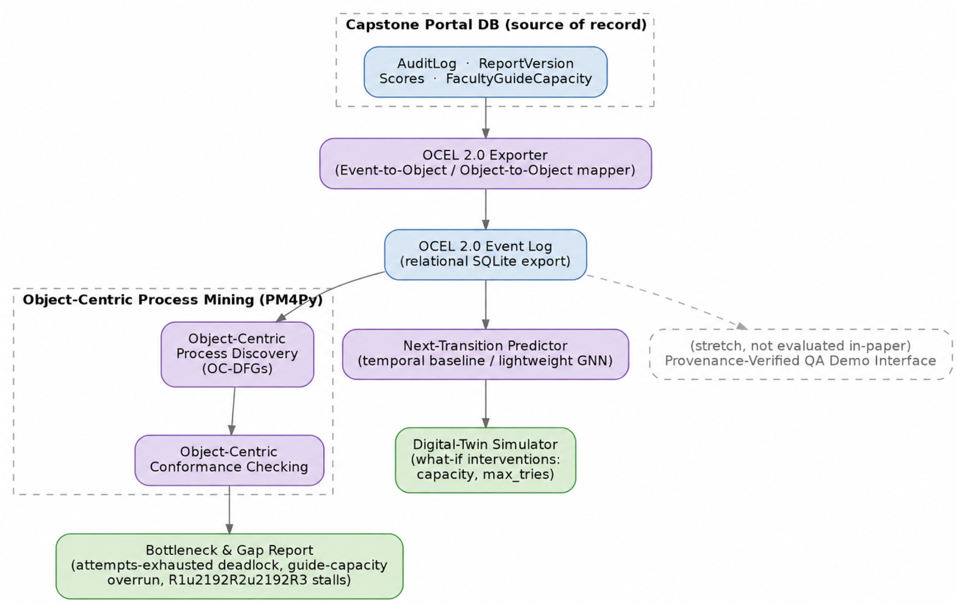
Figure 2. Team 1 architecture — AuditLog → OCEL 2.0 export → object-centric discovery/conformance → digital-twin simulation.

2.7 Deliverables
- A reusable OCEL 2.0 schema and exporter for Educational Capstone Portal's AuditLog, usable well beyond this paper.
- Object-centric process-discovery and conformance results.
- A bottleneck/gap report with quantified severities.
- A working next-transition predictor and a simple twin demo.

2.8 Target Venues
ICPM (International Conference on Process Mining) primary; LAK and IEEE Transactions on Learning Technologies as journal/conference fallback.

2.9 Key Risks
- OCEL export is genuine engineering, not a data pull — budget real time for schema design in weeks 1–4.
- One semester of data may be sparse for discovery/conformance — plan to pool VIT historical records early if statistical power looks thin, rather than waiting until week 9.

3. Paper 2 (Team 2) — Grounding AI-Augmented Feedback in an Immutable Score Ledger

3.1 Problem Statement
Multiple 2025–26 randomized trials already show AI-augmented feedback can improve student writing outcomes relative to human-only feedback, but each measures improvement with a synthetic post-test or self-report, not a tamper-evident institutional grade. Team 2 runs the same class of controlled intervention — traditional faculty feedback vs. AI-augmented feedback (AI drafts, faculty-reviewed) — on a live capstone cohort, but measures the outcome using Educational Capstone Portal's write-once, SERIALIZABLE-locked scores across the real R1→R2→R3 revision cycle, and applies full multi-rater statistics to characterize where AI and faculty judgment agree or diverge.

3.2 Novelty Positioning
The controlled-feedback-study design itself is no longer novel on its own — comparable randomized trials are already published or in press as of mid-2026. What is not published anywhere yet is the same design closed against a real, audited, immutable institutional grade rather than an artificial outcome measure, in a technical/STEM capstone setting rather than general essay writing. Lead the paper with that grounding, not with the intervention design.

3.3 Data
A current-semester live cohort is required — this cannot run on retrospective data alone. Also needs Educational Capstone Portal's immutable score ledger across R1/R2/R3 and the faculty feedback records generated during the intervention.

3.4 Method
- Recruit and randomize a live cohort into control (traditional faculty feedback only) and treatment (AI-augmented feedback: AI drafts rubric-grounded feedback, faculty reviews/edits/approves before it reaches the student) arms.
- Both arms proceed through Educational Capstone Portal's native R1→R2→R3 revision cycle unmodified.
- Record every AI draft and every faculty edit to it, alongside the real final scores.
- Apply the full multi-rater statistical toolkit (Cohen's/Fleiss' kappa, ICC, MAE, bias decomposition) to quantify AI/faculty agreement and any systematic bias, and compare score improvement between arms.

3.5 Evaluation Metrics
Score improvement (R1→R3) by arm as the primary outcome; inter-rater reliability (κ, ICC) between AI draft and faculty-approved final feedback; MAE between AI-suggested and faculty-assigned scores where applicable; bias decomposition by student subgroup (e.g., non-native-English or informal-register writers) to connect back to the stylistic-bias literature.

3.6 Architecture — First Draft
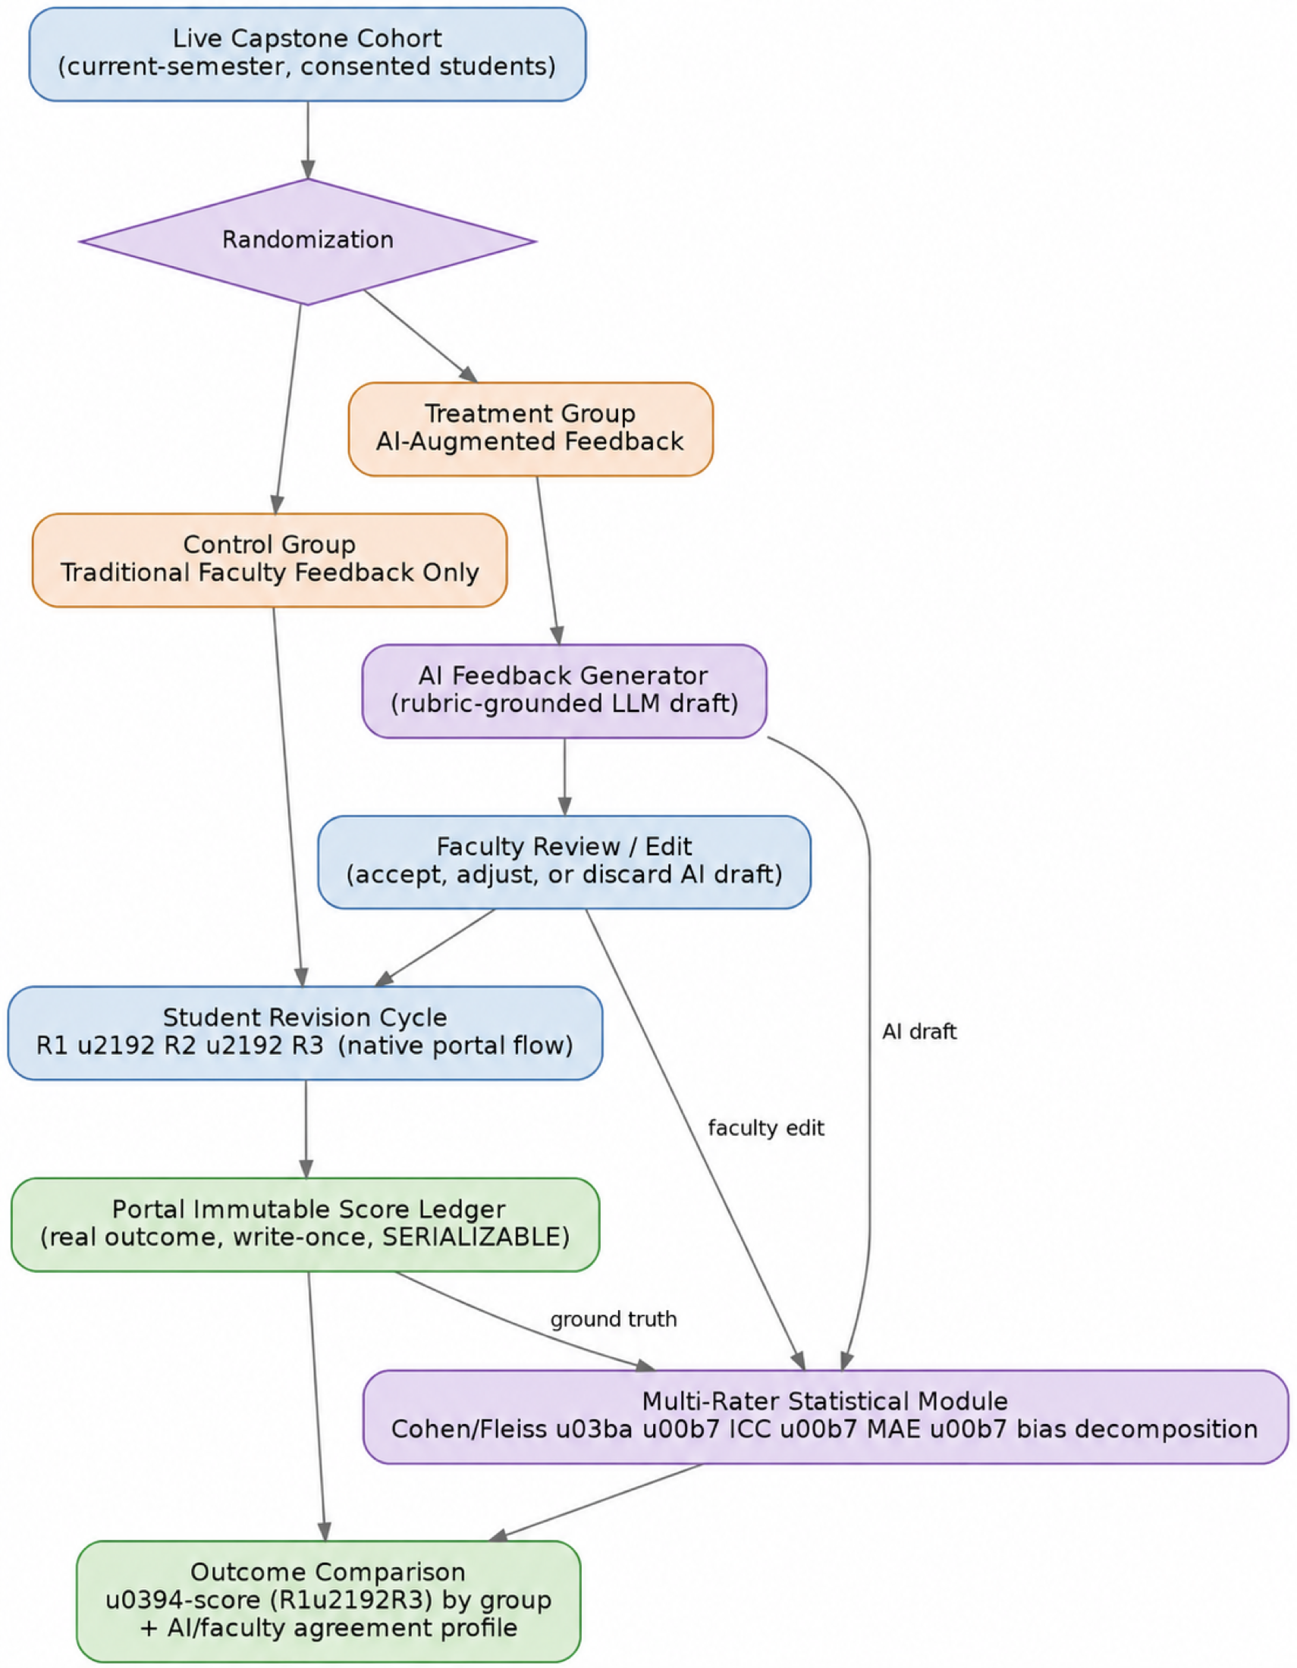
Figure 3. Team 2 architecture — randomized cohort → feedback arms → real R1–R3 revision cycle → immutable score ledger → multi-rater statistics.

3.7 Deliverables
- A working AI feedback-generation and faculty-review pipeline integrated with Educational Capstone Portal's existing R1/R2/R3 flow.
- An anonymized paired dataset: AI draft, faculty edit, and final score, per student, per stage.
- Statistical analysis and effect-size estimates grounded in real institutional grades.

3.8 Target Venues
AIED or LAK primary; IEEE Transactions on Learning Technologies and Computers & Education as faster-turnaround journal fallback.

3.9 Key Risks
- This is the only paper needing a live, prospective intervention — it cannot slip to week 10 and still work.
- Needs a real semester's R1→R2→R3 cycle to overlap the 12-week window, and IRB approval in place before it starts.
- Needs a large enough cohort split across two arms for statistical power — comparable published trials used 250–350+ students; report effect sizes as preliminary if the cohort is smaller.

4. Paper 3 (Team 3) — Traceability-Gap Detection Between Student Code and Thesis Claims

4.1 Problem Statement
Paper-code consistency detection now exists for published research papers, and a voice-AI system already conducts scaled oral exams that probe students on their specific project to catch unexplainable work — but nobody has validated a structural code-thesis mismatch detector against real faculty accept/reject decisions and grades in a student capstone setting. Team 3 builds that detector: parse a student's code (AST-level) and thesis (claimed architecture, algorithms, requirements), compute a structural and semantic gap between what is claimed and what is implemented, and validate the gap score against real, independent grading outcomes Educational Capstone Portal already records.

4.2 Novelty Positioning
The traceability-recovery technique itself is a fast-moving, now-crowded sub-area of software engineering research; the differentiator here is validating it against real grades and decisions in an academic-integrity framing, not the parsing technique itself. Any oral-exam extension should be framed explicitly as building on the existing published voice-AI system, not competing with its novelty claim.

4.3 Data
Student code archives (zip_path), thesis LaTeX source (pdf_path), and faculty accept/reject decisions and scores. One semester is enough to start; VIT historical records with confirmed integrity-violation cases would meaningfully strengthen validation if accessible.

4.4 Method
- Parse each submitted code archive with an AST parser to extract functions, API endpoints, and database schema elements.
- Parse the thesis LaTeX source with an LLM-assisted extractor to pull claimed architecture, algorithms, and requirements.
- Align the two artifact sets with a combined structural (Jaccard-style set overlap) and semantic (embedding similarity) matching module, producing a per-component traceability gap score.
- Correlate gap scores against real faculty accept/reject decisions and scores to validate the signal.
- Stretch, time permitting: feed the highest-gap components into a targeted question generator for a small oral-probe pilot, explicitly built as an extension of, and cited against, the existing published voice-AI oral-exam system.

4.5 Evaluation Metrics
Alignment F1 against a hand-labeled subset; correlation between gap score and real accept/reject outcomes and final scores; if the stretch goal is reached, ROC-AUC of the oral-probe pilot against known or simulated integrity-violation cases.

4.6 Architecture — First Draft
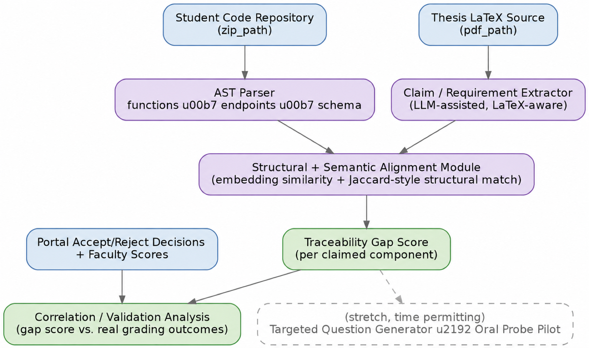
Figure 4. Team 3 architecture — code + thesis parsing → structural/semantic alignment → gap score → validation against real grading outcomes.

4.7 Deliverables
- A working AST + LaTeX-claim extraction and alignment pipeline.
- A gap-score dataset linked to real grading outcomes.
- A validation analysis (correlation/regression against outcomes).
- Stretch: a small oral-probe pilot demo, explicitly positioned as extending the existing published system.

4.8 Target Venues
MSR (Mining Software Repositories) or ICSE-SEET primary (software-engineering framing); IEEE Transactions on Learning Technologies as education-framed fallback.

4.9 Key Risks
- LaTeX claim-extraction quality depends heavily on how consistently students followed the VITSCOPE template — assess this in weeks 1–4 before committing to a fully automated extractor.
- Don't let the stretch-goal oral pilot consume time budgeted for the core detector.

5. Twelve-Week Timeline
Weeks 1–2 are shared across all three teams for infrastructure and ethics approval before any team-specific work begins.
Weeks | Team 1 | Team 2 | Team 3
1–2  Setup | OCEL schema design (E2O/O2O mapping); pilot AuditLog slice | IRB filing + live-cohort consent; finalize feedback rubric/prompts | Assess VITSCOPE LaTeX consistency; select AST toolchain
3–4  Foundations | Build and validate the OCEL 2.0 exporter | Randomize cohort; launch treatment/control arms at start of R1 | Build AST parser + LaTeX claim extractor
5–6  Core build I | Object-centric process discovery (OC-DFGs) | Track R1→R2; log AI drafts and faculty edits | Build alignment module; compute first gap scores
7–8  Core build II | Conformance checking; quantify bottlenecks | Track R2→R3; run preliminary stats on partial data | Correlate gap scores against available decisions
9–10  Evaluation | Fit next-transition predictor; run twin simulations | R3 scores land; full κ/ICC/MAE/bias analysis | Finalize validation; stretch oral-probe pilot if on schedule
11–12  Writing | Draft paper; cross-team review; finalize figures; submit or preprint | Draft paper; cross-team review; finalize figures; submit or preprint | Draft paper; cross-team review; finalize figures; submit or preprint
Note: weeks 1–2 also include the shared export-pipeline build described in Section 1.3, run in parallel to the team-specific items above.

6. Risk Register
Risk | Team(s) | Likelihood | Impact | Mitigation
IRB/ethics approval delayed | All | Medium | High — blocks Team 2 entirely | File in week 1, not after infra is built; pre-draft consent forms now.
Live cohort too small for statistical power | Team 2 | Medium | Medium | Recruit across multiple sections/departments; report effect sizes as preliminary if underpowered.
One semester of data too sparse for process discovery | Team 1 | Medium | Medium | Pool VIT historical cohorts early, don't wait until week 9.
LaTeX/VITSCOPE inconsistency breaks claim extraction | Team 3 | Medium | Medium | Assess template consistency in weeks 1–2 before committing to full automation.
Shared export pipeline becomes a bottleneck for all three teams | All | Low–Medium | High | Assign one clear owner in week 1; build before any team-specific work starts.
New prior art closes the claimed gap mid-project | All | Medium | Medium | Re-run a targeted literature check at the week-6 checkpoint, not only at the start.
Writing left entirely to weeks 11–12 with no buffer | All | High | High | Analysis & writing lead engaged from week 1; draft intro/related-work sections early.

7. Venue & Submission Strategy
Paper | Primary target | Type | Backup | Timing note
1 | ICPM | Conference | LAK / IEEE TLT | Check ICPM's next open call against your week-12 draft date.
2 | AIED or LAK | Conference | IEEE TLT / Computers & Education | Conference cycles are fixed (historically February deadlines) — a rolling-submission journal is the realistic path if you want to submit within 3–4 months.
3 | MSR / ICSE-SEET | Conference | IEEE TLT | Same fixed-cycle caveat as above.

8. Immediate Next Steps
- Assign the shared-infrastructure owner and file the IRB/ethics application — both start in week 1, not after kickoff.
- Confirm Team 2's live cohort has an active R1 window inside the 12-week clock; if not, that paper's timeline needs to shift to match the cohort's real cycle, not the reverse.
- Run the VITSCOPE-template consistency check (Team 3) before committing to a fully automated LaTeX extractor.
- Set a week-6 checkpoint across all three teams to re-run a targeted literature check and confirm nothing new has closed the gap being claimed.

