BCSE497J - Project-I
OBJECT-CENTRIC EVENT LOG MINING FOR ACADEMIC CAPSTONE PROCESSES:
A NATIVE OCEL 2.0 APPROACH
23BCE0434 MITISHA SHARMA
23BCE0498 TANMAY KHAMBETE
23BCE0500 AAKAASH SATHYA SARAVANAN
Under the Supervision of
Dr. Kalyanaraman P
Project Guide
School of Computer Science and Engineering (SCOPE)
B.Tech.
in
Computer Science and Engineering

September 2026

ABSTRACT
Academic capstone platforms record one lifecycle through many related entities: projects, teams, students, faculty, report versions, review stages and immutable scores. Conventional event-log extraction requires a single case identifier and can duplicate events or discard relationships that are essential for analysing supervision, version lineage and evaluation. This project develops a native Object-Centric Event Log (OCEL) 2.0 pipeline for the documented Educational Capstone Portal capstone process. In the absence of production logs, Review 2 uses a deterministic synthetic benchmark with three traceable scenarios: an intended clean lifecycle, the documented R1-only implementation baseline, and a controlled gap-injected counterfactual. The prototype exports relational OCEL SQLite and auditable CSV tables, validates references and timestamps, compares three single-case flattenings, executes six documented-gap predicates, evaluates a project-grouped next-transition baseline, and simulates attempt-limit and faculty-capacity interventions. Across 120 synthetic projects per scenario, OCEL preserves 100% of generated event-to-object relations, whereas flattened views preserve 19.8–27.9%. The six rule detectors obtain macro-F1 0.977 on their injected oracle labels. These figures establish feasibility only; they do not estimate operational Educational Capstone Portal accuracy or institutional impact. The proposed research contribution is a documentation-grounded normative–descriptive–adversarial evaluation design and a study-specific Cross-Object Observability Coverage measure that separates source instrumentation from representation loss.
Keywords — OCEL 2.0, object-centric process mining, academic capstone, conformance, synthetic benchmark, digital twin.

TABLE OF CONTENTS
Contents | Page
Abstract | i
1. Introduction | 1
1.1 Background | 1
1.2 Motivation | 1
1.3 Scope of the Project | 1
2. Project Description and Goals | 2
2.1 Literature Review | 2
2.2 Research Gap | 2
2.3 Objectives | 3
2.4 Problem Statement | 4
2.5 Project Plan | 4
3. Technical Specification | 5
4. Design Approach and Details | 7
5. References | 12
Appendix A. Synthetic Data and Reproducibility | 13

Page numbers should be refreshed after the final manuscript is frozen.

1. INTRODUCTION

1.1 Background
Process mining reconstructs and evaluates operational behaviour from event data. Traditional logs organise every event around one case notion, but capstone processes have several simultaneous case notions. A report upload belongs to a project and team, is authored by students, creates a version, is reviewed by faculty and may later contribute to an immutable score. Flattening this event around only the project, student or report version can duplicate the event or sever part of that relational context.
Object-centric process mining addresses this limitation by linking one event to multiple typed objects. OCEL 2.0 standardises the corresponding event, object, event-to-object and object-to-object structures. Educational Capstone Portal is a suitable study setting because its documentation defines registration, supervision, report-version, review and scoring state machines and records transitions in an audit ledger. The same documentation also lists implementation gaps, including exhausted attempts, incomplete review-stage coverage and guide-capacity behaviour.

1.2 Motivation
The immediate engineering need is observability: reviewers should be able to follow a project without losing student, faculty, version or score provenance. The research need is more demanding. A publishable study must demonstrate that the object-centric representation enables analyses that cannot be performed reliably on conventional flat logs, while separating missing source instrumentation from information destroyed during representation.
Because production audit logs and capstone PDFs are not yet available, the current work treats the documentation as an executable specification. Synthetic data provides a controlled oracle for testing integrity, observability and detectors. It does not replace real-data evaluation; it reduces design risk and creates a reproducible baseline that can be recalibrated once de-identified logs are approved.

1.3 Scope of the Project
• Included: Educational Capstone Portal capstone lifecycle mapping; OCEL 2.0 relational export; deterministic synthetic generation; integrity validation; flattening ablations; six documented-gap detectors; next-transition baseline; offline attempt/capacity simulation.
• Excluded for Review 2: production deployment, ingestion of identifiable logs or PDFs, causal claims about student outcomes, autonomous intervention, and general claims about every educational process.
• Evaluation boundary: all reported numeric results are synthetic proof-of-mechanism measurements using seed 4971 and the documented assumptions in the package.

2. PROJECT DESCRIPTION AND GOALS

2.1 Literature Review
The initial targeted review focuses on primary OCEL, object-centric conformance, educational process-mining and extraction-method sources. It is sufficient to set the Review 2 novelty boundary, but the final journal manuscript should expand the search protocol, databases, screening flow and quality assessment.
Reference | Objective | Method | Strength / limitation | Team 1 implication
[1] Berti et al., 2024 | OCEL 2.0 specification | Metamodel and SQLite/XML/JSON formats | Authoritative format; not an empirical evaluation | Defines export and validation target
[2] van der Aalst, 2019 | Avoid single-case distortion | Object-centric event-data theory | Foundational; mainly conceptual | Explains divergence/convergence risk
[3] Park et al., 2024 | Conformance and performance | OC-DFG comparison | Operational analysis; graph abstraction | Baseline family for deviations
[4] Park & van der Aalst, 2021 | Action-oriented digital twin | Process mining plus interventions | Strong intervention framing; not education-specific | Supports offline what-if layer
[5] Bogarín et al., 2018 | Survey educational process mining | Systematic survey | Broad coverage; largely case-centric | Establishes educational PM context
[6] Calegari & Delgado, 2025 | Curricular process-mining review | Systematic literature review | Recent evidence; curricular emphasis | Confirms need for rigorous protocols
[7] Miri et al., 2026 | Multi-entity educational PM | PM4Moodle to OCEL 2.0; real-course case | Direct educational OCEL prior art; LMS activity focus | Invalidates broad ‘first in education’ claim
[8] Wei et al., 2025 | Improve object-centric extraction | Dirigo and representation-quality criteria | General extraction method | Quality baseline for Educational Capstone Portal mapper

2.2 Research Gap
A June 2026 peer-reviewed study already demonstrates OCEL 2.0 extraction from Moodle. Team 1 therefore must not claim to be the first object-centric educational process-mining project. The defensible gap is narrower: transactional capstone lifecycles combine projects, teams, students, faculty, versioned reports, formal review stages, immutable scores, attempt limits and live guide capacity. The targeted literature does not directly evaluate this combination using a documentation-grounded synthetic oracle and representation-level observability tests.
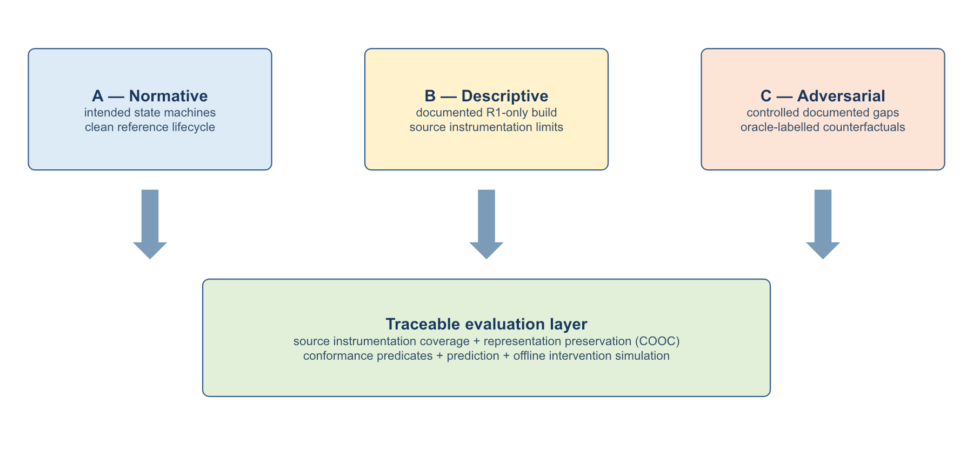
Fig. 1. Documentation-grounded normative–descriptive–adversarial evaluation design.
The proposed methodological contribution is the triad shown in Fig. 1: (A) the intended clean lifecycle, (B) the documented current implementation, and (C) controlled counterfactuals derived from named Educational Capstone Portal gaps. Every injected condition carries an oracle label and an executable predicate. This design makes synthetic evidence falsifiable and traceable to engineering documentation.

2.2.1 Cross-Object Observability Coverage
For a representation R and preregistered predicate set P, the study-specific Cross-Object Observability Coverage is COOC(R) = |{p in P: p is computable from R and correct on oracle tests}| / |P|. COOC is an analysis-readiness measure for the declared predicate set, not a universal measure of OCEL quality. It is reported separately from Source Instrumentation Coverage, which asks whether the necessary evidence was logged before representation.

2.3 Objectives
• O1 — Native mapping: define and validate an OCEL 2.0 mapping for Project, Team, Student, Faculty, ReportVersion, ReviewStage and Score.
• O2 — Representation ablation: quantify event–object relation retention and COOC under project-, student- and report-version-centric flattening.
• O3 — Conformance evidence: execute six documentation-grounded risk predicates and report per-risk precision, recall and F1.
• O4 — Prediction and intervention: evaluate a leakage-resistant next-transition baseline and offline attempt/capacity scenarios.
• O5 — Reproducibility and ethics: release seeds, assumptions, validation reports and synthetic labels while keeping real data behind approval and de-identification gates.

2.4 Problem Statement
How can Educational Capstone Portal’s multi-object capstone process be represented and analysed without losing cross-object provenance, and which documented risks and intervention questions remain observable after conventional single-case flattening? The current phase asks this as a synthetic, reproducible feasibility question; the later journal phase will test whether findings persist on de-identified production logs.

2.5 Project Plan
Work package | Review 2 state | Current evidence | Exit criterion
Literature + novelty audit | Complete | Updated against 2026 educational OCEL prior art | Systematic search and second-domain validation
Educational Capstone Portal schema and state-machine mapping | Complete | Traceable object/event catalogue | Guide review of mapping
Synthetic generator + OCEL export | Complete | Three scenarios, SQLite/CSV, seed 4971 | Multiple seeds and scale sweep
Ablations + six detectors | Complete | Relation retention, COOC, macro-F1 | PM4Py conformance baselines
Prediction + offline simulation | Baseline complete | Markov and two interventions | Object-aware predictor and calibration
Real-data study | Blocked on data/ethics | No production claim | De-identify, audit instrumentation, recalibrate
Journal manuscript | Framing drafted | Claims bounded to synthetic feasibility | Preregister, expert-validate, multi-cohort study

3. TECHNICAL SPECIFICATION

3.1 Requirements

3.1.1 Functional
• FR1 — Generate scenarios: produce clean-target, implemented-baseline and gap-injected lifecycles from a recorded seed and configuration.
• FR2 — Preserve relations: store qualified E2O and O2O relations using pseudonymous identifiers.
• FR3 — Export evidence: write relational OCEL 2.0 SQLite plus human-auditable CSV tables and checksums.
• FR4 — Validate integrity: check required tables, references, event ordering and deterministic hashes.
• FR5 — Compare representations: derive project, student and report-version flat views and measure retained relations and predicates.
• FR6 — Detect risks: evaluate G5, G9, E5, E10, E12 and E15 conditions against oracle labels.
• FR7 — Evaluate models: use project-grouped splits for a next-transition baseline and report macro-F1, top-k accuracy and log loss.
• FR8 — Simulate policies: compare baseline, attempt-escape, capacity-reallocation and combined scenarios without acting on users.

3.1.2 Non-Functional
• Reproducibility: fixed seeds, versioned configuration, manifest and SHA-256 hashes.
• Traceability: every synthetic anomaly links to a documented gap and oracle predicate.
• Privacy: no real student, faculty, report or score data in Review 2 artifacts.
• Portability: Python standard library pipeline with SQLite and CSV outputs.
• Auditability: results tables can be recomputed from package scripts and generated data.
• Honesty of claims: synthetic feasibility and production validity are reported separately.

3.2 Feasibility Study

3.2.1 Technical Feasibility
The Review 2 prototype runs locally and produces validated relational SQLite and CSV evidence without external infrastructure. OCEL 2.0 and SQLite provide stable representation targets. Remaining technical risk lies in production event extraction, PM4Py interoperability, state-aware conformance and object-aware prediction rather than in synthetic generation.

3.2.2 Economic Feasibility
The prototype uses open formats and commodity hardware. The main future costs are data governance, secure storage, faculty validation time and manuscript-scale experimentation. Offline simulation is deliberately used before any costly or risky live intervention.

3.2.3 Social and Ethical Feasibility
Capstone logs may reveal academic performance, supervision and behavioural patterns. Any real-data study requires institutional approval, purpose limitation, pseudonymisation, role-based access and reporting that avoids ranking or penalising individuals. Predictive or anomaly outputs must support human review; they must not become automated academic decisions.

3.3 System Specification

3.3.1 Hardware
• Minimum: multi-core laptop/desktop, 8 GB RAM and 2 GB free storage for the current 120-project benchmark.
• Recommended journal experiments: 16 GB RAM and encrypted project storage for multi-seed, multi-scale and de-identified log runs.

3.3.2 Software
Component | Specification
Operating systems | macOS/Linux/Windows with Python support
Language | Python 3
Storage | SQLite and CSV
Process-mining target | OCEL 2.0; planned PM4Py integration
Analysis | deterministic rules, first-order Markov baseline, offline Monte Carlo simulation
Versioning | source-controlled scripts, manifest and SHA-256 checksums

4. DESIGN APPROACH AND DETAILS

4.1 System Architecture
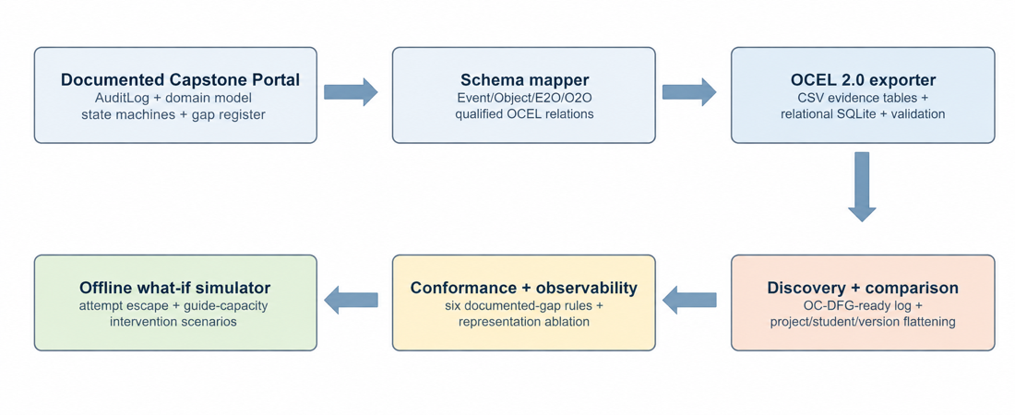
Fig. 2. Team 1 native OCEL research pipeline.
The pipeline begins from Educational Capstone Portal’s audit, domain, state-machine and gap documentation. The mapper emits qualified OCEL relations and a relational SQLite database. Validation precedes discovery, flattening comparison and conformance. The final layer evaluates transparent baselines and offline what-if scenarios; it does not change live Educational Capstone Portal state.

4.2 Design

4.2.1 Data Flow Diagram
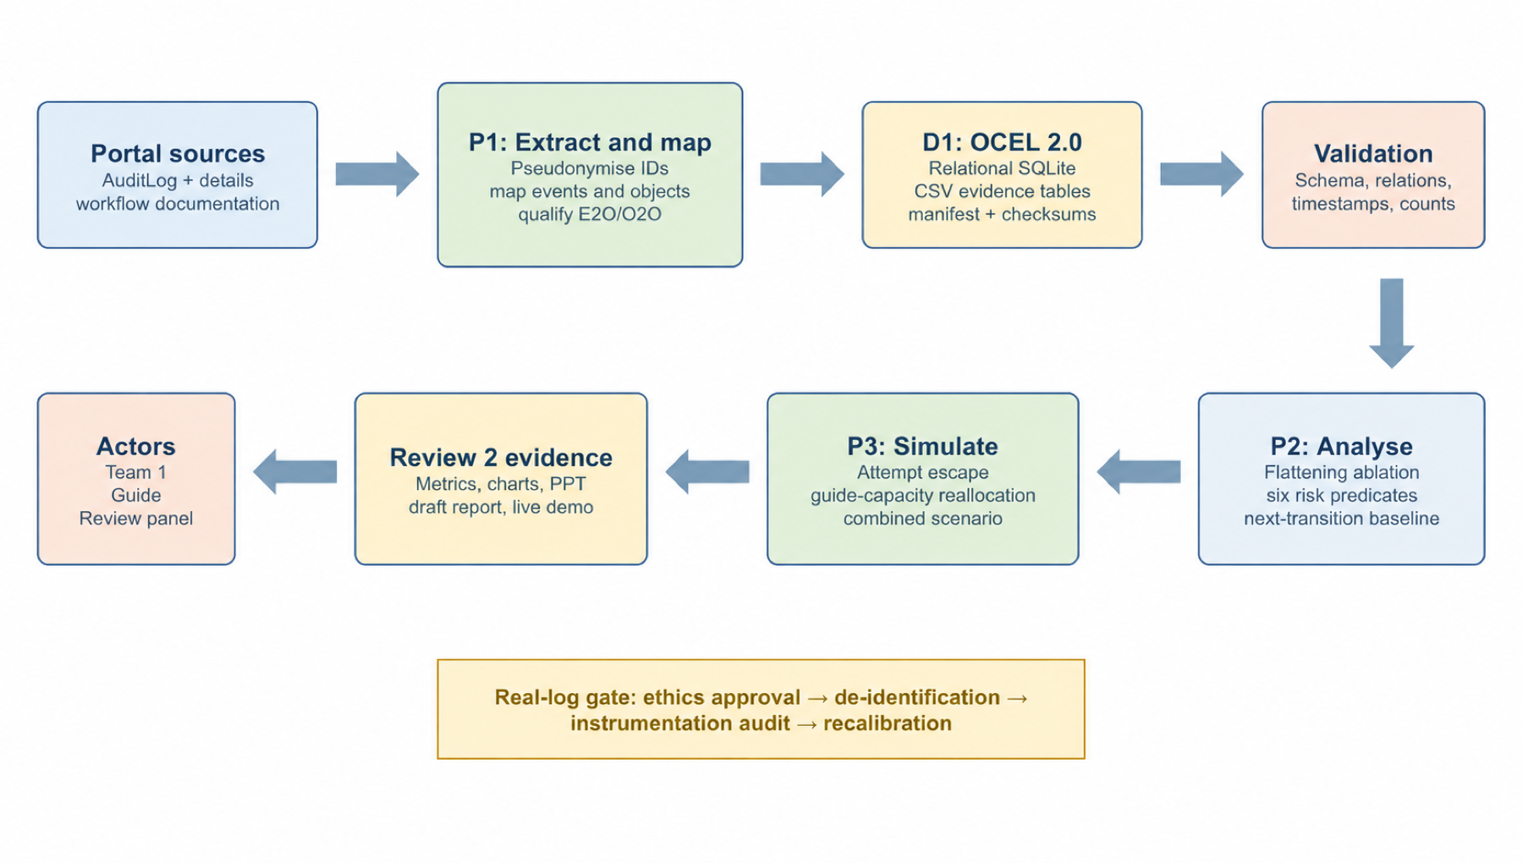
Fig. 3. Level-1 data flow for synthetic and future approved Educational Capstone Portal evidence.

4.2.2 Use Case Diagram
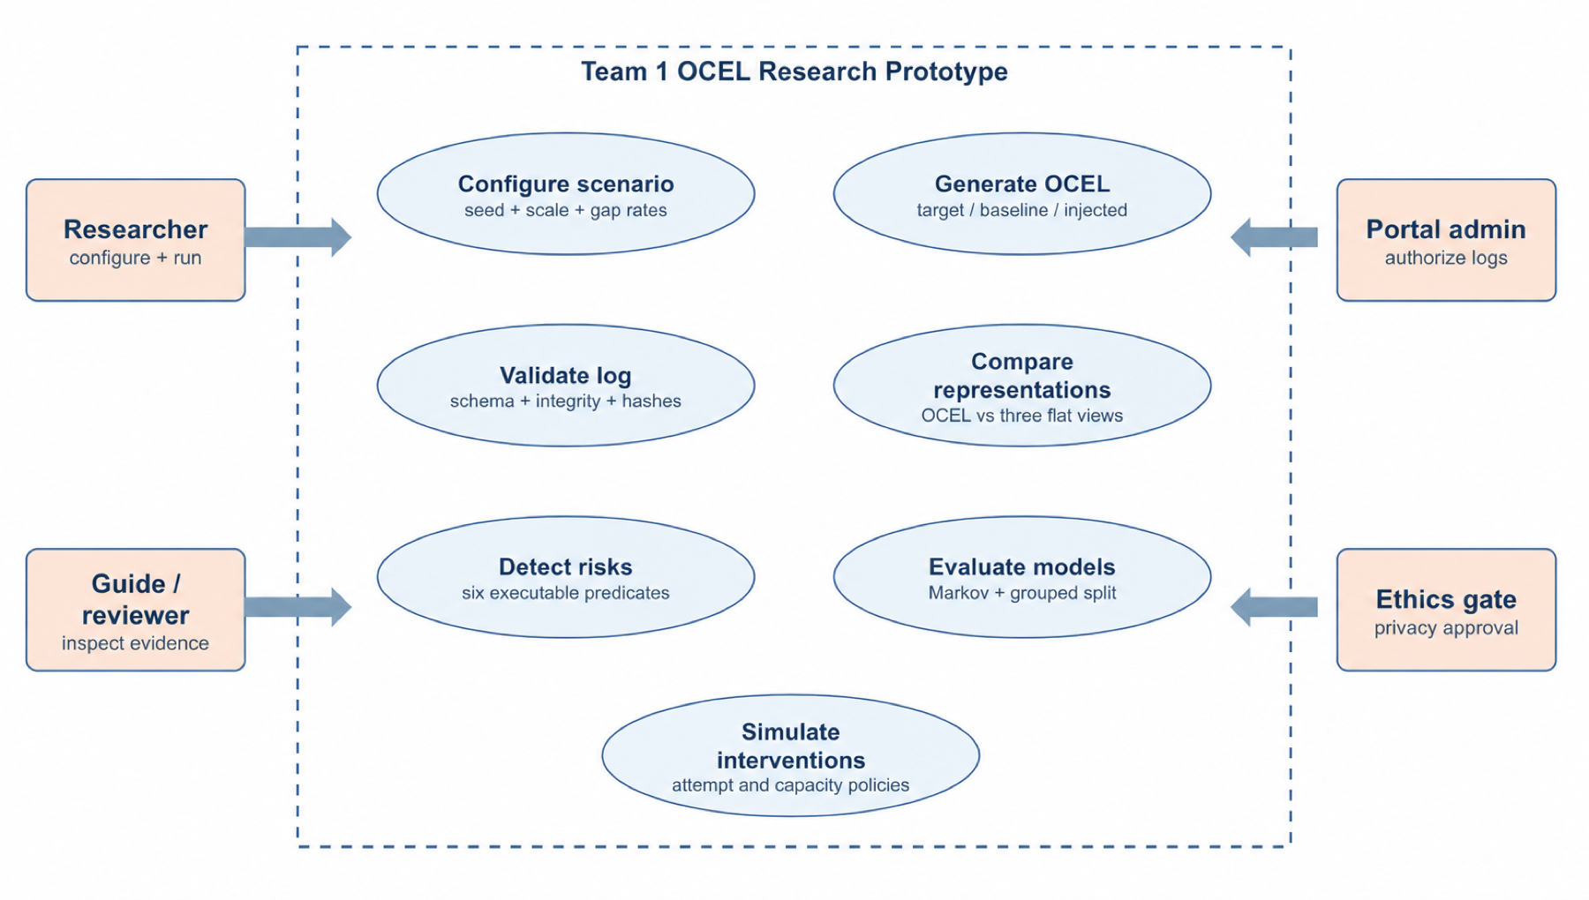
Fig. 4. Research-prototype use cases and approval actors.

4.2.3 OCEL Object and Relation Design
Object type | Role | Representative qualified relations
Project | Primary capstone instance | has_team; supervised_by; has_report_version
Team | Student collaboration unit | contains_student; owns_project
Student | Pseudonymous participant | member_of; authors_version
Faculty | Guide/reviewer | supervises; reviews; has_capacity
ReportVersion | Versioned academic artifact | version_of_project; submitted_in_stage
ReviewStage | R1/R2/R3 lifecycle stage | evaluates_version
Score | Write-once evaluation outcome | scores_version; assigned_by_faculty

4.3 Experimental Method
Each scenario contains 120 projects, 30 faculty members and three students per team. The generator uses seed 4971. The clean-target scenario follows the intended lifecycle; the implemented-baseline reflects the documented R1-only build; the gap-injected scenario adds controlled violations with oracle labels. IDs are synthetic and contain no institutional identities.
The evaluation is ordered to avoid conflating two failure modes. First, Source Instrumentation Coverage measures whether evidence exists in the source schema. Second, representation tests compare the same generated relations and risk predicates after project-, student- and report-version-centric flattening. Detector metrics are computed against injected labels. Prediction uses a 70/15/15 split grouped by project to prevent transition leakage. Simulation uses 5,000 offline projects per policy scenario.

4.4 Preliminary Results
Scenario | Events | Objects | E2O | O2O
Clean target | 2,346 | 1,530 | 8,412 | 1,860
Implemented baseline | 811 | 1,005 | 3,152 | 1,095
Gap injected | 2,083 | 1,411 | 7,471 | 1,670

Table 1. Synthetic corpus size; all integrity checks reported zero dangling relations.
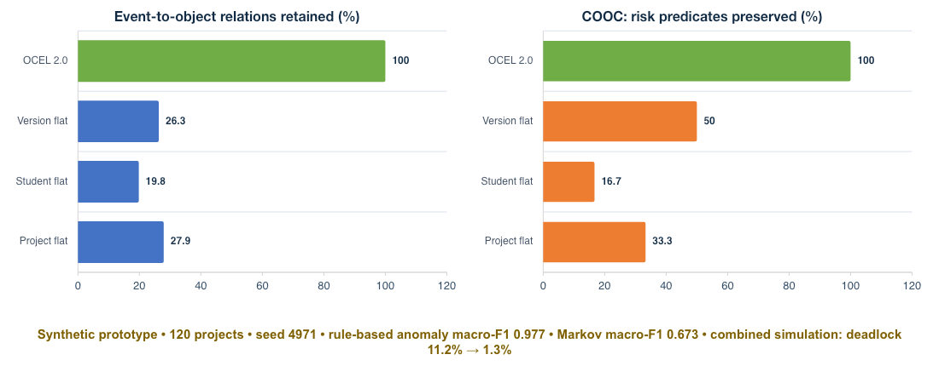
Fig. 5. Synthetic relation retention and COOC ablations (120 projects; seed 4971).
Representation | E2O retained | Risk predicates preserved
Project flat | 27.9% | 2/6 (33.3%)
Student flat | 19.8% | 1/6 (16.7%)
ReportVersion flat | 26.3% | 3/6 (50.0%)
OCEL 2.0 | 100.0% | 6/6 (100.0%)

Table 2. Representation-preservation results; COOC is specific to the six preregistered predicates.
Documented risk | F1
E10 | 1.000
E12 | 0.909
E15 | 1.000
E5 | 1.000
G5 | 0.952
G9 | 1.000
Macro | 0.977

Table 3. Rule-detector performance on controlled injected conditions.
The first-order Markov baseline obtained top-1 accuracy 0.912, top-2 accuracy 0.986, macro-F1 0.673 and log loss 0.276 over 283 grouped test transitions. The difference between high top-1 accuracy and lower macro-F1 indicates class imbalance and motivates per-transition reporting and stronger object-aware baselines.
Offline policy | Deadlock | Capacity fail | Completion | Median wait
Baseline | 11.2% | 11.8% | 74.5% | 36.2 h
Attempt escape | 2.2% | 10.9% | 84.9% | 36.9 h
Capacity reallocation | 10.8% | 2.6% | 78.8% | 27.3 h
Combined | 1.3% | 2.6% | 89.5% | 27.9 h

Table 4. Synthetic offline simulation over 5,000 projects per policy; not a causal deployment estimate.

4.5 Implementation Status and Review 2 Demo
State | Modules | Count
Complete | Schema map; generator; CSV evidence; OCEL SQLite; integrity validator; flattening comparison; six detectors; Markov and simulator baseline | 8 modules
Remaining | Real-log ingestion; PM4Py OC-DFG/conformance; object-aware predictor; empirical twin calibration | 4 modules

The declared Review 2 module scope is therefore 8/12, or 67% by module count. This percentage is a readiness indicator, not an effort-weighted estimate. The demo should regenerate the benchmark, show the manifest and validation report, query the OCEL SQLite database, then reproduce the representation, detector and simulation tables.

4.6 Threats to Validity and Journal Path
• Construct validity: synthetic gaps are derived from documentation, but their frequencies are assumptions. Mitigation: publish configuration and recalibrate on approved logs.
• Internal validity: rule detectors target structures used during injection. Mitigation: blind expert labelling, alternative injections and negative controls.
• External validity: one institution and synthetic traces cannot establish generality. Mitigation: second domain or cohort, multiple seeds/scales and real-log replication.
• Novelty validity: the broad first-in-education claim is obsolete after Miri et al. (2026). Mitigation: claim the capstone-specific transactional process and evaluation method, not universal priority.
• Journal-strength exit criteria: preregister predicates; release a formal benchmark; compare OCEL extraction/conformance baselines; report ablations and uncertainty; obtain independent expert validation and inter-rater agreement; validate on real logs and preferably a second setting.

5. REFERENCES
[1] A. Berti et al., ‘OCEL (Object-Centric Event Log) 2.0 Specification,’ arXiv:2403.01975, 2024. https://www.ocel-standard.org/2.0/ocel20_specification.pdf
[2] W. M. P. van der Aalst, ‘Object-Centric Process Mining,’ in Software Engineering and Formal Methods, LNCS 11724, pp. 3–25, 2019. doi:10.1007/978-3-030-30446-1_1.
[3] G. Park, J. N. Adams, and W. M. P. van der Aalst, ‘Conformance Checking and Performance Analysis Using Object-Centric Directly-Follows Graphs,’ BPM Forum, 2024. doi:10.1007/978-3-031-70418-5_11.
[4] G. Park and W. M. P. van der Aalst, ‘Realizing a Digital Twin of an Organization Using Action-Oriented Process Mining,’ ICPM, 2021. doi:10.1109/ICPM53251.2021.9576846.
[5] A. Bogarín, R. Cerezo, and C. Romero, ‘A Survey on Educational Process Mining,’ WIREs Data Mining and Knowledge Discovery, 2018. doi:10.1002/widm.1230.
[6] D. Calegari and A. Delgado, ‘A Systematic Review on Process Mining for Curricular Analysis,’ WIREs Data Mining and Knowledge Discovery, 2025. doi:10.1002/widm.70005.
[7] N. Miri, S. Khayatbashi, J. Zdravkovic, and A. Jalali, ‘An Object-Centric Approach to Multi-Entity Educational Process Mining,’ Decision Analytics Journal, vol. 19, 100724, 2026. doi:10.1016/j.dajour.2026.100724.
[8] J. Wei et al., ‘Dirigo: A Method to Extract Event Logs for Object-Centric Processes,’ Data & Knowledge Engineering, vol. 160, 102485, 2025. doi:10.1016/j.datak.2025.102485.

APPENDIX A. SYNTHETIC DATA AND REPRODUCIBILITY
The runnable Review 2 package contains the two Python scripts, three scenario folders, OCEL SQLite exports, CSV evidence, checksums and machine-readable result summaries. To reproduce the evidence, run the generator and then the analysis script from the package root. Generated artifacts should match the manifest when the same runtime and seed are used.
Item | Value
Seed | 4971
Projects/scenario | 120
Faculty | 30
Students/team | 3
Scenarios | clean_target; implemented_baseline; gap_injected
Primary outputs | events.csv; objects.csv; e2o.csv; o2o.csv; ocel2.sqlite; validation.json; manifest.json
Result outputs | flattening, COOC, detector, Markov and simulation CSV/JSON summaries

A.1 Evidence Interpretation Rules
• May claim: the current scripts deterministically generate and validate the documented synthetic benchmark and demonstrate representation/detector feasibility under those assumptions.
• May not claim: the reported rates occur in Educational Capstone Portal, that the intervention causes real-world improvement, or that the method generalises beyond the generated oracle.
• Next evidence: guide-approved data access, de-identification, instrumentation audit, preregistered real-log protocol, external baselines and independent validation.

