9415B 1:00 – 2:30 TF

iTutor

Andawi, Mark

Bayote, Rusell

Benitez, Jinci Clyde

Centino, Sarah Mae

Culbengan, Denver

De Guzman, Ryan Christian

Leonen, Aerhielle Cassandra

Macanlalay, Abigail

Madayag, Raoul

Suarez, Benedict

Tuyay, Jay Bryan

MODULE ACCOMPLISHMENT REPORT

**Project Accomplishment Report**

1. **Admin Module**

**Platform: PHP**

|  |  |  |
| --- | --- | --- |
| **Feature** | **Level of Functionality** | **Deficiencies** |
| Log in | The administrator can log in to the module. |  |
| Search Function | Searches the registered service provider and customer. |  |
| Sort Function | Sorting of registered / unregistered members |  |
| Approval Function | Approves the members registration |  |
| Add Function | Adding of services |  |
| Delete Function | Deleting of the services |  |
| List Function | Able to list the registered customer and service provider |  |
| Log out | Logs out the admin to the modul |  |

* Screen Shots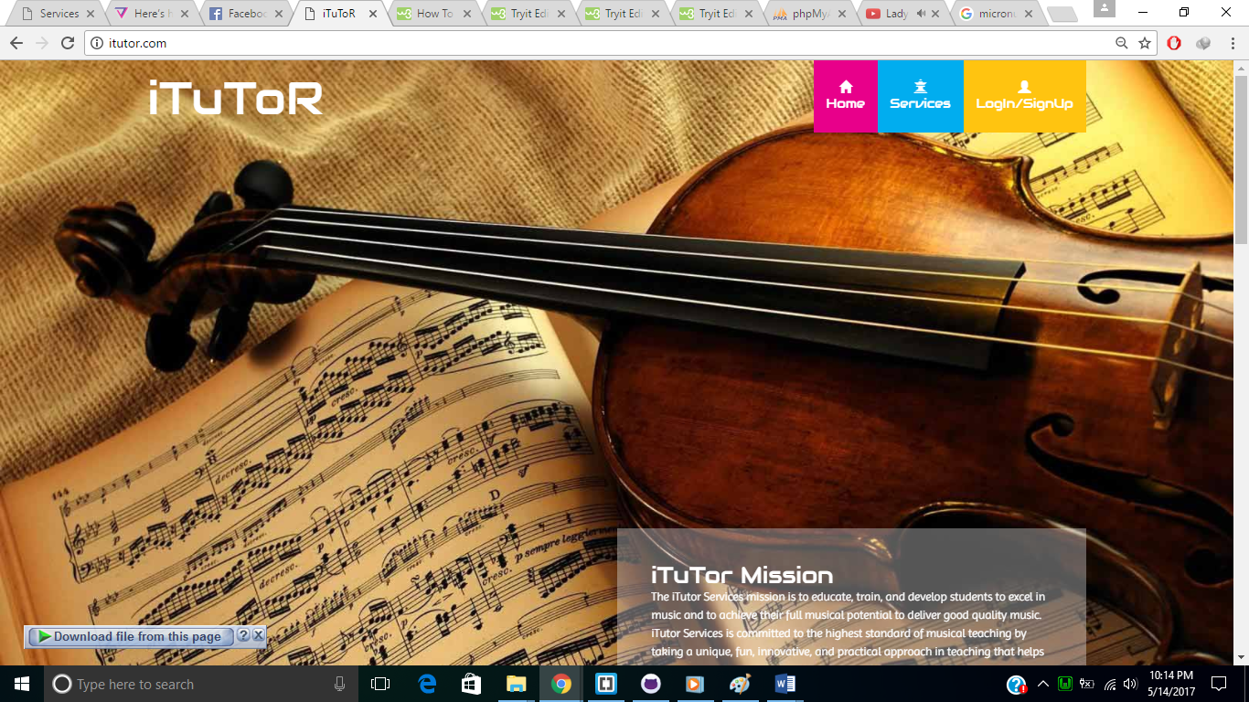

Fig1 Public Face

This is the main page of our website where visitor can view all about the iTuToR



Fig 1.1 Public Face

In this is page of iTuTor the visitor can view the Services Offered.

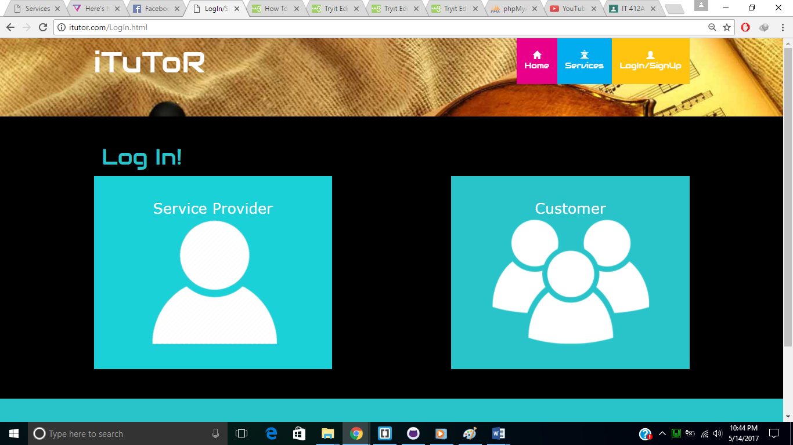

Fig 1.2 Public Face

In this page of iTuToR the visitor or user can select to log in as a customer or service provider.

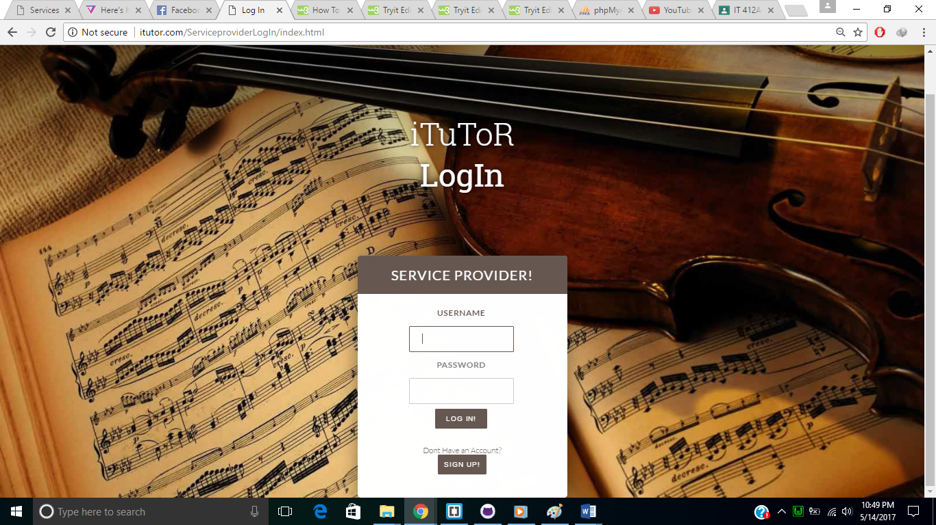

Fig 1.3 Public Face

In this page of iTuTor the user can now log in.

SUMMARY PEER EVALUATION

MEMBER ACCOMPLISHMENT REPORT

|  |  |  |  |
| --- | --- | --- | --- |
| **Member** | **Accomplishments** | **%Contributions** | **Signature** |
| Andawi, Mark |  |  |  |
| Bayote, Rusell |  |  |  |
| Benitez, Jinci Clyde |  |  |  |
| Centino, Sarah Mae |  |  |  |
| Culbengan, Denver |  |  |  |
| De Guzman, Ryan Christian |  |  |  |
| Leonen, Aerhielle Cassandra |  |  |  |
| Macanlalay, Abigail |  |  |  |
| Madayag, Raoul |  |  |  |
| Suarez, Benedict |  |  |  |
| Tuyay, Jay Bryan |  |  |  |