1 1
2 3
% Orbital Mechanics, Project 1
% Shai Sabaroche, 152007282
% Dan Carrollo, 159000852
% Mahmoud Elkayal, 155007835

1
clear,clc, close all
re=6378e3; mu=3.986e14;
rpi=345e3+re;
rai=1545e3+re;
rpf=975e3+re;
raf=9750e3+re;
% a) Find E, H, Vp, Va, P for the initial orbit
epsi=(rai-rpi)/(rai+rpi); % eccentricity
ai=rpi/(1-epsi); % semi major axis
opi=ai*(1-epsi^2); % orbital parameter
Ei=-mu/(2*ai); %total specific mechanical energy
Hi=sqrt(opi*mu); % specific angular momentum
Vpi=Hi/rpi; % Perigee Velocity
Vai=Hi/rai; % Apogee Velocity
Pi=2*pi*sqrt(ai^3/mu); % Orbital Period
% b) Find E, H, Vp, Va, P for the final orbit
epsf=(raf-rpf)/(raf+rpf); % eccentricity
af=rpf/(1-epsf); % semi major axis
opf=af*(1-epsf^2); % orbital parameter
Ef=-mu/(2*af); %total specific mechanical energy
Hf=sqrt(opf*mu); % specific angular momentum
Vpf=Hf/rpf; % Perigee Velocity
Vaf=Hf/raf; % Apogee Velocity
Pf=2*pi*sqrt(af^3/mu); % Orbital Period
% c) Find E, H, Vp, Va, P for the transfer trajectory
at=(rpi+raf)/2;
Et=-mu/(2*at);
Vpt=sqrt(2*(Et+mu/rpi));
Ht=rpi*Vpt;
Vat=Ht/raf;
epst=sqrt(1+2*Et*Ht^2/mu^2);
% d) Find the time of flight for the transfer trajectory and delta-Vs
nut=pi; % true anomaly
cosut=(epst+cos(nut))/(1+epst*cos(nut)); % eccentric anomaly
ut=acos(cosut);
Mt=ut-epst*sin(ut); % mean anomaly
TOFt=Mt*sqrt(at^3/mu);
deltaV1=Vpt-Vpi;
deltaV2=Vaf-Vat;
deltaVtotal=abs(deltaV1)+abs(deltaV2);
% e) Plots of trajectories
theta = 0:pi/50:2*pi;
re=re.*ones(size(theta));
xe=re.*cos(theta);
ye=re.*sin(theta);
ri=opi./(1+epsi*cos(theta));
xi=ri.*cos(theta);
yi=ri.*sin(theta);
opt=at*(1-epst^2);
rt=opt./(1+epst*cos(theta));
xt=rt.*cos(theta);
yt=rt.*sin(theta);
rf=opf./(1+epsf*cos(theta));
xf=rf.*cos(theta);
yf=rf.*sin(theta);
figure;
h1=plot(xe,ye);
hold on
h2=plot(xi,yi);
h3=plot(xt,yt);
h4=plot(xf,yf);
legend('Earth', 'Initial Orbit','Transfer Orbit','Final Orbit');
hold off
xlabel('$x$','interpreter','latex')
ylabel('$y$','interpreter','latex');set(get(gca,'ylabel'),'rotation',0);
axis([-2e7 1e7 -1.5e7 1.5e7]);
% If a polar representation is required, uncomment the following section
% figure;
% h1=polar(theta,rf);
% hold on
% h2=polar(theta,ri);
% h3=polar(theta,rt);
% h4=polar(theta,re);
%
% hHiddenText = findall(gca,'type','text');
% Angles = 0 : 30 : 330;
% hObjToDelete = zeros( length(Angles)-4, 1 );
% k = 0;
%
% for ang = Angles
% hObj = findall(hHiddenText,'string',num2str(ang));
% switch ang
% case 0
% set(hObj,'string','0','HorizontalAlignment','Left');
% case 90
% set(hObj,'string','3\pi/2','VerticalAlignment','Bottom');
% case 180
% set(hObj,'string','\pi','HorizontalAlignment','Right');
% case 270
% set(hObj,'string','\pi/2','VerticalAlignment','Top');
% otherwise
% k = k + 1;
% hObjToDelete(k) = hObj;
% end
% end
% delete( hObjToDelete(hObjToDelete~=0) );
% title('Orbital Transfer for Problem 1');
%
% hold off
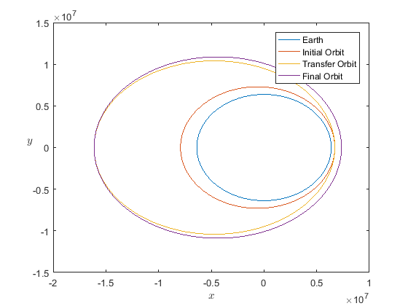

2
a)
close all
rpt2=rpi;
epst2=1.65*epst;
at2=rpt2/(1-epst2);
Et2=-mu/(2*at2);
Vpt2=sqrt(2*(Et2+mu/rpt2));
Ht2=rpi*Vpt2;
% b)
theta = 0:pi/50:2*pi;
re=re.*ones(size(theta));
xe=re.*cos(theta);
ye=re.*sin(theta);
ri=opi./(1+epsi*cos(theta));
xi=ri.*cos(theta);
yi=ri.*sin(theta);
opt2=at2*(1-epst2^2);
rt2=opt2./(1+epst2*cos(theta));
xt2=rt2.*cos(theta);
yt2=rt2.*sin(theta);
rf=opf./(1+epsf*cos(theta));
xf=rf.*cos(theta);
yf=rf.*sin(theta);
figure;
h1=plot(xe,ye);
hold on
h2=plot(xi,yi);
h3=plot(xt2,yt2);
h4=plot(xf,yf);
legend('Earth', 'Initial Orbit','Transfer Orbit 2','Final Orbit');
xlabel('$x$','interpreter','latex')
ylabel('$y$','interpreter','latex');set(get(gca,'ylabel'),'rotation',0);
hold off
L1=[xf;yf]; %computed using the attached m file "InterX' which has all the code
L2=[xt2;yt2];
P=InterX(L1,L2);
Xinter=P(1);
Yinter=P(2);
Rinter=sqrt(Xinter^2+Yinter^2) % intersection distance from centre of earth
thetaInter=atan(Yinter/Xinter) % true anomaly at intersection
% d) Elevation Angle and Velocity of final orbit at intersection
phifinter=atan(epsf*sin(thetaInter)/(1+epsf*cos(thetaInter)))
Vinterf=sqrt(2*(Ef+mu/Rinter))
% e) Elevation angle and velocity of transfer orbit at intersection
phitinter=atan(epst2*sin(thetaInter)/(1+epst2*cos(thetaInter)))
Vintert=sqrt(2*(Et2+mu/Rinter))
% f)
deltaV1fort2=Vpt2-Vpi % initial impulsive thrust from initial orbit to transfer 2
alpha=phitinter-phifinter %angle between the interception angles
deltaV2fort2=sqrt(Vinterf^2+Vintert^2-2*Vinterf*Vintert*cos(alpha)) % final orbit insertion
deltaVtotal2=abs(deltaV1fort2)+abs(deltaV2fort2)
Warning: NARGCHK will be removed in a future release. Use NARGINCHK or
NARGOUTCHK instead.
Rinter =
8.6433e+06
thetaInter =
1.1041
phifinter =
0.2783
Vinterf =
7.6343e+03
phitinter =
0.4349
Vintert =
8.5562e+03
deltaV1fort2 =
1.9684e+03
alpha =
0.1566
deltaV2fort2 =
1.5646e+03
deltaVtotal2 =
3.5331e+03
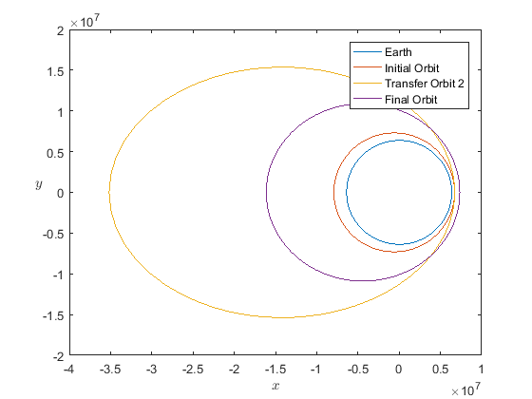
Published with MATLAB® R2016a

