Explainable AI for Heart Disease Risk Prediction:
Designing and Evaluating a Human-Centred SHAP Explanation Interface
BSc Technical Report
Precursor project for the proposed MSc research direction:
“Human-Centred Design Frameworks for Explainable AI in Healthcare Applications”
[Your Name]
[Your Programme]
[Date]

Abstract
Explainable AI (XAI) methods such as SHAP can attribute a machine learning model's predictions to its input features, but whether these explanations are genuinely understandable to the people who need them is far less established than their technical correctness. This report documents a small BSc-level project undertaken as a precursor to a proposed MSc research direction in human-centred design frameworks for explainable AI in healthcare. A machine learning pipeline was built to predict heart disease risk from the UCI Heart Disease dataset; four classification models were trained and compared, with Random Forest achieving the best performance (91.8% accuracy, 0.958 ROC-AUC); SHAP was used to generate both global and local explanations for this model; and an interactive Streamlit prototype was built presenting these explanations in two formats — a visual chart and a plain-language summary. A small human evaluation (n=7) compared comprehension, trust, and clarity across both formats. Comprehension of the model's true top contributing factor was low (14.3%) regardless of format, while trust and clarity ratings were similar between formats and the visual chart was preferred by a majority of participants. These findings suggest that explanation format alone may be less important to genuine understanding than the interpretability of the underlying feature representations — a gap that directly motivates the proposed MSc research.

1. Introduction
Cardiovascular disease is one of the leading causes of death worldwide, and while machine learning models can support early risk identification from routine clinical data, the most accurate models are typically the least transparent. This creates a barrier to real-world adoption, since clinicians and patients are reasonably reluctant to act on predictions they cannot interrogate. Explainable AI (XAI) techniques such as SHAP address the technical side of this problem by attributing predictions to input features, but whether these explanations are genuinely understandable to the people who need them is far less established — a gap that motivates my proposed MSc research into human-centred design frameworks for explainable AI in healthcare.
This report documents a smaller, self-contained BSc project undertaken as a precursor to that research direction. I built a machine learning pipeline to predict heart disease risk from the UCI Heart Disease dataset, implemented SHAP-based explanations for the resulting model, developed an interactive prototype presenting these explanations in two different formats, and conducted a small human evaluation comparing how those formats affected user comprehension and trust. The remainder of this report covers the methodology used, the system built, the results obtained, and what they suggest for human-centred XAI design more broadly.

2. Literature / Background
Cardiovascular disease remains one of the leading causes of death worldwide, and machine learning models trained on routinely collected clinical variables (age, blood pressure, cholesterol, ECG results, etc.) have repeatedly been shown to support early risk identification. However, the more accurate models in this space — ensembles, boosted trees, kernel methods — are also the least transparent. This “black box” problem is a recognised barrier to clinical adoption: clinicians and patients are reasonably reluctant to act on a prediction they cannot interrogate.
Explainable AI (XAI) methods such as SHAP and LIME address the technical half of this problem: they can attribute a model's prediction to its input features in a mathematically principled way. What is much less well established is the human half — whether the explanations these tools generate are actually understandable, trusted, and useful to the people who need to act on them. This gap directly motivates my proposed MSc research direction in human-centred design frameworks for explainable AI in healthcare.
This BSc project is a deliberately smaller, self-contained step into that space: I built a working risk-prediction model with SHAP explanations, wrapped it in an interactive prototype, and ran a small preliminary evaluation of how explanation format affects a user's understanding and trust. It does not produce generalisable clinical findings — it was not designed to — but it provides hands-on, defensible evidence of the technical and methodological skills the MSc will build on.

3. Problem Statement
Current explainable AI tools for clinical risk prediction are typically evaluated on technical properties (fidelity to the model, consistency, computational cost) rather than on whether their output is actually interpretable and trustworthy to the humans who use them. Without this evidence, it is unclear whether a technically correct explanation (e.g. a SHAP value) translates into a practically useful one. This project investigates, at small scale, (a) whether an interpretable machine learning pipeline can achieve competitive predictive performance on a real clinical dataset, and (b) whether the format in which a SHAP-based explanation is presented (visual chart vs. plain-language text) measurably affects a lay user's self-reported understanding and trust.

4. Aim and Objectives

Aim
To design, implement, and evaluate a small-scale explainable AI prototype for heart disease risk prediction that produces SHAP-based explanations, and to conduct a preliminary human-centred usability evaluation comparing two explanation presentation formats.

Objectives
- O1 — Acquire, clean, and document a reproducible preprocessing pipeline for the UCI Heart Disease dataset. Met.
- O2 — Train and compare at least three classification models, reporting accuracy, precision, recall, F1-score, and ROC-AUC on a held-out test set. Met — four models compared.
- O3 — Implement a SHAP-based explanation module producing both global and local explanations for the best-performing model. Met.
- O4 — Build an interactive Streamlit prototype displaying explanations in two formats. Met.
- O5 — Design and run a small human-centred evaluation (target n = 5–10) comparing comprehension, trust, and clarity across formats. Met — n = 7.
- O6 — Document the full pipeline, findings, and limitations in a technical report. Met — this report.

Research Questions
- RQ1: Which classification model provides the best trade-off between predictive performance and interpretability for heart disease risk prediction on this dataset?
- RQ2: What do SHAP explanations reveal about the clinical features driving predictions, and are these consistent with established cardiovascular risk factors?
- RQ3: Does the presentation format of a SHAP-based explanation (visual chart vs. plain-language text) affect a user's self-reported comprehension and trust?
- RQ4: What usability issues arise when presenting model explanations to non-expert users, and what do these suggest for the design of human-centred XAI tools in healthcare more broadly?

5. Methodology
The UCI Heart Disease dataset (303 instances, 13 clinical features) was obtained via the ucimlrepo package. A small number of missing values in the ca and thal columns, encoded as "?" in the raw data, were imputed using the column median, and the multi-class target variable was binarised into “disease present” versus “no disease”, following standard practice for this dataset. Exploratory analysis examined class balance, feature correlations, and distributions of key variables (age, maximum heart rate, ST depression) split by diagnosis, to build initial intuition before modelling.
Four classification models — Logistic Regression, Random Forest, Gradient Boosting, and an RBF-kernel SVM — were trained on an 80/20 stratified train/test split, chosen to span a spectrum from fully transparent (Logistic Regression) to black-box (SVM), enabling a direct, evidence-based comparison of predictive performance against interpretability. Features were standardised for the scale-sensitive models (Logistic Regression, SVM); tree-based models used unscaled features. Models were evaluated on accuracy, precision, recall, F1-score, and ROC-AUC.
SHAP was applied to the best-performing model (Random Forest, selected by test-set ROC-AUC) using TreeExplainer, producing both a global summary of feature importance across all test patients and local explanations for individual predictions. These explanations were then integrated into a Streamlit prototype allowing a user to enter patient data and view a prediction alongside either a visual (SHAP waterfall chart) or plain-language explanation. Finally, a small human evaluation (n=7) was conducted using a printed, counterbalanced instrument presenting one real model prediction in both formats, measuring comprehension of the top contributing factor, self-reported trust, self-reported clarity, and format preference.

6. System Design
The system consists of four components. A data and modelling pipeline (Jupyter notebook) handles data loading, cleaning, model training/comparison, and SHAP explanation generation, producing a saved model bundle (trained model, scaler, feature list, background sample for SHAP). An explanation engine (SHAP TreeExplainer) consumes this bundle to generate both global and local explanations on demand. An interactive prototype (Streamlit) loads the saved bundle, accepts patient-style input through a web form, and displays a prediction alongside a user-selected explanation format. Finally, an evaluation instrument (printed form, later digitised into a spreadsheet) captured participant responses independently of the software, to keep the study simple and free of technical barriers for participants.
UCI Heart Disease dataset -> Preprocessing & cleaning -> Model training & comparison
-> SHAP explainer -> Saved model bundle -> Streamlit prototype <-> End user
|
Evaluation data (printed form -> spreadsheet)

7. Implementation
The pipeline was implemented in Python using pandas, scikit-learn, SHAP, and Streamlit. One practical deviation from the original plan: SHAP's output shape varies between versions and explainer types (a list for some, a 3D array for others), which required writing a small normalisation function to reliably extract positive-class SHAP values regardless of version. Random Forest was selected as the best-performing model by test-set ROC-AUC (0.958), narrowly ahead of Logistic Regression (0.951) — see Results.
For the human evaluation, the original plan called for participants to interact with the live Streamlit prototype directly. In practice, this was simplified to a printed, self-contained form showing a real screenshot of one model prediction in both explanation formats side by side, with two counterbalanced versions (chart-first / text-first) to control for order effects. This change was made for practical reasons — it removed the need for a laptop during each session and let participants answer at their own pace — and is discussed as a limitation in Section 10, since it means participants compared formats for a single shared prediction rather than interacting with the system directly.

Prototype interface
The Streamlit prototype's patient input form:
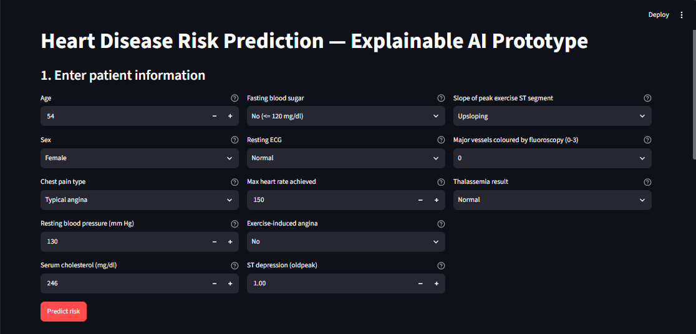
Figure: Prototype input form
A prediction with the plain-language explanation format:
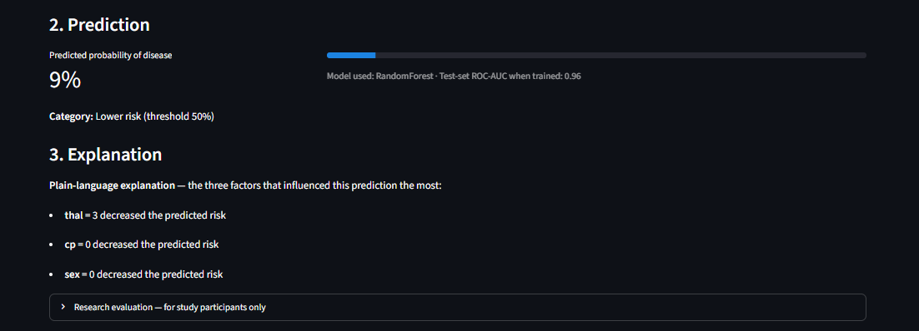
Figure: Prediction with plain-language explanation

8. Results

8.1 Data and Exploratory Analysis
The cleaned dataset contained 303 patients with a roughly balanced split between the “disease” and “no disease” classes [insert your exact class balance percentage from the notebook's Section 3 output here]. Exploratory analysis of age, maximum heart rate, and ST depression by diagnosis class showed visible separation between groups, consistent with these being informative predictors, which was later confirmed by the model comparison and SHAP analysis below.

8.2 Model Performance
Four classification models were trained and compared on the held-out test set:
Model | Accuracy | Precision | Recall | F1 | ROC-AUC
Random Forest | 0.918 | 0.871 | 0.964 | 0.915 | 0.958
Logistic Regression | 0.869 | 0.812 | 0.929 | 0.867 | 0.951
Gradient Boosting | 0.852 | 0.788 | 0.929 | 0.852 | 0.946
SVM (RBF) | 0.852 | 0.806 | 0.893 | 0.847 | 0.944
Random Forest was selected as the best-performing model, achieving the highest score on every metric, including a strong ROC-AUC of 0.958. Notably, Logistic Regression — the most interpretable model in the comparison, with no need for post-hoc explanation at all — came a close second, outperforming both Gradient Boosting and SVM on accuracy, F1, and ROC-AUC despite being the simplest model tested.
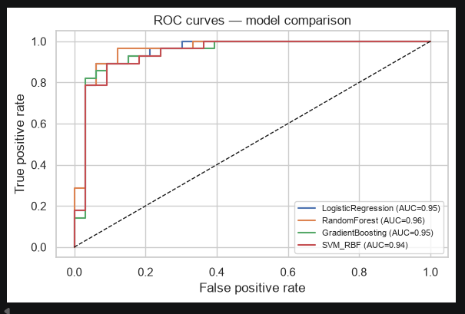
Figure: ROC curves — model comparison
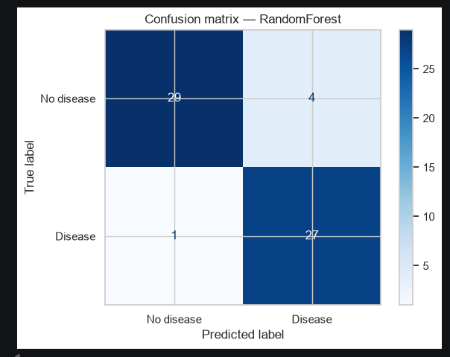
Figure: Confusion matrix — Random Forest
On the held-out test set, the Random Forest model correctly classified 29/33 “no disease” cases and 27/28 “disease” cases, for a combined 56/61 correct (matching the 91.8% accuracy in the table above). It made 4 false positives and just 1 false negative — notably, the model rarely missed an actual disease case, which is the more clinically important error to avoid.

8.3 Explainability
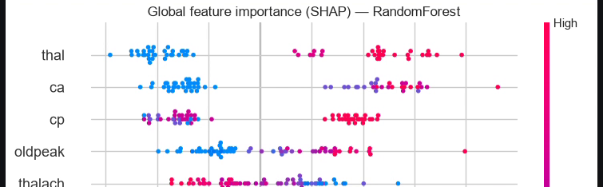
Figure: Global SHAP feature importance — Random Forest
The global SHAP summary plot for the Random Forest model ranked thal, ca, cp, and oldpeak as the most influential features across the test set — consistent with established cardiovascular risk factors in the clinical literature, giving reasonable confidence that the model learned clinically plausible patterns rather than spurious correlations.
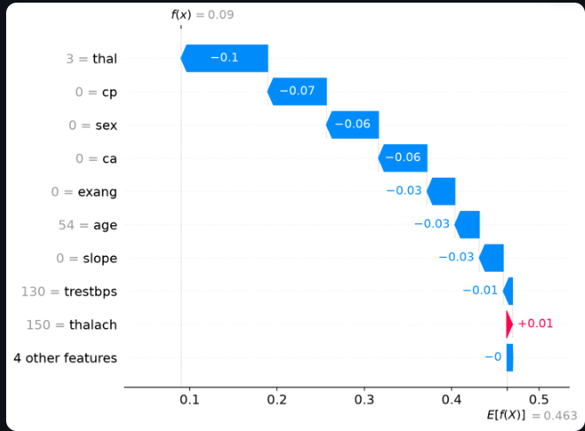
Figure: Local SHAP explanation for an example prediction
This example — a predicted probability of 9% (“lower risk”) — is also the exact prediction later shown to participants in the human evaluation described in Section 8.4 below. The waterfall breakdown shows thal (=3, normal) as the largest single contributor, pulling the prediction down by 0.10, followed by cp (=0) and sex (=0), each contributing roughly -0.06 to -0.07. This is the same ranking of factors that was reported to evaluation participants as the three most influential, making this figure and the Section 8.4 results directly traceable to one another.

8.4 Human Evaluation
Seven participants completed the paper-based evaluation, each viewing one real model prediction presented in two formats (a SHAP visual chart and a plain-language text summary).
Metric | Result
Comprehension accuracy | 14.3% (1/7 correctly identified thal as the top factor)
Avg. trust — Chart / Text | 3.57 / 3.43 (out of 5)
Avg. clarity — Chart / Text | 3.43 / 3.43 (out of 5)
Preferred format | Chart: 4, Text: 2, About the same: 1
Comprehension was low regardless of format, suggesting the barrier was the underlying feature names themselves (e.g. thal, cp) rather than how the explanation was presented. Trust and clarity ratings were nearly identical between formats, while the visual chart was preferred by a majority of participants — an interesting split between stated preference and measured understanding.

9. Discussion
RQ1 (best trade-off): Random Forest gave the best raw performance, but Logistic Regression's near-identical results suggest interpretability was not costly on this dataset — a fully transparent model was nearly competitive with the strongest black-box option.
RQ2 (SHAP vs. clinical knowledge): the top global features (thal, ca, cp, oldpeak) align with known cardiovascular risk indicators, supporting the model's clinical plausibility.
RQ3 (does format affect comprehension/trust?): in this small sample, no — trust and clarity were nearly identical across formats, and comprehension was low in both. This suggests explanation format alone may be less important than making the underlying feature names interpretable to non-experts in the first place.
RQ4 (design implications): the gap between preference (chart favoured) and comprehension (equally poor in both) is the most interesting finding here — it implies people can like an explanation without actually understanding it, which is a real risk for human-centred XAI design and a direct motivation for the proposed MSc research.

10. Limitations
This project has several limitations that should be considered when interpreting the results. The human evaluation involved only 7 participants, all recruited informally rather than sampled from the actual target user group (patients or clinicians), and the small sample size means the findings are descriptive and exploratory rather than statistically generalizable. All participants evaluated a single shared prediction rather than a range of cases, which limits what can be concluded about explanation format across different risk profiles. The comprehension question relied on recognizing technical feature names (thal, cp, sex), which may have confounded genuine explanation clarity with unfamiliarity with clinical terminology — a finding worth investigating directly at MSc scale. On the modelling side, the dataset was limited to 303 instances from a single site (the Cleveland subset), model comparison used a single train/test split rather than cross-validation, and the 50% classification threshold was not clinically validated. Finally, this is a research prototype, not a validated clinical tool, and should not be interpreted as making real diagnostic claims.

11. Conclusion
This project set out to design, implement, and evaluate a small-scale explainable AI prototype for heart disease risk prediction, combined with a preliminary human-centred evaluation of two explanation formats. All six objectives were met: a reproducible data pipeline was built and documented (O1); four models were trained and compared, with Random Forest achieving the best performance (91.8% accuracy, 0.958 ROC-AUC) closely followed by the fully transparent Logistic Regression baseline (O2); a SHAP-based explanation module was implemented, producing both global and local explanations that aligned with established cardiovascular risk factors (O3); an interactive Streamlit prototype was built supporting both visual and plain-language explanation formats (O4); a human evaluation with 7 participants was conducted and analysed, comparing comprehension, trust, and clarity across formats (O5); and findings, including clear limitations, are documented in this report (O6).
The most significant finding — that comprehension remained low (14.3%) regardless of explanation format, despite reasonable trust and clarity ratings for both — directly motivates the proposed MSc research direction. It suggests that human-centred XAI design cannot rely on presentation format alone; the underlying interpretability of feature representations themselves may be a more fundamental barrier to genuine understanding than how an explanation is visually or verbally packaged. This is precisely the kind of gap a human-centred design framework for XAI in healthcare would need to address, and this project provides an initial, evidence-based foundation for that larger investigation.

12. References
Janosi, A., Steinbrunn, W., Pfisterer, M., & Detrano, R. (1988). Heart Disease [Dataset]. UCI Machine Learning Repository. https://doi.org/10.24432/C52P4X
Lundberg, S. M., & Lee, S.-I. (2017). A Unified Approach to Interpreting Model Predictions. Advances in Neural Information Processing Systems, 30.
[Add any further sources cited in Section 2, in your department's required referencing style.]

