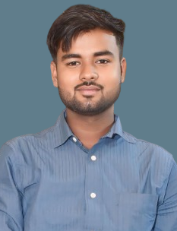**RESUME**

**SHIVAM SAHU**

**Contact: -** +919648388643

**Email Id:-**ssahuji910@gmail.com

**Address:-**Kalyanpur Lucknow Uttar Pradesh

**CAREER OBJECTIVE**

**OBJECTIVE**

Seeking employment in an organization where I can implement my academic and practical knowledge with dedication, team spirit and co-operation. Hoping to grow with the organization and to perform the best in the task assigned.

**SKILLS**

* Basic to advanced knowledge in computer concepts.
* Basic knowledge in git to upload Project.
* Frontend dvelopement (HTML,CSS).
* Basic knowledge in C , C++, JAVA, JAVA SCRIPT, MYSQL,Canva.
* Basic knowledge in Python.
* Linux /Unix ( Operating System ).
* Microsoft Office Packages.

**EDUCATION**

* Pursuing BCA Graduation From FIeMITS Lucknow, Affiliated to MCRP University, Bhopal.
* Completed my 12th in year 2021 from St.CPMA Pachwas Basti.
* Completed my 10th in year 2020 from St.CPMA Pachwas Basti.

**EXPERIENCE**

* Office work
* Graphic designing
* Paper formating
* Social media Handling
* Website Handling
* Duration- 3 Month’s

**PROJECT WORK**

* Project Name : LMS(Library Management System) (Frontend developer)
* Team size :01
* Duration : 6 Months.
* Technology & Tools Used: HTML,CSS And JS.

**PROJECT DESCRIPTION**

A library management system(LMS) is software that is designed to manage all the functions of a library. It helps librarian to maintain the database of new books and the books that are borrowed by members along with their due dates.

**PERSONAL INFORMATION**

## Name: Shivam sahu

## Father’s Name: Mangru Prasad sahu

## Date of Birth: 11/05/2004

## Hobbies: Playing Cricket,Vollyball,Chess.

## Marital Status: Single

## Pincode: 226022

## Known Language: English, Hindi

## Declaration:

I hereby declare that above information is correct to the best of my knowledge and belief.

**SHIVAM SAHU**