**Data Analytics Report for Parts Data**

1. **GParts Part Measures.xlsx**

**Percentage of Parts with No Dimensions**

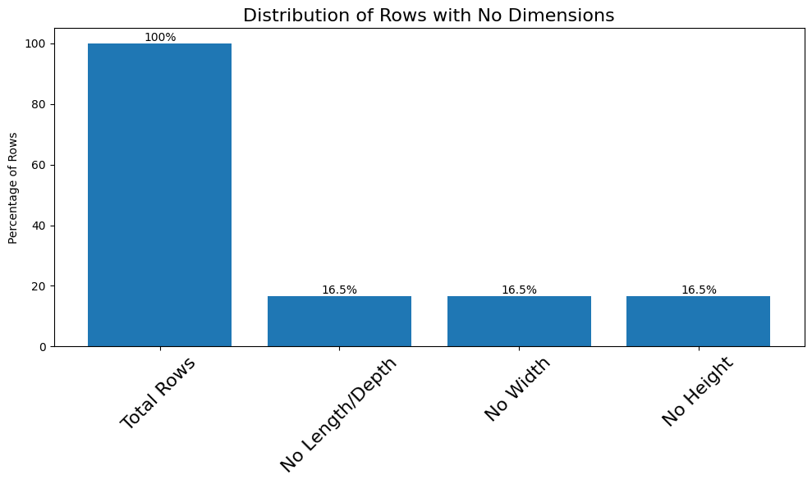

**Percentage of Active Parts of total Parts and No_Dim Parts**

**Active Parts: 212530; Active Percentage: 91.55%**

**Not Active Parts: 19615; Not Active Percentage: 8.45%**

**For All Parts For Parts without Dim**

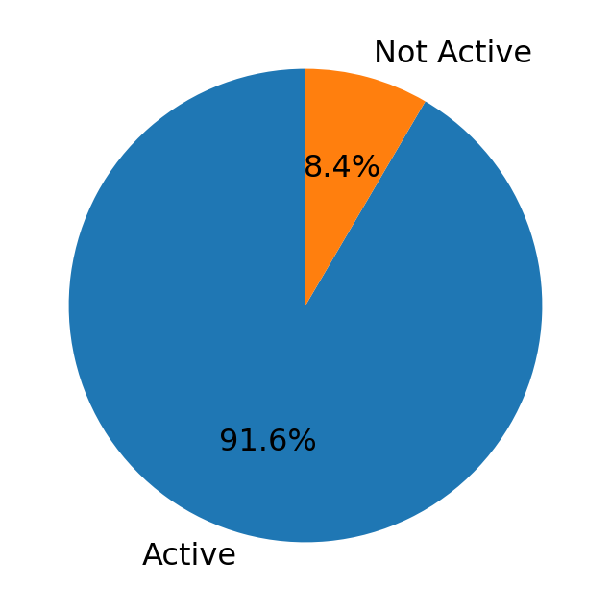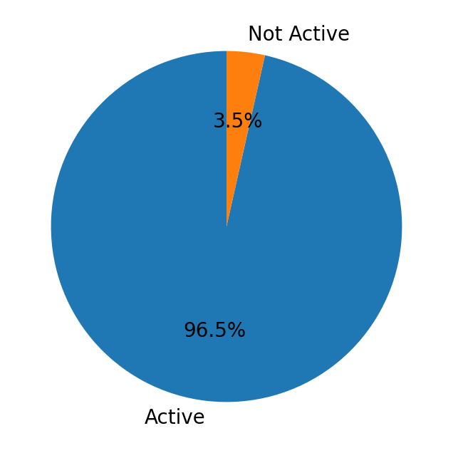

**Active Parts of No Dimensions: 36947;**

**Percentage of Active Parts having no Dims: 96.48%**

**Non-Active Parts of No Dimensions: 1347;**

**Percentage of non-Active Parts having no Dims: 3.52%**

**Active Parts with Dimensions: 175583;**

**Percentage of Active Parts with Dims: 90.58%**

**Non-Active Parts with Dimensions: 18268;**

**Percentage of Non-Active Parts with Dimensions: 9.42%**