- INTRODUCTION

  - PROJECT BACKGROUND

Library is regarded as the brain of any institute.Many institutes understand the importance of the library to the growth of the institute and their esteem users(students).Librrary system gives the all detailed information about students,staff and books.It will track on the how many books available in library and books issued to the students.All these transactions are carried out using library cards.Though these methods are successful and have been prevalent throughout the system,it is always tedious for a student to carry the library card to lend or return a book, it is even economically burdensome for the system to manage and maintain these cards. Interactive Library Management System also provides a single standalone application that can be used by a librarian to review the transactions and maintenance of library, a library staff to add new member, new book and updating information in the database, a student to lend and return books by just using his/her identification number. So, separate applications are not required for the management of library.
1.2 OBJECTIVES
- To design an simple user friendly application that perfectly substitutes the existing system and make it more efficient.
- To perform basic operations of a student like lending.returning a book and checking the status.
- To provide an interface for library staff to register a student,update books,fines and perform leave management.
- To provide an interface for librarian to register an employ,view profiles,databases,analyse transactions by both graphical,tabular analysis and manages leave approvals.

2.LITERATURE SURVEY
2.1 JAVA
2.1.1 OVERVIEW OF JAVA
Initially the language was called “oak” but it was renamed as “Java” in 1995. The primary motivation of this language was need for a platform-independent (i.e., architecture neutral) language that could be used software to the embedded in various consumer electronic devices. The Java programming language and environment is designed to solve a number of modern programming practices[2].
- Java is a programmer’s language.
- Java is cohesive and consistent.
- Except for those constraints imposed by the Internet environment, Java gives the programmer, full control.
Java can be used to create two types of programs
Applications and Applets: An application is a program that runs on our computer under the operating system of that computer. It is more or less like one creating using C or C++. Java’s ability to create Applets makes it important. An apple is an application designed to be transmitted over the Internet and executed by a Java-Compatible web browser. An applet is actually a tiny Java program, dynamically downloaded across the network, just like an image. But the difference is, it is an intelligent program, not just a media file. It can react to the user input and dynamically change.

2.1.2 FEATURES OF JAVA
Java: A simple, object-oriented, network-savvy, interpreted, robust, secure, architecture neutral, portable, high-performance, multithreaded, dynamic language.

java.io
The java.io package contains classes that support input and output. The classes in the package are primarily stream-oriented; however, a class for random access files is also provided. The central classes in the package are InputStream and OutputStream, which are abstract base classes for reading from and writing to byte streams, respectively. The related classesReader and Writer are abstract base classes for reading from and writing to character streams, respectively. The package also has a few miscellaneous classes to support interactions with the host file system.

java.util
The java.util package contains the collections framework, legacy collection classes, event model, date and time facilities, internationalization, and miscellaneous utility classes (a string tokenizer, a random-number generator, and a bit array).

2.2 CLASSES
- BufferedReader
public class BufferedReader extends Reader
Read text from a character-input stream, buffering characters so as to provide for the efficient reading of characters, arrays, and lines. The buffer size may be specified, or the default size may be used. The default is large enough for most purposes. In general, each read request made of a Reader causes a corresponding read request to be made of the underlying character or byte stream. It is therefore advisable to wrap a BufferedReader around any Reader whose read() operations may be costly, such as FileReaders and InputStreamReaders. Programs that use DataInputStreams for textual input can be localized by replacing each DataInputStream with an appropriate BufferedReader.
- DataOutputStream
public class DataOutputStream
extends FilterOutputStream
implements DataOutput
The class DataOutputStream allow a programmer to write primitive Java data types to an output stream in a portable way. This class provide different method to write different type of data like writeInt() for integer, writeChars() for string etc.
- IOException
public class IOException extends Exception
Signals that an I/O exception of some sort has occurred. This class is the general class of exceptions produced by failed or interrupted I/O operations.
- InputStreamReader
public class InputStreamReader
extends Reader
An InputStreamReader is a bridge from byte streams to character streams: It reads bytes and decodes them into characters using a specified charset. The charset that it uses may be specified by name or may be given explicitly, or the platform's default charset may be accepted.
Each invocation of one of an InputStreamReader'sread() methods may cause one or more bytes to be read from the underlying byte-input stream. To enable the efficient conversion of bytes to characters, more bytes may be read ahead from the underlying stream than are necessary to satisfy the current read operation.
- PrintStream
public class PrintStream
extends FilterOutputStream
implements Appendable, Closeable
A PrintStream adds functionality to another output stream, namely the ability to print representations of various data values conveniently. Two other features are provided as well. Unlike other output streams, a PrintStream never throws an IOException; instead, exceptional situations merely set an internal flag that can be tested via the checkError method. Optionally, a PrintStream can be created so as to flush automatically; this means that the flush method is automatically invoked after a byte array is written, one of the println methods is invoked, or a newline character or byte ('\n') is written. All characters printed by a PrintStream are converted into bytes using the platform's default character encoding. The PrintWriter class should be used in situations that require writing characters rather than bytes.

2.3 METHODS
- readLine()
This method is used to read the data line by line. Then returns the data of a line as a single string.
- writeBytes()
This method writes out the string to the underlying output stream as a sequence of bytes.
- start()
This method causes this thread to begin execution; the Java Virtual Machine calls the run method of this thread.
- trim():
This method removes the blank spaces from both ends of the given string (Front and End).
- valueof()
Thismethod converts data from its internal format into a human-readable form. It is a static method that is overloaded within String for all of Java's built-in types, so that each type can be converted properly into a string. valueOf( ) is also overloaded for type Object, so an object of any class type you create can also be used as an argument.

- equals()
This particular method is used to make equal comparison between two objects. There are two types of comparisons in Java. One is using “= =” operator and another is “equals()”. I hope that you know the difference between this two. More specifically the “.equals()” refers to equivalence relations. So in broad sense you say that two objects are equivalent they satisfy the “equals()” condition.

3 PROBLEM DEFINITION

3.1 APPLICATION OVERVIEW

Library project system that offers many flexible and convenient features, allowing librarians and library users to maximize time and efficiency, Library system gives the all detailed information about students, staff and books. It will track on the how many books available in library and books issued to the students. Generally these transactions are carried out using library cards but in this project we carry out without using any cards.It provides increased productivity and job satisfaction among staff members as it eliminates duplication of effort. More economical and safer means of storing and keeping track of information.Easier access to information like management reports and stock etc,as well as more accurate and faster results from statistical analyses. This application reduces errors and eliminating the ennui of long and repetitive manual processing.

3.2 PROBLEM DESCRIPTION
Interactive library management system includes basic transactions of a library without using any library cards.It has 3 module specifications.They are student, library and librarian. Student module includes lending,returning a book and checking the status.Lending is performed only when student has not yet taken 4 books and there is no fine on each book. Once lending is done,status database is updated with student id,name,bookid and particular book is removed from books database. Returning a book involves deletion of that details in status database, inserting that book into books database and updating fines database.Status checking involves retrieving data from fines,status database and displaying them.
Library staff performs various tasks like student registration,books updation,fines updation and leave management.Leave management refers to application of leave and checking the leave status.Student registration includes entering all the details of student and image. These details are entered into students database.Books updation includes addition of new books and deletion from books database.Fines updation refers to updating fines database and payment database when student pays his fine.Whenever librarystaff applies leave,the details are entered into leave database.Librarian checks these details and performs either approval or rejection.
Librarian module includes various tasks like employ registration,viewing profiles,databases,analyzing transactions. Employ registration includes entering all the details into employ database.Analysing transactions refers to analyzing transactions like inflow,outflow of books,fines collected using both tabular and graphical analysis.
This method surely is far better than existing system that is transactions using library cards and no separate application for leave management and analyising transaction.

3.3 MODULE SPECIFICATION

- STUDENT :

    - Designing a GUI using netbeans component.
    - Login through unique student id which is already registered.
    - Performing lending,returning books.
    - Checking the status of books he has taken and fines issued on him.

- LIBRARY STAFF:

    - Student–registration/Updation : Provides a interface for a new student to register by entering the student details including image.Updation is done whenever details like contact num and year of a student changes.
    - Updation of books : updation of books refers to addition of new books and deletion of unnecessary books from books database.
    - Fines updation: When students pays his fine,library staff updates the fines and payment database.
    - Leave management: Leave management includes leave application and leave status.leave status includes checking whether leave is approved or not.

- LIBRARIAN:
- Employ registration:Provides a interface for a new employ to register by entering the employ details including image.These details are entered into employ database.
- Viewing profiles/databases: Librarian can view the profiles of all students,employees and databases that were involved.
- Analysing transactions: Librarian analyses various transactions like inflow,outflow of books,fines collected using both tabular and graphical analysis.

4. ANALYSIS AND DESIGN

4.1 ANALYSIS

The development of a computer-based application includes a systems analysis phase which produces or enhances the data model which itself is a precursor. There are a number of different approaches to system analysis. When a computer-based application is developed, systems analysis (according to the Waterfall model) would constitute the following steps:
- The development of a feasibility study, involving determining whether a project is economically, socially, technologically and organizationally feasible.
- Conducting fact-finding measures, designed to ascertain the requirements of the system's end-users. These typically span interviews, questionnaires, or visual observations of work on the existing system.
- Gauging how the end-users would operate the system (in terms of general experience in using computer hardware or software), what the system would be used for and so on.
Another view outlines a phased approach to the process. This approach breaks systems analysis into 5 phases:
- Scope Definition
- Problem analysis
- Requirements analysis
- Logical design
- Decision analysis
Use Case Diagram: Use cases are a widely-used systems analysis modeling tool for identifying and expressing the functional requirements of a system. Each use case is a business scenario or event for which the system must provide a defined response. Use cases evolved out of object-oriented.analysis.however,their use as a modeling tool has become common in many other methodology.
Activity Diagram: The activity diagram shows the flow of interaction or sequence of interaction of the application.Firstly login into application and then select the module.If student module is selected then student can select any one option like lending,status,returning.else if library staff module is selected then there are various tasks like student registration,books,fines updation and leave management. Selecting librarian module includes various tasks like employ registration,viewing profiles,databases,analyzing transactions.

Class Diagram: The class diagram is a static diagram. It represents the static view of an application. Class diagram is not only used for visualizing, describing and documenting different aspects of a system but also for constructing executable code of the software application.Interactive library management system has various classes like student,librarystaff,librarian,library,books and fine and association relationship between them.

Object Diagram: Object diagrams are derived from class diagrams so object diagrams are dependent upon class diagrams.Object diagrams represent an instance of a class diagram. The basic concepts are similar for class diagrams and object diagrams. Object diagrams also represent the static view of a system but this static view is a snapshot of the system at a particular moment.Various objects are library.librarystaff,student,librarian,books,fines.
Sequence Diagram:
The purposes of interaction diagrams are to visualize the interactive behaviour of the system. Sequence and collaboration diagrams are the interaction diagrams.Sequence diagram gives the time ordering of messages.
Collaboration Diagram:Collaboration diagram gives the structural organization of messages.It is generated from the sequence diagram.
State-chart Diagram: A Statechart diagram describes a state machine. Now to clarify it state machine can be defined as a machine which defines different states of an object and these states are controlled by external or internal events.It also specifies dynamic behavior of system.
Component Diagram:
Component diagrams can also be described as a static implementation view of a system. Static implementation represents the organization of the components at a particular moment.This project includes various components like librarian,student,books,library staff,fines database,books database,students database and employ database.
Deployment Diagram: Deployment diagrams are used to visualize the topology of the physical components of a system where the software components are deployed.So deployment diagrams are used to describe the static deployment view of a system. Deployment diagrams consist of nodes and their relationships.This project includes various nodes like student,library,librarian,library staff,books,fines,books database,fines database,employ database.
DATA FLOW DIAGRAMS:
A data flow diagram is a graphical representation of the "flow" of data through an information system, modeling its process aspects. The DFDs describe the input-process-output view of the software. The Level 0 DFD (Context DFD) shows the major external entities in application. The Level 1 DFD refines the software system abstraction and describes the detail of processing the input information to produce the output.

4.2 DESIGN

Systems design is the process of defining the architecture, components, modules, interfaces, and data for a system to satisfy specified requirements. One could see it as the application of systems theory to product development. There is some overlap with the disciplines of systems analysis, systems architecture and systems engineering. If the broader topic of product development "blends the perspective of marketing, design, and manufacturing into a single approach to product development,"[9] then design is the act of taking the marketing information and creating the design of the product to be manufactured.
- Requirements analysis - analyzes the needs of the end users or customers.
- Benchmarking - is an effort to evaluate how current systems perform.
- Systems architecture - creates a blueprint for the design with the necessary specifications for the hardware, software, people and data resources.
- Design - designers will produce one or more 'models' of what they see a system eventually looking like, with ideas from the analysis section either used or discarded. A document will be produced with a description of the system.
Fig 4.2 Flowchart for virtual-money transfer

5. SYSTEM REQUIREMENTS

  - FUNCTIONAL REQUIREMENTS

The system should provide a better and an efficient way of making transactions rather than the existing method of using library cards. The system must provide the basic functionality of providing a secured way of making transactions.

- allows the new student,employ to register in the application
- should store the registered student,employ details in database.
- Allowing student to perform lending,status and returning.
- allowing library staff to update books,fines and manage leave.
- Allows librarian to perform viewing profiles,databases,analyse transactions and approve leave
.
5.1.1 HARWARE REQUIREMENTS

Processor : Pentium 2 266 MHz processor

Memory : 512 MB

5.1.2 SOFTWARE REQUIREMENTS

Operating System : Windows 7/8/ XP/ vista

Programming Language or Tools : Java

Front end : Java , jdk1.6.45 ,Net beans 7.3.1
Back end: Oracle database 11g ,SQL developer

5.2 NON FUNCTIONAL REQUIREMENTS

- The application must prevent unregistered or unauthorized users for using the application.
- If anywhere wrong or irrelevant details are entered the application must prevent the control to move ahead.
- If any impossible transactions are tried to made the application must prevent it from happening.
- The application must be able to work efficiently in spite any number and any type of inputs.
- The application must also be portable .

6.IMPLEMENTATION
  - BASIC APPROACH
Interactive library management system includes basic transactions of a library without using any library cards.It has 3 module specifications.They are student, library and librarian. Student module includes lending,returning a book and checking the status.Lending
is performed only when student has not yet taken 4 books and there is no fine on each book. Once lending is done,status database is updated with student id,name,bookid and particular book is removed from books database. Returning a book involves deletion of that details in status database, inserting that book into books database and updating fines database.Status checking involves retrieving data from fines,status database and displaying them.
Library staff performs various tasks like student registration,books updation,fines updation and leave management.Leave management refers to application of leave and checking the leave status.Student registration includes entering all the details of student and image. These details are entered into students database.Books updation includes addition of new books and deletion from books database.Fines updation refers to updating fines database and payment database when student pays his fine.Whenever librarystaff applies leave,the details are entered into leave database.Librarian checks these details and performs either approval or rejection.
Librarian module includes various tasks like employ registration,viewing profiles,databases,analyzing transactions. Employ registration includes entering all the details into employ database.Analysing transactions refers to analyzing transactions like inflow,outflow of books,fines collected using both tabular and graphical analysis.

6.2 CONTROL FLOW
Control flow (or alternatively, flow of control) refers to the order in which the individual statements, instructions or function calls of an imperative or a declarative program are executed or evaluated. Within an imperative programming language, a control flow statement is a statement whose execution results in a choice being made as to which of two or more paths should be followed. For non-strict functional languages, functions and language constructs exist to achieve the same result, but they are not necessarily called control flow statements.
The kinds of control flow statements supported by different languages vary, but can be categorized by their effect:
- continuation at a different statement (unconditional branch or jump),
- executing a set of statements only if some condition is met (choice - i.e., conditional branch),
- executing a set of statements zero or more times, until some condition is met (i.e., loop - the same as conditional branch),
- executing a set of distant statements, after which the flow of control usually returns (subroutines, co routines, and continuations),
- stopping the program, preventing any further execution (unconditional halt).

7.RESULTS

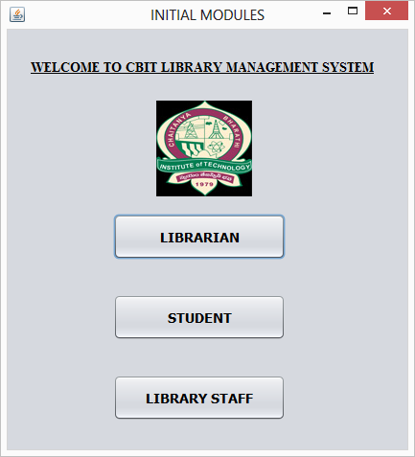
ScreenShot 7.1(a) Selecting student module

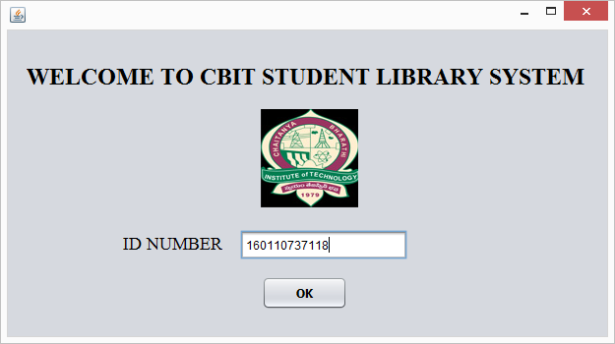
ScreenShot 7.2(a) entering student id
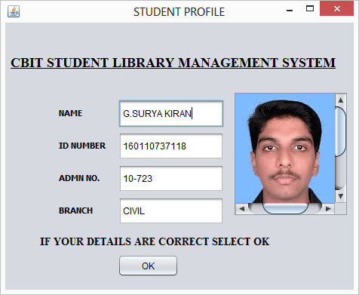
ScreenShot 7.2(b) Displaying details of student

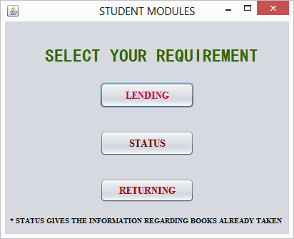
ScreenShot 7.2(c) Select lending requirement

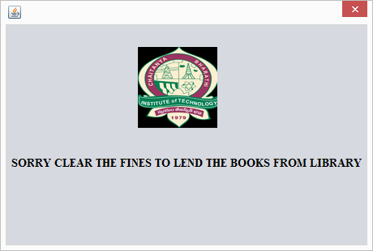
ScreenShot 7.2(d) lending not possible because of fine

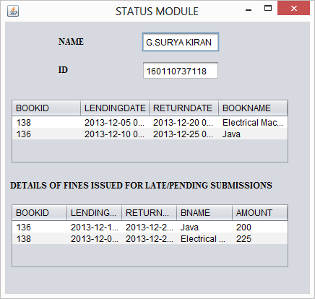
ScreenShot 7.2(e) displaying status of student
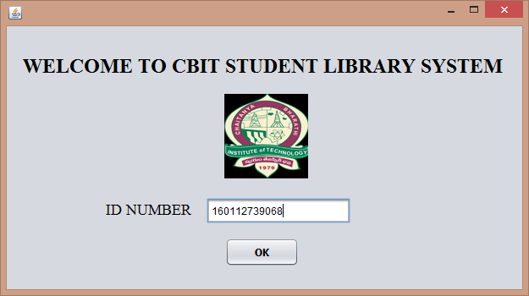
ScreenShot 7.2(f) entering id of student

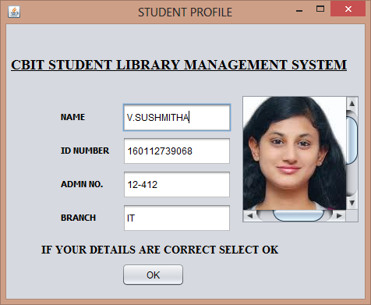
ScreenShot 7.2(g) displaying details of student

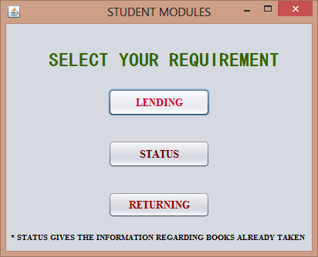
ScreenShot 7.2(h) select lending requirement
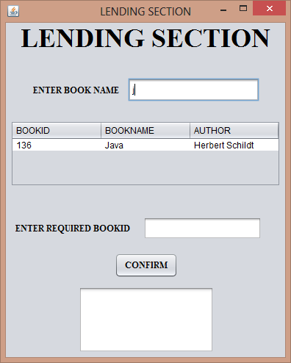
ScreenShot 7.2(i) entering the name of required book
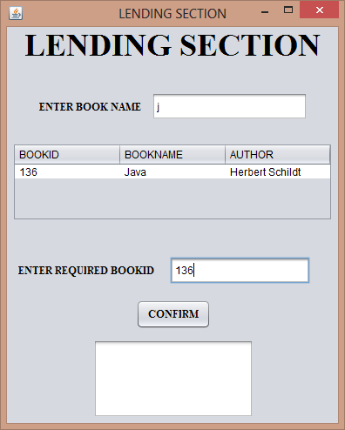
ScreenShot 7.2(j) displaying details of required book and entering book id
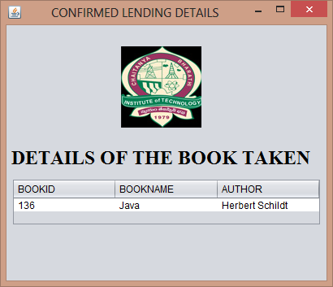
ScreenShot 7.2(k) displaying details of borrowed book
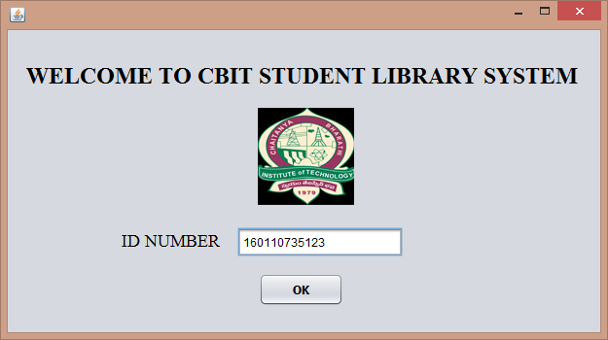
ScreenShot 7.2(l) entering id of student

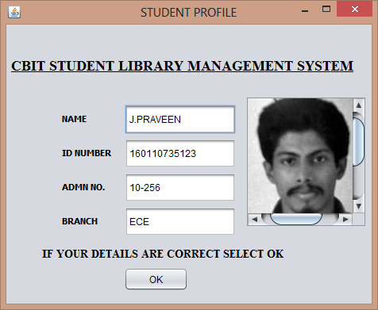
ScreenShot 7.2(m) displaying status of student

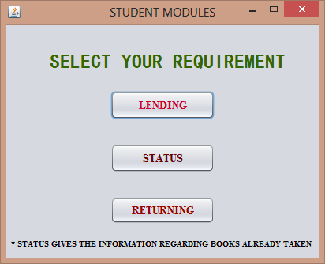
ScreenShot 7.2(n) select returning requirement
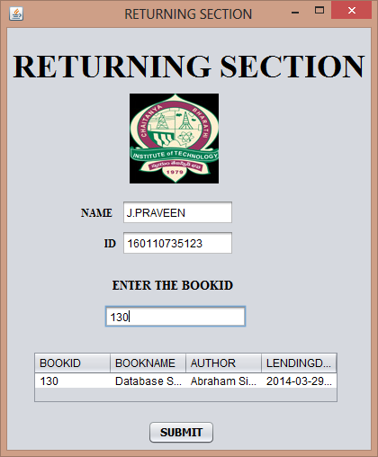
ScreenShot 7.2(o) entering book-id of book to be returned
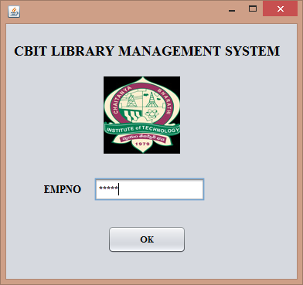
ScreenShot 7.3(a) entering employ-id

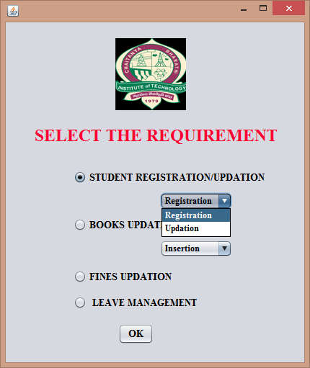
ScreenShot 7.3(b) selecting student registration

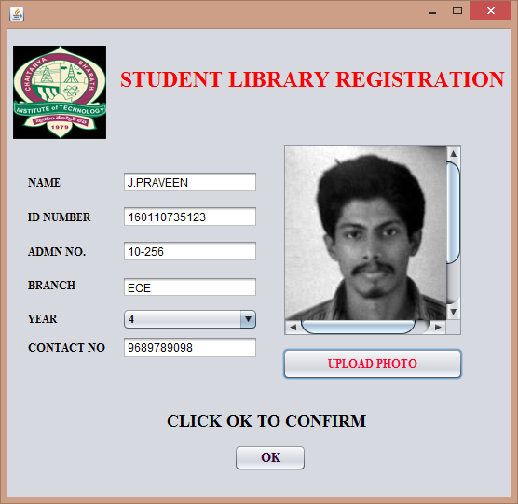
ScreenShot 7.3(c) Registering the student

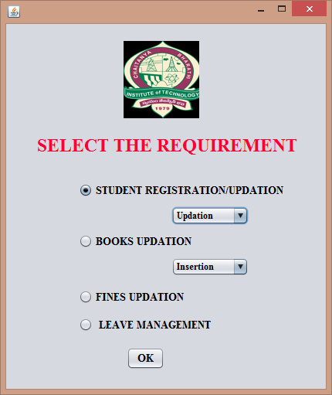
ScreenShot 7.3(d) selecting student updation
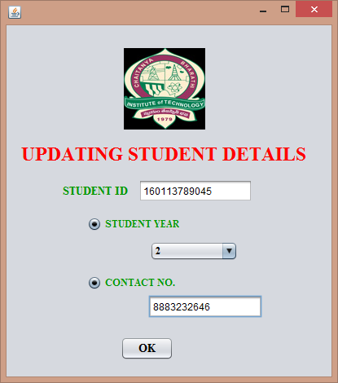
ScreenShot 7.3(e) updating student details

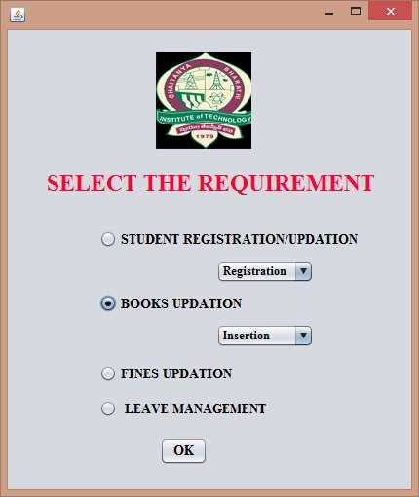
ScreenShot 7.3(f) selecting books insertion
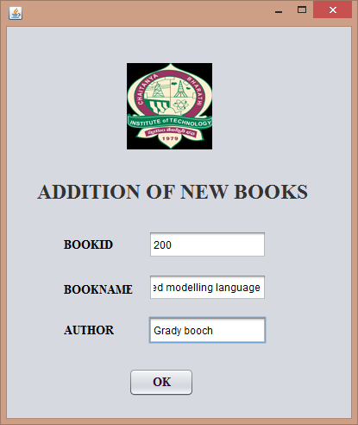
ScreenShot 7.3(g) adding details of book

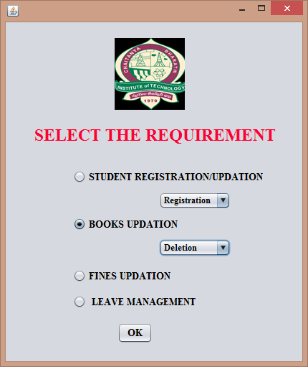
ScreenShot 7.3(h) selecting books deletion
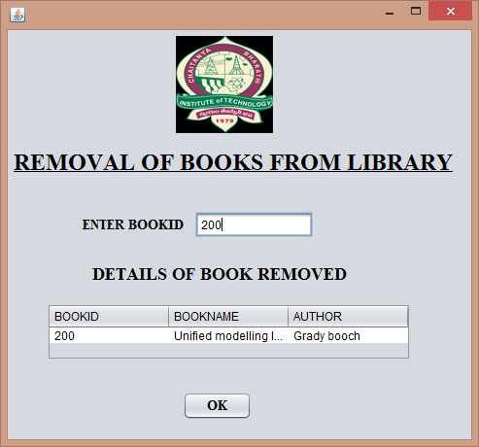
ScreenShot 7.3(i) entering book-id that is to be removed

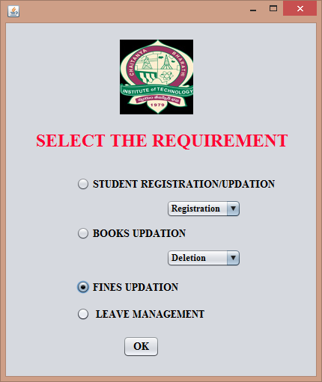
ScreenShot 7.3(j) selecting fines updation

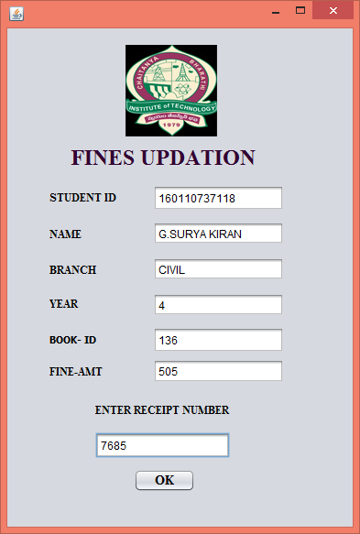
ScreenShot 7.3(k) entering studentid,bookid,receipt number

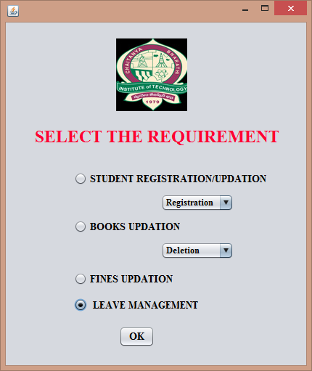
ScreenShot 7.3(l) selecting leave management

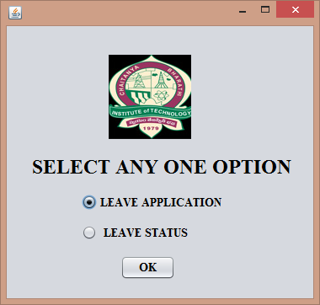
ScreenShot 7.3(m) selecting leave application

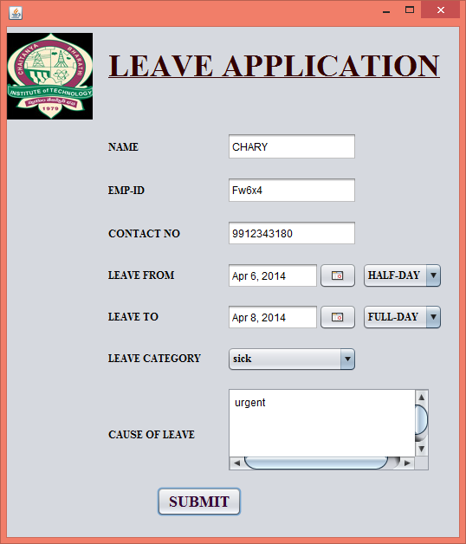
ScreenShot 7.3(n) submitting details for leave

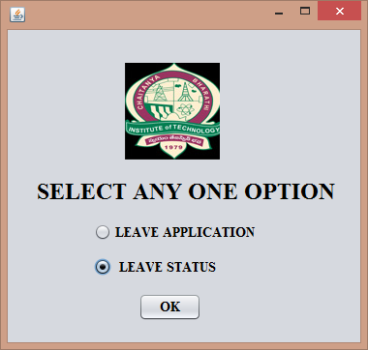
ScreenShot 7.3(o) selecting leave status

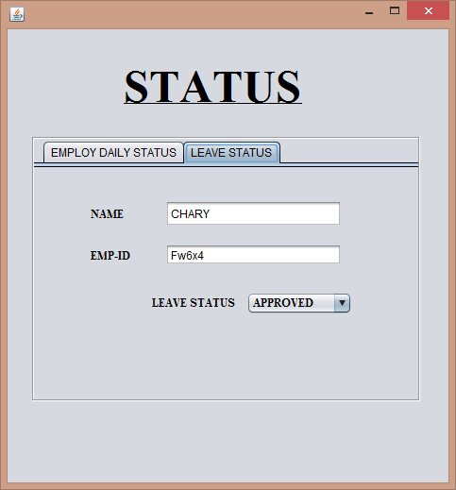
ScreenShot 7.3(p) displaying the status of leave
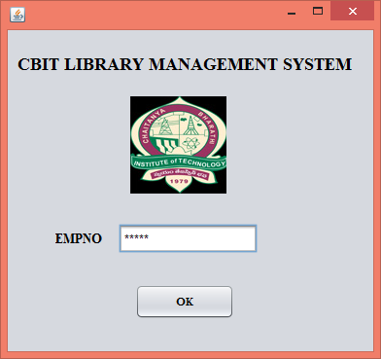
ScreenShot 7.4(a) entering librarian id

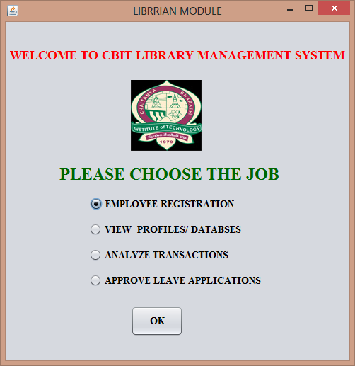
ScreenShot 7.4(b) selecting employ registration
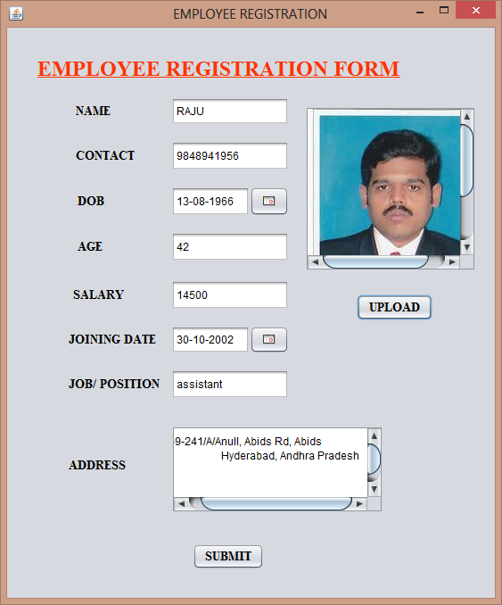
ScreenShot 7.4(c) entering details of an employ

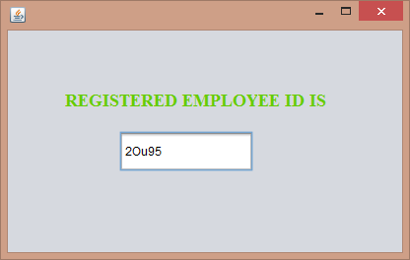
ScreenShot 7.4(d) generating employee id

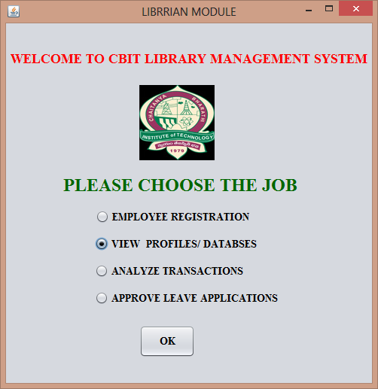
ScreenShot 7.4(e) selecting viewing profiles job

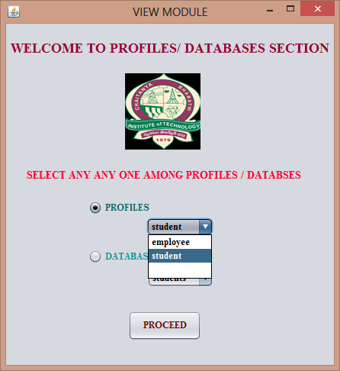
ScreenShot 7.4(f) selecting student profile

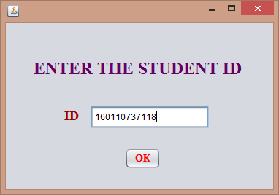
ScreenShot 7.4(g) entering the student id

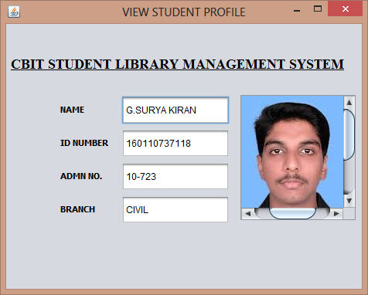
ScreenShot 7.4(h) viewing details of student

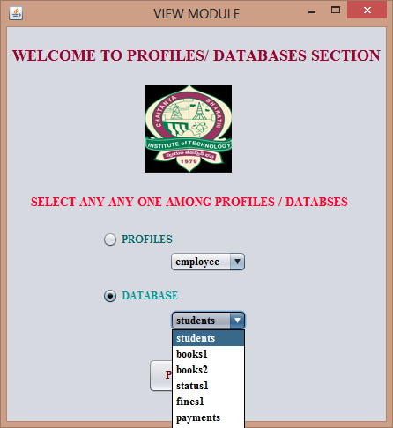
ScreenShot 7.4(i) selecting students database
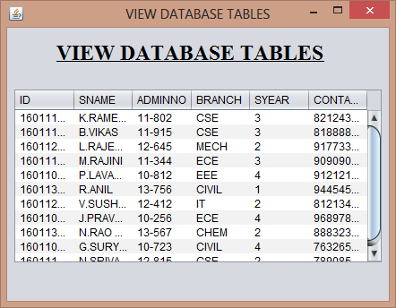
ScreenShot 7.4(j) displaying student database
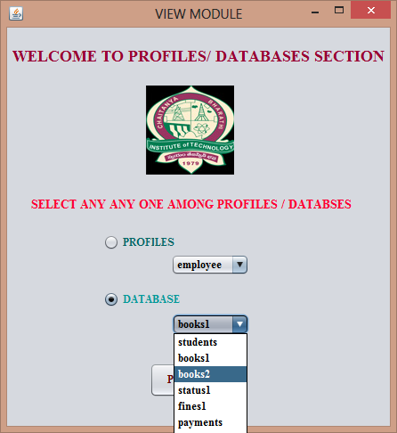
ScreenShot 7.4(k) selecting books database
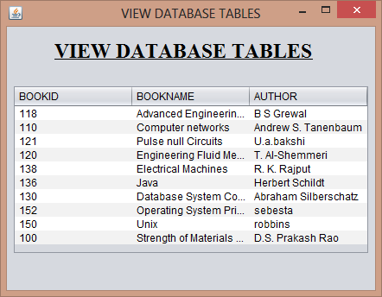
ScreenShot 7.4(l) displaying books database

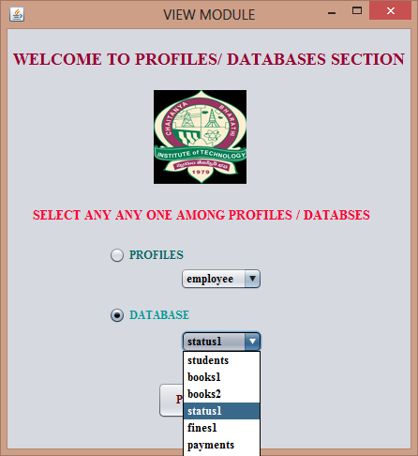
ScreenShot 7.4(m) selecting status database
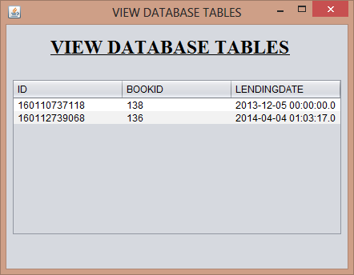
ScreenShot 7.4(n) displaying status database
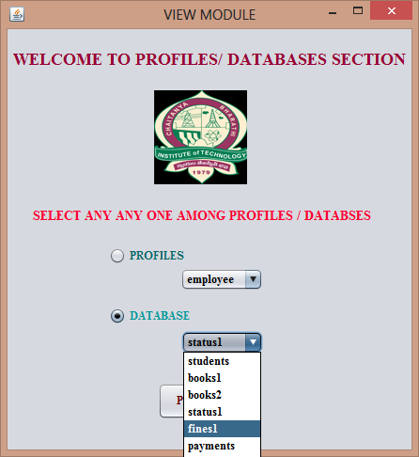
ScreenShot 7.4(o) selecting fines database
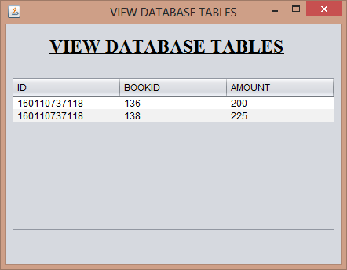
ScreenShot 7.4(p) displaying fines database
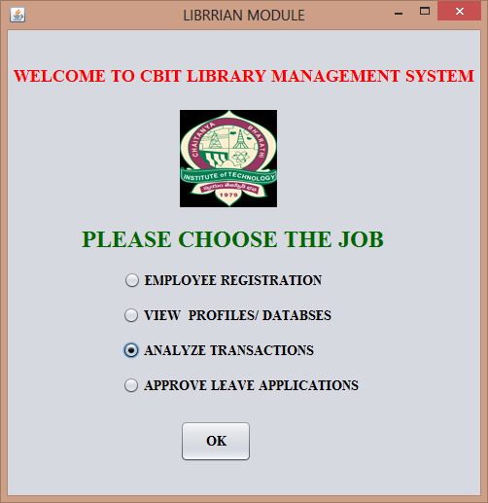
ScreenShot 7.4(q) selecting analyse transaction

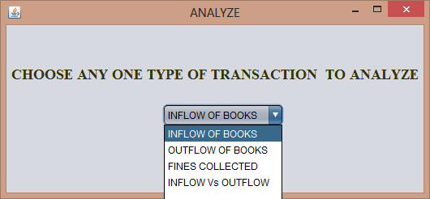
ScreenShot 7.4(r) selecting inflow of books

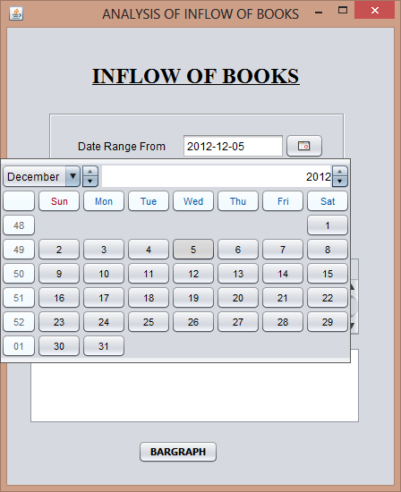
ScreenShot 7.4(s) selecting date

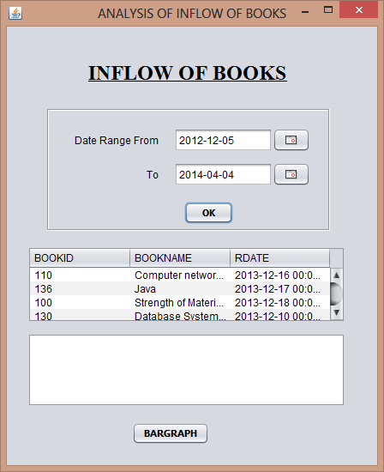
ScreenShot 7.4(t) tabular inflow analysis of books

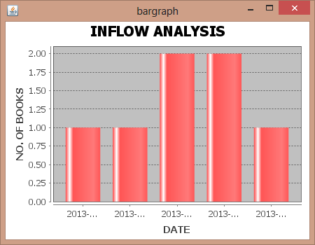
ScreenShot 7.4(u) graphical inflow analysis of books

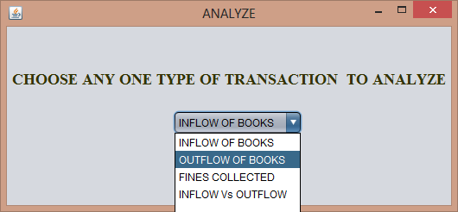
ScreenShot 7.4(v) selecting outflow of books

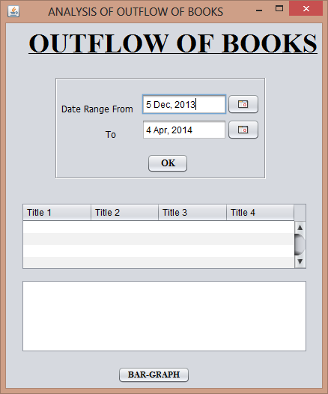
ScreenShot 7.4(w) selecting date for analysisng outflow

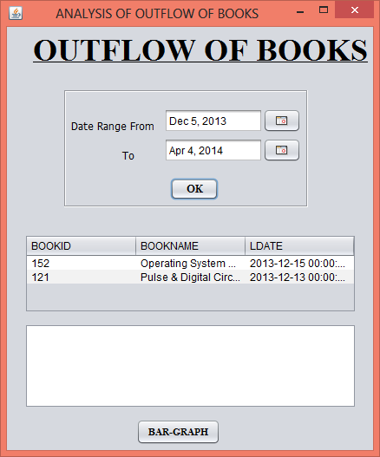
ScreenShot 7.4(x) tabular outflow analysis of books

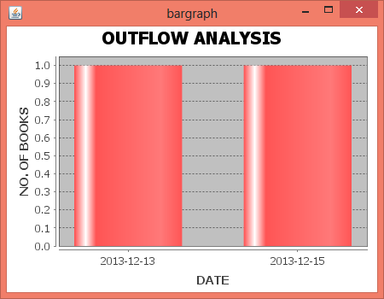
ScreenShot 7.4(y) graphical outflow analysis of books

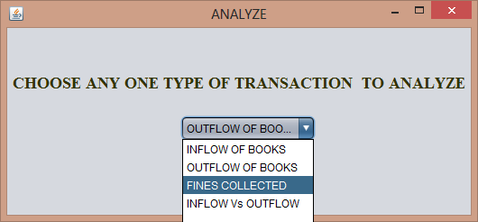
ScreenShot 7.4(z) selecting fines collected transaction
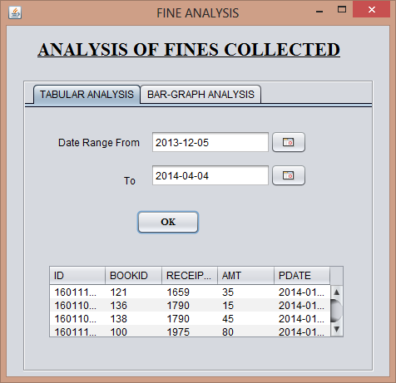
ScreenShot 7.5(a) tabular analysis of fines collected
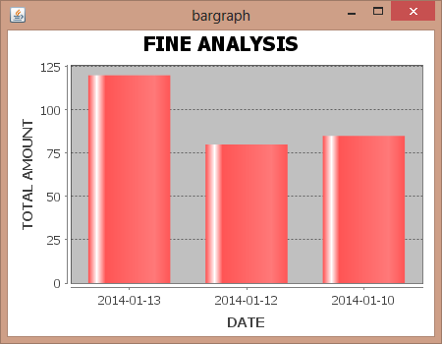
ScreenShot 7.5(b) graphical analysis of fines collected

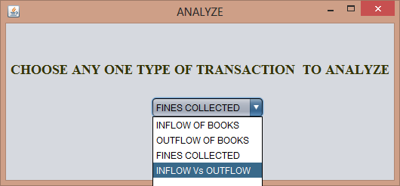
ScreenShot 7.5(c) selecting inflow vs outflow transaction

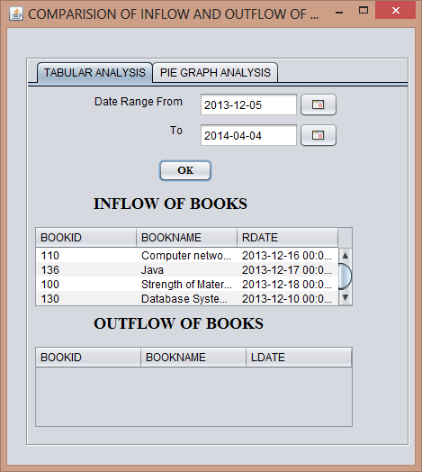
ScreenShot 7.5(d) tabular analysis of inflow vs outflow
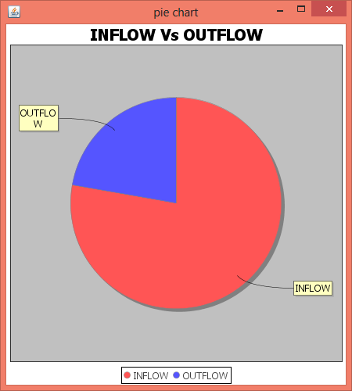
ScreenShot 7.5(e) graphical analysis of inflow vs outflow

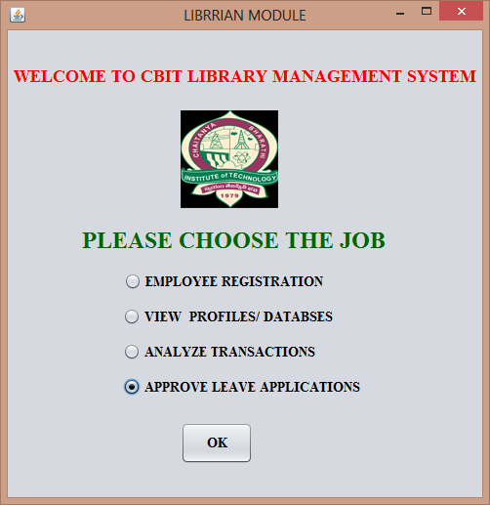
ScreenShot 7.5(f) selecting approve leave applications
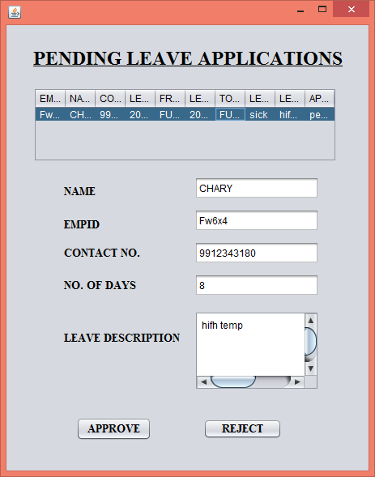
ScreenShot 7.5(g) analysing leave application

CONCLUSION
This android application is simple to use and can be even used by native users. As stated earlier Campus Connect’s main idea is to demonstrate how an android app can be used as an e-notice board. Using the services provided by the Cloud, the technology can be applied to solve many obstacles faced by the institutions and organizations while giving out any updates, by creating an efficient and reliable application on any mobile platform so that the end user remains updated on the latest news regarding their respective organizations. Push notifications save time and helps to get the information required, quickly after it was published. In addition, the server module which is being run in cloud (Google App Engine), allows the admins to pass the information to the students irrespective of their location, but just provided with internet. It provides students to stay updated with information consistently. Since all the databases are maintained in the cloud (Cloud SQL), the various details of students and their corresponding device GCM registration IDs are securely stored without any risks. The android client app allows the students to review the previous information (Notifications) which was received to his/her device through a convenient user-interface i.e., the user can clearly view all his/her previous notifications of class, department and college in separate respective sections. This application is a need of the hour as it allows users to stay updated in real time.
Limitations
Now for sending notifications to the devices, Google Cloud Messaging mechanism is being used which does not always guarantee the delivery of notifications. GCM is not suitable for time sensitive and/or “must-deliver-to-all” application scenarios. Furthermore, the GCM message arrival latency is unpredictable, namely having a reliable connection to Google’s GCM servers on the client device does not by itself guarantee a timely message arrival.
Future Work
This project can be further improved by making certain changes like, as of now Google’s GCM mechanism is being used to send the notifications to the client devices, in the place of it, a dedicated server can be implemented at the client app side in order to keep checking for the data., which will surely guarantee the delivery of information as notifications and overcome the arrival latency problem of Google Cloud Messaging.
REFERENCES

[1] Herbert Schildt, The Complete Reference JAVA, Tata McGraw-Hill Edition,2007
[2] Big Java by Cay Horstmann, John Wiley and Sons, 2nd Edition
[3] https://developers.google.com/eclipse/docs/install-eclipse-4.4
[4] http://romannurik.github.io/AndroidAssetStudio/index.html
[5] Beginning in Java 2 by Iver Horton, Wrox Publications.
[6] https://developer.android.com/google/gcm/index.html
[7] http://www.android4devs.com/2015/01/how-to-make-material-design-sliding-tabs.html
[8] http://stackoverflow.com/questions/21093170/table-has-no-column-named
[9] http://hmkcode.com/android-simple-sqlite-database-tutorial/
[10] http://www.roseindia.net/jsp/
[11] http://w3layouts.com/
[12] http://www.w3schools.com
[13] https://developer.android.com/design/patterns/navigation.html
[14] http://www.webopedia.com

