1. INTRODUCTION

1.1 PROJECT BACKGROUND
Today’s a very important aspect of communications is messaging. In universities, colleges and hospitals it is efficient to display messages on notice board regarding meeting times, exam dates, special events, class cancellations or any pertinent. But sticking various notices day-to-day is a difficult process which requires a separate person to manage these notices to be displayed. To overcome the limitations of old techniques, the push notification came into existence. The purpose of this new form of cloud-based push-styled mobile notifications that uses push services as a means for sending notifications to the user and displaying notifications on users mobile device.

1.2 OBJECTIVES
- To design a simple user friendly application that perfectly substitutes the existing system and makes it more efficient.
- To provide an interface for the corresponding admins to update the information that is to be updated to the students in the form of notifications.
- To provide an interface for the students to register into to the app and set up the app to receive campus notifications.
- To set up the GCM configuration, for performing the major task of sending and receiving notifications.

2. LITERATURE SURVEY
2.1 JAVA
2.1.1 OVERVIEW OF JAVA
Initially the language was called “oak” but it was renamed as “Java” in 1995. The primary motivation of this language was need for a platform-independent (i.e., architecture neutral) language that could be used software to the embedded in various consumer electronic devices. The Java programming language and environment is designed to solve a number of modern programming practices.
- Java is a programmer’s language.
- Java is cohesive and consistent.
- Except for those constraints imposed by the Internet environment, Java gives the programmer, full control.
Java can be used to create two types of programs
Applications and Applets: An application is a program that runs on our computer under the operating system of that computer. Java’s ability to create Applets makes it important. An applet is an application designed to be transmitted over the Internet and executed by a Java-Compatible web browser. An applet is actually a tiny Java program, dynamically downloaded across the network, just like an image. But the difference is, it is an intelligent program, not just a media file. It can react to the user input and dynamically change.

2.1.2 FEATURES OF JAVA
Java: A simple, object-oriented, network-savvy, interpreted, robust, secure, architecture neutral, portable, high-performance, multithreaded, dynamic language.
java.io
The java.io package contains classes that support input and output. The classes in the package are primarily stream-oriented The central classes in the package are InputStream and OutputStream, which are abstract base classes for reading from and writing to byte streams, respectively. The related classesReader and Writer are abstract base classes for reading from and writing to character streams, respectively.

java.util
The java.util package contains the collections framework, legacy collection classes, event model, date and time facilities, internationalization, and miscellaneous utility classes (a string tokenizer, a random-number generator, and a bit array).
javax.servlet
Servlets are Java classes which service HTTP requests and implement the javax.servlet.Servletinterface. Web application developers typically write servlets that extend javax.servlet.http.HttpServlet, an abstract class that implements the Servlet interface and is specially designed to handle HTTP requests.
java.sql
Provides the API for accessing and processing data stored in a data source (usually a relational database) using the Java programming language.

2.1.3 CLASSES
- BufferedReader
public class BufferedReader extends Reader
Read text from a character-input stream, buffering characters so as to provide for the efficient reading of characters, arrays, and lines. The buffer size may be specified, or the default size may be used. The default is large enough for most purposes. In general, each read request made of a Reader causes a corresponding read request to be made of the underlying character or byte stream. It is therefore advisable to wrap a BufferedReader around any Reader whose read() operations may be costly, such as FileReaders and InputStreamReaders. Programs that use DataInputStreams for textual input can be localized by replacing each DataInputStream with an appropriate BufferedReader.

- DataOutputStream
public class DataOutputStream extends FilterOutputStream implements DataOutput
The class DataOutputStream allow a programmer to write primitive Java data types to an output stream in a portable way. This class provide different method to write different type of data like writeInt() for integer, writeChars() for string etc.
- IOException
public class IOException extends Exception
Signals that an I/O exception of some sort has occurred. This class is the general class of exceptions produced by failed or interrupted I/O operations.
- InputStreamReader
public class InputStreamReader extends Reader
An InputStreamReader is a bridge from byte streams to character streams: It reads bytes and decodes them into characters using a specified charset. The charset that it uses may be specified by name or may be given explicitly, or the platform's default charset may be accepted.
Each invocation of one of an InputStreamReader'sread() methods may cause one or more bytes to be read from the underlying byte-input stream. To enable the efficient conversion of bytes to characters, more bytes may be read ahead from the underlying stream than are necessary to satisfy the current read operation.
- PrintStream
public class PrintStream extends FilterOutputStream implements Appendable, Closeable
A PrintStream adds functionality to another output stream, namely the ability to print representations of various data values conveniently. Two other features are provided as well. Unlike other output streams, a PrintStream never throws an IOException; instead, exceptional situations merely set an internal flag that can be tested via the checkError method.
2.1.4 METHODS
- readLine()
This method is used to read the data line by line. Then returns the data of a line as a single string.
- writeBytes()
This method writes out the string to the underlying output stream as a sequence of bytes.
- start()
This method causes this thread to begin execution; the Java Virtual Machine calls the run method of this thread.
- trim()
This method removes the blank spaces from both ends of the given string (Front and End).
- valueof()
This method converts data from its internal format into a human-readable form. It is a static method that is overloaded within String for all of Java's built-in types, so that each type can be converted properly into a string. valueOf( ) is also overloaded for type Object, so an object of any class type you create can also be used as an argument.
- equals()
This particular method is used to make equal comparison between two objects. There are two types of comparisons in Java. One is using “= =” operator and another is “equals()”.So in broad sense you say that two objects are equivalent they satisfy the “equals()” condition.
- forward()
The forward () method of RequestDispatcher will forward the ServletRequest and ServletResponse that it is passed to the path that was specified in getRequestDispatcher(String path). The response will not be sent back to the client

2.2 ANDROID
2.2.1 OVERVIEW OF ANDROID
Android delivers a complete set of software for mobile devices: an operating system, middleware and key mobile applications. Android was built from the ground-up to enable developers to create compelling mobile applications that take full advantage of all a handset has to offer. It is an open source and Linux-based Operating System for mobile devices such as smartphones and tablet computers. Android was developed by the Open Handset Alliance, led by Google, and other companies.
Android is popular with technology companies which require a ready-made, low-cost and customizable operating system for high-tech devices. Android's open nature has encouraged a large community of developers and enthusiasts to use the open-source code as a foundation for community-driven projects, which add new features for advanced users or bring Android to devices which were officially, released running other operating systems. The operating system's success has made it a target for patent litigation as part of the so-called "smartphone wars" between technology companies. The platform will continue to evolve as the developer community works together to build innovative mobile applications.
2.2.2 FEATURES OF ANDROID
- Messaging
SMS and MMS are available forms of messaging, including threaded text messaging and Android Cloud To Device Messaging (C2DM) and now enhanced version of C2DM, Android Google Cloud Messaging (GCM) is also a part of Android Push Messaging services.
- Web browser
The web browser available in Android is based on the open-source Blink (previously WebKit) layout engine, coupled with Chrome's V8 JavaScript engine. The browser scores 100/100 on the Acid3 test on Android 4.0.

- Voice based features
Google search through voice has been available since initial release.[4] Voice actions for calling, texting, navigation, etc. are supported on Android 2.2 onwards.[5] As of Android 4.1, Google has expanded Voice Actions with ability to talk back and read answers from Google's Knowledge Graph when queried with specific commands.[6] The ability to control hardware has not yet been implemented.
- Multi-touch
Android has native support for multi-touch which was initially made available in handsets such as the HTC Hero. The feature was originally disabled at the kernel level (possibly to avoid infringing Apple's patents on touch-screen technology at the time). Google has since released an update for the Nexus One and the Motorola Droid which enables multi-touch natively.
- Multitasking
Multitasking of applications, with unique handling of memory allocation, is available.
- Screen capture
Android supports capturing a screenshot by pressing the power and volume-down buttons at the same time. Prior to Android 4.0, the only methods of capturing a screenshot were through manufacturer and third-party customizations or otherwise by using a PC connection (DDMS developer's tool). These alternative methods are still available with the latest Android.
- Video calling
Android does not support native video calling, but some handsets have a customized version of the operating system that supports it, either via the UMTS network (like the Samsung Galaxy S) or over IP. Video calling through Google Talk is available in Android 2.3.4 and later. Gingerbread allows Nexus S to place Internet calls with a SIP account. This allows for enhanced VoIP dialing to other SIP accounts and even phone numbers. Skype 2.1 offers video calling in Android 2.3, including front camera support. Users with the Google+ Android app can video chat with other google+ users through hangouts.
- Multiple language support
Android supports multiple languages.
- Accessibility
Built in text to speech is provided by Talk back for people with low or no vision. Enhancements for people with hearing difficulties are available as are other aids.

    - ANDROID API CLASSES
- android.app.Activity
Create a screenful of content as part of your Android app.
- android.app.Fragment
The Fragment class can be used many ways to achieve a wide variety of results. In its core, it represents a particular operation or interface that is running within a larger Activity. A Fragment is closely tied to the Activity it is in, and can not be used apart from one. Though Fragment defines its own lifecycle, that lifecycle is dependent on its activity: if the activity is stopped, no fragments inside of it can be started; when the activity is destroyed, all fragments will be destroyed.
- android.content.Context
Interface to global information about an application environment. This is an abstract class whose implementation is provided by the Android system. It allows access to application-specific resources and classes, as well as up-calls for application-level operations such as launching activities, broadcasting and receiving intents, etc.
- android.view.View
This class represents the basic building block for user interface components. A View occupies a rectangular area on the screen and is responsible for drawing and event handling. View is the base class for widgets, which are used to create interactive UI components (buttons, text fields, etc.). The ViewGroup subclass is the base class for layouts, which are invisible containers that hold other Views (or other ViewGroups) and define their layout properties.
- android.content.Intent
Intent is an abstract description of an operation to be performed. It can be used with startActivity to launch an Activity, broadcastIntent to send it to any interested BroadcastReceiver components, and startService(Intent) or bindService(Intent, ServiceConnection, int) to communicate with a background Service. An Intent provides a facility for performing late runtime binding between the code in different applications.

- android.view.animation.Animation
This class is the starting point for Android's View Animation framework. Make items move, rotate and do other cool things on the device's screen.

- android.animation.Animator
This class is the starting point for Android's Property Animation framework. Programming property animation is more complicated than programming view animation. But property animation offers many more options than view animation.

    - ANDROID ARCHITECTURE
Android operating system is a stack of software components which is roughly divided into five sections and four main layers as shown below in the architecture diagram.

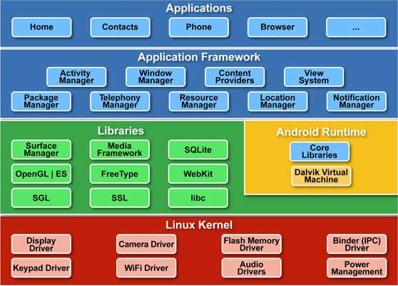
Figure 2.2 Android Architecture

Linux kernel
At the bottom of the layers is Linux - Linux 2.6 with approximately 115 patches. This provides basic system functionality like process management, memory management, device management like camera, keypad, display etc. Also, the kernel handles all the things that Linux is really good at such as networking and a vast array of device drivers, which take the pain out of interfacing to peripheral hardware.

Libraries
On top of Linux kernel there is a set of libraries including open-source Web browser engine WebKit, well known library libc, SQLite database which is a useful repository for storage and sharing of application data, libraries to play and record audio and video, SSL libraries responsible for Internet security etc.

Android Runtime
This is the third section of the architecture and available on the second layer from the bottom. This section provides a key component called Dalvik Virtual Machine which is a kind of Java Virtual Machine specially designed and optimized for Android. The Dalvik VM makes use of Linux core features like memory management and multi-threading, which is intrinsic in the Java language. The Dalvik VM enables every Android application to run in its own process, with its own instance of the Dalvik virtual machine.The Android runtime also provides a set of core libraries which enable Android application developers to write Android applications using standard Java programming language.

Application Framework
The Application Framework layer provides many higher-level services to applications in the form of Java classes. Application developers are allowed to make use of these services in their applications.

Applications
You will find all the Android application at the top layer. You will write your application to be installed on this layer only. Examples of such applications are Contacts Books, Browser, Games etc.

2.3 GOOGLE CLOUD MESSAGING (GCM)
2.3.1 OVERVIEW OF GCM
Google Cloud Messaging (GCM) is a free service that enables developers to send downstream messages (from servers to GCM-enabled client apps), and upstream messages (from the GCM-enabled client apps to servers). This could be a lightweight message telling the client app that there is new data to be fetched from the server (for instance, a "new email" notification informing the app that it is out of sync with the back end), or it could be a message containing up to 4kb of payload data (so apps like instant messaging can consume the message directly). The GCM service handles all aspects of queueing of messages and delivery to and from the target client app.
2.3.2 GCM ARCHITECTURE

1. Android device would send the sender’s ID and the application ID to GCM server for registration.
2. On successful registration, the GCM server issues a registration ID to android device.
3. After receiving registration ID, device will send it to the local server.
4. The local server will store the registration ID in the database for later use.
a. Whenever a notification is provided through the website, the server sends the message to the GCM server along with the registered ID.
b. GCM server will deliver that message to respective device using that registration ID.

The Google’s Cloud messaging platform as shown in the figure will act as the primary platform. The user will first be registering onto the GCM platform and will receive a token ID which will be stored on the server which identifies the user’s phone based on that ID. The server is where the organization will be having a PHP based web client which is going to send the notifications to individuals with respect to their registration ID or in bulk however intended

. 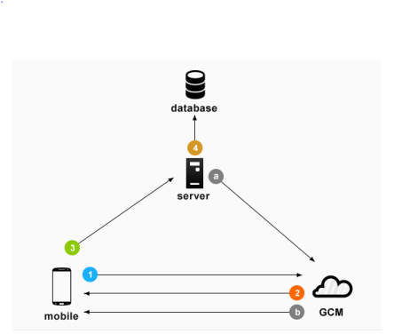
Figure 2.3 Gcm Mechanism

GCM is used as it is a client server architecture which is the most commonly and widely used architecture and is easy to implement. GCM has a feature of collapsible messages; collapsible messages are a better choice from a performance point of view, because they put less of a burden on the device battery.

Scalability implies the ability for the architecture to grow and accommodate increasing numbers of users, applications, and systems. Scalability and Extensibility refer to an application's ability to inherently support changes to the hardware and software on which it depends. Using GCM we can send messages to a single or a group of android devices simultaneously in a single transmission.

  - GOOGLE APP ENGINE

Google App Engine is a Platform as a Service (PaaS) offering that lets you build and run applications on Google’s infrastructure. App Engine applications are easy to build, easy to maintain, and easy to scale as your traffic and data storage needs change. With App Engine, there are no servers for you to maintain. You simply upload your application and it’s ready to go.

THE APP ENGINE RUNTIME ENVIRONMENT
Google App Engine supports apps written in a variety of programming languages.
- Java: Using App Engine’s Java runtime environment, you can build your application using standard Java technologies.
- Python: App Engine features a fast Python interpreter and standard Python libraries.
- PHP: App Engine uses Google's Cloud Platform services under the hood when you call standard PHP functions.
- Go: App Engine features a Go runtime environment that runs natively compiled Go code.
Google App Engine makes it easy to build and deploy an application that runs reliably even under heavy load and with large amounts of data. It includes the following features:
- Persistent storage with queries, sorting, and transactions.
- Automatic scaling and load balancing.
- Asynchronous task queues for performing work outside the scope of a request.
- Scheduled tasks for triggering events at specified times or regular intervals.
- Integration with other Google cloud services and APIs.

THE APP ENGINE DEVELOPMENT ENVIRONMENT
Software Development Kits (SDKs) for App Engine are available in all supported languages. Each SDK includes:
- All of the APIs and libraries available to App Engine.
- A simulated, secure sandbox environment, that emulates all of the App Engine services on your local computer.
- Deployment tools that allow you to upload your application to the cloud and manage different versions of your application.
The SDK manages your application locally, while the Administration Console manages your application in production. The Administration Console uses a web-based interface to create new applications, configure domain names, change which version of your application is live, examine access and error logs, and much more.

3. PROBLEM DEFINITION

3.1 APPLICATION OVERVIEW
The project is going to manage notices in different organization like colleges, companies, public places etc. that will minimize the effort of lengthy job for managing the notices in large scale organization. Wi-Fi is one of the latest technology for communication which using for transmit the data or notice information directly on the user mobile. So the person in the organization will always be updated about the circular or events. A new form of cloud-based push-styled mobile application that exploits today’s push notification services as a means of command dissemination. That creates an android application which registers itself on GCM (Google Cloud Messaging) using Google API Console which provides the platform to the push notification in web server. Whenever the server gets request it is verified by GCM and if a new update is available, it pushes the notification to the Android device
3.2 PROBLEM DESCRIPTION
During the monitoring of Information systems, Management systems, etc. it is often required that people are notified about some events and information in real time. Besides traditional notification methods such as e-mails and SMS messages, modern mobile devices and especially smartphones offer an innovative alerting mechanism: Push Notifications. Using this concept, “Campus Connect: An Android Application for Campus Notifications” intends to develop a mobile application for the college to notify its students regarding various updates.
It is a 3-level notification system within college i.e., for college, department and class. This project totally emphasizes on how a mobile app can act as an e-notice board. It can be used for classroom networking. All the relevant and required information of a classroom like assignments, records, exam dates are notified. All the important information to be passed on by the department can be posted in the form of push notification to the student’s android device.

3.3 MODULE SPECIFICATION

- Server(admin) application
    - Building a dynamic website with user friendly interface for allowing admins to be logged in to update information
    - Providing feature for the new admins to register with the application.
    - Providing an option to upload files which can be sent as a push notification.

- Google Cloud Messaging(GCM) mechanism

- Building GCM-enabled client app to receive notifications from server (admin) application via GCM server.
- Implementing an app server ("3rd-party app server") to interact with GCM connection server.
    - Registering the client app with GCM and get a registration ID.

- Android Client App
- Building a GCM enabled android client app.
- Providing a clear user interface which separates the 3 levels of notifications as specified.
- Providing a user interface for a new student to register with the application once after it is installed, and also for a registered student to login into the app.
- Maintaining the received notifications in the sqlite database which lies within the user’s device.

4. SYSTEM REQUIREMENTS
4.1 FUNCTIONAL REQUIREMENTS
The system should provide a better and an efficient way of passing the information to the students through push notifications transactions rather than the existing method of using circulars or notice boards. The system must provide the basic platforms for both admins and students to send and receive information respectively.

- Allows the new students to register with the app after installing it.
- Should store the details of the student along with the corresponding GCM registration key in the database.
- Allowing student to view all the notifications received till date in a list view.
- Allowing admins to upload files which can be sent as notifications to the respective registered students.
.
4.1.1 HARWARE REQUIREMENTS

Processor : Intel® processor with support for Intel® VT-x
Memory : 2 GB RAM
Hard Disk Space: 400 MB

4.1.2 SOFTWARE REQUIREMENTS

Operating System : Windows 7/8/8.1
Programming Language : Java, Android API
Developing Environments : Eclipse IDE (server), Android Studio (client)
Hosting Platform : Google App Engine (Paas)
Front end : HTML, CSS, JSP
Back end : Java Servlets, JavaScript, SQLite database, Cloud SQL (MySQL).

4.2 NON FUNCTIONAL REQUIREMENTS

- The application must prevent unregistered or unauthorized users from using the application.
- If anywhere wrong or irrelevant details are entered the application must prevent the control to move ahead.
- The information updated by the admins should be sent as push notifications to only the relevant students of his reachability but not to others.
- The application must be able to work efficiently in spite any number and any type of inputs.
- The application must be supported i.e., must be able to transfer notifications to the student at any location provided with internet irrespective of his/her location.
- The application must also be portable.

5. SYSTEM DESIGN

5.1 ANALYSIS

The development of a computer-based application includes a systems analysis phase which produces or enhances the data model which itself is a precursor. There are a number of different approaches to system analysis. When a computer-based application is developed, systems analysis (according to the Waterfall model) would constitute the following steps.
- The development of a feasibility study, involving determining whether a project is economically, socially, technologically and organizationally feasible.
- Conducting fact-finding measures, designed to ascertain the requirements of the system's end-users. These typically span interviews, questionnaires, or visual observations of work on the existing system.
- Gauging how the end-users would operate the system (in terms of general experience in using computer hardware or software), what the system would be used for and so on.
Another view outlines a phased approach to the process. This approach breaks systems analysis into 5 phases:
- Scope Definition
- Problem analysis
- Requirements analysis
- Logical design
- Decision analysis

5.2 Use Case Diagram
Use cases are a widely-used systems analysis modeling tool for identifying and expressing the functional requirements of a system. Each use case is a business scenario or event for which the system must provide a defined response. Use cases evolved out of object-oriented analysis; however, their use as a modeling tool has become common in many other methodologies. Here we have use case diagram for student and admin.
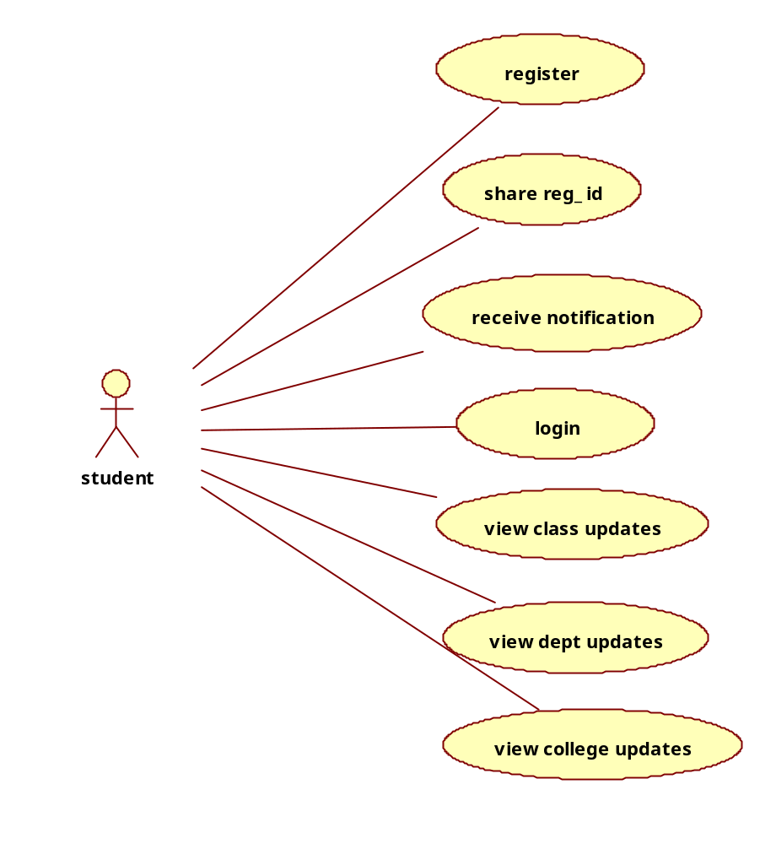
Figure 5.2.1 Use case Diagram for Student(Client)

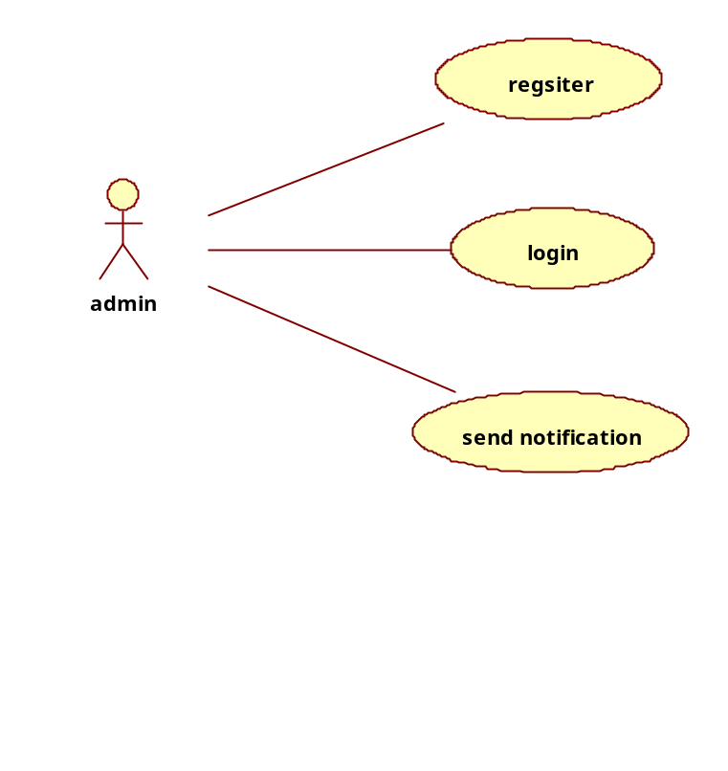
Figure 5.2.2 Use-case Diagram for Admin

5.3 Activity Diagram
The activity diagram shows the flow of interaction or sequence of interaction of the application.Firstly student must install the application and then register with the gcm.Then the details are sent to server. After registering, the student receives the notification if sent by admin. Student can check previous notifications by getting login into application. Admin login into server and sends notification.
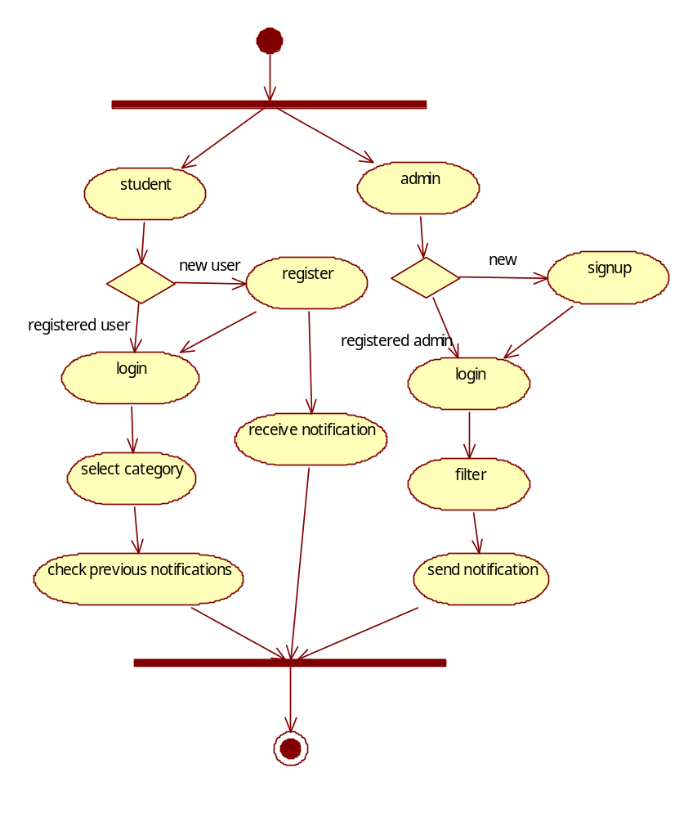
Figure 5.3 Activity Diagram

5.4 Class Diagram
The class diagram is a static diagram. It represents the static view of an application. Class diagram is not only used for visualizing, describing and documenting different aspects of a system but also for constructing executable code of the software application.Campus connect has various classes like student,gcm,server,admin.
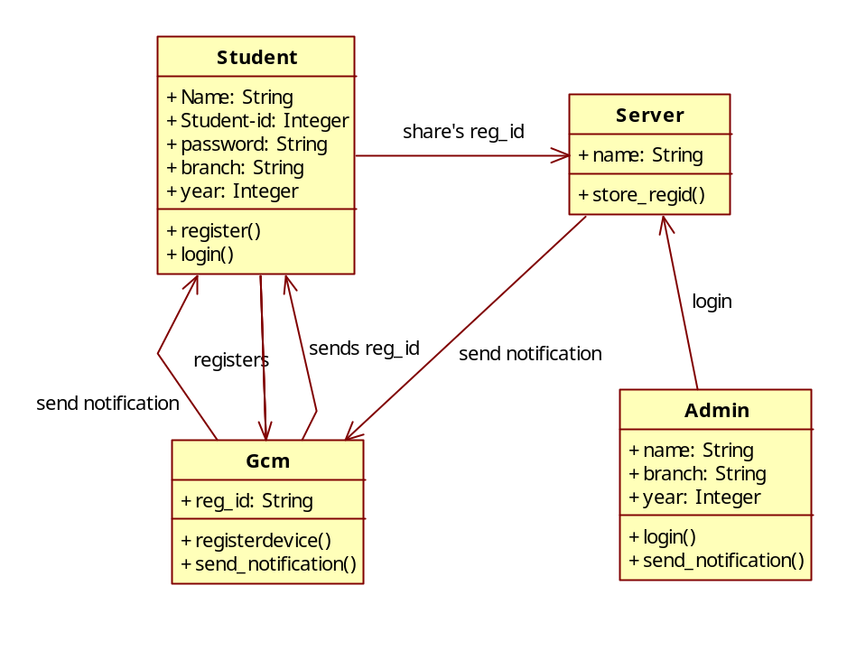
Figure 5.4 Class Diagram

5.5 Sequence Diagram
The purposes of interaction diagrams are to visualize the interactive behaviour of the system. Sequence and collaboration diagrams are the interaction diagrams.Sequence diagrams gives the time ordering of messages.
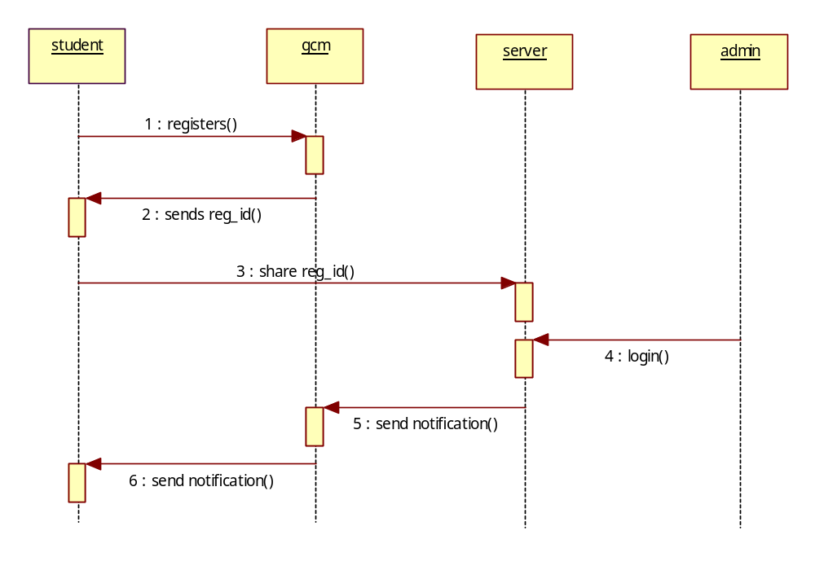
Figure 5.5 Sequence Diagram

5.6 Component Diagram
Component diagrams can also be described as a static implementation view of a system. Static implementation represents the organization of the components at a particular moment. This project includes various components like student, server, GCM API,notifications database, students database ,admin database.

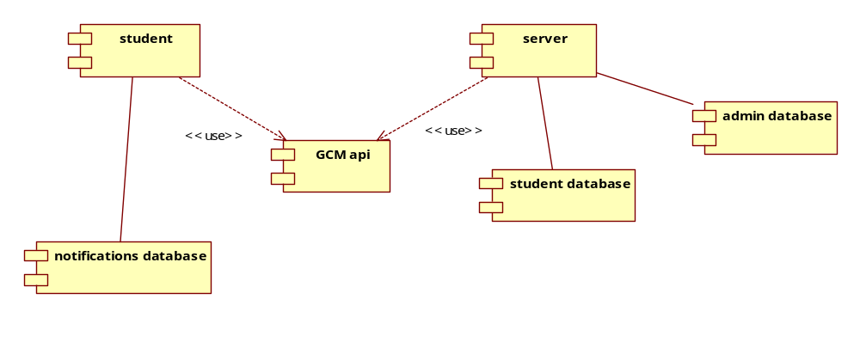

Figure 5.6 Component Diagram

5.7 Deployment Diagram
Deployment diagrams are used to visualize the topology of the physical components of a system where the software components are deployed.So deployment diagrams are used to describe the static deployment view of a system. Deployment diagrams consist of nodes and their relationships.This project includes various nodes like student,server,gcm,notification database,student database.admin database.
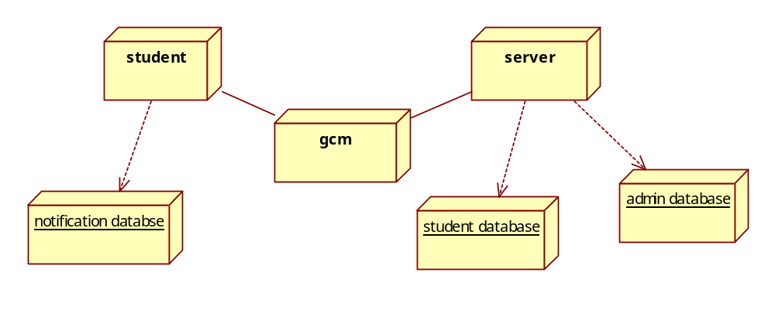
Figure 5.7 Deployment diagram

6. IMPLEMENTATION AND SCREENSHOTS

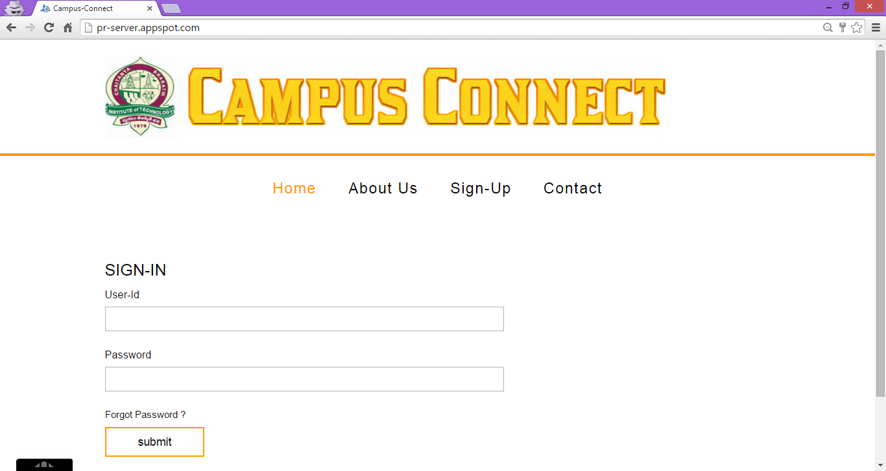

Figure 6.1 Home page of server module

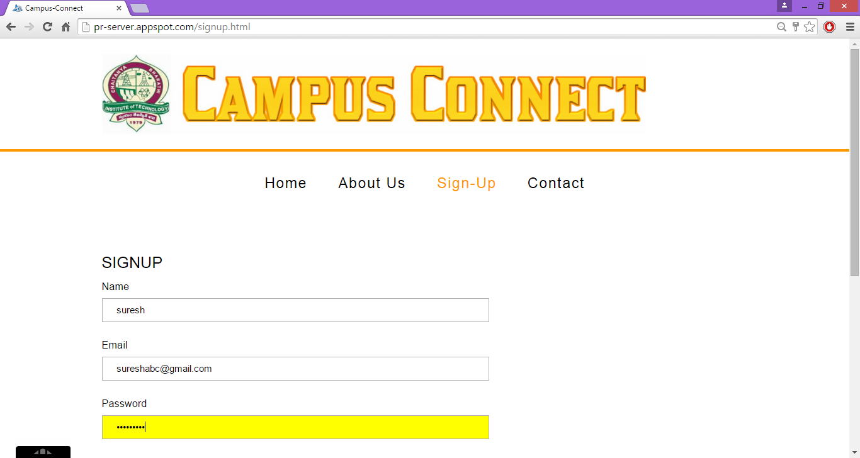

Figure 6.2 sign-up pages for the new admins to register

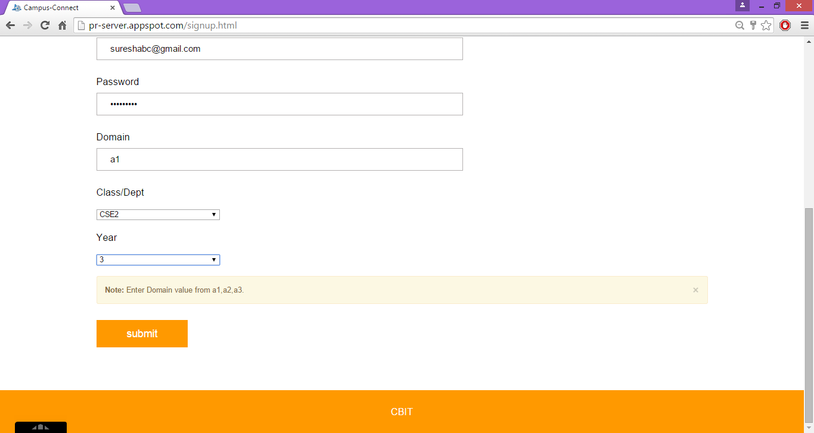

Figure 6.3 Admins choosing domain among a1,a2,a3 which represents class,dept,college respectively

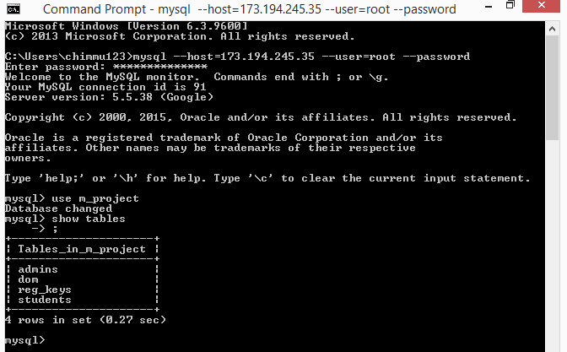

Figure 6.4 Database tables

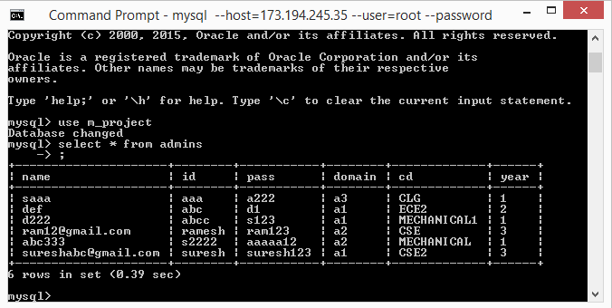
Figure 6.5 Admins table containing login details and their domain details i.e., details about the class/dept or college

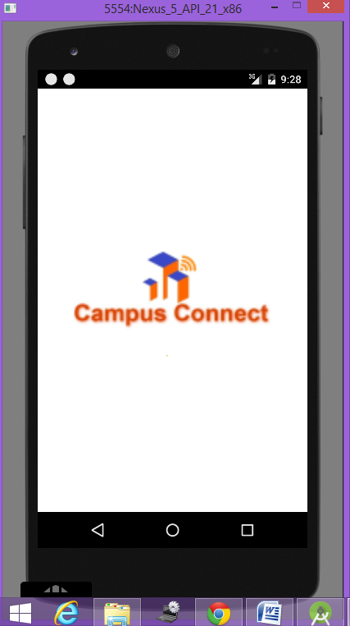

Figure 6.6 Launch screen of the campus connect app also known as splash screen

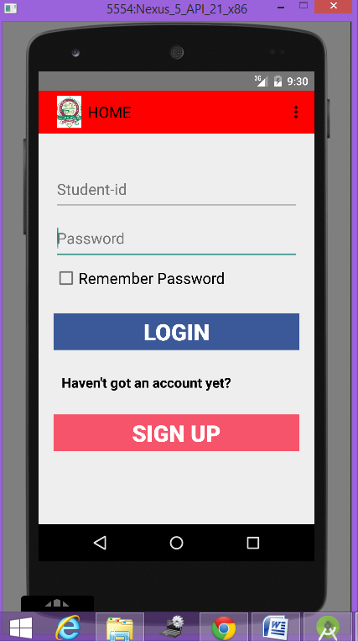
Figure 6.7 Login page of the app, showing options to enter login details, remember password for registered students and signup button for new students

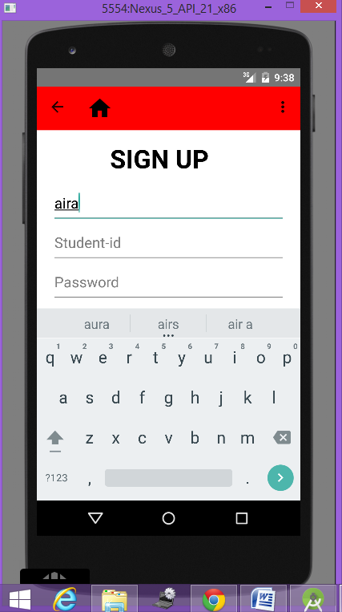

Figure 6.8 Student registering with her college identity details

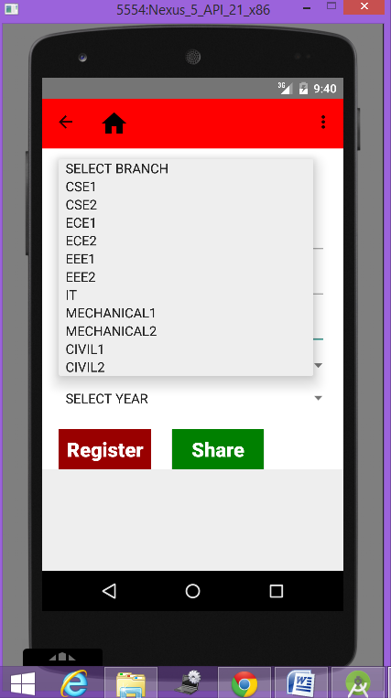

Figure 6.9 Student choosing the class among the options provided in the dropdown

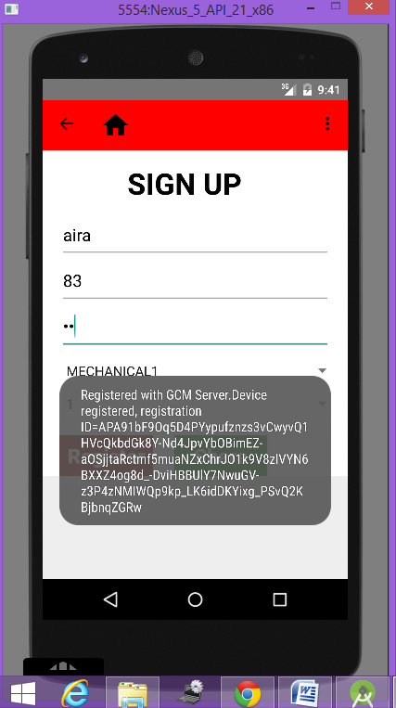

Figure 6.10 After filling the details, on clicking register the device gets registered with the google’s gcm server and in turn returns the device’s unique registration key

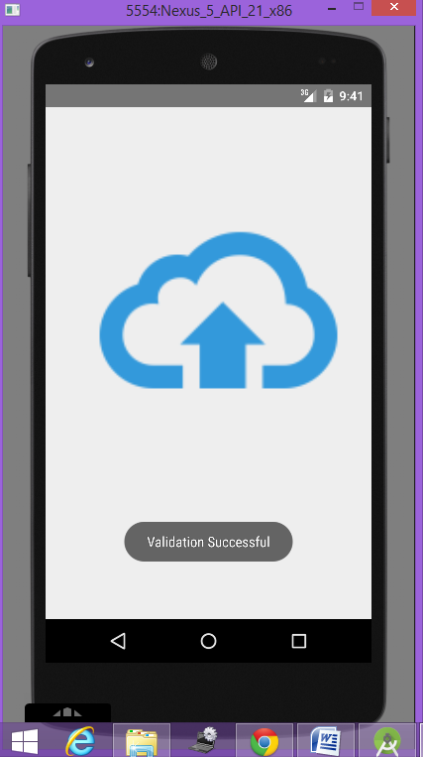

Figure 6.11 Now after register, on clicking share, the details of the student along with the registration key returned by gcm server are store in the database which reside in cloud

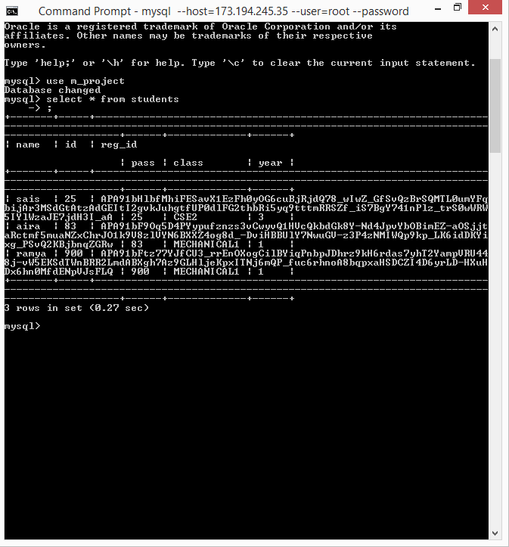

Figure 6.12 Students table containing the identity details of the student along with his/her registration key of the device

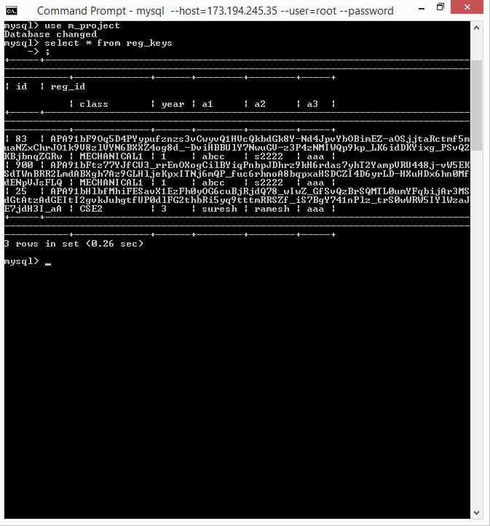

Figure 6.13 Reg_keys table containing the registration keys along with the student id related to it and also the corresponding admin related to the student.

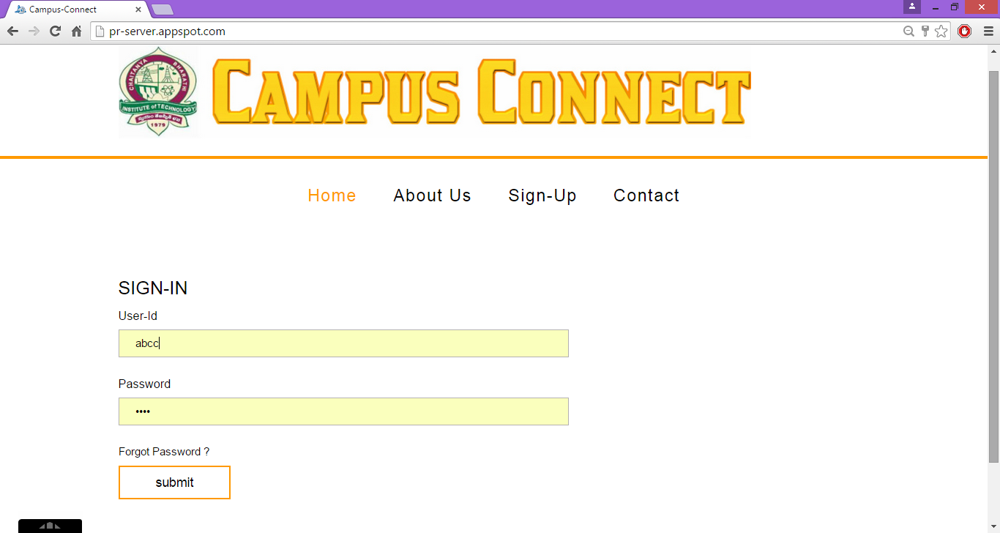

Figure 6.14 Now admin logging in at server module to send an information to the students

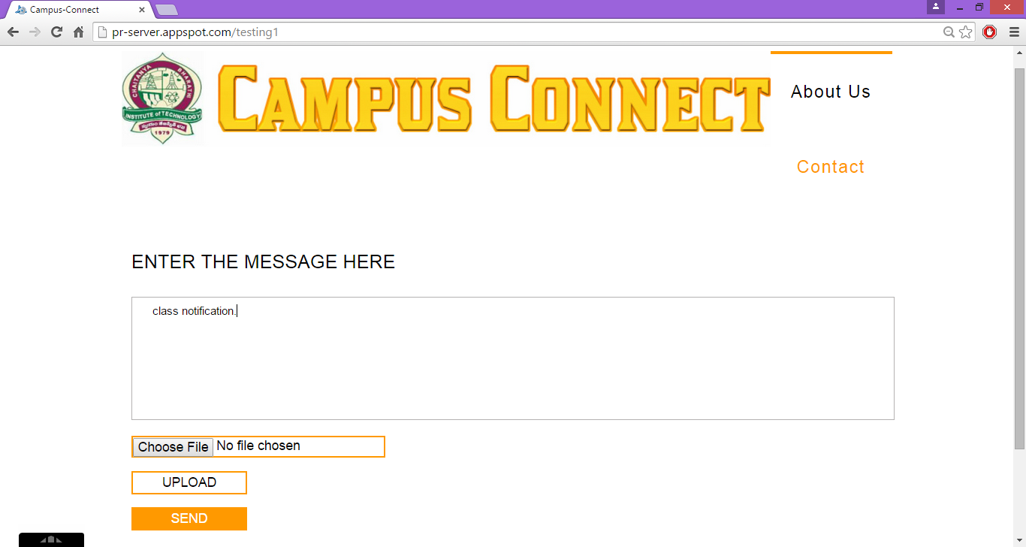

Figure 6.15 after the verification of login details, the message page open where the admin can enter the message that he/she wants to send as a notification

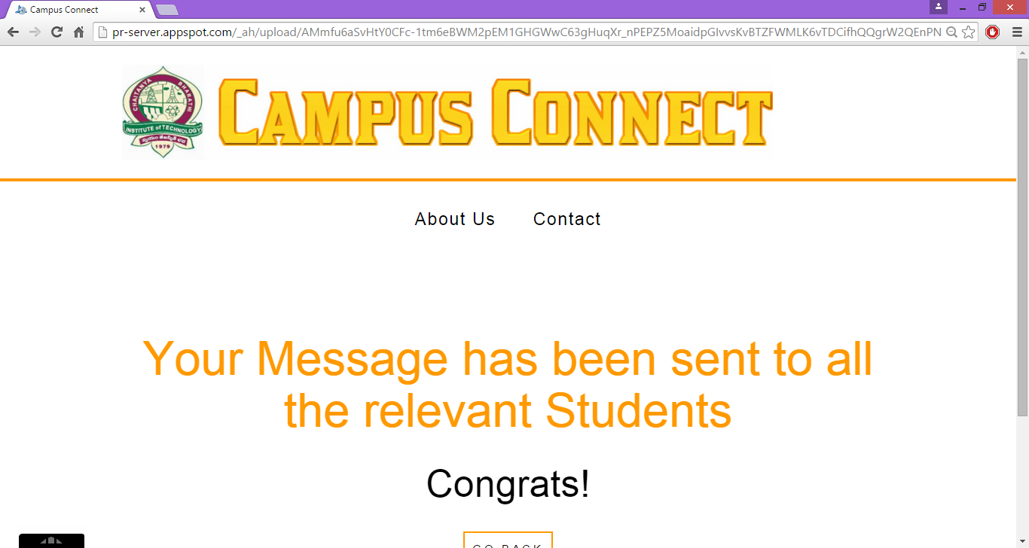

Figure 6.16 after completion of entering the message in the text area, on pressing send, the message will be sent to all respective students

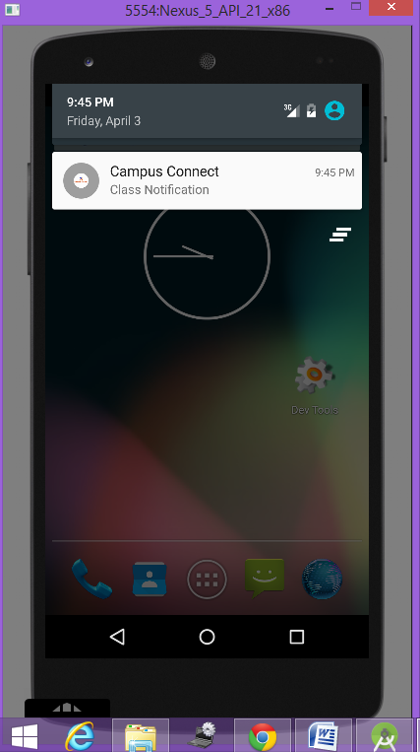

Figure 6.17 Notification from the class admin

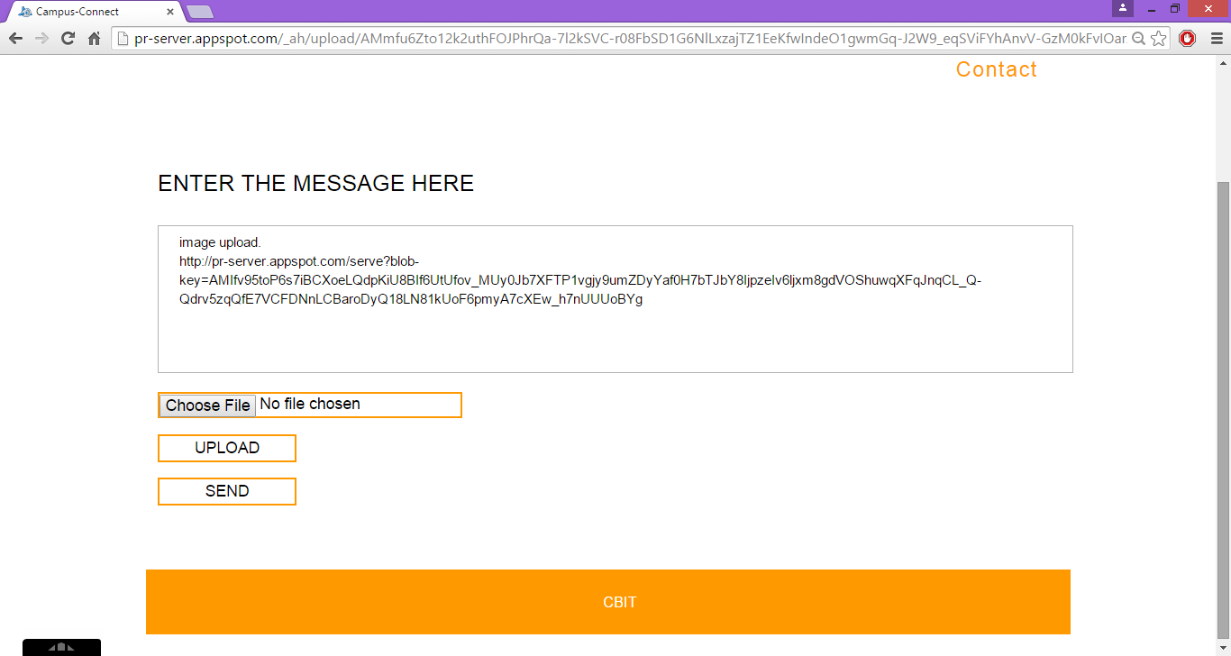

Figure 6.18 the admin can even upload files which are to be sent as notifications. Once after choosing the file, on pressing upload button a unique link is appended to the message entered and later on pressing send, the notification is sent to respective students

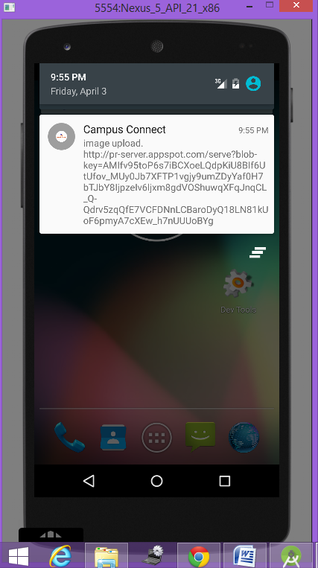

Figure 6.19 Notification containing the link of the file uploaded at server by admin

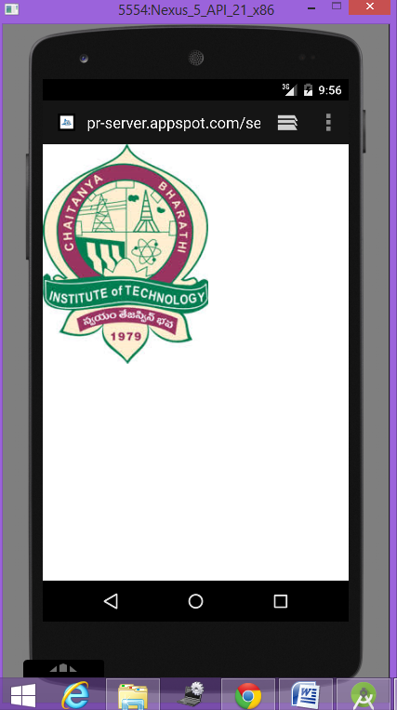

Figure 6.20 on clicking the link received in notification, based on the file uploaded, the content either open in a browser or is downloaded into the mobile

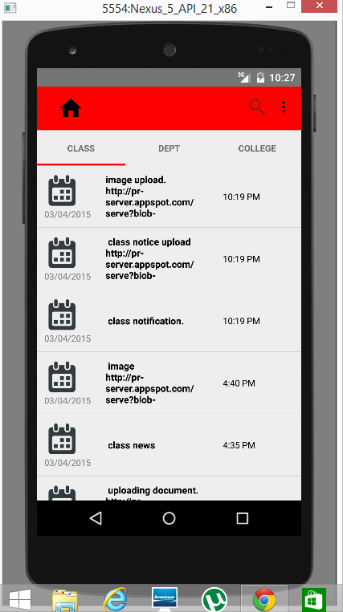

Figure 6.21 Class tab of the app, displaying the list view of all the class related notifications till date in the descending order

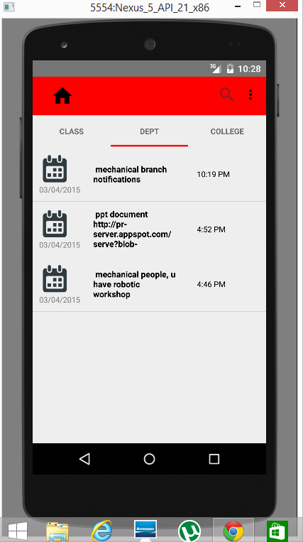

Figure 6.22 department tab of the app, displaying the list view of all the dept related notifications till date in the descending order

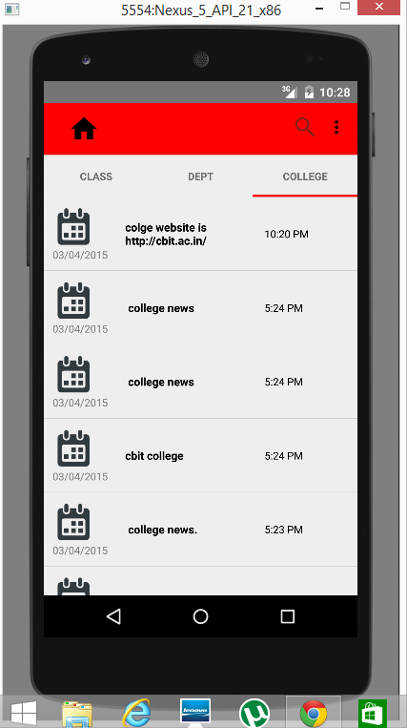

Figure 6.23 College tab of the app, displaying the list view of all the college related notifications till date in the descending order

7. CONCLUSION

This android application is simple to use and can be even used by native users. As stated earlier Campus Connect’s main idea is to demonstrate how an android app can be used as an e-notice board. Using the services provided by the Cloud, the technology can be applied to solve many obstacles faced by the institutions and organizations while giving out any updates, by creating an efficient and reliable application on any mobile platform so that the end user remains updated on the latest news regarding their respective organizations. Push notifications save time and helps to get the information required, quickly after it was published. In addition, the server module which is being run in cloud (Google App Engine), allows the admins to pass the information to the students irrespective of their location, but just provided with internet. It provides students to stay updated with information consistently. Since all the databases are maintained in the cloud (Cloud SQL), the various details of students and their corresponding device GCM registration IDs are securely stored without any risks. The android client app allows the students to review the previous information (Notifications) which was received to his/her device through a convenient user-interface i.e., the user can clearly view all his/her previous notifications of class, department and college in separate respective sections. This application is a need of the hour as it allows users to stay updated in real time.
Limitations
Now for sending notifications to the devices, Google Cloud Messaging mechanism is being used which does not always guarantee the delivery of notifications. GCM is not suitable for time sensitive and/or “must-deliver-to-all” application scenarios. Furthermore, the GCM message arrival latency is unpredictable, namely having a reliable connection to Google’s GCM servers on the client device does not by itself guarantee a timely message arrival.
Future Work
This project can be further improved by making certain changes like, as of now Google’s GCM mechanism is being used to send the notifications to the client devices, in the place of it, a dedicated server can be implemented at the client app side in order to keep checking for the data., which will surely guarantee the delivery of information as notifications and overcome the arrival latency problem of Google Cloud Messaging.

REFERENCES

[1] Herbert Schildt, The Complete Reference JAVA, Tata McGraw-Hill Edition,2007
[2]http://ieeexplore.ieee.org/xpl/login.jsp?tp=&arnumber=6228693&url=http%3A%2F%2Fieeexplore.ieee.org%2Fxpls%2Fabs_all.jsp%3Farnumber%3D6228693
[2] Big Java by Cay Horstmann, John Wiley and Sons, 2nd Edition
[3] https://developers.google.com/eclipse/docs/install-eclipse-4.4
[4] http://romannurik.github.io/AndroidAssetStudio/index.html
[5] Beginning in Java 2 by Iver Horton, Wrox Publications.
[6] https://developer.android.com/google/gcm/index.html
[7] http://www.android4devs.com/2015/01/how-to-make-material-design-sliding-tabs.html
[8] http://stackoverflow.com/questions/21093170/table-has-no-column-named
[9] http://hmkcode.com/android-simple-sqlite-database-tutorial/
[10] http://www.roseindia.net/jsp/
[11] http://w3layouts.com/
[12]http://www.developer.com/ws/android/development-tools/getting-started-with-googles-android-studio.html
[13] https://developer.android.com/design/patterns/navigation.html
[14]http://stackoverflow.com/questions/14675539/how-to-store-the-gcm-push-notification-message-into-sqlite-database

