**IMDB Movies**

1. **Swagger documentation**

**GET: swagger/**

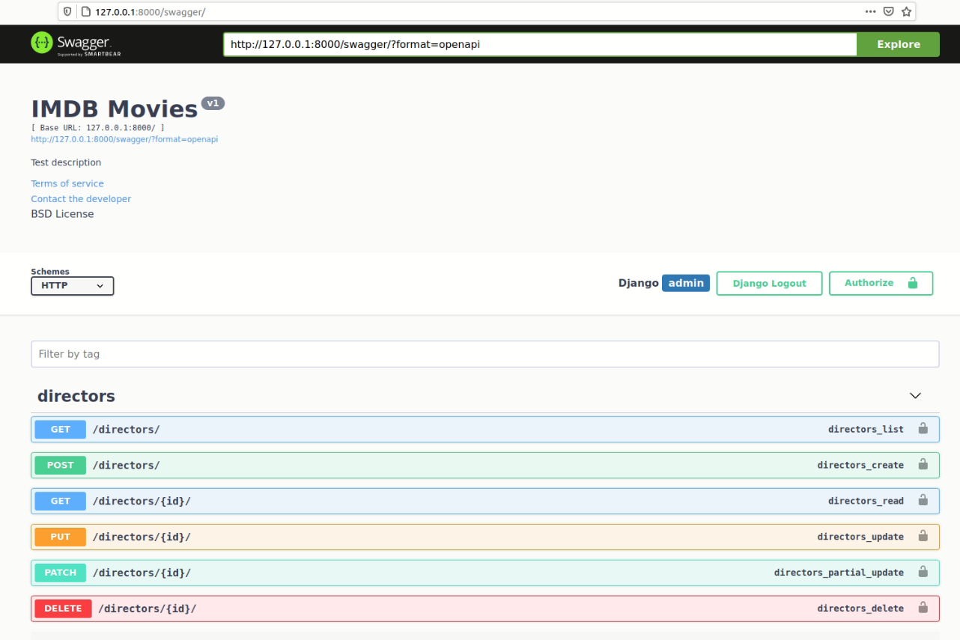

As I have implemented Token Authentication, swagger doesn’t allow

1. **Sign Up**

POST: signup/

Arguments required: username, password1, password2

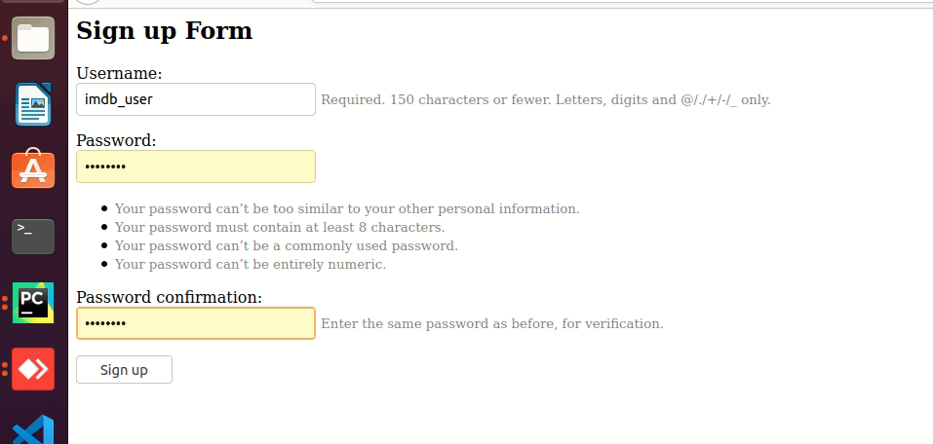

Response:

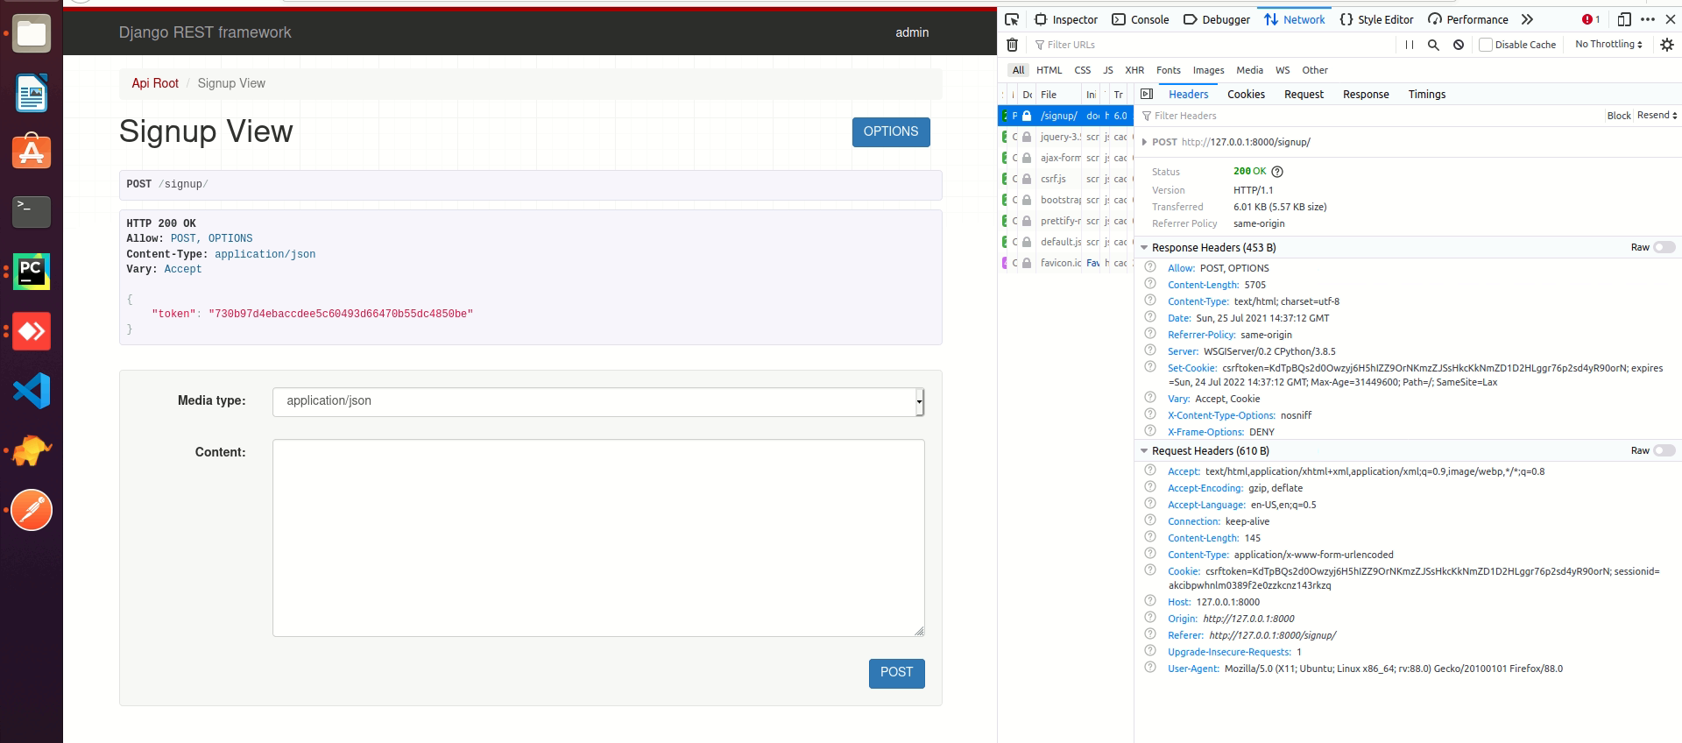

1. **Login:**

**POST: login/**

Arguments: username, password

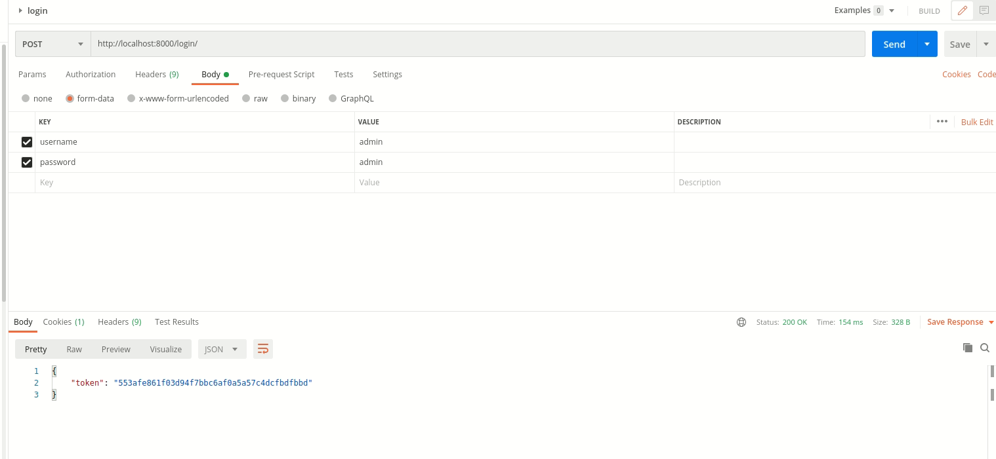

1. **Directors:**

Get all Directors:

GET: directors/

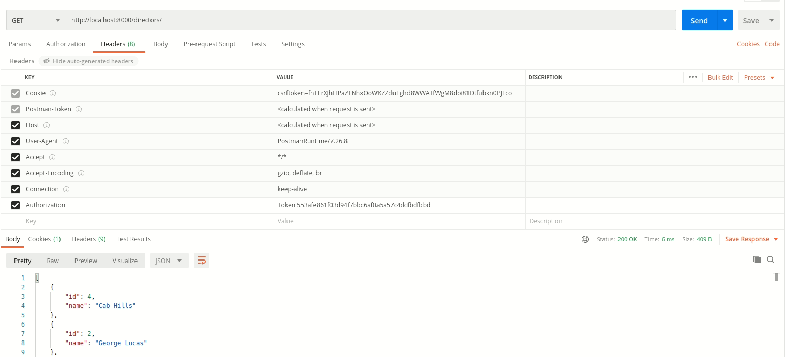

Token generated while login shall be used for every API hit.

POST: directors/

Arguments: name

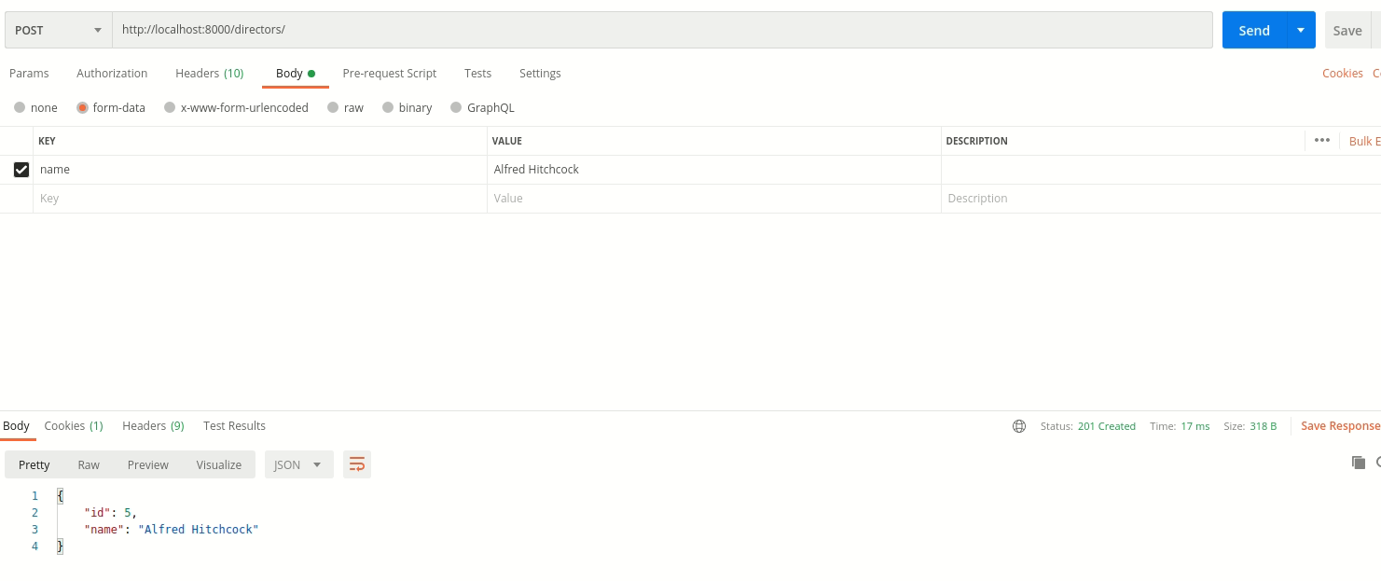

PUT:

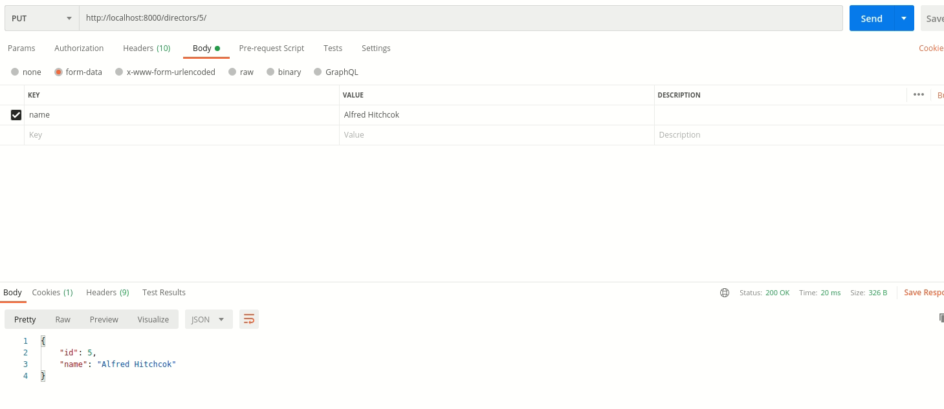

DELETE:

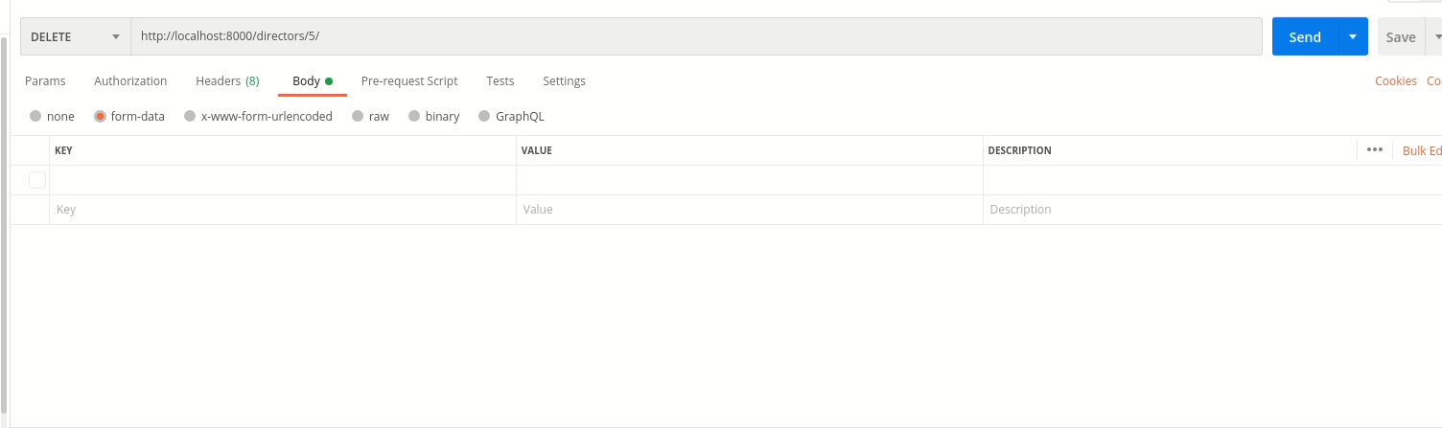

1. **Genres**

Genres can be used similar to directors. One example of GET is below:

GET: genres/

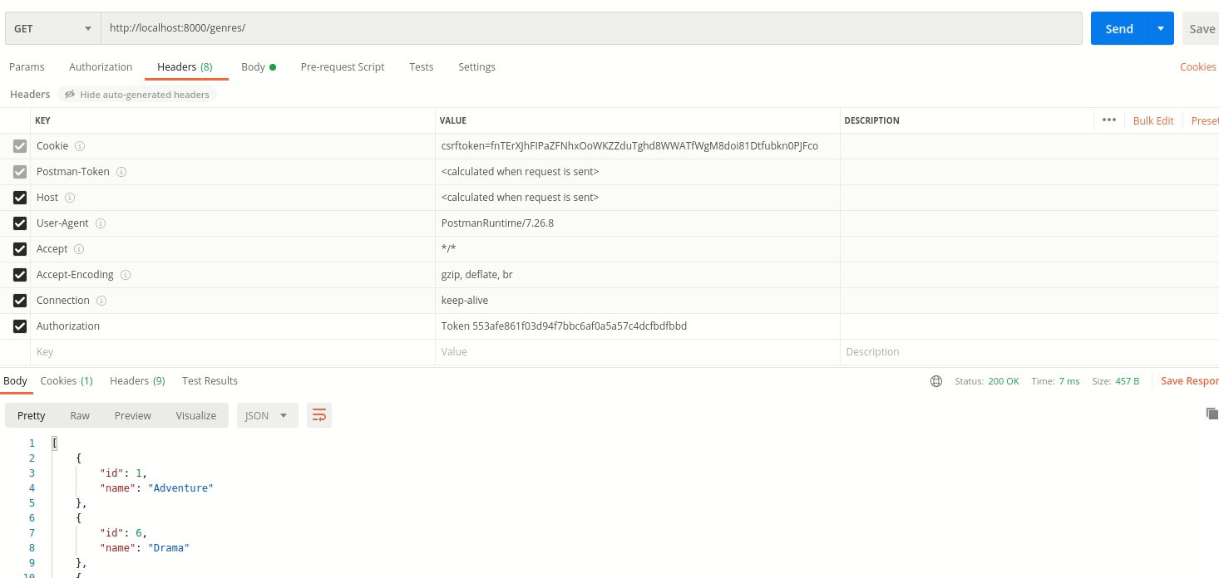

1. **Movies:**

**GET: movies/**

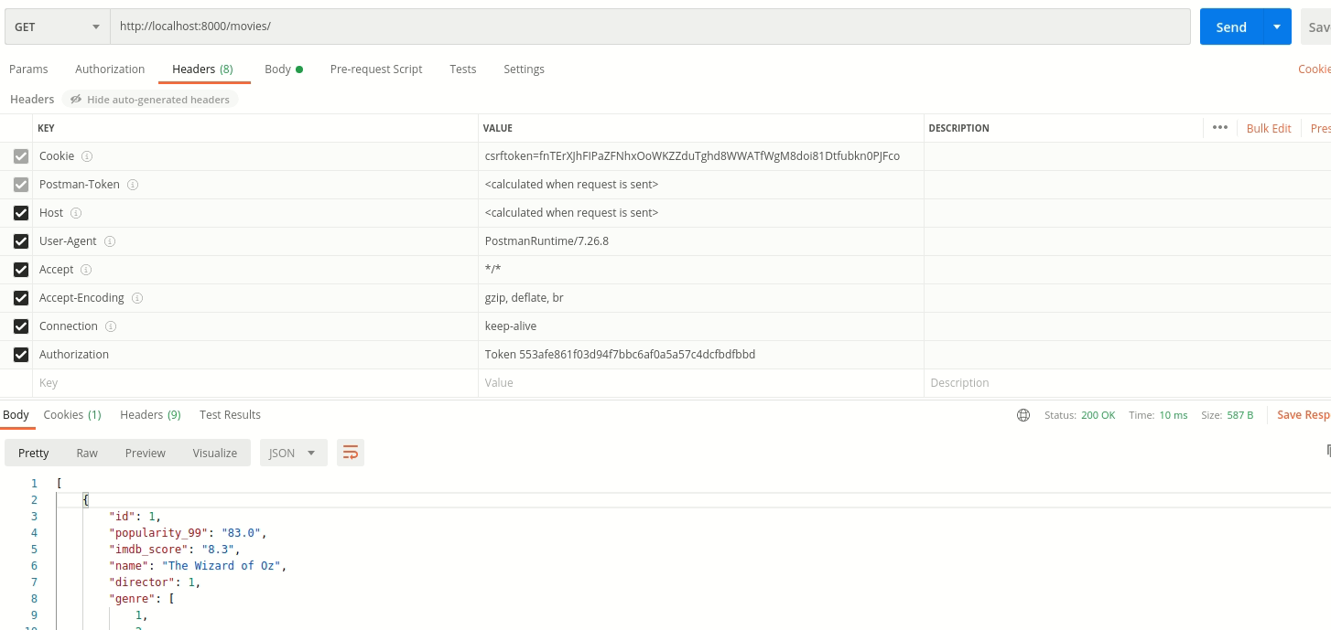

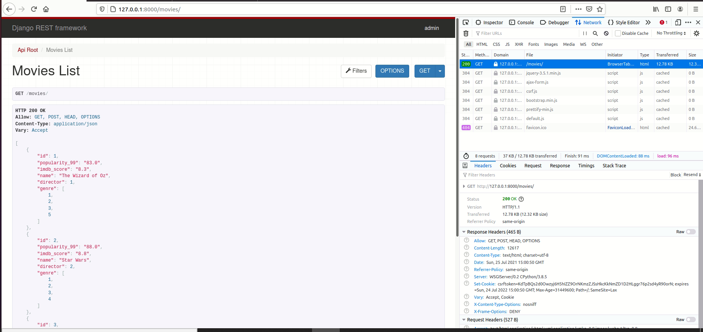

POST: movies/

Arguments: popularity_99, imdb_score, name, director, genre

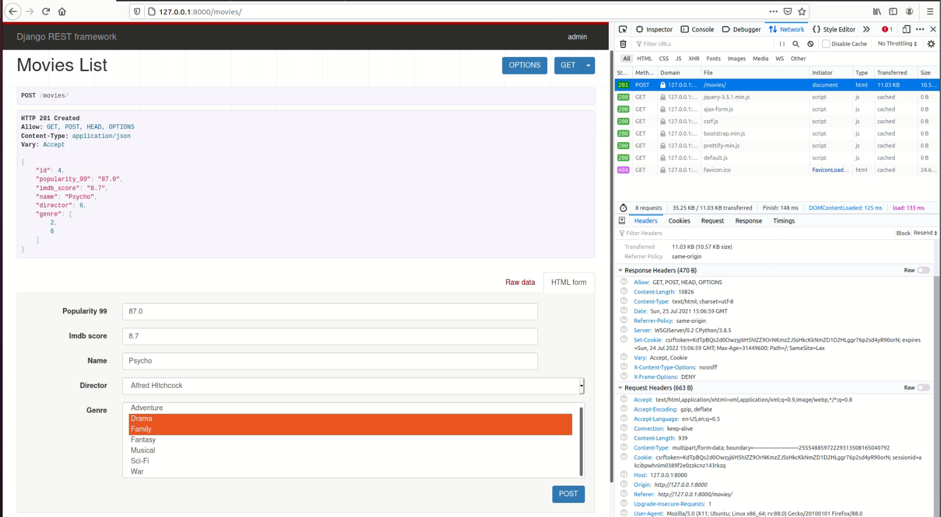

**Search**:

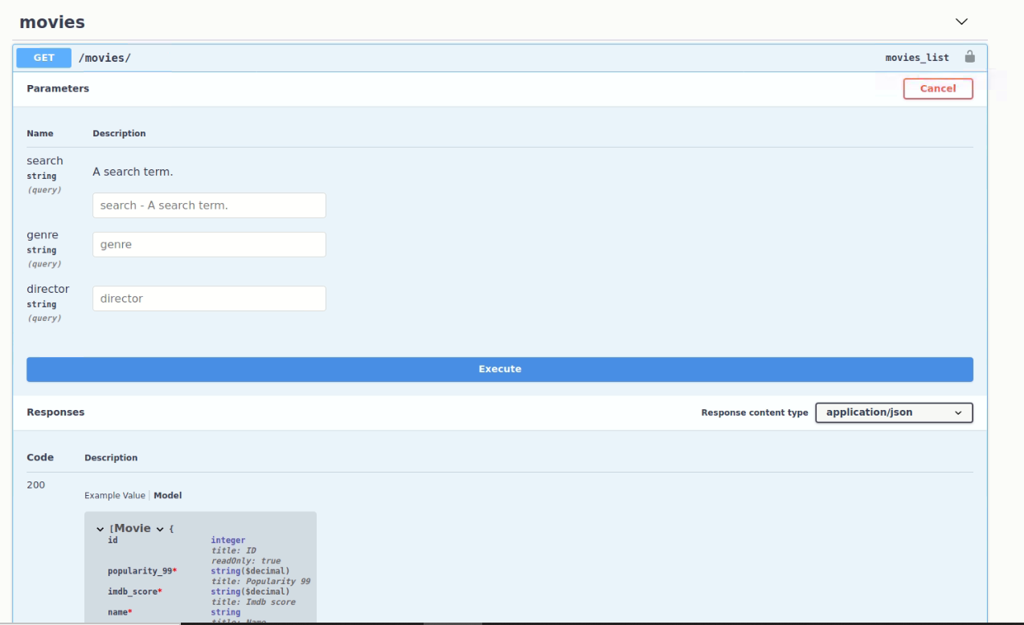

The API will get all the movies with search tag in either movie name or director’s name.

GET: movies/

Argument: search

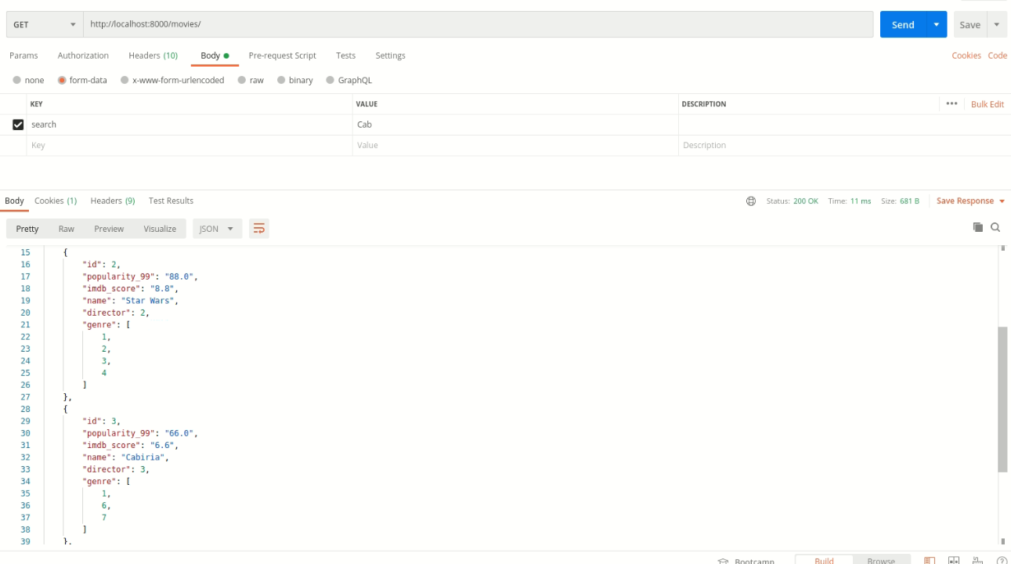

**Filter:**

One can search movies based on filter by genre/director.

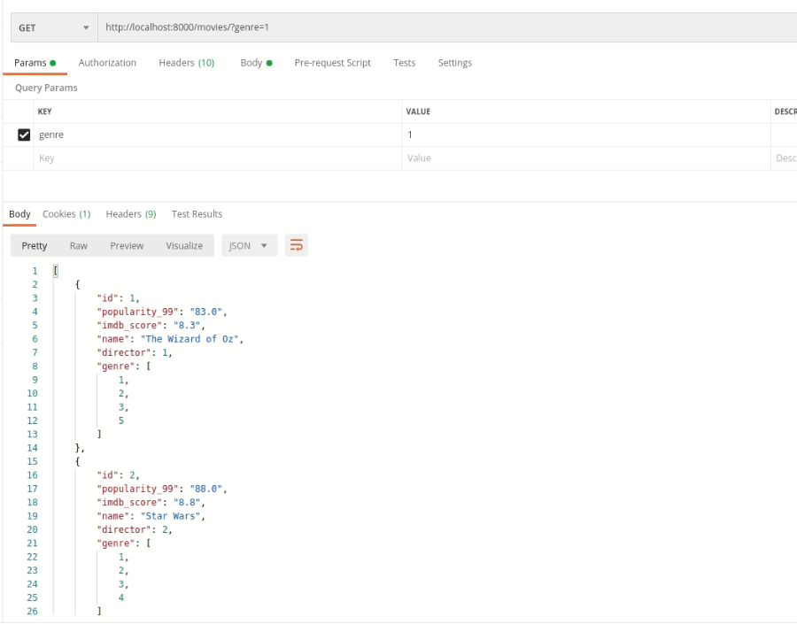

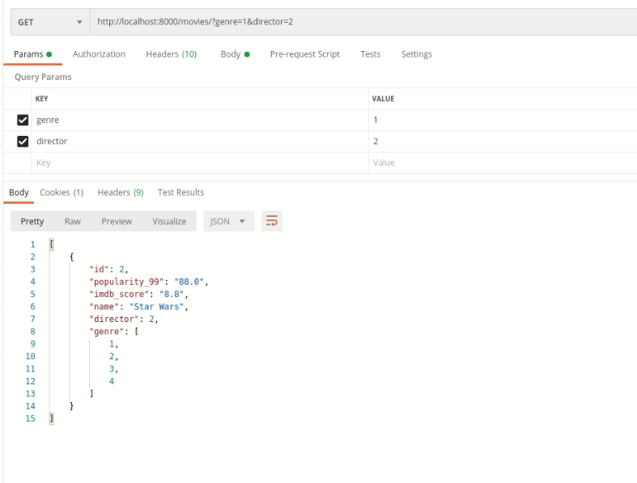

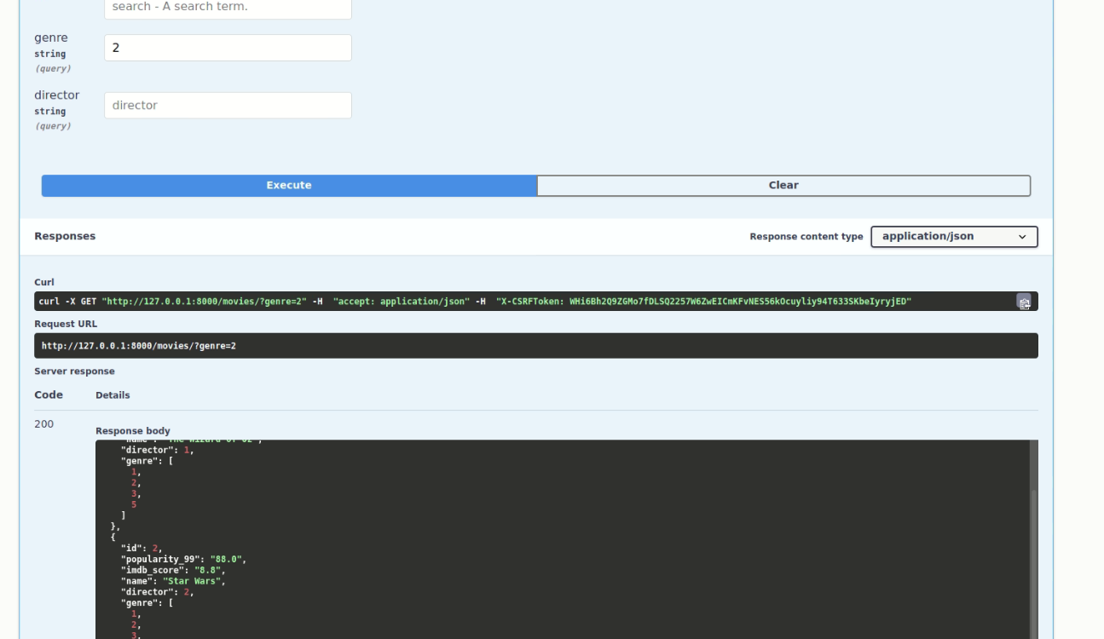

1. **Groups:**

Login using any admin and then go to admin panel using below URL. There you can navigate to groups where one can view the list of groups.

One can also update user’s group here.

**admin/**

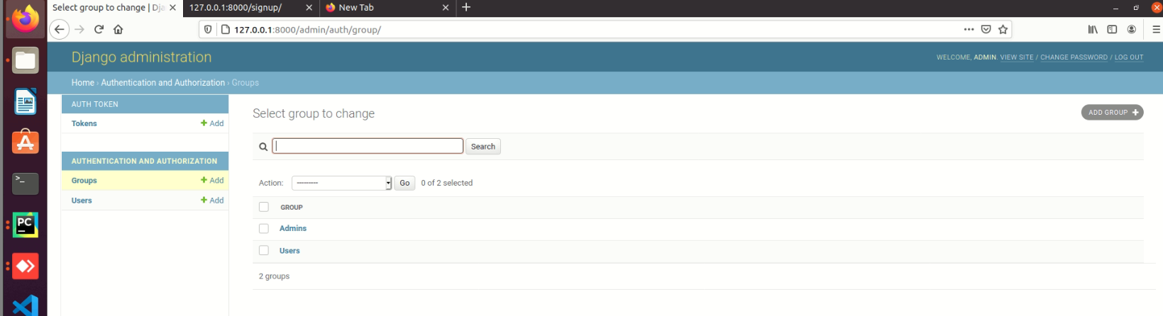

**Permission of each group:**

Permission of each group can be viewed by clicking on the group.

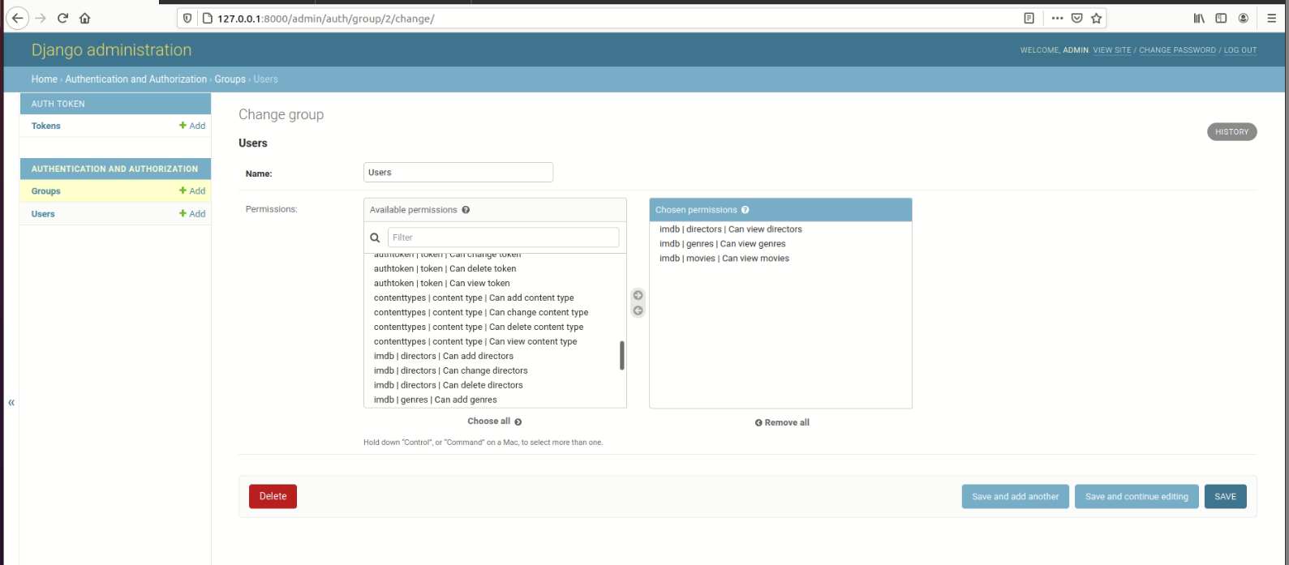

When a user tries to post a director, (s)he gets the below message.

