NZTA Deregistered VIN – User Guide

PROCESS OVERVIEW
The user receives the deregistration CSV file from NZTA via email and uploads it to the ftp.hyundai.co.nz server. The automated 4 AM and 6 AM background jobs validate the file, stage the records in BigQuery, and update Vehicle Status and deregistration dates in SugarCRM.

1. Upload Deregistration Files to Hyundai FTP
The screenshot below shows how to upload the NZTA deregistration CSV file to the Hyundai FTP server using WinSCP. The highlighted red boxes indicate key elements:
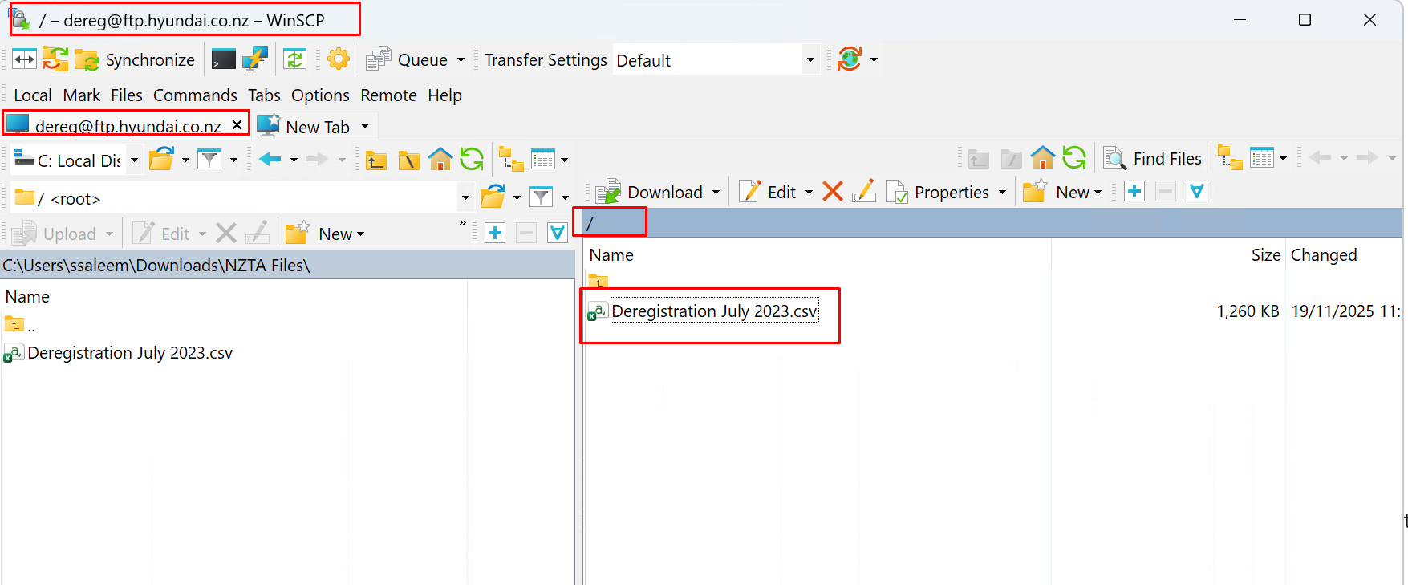
- **FTP Address Bar**: Shows you are connected to `dereg@ftp.hyundai.co.nz`.
- **Root Directory (`/`)**: Confirms you are in the correct FTP folder where NZTA files will be uploaded.
- **CSV File (Deregistration July 2023.csv)**: The file must be a csv.

2. Successful Ingest Email Notification
This email indicates that the NZTA deregistered VIN file ingest has successfully completed.
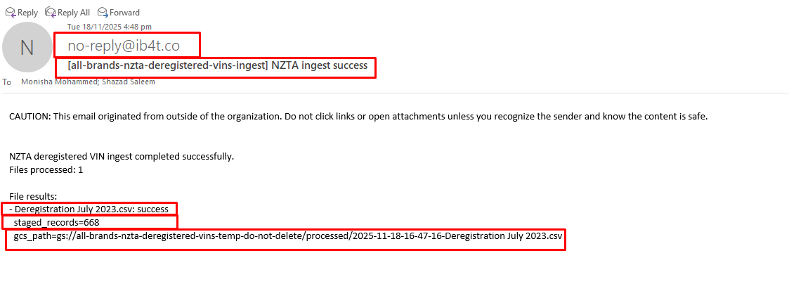
Explanation of highlighted areas:
- **Sender Address (`no-reply@ib4t.co`)**: Automated system email from the ingest job.
- **Subject Line**: Confirms the process: `[all-brands-nzta-deregistered-vins-ingest] NZTA ingest success`.
- **Filename**: The CSV file that was successfully processed.
- **Staged Records**: Shows how many rows were successfully loaded into BigQuery.
- **GCS Path**: The exact location where the file has been moved after processing.

3. Failed Ingest Email – Header Validation Error
This email is received when the CSV file does not meet the expected header format. The ingestion process stops and sends this alert.
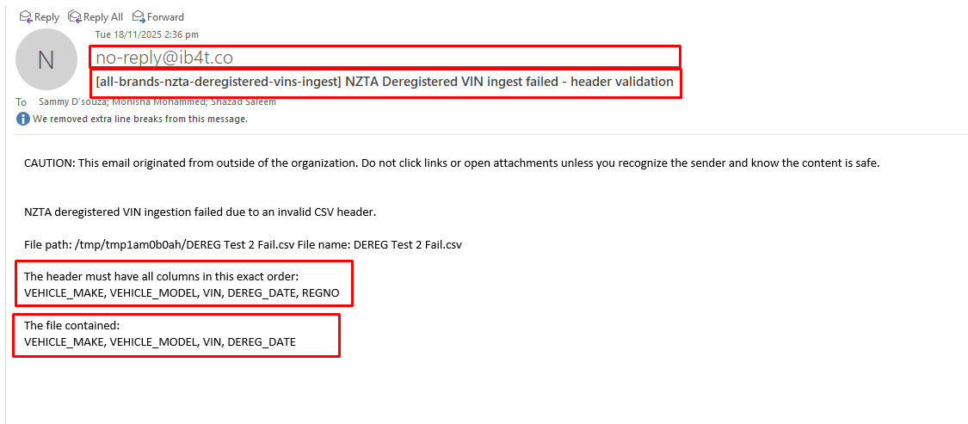
Explanation:
- **Subject Line**: Indicates ingest failure due to header validation.
- **Expected Header**: The required order of columns: `VEHICLE_MAKE, VEHICLE_MODEL, VIN, DEREG_DATE, REGNO`.
- **Actual Header Found**: The file was missing the `REGNO` column, causing the failure.
- **Action**: Fix the CSV header and re-upload.

4. No Files Found During Ingest
This email notification appears when the ingest process runs successfully but no files are found on the FTP server that match the configured pattern. This usually happens when the user has not yet uploaded the CSV file to the FTP location.
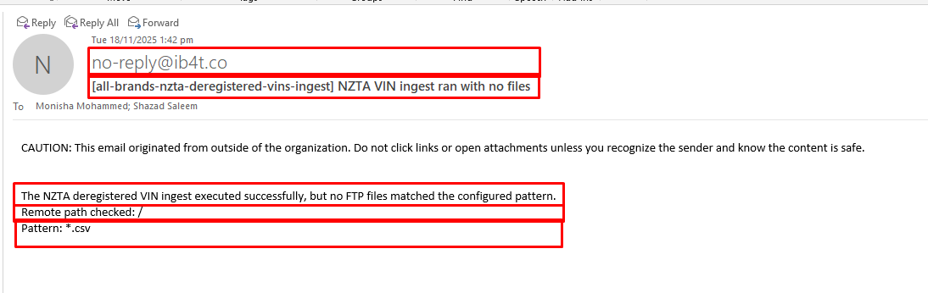
Explanation of highlighted areas:
- **Subject Line**: Indicates the ingest job ran but found no matching files.
- **Message Body**: Confirms the system checked the FTP directory but did not detect any `.csv` files.
- **Remote Path Checked (`/`)**: Shows the FTP directory scanned. Ensure your file is uploaded here.
- **Pattern (`*.csv`)**: Only files matching this extension will be processed.
⚠️ **Important**: Users must upload the deregistration CSV file from their local machine to the FTP directory before the scheduled ingest time.

5. Viewing Deregistered VINs in SugarCRM – List View
Once the Sync job processes deregistered VINs, the updates become visible in SugarCRM. The list view allows you to quickly see all deregistered vehicles and their updated statuses.
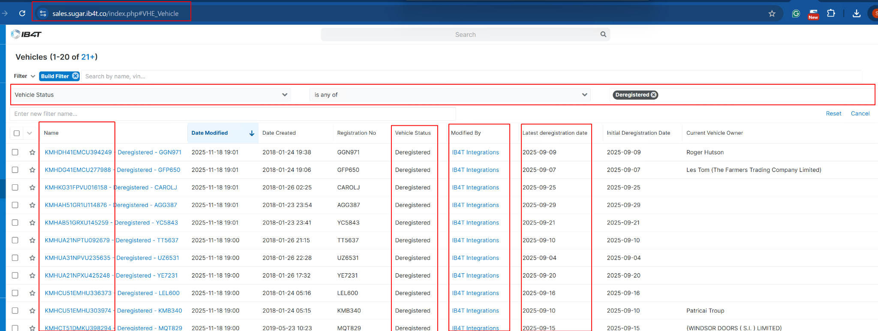
Explanation of key highlighted areas:
- **URL bar**: Confirms you are viewing the Vehicle module inside SugarCRM.
- **Filter Section**: The filter is set to show only vehicles where the Vehicle Status is *Deregistered*.
- **Name Column (VIN)**: Each record shows the VIN alongside its deregistered registration number.
- **Vehicle Status Column**: Displays the updated status `Deregistered` pushed from the Sync service.
- **Modified By Column**: Shows that the update was performed by `IB4T Integrations`, confirming automation.
- **Latest Deregistration Date**: Pulled from the NZTA file and stored in SugarCRM.

6. Viewing a Single Deregistered Vehicle Record
By clicking on any VIN from the list view, you will enter the detailed record view. This page shows full vehicle information including the deregistration status applied by the Sync job.
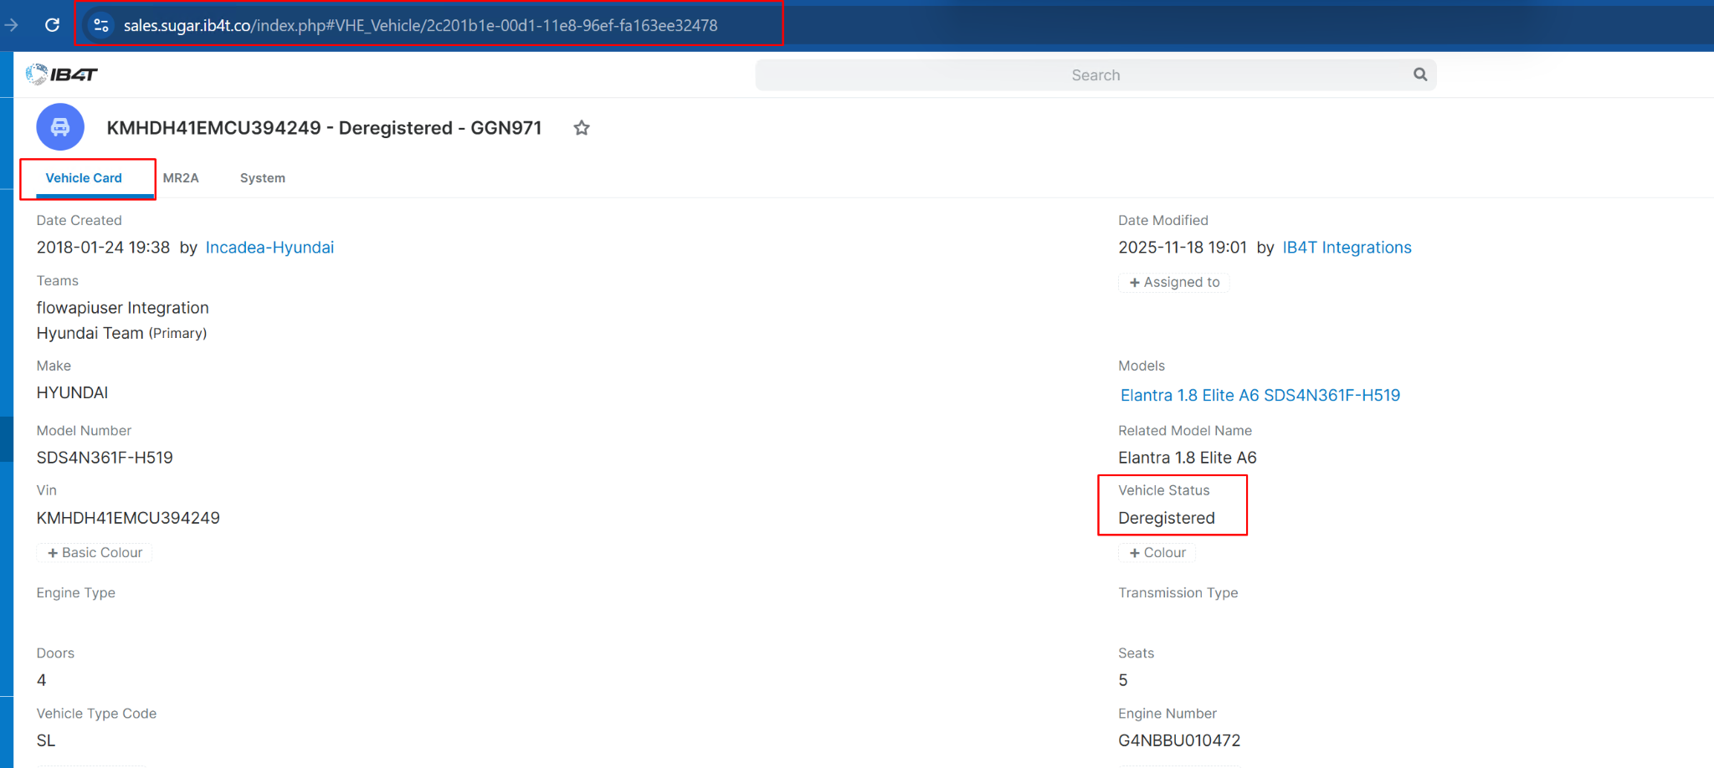
Highlighted areas explained:
- **Vehicle Card Tab**: Confirms you are in the main overview tab of the vehicle.
- **Vehicle Status Field**: Displays `Deregistered`, updated from the NZTA Sync process.
- **URL bar**: Confirms which record you're viewing using the unique SugarCRM record ID.

7. Checking Deregistration Dates in System Tab
The ‘System’ tab contains system-controlled values such as the initial and latest deregistration dates. These fields are updated automatically based on NZTA file data.
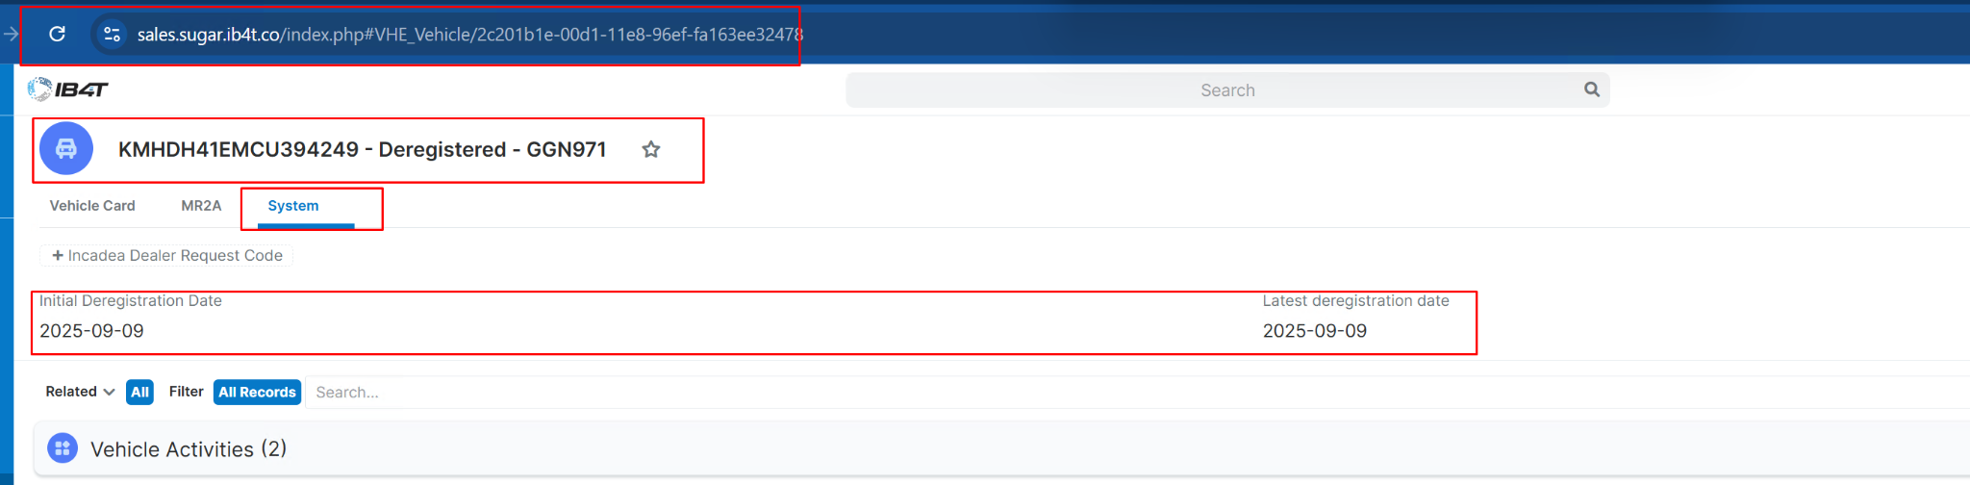
Explanation of highlighted regions:
- **System Tab**: Selected to display the backend/system-driven fields.
- **Initial Deregistration Date**: The first deregistration date ever recorded for the vehicle.
- **Latest Deregistration Date**: The most recent deregistration value processed from NZTA.
- These fields confirm that the Sync service correctly applied the deregistration updates to SugarCRM.

9. Sync Failure Notification Email
When the Sync process encounters issues updating VINs in SugarCRM, a failure summary email is sent. This email highlights how many records were processed, how many succeeded, and which VINs failed.
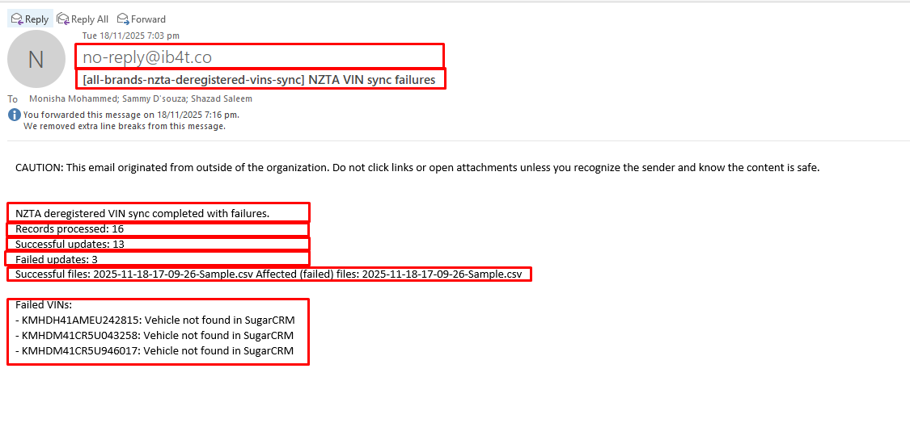
Explanation of highlighted areas:
- **Sender Address (`no-reply@ib4t.co`)**: Automated system notification.
- **Subject Line**: Indicates the sync encountered failures.
- **Records Processed**: Total rows read from BigQuery staging.
- **Successful Updates**: Number of VINs successfully updated in SugarCRM.
- **Failed Updates**: Number of VINs that could not be matched or updated.
- **Failed VINs Section**: Shows specific VINs that were not found in SugarCRM. These may be missing, incorrectly recorded, or not yet created in the system.
- **Affected File Reference**: The source CSV file that contained the failed VINs.

