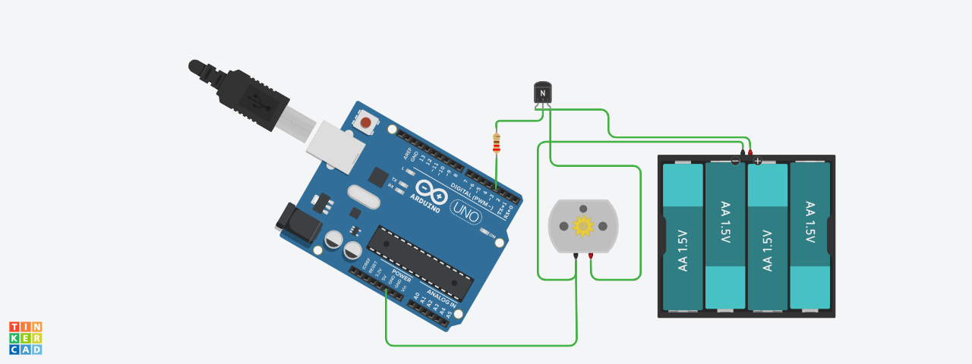

int pwmpin =3;

int val = 200;

void setup()

{

Serial.begin(9600);

}

void loop()

{

analogWrite(pwmpin, val);

}