**Introduction & Background:**

Over $2 billion has been raised using the massively successful crowdfunding service, Kickstarter, but not only 30 % of the projects found success by exceeding their initial goal. We will be looking at the past 4000 projects to discover some insights to finding success.

**Limitations of the Data:**

The data is heavily weighted by the US 74% and UK 15%. It is also heavily weighted by few categories (Theater, music 51%) and subcategories (plays 26 % of volume out of 41 subcategories)

**Methodology or Technology Used:**

Used Excel to calculate the category and the subcategory stats and to filter out by country. We estimated the outcome based on the launch Month (seasonality) and we estimated the outcome based on amount buckets

**Results of analysis/Conclusions/Future considerations:**

1. **Results of analysis**
2. **Category Stats:**

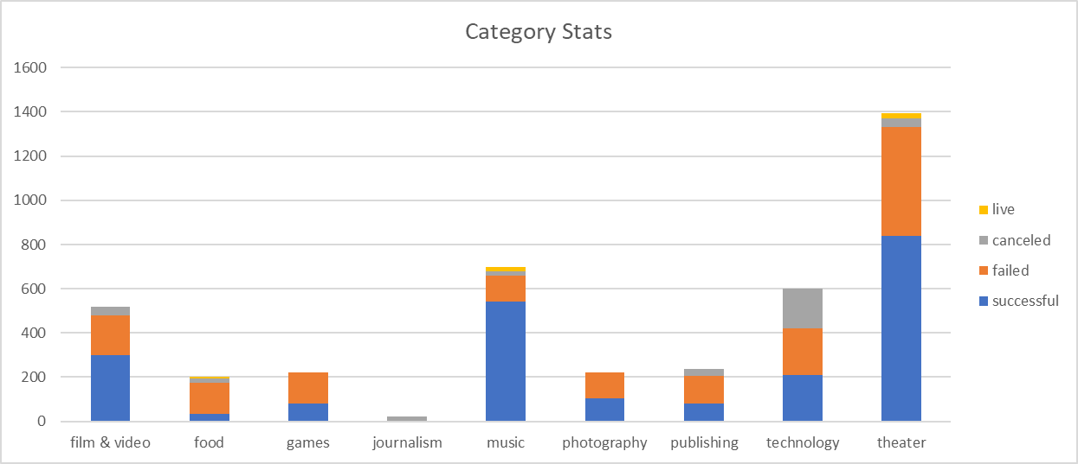

* **Theater,** Music, technology and film& video represent 78% of the campaigns (respectively 34%, 17% ,15% and 13%).
* **Music** has the highest success rate of 79% and technology a success rate of 61% when compare to average success rate by category of 54%.

1. **Sub-Category Stats:**

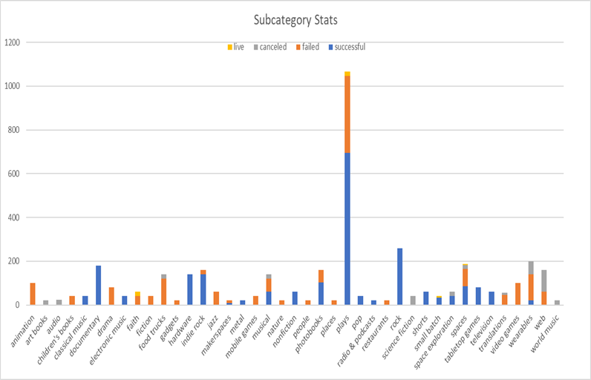

* Out of 42 subcategories, plays represented 26% of the total campaign volume and 76% of the theater category with a success rate of 66% that is 22% higher than the average success rate 54%.

1. **Outcomes Based on Launch Date**

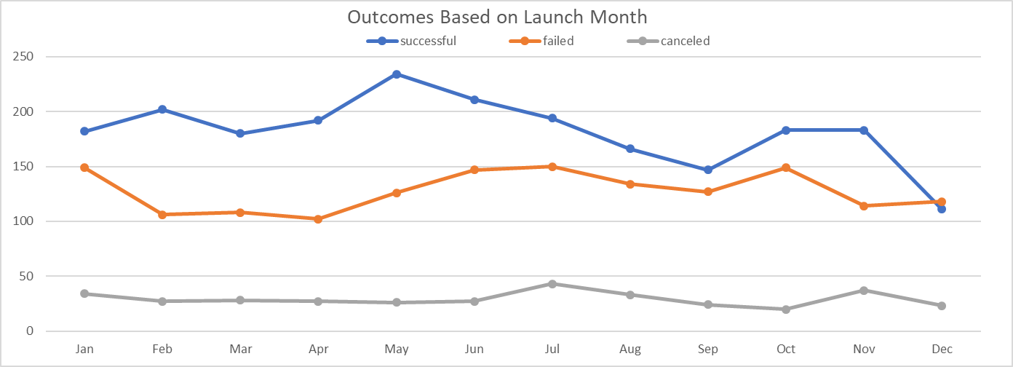

* The campaigns that started on Feb to May have the highest success rate ~60%
* The best month to start a campaign is February - low failure rate and high success rate.
* Seasonality or high success month could affect the campaigns when they launch.

1. **Outcome Based on Goal:**

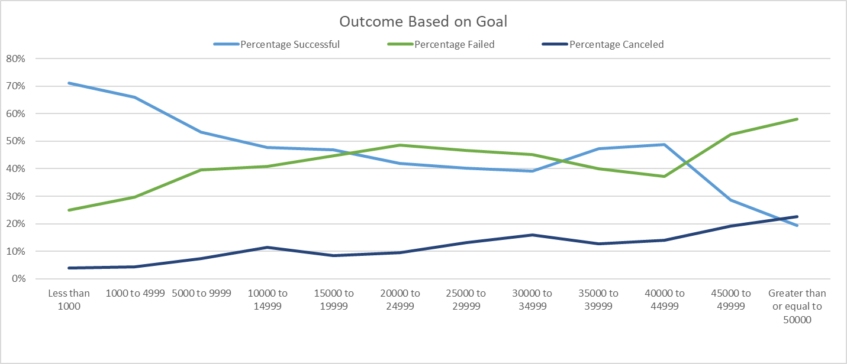

* 80% of the projects were under $20 K with a success rate of ~ 62 % higher by 15 % than the average of 54%
* Projects between $10 K to$55 K have a good chance to success as they are close 50%.
* The project that are greater than $50K have an average success rate of 19% with a cancellation rate of 23% (2.6X the average cancellation rate).

1. **Conclusion**

The start month, the category and the subcategory and the goal volume affect the success of the campaign.

1. **Future considerations:**

We could create Outcome_Based_on _Goal by category and subcategory based on the launch date.

We could also create Outcome_Based base on launch and duration of the campaign