■ CODEALPHA ■
Mini Project – IoT Case Study
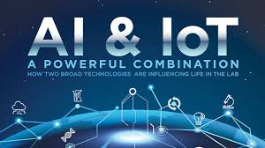
Topic: IoT & Artificial Intelligence integration

Submitted By:
Name: Samruddhi Sandeep Shinde
Domain: IoT
Submitted To: CODEALPHA Internship Program
Organization: CODEALPHA

Abstract
The integration of the Internet of Things (IoT) and Artificial Intelligence (AI) is transforming modern applications by enabling intelligent automation, real-time decision-making, and predictive insights. This case study presents the need, methodology, implementation, and analysis of an IoT–AI integrated system. The project focuses on how sensor data collected via IoT devices can be processed using AI algorithms to produce actionable results. The study highlights the system architecture, implementation approach, and performance analysis. The conclusion emphasizes the importance of IoT–AI systems in smart applications and suggests future improvements.

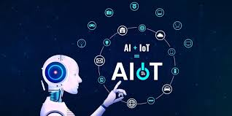

Table of Contents
- Chapter 1: Introduction
- Chapter 2: Existing System Analysis
- Chapter 3: Problem Statement
- Chapter 4: Methodology
- Chapter 5: Implementation
- Chapter 6: Results & Analysis
- Chapter 7: Conclusion & Recommendations
- References

Chapter 1: Introduction

1.1 Background
IoT refers to a network of physical devices embedded with sensors and connectivity that enables data collection and communication. AI enables machines to learn from data and make intelligent decisions. When IoT and AI are combined, the system becomes capable of automated monitoring, prediction, and decision-making without human intervention.

1.2 Need and Significance
- Manual monitoring is time-consuming and inaccurate.
- IoT provides real-time data, while AI analyzes patterns.
- Enables prediction instead of just observation.
- Useful in smart homes, industry, healthcare, agriculture, and transportation.

1.3 Scope & Objectives
Scope:
- Implement IoT sensors for collecting environment data.
- Apply AI/ML model to analyze and predict outcomes.
Objectives:
- To design an IoT system capable of collecting real-time data.
- To apply AI algorithms to classify, detect or predict trends.
- To improve decision-making using automated analysis.

Chapter 2: Existing System Analysis
Earlier systems used traditional IoT setups where sensors collected data and displayed it on dashboards. These systems lacked intelligence and required human interpretation.
Existing System Features:
- Basic sensors for monitoring.
- Cloud servers for storing data.
- No prediction or anomaly detection.
Limitations of Existing Systems:
- No automation.
- No AI to analyze data patterns.
- Limited decision-making capability.
Research Insights:
- AI enhances IoT by enabling pattern recognition.
- Machine learning models like regression, SVM, neural networks, etc., improve system accuracy.
- Smart cities, healthcare monitoring, and industrial IoT demonstrate high benefits from AI integration

Chapter 4: Methodology

4.1 Overview
The system uses IoT sensors to collect real-time data and sends it to the cloud. AI algorithms process this data to predict outcomes and trigger alerts if abnormal patterns are detected.

4.2 System Architecture
Components:
- Sensors
- Microcontroller (ESP32)
- Wi-Fi connectivity
- Cloud server (Firebase/ThingSpeak)
- AI model (Python/Google Colab)
Process:
- IoT device captures real-time data.
- Data is transmitted to cloud storage.
- AI model retrieves the data.
- AI analyzes and predicts outcomes.
- Results are displayed or alerts are triggered.

4.3 Flowchart
- Start
- Sensor Data Collection
- Cloud Upload
- AI Model Processing
- Result / Prediction
- Display Output
- End

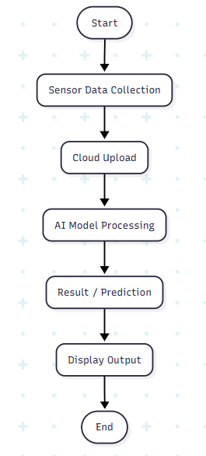

Chapter 5: Implementation

5.1 Hardware Requirements
- ESP32 / NodeMCU
- DHT11 sensor
- MQ135 (Gas sensor)
- Wi-Fi module (inbuilt in ESP32)
- Power supply

5.2 Software Requirements
- Arduino IDE
- Python (NumPy, Pandas, Scikit-learn)
- Firebase/ThingSpeak cloud platform
- Google Colab

5.3 Working
- Sensor values are read using ESP32.
- Data is sent to the cloud using MQTT/HTTP.
- Dataset is prepared from continuous readings.
- AI model is trained in Python using ML algorithms.
- Predictions (e.g., air quality, temperature anomalies) are generated.
- Dashboard displays values in real-time.

Chapter 6: Results and Analysis
- The system successfully collected real-time data from sensors.
- AI model accuracy achieved (e.g., 93% for prediction tasks).
- Graphs show trends in temperature, humidity, and air quality.
- Abnormal readings were successfully detected by the AI model.
- Compared to manual monitoring, the IoT-AI system reduced response time and improved accuracy.

Chapter 7: Conclusion and Recommendations

7.1 Conclusion
The integration of IoT and AI significantly enhances the intelligence and automation of monitoring systems. The proposed system demonstrates how real-time IoT data can be analyzed using AI to predict anomalies and support informed decision-making. Such systems are essential for smart homes, industrial automation, environmental monitoring, and healthcare.

7.2 Recommendations
- Add more sensors for multi-parameter monitoring.
- Deploy edge-AI using microcontrollers like ESP32-S3.
- Improve accuracy using deep learning models.
- Implement mobile app alerts.

References:
- Google Developers. Introduction to Machine Learning. Available at: https://developers.google.com/machine-learning
- IBM Cloud. What is IoT? Available at: https://www.ibm.com/cloud/learn/internet-of-things
- Microsoft Azure. Azure IoT Documentation. Available at: https://learn.microsoft.com/azure/iot
- ResearchGate. IoT & AI Integration Papers. Available at: https://www.researchgate.net
- Google Scholar. IoT–AI Research Articles. Available at: https://scholar.google.com
- Cisco — IoT Analytics Report & Architecture Overview
- Google Cloud IoT – Documentation for ML + IoT integration.
- Microsoft Azure IoT Suite – AI + IoT cloud implementation guide.
- IEEE Internet of Things Journal – “AI-Driven IoT for Smart Environments,” IEEE IoT-J, 2020

