Samnang San

Linux Admin Assignment #1

System Setup

The following is a guide on how to install distros on Linux systems. There are many distros out there, but this guide will be focused on Ubuntu and CentOS. In this guide, we will be using Virtual Machines (VMware Workstation 15.5 PRO) to install command line use for both operating systems.

**Ubuntu Server**

First, we need to install Ubuntu. We can download the disk image in the following link.

<https://releases.ubuntu.com/focal/>

Scroll down the page and select the disk image to download. Make sure you download the file to somewhere that you can easily locate.

Now, we are ready to begin the install. Pay attention to the next step as we are going to do the same for CentOS install.

Click on Create a New Virtual Machine.

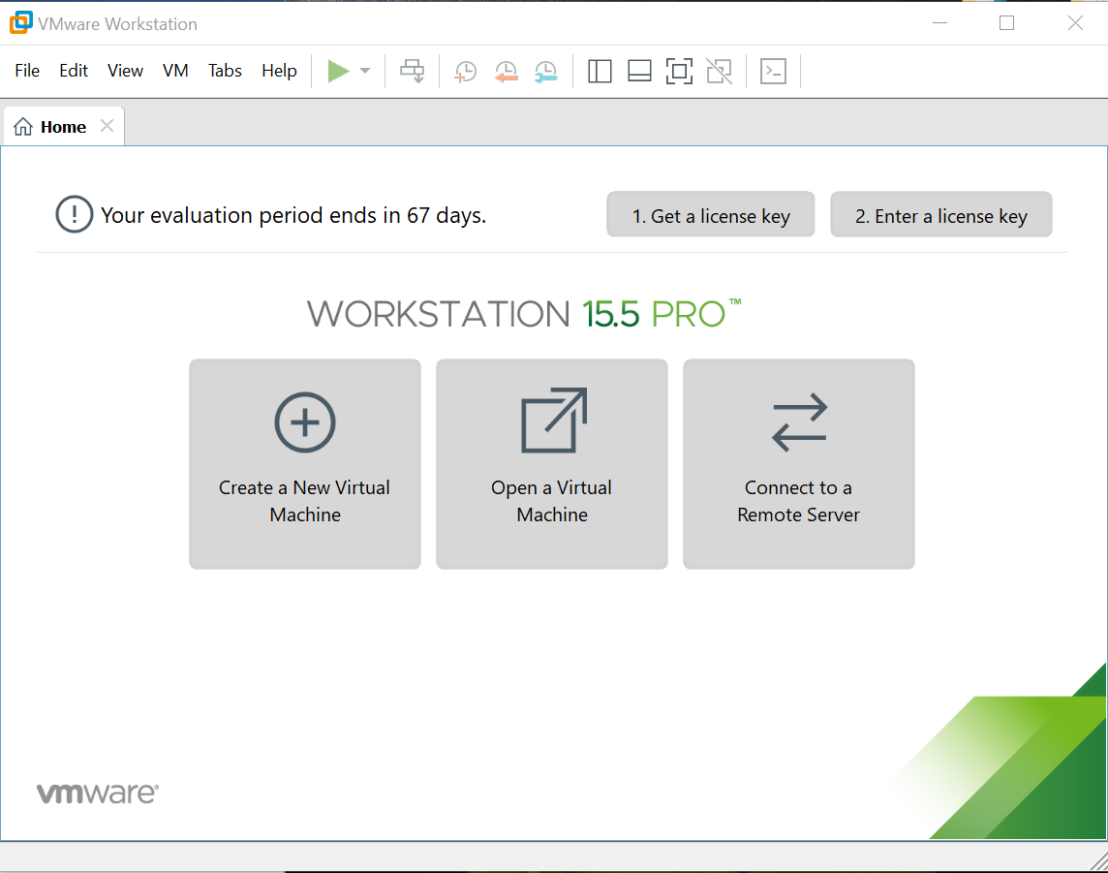

Click on Create a New Virtual Machine and choose the Typical(recommended) and hit next.

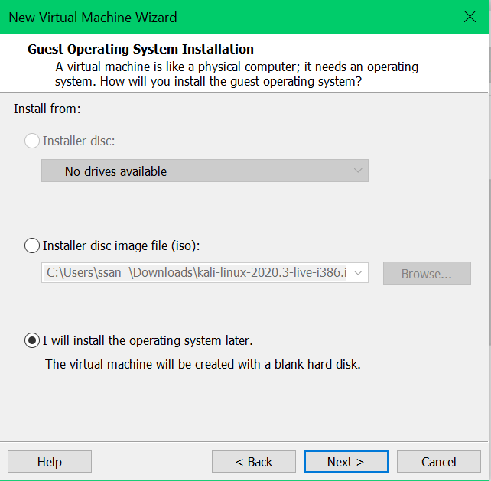

Select installer disc image file(iso) and click browse. Now locate that Ubuntu file you just downloaded and then click next.

Enter your credentials and click Next.

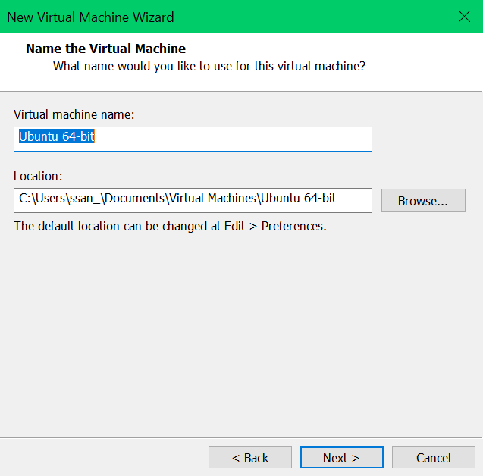

You will come to Page above where you can change the name and location of the virtual machine. Click next.

The next page will ask you how big you want the disk to be. Click Next.

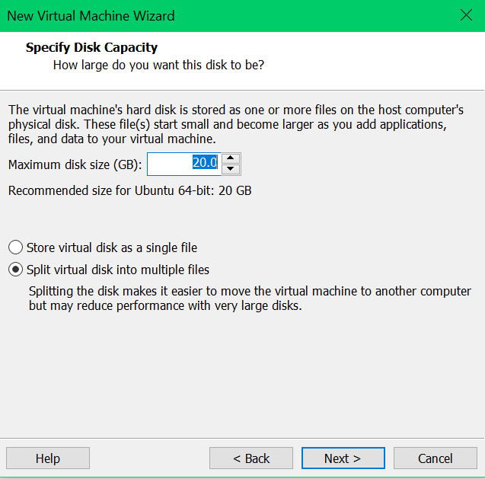

Then, click finish. Now we can continue with the install. Click to power on virtual machine.

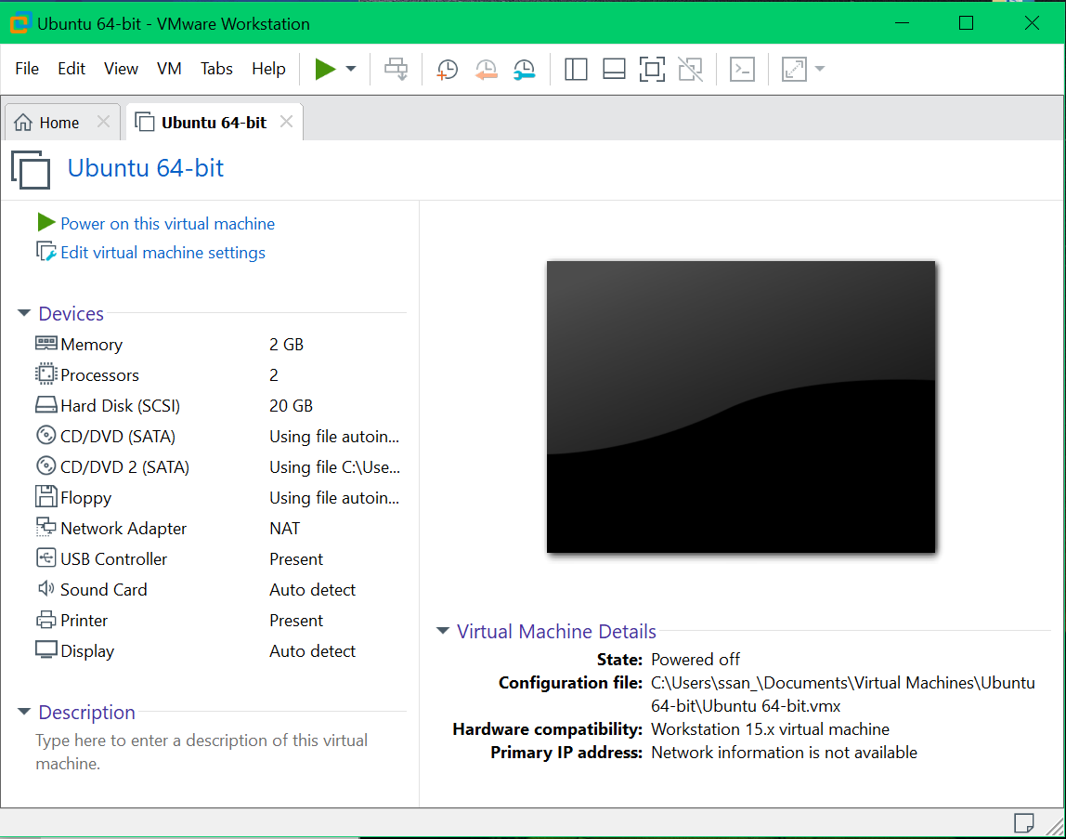

It will take a couple of minutes to load but you will eventually reach this page. Select your language and keyboard using Up and Down keys and hit enter.

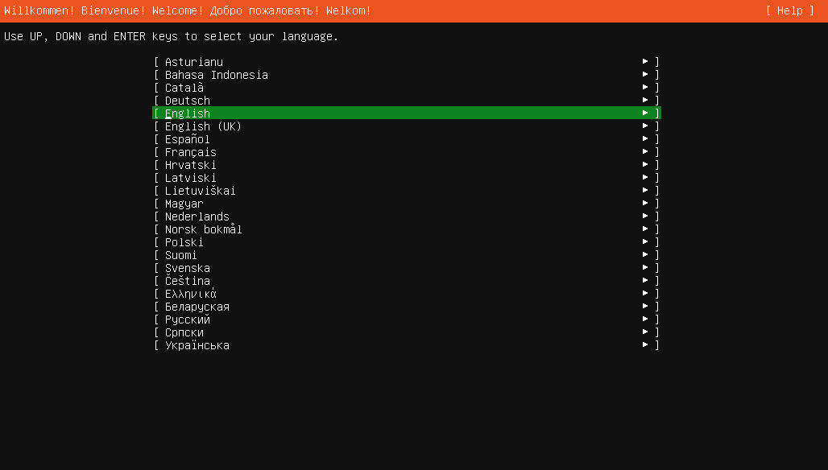

Network connection is the next category, Choose default settings and hit enter to continue.

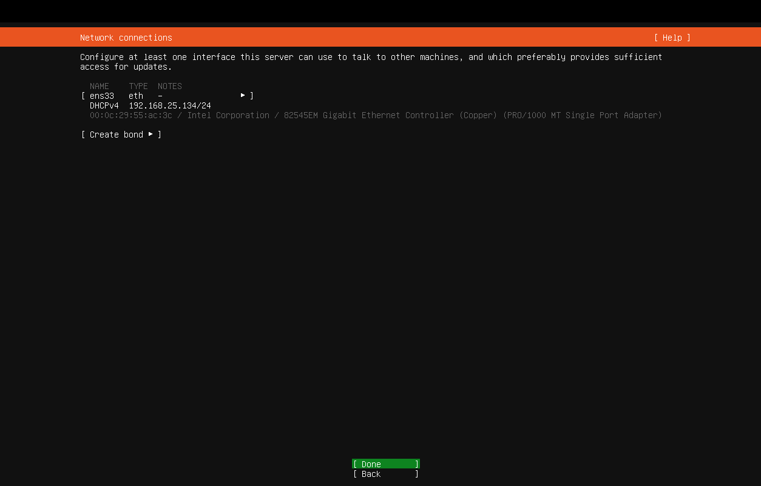

Leave proxy address blank and hit enter.

For mirror address, default the address, highlight done and hit enter.

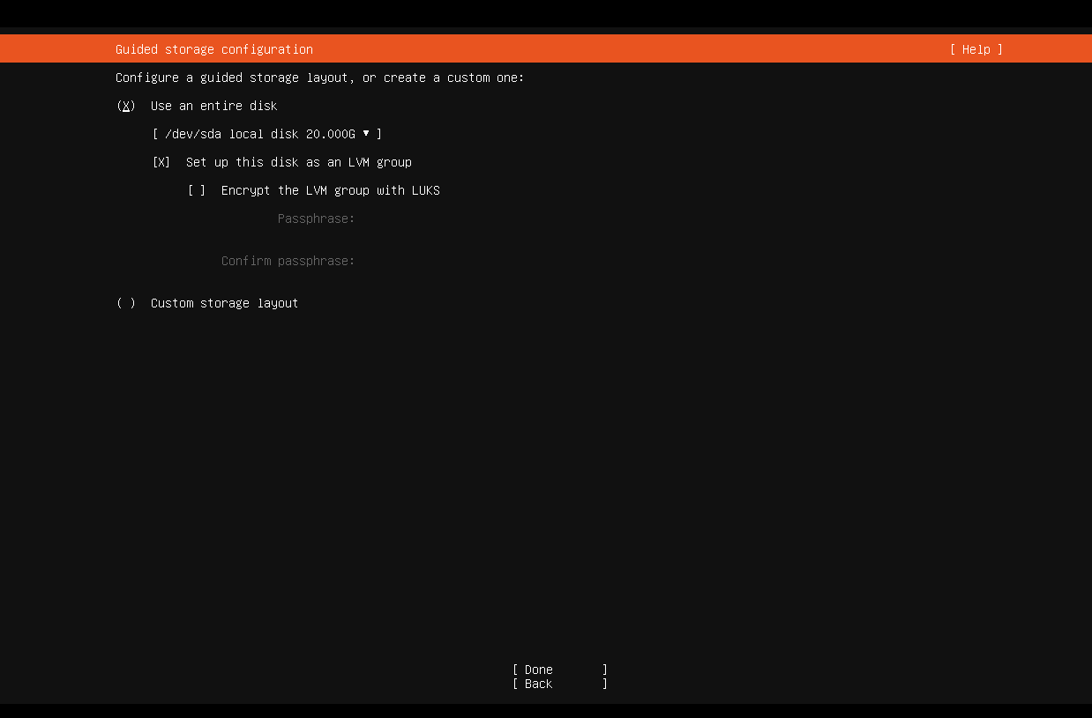The window below is asking to configure storage, its defaulted at use an entire disk. Highlight done and click next.

Below shows our system configuration where will format our disk to ext4

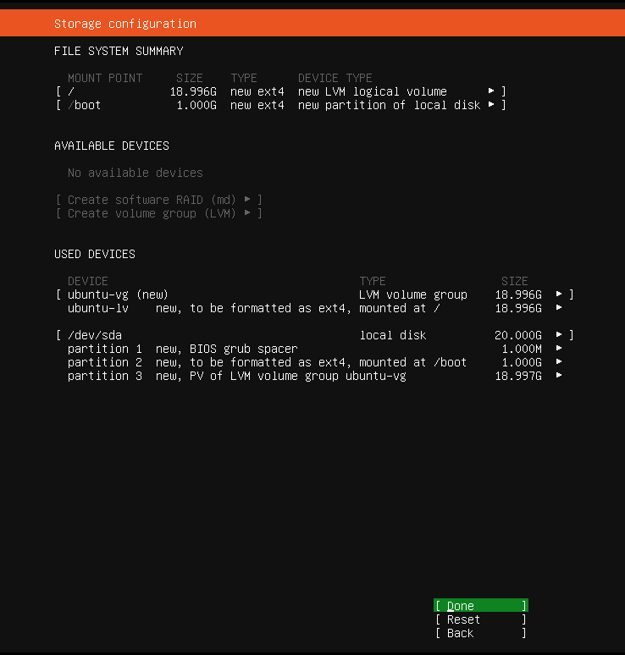

Highlight done and hit enter. Now, you get a prompt that says, “Are you sure you want to continue?”.

Highlight continue and hit enter.

You will be prompted to do a Profile setup. Do so and highlight done and click enter.

Now, you are prompted for SSH Setup. Select install OpenSSH server and hit done.

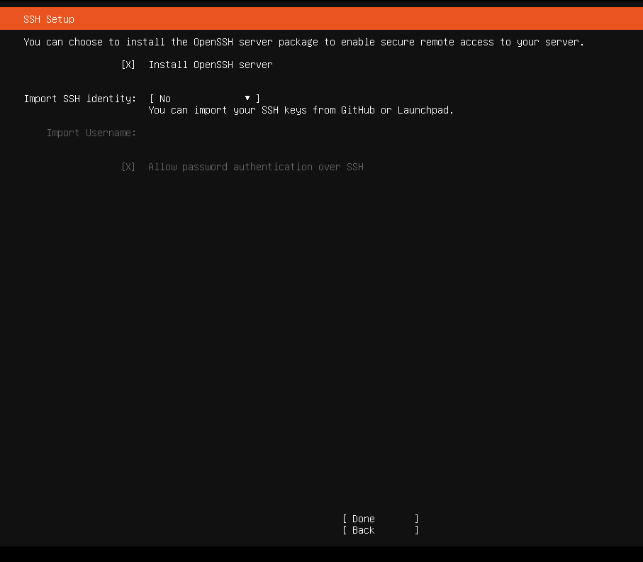

Featured Server Snaps is prompted next. Hit down key until you reach done and hit enter.

The install will begin.it will say install complete but other updates are going on. For example, in the picture it says install complete but in the box its still says downloading and installing security updates.

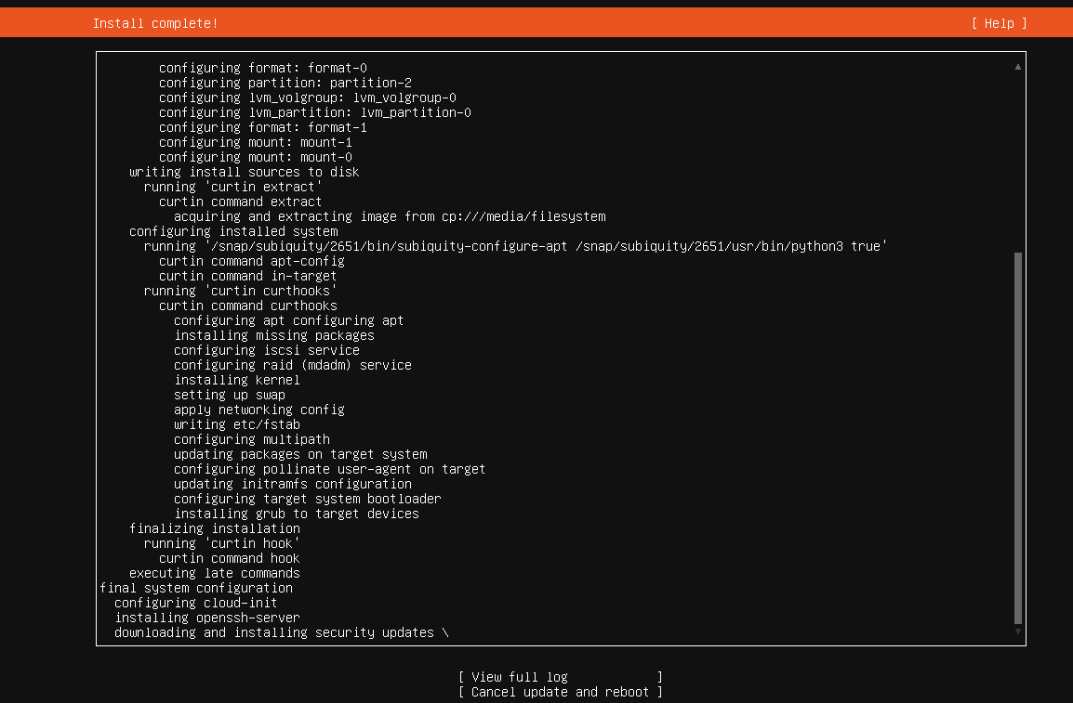

Once it is complete, you will see reboot now on the bottom of the page. Select reboot.

Once it’s finished, you will get a login prompt. Enter your credentials and you will receive the page below. Ubuntu has been installed and ready for use.

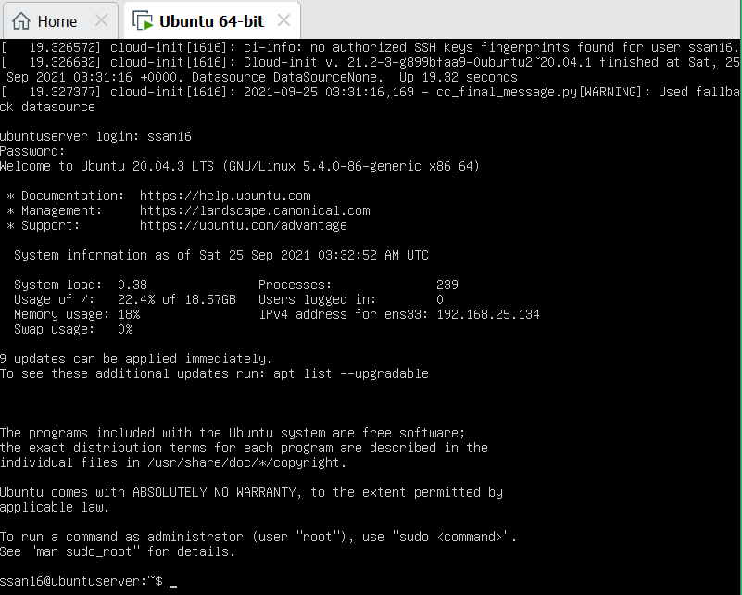

Notice in the screen it says 9 updates can be applied immediately. To see the updates run, type “apt list”

Also, ifconfig command is not found but can be installed. Type in “sudo apt install net-tools” and hit enter.

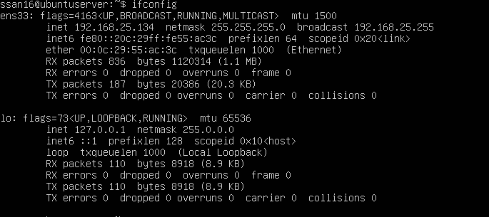

**CentOS 7**

Now we will work on installing CentOS server. Same as Ubuntu server, command line only. Let’s begin.

CentOS can be downloaded from the following link:

<https://centos.org/download/>

You will be brought to a screen like the one below.

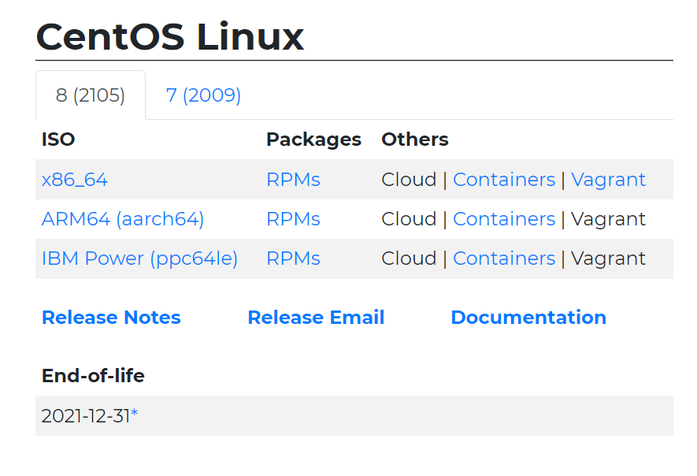

Click on x86_64 and you will be brought to a mirror link like the one below

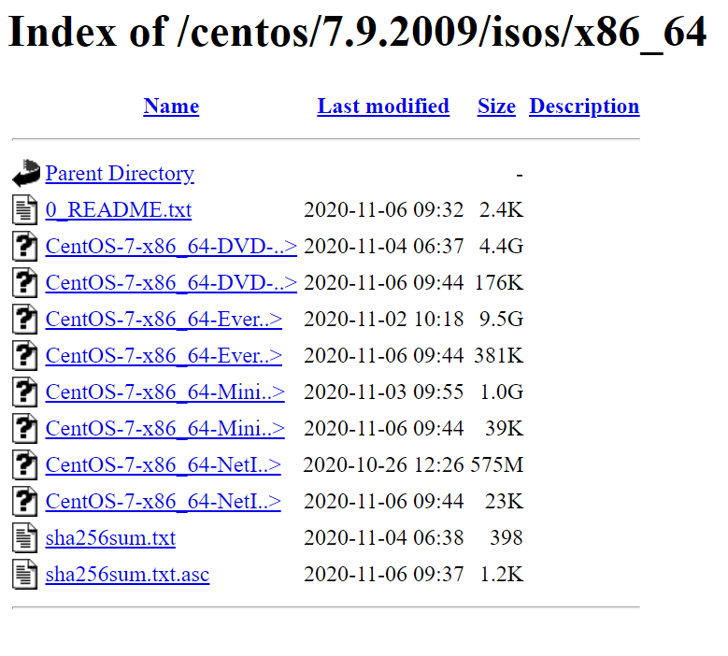

Choose the one ending in dvd1.iso to download, this may take a while to download.

Once the download is complete, you are ready to install CentOS. Make sure you know where you downloaded the file is.

Just like ubuntu, you have to create a virtual machine. You can scroll up and follow the guide again until you reach the Guest operating system installation. Here.



When you select installer disc image(iso) and click browse, instead of the ubuntu.iso file now you’re looking for the iso file you downloaded for CentOS.

Virtual machine has been set up, installing CentOS shall begin. This screen should come up.

Press the Tab

Once you press the key tab, another page will prompt like this. After “.check quiet”, type in “inst.text”. This lets the installer know that you want the command line install.

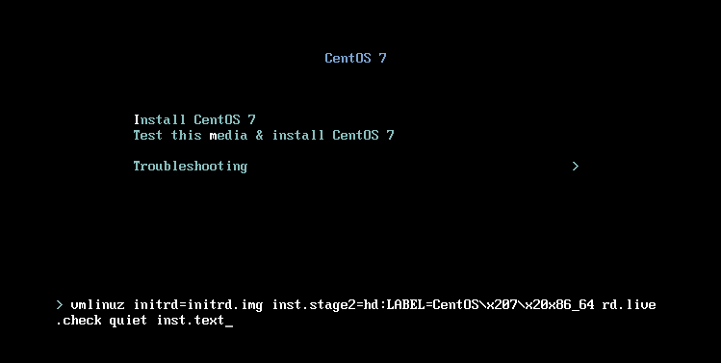

You will be prompted with a installer menu similar to the one below.

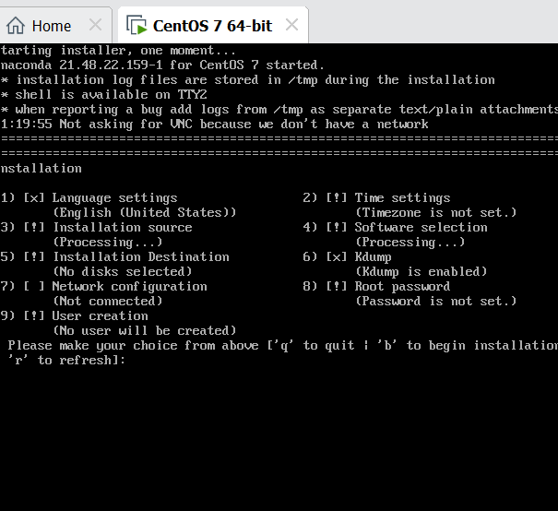

Exclamation marks has to be resolved before proceeding, the system will not allow you to install. Select each category and configure as needed.

Number 1 Language settings is defaulted to English (United States))

Number 2-time settings was not configured. I configured it to eastern time zone. Shown below.

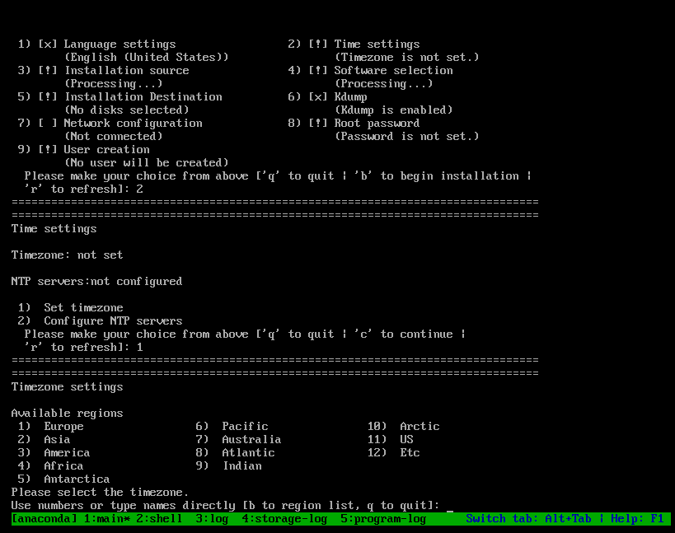

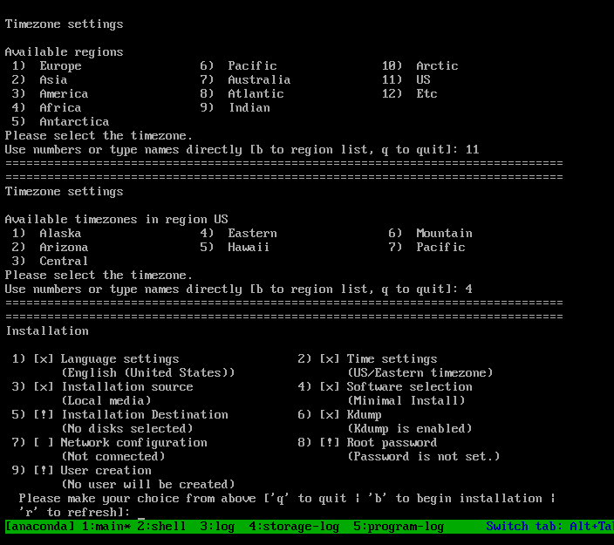

You notice when that is complete, it becomes an x and not an! anymore.

3. installation source.

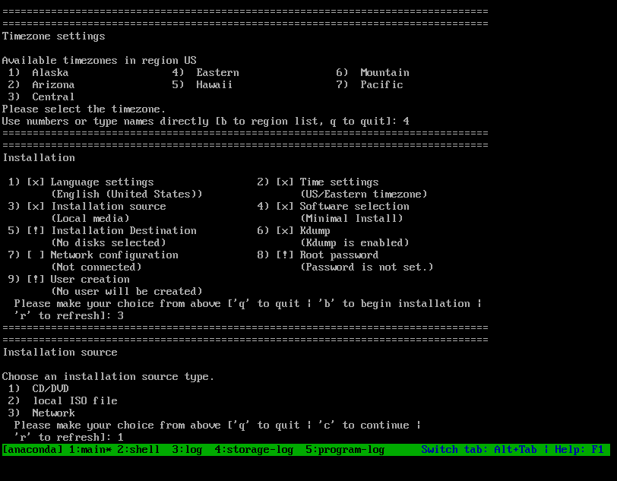

4. software selection- you can select what software you need.

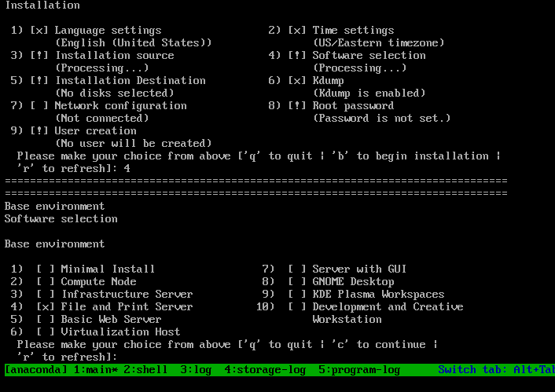

5.installation destination is set to use entire disk for we created virtual machine for installation.

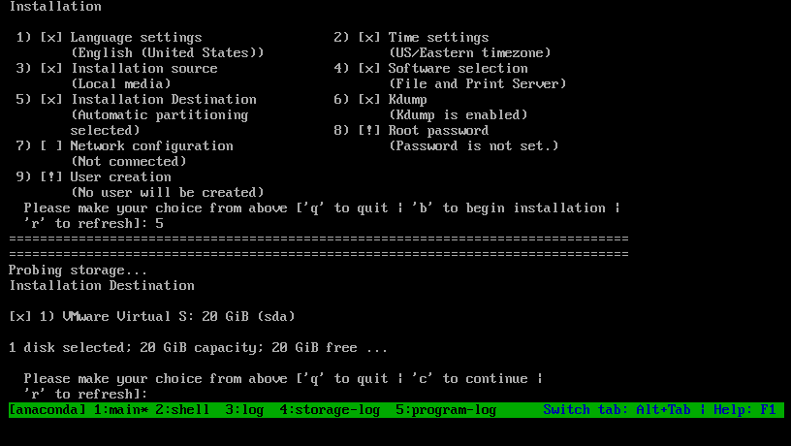

6.Kdump, we will keep that defaulted.

7. Network configuration – I set to connect automatically after reboot.

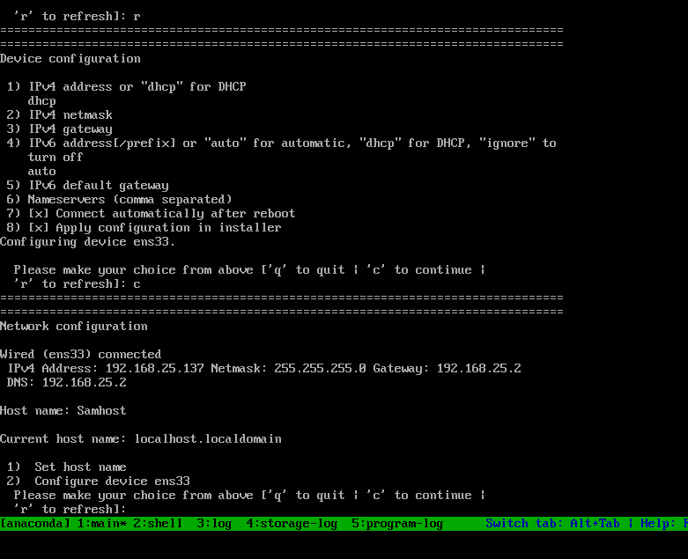

8.root password- set the password, you will be asked to type the password two times.

9. user creation- create user, full name, set password and groups. Example below

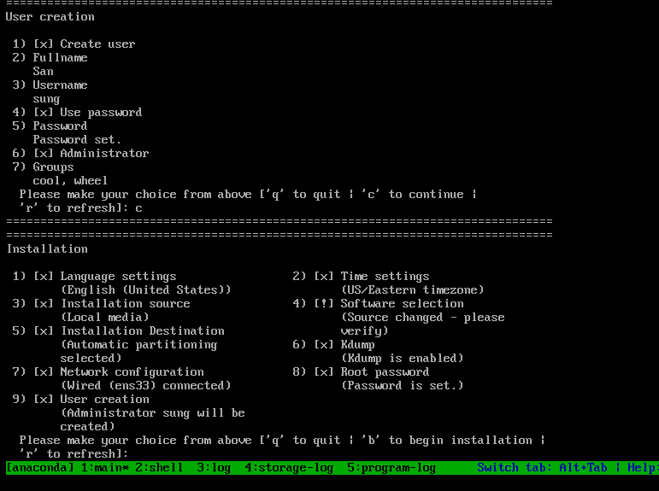

When all exclamations are gone, and everything is configured. You can type the letter “b” to begin installation.

Once install is complete, you get this screen below.

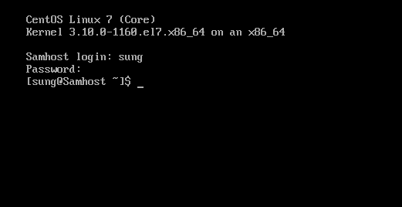

I successfully logged in. CentOS has been installed.

To make sure all packages were up to date, you can type in the command line “sudo yum update”, It will take some time to complete.

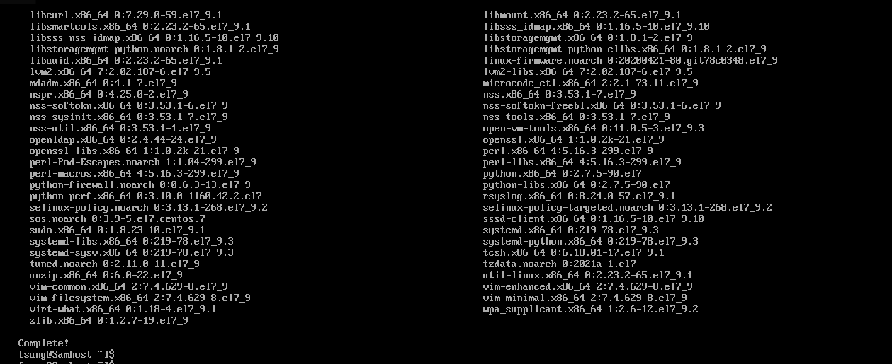

**A way to share files between the servers**

I am going to use a command called SCP or secure copy, to transfer files between the servers. The remote host will be the CentOS server.

When you type SCP in command line, you will receive this message which tells you what’s information needed to send.

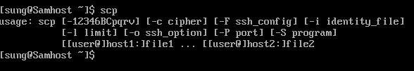

IP address and name is needed so I typed in Ifconfig on the ubuntu server.

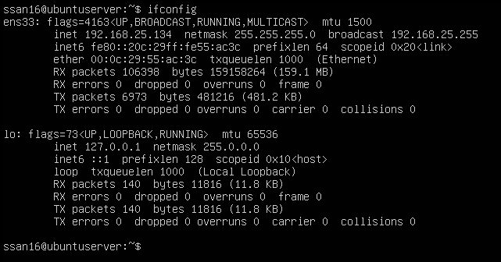

IP address and host name was obtained.

I created a file called itsfriday.txt, used the SCP command to transfer the file to Ubuntu server.

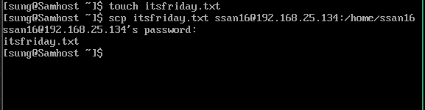

It will ask if you want to continue, just type yes.

Then you will be asked for the password of the server(ubuntu) receiving the file.

Now, at the Ubuntu server.

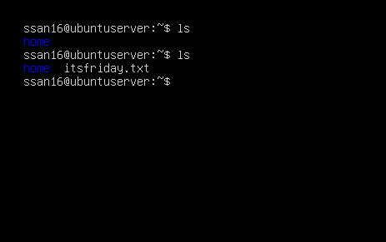

First, I did the LS command (listing the files), then after the transferred, I LS’ed again and there the itsfriday.txt file. It was transferred over successfully with the SCP command.