Samnang San

Linux Admin Assignment #2

Grep Command

Grep is a tool used in Linux that helps us search through a set of information and displays the line that matches the criteria. We will be using a file called datebook to show some examples to help you better understand the grep command.

1. Print all lines containing the string Street.

Command= grep Street datebook

Grep will search for the pattern “Street” in the file named datebook.

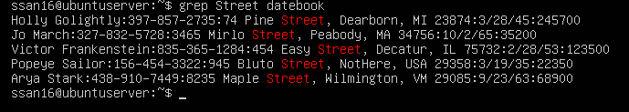

1. Print all lines where the person’s first name starts with M.

Command= grep ^M datebook

^M function will get lines that begin with the letter M. The “^” means the beginning of the line anchor. Here we used the example M, so it brought up all the names that begins with the letter M. You can change the M to other letters to see what comes up.

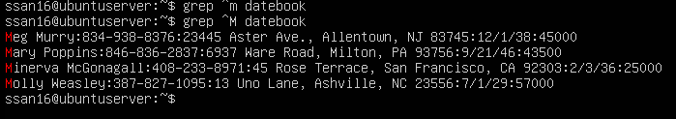

1. Print all lines ending in 000

Command = grep 000$ datebook

$ function at the end of the 000 means the end of the line anchor. Anything that end with 000 will come up using the $ anchor.

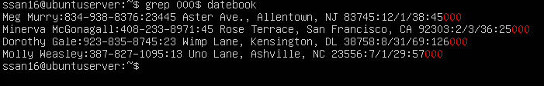

1. Print all lines that don’t contain 408

Command= grep -v 408 datebook

The “-v” option shows the line that do not match. Like in this example, it is not showing anything with 408

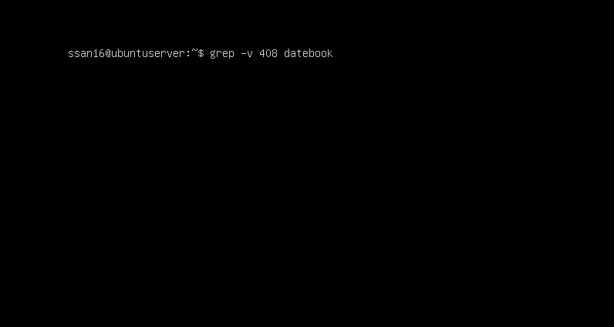

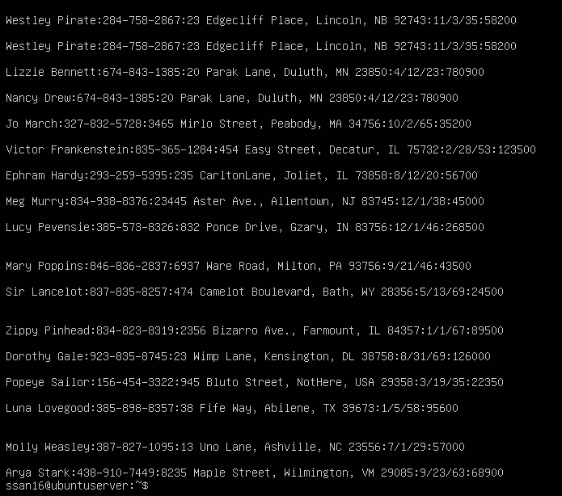

1. Print all lines where birthdays are in the year 1923.

Command= grep /23: datebook

This option shows us all the year 1923 because of /23:

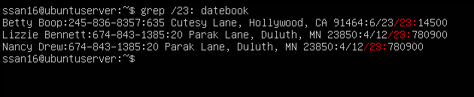

1. Print all lines where the phone numbers are in an area code that starts with an 8.

Command= grep :8[0-9] [0-9]- datebook

This option shows the number followed by 2 random numbers followed by a – to show an area code.

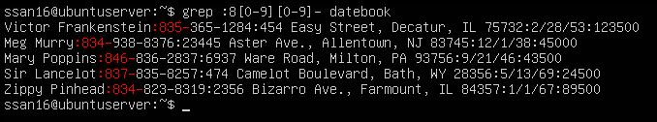

1. Print all lines containing an uppercase letter, followed by 5 lowercase letters, a comma, and one uppercase letter.

Command=grep ‘[A-Z][a-z]\{5\}, [A-Z}’ datebook

[A-Z] gives us the first uppercase letter. [a-z]\{5\} gives us the 5 lowercase letters followed by a “,” . The [A-Z] gives us the last uppercase letter.

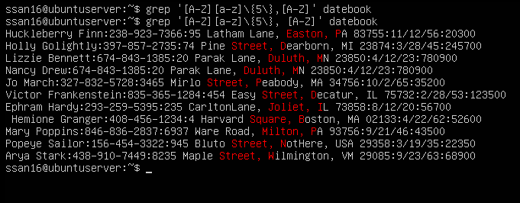

1. Print lines where the address begins with a two- or three-digit number.

Command = ‘:[0-9][0-9]\{1,2\} [A-Z]’ datebook

:[0-9] gives me the first digit, followed by[0-9]\{1,2\} which gives the one or two additional numbers of the address. [A-Z], so I can get the first letter of the address.

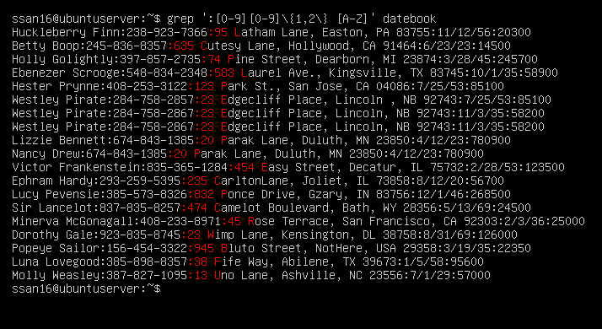

1. Print lines preceded by a line number where the person is from MA(Massachusetts)

Command= grep -n MA datebook

-n option shows each matching line with line number.

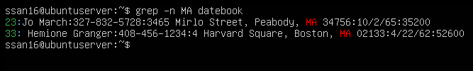

1. Print lines containing an address that doesn’t include St(street).

Command: grep -v ‘\<St’ datebook

-v option displays lines that doesn’t match. ‘\<St’ is anything that begins with an St.

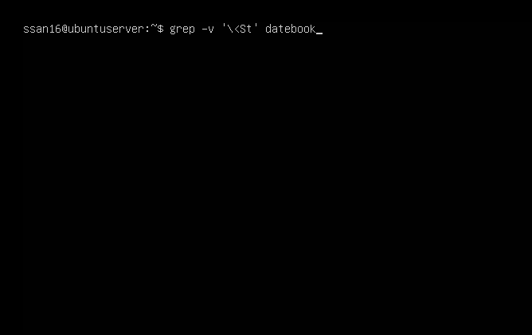

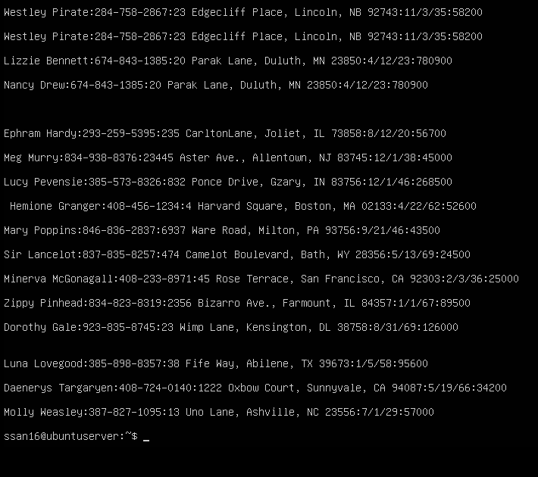

**Sources**

UNIX Shells by Example (4th Edition), Chapter 4. The grep Family

https://flylib.com/books/en/4.356.1.25/1/