Samnang San

Linux Admin

Centos Continue set up Assignment

October 10, 2021

Just like our Ubuntu server, we need to make sure our Server is up to date. Centos uses Yum as the default package tool that installs, removes and update packages.

To become root, you type in the command line: “su – “which stands for switch user. Enter root password and before you have a $ sign in front but after switching to root, you will notice a # in the beginning. In this tutorial, we will not switch to root.

If you do switch to root, to exit root mode, type in the command line: exit

First, we will run command: sudo yum update

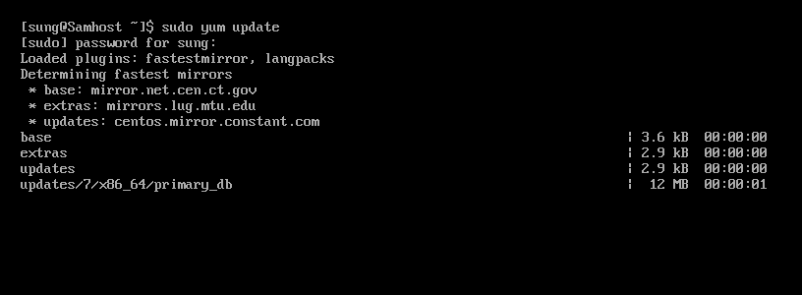

Sudo command elevates privileges in Linux. Yum is the default package tool, you will be prompted for your password. Enter password and hit enter.

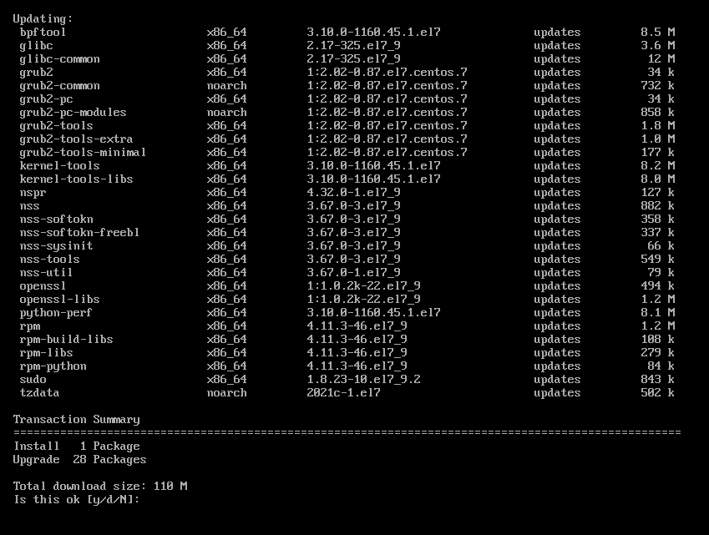

Type Y and enter, the updating will begin. It will take couple of mins to complete.

You will come to this screen where it will say Complete. We are now ready to install some software.

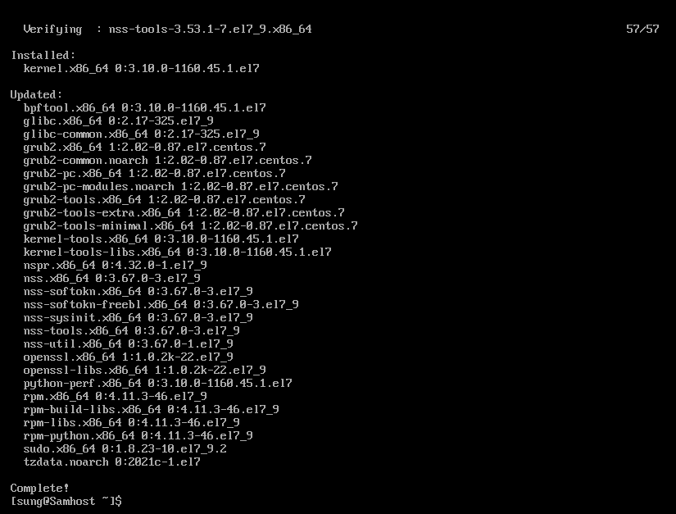

**Tmux**

We will start first with Tmux. Tmux is a terminal multiplexer. You are able to split screens into multiple terminals and manage your servers.

Below is an example you can get if you don’t put sudo in front of your command and you are not root.

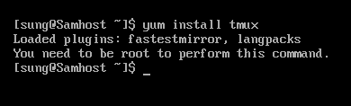

Now we’re going to enter command: sudo yum install tmux

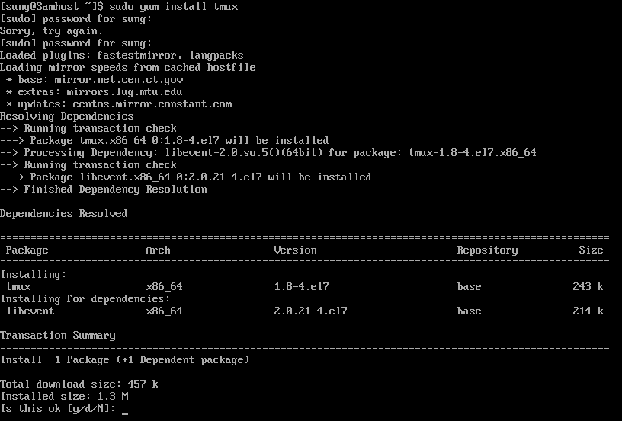

Type Y and enter to begin install process.

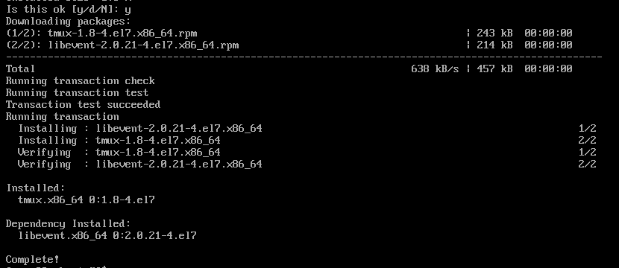

Tmux has been installed. To start tmux, you enter in the command line: tmux

**Emacs**

Emacs is a text editor that was designed to run on local terminals which is known as “extensible, customizable, self-documenting, real time display editor.

To install emacs, without being in root, you type in the command line: sudo yum install emacs

Then enter. You will get this screen

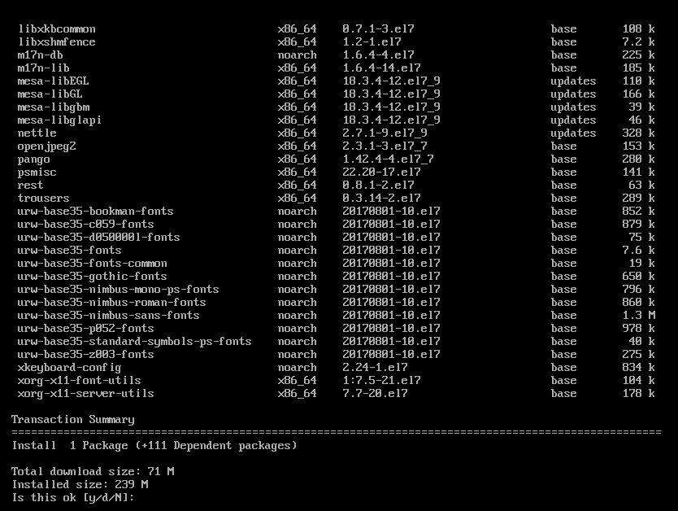

Type in Y and enter which will start the install

Once install is complete, you get this screen below

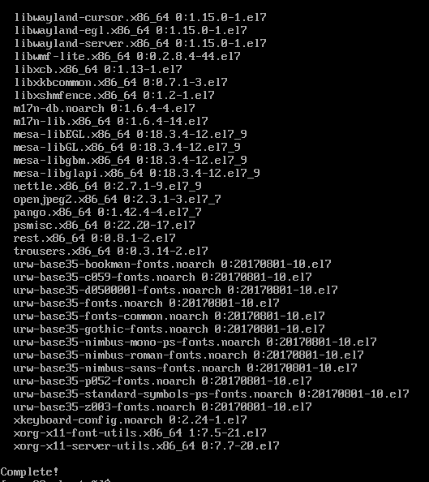

Emacs is now installed.

**Fail2ban**

Fail2ban is an intrusion prevention software that protects servers from brute force attacks. Unfortunately, Fail2Ban is not available from CentOS, so we have to install epel repository first.

**Once EPEL is downloaded**, I will show you how to install a repo. we can work on installing Fail2Ban.

Type in the command line: sudo yum install fail2ban fail2ban-systemd

Hit enter and you will get this screen.

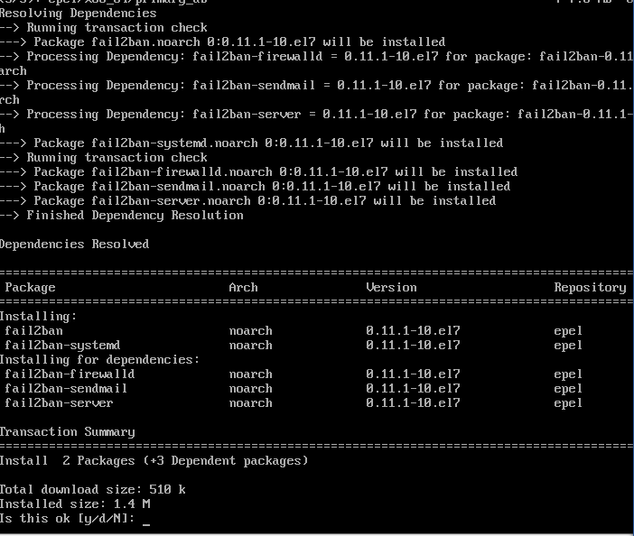

Type Y and hit enter, you will get another screen asking if it is ok. Type Y again and hit enter.

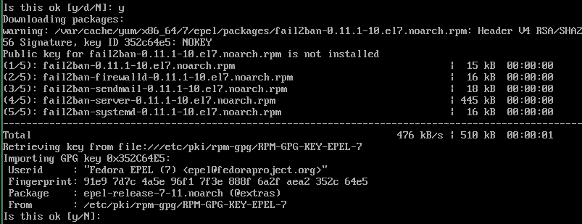

Finally, Fail2Ban is installed, you will get a screen like the one below.

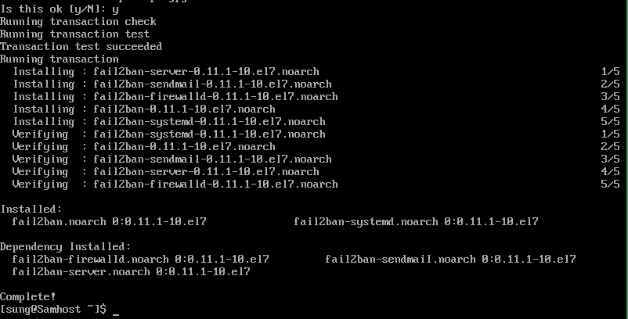

**Cowsay**

Cowsay is a program that generates a picture of a cow saying something provided by user.

To install Cowsay, type in command line: sudo yum install cowsay

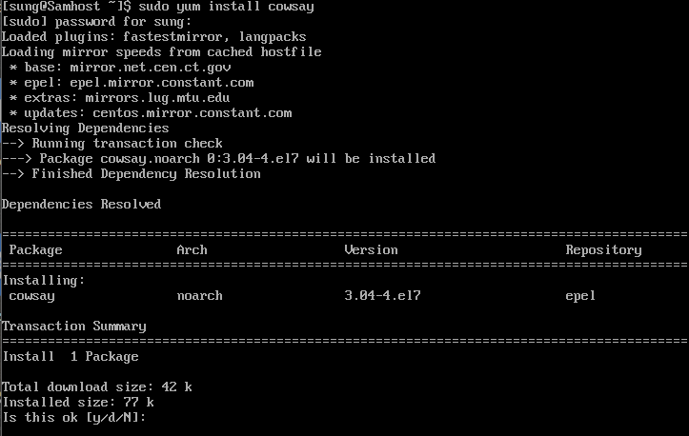

Type Y and hit enter, install will begin, once complete you will get this screen.

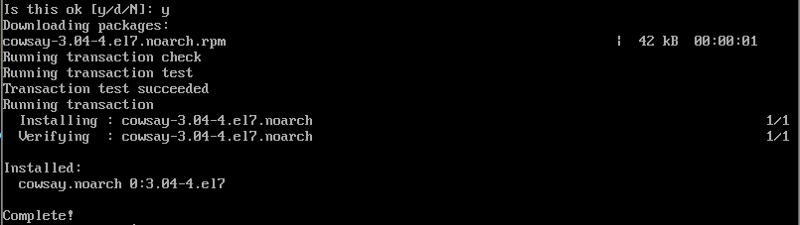

**Lolcat**

Lolcat is a utility for Linux, BSD and OSX that works like the cat command and outputs rainbow colors.

In CentOS, it’s called ruby instead of lolcat. To install lolcat(ruby), we enter in the command line:

“Sudo yum install ruby” followed by enter. You get a line that says it this ok to download, type Y and hit enter.

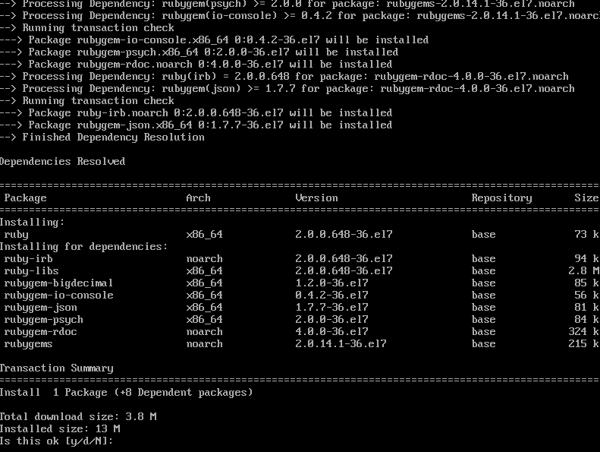

Once complete you get this screen below.

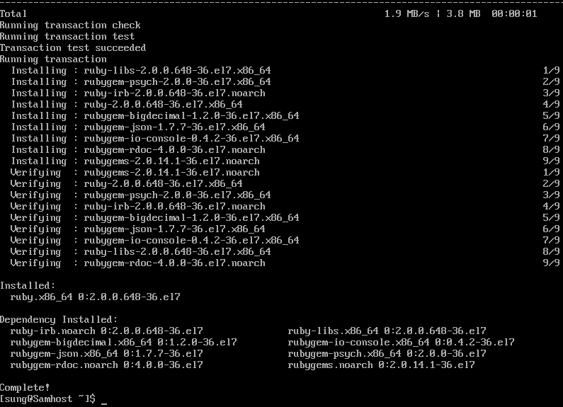

Lolcat(ruby) has been installed.

**Vim**

Vim is a text editor built to enable efficient text editing and it supports most file types. To install, in the command line you type: sudo yum install vim enhanced -y. My Operating system already has vim installed. All you have to do is type vim in command line and hit enter.

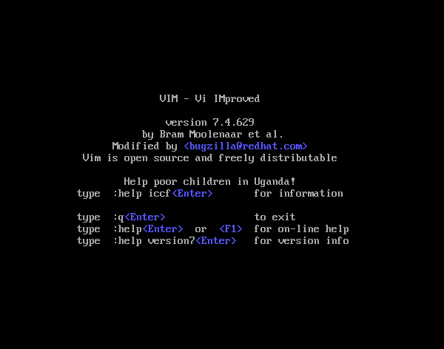

**Where do these files live on the server?**

To find the files we just installed.

Type in the command line: rpm -ql [file name]

For example, to locate tmux, we would type rpm -ql tmux and the results should be like the one below.

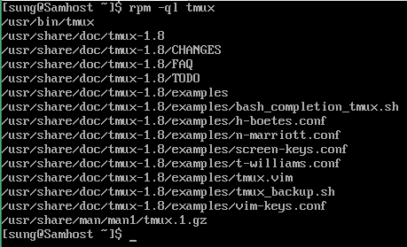

**What’s installed on my server?**

To list all installed packages,

type in command line: sudo yum list installed

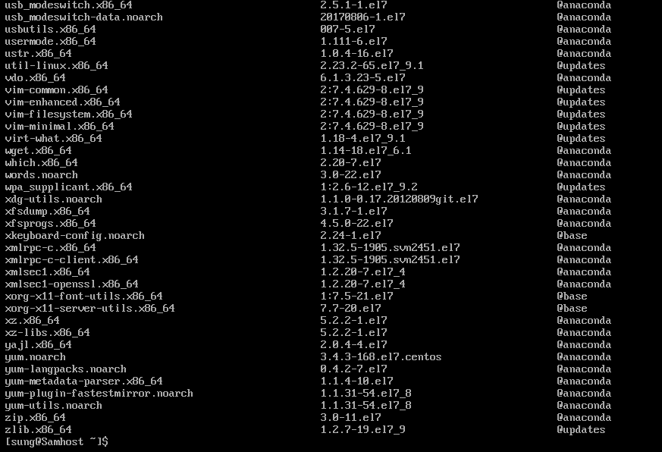

**Where do my repositories live on my server and how to add/modify a repository.**

To list repository, type in command line: yum repolist

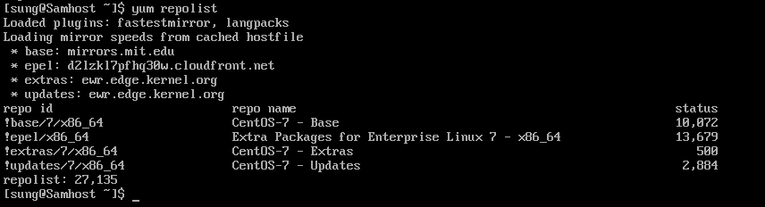

In order to install and use Fail2ban, I had to install the epel repository. It already appears in the repolist above as I already installed it. But I will show you below on how I did that.

To install EPEL, in the command line type: sudo yum install epel-release, followed by password

Type Y and enter to download. Once complete, you will get this screen

Repository installed.

Sources I used for this assignment.

https://www.cyberciti.biz/faq/yum-determining-finding-path-that-yum-package-installed-to/

<https://linuxize.com/post/how-to-install-updates-on-centos/>

<https://www.linuxcloudvps.com/blog/install-and-use-tmux-on-centos/>

https://portal.supercomputing.wales/wp-content/uploads/2017/07/Using-Emacs-HPC_Wales.pdf

<https://www.youtube.com/watch?v=ECg6fO5-Myc>

<https://evoluso.com/how-to-install-fail2ban-on-centos-7/>

<https://centos.pkgs.org/7/epel-x86_64/cowsay-3.04-4.el7.noarch.rpm.html>

<https://www.tecmint.com/lolcat-command-to-output-rainbow-of-colors-in-linux-terminal/>

https://www.cyberithub.com/how-to-install-vim-editor-on-linux-rhel-centos/