Samnang San

Linux Admin

Ubuntu Continue set up Assignment

October 10, 2021

APT is an acronym for Advance Package Tools. These tools can install, update and remove software packages. To log in as root, type on “sudo -I”. The $ should change to a # when you are root. Some administrative tasks require higher privilege. That’s where the “sudo” command comes in to play. To elevate privileges in Linux, you add “sudo” before the command to execute the tasks. The examples below we will use both apt and sudo.

First let’s make sure the Server is up to date to ensure that all of our software packages are up to date.

To update our Ubuntu server, type this command: sudo apt-get update. You will be prompted for password. Type in password and finally hit enter.

Update is complete.

Apt-file is a command line tool for searching for files in our repositories. To install, we have to this command: sudo apt install apt-file

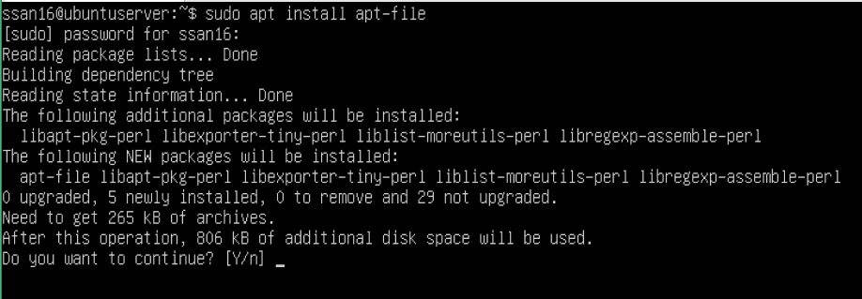

Type Y and enter followed by the password and enter.

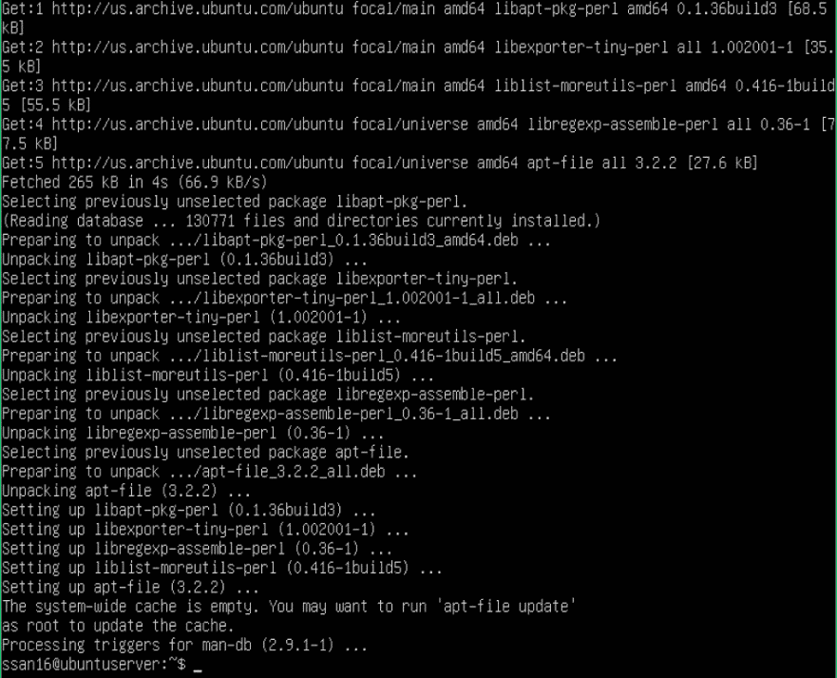

You must run another update with command: sudo apt-file update

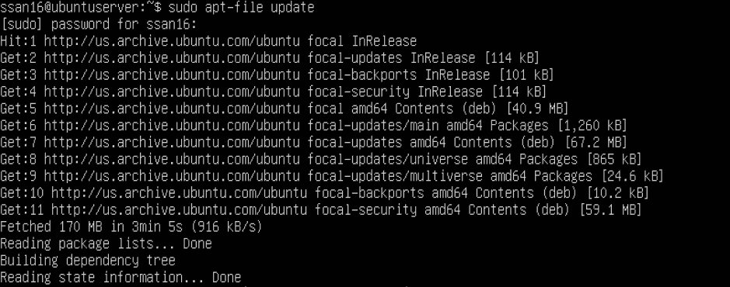

Now we should be able to use apt-file. Lets look at how to install some files.

**Tmux**

Tmux stands for Terminal Multiplexing which is a Linux application that allows multitasking in a terminal window. To install Tmux, type in the command line: sudo apt install tmux

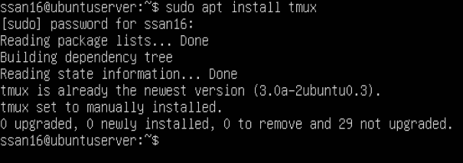

**Emacs**

Emac is a text editor available for Linux and Unix based systems which can be customized and extended with different modes. To install emacs, type in command line: sudo apt install emacs

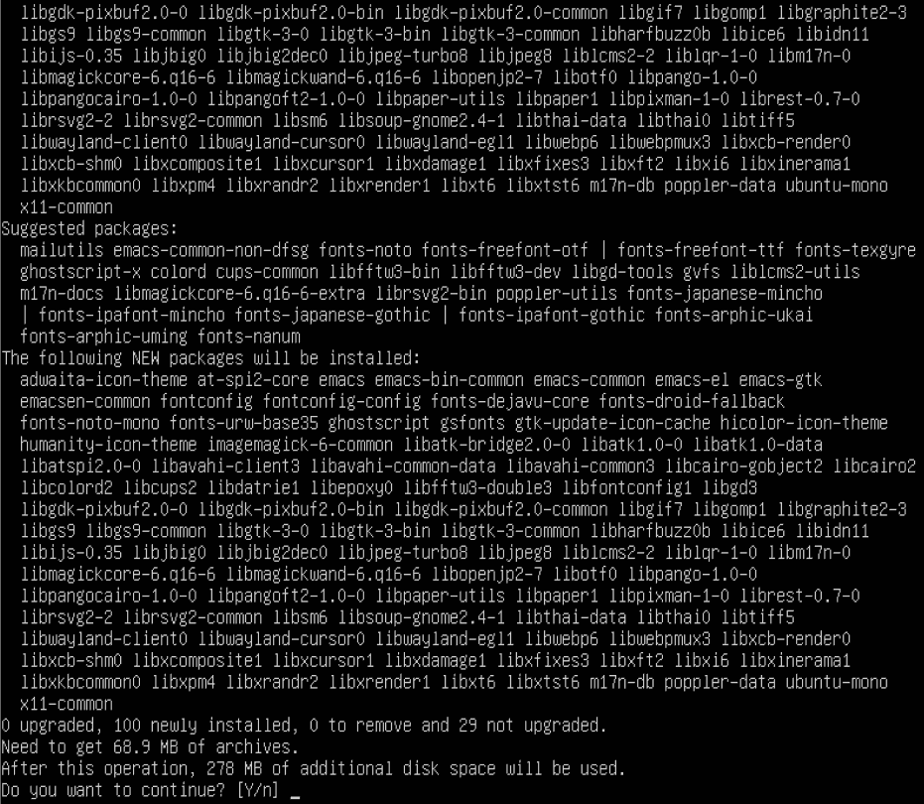

Type in Y and enter. It will take a minute or so to go through the install process. You will eventually get to this screen.

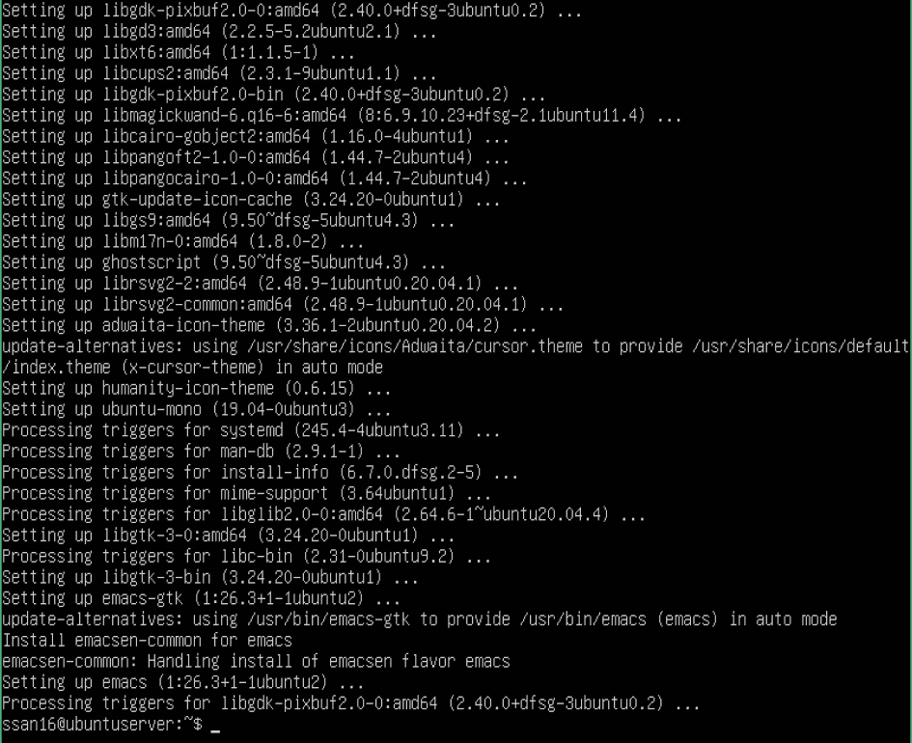

**Fail2ban**

Fail2ban is an intrusion prevention software that protects servers from brute force attacks. You can examine server’s logs and add additional rules to block problematic IP address. To install fail2ban, type in command line: sudo apt install fail2ban

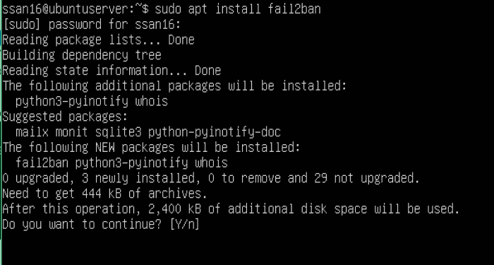

Type Y and enter, followed by password and enter. Your screen will look similar to the screenshot below.

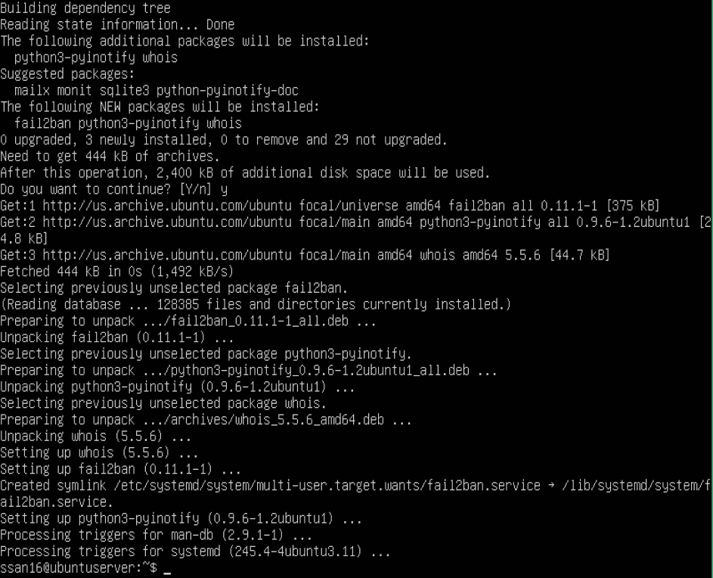

**Cowsay**

Cowsay is a program that generates a picture of a cow saying something provided by the user.

To install cowsay, type in the command line: sudo apt install cowsay

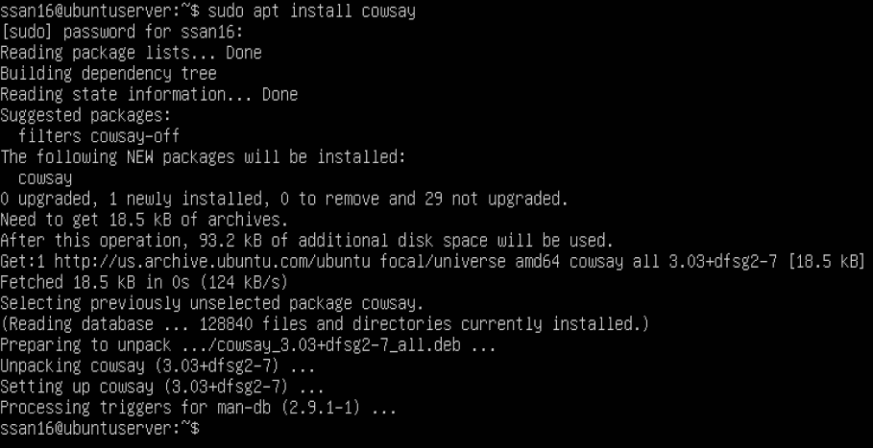

**Lolcat**

Lolcat is a utility for Linux, BSD and OSX that’s works like the cat command and outputs rainbow colors.

Command to install lolcat: sudo apt install lolcat

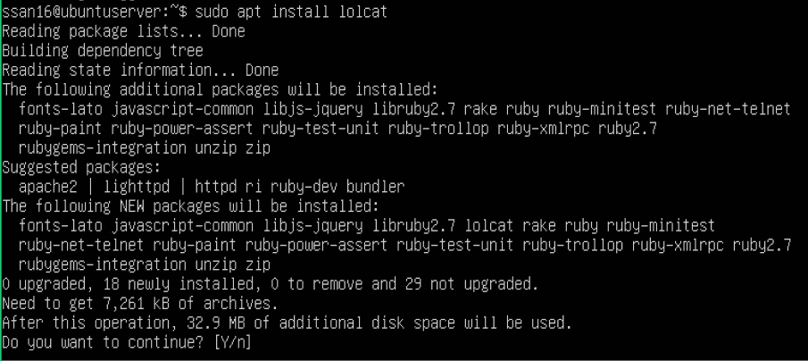

Type Y, press enter followed by password and hit enter again. Once complete the screen should look like below.

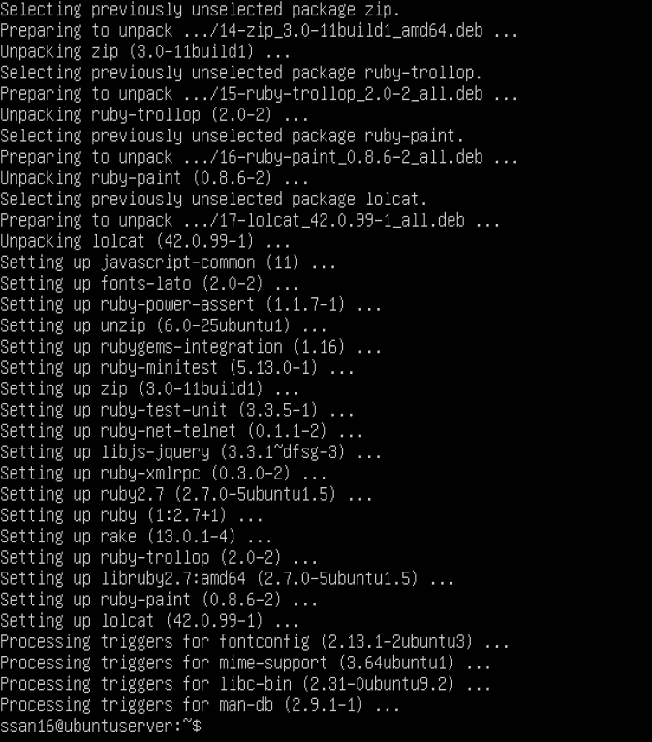

**Vim**

Vim is a text editor built to enable efficient text editing and it supports most file types. To install, in the command line you type: sudo apt-get install vim. My Operating system already has vim installed. All you have to do is type vim in command line and hit enter.

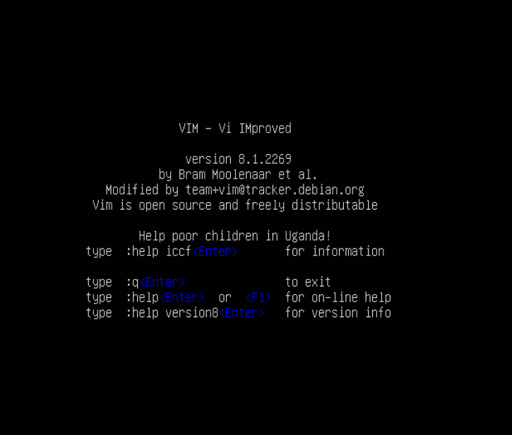

**Where are the files that were just installed?**

To locate these files, Type in the command line:

Apt-file list [file name]

For example, we are going to search for Tmux

Type in command line: apt-file list tmux

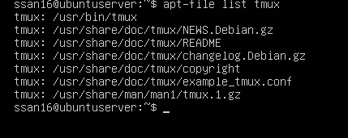

Search results will appear with the location.

**What is installed on my Ubuntu server?**

We are going to do a search for repositories that has been installed on the system. We are going to type on command line: apt list –installed

A list should look like the picture below.

**Where do repositories live on server and how to add/modify a repository.**

To list repositories in Ubuntu, type in command line: apt policy

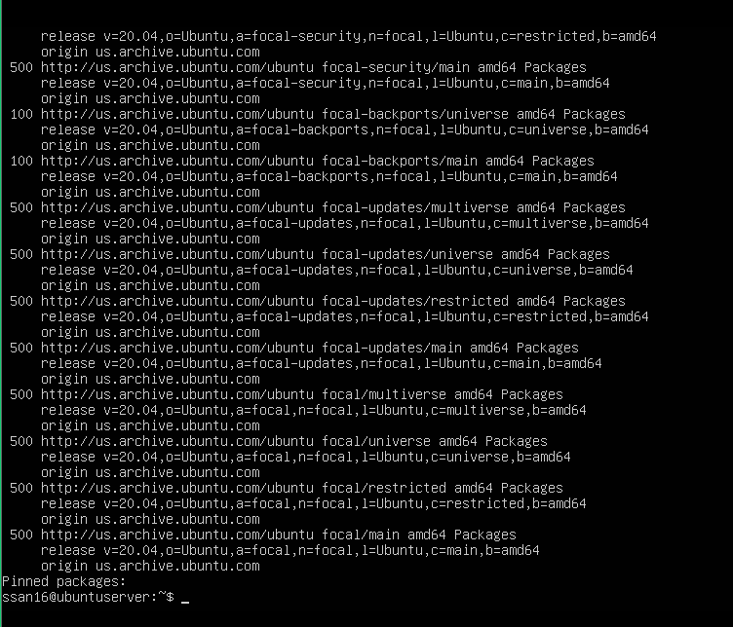

PPA stands for Personal Package Archive. Ppas are software repositories designed for ubuntu users.

An example on how to add a ppa on ubuntu server:

Type in command line: sudo add-apt-repository ppa:obsproject/obs-studio

Followed by password. Press enter then enter again.

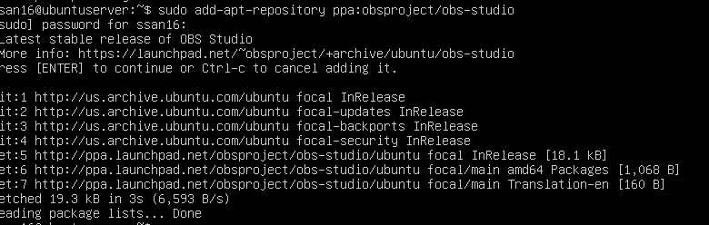

Just to verify that the ppa has been installed,

I typed in command line: sudo apt policy | grep obs

Searching in apt policy for obs in it using grep command. 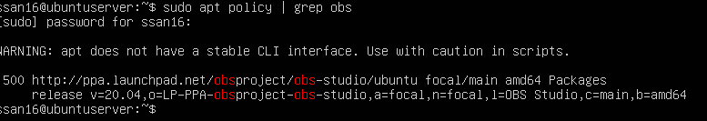

**Sources I used to complete assignment.**

<https://www.youtube.com/watch?v=-hVXW7dirFc>

<https://help.ubuntu.com/stable/ubuntu-help/addremove-ppa.html.en>

**http://manpages.ubuntu.com/manpages/trusty/man1/apt-file.1.html**

[**https://acloudguru.com/blog/engineering/linux-commands-for-beginners-sudo**](https://acloudguru.com/blog/engineering/linux-commands-for-beginners-sudo)

[**https://phoenixnap.com/kb/tmux-tutorial-install-commands**](https://phoenixnap.com/kb/tmux-tutorial-install-commands)

[**https://opensource.com/resources/what-emacs#:~:text=Emacs%20is%20a%20text%20editor,it%20for%20nearly%2040%20years**](https://opensource.com/resources/what-emacs#:~:text=Emacs%20is%20a%20text%20editor,it%20for%20nearly%2040%20years)**.**

[**https://www.howtogeek.com/675010/how-to-secure-your-linux-computer-with-fail2ban/**](https://www.howtogeek.com/675010/how-to-secure-your-linux-computer-with-fail2ban/)

[**https://www.howtoinstall.me/ubuntu/18-04/cowsay/**](https://www.howtoinstall.me/ubuntu/18-04/cowsay/)

[**https://www.tecmint.com/lolcat-command-to-output-rainbow-of-colors-in-linux-terminal/**](https://www.tecmint.com/lolcat-command-to-output-rainbow-of-colors-in-linux-terminal/)

**https://www.geeksforgeeks.org/getting-started-with-vim-editor-in-linux/**