Document Title: System Architecture Document
Document ID: HS-DES-001
Version: 1.0 Status: DRAFT
Author: Sandhya Patel
Date: September 8, 2025

1.0 Introduction
This document provides a high-level overview of the HydroSync system architecture. It describes the major subsystems and the interfaces between them. This document is the primary architectural reference for all detailed design activities. The architecture is designed to meet the requirements specified in the Product Requirements Document (HS-REQ-001).
2.0 System Architecture Diagram
This diagram illustrates the primary components of the HydroSync system and the flow of data between them.
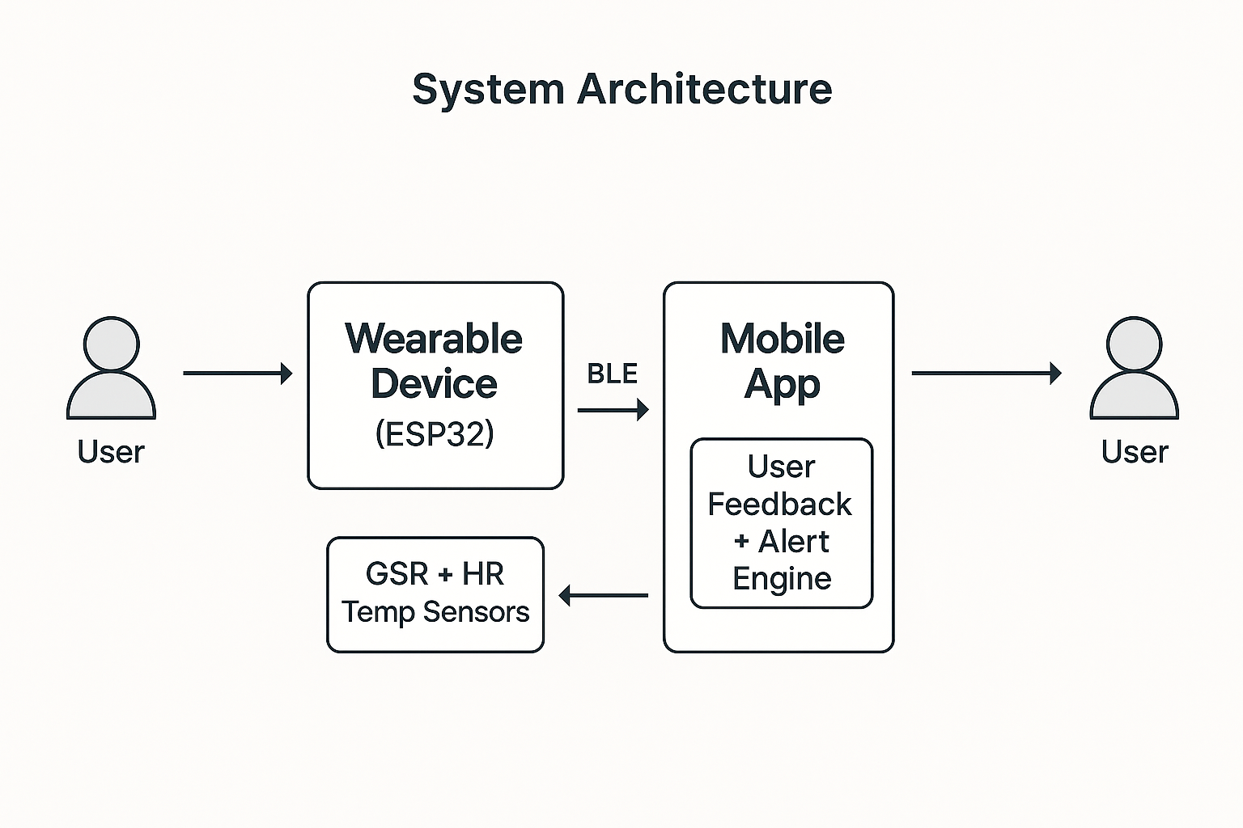
3.0 Subsystem Descriptions
The HydroSync system is composed of four primary subsystems:
3.1 Wearable Hardware Subsystem This subsystem consists of all physical components of the wearable device. Its function is to acquire physiological signals from the user and provide the platform for the firmware.
- Processing Unit: ESP32 Microcontroller. Chosen for its integrated Wi-Fi and Bluetooth Low Energy (BLE) capabilities.
- Physiological Sensors:
  - Galvanic Skin Response (GSR) Sensor.
  - Pulse/Heart Rate Variability (HRV) Sensor (e.g., MAX30100 PPG-based sensor).
  - Skin Temperature Sensor (e.g., LM35).
- Power Source: Rechargeable Li-Ion Battery. Target capacity to provide ≥ 5 hours of continuous operation.
3.2 Wearable Firmware Subsystem This subsystem consists of the software running on the ESP32 microcontroller. Its function is to control the hardware, acquire and process sensor data, and manage wireless communication.
- Development Environment: Arduino IDE.
- Core Functions:
  - Read sensor inputs at regular, configurable intervals.
  - Apply basic preprocessing to raw signals (e.g., smoothing, filtering).
  - Package data for transmission.
  - Manage the BLE communication link and data transmission protocol.
3.3 Communication Subsystem This subsystem defines the protocol for wireless data transfer between the wearable and the mobile application.
- Protocol: Bluetooth Low Energy (BLE).
- Performance: The protocol shall support a data transmission latency of ≤ 2 seconds.
- Range: The target operational range is approximately 10 meters.
- Optional Extension: The ESP32's Wi-Fi capability can be used for direct data upload to a cloud server as a future extension.
3.4 Mobile Application Subsystem This subsystem is the user-facing software that runs on a smartphone. It receives, displays, and logs data, and provides alerts and feedback to the user.
- Target Platform: Android, with potential for cross-platform deployment.
- User Interface (UI): Designed in Figma. The UI shall include a dashboard for live status, a trends screen for historical data, and an alerts screen, as defined in HS-REQ-001.
- Data Handling: The application receives BLE data packets, parses them, and stores the data locally on the device.
- Analytics: The application computes and displays derived metrics such as a relative hydration status and a fatigue score from the raw sensor data.

