Document Title: Hardware Design Document (HDD)
Document ID: HS-DES-002 Version: 1.0 Status: DRAFT
Author: Sandhya Patel
Date: September 8, 2025

1.0 Introduction
This document provides the detailed design specifications for the HydroSync Wearable Hardware Subsystem. It details the component selection, the electronic schematic, and the bill of materials required for assembly. This design implements the hardware requirements defined in HS-REQ-001 and adheres to the architecture specified in HS-DES-001.
2.0 Component Selection
The following major components have been selected for the prototype. The rationale for each selection is provided.
- Microcontroller: ESP32
  - Rationale: This component was selected for its integrated Wi-Fi and Bluetooth Low Energy (BLE) capabilities, which directly meets REQ-007. Its processing power is sufficient for the data acquisition and preprocessing tasks outlined in REQ-006.
- Heart Rate / HRV Sensor: MAX30100
  - Rationale: This is a readily available, integrated pulse oximetry and heart-rate monitor sensor module. It uses photoplethysmography (PPG) to meet the requirement for HRV data collection (REQ-002).
- GSR Sensor: Seeed Studio Grove - GSR Sensor
  - Rationale: This is a commercial off-the-shelf module that simplifies the measurement of skin conductivity (REQ-001). It provides two electrodes and the necessary amplification circuitry.
- Temperature Sensor: LM35
  - Rationale: The LM35 is a low-cost, precision analog temperature sensor. Its output voltage is linearly proportional to the Celsius temperature, simplifying the firmware implementation required to meet REQ-003.
3.0 Schematic Diagram
This schematic details the electrical connections between the microcontroller and the selected sensor components.
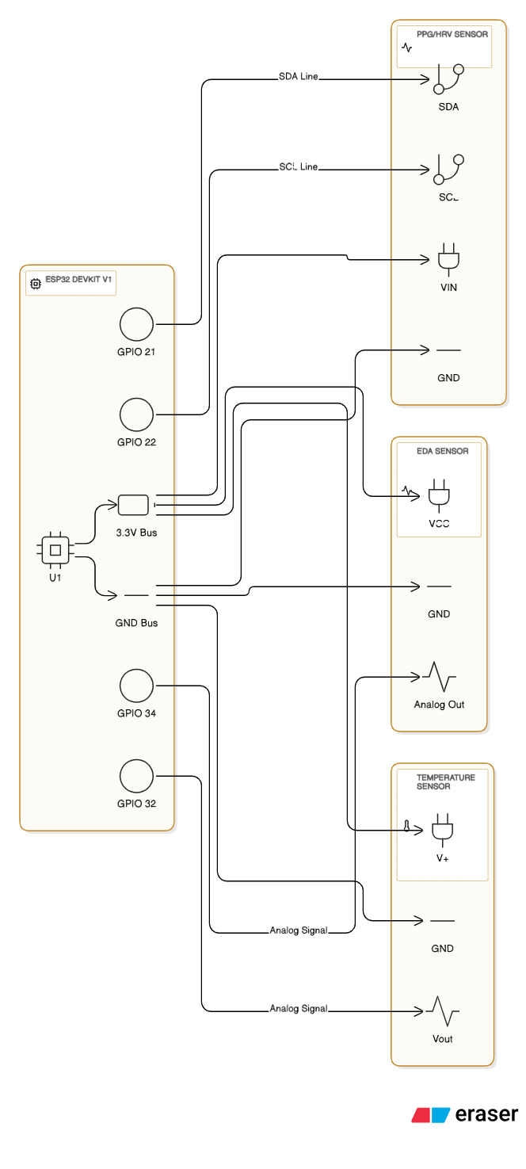
4.0 Bill of Materials (BOM)
Item ID | Part/Component | Quantity | Rationale / Link to Requirement | Column 1
BOM-001 | ESP32 Development Board | 1 | Fulfills REQ-004
BOM-002 | MAX30100 Module | 1 | Fulfills REQ-002
BOM-003 | Grove GSR Sensor Module | 1 | Fulfills REQ-001
BOM-004 | LM35 Temperature Sensor | 1 | Fulfills REQ-003
BOM-005 | Rechargeable Li-Ion Battery (500mAh) | 1 | Fulfills REQ-005
BOM-006 | Breadboard and Jumper Wires | 1 | For prototype assembly

