**Monitoring Operational and Financial Performance**

**Retail Strategy and Performance**

Different kinds of performance measures can be identified:

* productivity/effectiveness evaluation,
* inventory/supply chain evaluation,
* profit/turnover evaluation,
* financial performance evaluation.
* Productivity relates a single input factor to an output measure, other inputs assumed constant.
* Efficiency measures the effects of all inputs in combination and thus recognises that all inputs and the proportions in which they are employed may vary.
* Effectiveness takes into account goal achievement as well.

These measures are distinct, but there is a hierarchical relationship between them (Goodman 1985, p. 78): **“***High productivity is a necessary but not sufficient condition for high efficiency, as individual productive factors may not be combined in an optimal manner. Similarly, high efficiency is a necessary but not sufficient condition for high effectiveness, as the efficient combination may be directed to less than optimal goals*.”

**Productivity/Effectiveness Evaluation:**

The most common ratios are:

* sales per square metre (or square foot),
* sales per employee (i. e., per full-time equivalent, FTE).

The considerable differences within and between the sectors. It is important to note that the lower of these measures does not necessarily mean lower effectiveness. “A relatively high number and/or quality of staff may be a natural outcome of higher service positioning. Likewise, more space per unit of sales could reflect a more comfortable selling environment”.

**Inventory/Supply Chain Evaluation**

Retailers apply two main metrics for financial inventory control:

* stock turnover
* gross margin return on investment.

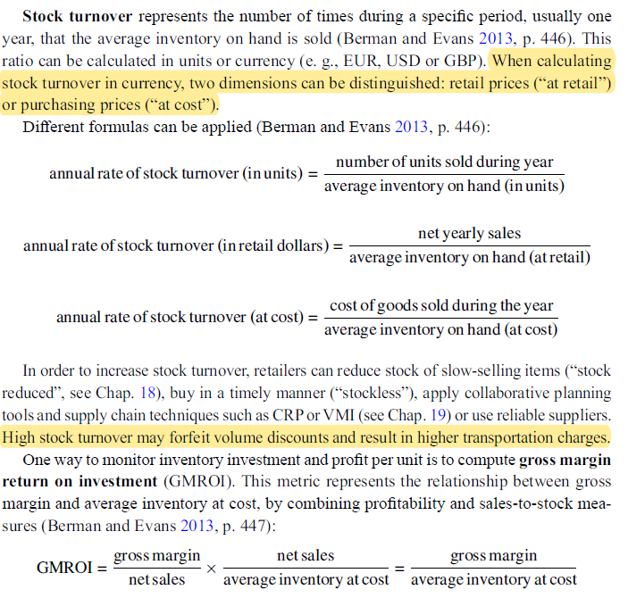

**Profit/Turnover Evaluation**

**Profitability Ratios**

Metrics from this group are designed to measure a retailer’s ability to achieve, sustain and increase profits (Dragun 2004a). Profitability can be measured by different indicators. One important relationship is between profits and sales (margin ratios); another dimension 444 20 Monitoring Operational and Financial Performance of profitability relates profits to capital. These so-called return ratios are discussed below within the context of financial performance evaluation.

The “top level” indicators of profitability are (Dragun 2004a):

* gross margin in %,
* net profit margin in %.

**Gross margin = net sales − costs of goods sold**

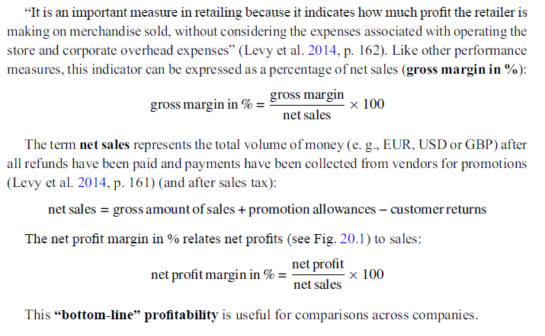

**Profit Path**

Expenses are the costs incurred by a retail company in the normal course of business. There are three types of retail operating expenses (Levy et al. 2014, p. 162):

* Selling expenses,
* general expenses,
* administrative expenses.

***Selling expenses*** comprise sales staff salaries, commission and benefits. ***General expenses*** include rent and utilities. ***Administrative expenses*** include salaries of all employees other than sales personnel, operational costs incurred by buying offices and other administrative expenses

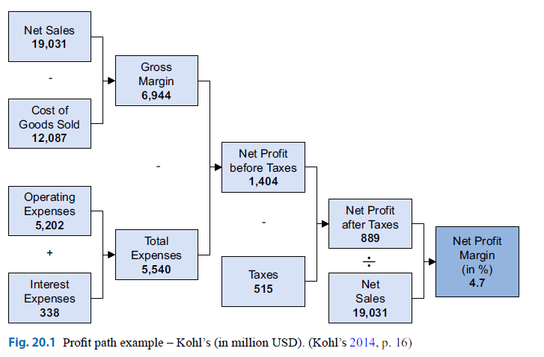

**Financial Performance Evaluation**

**Financial Ratios**

To evaluate the financial performances of retailers, financial ratios can be applied. In retail companies, four groups of financial ratios are utilised (Dragun 2004a):

* Internal liquidity ratios,
* return ratios,
* financial leverage ratios,
* earnings coverage ratios.

The limitations of ratio analysis have led to the development of a new class of measures called ***value metrics***. “The idea behind a value metric is simple and powerful: value is only created if the company generates return on capital exceeding the cost of that capital” (Dragun 2004a, p. 161).

**Liquidity Ratios**

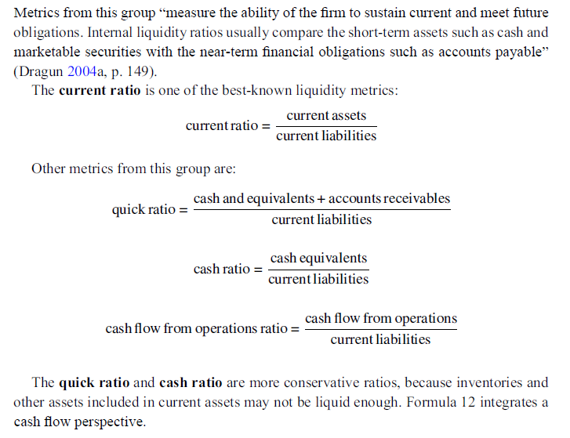

**Return Ratios and Return Path**

These metrics relate profits to capital in contrast to profitability ratios, which relate profits to sales. A “top-level” indicator measures the efficiency of a company in utilising assets for profit generation: return on assets (ROA). This indicator is usually calculated on an EBIT basis (earnings before (b) interest and taxes):



On an after-tax and after-interest basis (a), a second metric return on assets can be computed:



Other return metrics are return on invested capital (ROIC) and return on equity (ROE) (see Dragun 2004a; 2004b). Table 20.4 shows returns on assets (ROA) of selected retail companies operating worldwide.

The net profit margin model (Fig. 20.1) can be combined with the asset turnover model, which yields asset turnover by dividing net sales by total assets. As a result, the ROA path can be derived (see Fig. 20.2).

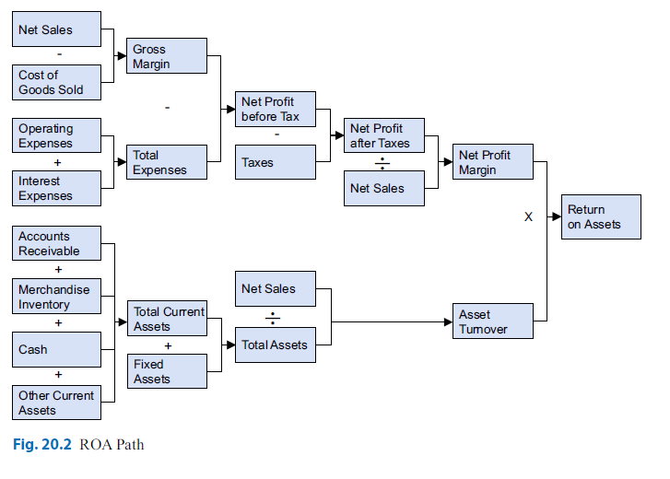

**Value Metrics**

**Economic Value Added**

These metrics measure the financial performances of firms by their ability to generate or add economic value. Measures of economic value include market value added (MVA), which is a purely stock market-based measure, and economic value added (EVA). Economic value added is computed according to formula (15) (see Dragun 2004a, p. 162):

**EVA = net operating profit .after taxes/−WACC ­ capital**

The weighted average cost of capital (WACC) is calculated as a weighted average of the costs of debt and the costs of equity capital. The costs of debt are the interest expenses required to serve the debt. “For equity, the cost is the rate of return on common stock expected by the shareholders” (Dragun 2004a, p. 161). These costs are more difficult to calculate because they depend “on the uncertain factors such as overall stock market risk, return expectations and the risk-free rate of return available to investors” (Dragun 2004a, p. 161).

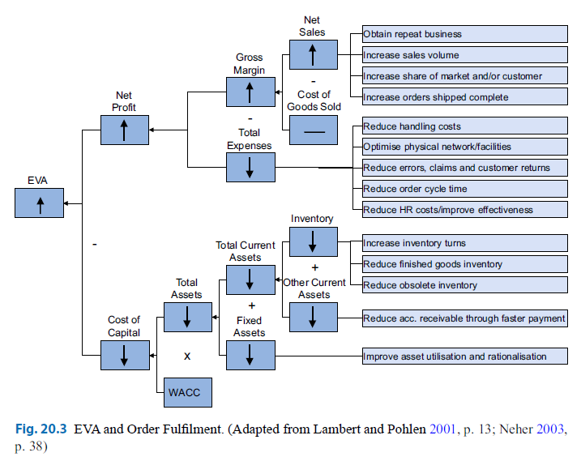

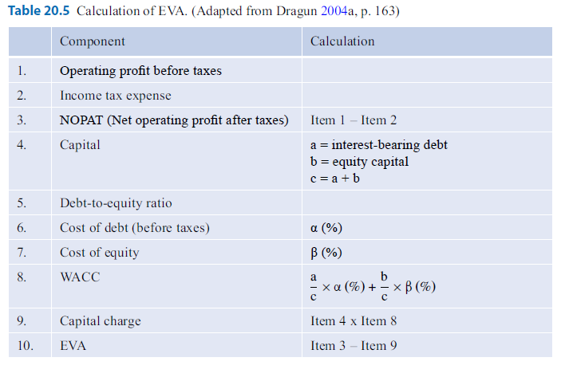**Retail Balanced Scorecard**

Apart from the concepts of monitoring operational and financial performance discussed here, new approaches have been developed in which the measurement of consumer satisfaction and other aspects comes to the fore. One of the most important concepts in this context is the balanced scorecard (BSC), proposed by Kaplan and Norton (1992; see also Morschett et al. 2015, pp. 543–545).

This is a specific, four-dimensional performance measurement system that comprises financial objectives as well as non-financial measures (see Fig. 20.4). “The balanced scorecard translates an organization’s mission and strategy into a comprehensive set of performance measures that provides the framework for a strategic measurement and management system. […] The BSC enables companies to track financial results while simultaneously monitoring progress in building the capabilities and acquiring the intangible assets they need for future growth” (Kaplan and Norton 1996, p. 2).

This concept can be adapted to retail companies. Fig. 20.5 illustrates the application of the balanced scorecard by the German department store chain *Breuninger*. They distinguish for performance dimensions: business finance, customer/market, goods/suppliers and internal processes & resources.

