Please could we have validation added to membermaint so that when agents enter the RCI Member Ids into membermaint the values they enter are validated as below?
The following validation rules would be for: (UK) only.
OVC Partner: RCI Cruise and Resort Holidays
Club url: www.rcicruiser.co.uk
Sub partner ID: 358
The rci member id is entered in the update member screen as below:
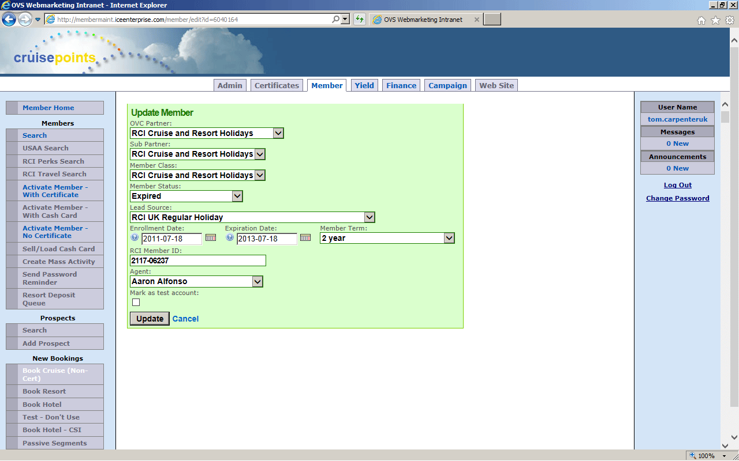
Validation rules:
1. RCI Member IDs can be input as 1 of 2 acceptable types & formats. Weeks or Points, please validate the entry of the member ID on the following rules.
RCI Weeks Member ID’s
An RCI weeks member ID must have the following format xxxx-xxxxx
An RCI weeks member ID must be 9 digits long
An RCI weeks member ID can have a letter (A-Z) but only as the very first value of the string. If a week’s member id starts with a letter it must be a capital letter / Uppercase letter. All other string values must be numeric values (0-9).
RCI Points Member ID’s
An RCI points member ID must have the following format x-xxxxx
An RCI points member ID will always begin with a 5- or a 1-
An RCI points member ID has no length constraint
An RCI points member ID must be numbers only, no other values are allowed only numeric values (0-9)
2. Ideally there would be 2 input fields that the agent has to enter the RCI member ID into and that both have to match.
3. Copy & paste on both input fields would ideally be disabled so as to encourage diligence.
If the format of the RCI member ID does not match the above criteria, or the agent has not entered the RCI member ID correctly in both input fields an error message will be displayed to the agent & the number will not be saved so the agent will not be able to proceed.

