[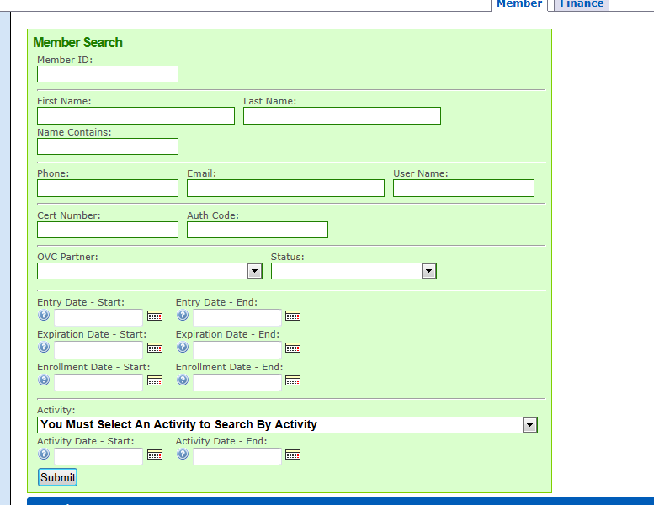  
http://membermaint.iceenterprise.com/member/search](http://membermaint.iceenterprise.com/member/search)