## CHAPTER 1

**INTRODUCTION**

Recipe app displays the list of food recipes on the web page, as requested by the user. To display a list of recipes, we require an Application Program Interface (API) which will fetch all the data from a database which is hosted somewhere else. A programmer writing an application program can make a request to the Operating System using API (using graphical user interface or command interface). It is a set of routines, protocols and tools for building software and applications.

The API used in this application is the Food2Fork’s recipe API. Food2Fork offers an API which exposes its powerful recipe discovery functions for the application to use. The API gives access to their ever expanding recipe database, powerful ingredient search function, and social-media based ranking algorithm. Any request will return a maximum of 30 results.

## ORGANIZATION/INDUSTRY

## 1.1.1 Company Profile

## "The Valley Bootcamp" is an intensive coding bootcamp in Bangalore. They teach us to code, to solve problems and become great Engineers. The Full Stack Web Development course is aimed at teaching technologies that are used to build powerful, multi-user web applications. The technologies covered was React JS on the front-end and NodeJS + MongoDB on the backend. They taught us how a REST API works, how APIs are used all the web today to power multi-platform applications and build a few along the way.

## 1.1.2 Domain/Technology (Web Development)

## Web development is the work involved in developing a [web site](https://en.wikipedia.org/wiki/Web_site) for the [Internet](https://en.wikipedia.org/wiki/Internet) ([World Wide Web](https://en.wikipedia.org/wiki/World_Wide_Web)) or an [intranet](https://en.wikipedia.org/wiki/Intranet) (a private network). Web development can range from developing a simple single static page of plain text to complex web-based internet applications, electronic businesses and social network services. The frontend tools used were HTML, CSS, React JS. The backend tools used include MongoDB, Node JS and Express API. The project developed during the internship is “React Recipe App”. This website is hosted on Heroku Platform.

## 1.2 PROBLEM STATEMENT

## 1.2.1 Existing system and their limitations

## In paper [1], we can infer that in today’s hectic world of work loaded life, there is no time for an individual to give a dedicated schedule for making his daily meals. You just want to relax after returning from work, either by ordering in a takeaway or heading out to a delicious establishment near you. At times it becomes a very tedious work for humans to think on, for what to make at dinner in such limited materials available. The food industry is an underserved market. The possibilities are wide-open, and the competition is scarce. Entrepreneurs can easily make a quick turn around by providing a much needed service.

## 1.2.2 Proposed solution

We are hence, developing an Android Application which would make the task of preparing meals a less tensed for an individual. The system is an innovative new recipe search engine which finds recipes you can make with the ingredients you currently have athand.

In paper [2], In today’s world a person can prepare a dish either by asking another person who has acquired such knowledge of cooking or by reading certain cooking recipe books, and gaining self-knowledge by owning such books. Another way of making delicious recipes is by searching for the recipes over the internet, read the instructions and prepare it. In most of the cases every person visiting a website, already know a name, by which he searches the website for the dish. We have come up with this unique idea of preparing meals just by providing ingredients to the system. Just add your ingredients and Foodie instantly finds matching recipes to give the required meals you want in a jiffy. We're all about good recipes, and about quality home cooking that everyone can enjoy. If you have a little gourmand at home, let him try his hand at making dinner with these simple methods to prepare a meal. It is like having a TV cooking show 'cheftestant' with you in the kitchen who always knows what to make, no matter what random ingredients are in your 'mystery basket'. The study therefore aimed at developing an application to enable user’s search for whatever recipes they are interestedin.

## 1.2.3 Problem formulation

The goal of this project is to create an application that is accessible to everyone. The app will be easy to use with a variety offeatures available. These features will include a hierarchy of how different foods are related to one another and a recipe generator. You can just start by typing in the names of the ingredients that you already have in hand. Searching by the ingredients allows you to set your parameters based on what you have. Apart from searching the recipes based on ingredients, this application also gives step by step cooking procedures, nutritional details of the recipes, reviews of the users and also the video directions to prepare that particular food item.

**CHAPTER 2**

**REQUIREMENT ANALYSIS,**

**TOOLS & TECHNOLOGS**

**2.1 Hardware & Software Requirements**

**Hardware requirements**

* + - * 64-bitprocessor
      * Internet Connectivity 100Mbps
      * 8 GBmemory

**Software requirements**

* Download [npm](https://www.npmjs.com/get-npm)
* Install React
* Download and installnode.js
* Install [React CLI](https://www.npmjs.com/package/react-cli)
* Install yarn
* Install SASS
* Operating System: Windows10
* VS Code editor

**2.2 Functional requirements**

* View Recipe: The user shall be able to see the recipes posted by other users. In other words, the user shall be able to access the Recipe Forum.
* Search for a Recipe: Any user shall able to search for a recipe using the title as a criterion. The search functionality will provide the users with a shortcut to find their targeted recipes if posted earlier.
* View Ingredients: The user of the app shall be able to view ingredients of recipe.

**2.3 Tools/Languages/Platform**

**2.3.1. MERN stack**

A stack is the combination of technologies used to create a web application. Any web application will be made using multiple technologies (frameworks, libraries, databases etc).The MERN stack is a JavaScript stack that’s designed to make the development process smoother. MERN includes four open-source components: MongoDB, Express, React, and Node.js. These components provide an end-to-end framework for developers to workin.

**2.3.2. MONGO DB**

MongoDB is a cross-platform document database [MongoDB](https://www.mongodb.com/) is a NoSQL (non-relational) document-oriented database. MongoDB is known for being flexible and easy to scale. It is written in C++.While conventional relational databases have a typical schema design based on columns and tables, MongoDB is schema-less. Data is stored in flexible documents with JSON(Java Script Object Notation) based query language. The content,size and number of fields in the documents can differ from one to the next. This means that the data structure to be changed over time.

Database is a physical container for collections. Each database gets its own set of files on the file system. A single MongoDB server typically has multipledatabases.

Collection is a group of MongoDB documents. It is the equivalent of an RDBMS table. A collection exists within a single database. Collections do not enforce a schema. Documents within a collection can have different fields. Typically, all documents in a collection are of similar or related purpose.

**2.3.3. EXPRESS JS**

Express is a minimal and flexible Node.js web application framework that provides a robust set of features for web and mobile applications. It is an open source framework developed and maintained by the Node.js foundation.

A back-end web application framework for Node.js, another MERN component. Instead of writing full web server code by hand on Node.js directly, developers

to repeat the same code over and over, as you would with the Node.js HTTP module.

The Express framework is designed for building robust web applications and APIs. It’s known for its fast speed and minimalist structure, with many features available asplugins.

**2.3.4. REACT JS**

React was originally created by a software engineer at Facebook, and was later open- sourced. It is maintained by Facebook, as well as a community of development companies and individualdevelopers.

The React library can be used for creating views rendered in HTML. React views are declarative. This means that developers don’t have to worry about managing the effects of changes in the view’s state (the object that determines how components behave) or changes in the data. Instead of relying on templates to automate the creation of repetitive HTML or DOM (Document Object Model) elements, React uses a full-featured programming language (JavaScript) to construct repetitive or conditional DOMelements.

**2.3.5. NODE JS**

It is built on Chrome’s V8 JavaScript engine. It’s designed to build scalable network applications, and can execute JavaScript code outside of a browser.

Node.js works without an enclosing HTML page, instead using its own module system based on CommonJS, to put together multiple JavaScript files.

Here are the benefits of using Node.js

* + - 1. Easy Scalability: Developers prefer to use Node.js because it is easily scale the application in both horizontal and vertical direction. We can also add extra resources during the scalability ofapplication.
      2. Real time web apps:If you are building a web app you can also use PHP and it will take the same amount of time when you use Node.js, But if I am talking about building chat apps or gaming apps Node.js is much more preferable because of faster synchronization. Also, event loop avoid HTTP overload for Node.js development.
      3. Fast Suite:NodeJs runs on the V8 engine developed by Google. Event loop in NodeJs handles all asynchronous operation so NodeJs acts like a fast suite and all the operations can be done quickly like reading or writing in the database, network connection or filesystem
      4. Easy to learn and code:NodeJs is easy to learn and code because it uses JavaScript. If you are a front-end developer and have a good grasp on JavaScript you can easily learn and build the application onNodeJS
      5. Advantage of Caching:It provides the caching of single module. Whenever there is any request for the first module, it gets cached in the application memory so you don’t need to re-execute thecode.
      6. Data Streaming:In NodeJs HTTP request and response are considered as two separate events. They are data stream so when you process a file at the time of loading it will reduce the overall time and will make it faster when the data is presented in the form of transmissions. It also allows you to stream audio and video files at lightningspeed.

**CHAPTER 3**

**DESIGN AND IMPLEMENTATION**

* 1. **Algorithms/Methods/Pseudocode**

**3.1.1 Importing libraries**

import React from 'react';

import ReactDOM from 'react-dom';

import'bootstrap/dist/css/bootstrapmin.css';

import Router from './components/Router';

import * as serviceWorker from './serviceWorker';

#### 3.1.2 Recipe details

#### import React from 'react';

#### import { Link } from 'react router-dom' function Recipe(props) {

#### return (

<div className="col-md-4" style={{ marginBottom: "2rem" }} >

<div className="recipesbox">

<img className="recipeboximg" src={props.data.image_url} alt={props.data.recipe_i} />

<div className="recipetext">

<h5 className="recipestitle{props.data.title}</h5>

<p className="recipessubtitle">Publisher:

<span>{props.data.publisher}</span>

</p>

</div>

<button className="recipe_buttons">

<Link to={{pathname:`/recipe/${props.data.recipe_id}`state: props.datA}}>View Recipe

</Link>

</button>

</div>

</div>

);

}

export default Recipe;

**3.1.3 Search**

FunctionSearchBar(props){ return(

<form style={{ marginBottom:"2rem" }} onSubmit={(e)=>{

e.preventDefault(); props.onSubmit(e.target.recipeName.value);}}>

<input className="forminput" type="text name="recipeName"/>

<input className="formbutton" type="submit" />

</form>

);

}

#### 3.1.4 Router

function Router( ) { return (

<BrowserRouter>

<Switch>

<Route exact path="/" component={App} />

<Route path="/recipe/:id" component={RecipeDetail}/>

</Switch>

</BrowserRouter>

);

}

.

# CHAPTER 4

**OBSERVATION AND RESULTS**

**4.1 TESTING**

**Software Testing** is the process used to help identify the correctness, completeness, security and quality of the developed computer software. Testing is the process of technical investigation and includes the process of executing a program with the intent of finding errors.

## 4.1.1 Unit Testing

1. Record valid input is checked to see if it is of characters:
   * Valid set of characters.
   * Characters uppercase or lowercase.

Table 7.1 Unit test case for Record valid input check

|  |  |
| --- | --- |
| Sl No. of test case | 1 |
| Name of test | Check test |
| Feature being tested | Valid input |
| Sample Input | Apple |
| Expected output | Prompt of list of all images of apple recipes along with view recipe button at bottom corner of the image. |
| Actual output | List of all images of apple recipes along with view recipe button. |
| Remarks | Test succeeded |

## 

## Figure 7.1 Unit testing result of search

The above figure shows the unit testing result for input.

## 4.1.2 Integration Testing

1. The submit is checked to see whether it accepts a proper input and gives a proper result to the user. Here validation is made by checking the set of characters typed by the user.

Table 7.2 Integration test case for submit

|  |  |
| --- | --- |
| Sl No. of test case | 1 |
| Name of test: | Integration Test Check |
| Feature being tested | Submit button |
| Sample Input | Cheese |
| Expected output | On click it must validate the input and produce a page with all recipes with images. |
| Actual output | A page with recipes along with their images are displayed. |
| Remarks | Test succeeded |

## 

Figure 7.2 Integration test result for submit button

The above figure shows the integration testing when pressed on submit button. The view button is checked to see whether on click displays the page with detailed recipe of food to prepare.

Table 7.3 Integration test case for view recipe

|  |  |
| --- | --- |
| Sl No. of test case | 2 |
| Name of test: | Integration Test Check1 |
| Feature being tested | VIEW RECIPE |
| Sample Input | Pineapple |
| Expected output | On click it must display the page of detailed recipe of food when user clicks at bottom corner of image. |
| Actual output | A page with detailed recipe along with their images are displayed. |
| Remarks | Test succeeded |

The above figure shows the integration testing when pressed on submit button.The view button is checked to see whether on click displays the page with detailed recipe of food to prepare.

Table 7.3 Integration test case for view recipe

|  |  |
| --- | --- |
| Sl No. of test case | 2 |
| Name of test: | Integration Test Check1 |
| Feature being tested | VIEW RECIPE |
| Sample Input | Pineapple |
| Expected output | On click it must display the page of detailed recipe of food when user clicks at bottom corner of image. |
| Actual output | A page with detailed recipe along with their images are displayed. |
| Remarks | Test succeeded |

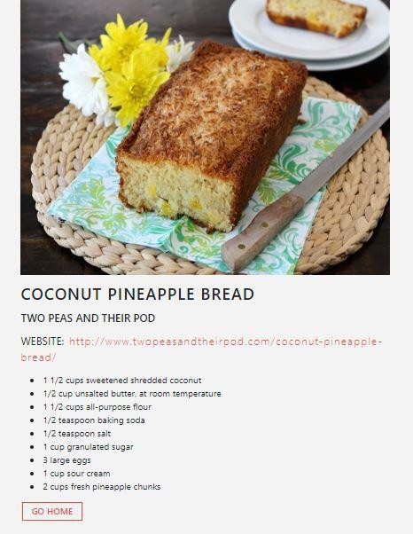

Figure 7.3 Integration test for view recipe

3.Integration testing for go home which displays the home page when clicked.

Table 7.4 Integration Testing for GO HOME

|  |  |
| --- | --- |
| Sl No. of test case | 3 |
| Name of test: | Integration Test Check2 |
| Feature being tested | GO HOME |
| Sample Input | Mango |
| Expected output | On click it must display the home page |
| Actual output | Home page is displayed |
| Remarks | Test succeeded |

The below figure shows the integration test results for go home

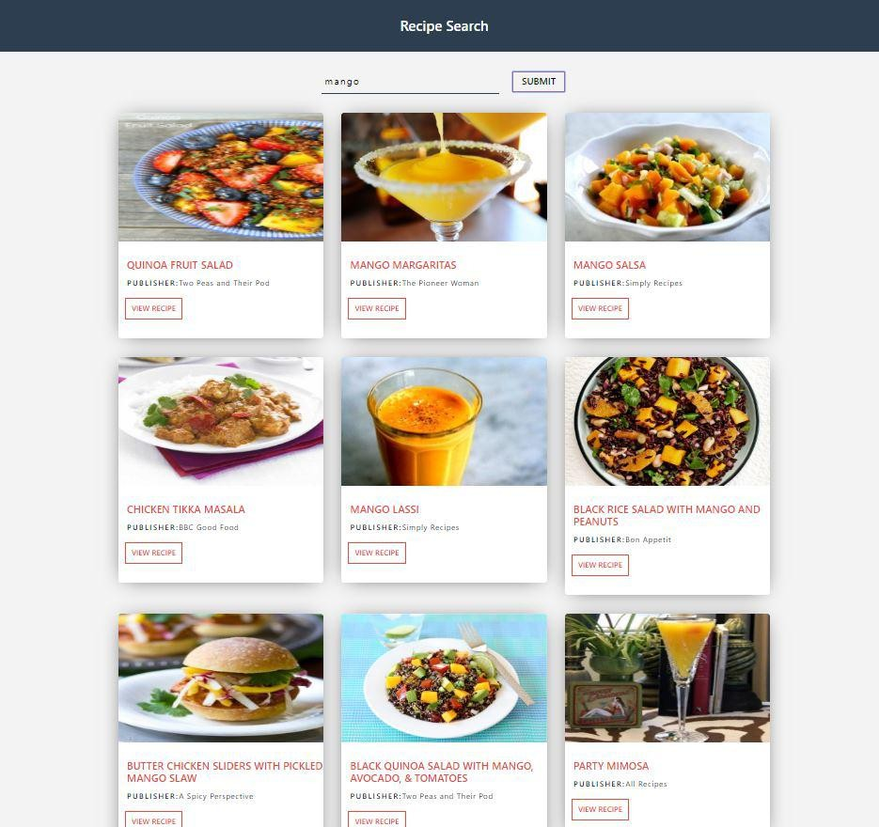 Figure 7.4 Integration test for go home

## 4.1.3 System Testing

System testing is a level of the software testing where a complete and integrated software is tested. The purpose of this test is to evaluate the system’s compliance with the specified requirements. The program is run to check if all the modules can be executed concurrently, if each return correct results of the operations performed by them.

Table 7.5 System test for Recipe Lists

|  |  |
| --- | --- |
| Sl No. of test case | 1 |
| Name of test: | System Test Check |
| Feature being tested | Recipe Lists |
| Sample Input | Choice of selective buttons provided like submit, view recipe, go home. |
| Expected output | Pages are to be displayed based on the click performed. |
| Actual output | Pages are displayed for all responsive buttons. |
| Remarks | Test succeeded |

The below figure shows the system testing results for recipe lists.

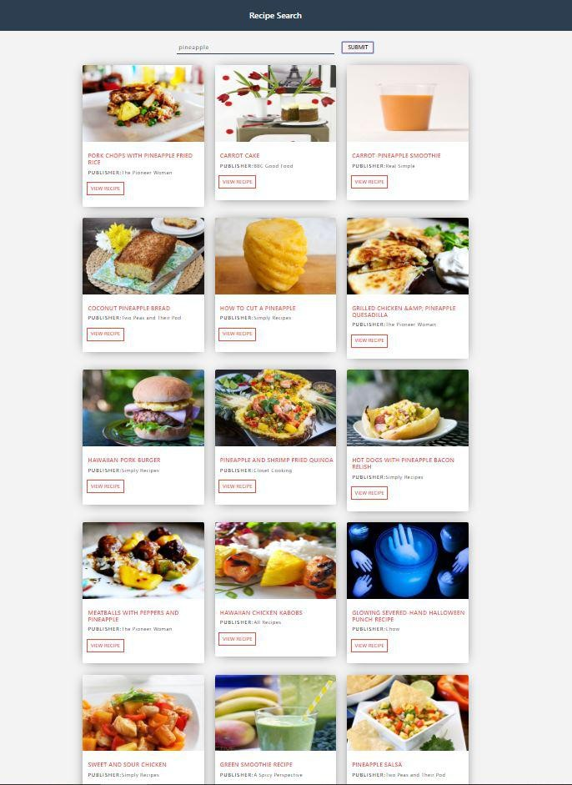 Figure 7.5 System test for Recipe Lists

## 4.1.4 Acceptance Testing

Acceptance testing, a testing technique performed to determined whether or not the software system has met the requirement specifications. The main purpose of this test is to evaluate the system’s compliance with the business requirements and verify if it has met the required criteria for delivery to end users.

There are three important forms of acceptance testing they are, Alpha testing, Beta testing and User acceptance testing.

**Alpha testing:** is a type of acceptance performed to identify all possible issues/bugs before releasing the product to everyday users or the public.

**Beta testing:** it is released to a limited number of end users of the product to obtain feedback on the product quality.

The below figure shows the acceptance testing made by the user.

Figure 7.6 Acceptance Testing done by the users

4.2 **Results and Snapshots**

The outcomes of test results for a variety of input images and user interactions with the application are discussed in the following sections of the chapter

### Menu

### 

The menu page shown below is the first page that appears when searched for web application which gives user to type the food item for which recipe is to be searched.

#### Figure 8.1Menu Page

* 1. **Suggestion for Search**

The suggestions page shown below are shown on menu page while doing a search for recipe for a particular ingredient.

#### Figure 8.2 Suggestions

* 1. **Search**

The above figure shows a page where search for recipe is done.

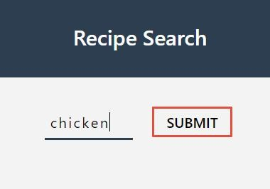 Figure 8.3 Search Page

### Result of search

The page shown below shows the result for the particular item for which recipe is searched.

#### Figure 8.2 Search results for item

* 1. **Particular Page for Search**

The below figure shows the result for a particular page of recipe and ingredients for a particular item.

Figure 8.4 Particular Page 

**Go Home Page**

The figure shown below has a button GO HOME at the end of each recipe page which redirects to home page i.e. Menu Page.

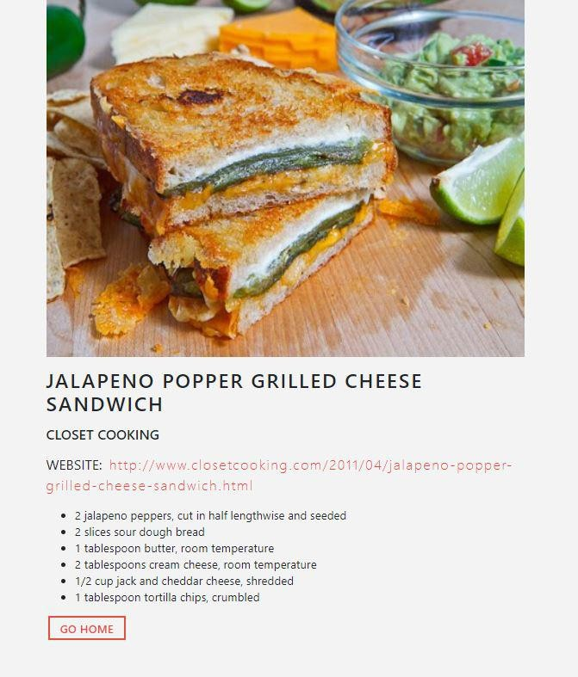Figure 8.5 Go Home Page

**CHAPTER 5**

**CONCLUSION AND FUTURE ENHANCEMENTS**

The recipe web application allows users to search for an item that can be used in a food recipe. This web application redirects the user to the page where the results of food recipes are shown. Based on requirements of food to be prepared the user can view the recipe page by clicking on VIEW RECIPE button present at the bottom corner of each image.

This web application is helpful to the user where it gives the user some of the delicious recipes for item searched. It is improvement of technology which replaces olden days recipe books and very easy to use.

* + - This web application can be further enhanced by allowing users to update their recipes in the web application so that other users can see that.
    - User can be given an option to rate the recipe so it will be helpful for other users to select the recipe.

**REFERENCES**

#### [1] https://www.freecodecamp.org

#### [2] https://www.w3schools.com

#### [3] https://www.stackoverflow.com

#### [4] https://www.reactjs.org

#### [5] https://www.tutorialspoint.com

#### [6] Fundamentals of Web Development by Randy Connolly, Ricardo Hoar

#### [7] The Little MongoDB Book by Karl Seguin

#### [8] https://www.javatpoint.com