AbstractFactory:

### Intent

* Provide an interface for creating families of related or dependent objects without specifying their concrete classes.
* A hierarchy that encapsulates: many possible "platforms", and the construction of a suite of "products".
* The new operator considered harmful.

The purpose of the Abstract Factory is to provide an interface for creating families of related objects, without specifying concrete classes.

Abstract Factory patterns work around a super-factory which creates other factories. This factory is also called as factory of factories. This type of design pattern comes under creational pattern as this pattern provides one of the best ways to create an object.

In Abstract Factory pattern an interface is responsible for creating a factory of related objects without explicitly specifying their classes. Each generated factory can give the objects as per the Factory pattern.

**Implementation**

We are going to create a *Shape* and *Color* interfaces and concrete classes implementing these interfaces. We create an abstract factory class *AbstractFactory* as next step. Factory classes *ShapeFactory* and *ColorFactory* are defined where each factory extends *AbstractFactory*. A factory creator/generator class *FactoryProducer* is created.

*AbstractFactoryPatternDemo*, our demo class uses *FactoryProducer* to get a *AbstractFactory* object. It will pass information (*CIRCLE / RECTANGLE / SQUARE* for *Shape*) to *AbstractFactory* to get the type of object it needs. It also passes information (*RED / GREEN / BLUE* for *Color*) to *AbstractFactory* to get the type of object it needs.

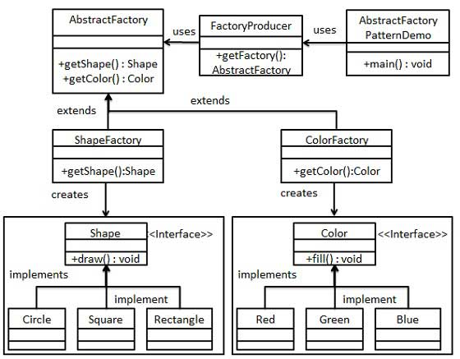

**Step 1**

Create an interface for Shapes.

*Shape.java*

public interface Shape {

void draw();

}

**Step 2**

Create concrete classes implementing the same interface.

*Rectangle.java*

public class Rectangle implements Shape {

@Override

public void draw() {

System.out.println("Inside Rectangle::draw() method.");

}

}

*Square.java*

public class Square implements Shape {

@Override

public void draw() {

System.out.println("Inside Square::draw() method.");

}

}

*Circle.java*

public class Circle implements Shape {

@Override

public void draw() {

System.out.println("Inside Circle::draw() method.");

}

}

**Step 3**

Create an interface for Colors.

*Color.java*

public interface Color {

void fill();

}

**Step4**

Create concrete classes implementing the same interface.

*Red.java*

public class Red implements Color {

@Override

public void fill() {

System.out.println("Inside Red::fill() method.");

}

}

*Green.java*

public class Green implements Color {

@Override

public void fill() {

System.out.println("Inside Green::fill() method.");

}

}

*Blue.java*

public class Blue implements Color {

@Override

public void fill() {

System.out.println("Inside Blue::fill() method.");

}

}

**Step 5**

Create an Abstract class to get factories for Color and Shape Objects.

*AbstractFactory.java*

public abstract class AbstractFactory {

abstract Color getColor(String color);

abstract Shape getShape(String shape) ;

}

**Step 6**

Create Factory classes extending AbstractFactory to generate object of concrete class based on given information.

*ShapeFactory.java*

public class ShapeFactory extends AbstractFactory {

@Override

public Shape getShape(String shapeType){

if(shapeType == null){

return null;

}

if(shapeType.equalsIgnoreCase("CIRCLE")){

return new Circle();

}else if(shapeType.equalsIgnoreCase("RECTANGLE")){

return new Rectangle();

}else if(shapeType.equalsIgnoreCase("SQUARE")){

return new Square();

}

return null;

}

@Override

Color getColor(String color) {

return null;

}

}

*ColorFactory.java*

public class ColorFactory extends AbstractFactory {

@Override

public Shape getShape(String shapeType){

return null;

}

@Override

Color getColor(String color) {

if(color == null){

return null;

}

if(color.equalsIgnoreCase("RED")){

return new Red();

}else if(color.equalsIgnoreCase("GREEN")){

return new Green();

}else if(color.equalsIgnoreCase("BLUE")){

return new Blue();

}

return null;

}

}

**Step 7**

Create a Factory generator/producer class to get factories by passing an information such as Shape or Color

*FactoryProducer.java*

public class FactoryProducer {

public static AbstractFactory getFactory(String choice){

if(choice.equalsIgnoreCase("SHAPE")){

return new ShapeFactory();

}else if(choice.equalsIgnoreCase("COLOR")){

return new ColorFactory();

}

return null;

}

}

**Step 8**

Use the FactoryProducer to get AbstractFactory in order to get factories of concrete classes by passing an information such as type.

*AbstractFactoryPatternDemo.java*

public class AbstractFactoryPatternDemo {

public static void main(String[] args) {

//get shape factory

AbstractFactory shapeFactory = FactoryProducer.getFactory("SHAPE");

//get an object of Shape Circle

Shape shape1 = shapeFactory.getShape("CIRCLE");

//call draw method of Shape Circle

shape1.draw();

//get an object of Shape Rectangle

Shape shape2 = shapeFactory.getShape("RECTANGLE");

//call draw method of Shape Rectangle

shape2.draw();

//get an object of Shape Square

Shape shape3 = shapeFactory.getShape("SQUARE");

//call draw method of Shape Square

shape3.draw();

//get color factory

AbstractFactory colorFactory = FactoryProducer.getFactory("COLOR");

//get an object of Color Red

Color color1 = colorFactory.getColor("RED");

//call fill method of Red

color1.fill();

//get an object of Color Green

Color color2 = colorFactory.getColor("Green");

//call fill method of Green

color2.fill();

//get an object of Color Blue

Color color3 = colorFactory.getColor("BLUE");

//call fill method of Color Blue

color3.fill();

}

}

**Step 9**

Verify the output.

Inside Circle::draw() method.

Inside Rectangle::draw() method.

Inside Square::draw() method.

Inside Red::fill() method.

Inside Green::fill() method.

Inside Blue::fill() method.