A Practical Guide To Automated Testing of Legacy Applications
Shachi M. Sapre
September 2015

Revision History
Date | Version | Description | Author
11/2014 | 0.1 | Basic Guide for test development | TC
8/2015 | 0.2 | Initial working version from Guide, script notes and accumulated experience | SS
9/4/2015 | 0..3 | First review version | SS
9/8/2015 | 0.4 | Updated with excerpt from initial guide text | SS
9/14/2015 | 0.5 | Updated with screen shots from TA | SS
9/24/2015 | 0.6 | Technical review, edit, first review copy | SS
9/28/2015 | 0.7 | Second Technical review, formatting for publication | SS/TC
10/1/2015 | 1.0 | First released version | SS

CONTENTS
Table of Figures iv
Introduction 1
Authorship 1
Limitations 1
Overview 2
Analysis and Discussion/ Evaluation 2
Creating and Editing Test Scripts: 3
Viewing recorded test scripts 5
Working with the Smart Recorder 7
Working with the Web Recorder 10
Aggregating Script Blocks into a Test Task 12
Looping in testing 12
Viewing Test Results 13
Creating exe files 14
Executing Completed Test Scripts: 14
Appendix A – Sample Testing Anywhere Test Script Development Guide 16
General Suggestions 16
Script Development 16
UAT Development 16

Table of Figures

Figure 1: Legacy Application Home screen 6
Figure 2: Sample Testing Anywhere Test Script 7
Figure 3: Selecting the Smart Recorder 8
Figure 4: Smart Recorder Configuration Dialog 10
Figure 5: Using the Smart Recorder to select a control 11
Figure 6: Web Recorder Configuration Dialog 13
Figure 7: Looping Excel test data in Testing Anywhere 15
Figure 8: Creating a stand-alone .EXE from a test script 16

Introduction
This document presents practical guidance for designing, recording, documenting, organizing and using automated test scripts to test legacy Microsoft Windows (thick client) applications. The scripts, screen shots and projects shown are based on the Testing Anywhere branded software testing application, a ‘robotic process automation product’, published by Automation Anywhere and available at: https://www.automationanywhere.com. The Testing Anywhere application is copyright © 2015 Automation Anywhere, Inc.
Screen shots and other output from Testing Anywhere are employed in this document for illustration and teaching purposes under the Fair Use Doctrine of United States Copyright law: http://copyright.gov/fair-use/.

Authorship
Shachi M. Sapre is the sole author and owner of the content herein.
This document is copyright © 2015 Shachi M. Sapre. All Rights Reserved.
The technical reviewer and editorial advisor is Edward Campbell, whose assistance is acknowledged.

Limitations
This document may be used without limitation provided the copyright notice is preserved.

Overview
Testing Anywhere handles the automated testing for the legacy application. Testing Anywhere records mouse movements, clicks and keystrokes. Subsequently these recorded actions can be played back for testing purposes. The results of script playback are displayed in the main window of the software, allowing the tester to see the results of the automated tests.
The sample legacy application is an application developed by my client to create and issue licenses, permits and other documentation. The testing effort also includes testing a new peripheral that is part of the legacy application and license generation process. The peripheral introduces better quality output and more features that the previous peripheral did not offer.

Analysis and Discussion/ Evaluation
In this document I will outline the key steps to creating, editing and running scripts on Testing Anywhere, specifically in running scripts for my client’s legacy applications.
To start off with the testing and editing process, following are a few general guidelines that will allow for more effective test script development and running of the developed scripts. These guidelines will allow for a more efficient practice of testing using Testing Anywhere to record, edit and run test scripts:
- Use the most advanced script recording technology that is effective: Smart Recorder, Web Recorder, and Standard Recorder. This results in the most readable and maintainable script product.
- Name your full scripts with a leading underscore (so they will appear at the top of the TA screen) and so the test case on which each is based, is clear.
- Compose your scripts of smaller units that: begin with a comment line describing what the block does, perform a single action and are named for that action.
- Organize your scripts in directories that contain the completed end-to-end script and the collection of individual smaller, single script blocks. Name each directory after the test case or work flow it tests.
- Use the project object naming convention to devise consistent object and action names.
- Utilize small script blocks to accomplish single actions, e.g. ClickNextButton, SetDateOfBirth, SelectDropDownItem, etc.
A separate, draft copy of the guidelines is available in Appendix A - Sample Testing Anywhere Test Script Development Guide

Creating and Editing Test Scripts:
Starting off with the creation of tests, the first thing to note is the different types of recorders and their purposes. The standard recorder is the most basic, straightforward recorder. It records mouse movements, general clicks and general keystrokes. It is the easiest recorder to use and is used for the majority of the legacy application recordings.
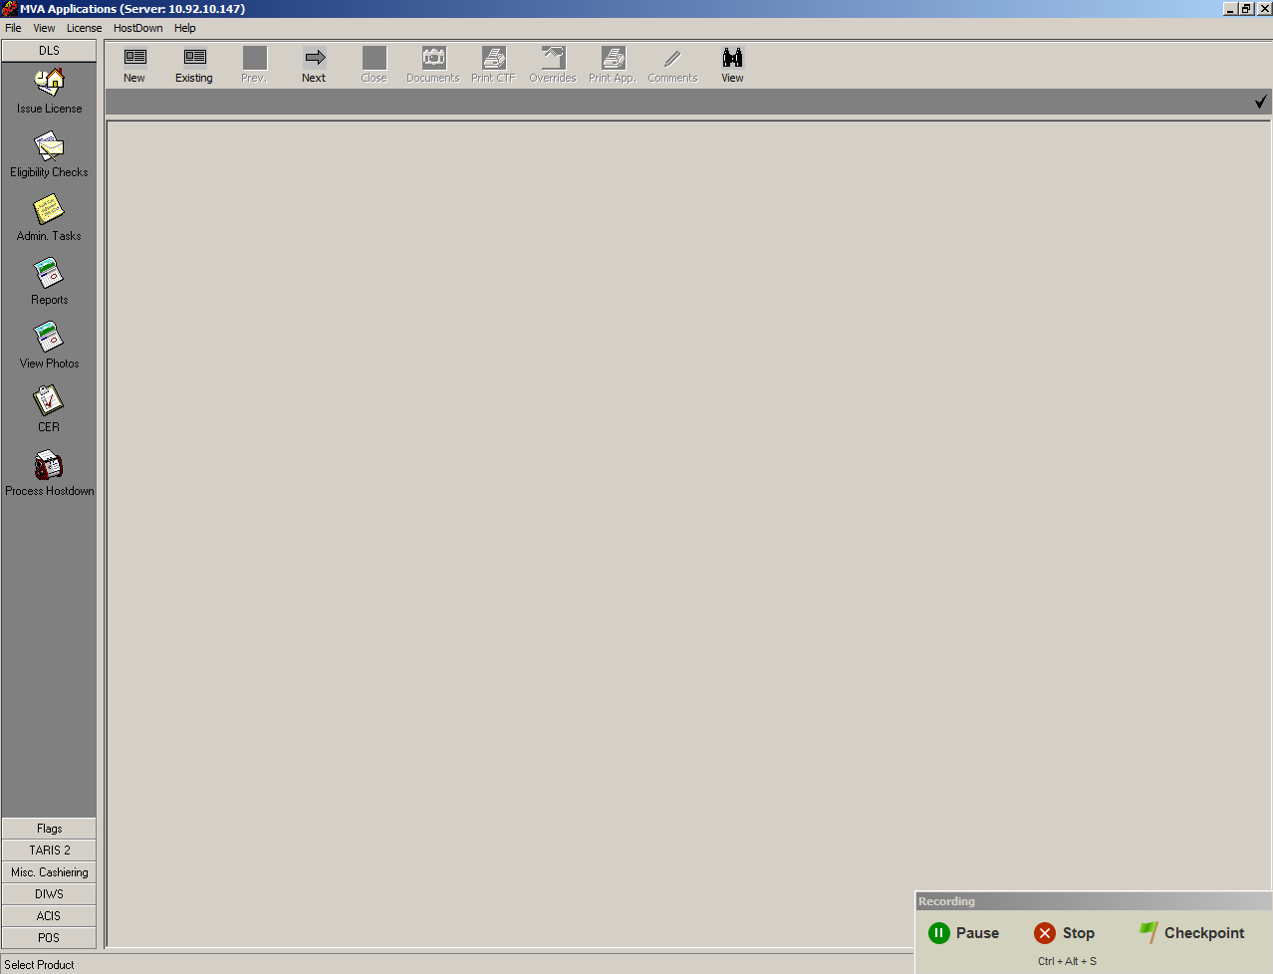
Figure 1: Legacy Application Home screen
The above picture shows how Testing Anywhere records the tests. Testing Anywhere will record all mouse moves and clicks as well as keystrokes during the recording process. To pause, stop the test or insert a checkpoint during the recording process, select from the options at the bottom right corner of the screen. After recording the test, it can be edited by going to the Testing Anywhere Client and selecting the test and clicking the ‘Edit’ button on the top right corner of the screen or by right-clicking the test and clicking edit, which will then open a separate window with the test code that can be edited.

Viewing recorded test scripts
Below, a screenshot of the test editor window shows how the test code appears for a test. Each line of the code can be edited using the commands on the left side of the screen.
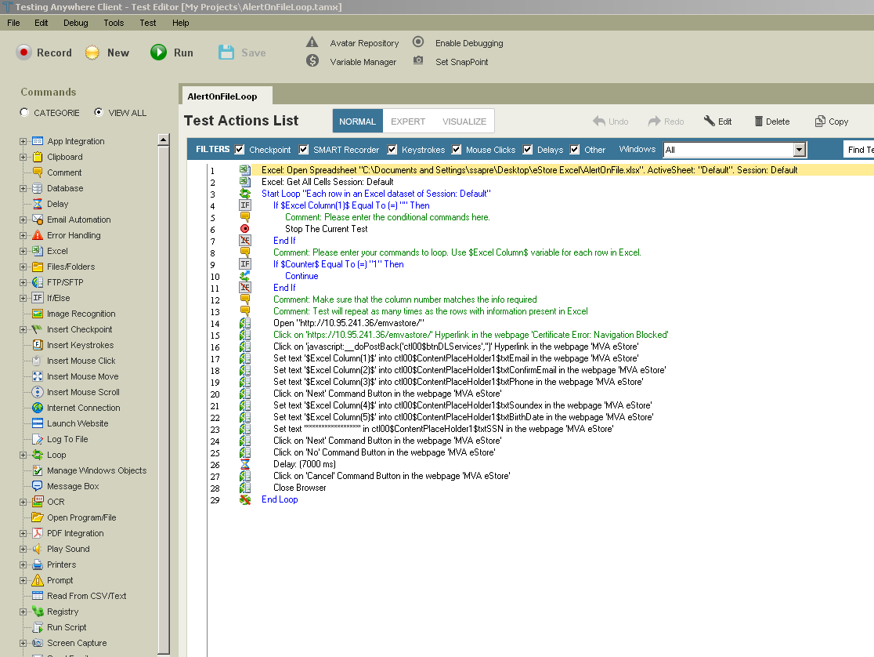
Figure 2: Sample Testing Anywhere Test Script
The SMART recorder is more specific than the standard recorder and is used for precise mouse clicks and keystrokes. It is used for clicking select buttons and ensures accurate selection.
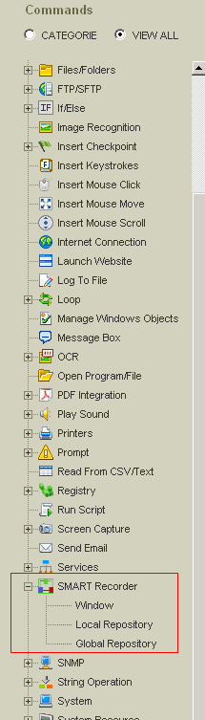
Figure 3: Selecting the Smart Recorder

Working with the Smart Recorder
Select the drop down option for SMART recorder from the commands list in the edit page. Select the ‘Window’ option (See above image) and a small window will open to add a SMART recorder command. Select the window (from dropdown menu in the image below) where the mouse click/keystroke will take place and then click the capture button. With the Left Click button still pressed, highlight the outside of the box/tab button that needs to be selected. Then, from the drop down menu under select action, the right action should be selected.
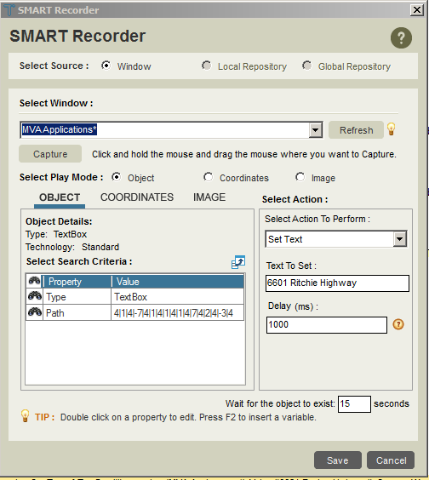
Figure 4: Smart Recorder Configuration Dialog
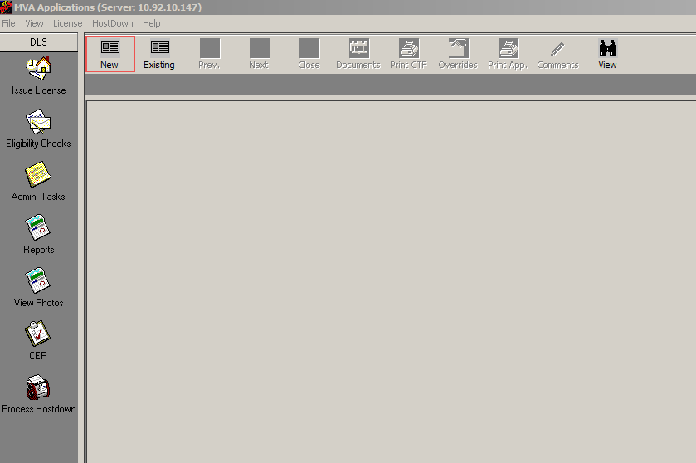
Figure 5: Using the Smart Recorder to select a control
Red box outlines the selected portion. Text can be inserted here by entering the text in the ‘Set Text’ action from the SMART Recorder action options. If there is no text to be selected but instead a tab or a button to click, it will highlight the selection in red just as it did in the above picture. The only exception for that would be that the action selected for the SMART recorder will be ‘Left Click’ instead of ‘Set Text’.
To enter in keystrokes, select the ‘Set Text’ option from the dropdown menu. Then enter the text that will be displayed on the window that was selected. Include a delay to ensure that the characters are entered at an interval, hence allowing for the program to run properly. Please note that for the legacy application SMART recording keystrokes, a delay is essential or the test will fail. As for using the SMART recorder to select or click on a tab in the application, follow the steps as above and select the ‘Left Click’ option from the dropdown list.
Note that for the legacy application, all the text entered is done using the SMART recorder, even though it can be done through entering keystrokes using the Standard recorder. This is because the SMART recorder ensures that the text is entered into the text boxes, whereas for the Standard recorder, a lot of times, the text entered will not show up during the running of the test on the legacy application.
Also, note that the SMART recorder can be used on testing web based applications as well. This can be used in tests where the web recorder may not successfully record specific data in the space provided on a website. For the some web testing, many of the steps were completed using the SMART recorder.

Working with the Web Recorder
The Web recorder, which is used for testing web-based applications, is used for testing the central websites for my client. The web recorder creates and runs tests a lot differently than the other two recorders. For starters, it is only used for web based recordings. Also, web recorder has different commands than the other two recorders. For the looping and running of tests for the legacy web application, we use the command ‘Manage Web Objects’.

Below, the screenshot outlines the information included in a Web Recorder window. This window is also part of a test loop (explained in detail below). The tools and functions of Web testing are also different from the standard and SMART recorder.
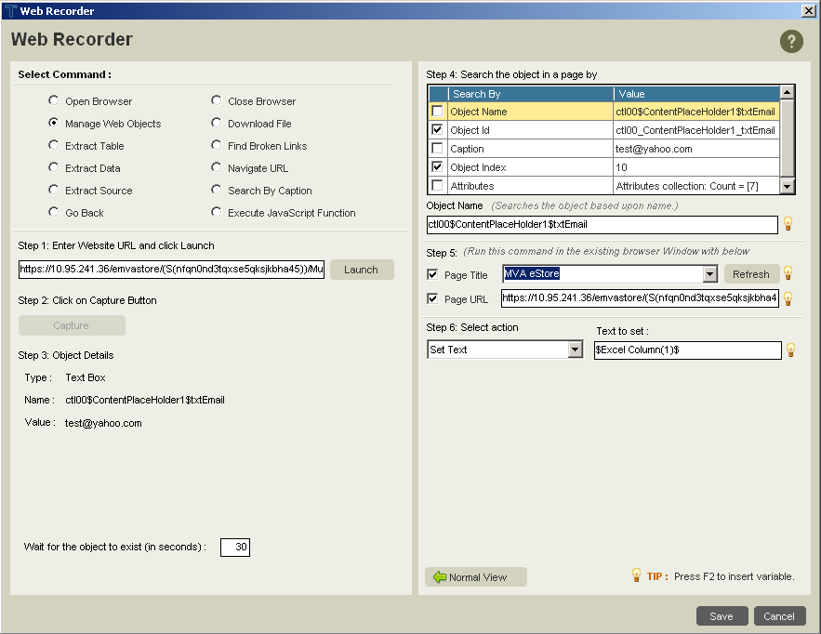
Figure 6: Web Recorder Configuration Dialog

Aggregating Script Blocks into a Test Task
Aggregate script blocks in to a Task sized script by simple cut and paste. For example, if there is a block of script that controls the camera functions like clicking and accepting the photo, then that block of test code can be copied and pasted into another test script code to allow for speedier and more efficient script editing.
Another point to note for legacy application testing is when using the SMART recorder, when selecting the window, use the legacy window title, as it appears on the windows desktop, followed by an asterisk, “*” when the task is to be completed for the legacy application page. The asterisk allows for the action to take place irrespective of name changes for the legacy application that might contain navigation or server information. This allows the correct window to be found when the script is run.

Looping in testing
Looping using Excel will allow the tester to run the test multiple times without having to actually run the same test multiple times. Doing this reads the data from an excel spreadsheet and enters it in the spaces where the text needs to be entered. The number of loops that run will be equal to the number of rows with data on the Excel spreadsheet. Using the Excel: Open Spreadsheet command, link the Excel spreadsheet created for the specific test by
Use the formula - $Excel Column(column#)$ [Example: $Excel Column(1)$] to have Testing Anywhere read the data from the spreadsheet corresponding the column values to the values to be entered in the legacy application.
Also, as mentioned in the above paragraph about looping tests, instead of inserting the similar data in different rows of an Excel spreadsheet, variables can be created and copied to different tests. Using variables will allow for faster editing using the SMART recorder and save time in terms of entering repeated data. For example when using the same address for testing, variables can be created to enter the street address, the city and zip code and can be used on various different tests without having to actually enter the same information each time. Use the formula - $VariableName$ or as an example - $StreetName$ to enter the same street name in various different tests.
The image below lists the block of code that executes a loop. An End loop code has to be inserted to complete the looping code.
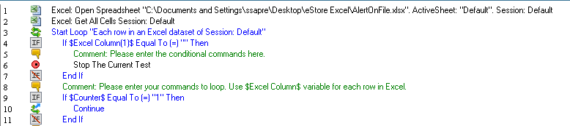
Figure 7: Looping Excel test data in Testing Anywhere

Viewing Test Results

Testing Anywhere allows testers to view the past results of tests run by providing a visual log in the client software. The visual log allows the tester to view if the test passed or failed, when it ran and the start and end times of that session.

Creating exe files
Right click the test you want to convert into an exe file and click on ‘Create Exe’ (As shown in the picture below). This allows the tester to run the exe file on different PCs without having to install Testing Anywhere on all test machines. This enables load testing.
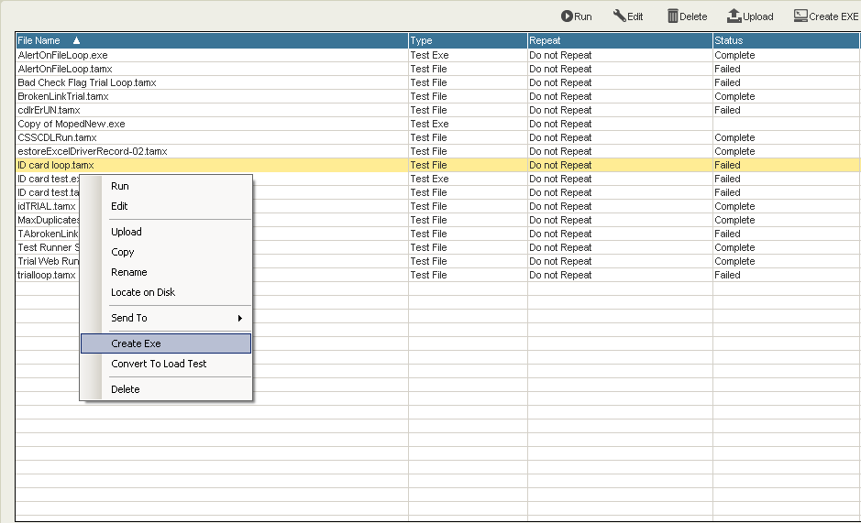
Figure 8: Creating a stand-alone .EXE from a test script

Executing Completed Test Scripts:

Steps to execute a test script for a legacy application:
- Log into the test account.
- Open Testing Anywhere Client (Make sure it is TA Client and not the other TA) and the legacy application.
- Run all the tests in the ‘My Projects’ folder by clicking on the test and pressing Run test on the top (green button)
- Make sure you pay attention to the running of the tests to ensure that it does not stop in the middle and if it does, note why it failed.
- Should the test stop at some point, it will tell you the line number it failed at. However, this may not always be the most accurate way to find out the step at which the test failed as it might run some mouse moves and wrong clicks until it does fail, much later than the actual step that caused the problem.
- Make sure to sign on the signature pad and press OK to continue.
- Run all the tests and see if they pass.
- Check the status of the test (complete or failed) by clicking on the test name and looking at the run test log underneath.

Steps to execute a test for a legacy web application:
- Log into the test account.
- Open Testing Anywhere Client (Make sure it is TA Client and not the other TA).
- Run all the tests in the ‘My Projects’ folder by clicking on the test and pressing Run test on the top (green button)
- Make sure you pay attention to the running of the tests to ensure that it does not stop in the middle and if it does, note why it failed.
- Should the test stop at some point, it will tell you the line number it failed at. However, this may not always be the most accurate way to find out the step at which the test failed as it might run some mouse moves and wrong clicks until it does fail, much later than the actual step that caused the problem.
- Run all the tests and see if they pass.
- Check the status of the test (complete or failed) by clicking on the test name and looking at the run test log underneath.

Appendix A – Sample Testing Anywhere Test Script Development Guide

General Suggestions
- Use the most advanced script recording technology that is effective: Smart Recorder, Web Recorder or Standard Recorder. This results in the most readable and maintainable script product.
- Name your full scripts with a leading underscore (so they will appear at the top of the TA screen) and so the test case on which each is based, is clear.
- Compose your scripts of smaller units that: begin with a comment line describing what the block does, perform a single action and are named for that action.
- Organize your scripts in directories that contain the completed end-to-end script and the collection of individual smaller, single script blocks. Name each directory after the test case or work flow it tests.
- Use the project object naming convention to devise consistent object and action names.

Script Development
- Utilize small script blocks to accomplish single actions, e.g. ClickNextButton, SetDateOfBirth, SelectDropDownItem, etc
- Once recorded and tested, add a leading comment line to each script block describing the object or action
- Aggregate script blocks in to a Task sized script by simple cut and paste.
- When running satisfactorily, rework medium sized scripts to use variables for all input values, e.g. vFirstName, vDOB, vSSN
- Read input values into variables from an Excel spreadsheet
- Add a loop construct to run the Task repeatedly for each line in the Excel spreadsheet.

UAT Development
Aggregate tested Task scripts into 'Run Suites' that accomplish a UAT Test objective.

