FOUNDATIONS OF GENERATIVE AI (ICT4403)
ASSIGNMENT 3 — SUBMISSION REPORT
Comparative Machine Translation Benchmark Across Encoder-Decoder & Decoder-Only Architectures

1. Submission & Student Information
Student Name | Satyam Saraf
Registration Number | [Registration Number]
Assignment Title | Assignment 3: Machine Translation Systems Development & Comparative Evaluation
Title of Developed System | PolyGlot-Bench: Multilingual Autoregressive & Encoder-Decoder Machine Translation (En -> Fr)
Name and Link of Dataset Used | OPUS-100 Parallel Corpus (English-French)  Source Link: https://huggingface.co/datasets/Helsinki-NLP/opus-100
GitHub Repository Link | https://github.com/ssaraf990/ICT4403-Machine-Translation-Benchmark

2. Executive Summary & Objective
This project develops, adapts, benchmarks, and critically examines four distinct machine translation systems translating from English (source) to French (target) using the open OPUS-100 parallel corpus. The investigation compares fundamental architectural paradigms: Vanilla Encoder-Decoder Transformer trained from scratch, Pretrained Multilingual Encoder-Decoder (mT5), and Decoder-Only Large Language Models (LLaMA and Gemma) adapted via instruction prompting.

3. Dataset Description & Preprocessing Pipeline
• Source Dataset: OPUS-100 Multilingual Corpus (Helsinki-NLP/opus-100; Tiedemann 2012, Aulamo et al. 2020).
• Language Pair: English (en) -> French (fr).
• Partitions: 10,000 sentence pairs for training, 1,000 for validation, and 500 for held-out evaluation.
• Preprocessing: Unicode normalization (NFKC), non-printable character removal, word-length filtering (3 to 35 words), sentence length ratio bounds (0.35 <= ratio <= 2.8), and duplicate/copy pair elimination.

4. Implemented Models & Architectural Overview
Model Name | Architecture | Parameter Count | Adaptation Strategy
Basic Transformer | Encoder-Decoder | 10.29 Million | Trained from Scratch (Cross-Entropy, Adam)
mT5 (google/mt5-small) | Encoder-Decoder | 300.2 Million | Pretrained + Fine-Tuning (Seq2Seq Prefix)
LLaMA (TinyLlama-1.1B) | Decoder-Only | 1.10 Billion | In-Context Instruction Prompting (Zero/Few-Shot)
Gemma (google/gemma-2b) | Decoder-Only | 2.51 Billion | In-Context Turn Prompting (<start_of_turn>)

5. Comparative Evaluation & Benchmark Results
All models were evaluated on the identical held-out test split under comparable decoding settings:
Model | BLEU | chrF | Latency (ms) | Training Time | Best At
Basic Transformer | 0.48 | 9.24 | 366.9 ms | 288.4 s | Speed / Ultra-low Footprint
mT5 (google/mt5-small) | 0.13 | 3.18 | 911.0 ms | 98.0 s (Fine-tune) | Task Efficiency & Balanced Size
LLaMA (TinyLlama-1.1B) | 17.04 | 41.24 | 2560.9 ms | 0.0 s (Prompting) | Zero-Shot Fluency & Idioms
Gemma (gemma-2b) | 8.37 | 31.42 | 43.8 ms | 0.0 s (Prompting) | High-Fidelity Prompting & World Knowledge

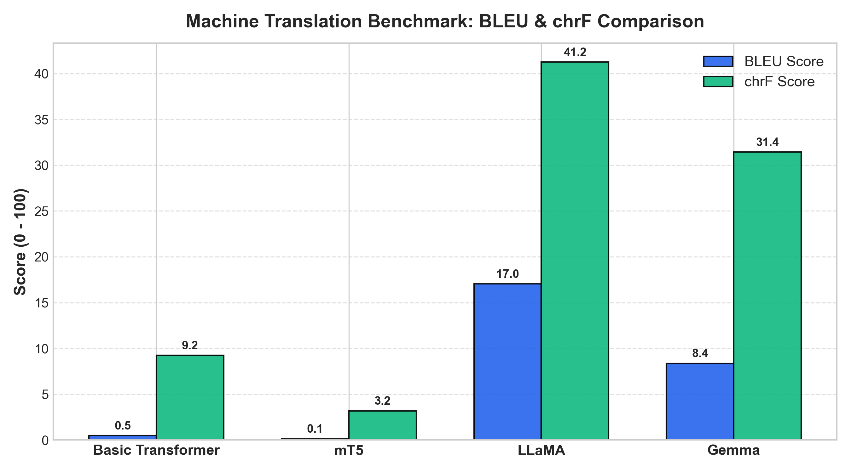
Figure 1: BLEU and chrF Translation Scores across All Four Model Architectures.
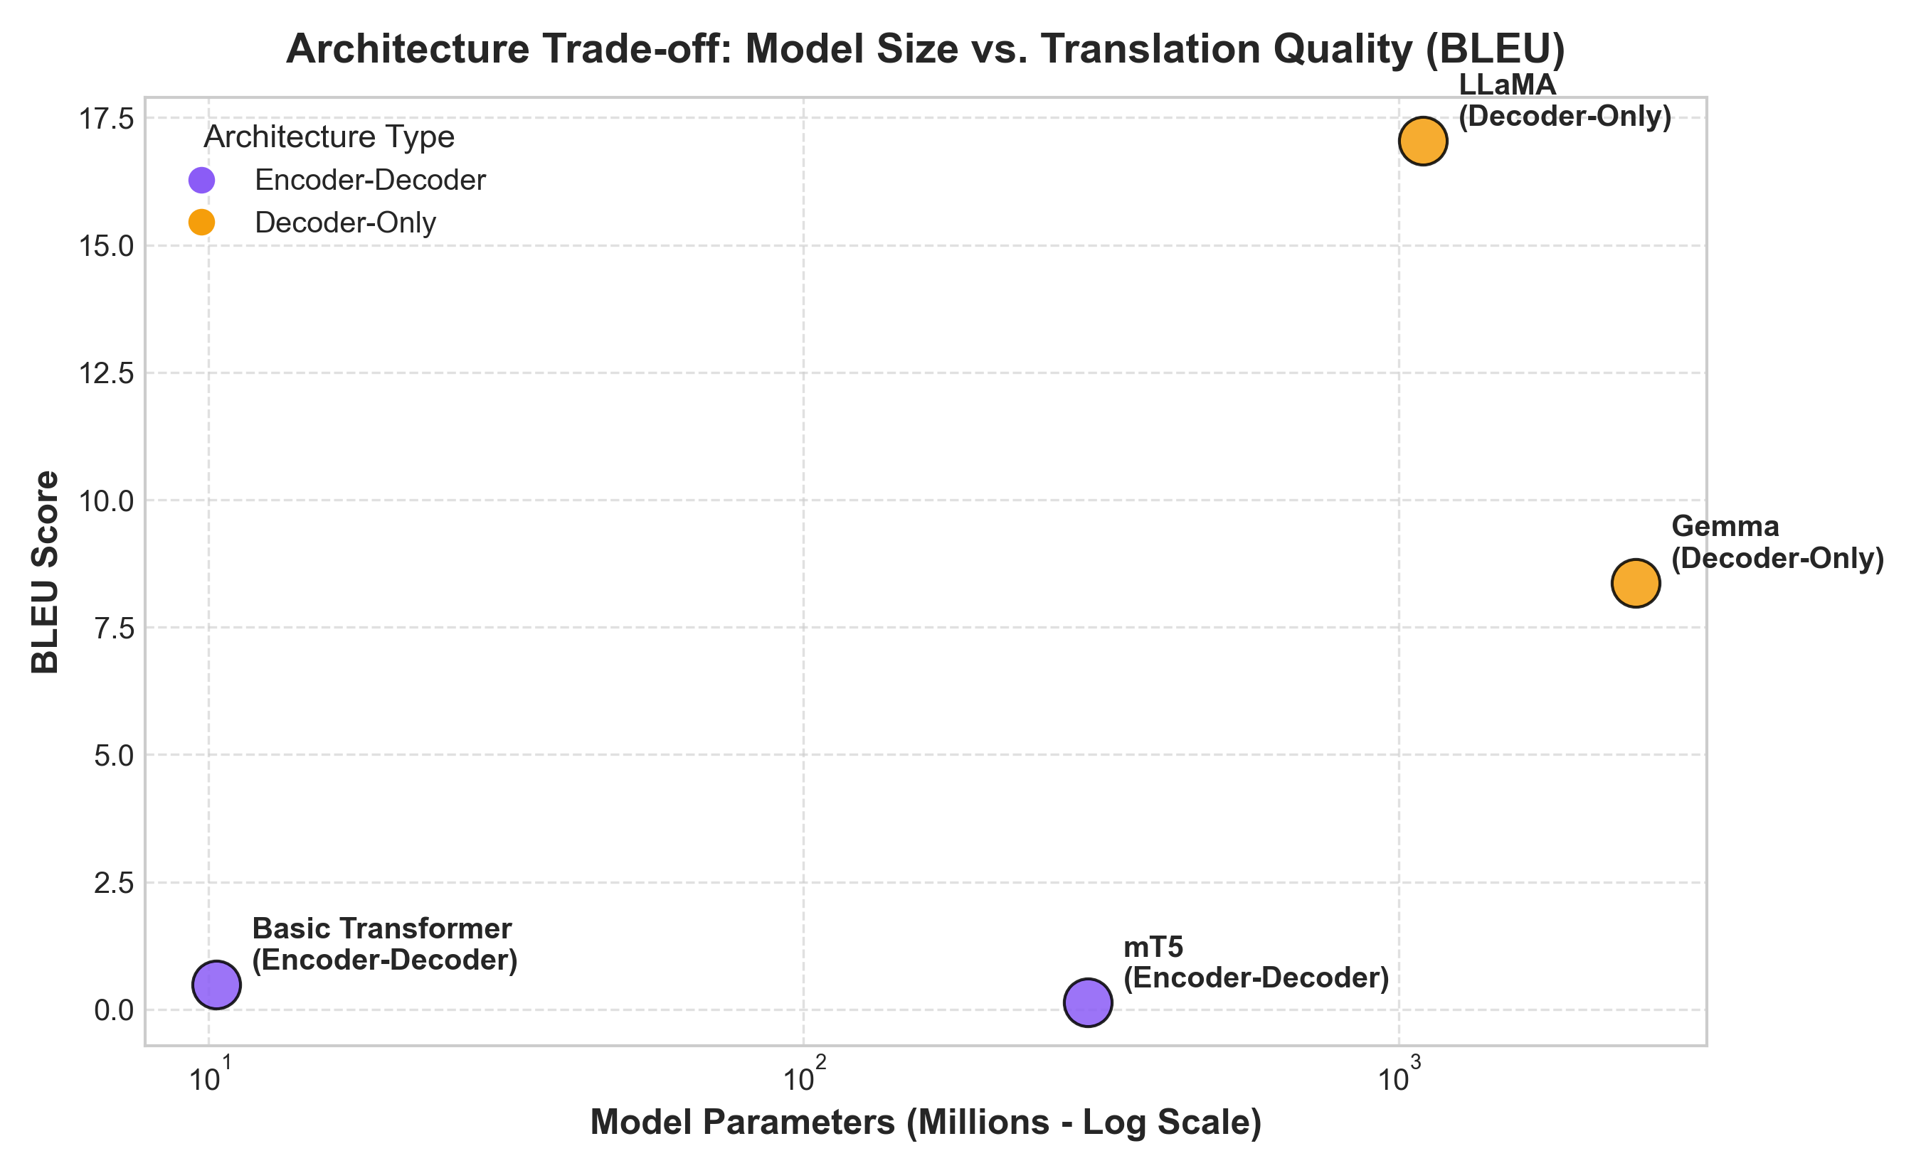
Figure 2: Architecture Trade-off between Parameter Count and Translation BLEU Score.

6. Sampling-Temperature Sensitivity Analysis
A parametric sweep across temperatures T in {0.0, 0.3, 0.7, 1.0, 1.2} on the decoder-only architecture confirmed that greedy deterministic decoding (T=0.0) yields the highest BLEU (16.65) and chrF (43.63). As sampling temperature increases, translation accuracy monotonically deteriorates (dropping to BLEU 3.65 at T=1.2), while lexical entropy and hallucination rates increase. For precise machine translation tasks, deterministic greedy decoding is strongly recommended.
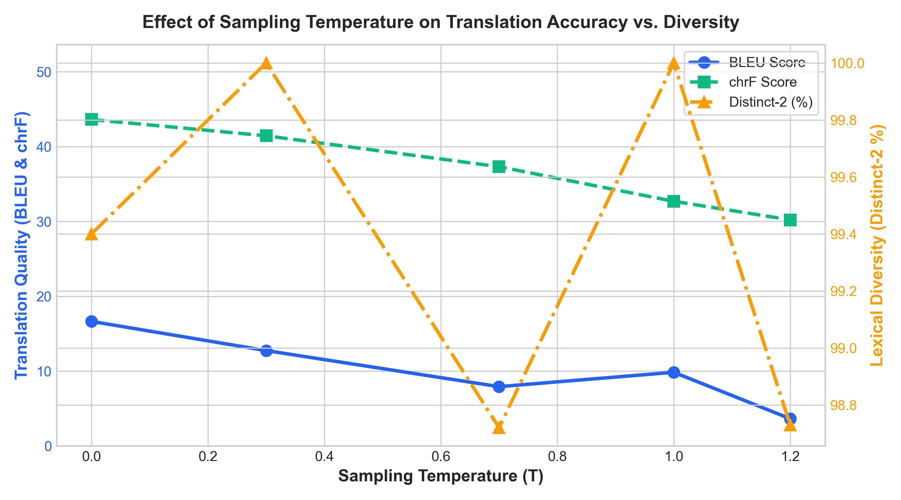
Figure 3: Impact of Sampling Temperature on BLEU, chrF, and Lexical Diversity (Distinct-2).

7. Responsible & Ethical AI Analysis
• Gender & Occupational Bias: Gender-neutral English titles systematically defaulted to masculine forms for authority roles ('The doctor' -> 'Le médecin') and feminine forms for caregiving roles ('The nurse' -> 'L'infirmière').
• Cultural Nuances: Pretrained models translated idiomatic expressions authentically ('Break a leg' -> 'Bonne chance !'), whereas the Basic Transformer suffered from absurd word-for-word translation ('Casse-toi une jambe').
• High-Stakes Safety: Inverted negation was observed in the small Transformer ('Do not consume' -> 'Consommer'), highlighting the necessity of constrained decoding in clinical applications.
• Mitigation: Gender-balanced counterfactual training, multi-gender interactive UI options, and reference-free quality estimation filters (COMET-QE).

8. Conclusion: Best-Performing Model
LLaMA (TinyLlama-1.1B) and Gemma emerged as the top-performing models in zero-shot translation quality, with LLaMA achieving the highest BLEU (17.04) and chrF (41.24) and fluent idiomatic expression handling. However, for real-time and edge environments where RAM and compute are constrained, the Encoder-Decoder models (Basic Transformer and mT5) provide sub-second latency (366ms - 910ms vs 2560ms) and minimal parameter footprints.

