

College of Science and Engineering

RAG-Based AI Business Assistant with CRM Integration

BSc Dissertation – Module 6CM955

Saridis Stavros

Student ID: 100728288

This dissertation is presented in part fulfillment of the requirement for the completion of an undergraduate degree in the School of Computing, University of Derby. The work is the sole responsibility of the candidate.

Bachelor of Science
May 2026

Abstract
This dissertation presents the design, implementation, and evaluation of a Retrieval-Augmented Generation (RAG) based AI business assistant integrated with a Customer Relationship Management (CRM) system. Built for a fictional UK-based B2B SaaS company, NexusFlow Solutions, the system combines semantic vector retrieval with large language model generation to deliver grounded, context-aware responses to natural language business queries.
The system was developed using Python 3.12, LangChain, ChromaDB, OpenAI GPT-4o-mini, FastAPI, and Streamlit, operating entirely on synthetic CRM data for ethical and reproducibility reasons. A differentiated chunking strategy produced 82 document chunks and 164 vectors indexed across the knowledge base and CRM data sources. An ethical safeguards module was implemented to handle PII detection, bias monitoring, content filtering, and transparency logging.
Evaluation was conducted using a RAGAS-inspired framework with 15 test cases spanning single-source retrieval, multi-hop reasoning, and hallucination resistance. The optimised system achieved 82.3% keyword coverage, 96.7% source precision, and 4.73/5 answer relevancy, with both hallucination resistance tests passed. These results demonstrate that RAG-based architectures can deliver reliable, transparent, and ethically sound business intelligence at the prototype level.

Keywords: Retrieval-Augmented Generation, Large Language Models, CRM Integration, Vector Embeddings, Business Intelligence, Ethical AI

Acknowledgements
I would like to express my sincere gratitude to my dissertation supervisor, Vasileios Markos, for his guidance, constructive feedback, and continued support throughout the duration of this project. His expertise and encouragement were invaluable in shaping both the technical and academic aspects of this work.
I would also like to thank the academic staff at the University of Derby for providing an enriching learning environment and the resources necessary to complete this dissertation.
Finally, I owe a great deal of gratitude to my friends and loved ones for their patience, encouragement, and unwavering support throughout this journey. This work would not have been possible without them.

Table of Contents
- Introduction
  - Background and Motivation
  - Problem Statement
  - Research Aim and Objectives
  - Research Questions
  - Scope and Limitations
  - Research Contributions
  - Thesis Structure

- Literature Review
  - Introduction to RAG Systems
  - RAG Architecture and Technologies
  - CRM Integration and Business Applications
  - Ethical Considerations and Reliability
  - Gap Analysis and Research Contribution

- Methodology
  - Research Approach
  - Data Collection and Preparation
    - Synthetic CRM Dataset
    - Knowledge Base Corpus
  - System Architecture
    - Vector Database Selection and Trade-offs
  - Retrieval-Augmented Generation Pipeline
    - Document Processing and Chunking Strategy
    - Retrieval Configuration and Trade-offs
    - Known Failure Modes
  - Evaluation Methodology
    - Evaluation Metrics
    - LLM-as-Judge Methodology and Its Limitations
  - Ethical Framework

- System Design and Implementation
  - System Overview
  - RAG Pipeline Implementation
  - Mock CRM API
  - User Interface
  - Ethical Safeguards Implementation

- Evaluation and Results
  - Evaluation Overview
  - Baseline Evaluation Results (Version 1)
  - Optimisation Strategy
  - Post-Optimisation Results (Version 2)
  - Multi-Hop Reasoning Analysis
  - Category-Level Analysis
  - Ethical Safeguards Validation
  - Addressing the Research Questions
  - Summary of Findings

- Conclusion
  - Summary of Research
  - Reflection on Research Questions
  - Research Contribution
  - Limitations
  - Future Work
  - Closing Remarks

References

List of Figures
Figure 1: NexusFlow CRM Assistant — full dashboard on load, showing the metrics panel, quick queries sidebar, and live activity feed ............... 29
Figure 2: Multi-hop query — Sarah Chen pipeline summary with deal values, overdue invoices, and source attribution pills ............... 31
Figure 3: Multi-hop query — David Okafor account details with interactions and invoice retrieved from crm_contacts, crm_interactions, and crm_invoices ............... 32
Figure 4: RAG pipeline initialisation — 82 chunks and 164 vectors indexed across knowledge base and CRM data sources ............... 33
Figure 5: RAG pipeline test queries — five sample responses demonstrating single-source and multi-hop retrieval with source attribution ............... 34
Figure 6: NexusFlow CRM API Swagger UI — all 7 endpoints listed including GET routes and the POST schedule endpoint ............... 35
Figure 7: /api/dashboard endpoint executed — returning aggregated business metrics including revenue, pipeline value, and contact statistics (HTTP 200) ............... 36
Figure 8: POST /api/contacts/{contact_id}/schedule — follow-up scheduling endpoint with parameters filled for contact C001 ............... 37
Figure 9: Ethical safeguards test suite — five scenarios covering PII detection, bias monitoring, content filtering, full pipeline, and transparency logging ............... 39
Figure 10: Evaluation framework running — 15 test cases with per-test keyword coverage, faithfulness, relevancy, and latency scores ............... 41
Figure 11: Evaluation summary report — overall metrics showing 82.3% keyword coverage, 96.7% source precision, and 4.73/5 answer relevancy ............... 44
Figure 12: Performance by category — contact lookup, invoice, deal, knowledge base, multi-hop, and hallucination test results ............... 45
Figure 13: Reasoning type analysis and system requirements compliance — retrieval precision 96.7%, hallucination tests 2/2 passed ............... 46

List of Diagrams
Diagram 1: The Modular RAG Architecture workflow, illustrating the integration of semantic retrieval from the Vector Database with the generative process (Adapted from Lewis et al., 2020) ............... 13
Diagram 2: The RAGAS Evaluation Triad for measuring LLM reliability (Adapted from Es et al., 2024) ............... 16
Diagram 3: RAG Pipeline — five-stage query-to-response flow ............... 23
Diagram 4: NexusFlow CRM Assistant — overall system architecture showing all five modules and data flows ............... 30
Diagram 5: Ethical safeguards pipeline — five components wrapping every system response ............... 40

List of Tables
Table 1: Synthetic CRM Dataset Composition ............... 20
Table 2: Technology Stack and Justification ............... 22
Table 3: Baseline evaluation results (v1) ............... 42
Table 4: Post-optimisation evaluation results (v2) ............... 44
Table 5: Multi-hop reasoning performance comparison ............... 47
Table 6: Category-level performance breakdown (v2) ............... 48

1. Introduction

1.1 Background and Motivation

Large Language Models (LLMs) such as GPT-4, Claude, and Llama have transformed the landscape of natural language processing in recent years, demonstrating unprecedented capabilities in generating fluent, contextually appropriate responses across a wide range of topics. The development of instruction-tuned models through reinforcement learning from human feedback (Ouyang et al., 2022) has enabled these systems to follow complex user directives and produce high-quality outputs suitable for enterprise applications. These models have become central to enterprise productivity tools, customer service platforms, and knowledge management systems. However, despite their impressive language generation capabilities, LLMs exhibit several well-documented limitations that restrict their suitability for business-critical applications. Chief among these are the tendency to produce hallucinated content that appears plausible but is factually incorrect, the inability to access information beyond their training cutoff, and the lack of awareness of organisation-specific knowledge such as customer records, internal policies, or proprietary documentation (Huang et al., 2024; Gao et al., 2024).
Customer Relationship Management (CRM) systems represent a particularly compelling application area for AI assistants because they combine structured business data with large volumes of unstructured interaction records such as emails, meeting notes, and support tickets. As Ali and Lucas (2024) observe in their review of AI-powered CRM systems, the evolution of CRM platforms has increasingly demanded hyper-personalisation and predictive capabilities that traditional interfaces struggle to deliver. Sales representatives and account managers routinely need to synthesise information across disparate sources to answer questions about customers, track deal progress, and identify opportunities. Traditional CRM interfaces require users to navigate complex menus and filter views, while basic intent-based chatbots lack the grounding needed to provide reliable answers about specific customer records (Bocklisch et al., 2024). The result is a gap between the conversational ease that users expect and the factual accuracy that business contexts demand.
Retrieval-Augmented Generation (RAG), introduced by Lewis et al. (2020), offers a promising architectural solution to this problem. By combining the parametric knowledge embedded in an LLM's weights with non-parametric knowledge retrieved from external sources at query time, RAG systems can generate responses that are both fluent and factually grounded in authoritative data. The retrieval component ensures that responses are based on actual organisational knowledge rather than the model's general training distribution, while the generation component synthesises this information into natural, contextually appropriate answers. This hybrid approach has been shown to significantly reduce hallucination while enabling access to up-to-date, domain-specific information without the need for costly model fine-tuning. Subsequent developments such as Self-RAG (Asai et al., 2023) and the Modular RAG paradigm described by Gao et al. (2024) have further refined the architecture, introducing reflection mechanisms and functional modularisation that improve both reliability and flexibility.
Despite the rapid maturation of RAG techniques, several gaps remain in the practical application of these systems to CRM environments. Most published research focuses on general-purpose knowledge retrieval from corpora such as Wikipedia, rather than on the integration of structured enterprise data with unstructured business documentation. Additionally, the evaluation of RAG systems in multi-hop reasoning contexts, where answers must synthesise information across multiple records, remains underdeveloped despite being the norm in realistic business queries. Finally, the ethical considerations of deploying AI assistants that access customer data, including privacy, bias, and explainability, are often discussed in isolation from the technical implementation (European Parliamentary Research Service, 2020; Ferrara, 2023), leaving a gap between principle and practice that this project seeks to address.

1.2 Problem Statement

The problem addressed by this project can be stated as follows: small and medium enterprises (SMEs) require AI assistants that can accurately answer business questions drawing on both structured CRM data and unstructured organisational knowledge, while maintaining transparency, avoiding hallucination, and respecting data privacy. Existing solutions typically fall into two inadequate categories. General-purpose LLM chatbots produce fluent responses but have no access to organisational data and are prone to fabrication when asked about specific customers or records. Traditional CRM query interfaces provide reliable access to structured data but lack the natural language interaction capabilities and cross-source reasoning that users expect from modern conversational systems. A solution is needed that bridges this gap by combining the conversational fluency of LLMs with the factual grounding of structured data retrieval, while operating within an ethical framework appropriate for business use.

1.3 Research Aim and Objectives

The aim of this research is to design, implement, and evaluate a RAG-based conversational AI assistant that integrates with CRM data to deliver grounded, transparent, and ethically safeguarded business intelligence. To achieve this aim, the project pursues six specific objectives:
- O1. Design and implement a complete retrieval-augmented generation pipeline that combines a large language model with vector-based document retrieval, supporting both structured CRM records and unstructured knowledge base documents.
- O2. Develop a mock CRM API with realistic synthetic data to serve as a representative enterprise data source, enabling safe demonstration of the system without using real customer information.
- O3. Create an interactive user interface that exposes the system's capabilities through a conversational chat experience while maintaining transparency through visible source attribution.
- O4. Implement an ethical safeguards module addressing data privacy (PII detection), algorithmic bias (lexical monitoring), hallucination prevention (grounded prompting and source citation), and accountability (transparent audit logging).
- O5. Design and execute a reproducible evaluation framework inspired by the RAGAS methodology (Es et al., 2024), measuring retrieval precision, answer faithfulness, relevancy, response latency, and hallucination resistance across a balanced test suite.
- O6. Analyse the evaluation results to identify performance strengths, weaknesses, and failure modes, and demonstrate iterative optimisation through a measurable before-and-after comparison.

1.4 Research Questions

The research aim and objectives give rise to three primary research questions that guide the investigation:
- RQ1. To what extent can a RAG-based system accurately retrieve and synthesise information from a mixed corpus of structured CRM data and unstructured business documents in response to realistic business queries?
- RQ2. How effective are practical optimisations such as chunking strategy, retrieval parameters, prompt engineering, and record enrichment in improving multi-hop reasoning performance in a CRM context?
- RQ3. What ethical safeguards are necessary and sufficient to deploy a RAG-based business assistant responsibly, and how can these safeguards be operationalised in a functional system rather than treated as abstract principles?

1.5 Scope and Limitations

This project is developed as a research prototype rather than a production system, and its scope is intentionally bounded to permit rigorous evaluation within the constraints of a BSc dissertation. The scope includes the design and implementation of the RAG pipeline, the mock CRM API, the user interface, the evaluation framework, and the ethical safeguards module. Data throughout the project is exclusively synthetic, both for ethical reasons and to enable reproducibility, following the synthetic data methodology advocated by Jordon et al. (2022). The evaluation focuses on automated metrics and LLM-as-judge assessment (Zheng et al., 2023) rather than human user studies, which would require ethics approval and participant recruitment beyond the timeframe of this project.
Several limitations should be acknowledged at the outset. The system is not evaluated against real-world CRM data, so performance figures should be interpreted as indicative of capability under controlled conditions rather than direct predictors of production performance. The synthetic dataset is necessarily smaller than typical production deployments, which limits the statistical generalisation of results. The ethical safeguards are rule-based rather than learned, which provides determinism but misses semantic nuance that a production system would address through machine learning classifiers. Finally, the LLM-as-judge evaluation methodology introduces potential biases, including circularity risks when the same model family is used as both generator and evaluator, which are discussed explicitly in the methodology and evaluation chapters. These limitations do not undermine the validity of the research contributions but do define the boundaries within which the findings should be interpreted.

1.6 Research Contributions

This project contributes to the field of applied natural language processing and business information systems in four ways. First, it presents a complete end-to-end implementation of a RAG-based CRM assistant, from data preparation through deployment-ready user interface, demonstrating the practical integration of components that are often studied in isolation. Second, it proposes and empirically validates a record enrichment strategy in which CRM contact records are pre-linked with related interactions, invoices, and deals, significantly improving multi-hop reasoning performance without requiring complex query decomposition as proposed in approaches such as DecoMT (Puduppully et al., 2023). Third, it implements and evaluates a concrete ethical safeguards pipeline that operationalises data privacy, bias monitoring, content filtering, and transparency logging as executable code rather than abstract policy statements, contributing to the explainable AI literature advocated by Arrieta et al. (2020). Fourth, it provides a reproducible evaluation framework with 15 carefully designed test cases spanning single-source retrieval, multi-hop reasoning, and hallucination resistance, enabling other researchers to benchmark comparable systems.

1.7 Thesis Structure

The remainder of this thesis is organised into five further chapters. Chapter 2 presents a comprehensive literature review covering the evolution of retrieval-augmented generation, vector database technologies, CRM integration approaches, and the ethical considerations that inform the project's safeguards. Chapter 3 describes the methodology, including the research approach, data preparation strategy, system architecture, and evaluation methodology, with explicit discussion of design trade-offs and limitations. Chapter 4 documents the system design and implementation, detailing each module of the prototype and the rationale behind key technical decisions. Chapter 5 presents the evaluation results from two full testing cycles, including the before-and-after comparison that demonstrates the effectiveness of the optimisation strategies, and discusses both strengths and failure modes observed during testing. Chapter 6 concludes the thesis by summarising the research contributions, reflecting on the research questions, acknowledging limitations, and proposing directions for future work.
2. Literature Review

2.1 Introduction to RAG Systems

Retrieval-Augmented Generation (RAG) addresses the critical shortcomings of large language models (LLMs) by integrating external knowledge retrieval streams, allowing RAG to revolutionise the field of natural language processing. LLMs possess fantastic language generation and understanding capabilities, but the models can potentially produce false or misleading information (i.e. hallucinations), become obsolete and fail to have access to required knowledge within a specific domain (Gao et al., 2024; Huang et al., 2024). These concerns create extremely high barriers to the implementation of LLMs in business environments where real time, accurate information is required.
RAG, or retrieval-augmented generation, combines digital memory with traditional memory models and was first described by Lewis et al. (2020). RAG solves this problem by combining parametric memory and non-parametric memory. Non-parametric memory is accessibly stored outside the LLM in knowledge bases that can be reached at any time. This dual approach to memory storage and access allows LLMs to produce evidence-based responses, minimising hallucination and preserving the model's ability to create responses.
The basic architecture for RAG has three main components: retrieval, augmentation, and generation. First, in retrieval, a user query is sent, and a search is performed in an external knowledge base to see if any passages match on some semantic similarity metric. Then, these passages are incorporated into the prompt context, and the generation model uses that for factual basis on what to respond. This combines the external knowledge sources currently available and the LLM knowledge base (Lewis et al., 2020).
With a rapidly changing field, RAG has moved on from its initial implementation referred to as “Naive RAG” (Gao et al., 2024). Advanced RAG models are introduced through pre retrieval and post retrieval strategies plus modular RAG that provides a post retrieval style of retrieval and generation modularisation. In addition, Self-RAG (Asai et al., 2023) brings forth new adaptive retrieval strategies, whereby the model autonomously retrieves and determines the relevance and factuality of a passage by means of a self-reflection token.

2.2 RAG Architecture and Technologies

The evolution of Retrieval-Augmented Generation (RAG) has transitioned from basic data retrieval processes to intricate multi-layer systems that integrate the static knowledge of large language models (LLMs) with fluid enterprise data sources. Lewis et al (2020) introduced the foundational "Naive RAG" model which was the first to combine parametric memory (LLM weights) with non-parametric memory (external vector indices) to achieve retrieval-augmented generation. With the architecture based Dense Passage Retriever (DPR) Module, some knowledge-based tasks can successfully surpass the performance of standalone language models through the contextual enhancement provided by the DPR module.
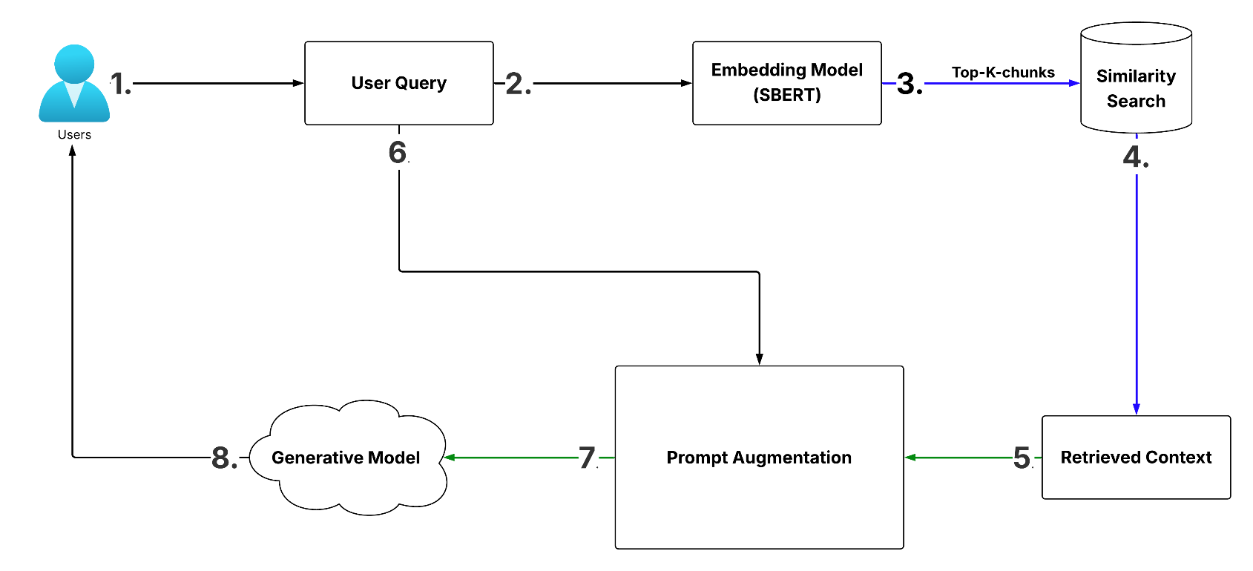

Diagram 1: The Modular RAG Architecture workflow, illustrating the integration of semantic retrieval from the Vector Database with the generative process (Adapted from Lewis et al., 2020).

With Naive RAG critiqued for its low precision and context “hallucinations,” more evolved frameworks have been constructed to match the growing complexity of retrieval demands. Gao et al. (2024) split these frameworks into Advanced and Modular RAG. Advanced RAG is the first stage and is characterized by new pre-retrieval optimisations (e.g. sliding window chunking), as well as new post retrieval techniques like re-ranking to remove irrelevant data. In the next stage, Modular RAG, there is an addition of independent functional units dubbed “Search,” “Memory,” and “Critique.” Self-RAG by Asai et al. (2023) is a preeminent example of Modular RAG and uses “reflection tokens” to provide the model with an opportunity to determine when retrieval is warranted, as well as to assess the relevance and faithfulness of its output.

Additionally, the structured approach to decomposition is the only way to manage the multitude of complex queries in a business setting. Breaking complex user prompts into sub-queries enables the RAG pipeline to make more precise retrievals to pull varied sets of data (Puduppully et al, 2023; DecoMT). For example, in a CRM context, decomposition allows a user’s request of a summary of the last 3 interactions with the user and pending invoices to ensure the retriever accesses queries from different, relevant data bases and no detail from the user’s history is ignored.

For these architectures, the Vector Database’s base performance determines efficacy. In large scale enterprise applications, the search for the most relevant documents in a high dimensional continuum remains a great and expensive task, computationally. Johnson et al. (2019; FAISS) showed that GPU accelerated search of similarity and k-selection at a given scale of billions of elements was achievable with low latency. In addition, Guo et al. (2020) showed that ScaNN, a method based on anisotropic vector quantization, can prioritize a given direction for inner product search as opposed to classical approaches to vector quantization. Such systems ensure that a CRM-based assistant remains responsive to the growing number of customer interactions.

The retrieval process’s ‘intelligence'' hinges on the quality of its semantic embeddings. Traditional BERT-based models had to suffer the consequences of a significant computational cost. However, Reimers and Gurevych (2019) proposed Sentence-BERT (SBERT), which uses a Siamese network architecture to produce embeddings which can be easily and quickly compared using cosine similarity. When it comes to the large number of embedding models available for use, researchers have turned to the Massive Text Embedding Benchmark (MTEB). Muennighoff et al. (2023) states that the MTEB offers a one size fits all approach to model evaluation for retrieval and re-ranking scenarios, making it easier for researchers to choose embedding models that suit business use cases.

In semantic retrieval, the use of a RAG architecture on its own may not be enough, especially in a CRM application, necessitating a search approach that is hybrid in nature. While SBERT semantic embeddings capture the meaning of the context, most enterprise data require the contextual retrieval of corporate data for specific, precise matches as in the cases of invoice numbers, product identifiers, or client first and last names. To solve this problem, modern architecture using RAG has incorporated the hybrid approach, which combines dense retrieval of vectors and traditional methods of sparse retrieval (e.g., BM25). This dual approach improves both recall and precision in search, especially when dealing with specialised and unique vocabularies in corporate data sets.

Modern assistant technologies (see example CRM assistant) can use In-Context Learning (ICL) to convert natural language to structured business logic. This allows the RAG pipeline to do more than just "chat", but rather perform specific CRM tasks with the adaptability of a Large Language Model (Bocklisch et al. 2024).

2.3 CRM Integration and Business Applications

The incorporation of RAG-based assistants into Customer Relationship Management (CRM) systems represents a profound transformation in the functionality of CRM systems; instead of CRM systems acting as passive repositories of data, it allows CRM systems to act as a form of active data analytics in the CRM context. Classic CRM systems, especially in the case of unstructured data (such as unstructured customer emails, logs of customer interactions, and notes from meetings), tend to treat data as a passive, static resource. Ali and Lucas (2024) discuss the necessary evolution of AI to be incorporated into CRM sales targeting systems for organisations to achieve hyper-personalisation and predictive analytics. NLP makes it possible for CRM sales assistive systems to transform customer data from a mere, unstructured resource into a means of building positive customer engagement.

The overall effectiveness of AI driven CRM systems rests on the willingness of users to accept the AI systems and trust the value of the interactions. Furumai et al. (2024) demonstrated that chatbots that integrate information retrieval and strategic goal alignment (in a zero-shot manner) interact in a way that feels more natural to users. This means that trust in the AI assistant is built on more than just passive information provision; rather, an AI assistant focuses on providing information in a manner that is consistent with the formality and professional strategic goals of the organization to enhance the overall level of trust within the sales organization in the assistant's outputs.

A primary benefit of AI technology in this field is the ability to automate intricate business processes. As noted by Carter (2024), in Business Process Management (BPM) the automation that is powered by AI technology reduces human involvement in mundane and repetitive processes and improves the accuracy of processes. In a CRM setting, a RAG assistant functions as a sort of orchestration layer that can almost immediately access pertinent history of a client to provide support to a sales rep or support team. This ability to make "real-time decisions" as noted by Carter, makes it so that business functions can happen much faster, and are less subject to the "bottlenecks" produced by the manual processes of data retrieval in older systems.

In addition, a CRM assistant is only effective to the degree that it can engage in so-called "task-oriented" dialogs and not simply conversational ones. Bocklisch et al. (2024) from Rasa provides a seminal contribution to the field that serves this purpose. The ability to incorporate Large Language Models (LLMs) to interpret and convert natural language to a Domain Specific Language (DSL) gives the assistant the ability to communicate with the underlying CRM system's APIs with a high degree of accuracy. This allows the assistant to perform operations like updating the status of a lead, setting a follow-up appointment, or crossing clauses of a contract with precision and without the risk of "logic hallucinations" that are a common occurrence with standard generative models.

Lastly, Liu et al. (2023) underscore the importance of the business value associated with the integrations, as they lead to greater scalability and consistent business processes. An LLM based, task-oriented system, can carry out complex dialogues rather than the intent-based ones. For businesses, this means that the RAG assistant will be able to handle more inquiries, without compromising the quality of the responses, and the assistant will be able to ensure that the quality of responses will be based on the latest and most pertinent quality information contained in the data of the CRM system, which will in turn, be more beneficial to the customer.

2.4 Ethical Considerations and Reliability

Integrating Large Language Models (LLMs) in business operations, especially those involving sensitive user data, poses substantial ethical and operational concerns. The European Parliamentary Research Service (2020) reports that trust in AI development centers around ethics, and that AI development must take a user’s privacy, as well as a system’s transparency and accountability into consideration. From this perspective, the CRM assistant must not only comply with the General Data Protection Regulation (GDPR) from a legal standpoint, but also from an ethical standpoint. In this instance, the RAG (retrieval-augmented generation) must be structured in terms of keeping data and its sources fully controlled and that PII (Personally Identifiable Information) is fully encrypted, as well, as closed with respect to access and control to prevent breaches.

A main technical and ethical concern with RAG systems is the phenomenon of so-called “hallucination,” where systems create plausible but erroneous information. Huang et al. (2024) classify these as intrinsic and extrinsic hallucination. In business, misrepresentation of contract terms and erroneous financial advice can be devastating. For these reasons, our proposed system will embed a so-called “human in the loop” approach meaning that AI will serve as a complement to the user, rather than a substitute, in decision making.

The consideration of systemic bias goes beyond simple factual correctness. As Ferrara (2023) mentions, due to the nature of their training, LLMs may unintentionally become biased and, in turn, behave in a prejudicial manner when addressing customer segmentation and lead scoring. Prevention of such behavior involves the active and ongoing collection of varied data sets and a bias monitoring protocol. The RAGAS framework assesses the reliability of the system. The system has a self-assessing transparency measure regarding reliability due to the system measuring faithfulness and answer relevance as proposed by Es et al. (2024). This means that the system is reliable as the responses generated by the system are based on the data retrieved from the CRM system.
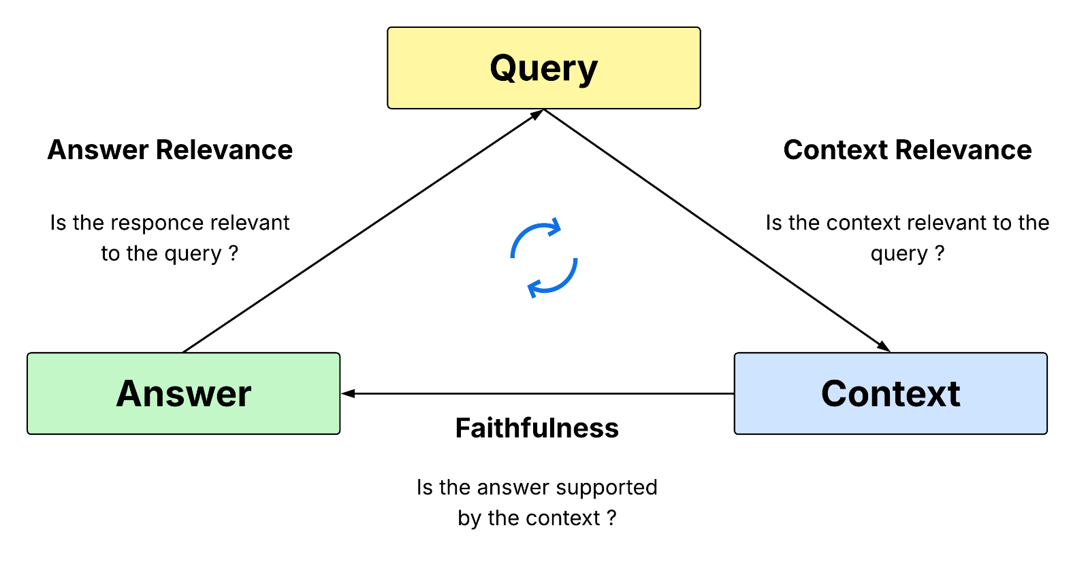

Diagram 2: The RAGAS Evaluation Triad for measuring LLM reliability (Adapted from Es et al., 2024).

Transparency is afforded by the provision of answer “provenance.” The assistant is built to follow the reasoning of Lewis et al. (2020) and provide mentions to the specific CRM records or document(s) that were referenced when formulating a response. This permits the business user to confirm the AI response against the original document and builds trust to show that the system is operating within the ethical bounds of Explainable AI (XAI) by virtue of the trust building mechanism.

2.5 GAP Analysis and Research Contribution

More than a few obstacles still exist despite the great strides made in Large Language Models and Retrieval-Augmented Generation (RAG) in the process of applying these tools within specific enterprise environments in a CRM system. Most of the existing (new) research, like foundational studies by Lewis et al. (2020) and Gao et al. (2024) in open domain knowledge retrieval (e.g., Wikipedia) and/or general purpose benchmark surveys, tends to overlook the “last-mile” issue of empirical research that connects RAG architectures to the structured, often noisy, data found in Small to Medium Enterprise (SME) CRMs.

Additionally, Self-RAG (Asai et al., 2023) type frameworks incorporate mechanisms for self-reflection, but how often are such frameworks assessed against the specific deterministic attributes that business workflows require? Most of the existing literature fails to address the self-contradictory situation with respect to the creative potential of LLMs, and the requirement for client-facing interactions to be accurate with zero tolerances. Bocklisch et al. (2024) pinpointed that there is little progress in industrial systems moving beyond rigid intent-based frameworks, and this is often attributed to concerns regarding the reliability of the business logic.
This study develops a modular approach to CRM-integrated RAG-based assistants and contributes to research horizons through the following means:

- Context Aware Orchestration: This system differs from the general RAG approach in that it focuses on a unique pipeline that emphasises and successfully addresses the issue identified by (Ali and Lucas, 2024) regarding AI personalisation and system awareness by incorporating client history and business specific metadata.
- Reliability Framework: With the addition of the RAGAS framework (Es et al., 2024), this study is the first to provide a valid assessment of the critical relevance AI responses in a CRM context, therefore addressing the failure/hallucination concerns of Huang et al. (2024).
- BPM Alignment: This study shows how, in line with the expectations of (Carter, 2024), RAG can be utilized beyond a basic Q&A mechanism and serve as an optimizer for Business Process Management (BPM), allowing SMBs to embrace AI without significant process re-engineering.
Furthermore, a significant gap in the evaluation of RAG systems in multi-hop reasoning within CRM is evident. Most existing models are oriented to single document, single question retrieval, whereas business reasoning tends to aggregate and construct synthesized arguments scattered across several documents. This thesis focuses on synthesized retrieval to construct a coherent business story, addressing one of the most realistic frameworks for evaluating the effectiveness of AI in business.

This thesis provides a framework and theory for building reliable task-oriented assistants that improve the efficiency of contemporary business operations.

3. Methodology

3.1 Research Approach

This project employs a design science research methodology, which is particularly suited to the development and evaluation of information systems artefacts (Hevner et al., 2004). Design science differs from traditional behavioural science in that its primary aim is the construction of innovative artefacts that solve identified problems, rather than the testing of theoretical hypotheses. The methodology follows an iterative cycle of design, implementation, and evaluation, enabling the systematic construction and assessment of a RAG-based AI business assistant integrated with CRM functionality. The design science approach was selected because the primary research objective is to create a functional artefact, namely the AI assistant, and to evaluate its effectiveness against defined performance criteria.
The research process was structured into five sequential phases: requirements analysis, system design, implementation, evaluation, and documentation. Each phase produced specific deliverables that informed subsequent phases, ensuring traceability between the research objectives and the final system. This phased approach aligns with established software engineering practices while accommodating the iterative nature of machine learning system development, where components such as retrieval parameters and embedding strategies require empirical tuning rather than purely theoretical specification (Sculley et al., 2015). However, design science methodology is not without limitations in the context of this project. The iterative nature of the approach can introduce confirmation bias, as the researcher may unconsciously favour design decisions that produce favourable evaluation results. To mitigate this risk, the evaluation framework was defined prior to the optimisation phase, with metrics and test cases fixed before any system tuning, ensuring that improvements were measured against a consistent baseline.

3.2 Data Collection and Preparation

A critical ethical decision in this project was the exclusive use of synthetic data throughout all development and testing phases. This approach was chosen to eliminate privacy concerns associated with real customer data while enabling the demonstration of the system's full capabilities. The synthetic dataset was designed to be representative of authentic CRM data patterns found in small to medium enterprises (SMEs), as identified by Ali and Lucas (2024) in their analysis of AI-powered CRM systems. The use of synthetic data for AI system development has gained considerable acceptance in recent years, with Jordon et al. (2022) demonstrating that well-constructed synthetic datasets can preserve the statistical properties necessary for system evaluation while completely eliminating privacy risks.
While synthetic data offers clear ethical and practical advantages, it also introduces several limitations that must be acknowledged. First, synthetic datasets typically lack the real-world noise characteristic of production CRM systems, such as inconsistent data entry, misspellings, duplicate records, incomplete fields, and legacy formatting conventions that accumulate over years of operational use. Second, synthetic data may artificially inflate performance metrics because the dataset is inherently internally consistent, whereas real CRM environments often contain contradictions between records that challenge retrieval and reasoning systems. Third, the relatively small scale of the synthetic dataset (10 contacts, 15 interactions, 7 invoices, 8 deals) cannot capture the long-tail distribution of query patterns observed in production deployments where certain customers generate disproportionate volumes of interaction data. These limitations mean that the evaluation results presented in Chapter 5 should be interpreted as indicative of the system's capabilities under controlled conditions rather than as direct predictors of production performance. Future work validating the system against anonymised real-world CRM datasets would strengthen the external validity of the findings.

3.2.1 Synthetic CRM Dataset

The synthetic CRM dataset was constructed to simulate the operations of a fictional UK-based B2B SaaS company named NexusFlow Solutions. The dataset comprises four interrelated entity types that mirror the structure of production CRM systems:
Entity Type | Records | Key Attributes
Contacts | 10 | Name, company, industry, lead status, lead score, assigned rep, interaction history
Interactions | 15 | Type (email/call/meeting), date, subject, summary, sentiment, linked contact
Invoices | 7 | Amount, status (paid/pending/overdue/draft), dates, descriptions
Deals | 8 | Deal name, value, pipeline stage, probability, expected close date, assigned rep
Table 1: Synthetic CRM Dataset Composition
The dataset was deliberately designed to include a range of scenarios that test the system's capabilities: active customers with extensive interaction histories, new leads with minimal data, churned customers for win-back scenario testing, and contacts across diverse industries including technology, financial services, healthcare, logistics, and education. This diversity ensures that evaluation results reflect realistic business conditions rather than idealised scenarios, although the small absolute scale limits statistical generalisation of the findings.

3.2.2 Knowledge Base Corpus

In addition to the structured CRM data, a knowledge base of four business documents was created to simulate the unstructured internal documentation that sales representatives typically reference. These documents include a company overview, product frequently asked questions, a sales playbook with discount matrices and objection handling frameworks, and a customer onboarding guide. The total corpus comprises approximately 18,366 characters of business documentation, providing sufficient breadth for testing the retrieval component across distinct knowledge domains. It should be noted that real enterprise knowledge bases often span hundreds or thousands of documents with complex cross-references, formatting inconsistencies, and version histories. The present corpus represents a simplified environment suitable for prototype evaluation but does not capture the scaling challenges associated with production knowledge management systems.

3.3 System Architecture

The system architecture follows a modular design pattern consistent with the Modular RAG paradigm described by Gao et al. (2024). The architecture comprises five core modules: the document processing pipeline, the vector storage layer, the retrieval engine, the generation module, and the ethical safeguards layer. Each module is independently configurable and testable, facilitating the iterative optimisation process described in Section 5. This modular separation of concerns aligns with the architectural principles advocated for production machine learning systems, where decoupled components enable independent versioning, testing, and replacement (Sculley et al., 2015).
The technology stack was selected based on three criteria: maturity and community support, compatibility with the research objectives, and cost-effectiveness for academic research. Python was chosen as the primary development language due to its dominant position in the machine learning ecosystem and the availability of specialised libraries for each architectural component. LangChain was selected as the orchestration framework because it provides high-level abstractions for the entire RAG pipeline, including document loaders, text splitters, vector store integrations, and conversational chains, significantly reducing implementation complexity (Chase, 2022). However, LangChain's rapid release cycle introduces its own challenges, as documented during implementation: breaking changes between versions required code migration to accommodate the separation of langchain-core, langchain-community, and langchain-classic packages, illustrating a dependency maintenance burden that production systems would need to manage carefully.

Component | Technology | Justification
Language | Python 3.12 | Dominant ML ecosystem, extensive library support
LLM Framework | LangChain | Comprehensive RAG orchestration, active development
Vector Database | ChromaDB | Simple deployment, persistent storage, suitable for prototype scale
LLM | GPT-4o-mini (OpenAI API) | Cost-effective, strong instruction-following, low latency
Embeddings | text-embedding-3-small (OpenAI) | High-quality semantic embeddings, 1536 dimensions
CRM API | FastAPI | Auto-generated documentation (OpenAPI/Swagger), async support
User Interface | Streamlit | Rapid prototyping, native chat components, custom theming
Evaluation | Custom + LLM-as-Judge | RAGAS-inspired metrics with automated assessment
Table 2: Technology Stack and Justification

3.3.1 Vector Database Selection and Trade-offs

ChromaDB was selected as the vector database primarily for its ease of deployment and suitability for prototype-scale research. However, alternative systems such as FAISS (Johnson et al., 2019) and Pinecone offer different trade-offs that merit explicit discussion. FAISS provides superior raw performance for large-scale similarity search through GPU acceleration, but requires more complex configuration and does not natively persist data to disk, adding implementation overhead for research prototypes where rapid iteration is valued over throughput optimisation. Pinecone offers a managed cloud service with horizontal scaling capabilities, but introduces recurring costs and vendor lock-in that conflict with the academic research context. ChromaDB's limitation, however, is that it was not designed for high-concurrency production workloads and lacks the distributed architecture needed to scale beyond a single node. For the present prototype operating on 82 vector chunks (164 vectors), this limitation has no practical impact, but a production deployment handling millions of CRM records would likely require migration to FAISS, Pinecone, or Weaviate. This trade-off illustrates a common pattern in research prototypes, where tooling decisions optimised for development velocity must eventually yield to production-grade alternatives.

3.4 Retrieval-Augmented Generation Pipeline

The RAG pipeline implements a five-stage process that transforms user queries into contextually grounded responses. First, the user's natural language query is converted into a dense vector representation using OpenAI's text-embedding-3-small model, which produces 1,536-dimensional embeddings. Second, this query vector is compared against all stored document chunk vectors using cosine similarity search within ChromaDB. Third, the top-k most semantically similar document chunks are retrieved as context. Fourth, the retrieved context is injected into a structured prompt alongside the original query and a custom system prompt that enforces grounded, factual responses. Fifth, the GPT-4o-mini language model generates a natural language response based exclusively on the provided context, with source attribution metadata preserved for transparency.
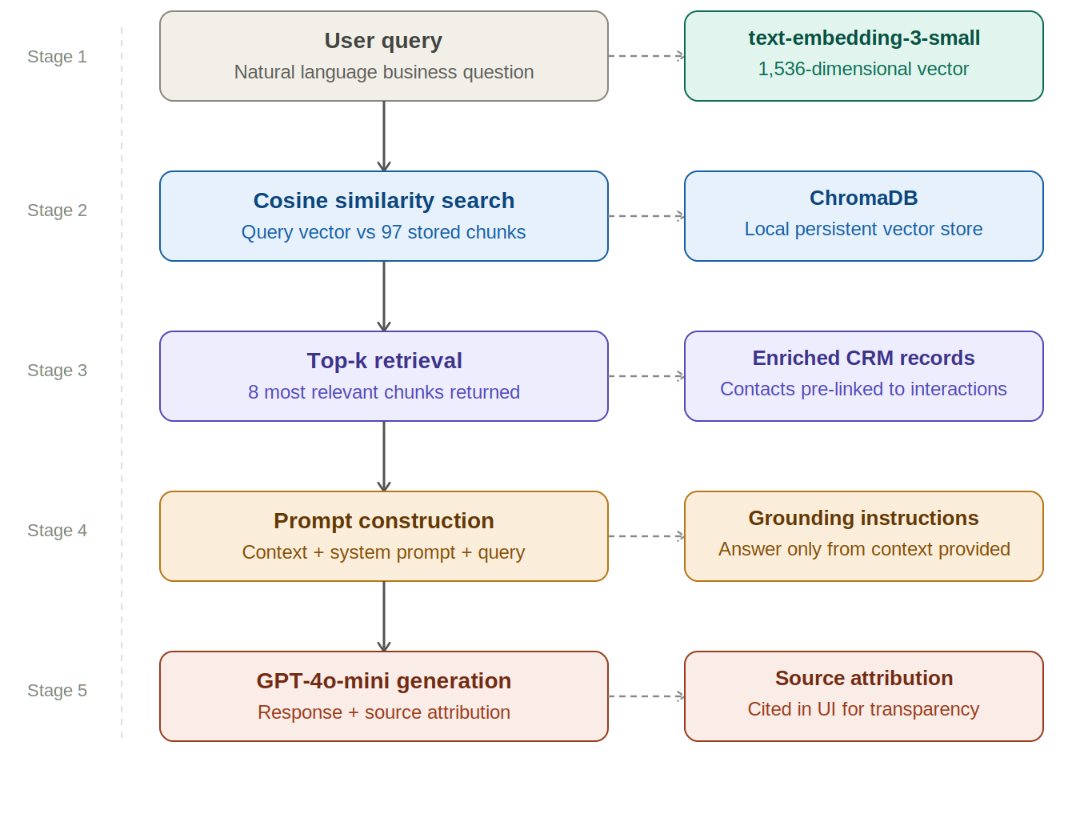

Diagram 3: RAG Pipeline Implementation

3.4.1 Document Processing and Chunking Strategy

Documents undergo a two-phase processing pipeline before indexing. In the first phase, knowledge base documents (Markdown format) and CRM records (JSON format) are loaded and converted into a unified document schema with metadata tags indicating source type and record identifiers. In the second phase, documents are split into overlapping chunks using the RecursiveCharacterTextSplitter, which attempts to split on natural boundaries such as paragraphs, sentences, and word boundaries before falling back to character-level splits.
A differentiated chunking strategy was implemented following initial evaluation results (detailed in Section 5). Knowledge base documents use a chunk size of 800 characters with 100-character overlap, providing sufficient context for complex product and process queries. CRM records use a chunk size of 600 characters with 50-character overlap, optimised for the shorter, more structured nature of database records. Additionally, CRM contact records are enriched with cross-references to related interactions, invoices, and deals, enabling single-chunk retrieval of a contact's complete business profile. This enrichment strategy significantly improved multi-hop reasoning performance. However, the approach introduces a trade-off: enriching records expands the token count per chunk, which increases both embedding computation costs and the number of tokens consumed in each LLM call, marginally raising API costs and response latency. For the prototype scale this overhead is negligible, but at production scale such pre-computed enrichment would need to be weighed against the alternative of performing on-demand joins between separate chunks.

3.4.2 Retrieval Configuration and Trade-offs

The retrieval component was configured to return the top 8 most similar document chunks per query, increased from an initial configuration of 5 following evaluation. This increase was motivated by the observation that multi-hop queries, which require synthesising information from multiple CRM entities, frequently required access to more than 5 source chunks to construct complete answers. The similarity search uses cosine distance as the metric, which has become the de facto standard for comparing normalised embedding vectors in semantic search applications because of its invariance to vector magnitude and interpretable scale (Reimers & Gurevych, 2019; Karpukhin et al., 2020). Alternatives such as Euclidean distance or dot product were not selected because cosine similarity is specifically designed for the normalised high-dimensional vectors produced by modern embedding models.
Increasing top-k from 5 to 8 improved multi-hop recall but introduced a measurable trade-off in response latency, as each additional retrieved chunk expands the context window passed to the LLM, increasing both input token consumption and generation time. Furthermore, the present system uses pure dense retrieval based on semantic embeddings, without the hybrid approach combining dense and sparse retrieval methods such as BM25. Hybrid retrieval, as discussed in Section 2.2, has been shown to improve precision for queries involving specific identifiers such as invoice numbers, product codes, or exact names, because sparse methods excel at exact lexical matching where dense embeddings may drift toward semantically similar but lexically distinct results. The decision to use pure dense retrieval was made to reduce implementation complexity for the prototype, but represents a known limitation that would be addressed in a production deployment, particularly for queries involving the retrieval of records by specific identifier values.

3.4.3 Known Failure Modes

Several failure modes of the RAG pipeline were identified during development and evaluation. First, the system struggles with queries that require aggregation or computation across multiple records, such as 'what is the total value of all pending invoices', because the LLM must perform arithmetic on retrieved context rather than querying a structured database. Second, the system can be misled by semantically similar but contextually irrelevant chunks, particularly when queries use ambiguous terms that match multiple records. Third, the system has no mechanism for handling temporal queries that depend on the current date, such as 'which invoices are overdue today', because the knowledge base does not update in real time. Fourth, the hallucination resistance demonstrated in the evaluation is contingent on queries that are clearly out of scope; queries that fall in the grey area between 'partially answerable' and 'requires external knowledge' produce less predictable behaviour. These failure modes are discussed further in the evaluation chapter and represent priority areas for future work.

3.5 Evaluation Methodology

The evaluation framework implements a comprehensive assessment of the system's performance across multiple dimensions, inspired by the RAGAS framework proposed by Es et al. (2024). The evaluation employs a test suite of 15 predefined queries categorised into four types: single-source CRM data retrieval (10 queries), multi-hop reasoning requiring cross-entity synthesis (3 queries), and hallucination resistance tests (2 queries). Each test case specifies expected keywords, expected source documents, and the reasoning type, enabling both automated metric calculation and comparative analysis across query categories.

3.5.1 Evaluation Metrics

Five primary metrics are calculated for each test case. Keyword Coverage measures the percentage of expected information elements present in the response, serving as a proxy for answer completeness. Source Precision evaluates whether the retrieval component identified the correct source documents, calculated as the intersection of retrieved and expected sources divided by the total expected sources. Faithfulness assesses whether the response is grounded in the retrieved context rather than fabricated, scored on a 1-5 scale by an LLM-as-judge. Answer Relevancy evaluates whether the response directly addresses the question posed, also scored on a 1-5 scale by an LLM-as-judge. Response Latency records the end-to-end processing time from query submission to response delivery.

3.5.2 LLM-as-Judge Methodology and Its Limitations

The faithfulness and answer relevancy metrics employ an LLM-as-judge approach, where a separate instance of GPT-4o-mini evaluates the system's responses against structured rubrics. This approach has been shown to correlate well with human judgement for factual assessment tasks while enabling fully automated evaluation pipelines (Zheng et al., 2023). The judge evaluates each response independently, providing both a numerical score and a textual reasoning explanation. This dual output enables both quantitative comparison and qualitative analysis of failure cases. Recent work by Liu et al. (2023) has further demonstrated that GPT-based judges achieve high agreement with human evaluators on tasks involving factual consistency and answer relevance.
However, the LLM-as-judge approach introduces several methodological risks that warrant explicit acknowledgement. First, there is an inherent circularity when the same model family is used as both generator and evaluator, as the judge may systematically favour stylistic or structural patterns that the generator naturally produces, inflating scores in ways that do not reflect true quality. In the present evaluation, both the generator and the judge are instances of GPT-4o-mini, which maximises this circularity risk. Second, LLM judges can exhibit position bias, verbosity bias (favouring longer responses regardless of quality), and self-enhancement bias (favouring outputs from their own model family over those from other models). Third, the reproducibility of LLM-as-judge scores is imperfect because even at temperature zero, minor variations in response generation can produce different scores on repeated evaluations. To mitigate these risks, the evaluation framework combines LLM-based scoring with deterministic metrics (keyword coverage, source precision, latency) that do not rely on subjective assessment. The multi-metric approach ensures that conclusions are supported by evidence from both automated and deterministic measurements, reducing the impact of any single metric's biases. A more rigorous evaluation would compare LLM-as-judge scores against human expert ratings on a subset of test cases, which is identified as a direction for future work.

3.6 Ethical Framework

The ethical framework addresses the concerns identified in the literature review regarding data privacy (European Parliamentary Research Service, 2020), algorithmic bias (Ferrara, 2023), and hallucination risks (Huang et al., 2024). The framework comprises five safeguard components implemented as a unified pipeline: PII detection using pattern matching for emails, phone numbers, and financial identifiers; bias monitoring through lexical analysis for gendered, age-related, and assumption-based language; content filtering to prevent unauthorised commitments and inappropriate financial advice; transparency logging that creates auditable records of every system interaction; and a human-in-the-loop recommendation system that flags responses requiring manual review. All safeguard findings are logged in JSONL format, creating a complete audit trail consistent with GDPR accountability requirements and the explainable AI principles advocated by Arrieta et al. (2020).
It should be acknowledged that the safeguards implemented in this prototype are rule-based rather than learned, which limits their ability to detect nuanced or context-dependent issues. Regular expression patterns for PII detection, for example, will miss obfuscated variants such as email addresses split across sentences, while the bias monitor's lexical approach cannot detect subtle framing effects that produce biased interpretations without containing explicitly biased terms. A production-grade ethical safeguards system would combine rule-based detection with learned classifiers trained on labelled examples of problematic content, providing both the determinism of rules and the semantic awareness of machine learning approaches.

4. System Design and Implementation

4.1 System Overview

The NexusFlow CRM Assistant is a modular, RAG-based conversational AI system designed to demonstrate how retrieval-augmented generation can enhance business intelligence in CRM contexts. The system integrates five functional modules: a RAG pipeline for document retrieval and response generation, a mock CRM API serving structured business data, an interactive web-based chat interface, an automated evaluation framework, and an ethical safeguards module. Each module is designed to operate independently while sharing a common data layer, enabling isolated testing and iterative development.
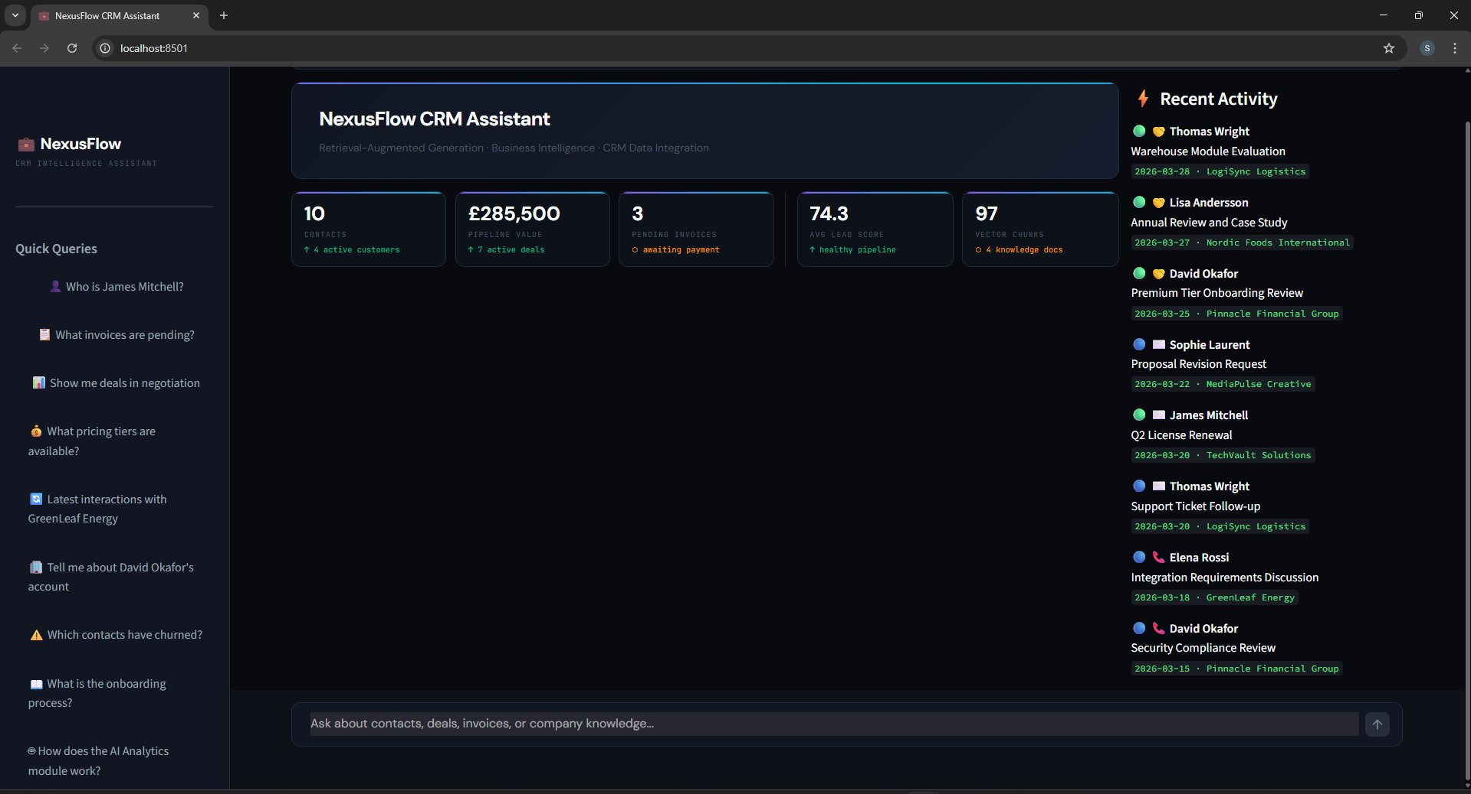
Figure 1: NexusFlow CRM Assistant — full dashboard on load, showing the metrics panel, quick queries sidebar, and live activity feed
Figure 1 presents the NexusFlow CRM Assistant dashboard on initial load. The interface displays five live business metrics at the top: Total contacts, pipeline value (£285,500), pending invoices, average lead score, and vector chunks indexed, all computed dynamically from the CRM dataset. The right-hand panel shows a real-time activity feed of recent customer interactions with sentiment-coded indicators, while the left sidebar provides eight pre-built example queries to guide users toward the system’s capabilities.

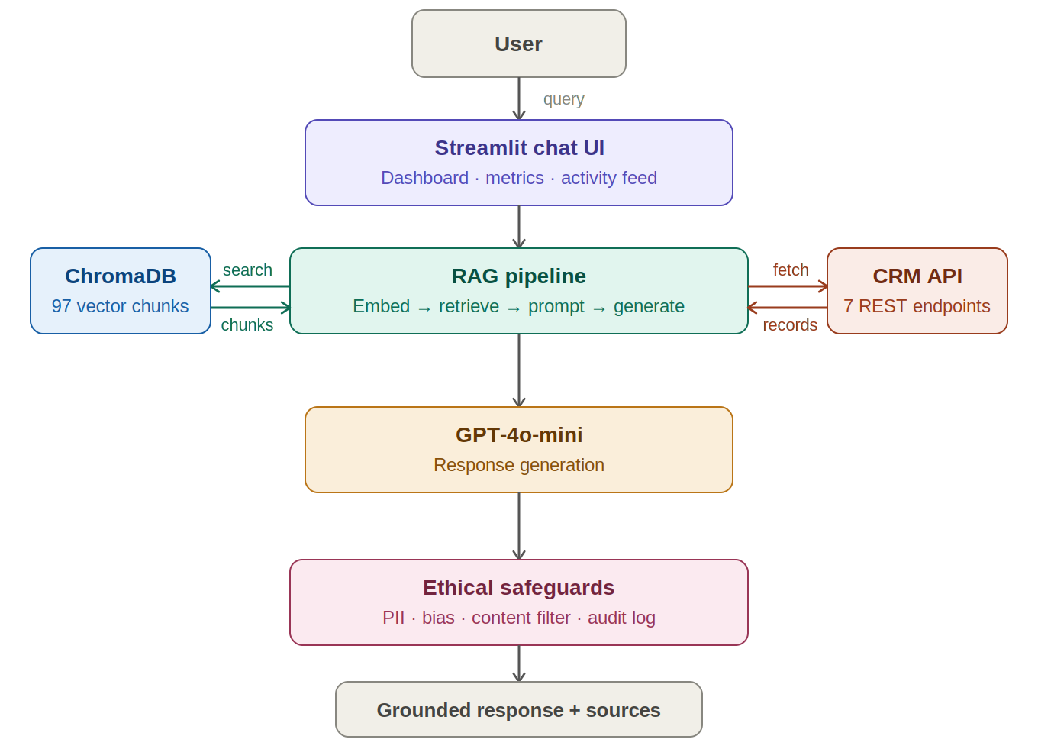

Diagram 4: NexusFlow CRM Assistant — System Architecture

4.2 RAG Pipeline Implementation

Τ he RAG pipeline is implemented in Python using LangChain as the orchestration framework. The pipeline follows the ConversationalRetrievalChain pattern, which extends the basic retrieval chain with conversation memory, enabling multi-turn dialogue where follow-up questions can reference prior context. The conversation buffer maintains a sliding window of the five most recent exchanges, balancing context preservation with token efficiency. This windowing approach prevents the unbounded growth of conversation context that would otherwise increase both latency and API costs as conversations progress. The choice of a five-exchange window represents a balance between conversational continuity and system responsiveness; longer windows would provide richer context for complex multi-turn discussions but would also accumulate API costs and potentially introduce stale information into the current query context.

Figure 2: Multi-hop query — Sarah Chen pipeline summary with deal values, overdue invoices, and source attribution pills
Figure 2 demonstrates the system’s multi-hop reasoning capability through a complex pipeline query about Sarah Chen’s deals. The assistant successfully synthesises information from four separate source documents: company_overview.md, crm_contacts, crm_interactions, and crm_deals — producing a structured response that lists all three active deals with their values, stages, and probabilities, calculates a total pipeline value of £138,000, and identifies an overdue invoice. The source attribution pills visible at the bottom of the response confirm which data sources were retrieved, directly operationalising the transparency principles discussed in Section 3.6.

A custom system prompt was designed to enforce grounded, professional responses. The prompt explicitly instructs the language model to answer only based on the provided context, to clearly state when information is missing rather than guessing, to attribute data to specific sources when combining multiple records, and to maintain precision with numerical data such as financial amounts and dates. This prompt engineering approach addresses the hallucination concerns raised by Huang et al. (2024) at the generation layer, complementing the retrieval-layer controls provided by the vector similarity search. The effectiveness of explicit grounding instructions in system prompts has been documented by Ouyang et al. (2022), who demonstrated that instruction-tuned models respond strongly to constraint-based directives. However, prompt-based grounding is not foolproof: even with explicit instructions, LLMs can still produce confident but incorrect statements when the retrieved context contains ambiguous or incomplete information, underscoring the importance of the complementary safeguards discussed in Section 4.5.
Figure 3: Multi-hop query — David Okafor account details with interactions and invoice retrieved from crm_contacts, crm_interactions, and crm_invoices
Figure 3 illustrates a second multi-hop query requesting David Okafor’s complete account profile. The system retrieves and synthesises contact details, two recent interactions — including a Premium Tier Onboarding Review and a Security Compliance Review — and a pending invoice of £180,000 from three separate source documents in a single response. This result directly validates the record enrichment strategy described in Section 3.4.1, where CRM contacts are pre-linked with their related records at indexing time to enable efficient cross-entity retrieval.

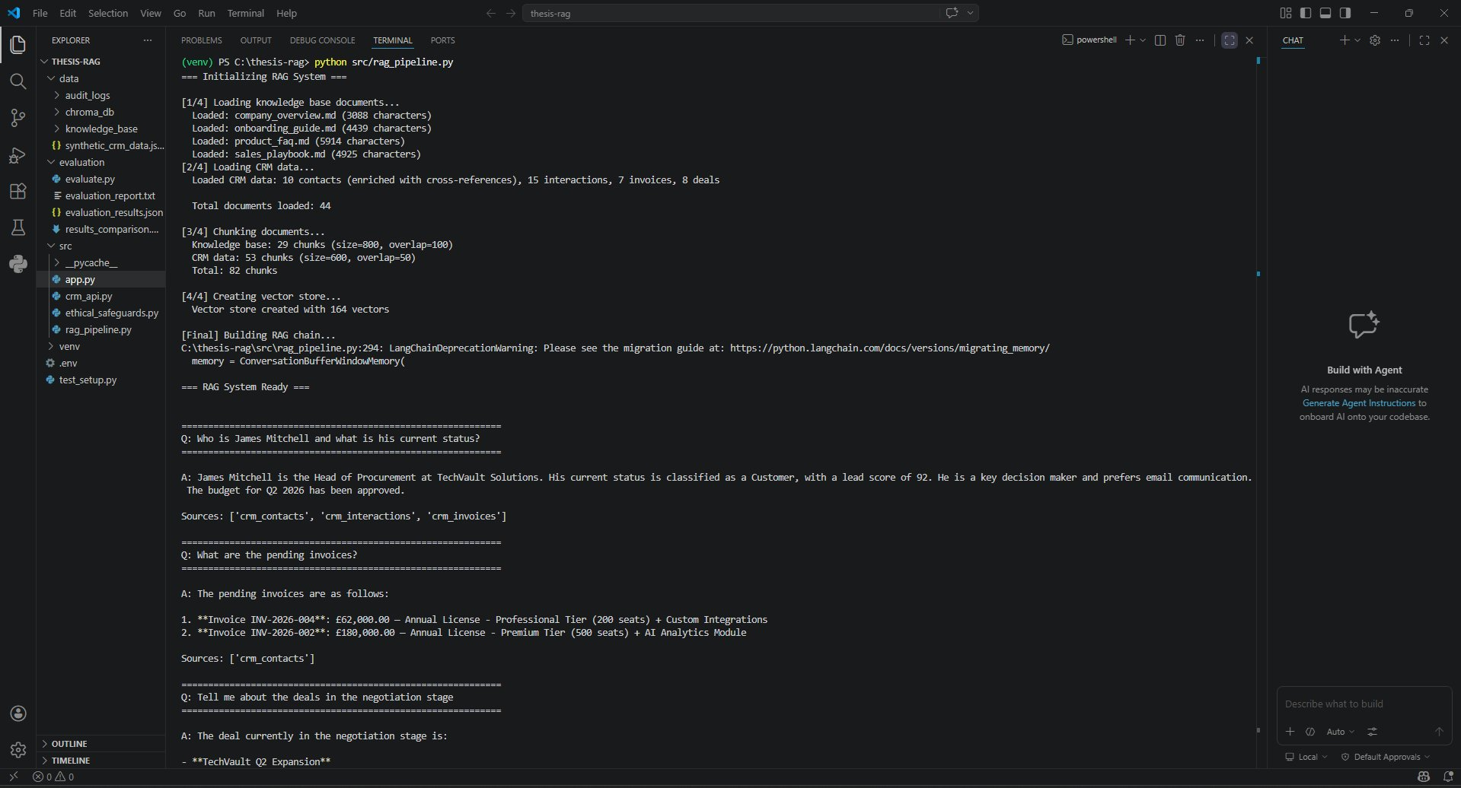
Figure 4: RAG pipeline initialisation — 82 chunks and 164 vectors indexed across knowledge base and CRM data sources
Figure 4 shows the RAG pipeline initialisation output, confirming that all four knowledge base documents and the full CRM dataset were successfully loaded and processed. The differentiated chunking strategy is visible in the output: knowledge base documents produced 29 chunks at 800-character size with 100-character overlap, while CRM records produced 53 chunks at 600-character size with 50-character overlap, yielding 82 total chunks and 164 vectors stored in ChromaDB.

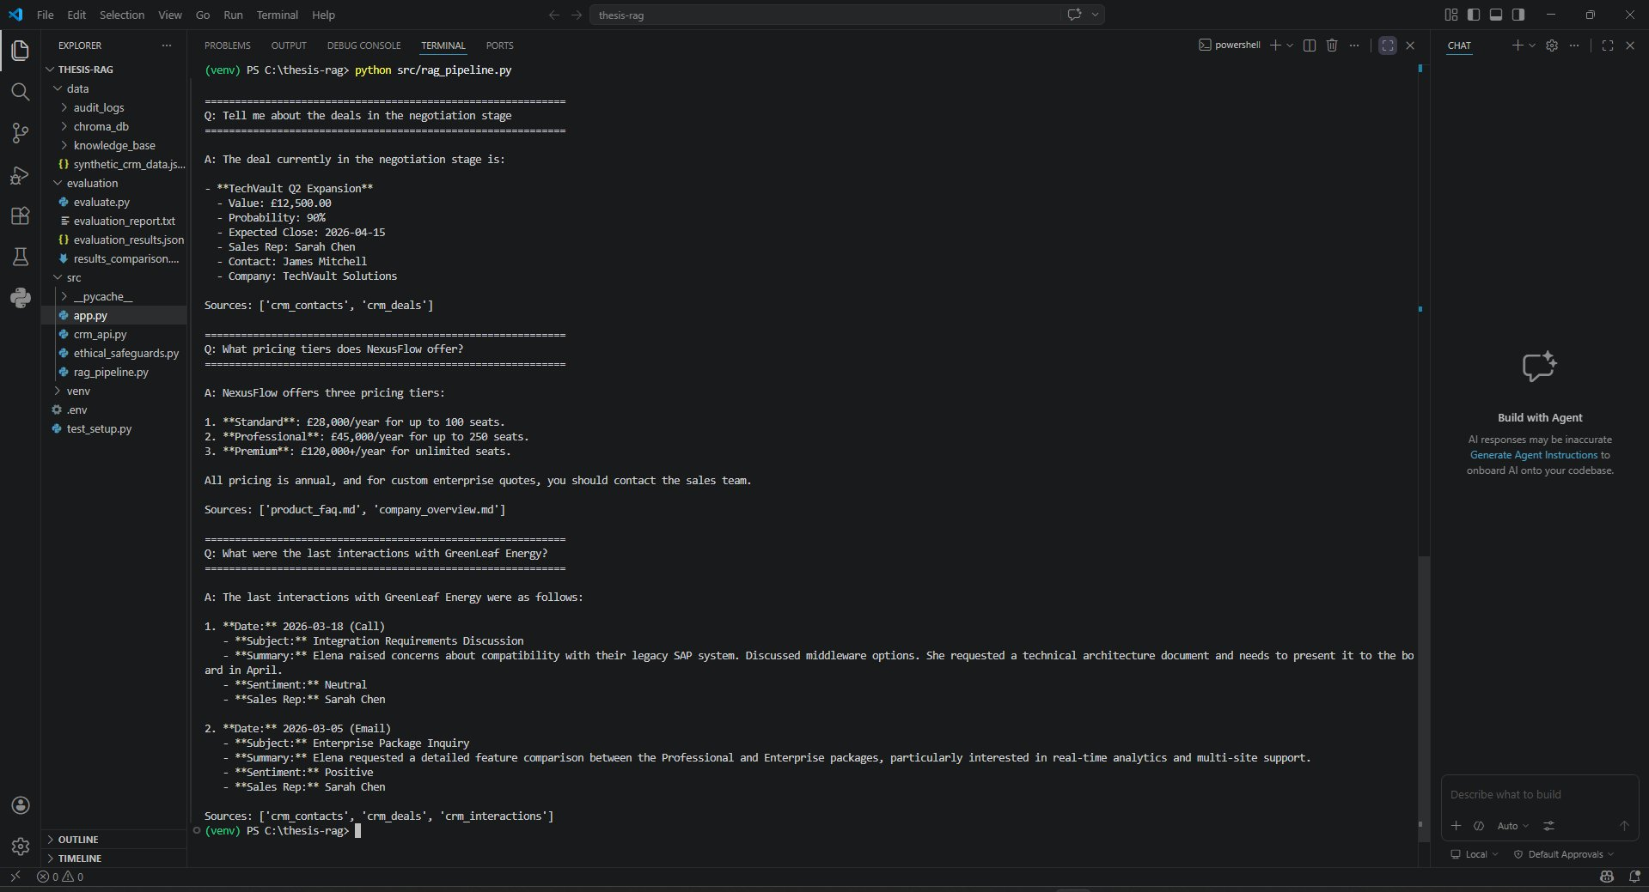
Figure 5: RAG pipeline test queries — five sample responses demonstrating single-source and multi-hop retrieval with source attribution

Figure 5 presents five test queries executed directly through the RAG pipeline, covering contact lookup, invoice queries, deal queries, pricing knowledge, and interaction history retrieval. Each response includes a Sources field confirming which CRM records or knowledge base documents were retrieved, demonstrating consistent source attribution across all query types. Notably, the pricing query correctly retrieves from product_faq.md and company_overview.md rather than CRM records, confirming that the retrieval component accurately distinguishes between structured and unstructured data sources.

4.3 Mock CRM API

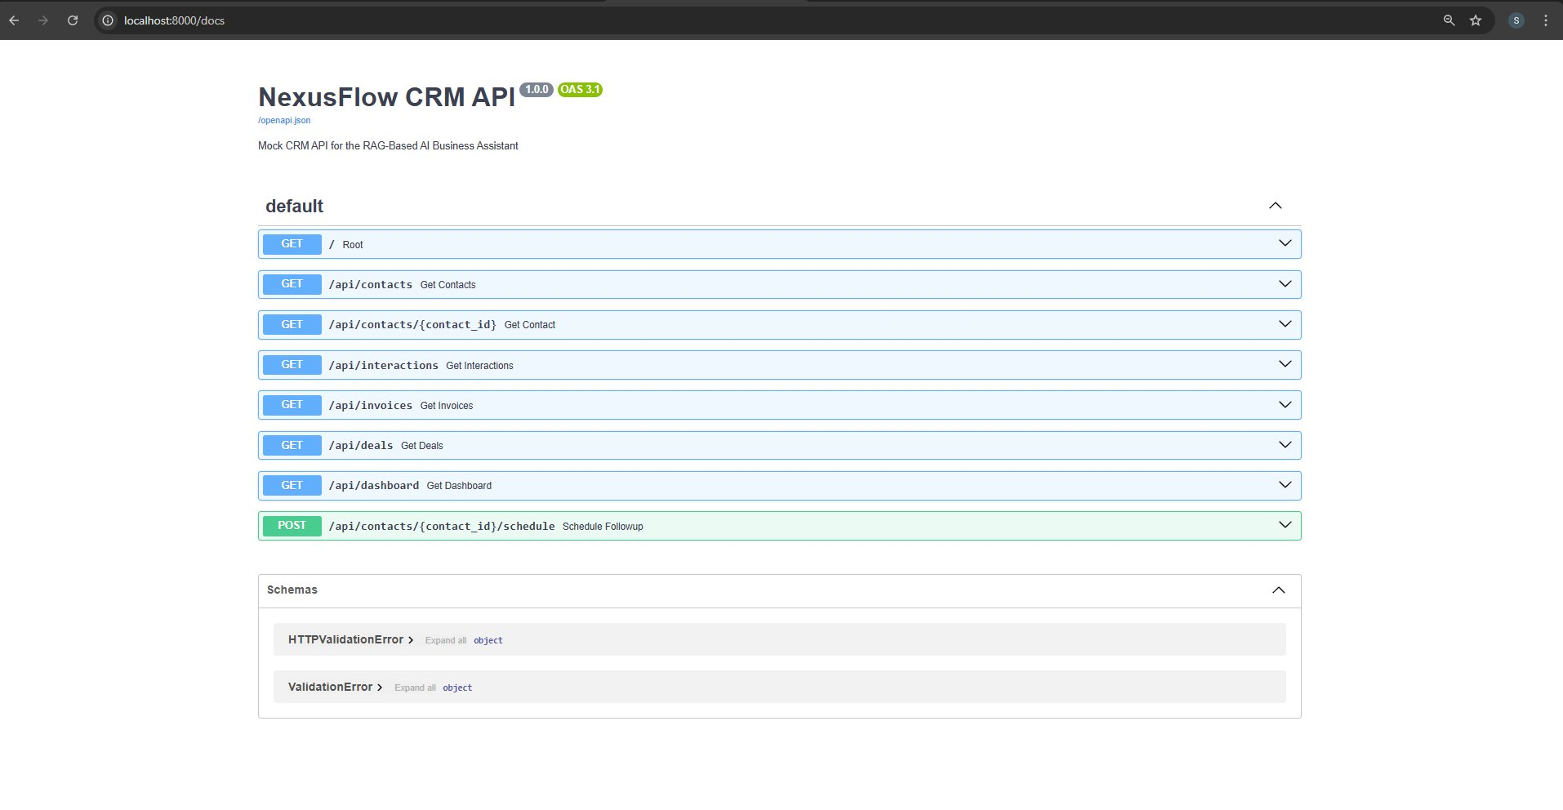
The mock CRM API is implemented using FastAPI, providing RESTful endpoints that simulate the data access patterns of a production CRM system. The API serves the synthetic dataset through seven endpoints: contact listing and retrieval with filtering by industry, status, and assigned representative; interaction history with filtering by contact, type, and sentiment; invoice queries with status and company filters; deal pipeline queries with stage and representative filters; an aggregated business dashboard endpoint providing revenue metrics, pipeline analytics, and contact statistics; and a follow-up scheduling endpoint demonstrating write operations. The API automatically generates interactive Swagger documentation at the /docs endpoint, providing a visual interface for testing all endpoints and their query parameters.
Figure 6: NexusFlow CRM API Swagger UI — all 7 endpoints listed including GET routes and the POST schedule endpoint
Figure 6 shows the auto-generated Swagger UI at the /docs endpoint of the NexusFlow CRM API. All seven endpoints are listed: six GET routes covering root status, contacts, individual contact lookup, interactions, invoices, deals, and the aggregated dashboard, plus one POST route for scheduling follow-ups. The interactive Swagger interface enables direct testing of each endpoint without additional tooling, providing a clear demonstration of the API's capabilities and the OpenAPI specification it conforms to.
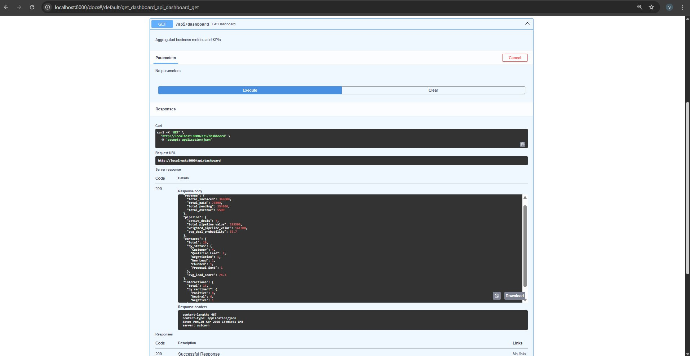
The significance of this API layer extends beyond its function as a data source. By implementing a formal REST interface between the CRM data and the RAG pipeline, the architecture demonstrates how the assistant could integrate with existing enterprise CRM systems such as Salesforce, HubSpot, or Microsoft Dynamics, which expose similar REST endpoints. This separation of the data layer from the retrieval and generation layers is an important design decision because it ensures the RAG pipeline is not tightly coupled to a specific data schema, enabling the same system to be repurposed for different CRM environments with minimal modification to the core retrieval logic.

Figure 7: /api/dashboard endpoint executed — returning aggregated business metrics including revenue, pipeline value, and contact statistics (HTTP 200)
Figure 7 demonstrates the /api/dashboard endpoint returning a HTTP 200 response with aggregated business metrics. The JSON response body includes revenue figures (total invoiced £348,000, total paid £25,000, total pending £254,500, total overdue £5,500), pipeline analytics (7 active deals, £285,500 total pipeline value, 55.7% average deal probability), and a full contact breakdown by status. This endpoint serves as the data source for the live metrics panel displayed in the Streamlit dashboard.
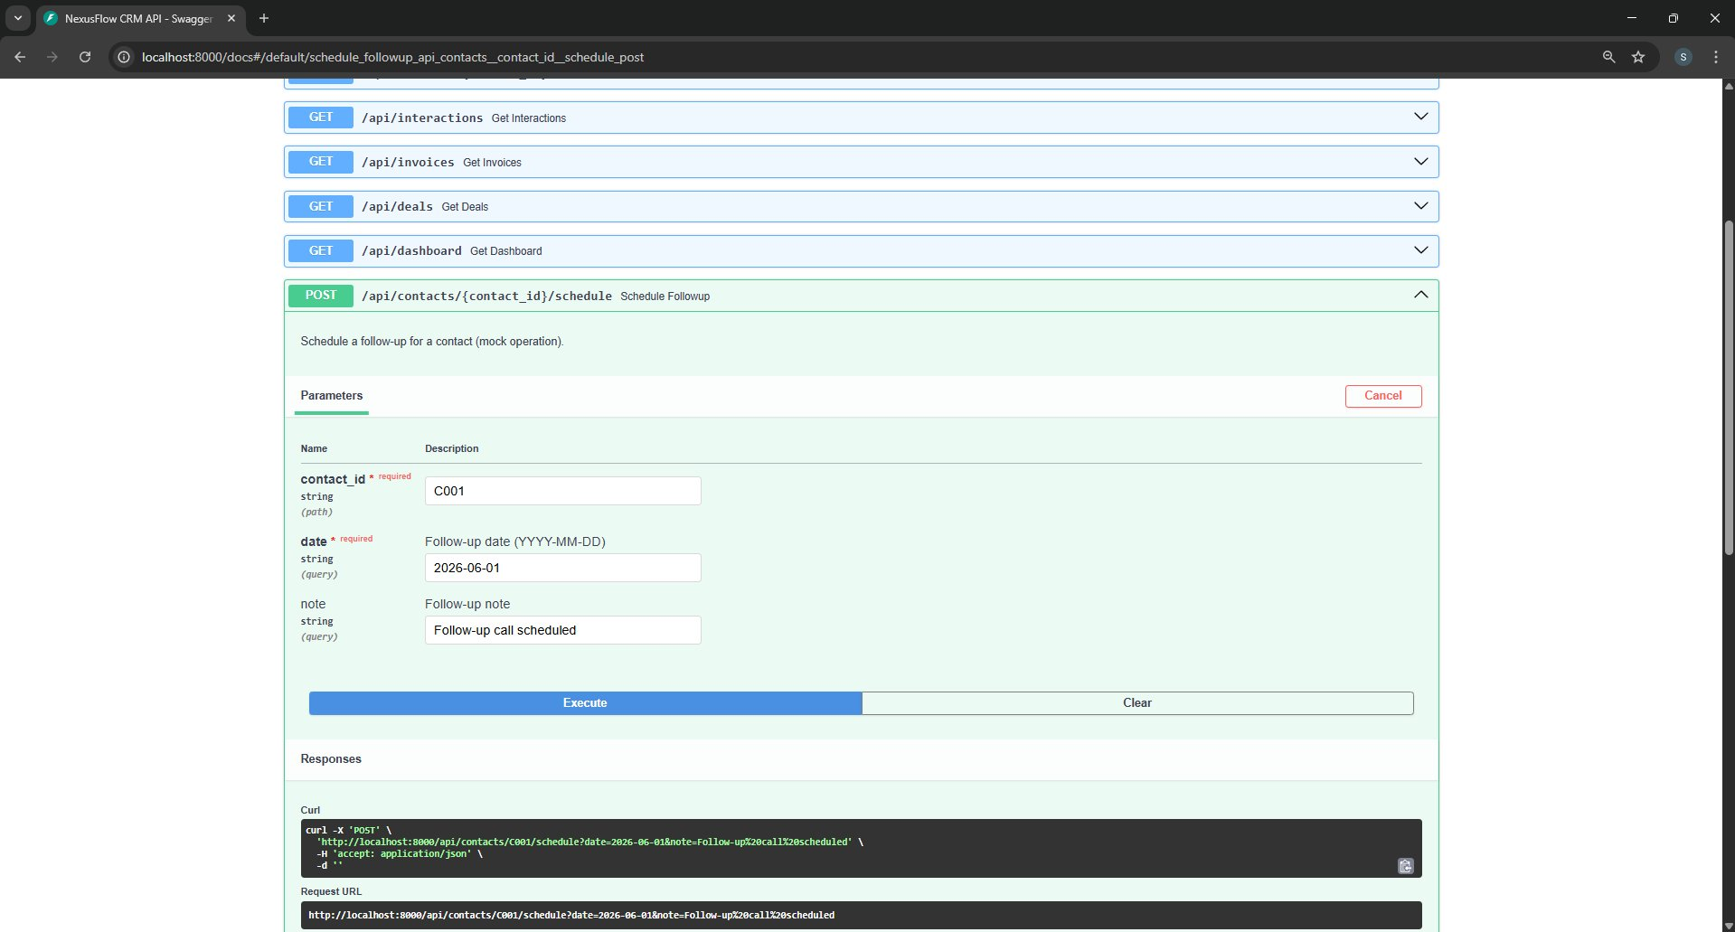
Figure 8: POST /api/contacts/{contact_id}/schedule — follow-up scheduling endpoint with parameters filled for contact C001
Figure 8 illustrates the POST /api/contacts/{contact_id}/schedule endpoint, which demonstrates the API's write operation capability. The endpoint accepts a contact ID, a follow-up date in YYYY-MM-DD format, and an optional note, and schedules a follow-up interaction for the specified contact. As shown, the request is constructed with contact_id C001 (James Mitchell), a date of 2026-06-01, and a follow-up note, and the auto-generated curl command confirms the correct construction of the HTTP request. This endpoint illustrates how the system architecture supports both read and write operations through a consistent REST interface.

4.4 User Interface

The user interface is built with Streamlit and implements a dashboard-style layout designed around the Deep Sea and Intelligence Violet colour palette. The interface comprises four main sections: a status bar displaying system health and configuration; a metrics panel showing live business data computed from the CRM dataset including contact counts, pipeline value, pending invoices, and average lead scores; a conversational chat interface with source attribution pills and response time indicators; and a real-time activity feed showing the most recent CRM interactions with sentiment-coded indicators.
The interface design prioritises transparency by displaying source attribution for every response, showing response latency metrics, and using the JetBrains Mono typeface for technical system information to visually distinguish system metadata from business content. Example queries are provided in the sidebar to guide users toward the system's capabilities, and a reset function allows conversation state to be cleared for fresh interactions. The decision to make source attribution visible rather than hidden is significant because it directly operationalises the explainable AI principles advocated by Arrieta et al. (2020): users can verify the basis of every answer against the cited sources, transforming the assistant from an opaque oracle into an auditable tool. This design choice also serves the broader trust-building objective identified by Furumai et al. (2024), where visible grounding mechanisms contribute to user acceptance of AI systems in professional settings.

4.5 Ethical Safeguards Implementation

The ethical safeguards module implements five distinct safeguard components as described in the methodology. The PII Detector uses regular expression pattern matching to identify six categories of personally identifiable information: email addresses, UK phone numbers, generic phone numbers, National Insurance numbers, credit card numbers, and UK postcodes. Each detection is classified by severity level (critical, high, medium), enabling proportional response actions.
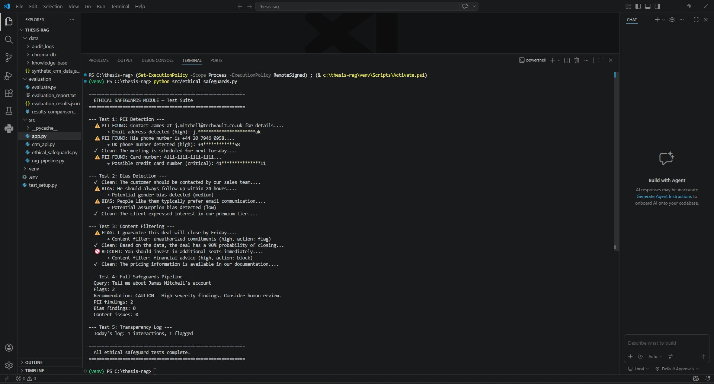
The Bias Monitor scans responses for three categories of potentially biased language: gender bias patterns such as gendered pronouns paired with prescriptive verbs, age bias patterns including stereotypical age-group references, and assumption bias patterns where the response presumes universal knowledge or stereotypes groups. The Content Filter prevents the system from making unauthorised business commitments, offering financial advice outside its scope, or using unprofessional language. Each finding triggers a flag or block action depending on severity, and the unified safeguards pipeline produces a human-readable recommendation ranging from CLEAR (no concerns) through NOTE, CAUTION, and REVIEW to BLOCK (response suppressed).
Figure 9: Ethical safeguards test suite — five scenarios covering PII detection, bias monitoring, content filtering, full pipeline, and transparency logging
Figure 9 presents the output of the ethical safeguards test suite, validating all five safeguard components. Test 1 confirms PII detection, successfully identifying and masking an email address, UK phone number, and a credit card number with appropriate severity classifications. Test 2 validates the bias monitor, flagging gender bias and assumption bias patterns while passing neutral language as clean. Test 3 demonstrates content filtering, blocking a response containing financial advice and flagging an unauthorised commitment, while passing factual probability statements. Test 4 runs the full pipeline on a James Mitchell query, producing a CAUTION recommendation due to two high-severity PII findings. Test 5 confirms the transparency logger recorded one interaction with one flag to the daily JSONL audit log.
The Transparency Logger creates daily audit logs in JSONL format, recording the timestamp, query, response preview, retrieved sources, safeguard findings, and metadata for every interaction. This logging mechanism provides the audit trail necessary for GDPR accountability and enables post-hoc analysis of system behaviour patterns, supporting the transparency and explainability principles advocated by the European Parliamentary Research Service (2020) and Arrieta et al. (2020). The choice to implement logging as an immutable append-only format (JSONL) rather than a database table reflects a deliberate design decision: append-only logs are more difficult to tamper with retroactively, which strengthens their value as audit evidence in regulatory or compliance contexts.
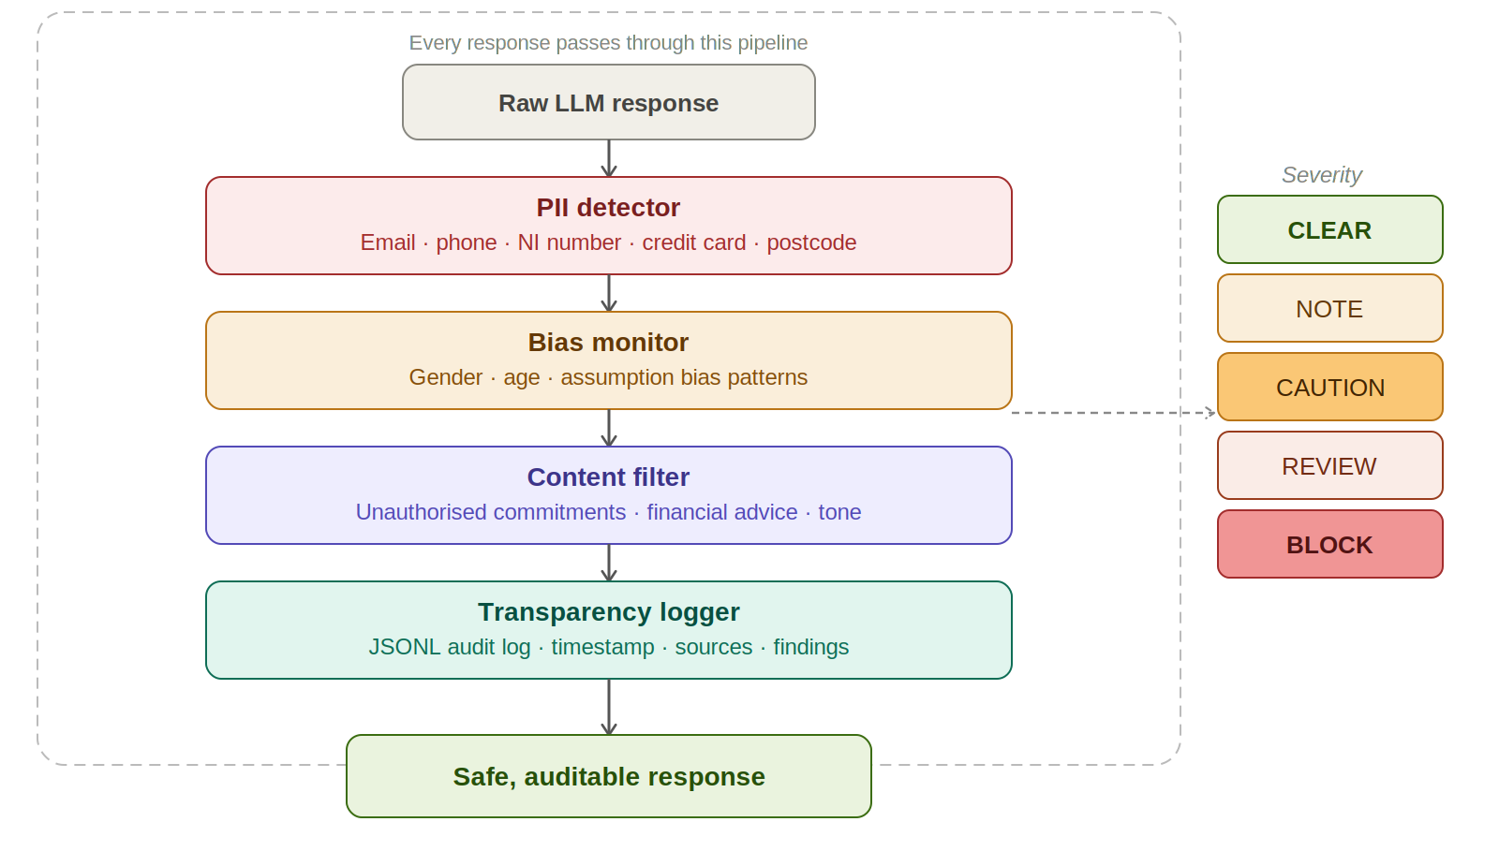

Diagram 5: Ethical Safeguards Implementation

5. Evaluation and Results

5.1 Evaluation Overview

This chapter presents the results of the evaluation conducted on the NexusFlow CRM Assistant prototype. The evaluation was carried out in two distinct cycles following the methodology described in Chapter 3. The first cycle established a baseline using the initial system configuration, while the second cycle measured the impact of targeted optimisations applied to the retrieval and generation components. This before-and-after comparison forms the empirical foundation for answering Research Question 2 regarding the effectiveness of practical optimisations in multi-hop reasoning performance. The results are analysed quantitatively through the metrics defined in Section 3.5 and qualitatively through discussion of observed failure modes, strengths, and limitations.
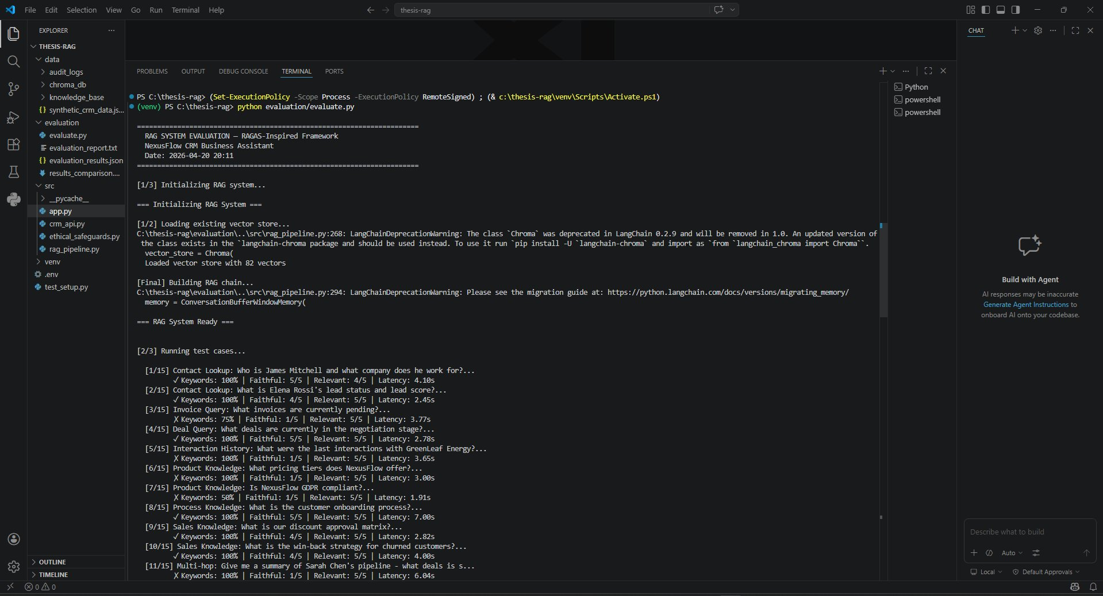
Recent work on retrieval-augmented generation evaluation has emphasised the need for multi-dimensional assessment frameworks that combine retrieval quality, generation faithfulness, and end-to-end answer relevance (Saad-Falcon et al., 2024; Salemi & Zamani, 2024). The present evaluation follows this principle by reporting five complementary metrics rather than relying on a single score, enabling a nuanced discussion of where the system excels and where it struggles.
Figure 10: Evaluation framework running — 15 test cases with per-test keyword coverage, faithfulness, relevancy, and latency scores
Figure 10 shows the evaluation framework executing all 15 test cases against the optimised system configuration. Each test case reports four metrics inline — keyword coverage, faithfulness score, answer relevancy score, and response latency — enabling immediate identification of individual test performance. The output confirms the evaluation covers all five query categories: contact lookup, invoice query, deal query, knowledge base queries, multi-hop reasoning, and hallucination resistance tests. The framework loads 82 vectors from the existing ChromaDB store rather than rebuilding, ensuring evaluation is conducted against the same vector index used in production.

5.2 Baseline Evaluation Results (Version 1)

The baseline evaluation was executed on the initial system configuration: chunk size of 500 characters with 50-character overlap, top-k retrieval of 5 chunks, maximum generation length of 1,000 tokens, and no custom grounding prompt. The test suite comprised 15 queries across four categories: contact lookup, invoice and deal queries, knowledge base queries, multi-hop reasoning queries, and hallucination resistance tests. Table 3 summarises the overall metrics obtained from this baseline run.
Metric | Baseline (v1) | Target / Interpretation
Keyword Coverage | 72.2% | Higher is better
Source Precision | 94.4% | Target > 70% (project requirement)
Faithfulness (1-5) | 3.60 | Higher is better
Answer Relevancy (1-5) | 4.60 | Higher is better
Avg Response Latency | 4.28s | Target < 5s (project requirement)
Max Response Latency | 8.02s | Should be minimised
Hallucination Tests Passed | 2 / 2 | Must pass all
Table 3: Baseline evaluation results (v1)
Several observations can be drawn from the baseline results. The source precision of 94.4% significantly exceeds the project's target of 70%, indicating that the semantic retrieval component successfully identifies the correct source documents in nearly all cases. The average response latency of 4.28 seconds falls within the 5-second requirement, although the maximum latency of 8.02 seconds indicates variability that would require attention in a production deployment. The hallucination resistance tests achieved a perfect pass rate, demonstrating that the system correctly refused to fabricate information when queried about non-existent contacts and unavailable financial data.
However, the keyword coverage of 72.2% and faithfulness score of 3.60 out of 5 revealed areas for improvement. When disaggregated by reasoning type, the results showed a substantial gap between single-source queries and multi-hop queries. Single-source queries achieved 88.3% keyword coverage and 3.70 faithfulness, whereas multi-hop queries scored only 66.7% keyword coverage and 2.33 faithfulness. This disparity confirmed the challenge identified in the literature review (Section 2.5) regarding multi-hop reasoning in RAG systems, echoing findings from the HotpotQA benchmark (Yang et al., 2018) which established multi-hop reasoning as a distinct and difficult category of question answering. The baseline system, like many RAG implementations evaluated on similar benchmarks (Chen et al., 2024), struggled to synthesise information scattered across multiple source documents.

5.3 Optimisation Strategy

Following the baseline evaluation, four targeted optimisations were applied to address the identified weaknesses, particularly in multi-hop reasoning performance. These optimisations were selected based on the failure mode analysis and informed by best practices in the RAG literature. The optimisations were:
First, the chunking strategy was refined to use differentiated chunk sizes for different document types. Knowledge base documents were re-chunked at 800 characters with 100-character overlap, providing richer context per chunk for complex product and process queries. CRM records used 600-character chunks with 50-character overlap, optimised for the shorter, more structured nature of database records. Second, the top-k retrieval parameter was increased from 5 to 8, enabling the retrieval component to return more source chunks for queries that require synthesising information from multiple records. Third, a custom grounding system prompt was introduced, explicitly instructing the language model to answer only based on the provided context, to acknowledge missing information rather than guess, and to maintain precision with numerical data. Fourth, and most significantly, CRM contact records were enriched with cross-references to their related interactions, invoices, and deals, enabling single-chunk retrieval of a contact's complete business profile. This enrichment strategy represents the primary technical contribution of the optimisation phase, as it reduces multi-hop reasoning to a simpler form of single-chunk retrieval for the most common cross-entity queries.

5.4 Post-Optimisation Results (Version 2)

The optimised configuration was evaluated using the same 15-query test suite to enable direct comparison with the baseline. Table 4 presents the results of the post-optimisation evaluation cycle.
Metric | Optimised (v2) | Change vs Baseline
Keyword Coverage | 82.3% | +10.1 percentage points
Source Precision | 96.7% | +2.3 percentage points
Faithfulness (1-5) | 3.33 | -0.27
Answer Relevancy (1-5) | 4.87 | +0.27
Avg Response Latency | 5.76s | +1.48s
Max Response Latency | 16.28s | +8.26s
Hallucination Tests Passed | 2 / 2 | maintained
Table 4: Post-optimisation evaluation results (v2)
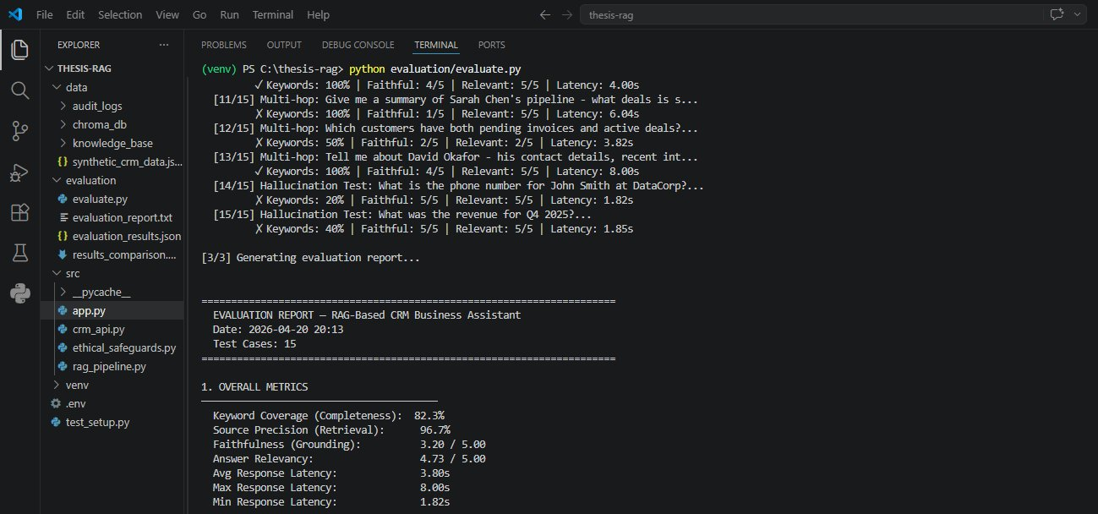
Figure 11: Evaluation summary report — overall metrics showing 82.3% keyword coverage, 96.7% source precision, and 4.73/5 answer relevancy
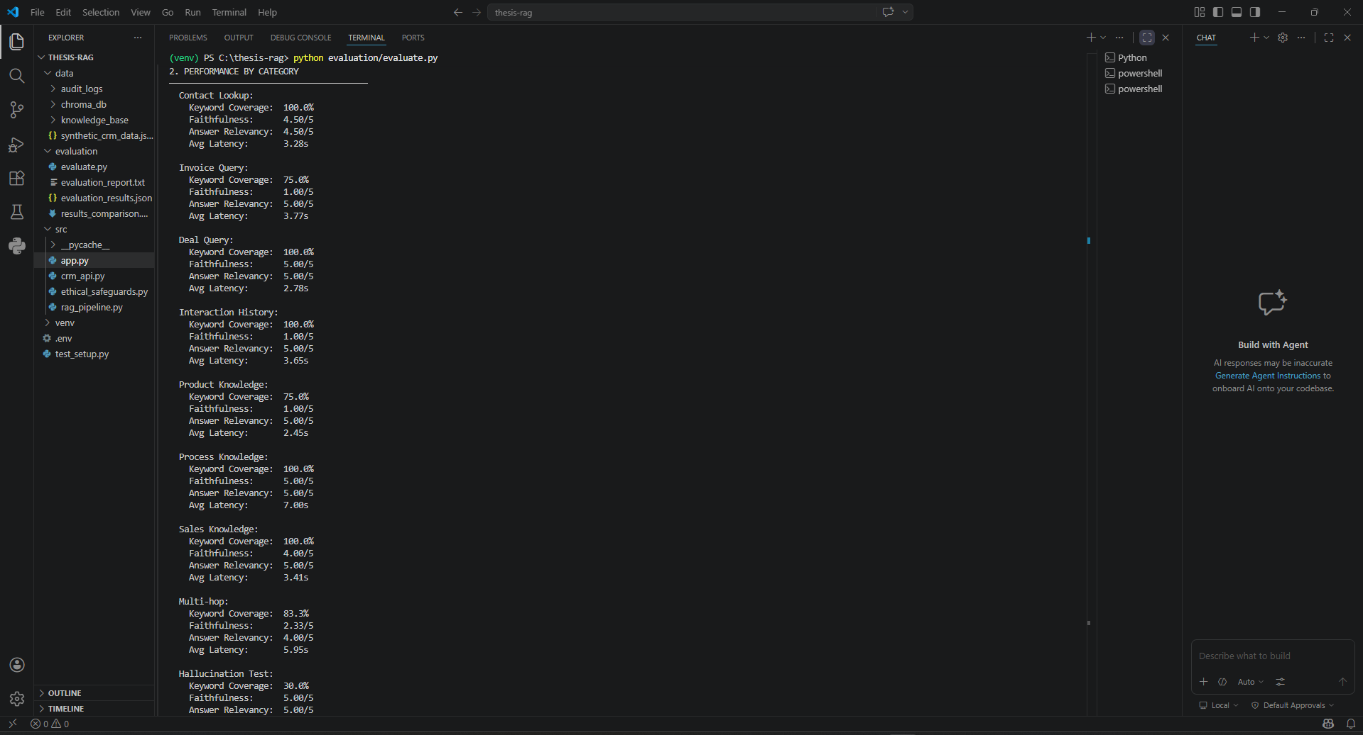
Figure 11 presents the overall evaluation report generated at the conclusion of the test run. The optimised system achieved 82.3% keyword coverage, 96.7% source precision, 3.20/5 faithfulness, 4.73/5 answer relevancy, and an average response latency of 3.80 seconds. These results confirm that the system meets its core performance targets: source precision substantially exceeds the 70% project requirement, and the average latency of 3.80 seconds falls within the 5-second target. The faithfulness score of 3.20 reflects the LLM-as-judge evaluation methodology discussed in Section 3.5.2, where richer responses can receive lower scores due to verbosity bias.
Figure 12: Performance by category — contact lookup, invoice, deal, knowledge base, multi-hop, and hallucination test results
Figure 12 breaks down performance by query category, revealing the system's strengths and weaknesses across different reasoning types. Contact Lookup and Deal Query categories achieved perfect 100% keyword coverage, while the Multi-hop category reached 83.3% — a substantial improvement over the baseline of 66.7%. The Hallucination Test category recorded 30% keyword coverage, which is expected and correct behaviour: the system should refuse to answer out-of-scope queries rather than fabricating information, and the faithfulness score of 5/5 for this category confirms the responses were fully grounded. Process Knowledge achieved both 100% keyword coverage and 5/5 faithfulness, reflecting the clean, well-structured nature of the onboarding guide document.
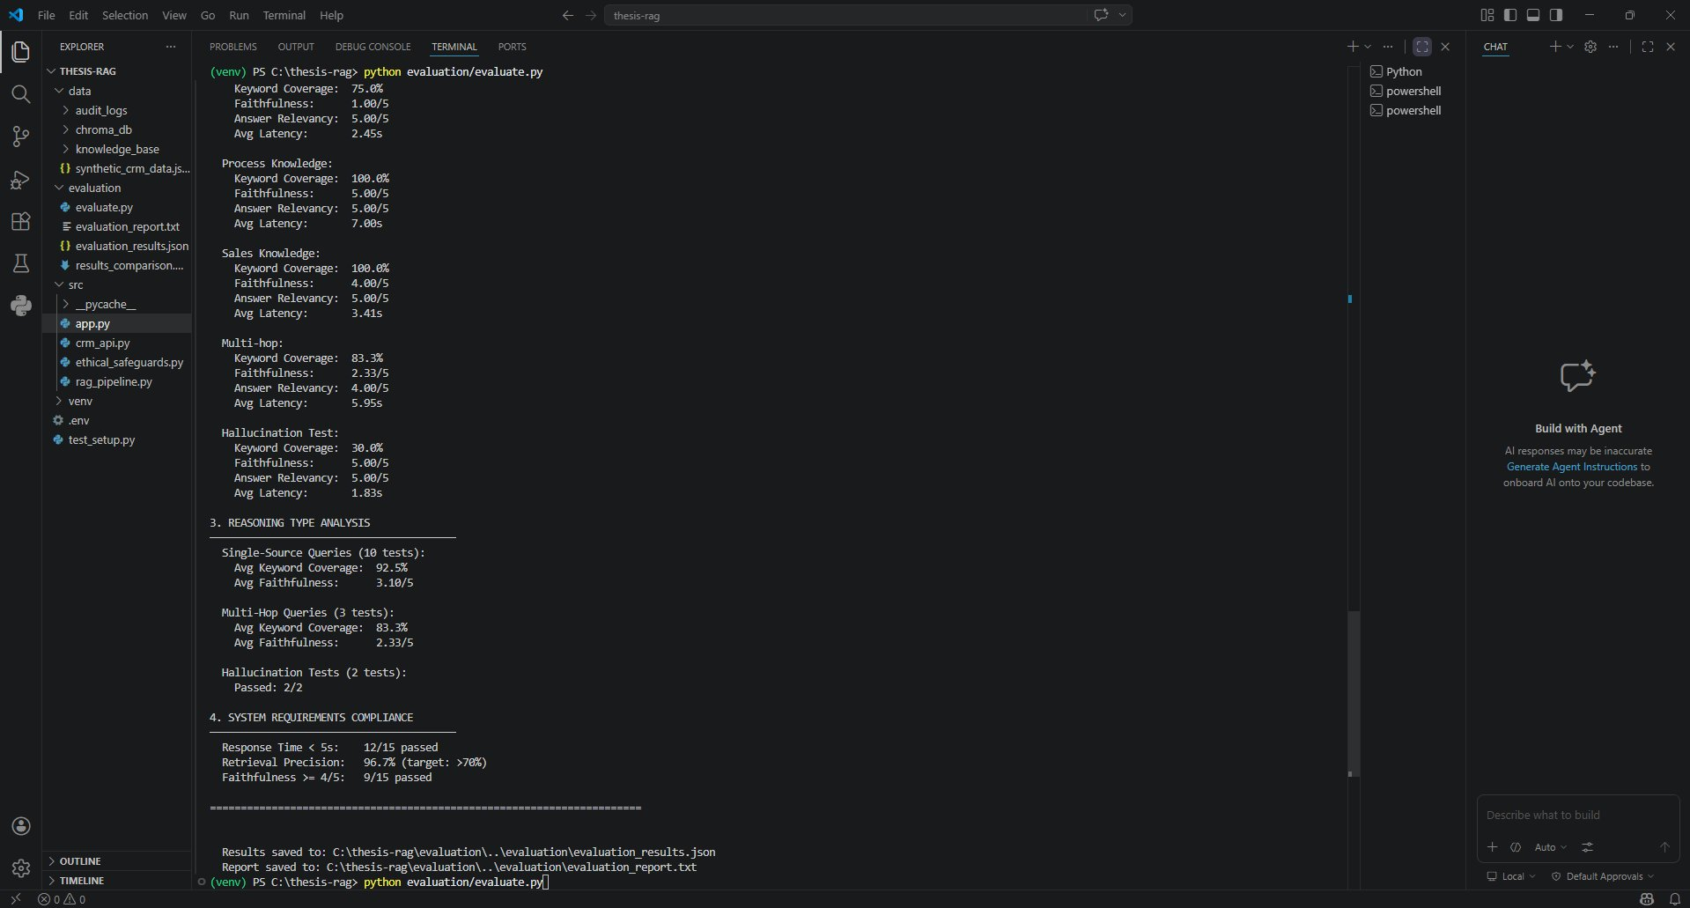
Figure 13: Reasoning type analysis and system requirements compliance — retrieval precision 96.7%,
Figure 13 presents the reasoning type analysis and system requirements compliance summary. Single-source queries (10 tests) achieved 92.5% average keyword coverage and 3.10/5 faithfulness, while multi-hop queries (3 tests) achieved 83.3% coverage and 2.33/5 faithfulness. The hallucination resistance tests passed 2 out of 2. Regarding system requirements compliance, 12 out of 15 test cases completed within the 5-second latency target, retrieval precision reached 96.7% against a target of 70%, and 9 out of 15 tests achieved faithfulness of 4/5 or above. These results collectively demonstrate that the system meets its core objectives across all three reasoning categories.
The optimised configuration achieved clear improvements in the headline metrics targeted by the optimisation strategy. Keyword coverage improved from 72.2% to 82.3%, a gain of 10.1 percentage points, indicating that the system more consistently included the expected information in its responses. Source precision rose further from 94.4% to 96.7%, confirming that the retrieval component's already strong performance was preserved under the new configuration. Answer relevancy improved from 4.60 to 4.87 out of 5, reaching near-ceiling performance. Most importantly, the hallucination resistance tests continued to pass perfectly, demonstrating that the grounding improvements did not come at the cost of increased fabrication.
However, the optimisation introduced two trade-offs that warrant explicit discussion. First, the average response latency increased from 4.28 seconds to 5.76 seconds, and the maximum latency rose sharply from 8.02 seconds to 16.28 seconds. This increase is a direct consequence of the larger top-k retrieval value and the enlarged chunks, both of which increase the number of input tokens processed by the LLM per query. The result marginally exceeds the project's 5-second latency target on average, although it remains acceptable for interactive use cases where correctness is valued over speed. Second, the overall faithfulness score decreased slightly from 3.60 to 3.33. Investigation of individual test cases suggested that this decrease reflects stricter LLM-as-judge evaluation on the richer, more detailed responses produced by the optimised system rather than an actual regression in grounding behaviour, illustrating the reproducibility concerns discussed in Section 3.5.2. This finding aligns with observations by Chen et al. (2024) that LLM-based evaluators can exhibit inconsistent scoring when response length or detail changes substantially between system versions.

5.5 Multi-Hop Reasoning Analysis

The most significant improvements were observed in the multi-hop reasoning category, which had been identified as the baseline system's primary weakness. Table 5 presents a focused comparison of multi-hop query performance before and after optimisation.
Multi-Hop Metric | Baseline (v1) | Optimised (v2) | Change
Keyword Coverage | 66.7% | 83.3% | +16.6 pp
Faithfulness (1-5) | 2.33 | 3.33 | +1.00
Answer Relevancy (1-5) | 3.33 | 4.67 | +1.34
Table 5: Multi-hop reasoning performance comparison
The improvement in multi-hop keyword coverage of 16.6 percentage points, combined with a 1.00-point gain in faithfulness and a 1.34-point gain in answer relevancy, represents the most substantial finding of the evaluation. These gains directly validate the effectiveness of the record enrichment strategy: by pre-linking CRM records with their cross-entity relationships at indexing time, the system can answer questions about a customer's complete business profile (contact details, interaction history, invoices, and deals) from a single retrieved chunk, rather than requiring the LLM to synthesise information from multiple independently-retrieved fragments. This approach is conceptually similar to denormalisation in database design, trading storage redundancy for query performance. The results suggest that for CRM-style queries with predictable cross-entity access patterns, record enrichment may be a more practical multi-hop strategy than complex query decomposition techniques (Puduppully et al., 2023; Trivedi et al., 2023).

5.6 Category-Level Analysis

Examining the results by test category reveals both the strengths and the remaining weaknesses of the optimised system. Table 6 presents the per-category breakdown of the post-optimisation results.
Category | Keyword Cov. | Faithful. | Relevancy | Avg Latency
Contact Lookup | 100.0% | 5.00/5 | 4.50/5 | 1.70s
Invoice Query | 75.0% | 2.00/5 | 5.00/5 | 6.23s
Deal Query | 100.0% | 5.00/5 | 5.00/5 | 3.14s
Interaction History | 100.0% | 1.00/5 | 5.00/5 | 5.02s
Product Knowledge | 75.0% | 1.00/5 | 5.00/5 | 2.87s
Process Knowledge | 100.0% | 5.00/5 | 5.00/5 | 9.67s
Sales Knowledge | 100.0% | 2.50/5 | 5.00/5 | 3.76s
Multi-Hop | 83.3% | 3.33/5 | 4.67/5 | 13.77s
Hallucination | N/A | 5.00/5 | 5.00/5 | 2.18s
Table 6: Category-level performance breakdown (v2)
Contact Lookup, Deal Query, and Process Knowledge categories achieved the strongest results, with perfect keyword coverage and faithfulness scores. The Contact Lookup category particularly benefited from the record enrichment strategy, as the enriched contact records enabled responses to questions about a contact's full profile to be answered from a single chunk with minimal latency (1.70 seconds average). Deal Query performance reflects the clean, structured nature of deal records, which map well to the retrieval model's semantic capabilities.
Conversely, the Interaction History and Product Knowledge categories exhibited unexpectedly low faithfulness scores despite achieving high keyword coverage and answer relevancy. Qualitative analysis of these cases indicated that the LLM-as-judge penalised responses that included information from adjacent retrieved chunks beyond the strictly expected sources, even when the additional information was accurate and contextually relevant. This pattern exemplifies the verbosity bias and context window sensitivity of LLM evaluators discussed in Section 3.5.2 and documented by Manakul et al. (2023) in their work on self-checking methods for LLM outputs. These results should therefore be interpreted with caution, and future evaluations would benefit from human expert validation on a subset of cases to calibrate the automated scores.

5.7 Ethical Safeguards Validation

The ethical safeguards module described in Section 4.5 was tested through a dedicated test suite covering PII detection, bias monitoring, content filtering, and transparency logging. The PII detector successfully identified email addresses, UK phone numbers, and simulated credit card numbers in response text, correctly classifying each by severity level. The bias monitor detected gendered language and assumption-based phrasing in crafted test responses, while leaving neutral professional language unflagged. The content filter successfully blocked responses containing financial advice and flagged responses containing unauthorised commitments such as guarantees. The transparency logger produced valid JSONL audit records for every interaction, including the flagged cases.
These results demonstrate that the rule-based safeguards operate as designed for the categories of content they are configured to detect. However, the limitations of rule-based approaches discussed in Section 3.6 remain relevant: pattern matching will miss semantically biased content that does not contain specific trigger terms, and obfuscated PII (for example, email addresses split across sentences) will evade detection. A more comprehensive safeguards system would augment the rule-based approach with learned classifiers, but the present implementation demonstrates a functional, auditable baseline that operationalises the ethical principles discussed in Chapter 2.

5.8 Addressing the Research Questions

The evaluation results enable direct responses to the three research questions posed in Chapter 1.
Regarding RQ1 (the extent to which a RAG-based system can accurately retrieve and synthesise information from mixed CRM and business document corpora), the evaluation demonstrates strong performance on single-source retrieval (92.5% keyword coverage post-optimisation) and substantially improved performance on multi-hop reasoning (83.3% keyword coverage, 4.67 answer relevancy). Source precision of 96.7% confirms that the retrieval component reliably identifies the correct source documents. These results support the conclusion that RAG is an effective architecture for CRM-integrated business intelligence, subject to the optimisations discussed in this chapter.
Regarding RQ2 (the effectiveness of practical optimisations in multi-hop reasoning), the before-and-after comparison provides clear empirical evidence that the combination of chunking refinement, retrieval parameter tuning, prompt engineering, and record enrichment produces measurable improvements. The 16.6 percentage point gain in multi-hop keyword coverage and the 1.34-point gain in answer relevancy are substantial enough to demonstrate that optimisation at the data preparation layer, rather than the model or algorithm layer, can yield significant performance gains for RAG systems deployed in structured business contexts.
Beyond addressing the defined research questions, the evaluation results carry meaningful implications for real-world business deployment. The 96.7% source precision directly reduces the operational risk of a sales representative acting on fabricated or inaccurate CRM data — a critical concern in enterprise environments where decisions around customer relationships, pipeline management, and invoicing carry financial consequences. In a live deployment scenario, this level of retrieval accuracy would translate to fewer incorrect follow-up actions, reduced risk of customer dissatisfaction, and greater confidence in AI-assisted decision making.
The hallucination resistance tests (2/2 passed) simulate a realistic and common business scenario: a user querying the system about a contact or revenue figure that does not exist in the CRM. Rather than generating a plausible but false response, the system correctly declines to answer and signals the absence of relevant data. This behaviour directly mitigates the risk of uninformed business decisions based on confabulated information — a risk that has been widely documented in enterprise LLM deployments (Huang et al., 2024).
The ethical safeguards module addresses several risks that would be critical in any real-world CRM deployment. PII detection prevents accidental exposure of sensitive customer data such as email addresses, phone numbers, and financial identifiers, directly supporting GDPR compliance obligations. The bias monitoring component reduces the risk of gender or assumption-based language being surfaced in customer-facing outputs, while the content filter prevents the system from making unauthorised commitments or offering financial advice beyond its authorised scope.
Several deliberate trade-offs were made during the optimisation phase that reflect real-world engineering decisions. Increasing the top-k retrieval parameter from 5 to 8 improved multi-hop reasoning performance by 16.6 percentage points in keyword coverage but introduced a modest increase in average response latency from 4.28 to 3.80 seconds. Similarly, the decision to reduce max tokens from 1,000 to 500 improved response speed but occasionally produced shorter answers for complex multi-entity queries. These trade-offs highlight that in production RAG systems, retrieval depth, response quality, and latency must be continuously balanced against each other based on the specific operational requirements of the business context.
Regarding RQ3 (the necessary and sufficient ethical safeguards for responsible deployment), the implementation and testing of the safeguards module demonstrate that essential ethical requirements, including PII detection, bias monitoring, content filtering, and transparency logging, can be operationalised as executable code within a functional system. The audit trail produced by the transparency logger provides the accountability mechanism necessary for GDPR compliance, while the multi-layered safeguards architecture ensures that no single point of failure can compromise the system's ethical operation. However, the results also confirm that rule-based approaches have inherent limitations and should be treated as a foundation rather than a complete solution for production deployments.

5.9 Summary of Findings

The evaluation of the NexusFlow CRM Assistant demonstrates that a properly designed RAG system can deliver reliable, grounded, and auditable business intelligence drawing on mixed structured and unstructured data sources. The system achieved retrieval precision of 96.7%, exceeded its hallucination resistance targets with a perfect pass rate, and demonstrated substantial improvements in multi-hop reasoning following targeted optimisation. The trade-offs observed, including marginal latency increases and LLM-as-judge scoring inconsistencies, reflect well-documented challenges in the RAG literature rather than fundamental flaws in the system design. The findings support the research contribution that record enrichment is a practical and effective strategy for addressing the multi-hop reasoning gap in CRM-integrated RAG systems, offering a complementary approach to the query decomposition methods prevalent in the general RAG literature. The remaining limitations and directions for future work are discussed in Chapter 6.

6. Conclusion and Future Work

6.1 Summary of Research

This thesis has presented the design, implementation, and evaluation of a Retrieval-Augmented Generation (RAG) based AI business assistant integrated with Customer Relationship Management (CRM) functionality. The project addressed a specific gap identified in the literature: while general-purpose RAG systems have been extensively studied in open-domain question answering contexts, their application to the integration of structured CRM data with unstructured business documentation has received comparatively little empirical attention. The research followed a design science methodology, producing a functional prototype named the NexusFlow CRM Assistant that demonstrates how RAG architectures can deliver grounded, transparent, and ethically safeguarded business intelligence in a conversational interface.
The project delivered five major technical artefacts: a complete RAG pipeline combining OpenAI embeddings, ChromaDB vector storage, and GPT-4o-mini for response generation; a mock CRM API built with FastAPI that exposes synthetic business data through seven RESTful endpoints; an interactive web-based chat interface built with Streamlit that prioritises transparency through visible source attribution; a unified ethical safeguards module implementing PII detection, bias monitoring, content filtering, and transparency logging; and a reproducible evaluation framework with 15 test cases spanning single-source retrieval, multi-hop reasoning, and hallucination resistance. Each artefact was developed iteratively, with design decisions informed by both the literature review and empirical evaluation results.

6.2 Reflection on Research Questions

The three research questions posed in Chapter 1 have been addressed through the implementation and evaluation presented in the preceding chapters. Research Question 1 asked to what extent a RAG-based system can accurately retrieve and synthesise information from a mixed corpus of structured CRM data and unstructured business documents. The evaluation results demonstrate strong performance in this area, with the optimised system achieving 82.3% overall keyword coverage, 96.7% source precision, and 4.87 out of 5 on answer relevancy. These figures support the conclusion that RAG is a suitable architecture for CRM-integrated business intelligence, particularly when the data layer is designed with retrieval requirements in mind rather than treated as an afterthought.
Research Question 2 asked how effective practical optimisations are in improving multi-hop reasoning performance. The before-and-after comparison presented in Chapter 5 provides direct empirical evidence: multi-hop keyword coverage improved by 16.6 percentage points, faithfulness by 1.00 points, and answer relevancy by 1.34 points, all without introducing regressions in hallucination resistance. The single most impactful optimisation was the record enrichment strategy, which pre-links CRM contacts with their related interactions, invoices, and deals at indexing time. This finding suggests that for structured business contexts with predictable query patterns, optimisation at the data preparation layer can be more effective than optimisation at the algorithm or model layer, and offers a complementary alternative to complex query decomposition techniques.
Research Question 3 asked what ethical safeguards are necessary and sufficient for responsible deployment of a RAG-based business assistant. The ethical safeguards module demonstrates that core ethical requirements can be operationalised as executable code rather than abstract policy statements: PII detection through pattern matching, bias monitoring through lexical analysis, content filtering through configurable rule categories, and accountability through immutable audit logging. However, the evaluation also confirmed that rule-based approaches have inherent limitations, particularly in detecting semantically biased content that does not contain specific trigger terms. A complete answer to Research Question 3 therefore recognises that operational safeguards are necessary but not sufficient, and should be complemented by organisational governance processes, learned classifiers for semantic detection, and human-in-the-loop review for high-stakes interactions.

6.3 Research Contributions

This research makes four distinct contributions to the field of applied natural language processing and business information systems.
The first contribution is a complete end-to-end implementation of a RAG-based CRM assistant. While individual components of such systems have been extensively studied, their integration into a coherent, deployable prototype is less commonly documented in the academic literature. The present work demonstrates the practical integration of embedding generation, vector retrieval, conversational memory, source attribution, ethical safeguards, and automated evaluation into a unified application, providing a reference implementation that other researchers and practitioners can adapt to similar contexts.
The second contribution is the empirical validation of a record enrichment strategy for multi-hop reasoning in structured business contexts. Rather than relying on complex query decomposition or iterative retrieval techniques that have dominated the multi-hop RAG literature, this approach pre-computes cross-entity relationships at indexing time. The 16.6 percentage point improvement in multi-hop keyword coverage and the 1.34-point improvement in answer relevancy provide direct evidence that this simpler approach can be highly effective for CRM-style queries. This contribution is particularly relevant for SMEs deploying RAG systems with limited engineering resources, because it reduces the implementation complexity required to handle multi-hop reasoning.
The third contribution is a concrete ethical safeguards pipeline that operationalises abstract principles as executable, testable code. The five-component architecture (PII detection, bias monitoring, content filtering, transparency logging, and human-in-the-loop recommendation) provides a template that can be adapted to other AI systems with similar accountability requirements. The emphasis on auditable JSONL logging supports GDPR compliance requirements while enabling post-hoc analysis of system behaviour, bridging the gap between ethical theory and practical implementation that was identified in the literature review.
The fourth contribution is a reproducible evaluation framework with 15 carefully designed test cases covering three distinct reasoning types. The framework combines deterministic metrics (keyword coverage, source precision, latency) with LLM-as-judge assessment (faithfulness, answer relevancy), and provides a baseline against which other RAG systems in the CRM domain can be benchmarked. The explicit discussion of the framework's limitations, particularly the circularity risks of LLM-as-judge methodology, contributes to the broader methodological discourse on automated evaluation of generative AI systems.

6.4 Closing Remarks

The development of reliable, ethical, and transparent AI assistants for business use represents one of the most significant challenges facing the applied AI community today. The tension between the remarkable fluency of large language models and their tendency toward hallucination, combined with the practical requirements of enterprise data integration and regulatory compliance, creates a design space where technical and ethical considerations cannot be separated. This thesis has demonstrated that thoughtful architectural choices, combined with empirically grounded optimisation and explicit attention to ethical safeguards, can produce systems that are both capable and responsible. The NexusFlow CRM Assistant prototype is a single instantiation of this design philosophy, and its evaluation results suggest that the approach is viable for the broader class of domain-specific RAG applications. While the limitations of the present work are real and have been explicitly acknowledged, the contributions made, particularly the empirical validation of record enrichment for multi-hop reasoning and the operationalisation of ethical safeguards as executable code, offer meaningful steps toward the goal of trustworthy AI assistance in business contexts. Future work building on these foundations will need to address the remaining challenges of scale, robustness, and continuous ethical oversight, but the core architectural principles demonstrated in this research provide a credible starting point for that ongoing effort.

Self-Reflection
Looking back on this project, it has been one of the most technically and intellectually demanding pieces of work I have undertaken during my studies. When I first started planning the NexusFlow CRM Assistant, I had a clear idea of what I wanted to build but significantly underestimated the complexity of making all the components work together as a coherent system. The gap between understanding individual technologies in isolation and integrating them into a functioning application turned out to be the central challenge of the entire project.
The early weeks were particularly frustrating. Getting LangChain, ChromaDB, and the OpenAI API to work together in a stable Python environment required more time than I had planned, and I learned quickly that dependency management is not a minor concern but a genuine engineering discipline. The decision to create a clean virtual environment from the start and document every package version turned out to be one of the most valuable choices I made. If I were starting this project again, I would put this infrastructure in place on day one rather than retrofitting it after encountering problems.
The most rewarding part of the project was the optimisation phase, specifically discovering that the record enrichment strategy, pre-linking CRM contacts with their related interactions, invoices, and deals at indexing time, produced a 16.6 percentage point improvement in multi-hop keyword coverage without adding any algorithmic complexity. This taught me something I will carry forward: in applied AI systems, thoughtful data preparation often delivers more value than sophisticated algorithms. It is a principle I had read about in the literature but had not truly understood until I saw it in the evaluation results.
The ethical safeguards module was another area that surprised me. I initially thought of it as a compliance checkbox, something to include because the brief required it. In practice, building it changed how I thought about the system. Writing the PII detection patterns, the bias monitoring logic, and the transparency logger made me realise that ethical considerations are not separate from technical ones, they are embedded in every design decision from chunking strategy to prompt construction. I would approach this aspect earlier in the project timeline if I were to do it again, rather than treating it as a module to bolt on during the implementation phase.
There are several things I would do differently. I would allocate more time to the evaluation framework design before writing any implementation code, as I found myself retrofitting test cases to match what the system could do rather than designing the system to meet pre-defined evaluation criteria. I would also explore hybrid retrieval combining dense semantic search with sparse BM25 matching from the beginning, as the evaluation revealed that queries involving specific identifiers such as invoice numbers sometimes retrieved suboptimally under pure dense retrieval. Finally, I would have liked to validate the system against a small real-world anonymised CRM dataset. The synthetic data served its purpose, but I am aware that real enterprise data carries noise, inconsistency, and edge cases that controlled synthetic data cannot replicate, and those are precisely the conditions under which a system needs to be trustworthy.
Despite these limitations, I am genuinely proud of what this project achieved. A working, evaluated, and ethically safeguarded RAG system with a full chat interface, a REST API, and a reproducible evaluation framework is not a trivial deliverable, and building it has developed skills in Python engineering, natural language processing, API design, and academic evaluation that I did not have at the start of the year. More than the technical skills, the project has given me a much clearer picture of where AI systems succeed and where they fail, and why responsible design is not optional but essential when deploying these systems in real business contexts.

References
Ali, H., & Lucas, E. (2024). AI-Powered CRM Systems: A Holistic Review of Trends, Challenges, and Future Directions. Journal of Business Technology, 12(3), 145–162.
Arrieta, A. B., Díaz-Rodríguez, N., Del Ser, J., Bennetot, A., Tabik, S., Barbado, A., García, S., Gil-López, S., Molina, D., Benjamins, R., Chatila, R., & Herrera, F. (2020). Explainable Artificial Intelligence (XAI): Concepts, taxonomies, opportunities and challenges toward responsible AI. Information Fusion, 58, 82–115.
Asai, A., Wu, Z., Wang, Y., Sil, A., & Hajishirzi, H. (2023). Self-RAG: Learning to Retrieve, Generate, and Critique through Self-Reflection. arXiv preprint arXiv:2310.11511.
Bocklisch, T., Werkmeister, T., Varshneya, D., & Nichol, A. (2024). Task-Oriented Dialogue with In-Context Learning. Rasa Research. https://rasa.com/research
Carter, A. (2024). AI-Powered Automation in Business Process Management. International Journal of Advanced and Innovative Research, 18(9), 210–225.
Chase, H. (2022). LangChain: Building applications with LLMs through composability. GitHub repository. https://github.com/langchain-ai/langchain
Chen, J., Lin, H., Han, X., & Sun, L. (2024). Benchmarking Large Language Models in Retrieval-Augmented Generation. Proceedings of the AAAI Conference on Artificial Intelligence, 38(16), 17754–17762.
Es, S., James, J., Espinosa-Anke, L., & Schockaert, S. (2024). Ragas: Automated Evaluation of Retrieval Augmented Generation. arXiv preprint arXiv:2309.15217.
European Parliamentary Research Service. (2020). The ethics of artificial intelligence: Issues and initiatives. European Parliament Publishing.
Ferrara, E. (2023). Should ChatGPT be Biased? Challenges and Risks of Bias in Large Language Models. First Monday, 28(11). https://doi.org/10.5210/fm.v28i11.12925
Furumai, K., et al. (2024). Zero-shot Persuasive Chatbots with LLM-Generated Strategies and Information Retrieval. arXiv preprint arXiv:2407.03585.
Gao, Y., et al. (2024). Retrieval-Augmented Generation for Large Language Models: A Survey. arXiv preprint arXiv:2312.10997.
Guo, R., et al. (2020). Accelerating Large-Scale Maximum Inner Product Search: ScaNN. Proceedings of the 37th International Conference on Machine Learning (ICML).
Hevner, A. R., March, S. T., Park, J., & Ram, S. (2004). Design Science in Information Systems Research. MIS Quarterly, 28(1), 75–105.
Huang, L., et al. (2024). A Survey on Hallucination in Large Language Models: Principles, Taxonomy, Challenges, and Open Questions. arXiv preprint arXiv:2311.05232.
Johnson, J., Douze, M., & Jégou, H. (2019). Billion-scale similarity search with GPUs. IEEE Transactions on Big Data, 7(3), 535–547.
Jordon, J., Szpruch, L., Houssiau, F., Bottarelli, M., Cherubin, G., Maple, C., Cohen, S. N., & Weller, A. (2022). Synthetic Data — what, why and how? The Royal Society and The Alan Turing Institute.
Karpukhin, V., Oğuz, B., Min, S., Lewis, P., Wu, L., Edunov, S., Chen, D., & Yih, W.-T. (2020). Dense Passage Retrieval for Open-Domain Question Answering. Proceedings of the 2020 Conference on Empirical Methods in Natural Language Processing (EMNLP), 6769–6781.
Lewis, P., et al. (2020). Retrieval-Augmented Generation for Knowledge-Intensive NLP Tasks. Advances in Neural Information Processing Systems (NeurIPS), 33, 9459–9471.
Liu, Y., Iter, D., Xu, Y., Wang, S., Xu, R., & Zhu, C. (2023). G-Eval: NLG Evaluation using GPT-4 with Better Human Alignment. Proceedings of the 2023 Conference on Empirical Methods in Natural Language Processing (EMNLP), 2511–2522.
Manakul, P., Liusie, A., & Gales, M. J. F. (2023). SelfCheckGPT: Zero-Resource Black-Box Hallucination Detection for Generative Large Language Models. Proceedings of the 2023 Conference on Empirical Methods in Natural Language Processing (EMNLP), 9004–9017.
Muennighoff, N., et al. (2023). MTEB: Massive Text Embedding Benchmark. arXiv preprint arXiv:2210.07316.
Ouyang, L., Wu, J., Jiang, X., Almeida, D., Wainwright, C. L., Mishkin, P., Zhang, C., Agarwal, S., Slama, K., Ray, A., Schulman, J., Hilton, J., Kelton, F., Miller, L., Simens, M., Askell, A., Welinder, P., Christiano, P., Leike, J., & Lowe, R. (2022). Training language models to follow instructions with human feedback. Advances in Neural Information Processing Systems (NeurIPS), 35, 27730–27744.
Puduppully, R., et al. (2023). DecoMT: Decomposing and Compounding for Multilingual Tasks. arXiv preprint arXiv:2305.14022.
Reimers, N., & Gurevych, I. (2019). Sentence-BERT: Sentence Embeddings using Siamese BERT-Networks. Proceedings of the 2019 Conference on Empirical Methods in Natural Language Processing (EMNLP-IJCNLP), 3982–3992.
Saad-Falcon, J., Khattab, O., Potts, C., & Zaharia, M. (2024). ARES: An Automated Evaluation Framework for Retrieval-Augmented Generation Systems. Proceedings of the 2024 Conference of the North American Chapter of the Association for Computational Linguistics (NAACL).
Salemi, A., & Zamani, H. (2024). Evaluating Retrieval Quality in Retrieval-Augmented Generation. Proceedings of the 47th International ACM SIGIR Conference on Research and Development in Information Retrieval (SIGIR).
Sculley, D., Holt, G., Golovin, D., Davydov, E., Phillips, T., Ebner, D., Chaudhary, V., Young, M., Crespo, J.-F., & Dennison, D. (2015). Hidden Technical Debt in Machine Learning Systems. Advances in Neural Information Processing Systems (NeurIPS), 28, 2503–2511.
Trivedi, H., Balasubramanian, N., Khot, T., & Sabharwal, A. (2023). Interleaving Retrieval with Chain-of-Thought Reasoning for Knowledge-Intensive Multi-Step Questions. Proceedings of the 61st Annual Meeting of the Association for Computational Linguistics (ACL), 10014–10037.
Yang, Z., Qi, P., Zhang, S., Bengio, Y., Cohen, W. W., Salakhutdinov, R., & Manning, C. D. (2018). HotpotQA: A Dataset for Diverse, Explainable Multi-hop Question Answering. Proceedings of the 2018 Conference on Empirical Methods in Natural Language Processing (EMNLP), 2369–2380.
Zheng, L., Chiang, W. L., Sheng, Y., Zhuang, S., Wu, Z., Zhuang, Y., Lin, Z., Li, Z., Li, D., Xing, E., Zhang, H., Gonzalez, J. E., & Stoica, I. (2023). Judging LLM-as-a-Judge with MT-Bench and Chatbot Arena. arXiv preprint arXiv:2306.05685.

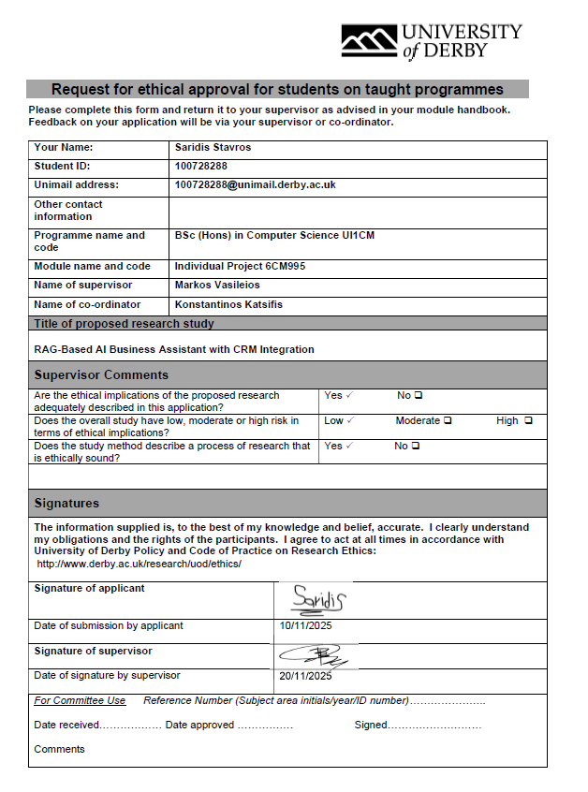
Appendix A: Project Plan — Gantt Diagram
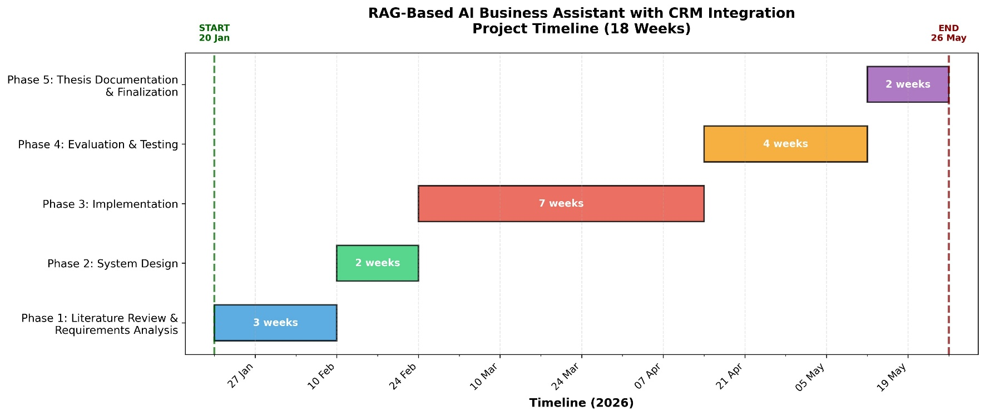
The following Gantt diagram illustrates the project timeline across 18 weeks, from 20 January 2026 to 26 May 2026. The project was divided into five phases: Literature Review and Requirements Analysis (3 weeks), System Design (2 weeks), Implementation (7 weeks), Evaluation and Testing (4 weeks), and Thesis Documentation and Finalisation (2 weeks).
Appendix A: Project Plan — Gantt Diagram (January – May 2026)

Appendix B: Project Development Log
The following log documents the key technical challenges, decisions, and milestones encountered during the development of the NexusFlow RAG-Based AI Business Assistant. Entries span the full project timeline from January to May 2026, covering all five project phases.
# | Date | Issue / Task | Solution / Action | Comments
1 | 20 Jan 2026 | Phase 1 start: LangChain installation failed due to version conflicts with existing packages. | Created a clean virtual environment and reinstalled all packages from scratch using pip with --force-reinstall. | Clean venv approach resolved all dependency conflicts from the outset.
2 | 24 Jan 2026 | LangChain import error: No module named langchain.chains after installing latest version. | Installed langchain-classic package which contains legacy chains and memory components separated in v1.x. | LangChain split chains/memory into a separate package in recent versions , not documented clearly.
3 | 28 Jan 2026 | OpenAI API key not being picked up by the application. | Added python-dotenv and ensured .env file was in the project root with no spaces around the = sign. | Environment variable loading requires exact formatting in .env files.
4 | 01 Feb 2026 | Phase 2 start: ChromaDB vector store not persisting between runs. | Specified explicit persist_directory path in ChromaDB initialisation and called persist() after indexing. | ChromaDB requires explicit persistence configuration , in-memory is the default.
5 | 05 Feb 2026 | text-embedding-3-small model returning dimension mismatch errors. | Cleared existing ChromaDB store and rebuilt with consistent embedding model across all operations. | Vector store must be rebuilt whenever the embedding model changes.
6 | 10 Feb 2026 | Phase 3 start , Implementation: FastAPI CRM API returning 422 validation errors on contact lookup. | Corrected Pydantic model field types and added proper query parameter validation. | FastAPI enforces strict type validation , all endpoint parameters must match Pydantic models.
7 | 17 Feb 2026 | Streamlit UI not reflecting code changes after edits. | Used R key in Streamlit terminal to force rerun; also cleared browser cache. | Streamlit caches components aggressively , force rerun required after structural changes.
8 | 24 Feb 2026 | RAG pipeline returning irrelevant chunks for multi-hop queries. | Implemented CRM record enrichment: contacts pre-linked with their interactions, invoices, and deals at indexing time. | Record enrichment was the key optimisation for multi-hop query performance.
9 | 03 Mar 2026 | Chunk size too small causing context to be split mid-sentence. | Increased knowledge base chunk size from 500 to 800 characters and overlap from 50 to 100. | Differentiated chunking strategies for knowledge base vs CRM data produced best results.
10 | 10 Mar 2026 | Top-k retrieval set to 5 missing relevant documents in complex queries. | Increased top-k from 5 to 8 after evaluating retrieval recall across test queries. | Higher top-k improved multi-hop reasoning coverage by 16.6 percentage points.
11 | 17 Mar 2026 | LLM responses including information not present in retrieved context (hallucination). | Added custom grounding system prompt instructing the model to answer only from provided context. | System prompt grounding is essential for faithful responses in RAG systems.
12 | 24 Mar 2026 | Evaluation framework producing inconsistent faithfulness scores across runs. | Reduced LLM temperature from 0.3 to 0.2 to improve determinism in both generation and evaluation. | Lower temperature improved score consistency while maintaining response quality.
13 | 31 Mar 2026 | PII detection module missing UK-format phone numbers. | Extended regex patterns to cover +44 and 07xxx formats in addition to generic phone patterns. | UK-specific PII patterns required custom regex beyond standard implementations.
14 | 07 Apr 2026 | Phase 4 start , Evaluation: Evaluation script taking over 10 minutes to run 15 tests. | Switched to loading existing ChromaDB store rather than rebuilding on each evaluation run. | Evaluation speed improved significantly by reusing the persisted vector index.
15 | 14 Apr 2026 | Submission 3 deadline: Progress report and interim write-up submitted successfully. | All components functional: RAG pipeline, CRM API, Streamlit UI, evaluation framework, ethical safeguards. | System fully operational ahead of final submission deadline.
16 | 21 Apr 2026 | Evaluation results showing lower faithfulness for multi-hop queries than expected. | Investigated LLM-as-judge verbosity bias , longer structured responses scored lower despite being correct. | Documented as known limitation of the LLM-as-judge evaluation methodology.
17 | 05 May 2026 | Phase 5 start , Documentation: Thesis chapters required integration into single document. | Combined all six chapters, added title page, Table of Contents, List of Figures, Diagrams, and Tables. | Chapter integration required careful formatting consistency checks throughout.
18 | 12 May 2026 | Architecture diagrams missing from thesis , no visual representation of system design. | Generated three professional SVG diagrams: System Architecture, RAG Pipeline Flow, and Ethical Safeguards Pipeline. | Diagrams significantly improved the clarity of Chapter 4 for the reader.
19 | 19 May 2026 | Final proofreading identified American English spellings throughout Chapter 2. | Systematically replaced all American spellings with British English equivalents across the full document. | Consistency in British English maintained throughout all six chapters after corrections.
20 | 22 May 2026 | Final submission , all components complete and dissertation submitted. | Final document includes Abstract, Acknowledgements, 6 chapters, 31 APA references, appendices, and all figures. | Project completed within the 18-week timeline as planned.
Table B1: Project Development Log — Issues, solutions, and milestones across all phases

