# Project 2 – Mom and Pop Johnson Video Store

## Database Design

## CMIS 320 6382 – 2178

## September 12, 2017

## Denton Guy-Williams

## Surtej Sarin

## Determine and list your entities.

The following list contains the 14 entities I found for the Mom and Pop Johnson Video Store database.

1. Customers

2. Rental

3. Movies_rented

4. Movie_inventory

5. Store

6. Distributor_catalog

7. Distributor

8. Movie

9. Actor_movie

10. Director_movie

11. Academy_award_movie

12. Actor

13. Director

14. Academy_award

## Relationship sentence pairs

The following are the relationship sentence pairs for 14 entities, between entities that are related. There are a few bridge entities that resolve the many-to-many relationships into one-to-many relationships.

1. Customer

* One Customer can have many Rentals

2. Rental

* Many Rental can be rented by one Customer
* One Rental can contain many rented movies (Movies_rented)

3. Movies_rented

* Many rented movies (Movies_rented) can be contained in one Rental at a time
* Many rented movie (Movies_rented) can be contained in one Movie_inventory

4. Movie_inventory

* Many inventories of movies (Movie_inventory) can be contained in one Store
* Many inventories of movies (Movie_inventory) can belong to one Distributor_catalog

5. Store

* One Store contains many inventories of movies (Movie_inventory)

6. Distributor_catalog

* One Distributor_catalog shows many inventory of movies (Movie_inventory)

7. Distributor

* One Distributor provides many Distributor_catalog

8. Movie

* One Movie exists in many Distributor_catalog
* One Movie has many actors in Actor_movie
* One Movie has many directors in Director_movie
* (Optional) One Movie has received many Academy_award_movie

9. Actor_movie

* Many Actor_movie have actors in one Movie
* Many Actor_movie have one acting Actor

*(Bridge entity solves M:M = Many Actors act in many Movie)

10. Director_movie

* Many Director_movie have directors in one Movie
* Many Director_movie have one directing Director

*(Bridge entity solves M:M = Many Director direct in many Movie)

11. Academy_award_movie

* Many Academy_award_movie have received an academy award in one Movie
* Many Academy_award_movie have one won Academy_award

*(Bridge entity solves M:M = Many Academy_award have been won by many Movie)

12. Actor

* One Actor has acted in many Actor_movie

13. Director

* One Director has directed in many Director_movie

14. Academy_award

* One Academy_award has been won by many Academy_award_movie

## 2. Create an entity/relationship diagram (ERD) showing all your entities, attributes, and relationships. Sketch your ERD by hand or use a drawing program. Your diagram must be on a single page. All entities should be related to at least one other entity. Your ERD should have all one-to-many relationships and not have any many-to-many relationships.

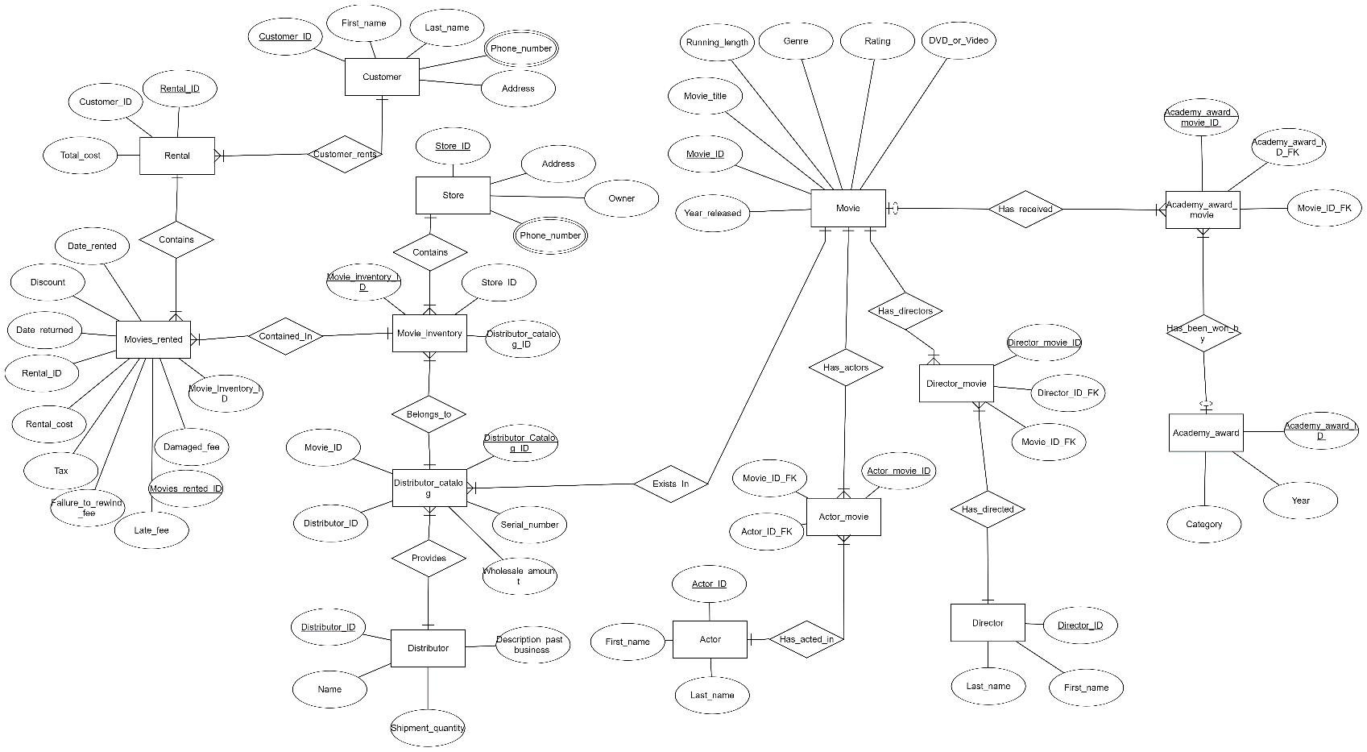

## 3) Create metadata that describes the table created from each entity and the column created from each attribute in the ERD. Particular attention will be given to the proper specification of all primary key (via "PK") and foreign key (via "FK") columns in the table layouts. These should match your ERD exactly.

### Table 1: Entities

|  |  |  |  |
| --- | --- | --- | --- |
| Entity | Attributes | Datatype | Description |
| 1. Customers | Customer_ID **<PK>** | integer | An entity for storing customer information. |
| First_name | Char |
|  | Last_name | Char |
|  | Phone_number | smallint |
|  | Address | Char |
| 1. Rental | Rental_ID **<PK>** | integer | An entity for rental and return information including total cost. |
| Customer_ID **<FK>** | integer |
|  | Total_cost | money |
| 1. Movies_rented | Movies_rented_ID **<PK>** | integer | An entity for storing a movie rented by the customer, including rental information i.e. date rented, returned, cost, discount, tax, and additional fees if applicable. |
| Rental_ID **<FK>** | integer |
|  | Movie_inventory_ID **<FK>** | integer |
|  | Date_rented | Date |
|  | Date_returned | Date |
|  | Rental_cost | money |
|  | Discount | money |
|  | Tax | money |
|  | Late_fee | money |
|  | Damaged_fee | money |
|  | Failure_to_rewind_fee | money |
| 1. Movie_inventory | Movie_inventory_ID **<PK>** | integer | An entity that is an inventory of all the movies in the store. |
| Store_ID **<FK>** | Char |
|  | Distributor_catalog_ID **<FK>** | Char |
| 1. Store | Store_ID **<PK>** | integer | An entity of the store number, owner, address, and phone number. |
| Address | Char |
|  | Owner | Char |
|  | Phone_number | smallint |
| 1. Distributor_catalog | Distributor_catalog_ID **<PK>** | integer | An entity that is a catalog of movies provided by the distributor. |
| Distributor_ID **<FK>** | integer |
|  | Movie_ID **<FK>** | integer |
|  | Serial_number | Char |
|  | Wholesale_amount | money |
| 1. Distributor | Distributor_ID **<PK>** | integer | An entity the covers the distributor name, shipment_quantity, and past business information. |
| Name | Char |
|  | Shipment_quantity | smallint |
|  | Description_past_business | Char |
| 1. Movie | Movie_ID **<PK>** | integer | An entity that has information on movies, including its title, year, length, genre, rating, and type (DVD/Video) provided by distributors. |
|  | Movie_title | Char |
|  | Year_released | smallint |
|  | Running_length | decimal |
|  | Genre | Char |
|  | Rating | decimal |
|  | DVD_or_Video | Char |
| 1. Actor_movie | Actor_movie_ID **<PK>** | integer | A bridge entity between Actor and Movie entity, which is an actor in a movie |
|  | Actor_ID_FK **<FK>** | integer |
|  | Movie_ID_FK **<FK>** | integer |
| 1. Director_movie | Director_movie_ID **<PK>** | integer | A bridge entity between Directory and Movie entity, which is a director in a movie. |
|  | Director_ID_FK **<FK>** | integer |
|  | Movie_ID_FK **<FK>** | integer |
| 1. Academy_award_movie | Academy_award_movie_ID **<PK>** | integer | A bridge entity between an Academy_award and Movie entity, which is a academy award in a movie. |
|  | Academy_award _ID_FK **<FK>** | integer |
|  | Movie_ID_FK **<FK>** | integer |
| 1. Actor | Actor_ID **<PK>** | integer | An entity that contains information on an actor and/or actress. |
|  | First_name | Char |
|  | Last_name | Char |
| 1. Director | Director_ID **<PK>** | integer | An entity that contains information on a director. |
|  | First_name | Char |
|  | Last_name | Char |
| 1. Academy_award | Academy_award_ID **<PK>** | integer | An entity that contains information on an academy_award. |
|  | Year | smallint |
|  | Category | Char |