MLOps Pipeline for Heart Disease Prediction

1. Introduction & Setup
This project builds an end-to-end MLOps pipeline for the UCI Heart Disease dataset. The objective is to develop a binary classification model that predicts the presence or absence of heart disease based on patient clinical features.
GitHub Repository: https://github.com/ssathishhkumarr/AIMLCZG523_Heart_Disease_Pipeline_2025AE05311
Video Demonstration: https://github.com/ssathishhkumarr/AIMLCZG523_Heart_Disease_Pipeline_2025AE05311/blob/main/demonstration.mp4
Setup & Installation Instructions: To reproduce this pipeline locally from the clean repository, execute the following commands in the terminal:
- Clone the repository: git clone [https://github.com/ssathishhkumarr/AIMLCZG523_Heart_Disease_Pipeline_2025AE05311](https://github.com/ssathishhkumarr/AIMLCZG523_Heart_Disease_Pipeline_2025AE05311)
- Navigate to the directory: cd AIMLCZG523_Heart_Disease_Pipeline_2025AE05311
- Create and activate a virtual environment: python -m venv venv followed by source venv/bin/activate (Linux/Mac) or venv\Scripts\activate (Windows).
- Install dependencies: pip install -r requirements.txt
- Run unit tests to verify: pytest tests/

Pipeline Architecture Diagram:

2. Exploratory Data Analysis (EDA)
The dataset was loaded and cleaned using the data_loader.py script. Initial exploratory analysis was performed to understand feature distributions, class balance, and correlations.

- Class Balance:

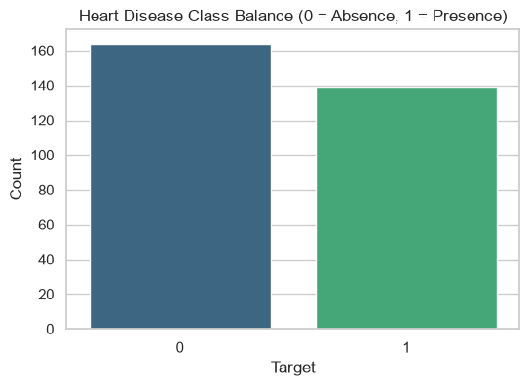

- Feature Distributions (Histograms):

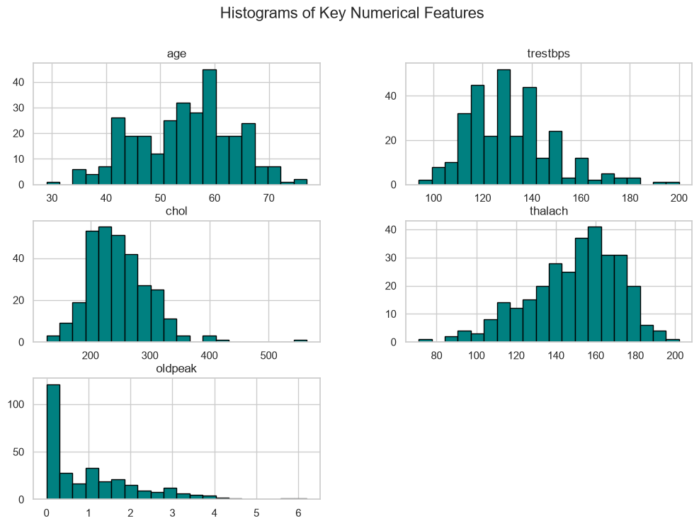

- Correlation Heatmap:

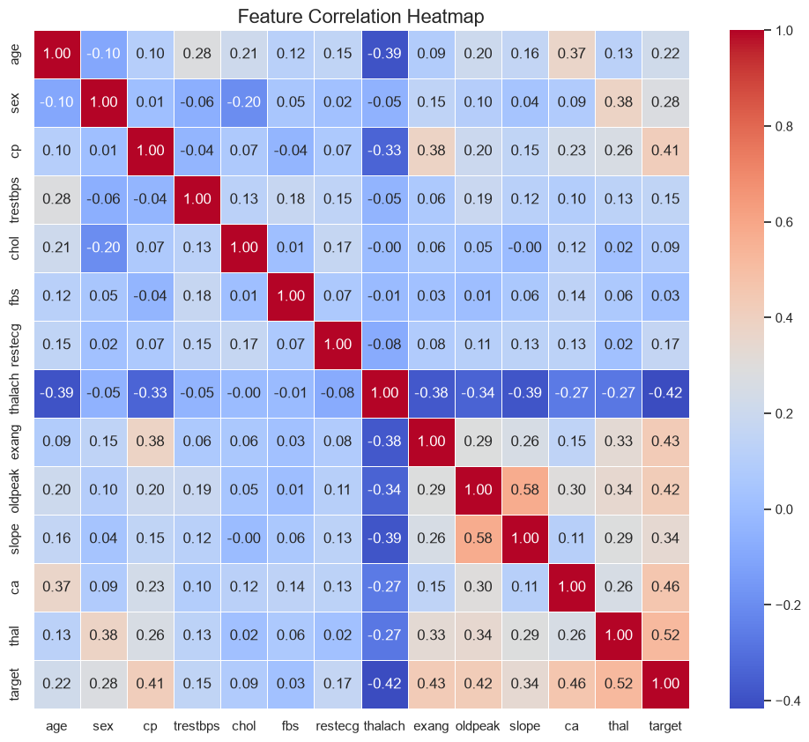

3. Model Development & Experiment Tracking
A comprehensive preprocessing pipeline was constructed using Scikit-learn. Numerical features were scaled using StandardScaler, and categorical features were one-hot encoded. Two models, Logistic Regression and Random Forest, were trained and evaluated. MLflow was integrated to systematically track experiments, log model parameters, and record evaluation metrics (Accuracy, Precision, Recall, and ROC-AUC).
- MLflow Tracking - Random Forest:

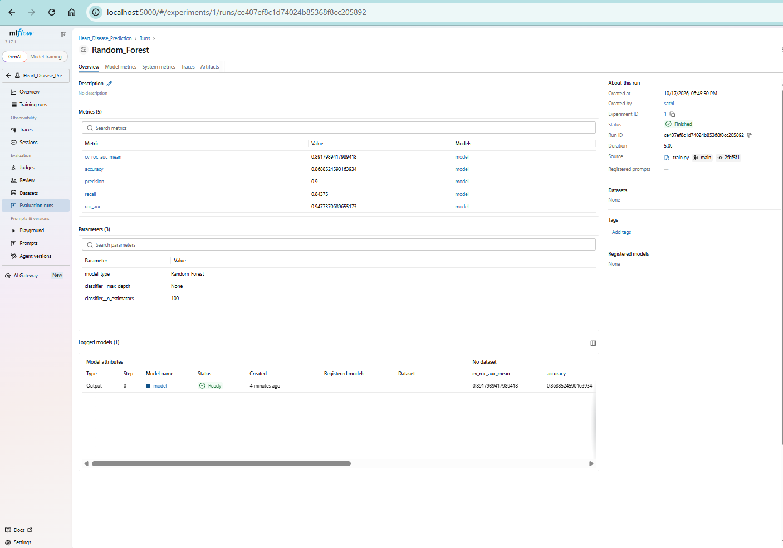

- MLflow Tracking - Logistic Regression:

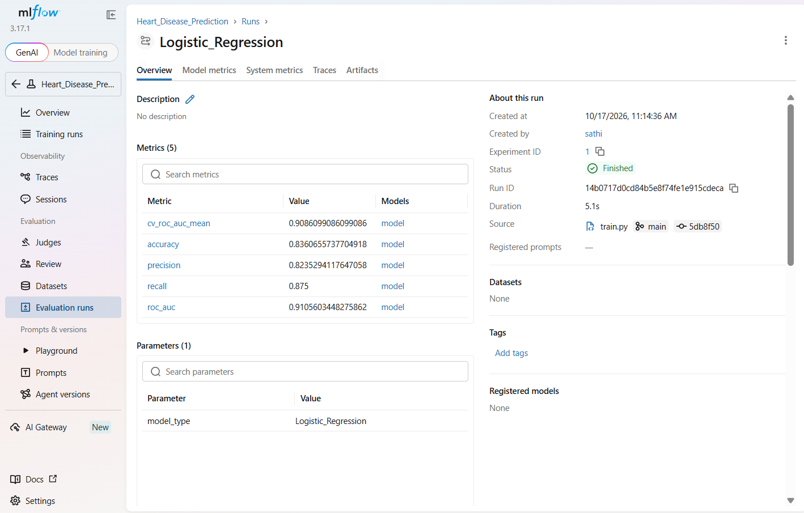

Model Selection, Tuning & Justification: Both models underwent systematic hyperparameter tuning using GridSearchCV with 5-fold cross-validation. For the Random Forest classifier, grid search evaluated n_estimators [50, 100] and max_depth [None, 10]. The optimal parameters converged on n_estimators=100 and max_depth=None (mirroring the baseline configuration), while tuning the C parameter for Logistic Regression. The optimal hyperparameters were automatically tracked in MLflow. Ultimately, the tuned Random Forest model was selected for production because its ensemble architecture captured the complex, non-linear relationships in the clinical health data more effectively. Demonstrating superior performance across Accuracy, Precision, Recall, and ROC-AUC metrics, it was serialized as model.pkl for deployment.

4. Unit Testing & CI/CD Pipeline
To ensure the reliability of the trained model, unit tests were implemented using pytest. The tests verified the existence of the model artifact and validated its predictive capability on sample data.
- Pytest Execution:
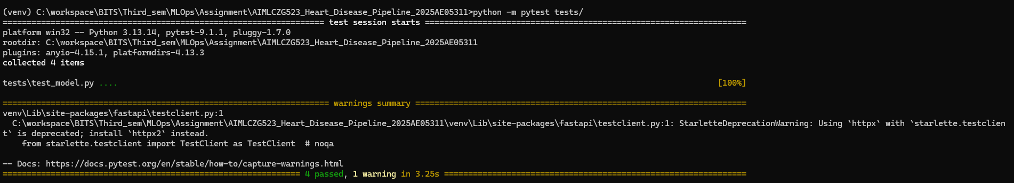
- A Continuous Integration (CI) pipeline was established using GitHub Actions (ci.yml). This workflow automatically provisions an Ubuntu server, installs dependencies, executes flake8 linting, runs the pytest suite, and executes model training upon every push to the main branch.
- GitHub Actions Status:

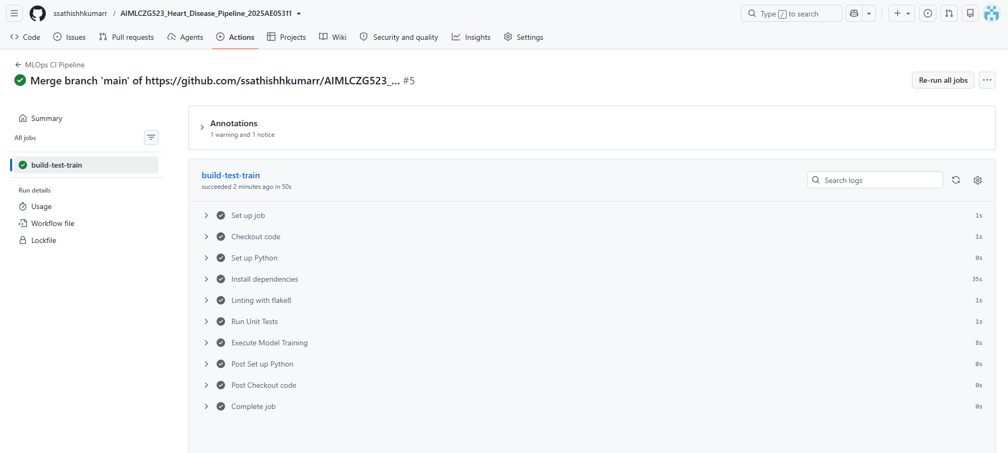

5. Model Deployment via API
The packaged Random Forest model was deployed as a RESTful API using the FastAPI framework. The Pydantic library was utilized to define the data schema and validate incoming JSON payloads.
- FastAPI Swagger UI Testing:

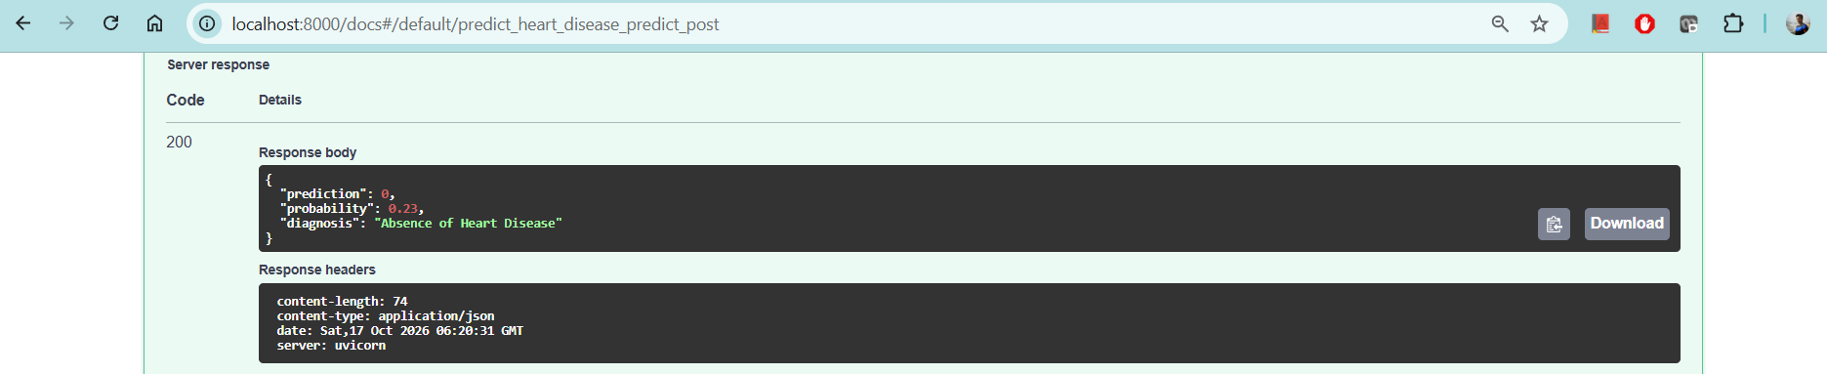

6. Containerization
To ensure cross-platform compatibility and ease of deployment, the entire application—including the Python runtime, dependencies, serialized model, and FastAPI server—was containerized using Docker.
- Docker Container Running:

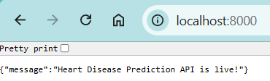
7. Monitoring & Logging
To satisfy production monitoring requirements, the FastAPI application was instrumented using the prometheus-fastapi-instrumentator library. This automatically tracks API request counts, latency, and response status codes, exposing them via a dedicated /metrics endpoint for Prometheus scraping.
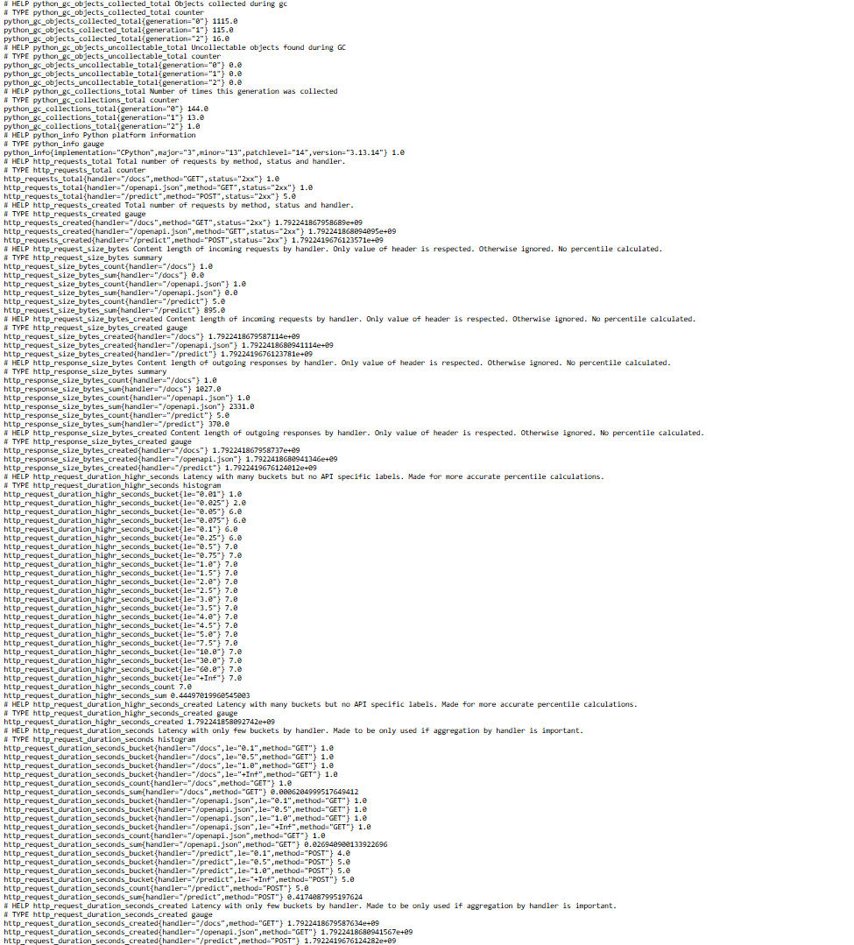
The /metrics endpoint dynamically exposes standard Prometheus-compatible metrics, including http_requests_total which accurately logs incoming /predict API traffic.
8. Production Deployment (Kubernetes)
To ensure high availability and scalability, the Dockerized API was deployed to a local Kubernetes cluster using a deployment manifest (k8s-manifest.yaml). The application was exposed to external traffic using a LoadBalancer service, fulfilling production-readiness requirements for cloud deployment.
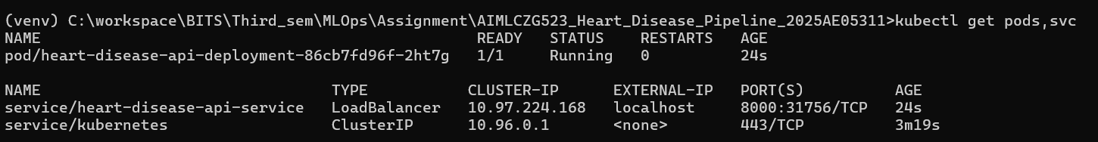
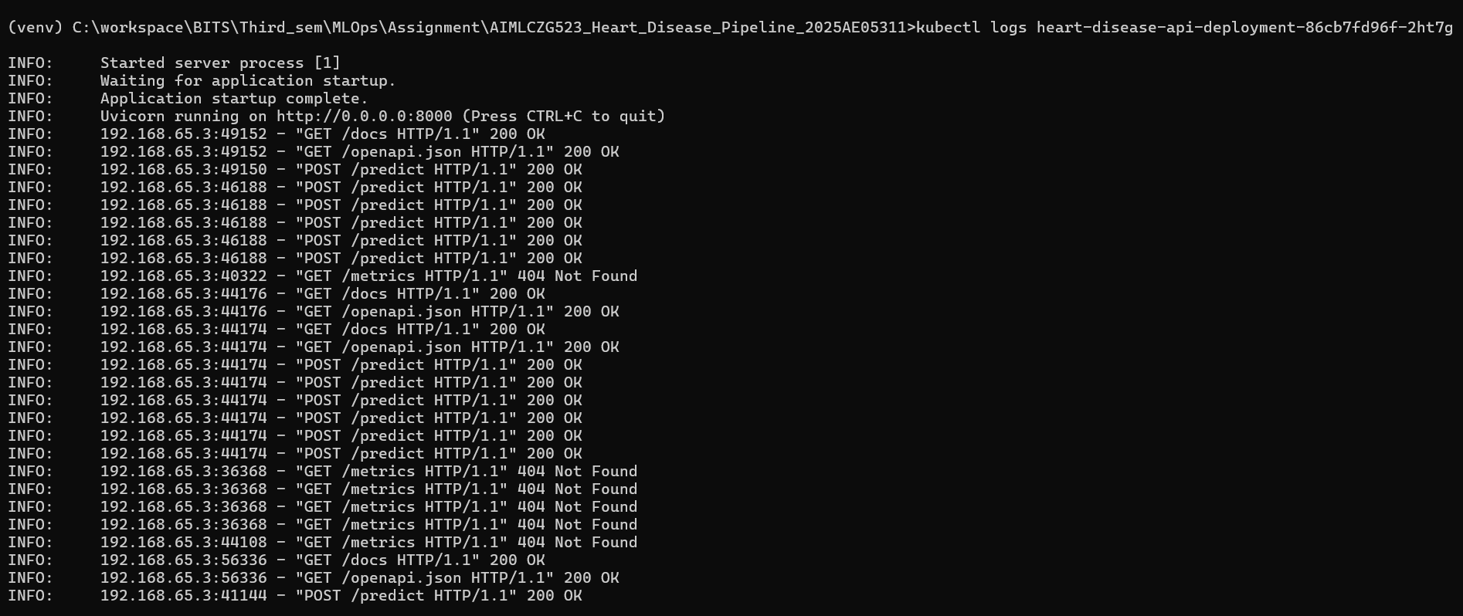

9. Conclusion
This project successfully implemented a complete MLOps lifecycle for heart disease prediction. The pipeline encompasses data ingestion and analysis, model training with experiment tracking, automated testing via CI/CD, containerization, deployment to a local Kubernetes cluster (Docker Desktop), and Prometheus-compatible metric exposure, fulfilling all technical requirements for a production-ready machine learning system.

