MLOps Pipeline for Heart Disease Prediction

1. Introduction & Setup
This project builds an end-to-end MLOps pipeline for the UCI Heart Disease dataset. The objective is to develop a binary classification model that predicts the presence or absence of heart disease based on patient clinical features.
GitHub Repository: https://github.com/ssathishhkumarr/AIMLCZG523_Heart_Disease_Pipeline_2025AE05311
Video Demonstration: https://drive.google.com/file/d/1mvkLkXLtIEvC_TjLRqr940o8CsD-HKqs/view?usp=drive_link
Setup & Installation Instructions: To reproduce this pipeline locally from the clean repository, execute the following commands in the terminal:
- Clone the repository: git clone https://github.com/ssathishhkumarr/AIMLCZG523_Heart_Disease_Pipeline_2025AE05311
- Navigate to the directory: cd AIMLCZG523_Heart_Disease_Pipeline_2025AE05311
- Create and activate a virtual environment: python -m venv venv followed by source venv/bin/activate (Linux/Mac) or venv\Scripts\activate (Windows).
- Install dependencies: pip install -r requirements.txt
- Run unit tests to verify: pytest tests/

Pipeline Architecture Diagram:

2. Exploratory Data Analysis (EDA)
The dataset was loaded and cleaned using the data_loader.py script. Initial exploratory analysis was performed to understand feature distributions, class balance, and correlations.
- Class Balance:
Figure 1: Class balance of the target variable
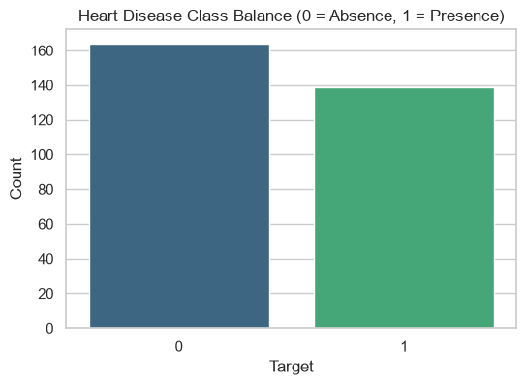

- Feature Distributions (Histograms):
Figure 2: Histograms showing the distribution of key numerical features
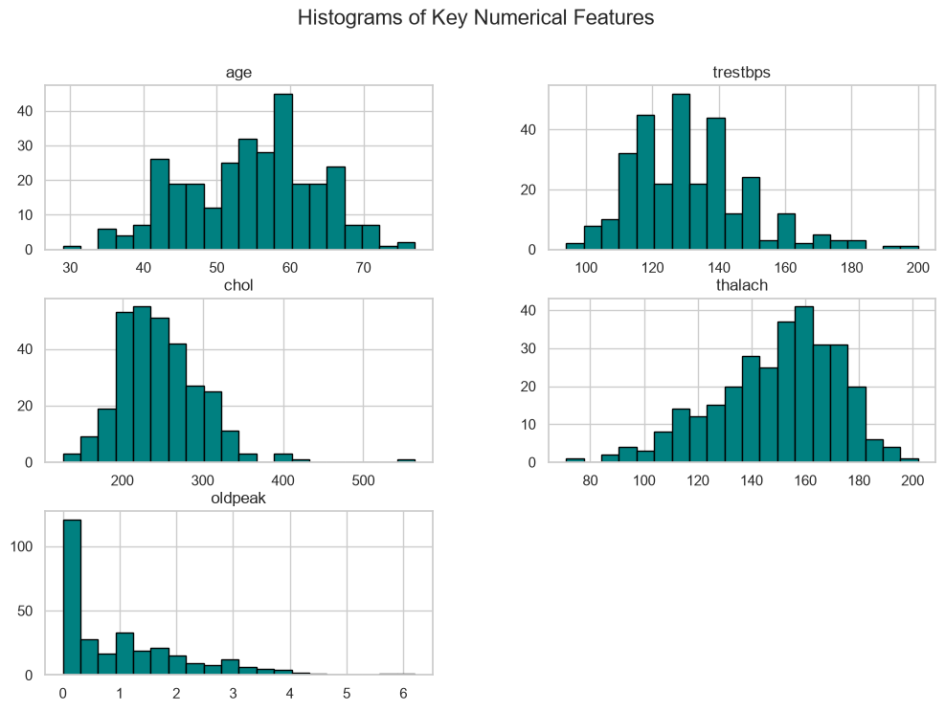

- Correlation Heatmap:
Figure 3: Feature correlation heatmap showing relationships between the clinical variables 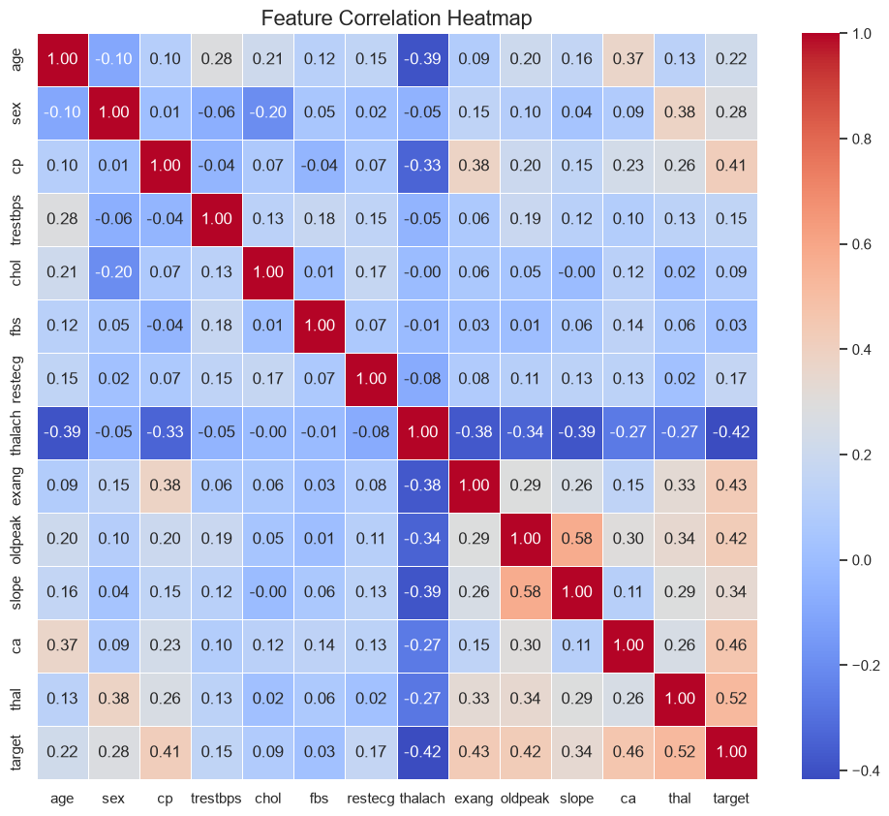

3. Model Development & Experiment Tracking
A comprehensive preprocessing pipeline was constructed using Scikit-learn. Numerical features were scaled using StandardScaler, and categorical features were one-hot encoded. Two models, Logistic Regression and Random Forest, were trained and evaluated. MLflow was integrated to systematically track experiments, log model parameters, and record evaluation metrics (Accuracy, Precision, Recall, and ROC-AUC).
- MLflow Tracking - Random Forest:
Figure 4: MLflow tracking UI displaying the Random Forest model run metrics and parameters
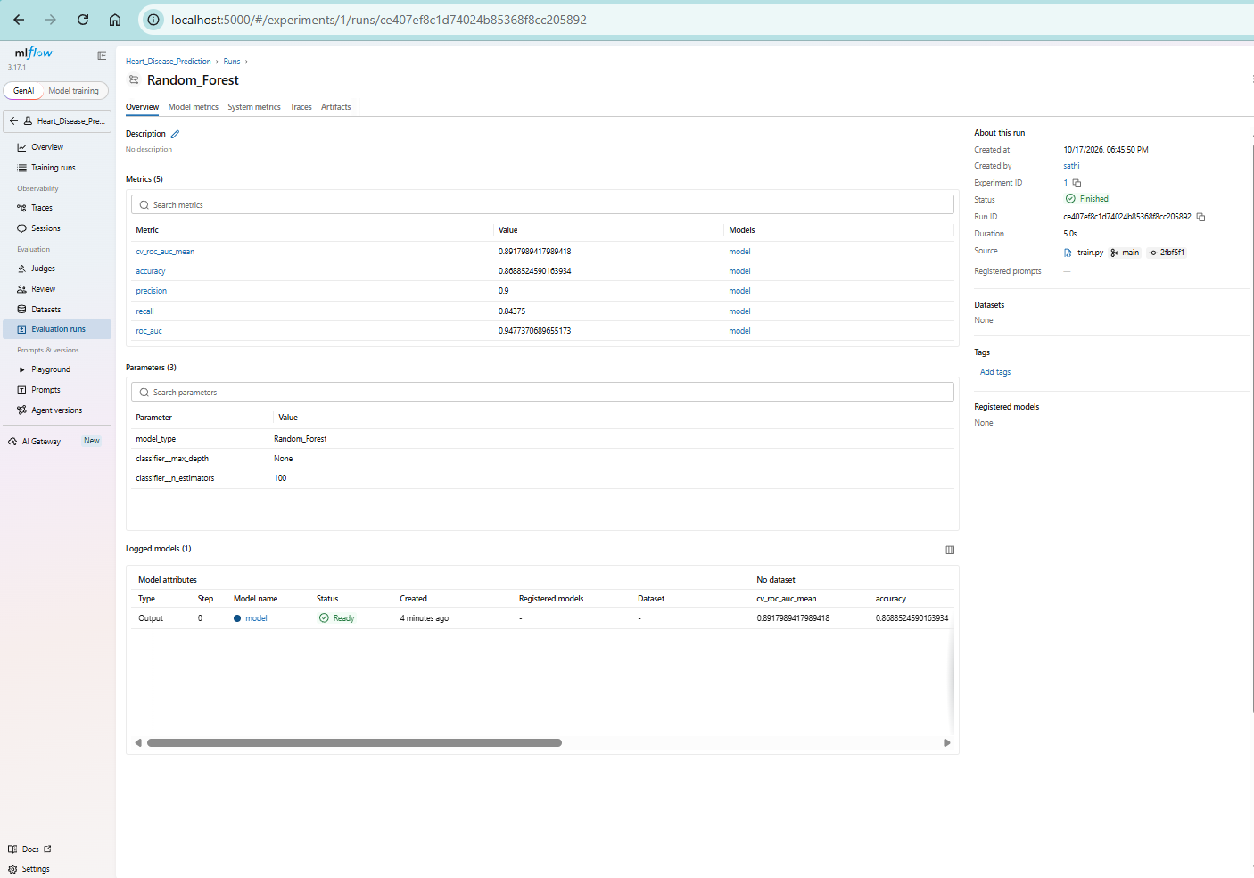

- MLflow Tracking - Logistic Regression:
Figure 5: MLflow tracking UI for the Logistic Regression model run
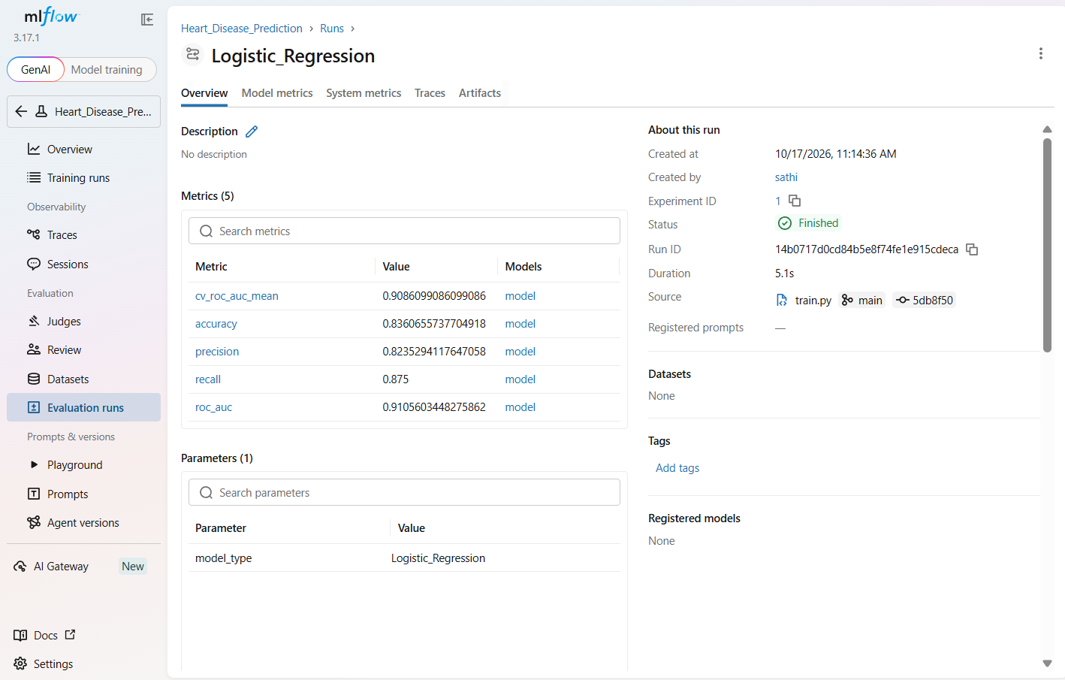

Model | CV ROC-AUC Mean | Accuracy | Precision | Recall | Test ROC-AUC
Logistic Regression | 0.908 | 0.836 | 0.823 | 0.875 | 0.910
Random Forest | 0.891 | 0.868 | 0.900 | 0.843 | 0.947

Model Selection, Tuning & Justification: Both models underwent systematic hyperparameter tuning using GridSearchCV with 5-fold cross-validation. For the Random Forest classifier, grid search evaluated n_estimators [50, 100] and max_depth [None, 10], converging on n_estimators=100 and max_depth=None. For Logistic Regression, tuning the inverse regularization strength converged on C=1.0. Ultimately, the tuned Random Forest model was selected for production. While Logistic Regression achieved a slightly higher CV ROC-AUC (0.908) and Recall (0.875), Random Forest was chosen for its superior generalization on the unseen test set, evidenced by its higher Test ROC-AUC (0.947), Accuracy (0.868), and Precision (0.900). The entire pipeline—including the StandardScaler and OneHotEncoder preprocessing steps alongside the chosen classifier—was serialized together as model.pkl to ensure full reproducibility. Additionally, all environment dependencies and exact versions were strictly pinned in requirements.txt.
Figure 6: MLflow Artifacts UI displaying the logged Confusion Matrix for the selected model.
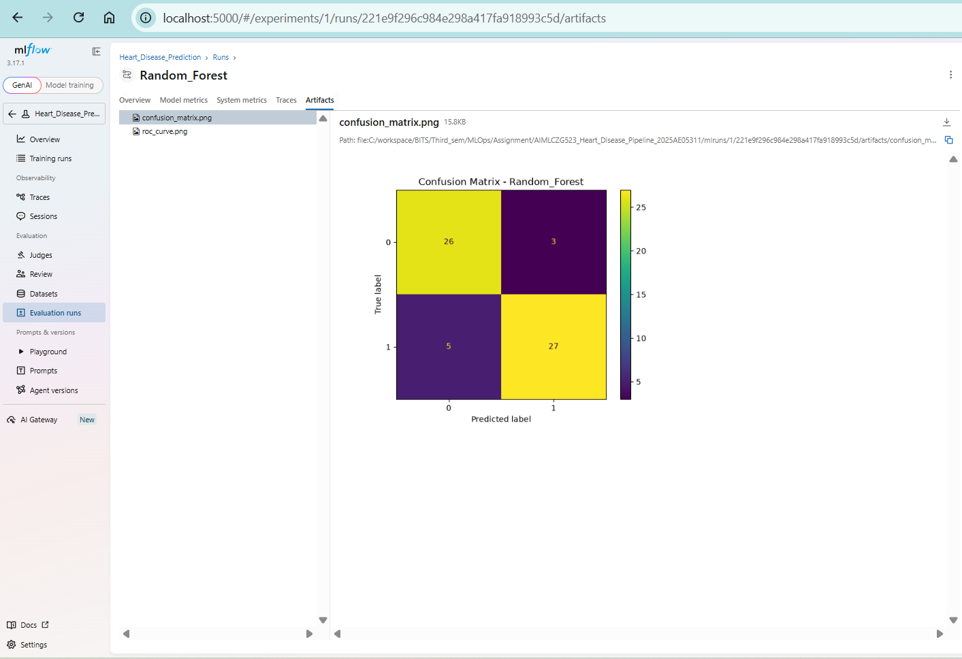
Figure 7: MLflow Artifacts UI displaying the logged ROC Curve evaluation plot.

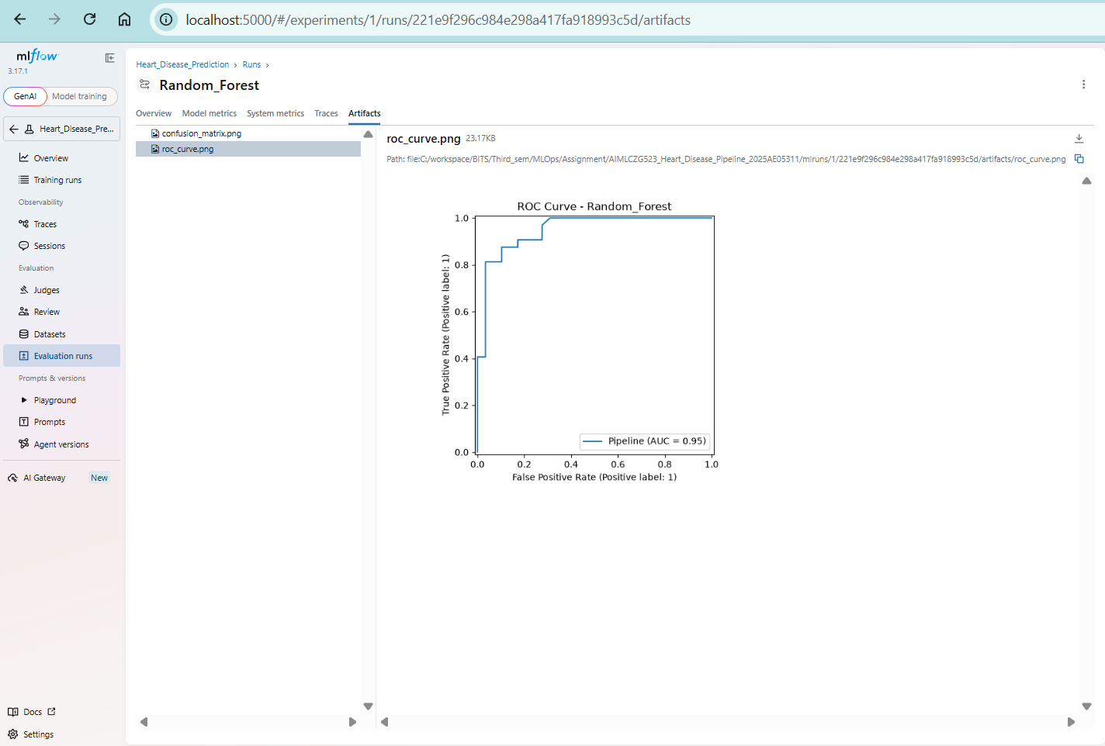

Additionally, visual evaluation plots including the Confusion Matrix and ROC Curve were automatically generated and logged as run artifacts in MLflow to enable comprehensive performance analysis.

4. Unit Testing & CI/CD Pipeline
To ensure the reliability of the trained model, unit tests were implemented using pytest. The comprehensive test suite verified model existence, binary prediction constraints, data loading, and API payload validation. A Continuous Integration (CI) pipeline was established using GitHub Actions (ci.yml). This workflow automatically provisions an Ubuntu server, installs dependencies, executes flake8 linting, runs the pytest suite, executes model training, and packages the trained model.pkl as an automated deployment artifact upon every push to the main branch.
- Pytest Execution:
Figure 8: Local Pytest execution showing all tests passing
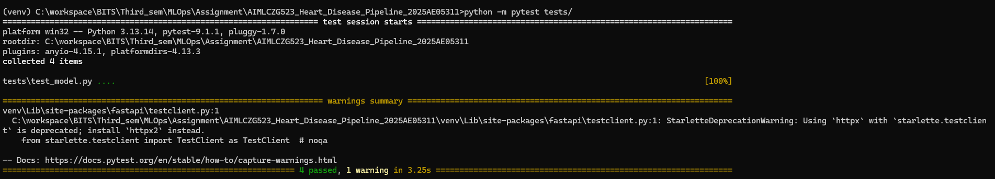
- A Continuous Integration (CI) pipeline was established using GitHub Actions (ci.yml). This workflow automatically provisions an Ubuntu server, installs dependencies, executes flake8 linting, runs the pytest suite, and executes model training upon every push to the main branch.

- GitHub Actions Status:
Figure 9: GitHub Actions CI/CD pipeline successful run
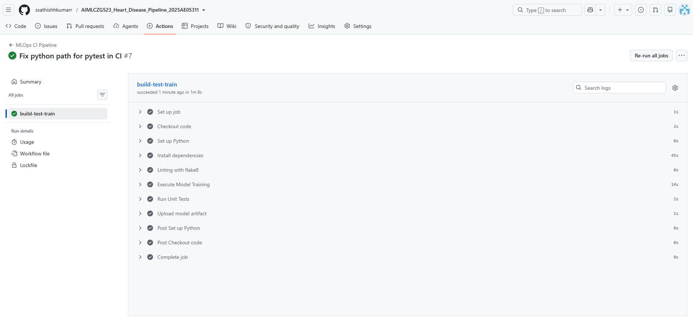

5. Model Deployment via API
The packaged Random Forest model was deployed as a RESTful API using the FastAPI framework. The Pydantic library was utilized to define the data schema and validate incoming JSON payloads.
- FastAPI Swagger UI Testing:
Figure 10: FastAPI Swagger UI demonstrating a successful prediction response
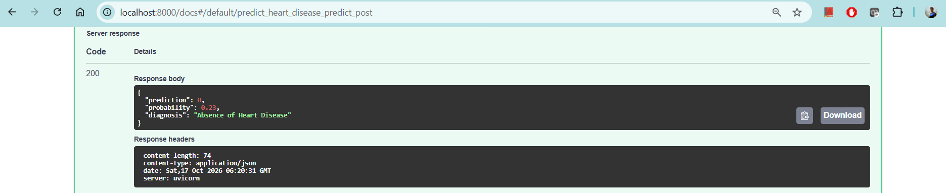

6. Containerization
To ensure cross-platform compatibility and ease of deployment, the entire application—including the Python runtime, dependencies, serialized model, and FastAPI server—was containerized using Docker.
Figure 11: Docker build execution demonstrating successful containerization of the API and dependencies.
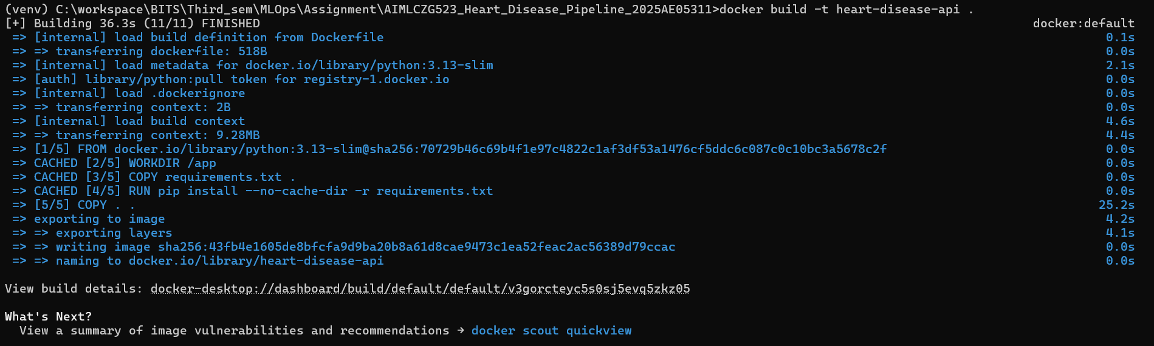
Figure 12: Live prediction executed against the running Docker container via curl, displaying the JSON input payload and calculated probability.
7. Monitoring & Logging
To satisfy production monitoring requirements, the FastAPI application was instrumented using the prometheus-fastapi-instrumentator library. This automatically tracks API request counts, latency, and response status codes, exposing them via a dedicated /metrics endpoint for Prometheus scraping.
Figure 13: Prometheus metrics exposed at the /metrics endpoint
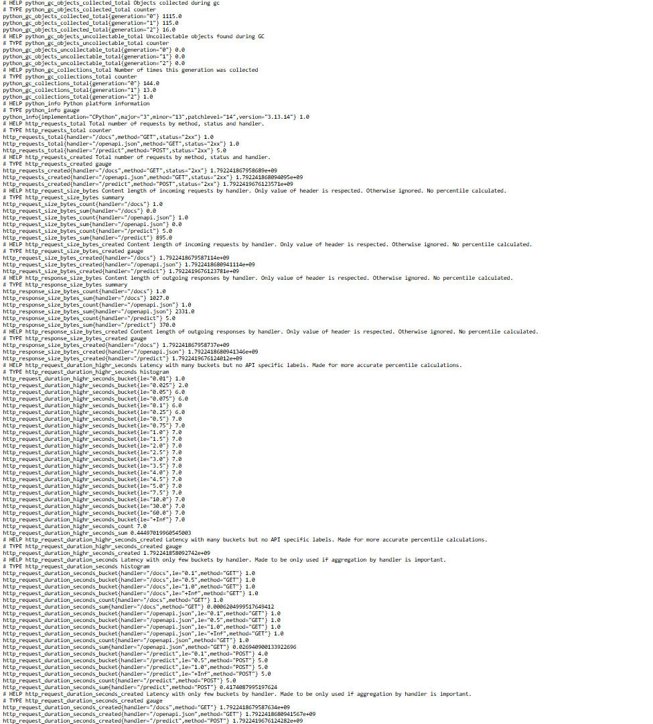
The /metrics endpoint dynamically exposes standard Prometheus-compatible metrics, including http_requests_total which accurately logs incoming /predict API traffic.

Figure 14: Prometheus UI dashboard successfully querying the scraped http_requests_total metric from the active /metrics endpoint.
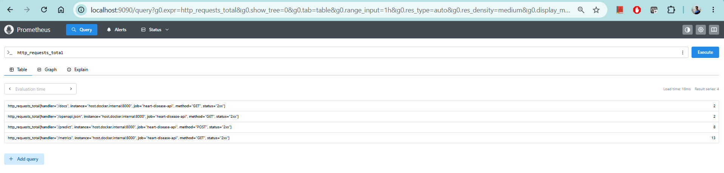
8. Production Deployment (Kubernetes)
To ensure high availability and scalability, the Dockerized API was deployed to a local Kubernetes cluster using a deployment manifest (k8s-manifest.yaml). The application was exposed to external traffic using a LoadBalancer service, fulfilling production-readiness requirements for cloud deployment.
Figure 15: Kubernetes deployment status and corresponding pod logs confirming successful live traffic routing and metrics exposure.
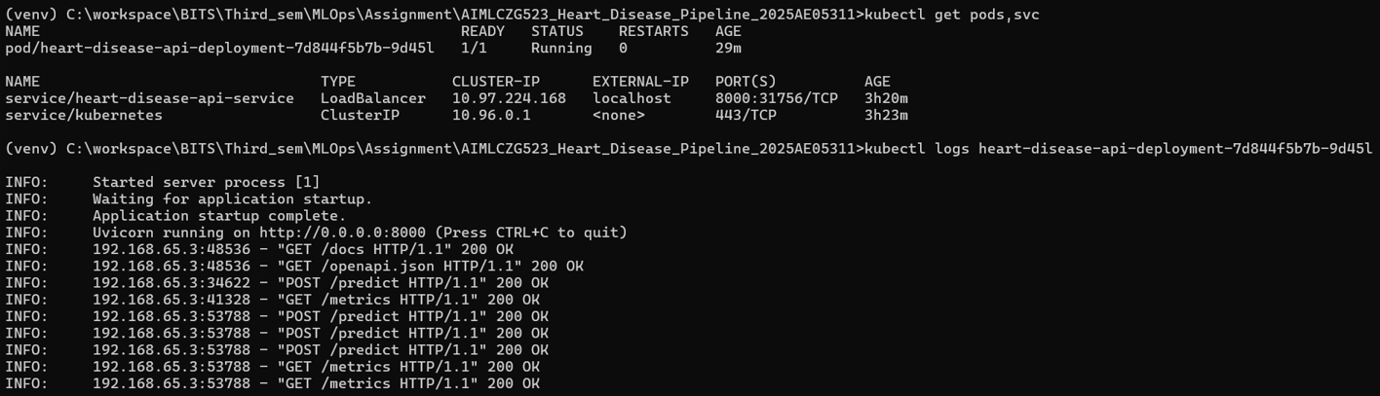

9. Conclusion
This project successfully implemented a complete MLOps lifecycle for heart disease prediction. The pipeline encompasses data ingestion and analysis, model training with experiment tracking, automated testing via CI/CD, containerization, deployment to a local Kubernetes cluster (Docker Desktop), and Prometheus-compatible metric exposure, fulfilling all technical requirements for a production-ready machine learning system.

