

IQS Nigeria Cloudflare
Sandbox Setup Guide
  - Step by step instructions for sharing the local OpenG2P platform
Edition 1 | 3 October 2026
This guide documents how nigeriag2p.com was connected to the running Nigeria IQS platform on Windows WSL2. Follow it to understand the domain delegation, named tunnel, application URL migration, public login tests and daily startup process. It assumes OpenG2P is already installed and operational.
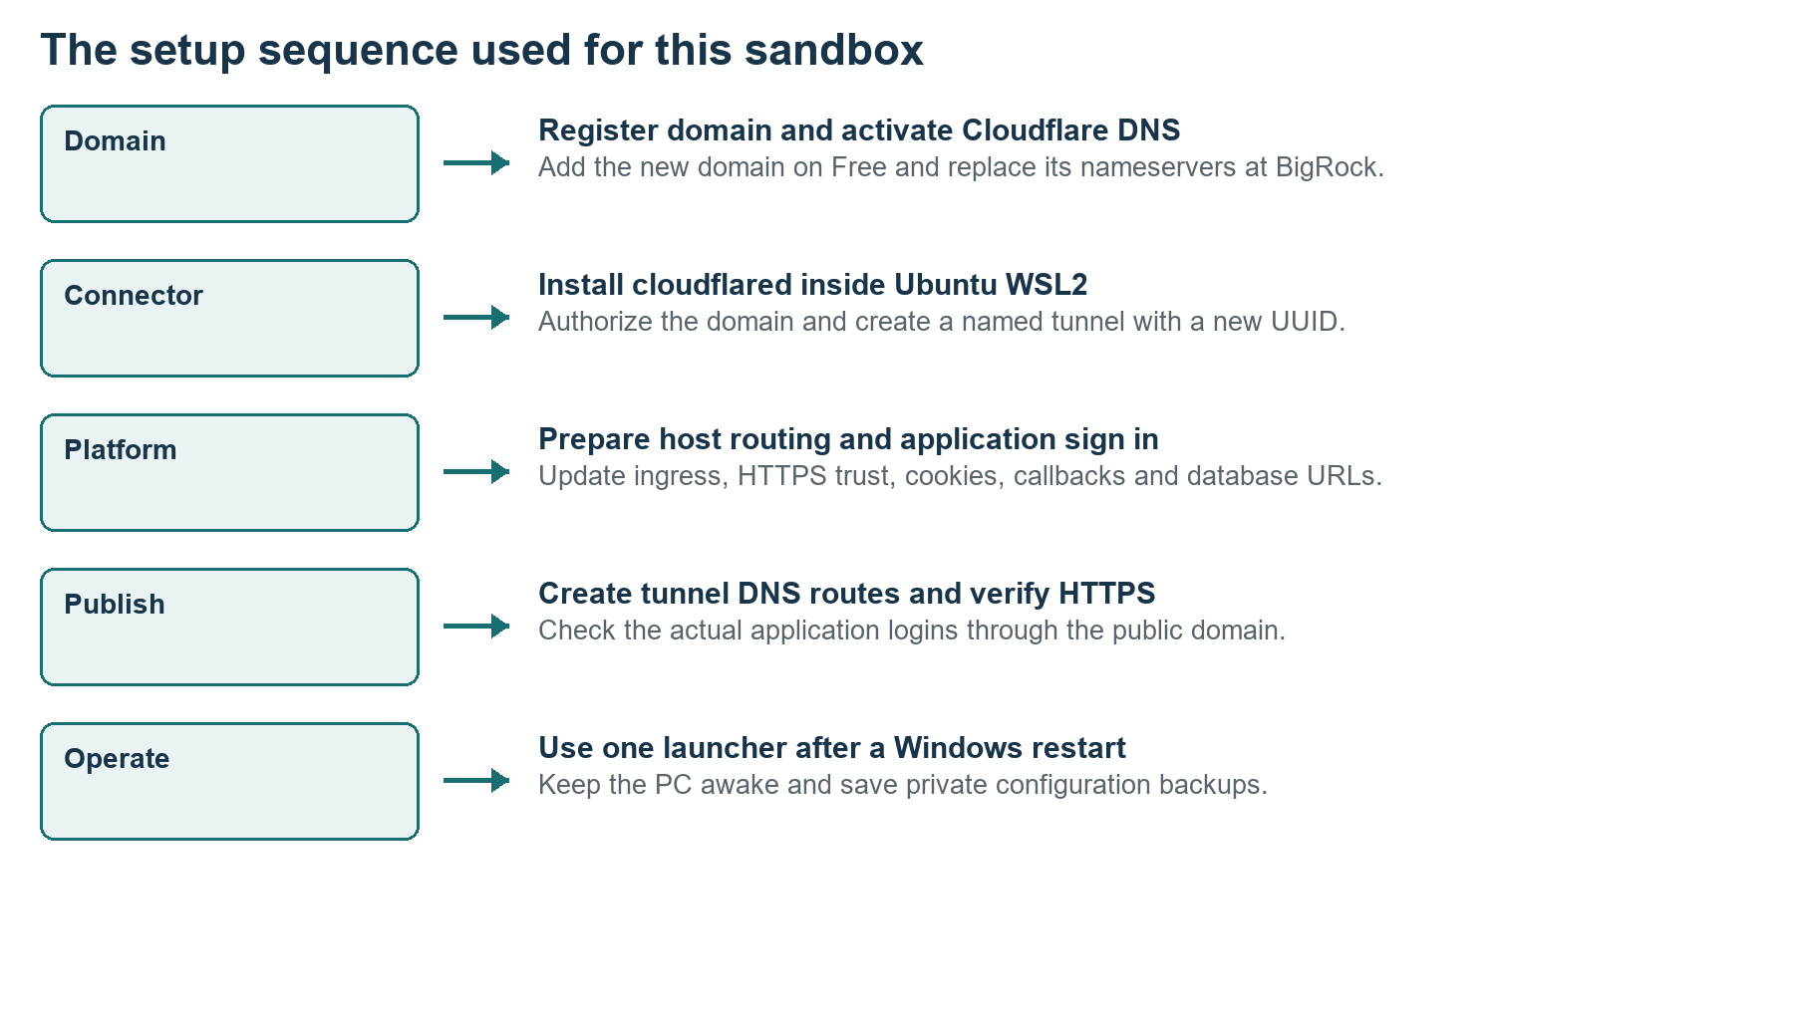
Figure 1 Five stages connect the existing platform to the internet
The working result uses Cloudflare Free DNS and a locally managed tunnel. Visitors can reach the application login pages without a Cloudflare invitation. Application credentials are still required. The workstation remains the server and must be awake and online.

01 How to use this guide
Use the existing domain values to understand this installation. For a different domain or machine, substitute the values deliberately and create fresh tunnel credentials.
1. Read the architecture and value record before running commands. Choose whether you are documenting this working machine or reproducing the setup elsewhere.
2. Complete the domain and nameserver steps, install the connector and authorize the correct domain.
3. Prepare application routing and login settings before publishing DNS routes. A working home page alone does not prove that the other services can sign in.
4. Verify public HTTPS, application logins and the intended private boundaries. Record results for the new environment.
5. Use one public launcher after each Windows restart, and create a private backup after configuration changes.
Commands are labeled Windows PowerShell or Ubuntu root Bash. Commands shown for inspection are safe to repeat. Creation and migration commands are for a new setup; do not replay them blindly on this already working sandbox.
The screenshots show this project during setup or verification. Diagrams explain the actual architecture. No login passwords, tunnel JSON contents or private keys are included in this document.

Companion manuals
Use the IQS Nigeria OpenG2P Installation Guide to install the platform first, and the IQS Nigeria Platform Usage and Operations Guide for programme, registry and beneficiary procedures. This manual covers the additional public access layer.

02 Contents
Select a procedure below or use Word Navigation Pane. The section links remain usable even when pagination changes.
01 How to use this guide
03 Architecture and responsibility
04 Prerequisites and recorded values
05 Step 1 Inspect the local platform
06 Step 2 Add the domain to Cloudflare
07 Step 3 Change nameservers at BigRock
08 Step 4 Verify domain delegation
09 Step 5 Install the connector in WSL
10 Step 6 Authorize the domain
11 Step 7 Create a named tunnel
12 Step 8 Plan the public hostnames
13 Step 9 Understand the application migration
14 Step 10 Add public Istio routes
15 Step 11 Update runtime and identity settings
16 Step 12 Update stored login and Odoo URLs
17 Step 13 Preserve internal HTTPS and DNS
18 Step 14 Create the public Nginx origin
19 Step 15 Forward allowed applications
20 Step 16 Validate the origin before publication
21 Step 17 Write the connector configuration
22 Step 18 Start the tunnel as a service
23 Step 19 Publish the DNS routes
24 Step 20 Check public HTTPS and logins
25 Step 21 Confirm the public boundaries
26 Step 22 Start after a Windows restart
27 Step 23 Recreate the public launcher
28 Step 24 Stop resume and preserve the setup
29 Troubleshoot in dependency order
30 Diagnostic commands and acceptance checklist
31 Project scripts and reuse on another machine
32 The completed public sandbox
33 Official references and evidence record

03 Architecture and responsibility
BigRock registers the domain, Cloudflare provides DNS and the public connection, and your PC runs the actual OpenG2P services.
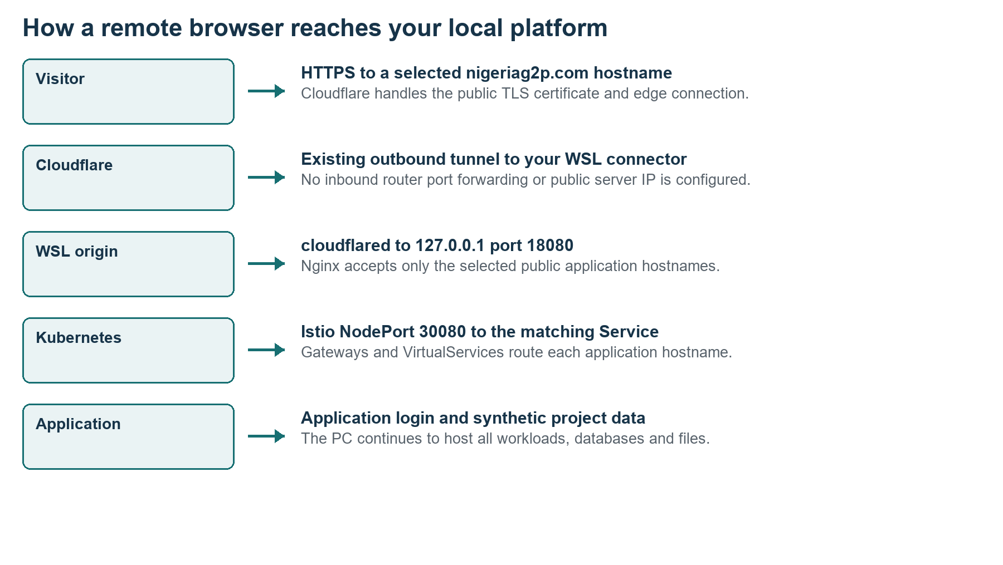
Figure 2 The public request path and the local application layers
Component | Role in this setup
BigRock | Domain registration, renewal and nameserver delegation
Cloudflare DNS | Public hostname records and edge proxying
cloudflared | Outbound connector running inside Ubuntu WSL2
Nginx | Loopback public origin on port 18080 and internal HTTPS on 443
Istio and K3s | Hostname routing to application Services and Pods
Keycloak and applications | Identity, application permissions and synthetic records

No application containers were moved to Cloudflare. The tunnel passes traffic to the workstation. Cloudflare can stay online while the workstation is offline, but the application origin will then be unavailable.

04 Prerequisites and recorded values
The original platform was already operational. The tunnel is an additional connector rather than a replacement for the installation requirements.
Item | Value used
Windows and Linux | Windows workstation with Ubuntu-22.04 on WSL2 and systemd
Project source | H:\Nigeria_Mosip\codex\openg2p-lab
Private runtime | /opt/openg2p-lab
Kubernetes namespace | nigeria
Domain | nigeriag2p.com
Nameservers | athena.ns.cloudflare.com and thomas.ns.cloudflare.com
Tunnel name | iqs-nigeria-sandbox
Recorded tunnel UUID | 50914faf-9f90-43d6-b178-ac8a5dba1489
Connector version recorded | cloudflared 2026.9.3
Public local origin | http://127.0.0.1:18080
Istio NodePort | 30080
Access choice | Anyone with the link may reach application login pages

The UUID and nameserver pair above belong to this setup. A new tunnel receives a different UUID, and a different Cloudflare zone may receive different nameservers. Never copy these identifiers as if they were universal settings.
You need domain registrar access, a Cloudflare account, Linux root or sudo privileges and outbound internet access. Existing K3s and application memory requirements still apply. The connector does not remove the need for the PC, WSL, storage and application resources.

05 Step 1 Inspect the local platform
Start with a healthy local environment and a private backup. Fix a local service failure before diagnosing Cloudflare.

Windows PowerShell
wsl --list --verbose
wsl -d Ubuntu-22.04 -u root

Ubuntu root Bash
export KUBECONFIG=/etc/rancher/k3s/k3s.yaml
systemctl is-active k3s nginx
kubectl -n nigeria get deploy,sts
ss -lnt | grep -E ':443|:18080|:30080'
1. Confirm Ubuntu is WSL version 2 and that its systemd services are active.
2. Confirm the expected Deployment and StatefulSet workloads are ready. The original completed migration had 68 ready workloads.
3. Open the local home page and test at least PBMS, staff SSO and the beneficiary portal.
4. Run the existing backup script in this lab before changing public domain settings.
python3 /mnt/h/Nigeria_Mosip/codex/openg2p-lab/backup-lab.py

Expected result
K3s and Nginx are active, application screens work locally, and the script prints a new private backup directory under /opt/openg2p-lab/backups. The original pre-public backup was 20261003-200132.
On native Ubuntu, use sudo -i instead of entering WSL, and adapt the source path. Do not reinstall K3s, Helm or OpenG2P merely to add the tunnel.

06 Step 2 Add the domain to Cloudflare
The new domain was registered at BigRock to keep the existing sathvick.com hosting outside this change.
1. Sign in at dash.cloudflare.com. Open Add a domain or Connect a domain.
2. Enter nigeriag2p.com, or the domain you are configuring.
3. Choose the Free plan. Review imported DNS records before continuing.
4. Preserve any records required for existing websites or email. In this newly registered zone, the imported root, www and wildcard A records pointed to 127.0.0.1.
5. Continue to activation and record the two nameservers Cloudflare assigns.
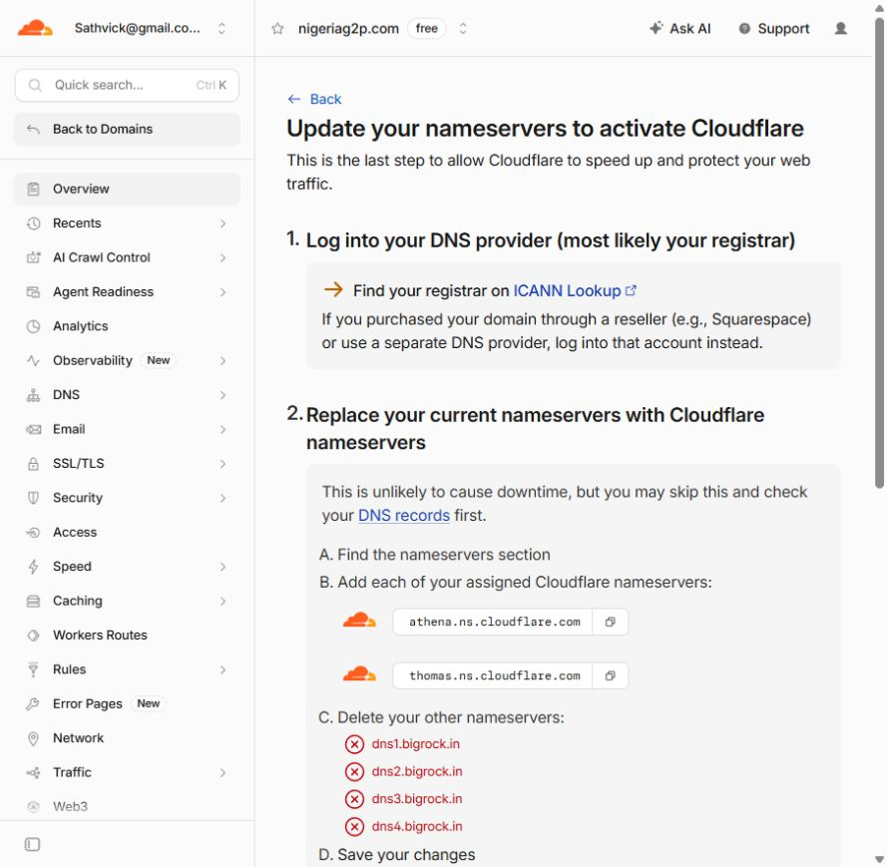
Figure 3 Cloudflare assigned this project its nameserver pair
The imported 127.0.0.1 records were placeholders, not a route to the workstation from the internet. The tunnel commands later replaced matching hostnames with proxied CNAME routes. For an established domain, examine MX, TXT and other records before changing delegation. [S1]

07 Step 3 Change nameservers at BigRock
Change the nameservers of the new domain only. Registration and renewal remain with BigRock.
1. Sign in to BigRock and open the order or domain management page for nigeriag2p.com.
2. Open Name Servers and DNS or the corresponding nameserver settings.
3. Replace the existing dns1 through dns4.bigrock.in entries with the pair assigned by Cloudflare.
4. Save the change. For this domain the saved values were athena.ns.cloudflare.com and thomas.ns.cloudflare.com.
5. Return to Cloudflare and select I updated my nameservers or Check nameservers now.
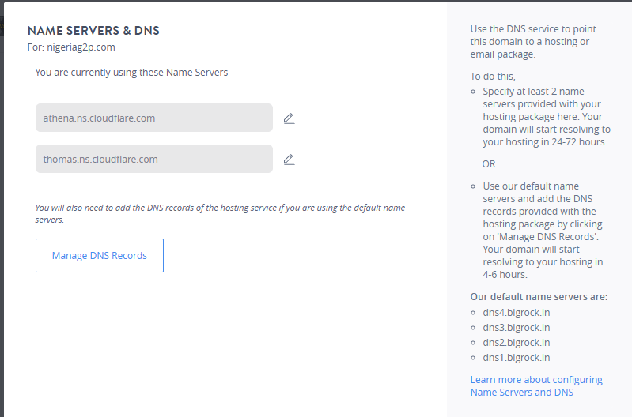
Figure 4 BigRock shows the Cloudflare nameservers saved for nigeriag2p.com
If DNSSEC is already enabled, follow Cloudflare’s documented delegation procedure before switching nameservers; an obsolete registrar DS record can break resolution. That is a conditional migration step, not a record of a DNSSEC change performed here. [S1]

Expected result
BigRock displays the assigned Cloudflare nameservers for the new domain. The existing sathvick.com domain is unchanged.

08 Step 4 Verify domain delegation
DNS propagation and Cloudflare activation are related checks. Confirm the actual nameservers rather than assuming a saved registrar form means the change has propagated.

Windows PowerShell
Resolve-DnsName nigeriag2p.com -Type NS -Server 1.1.1.1

Expected result
The answer lists athena.ns.cloudflare.com and thomas.ns.cloudflare.com. In another project compare the answer with that zone’s assigned pair.
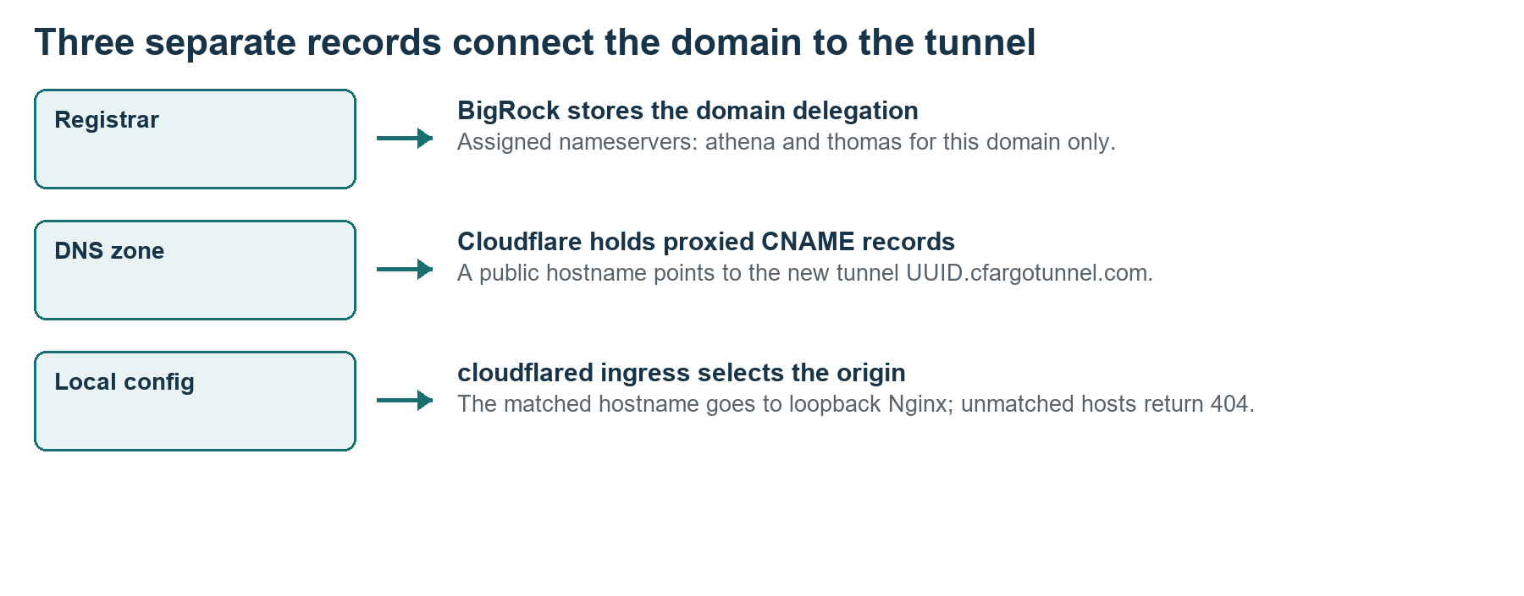
Figure 5 Registrar delegation DNS records and connector routing are different layers
1. Check Cloudflare’s domain overview for Active status. Its cached screen can briefly say it is still checking even after public DNS shows the new nameservers.
2. Allow propagation time if the values are not yet visible. Cloudflare documents that activation can take up to 24 hours.
3. Do not add an A record pointing to your home IP for this tunnel design. The selected hostnames will use the tunnel CNAME.
Reference Cloudflare full zone setup [S1]; actual Resolve-DnsName result for the project [L1].

09 Step 5 Install the connector in WSL
We installed cloudflared in Ubuntu WSL2, alongside the running platform. The commands below use the vendor’s official GitHub release download.

Ubuntu root Bash
uname -m
command -v cloudflared || true
curl -fsSL \
https://github.com/cloudflare/cloudflared/releases/latest/download/cloudflared-linux-amd64.deb \
-o /tmp/cloudflared.deb
dpkg -i /tmp/cloudflared.deb
cloudflared --version
1. Confirm uname -m reports x86_64 before selecting the amd64 package.
2. If cloudflared is already installed, inspect its version and configuration before reinstalling it.
3. Download and install the package. The original setup installed version 2026.9.3.
4. Record the version actually installed on the new machine; latest can change.
On native Ubuntu the same Linux commands apply after entering a root shell. An ARM machine needs the matching package and a separately qualified application installation. No Windows cloudflared installation or router port forwarding was used here.
The connector needs outbound access to Cloudflare. If a corporate firewall restricts it, consult the official tunnel firewall guidance, including TCP or UDP port 7844. Do not solve this by opening inbound application ports on the router. [S5]

Expected result
cloudflared --version returns an installed release, and dpkg reports a successful package installation.

10 Step 6 Authorize the domain
The locally managed tunnel uses a Cloudflare authorization certificate on the Linux host. This is separate from the public browser HTTPS certificate.

Ubuntu root Bash
cloudflared tunnel login
1. Keep the command running. Open the URL it prints in the browser where you are signed in to Cloudflare.
2. Select the correct domain from Authorize Cloudflare Tunnel.
3. Review the authorization dialog and click Authorize for your intended zone.
4. Return to the terminal and confirm that cloudflared saved cert.pem.
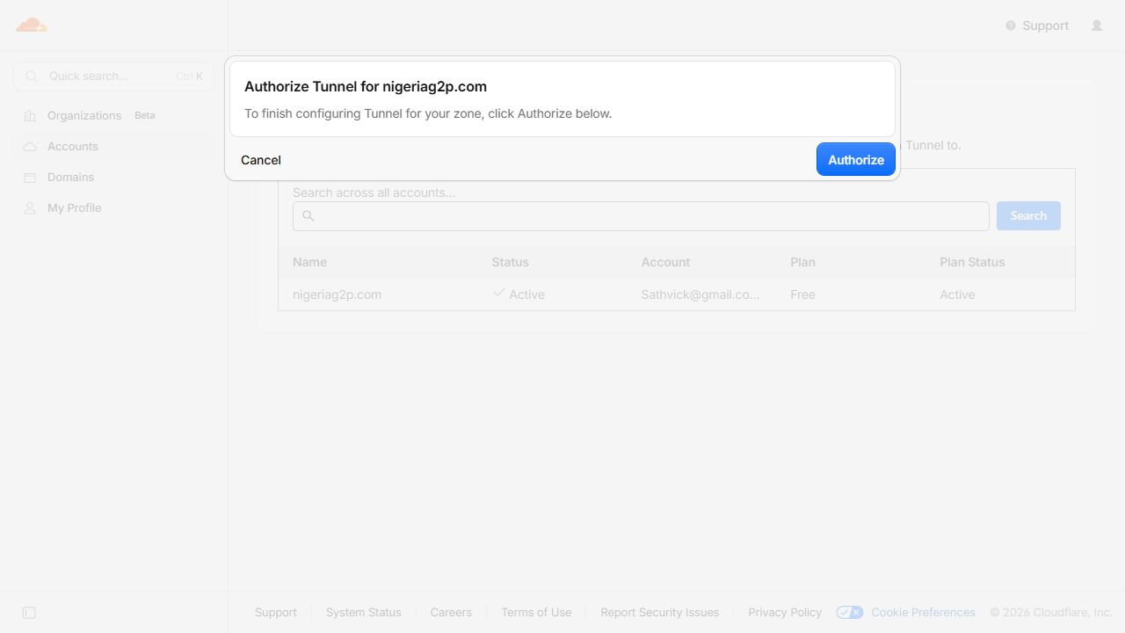
Figure 6 The authorization dialog for the project domain
test -s /root/.cloudflared/cert.pem && echo Authorized
cloudflared tunnel list

Expected result
The certificate exists. On a new account or zone, the tunnel list may be empty until the next step.
The account authorization file grants management capability. Keep it private. Do not paste its contents into a document or place it in the public web directory. [S2]

11 Step 7 Create a named tunnel
A stable named tunnel was selected so the multiple application domains and sign-on callbacks have predictable addresses.

Ubuntu root Bash
cloudflared tunnel create iqs-nigeria-sandbox
cloudflared tunnel list
1. Choose a clear tunnel name. On another machine or reproduction use a new name unless you deliberately intend to operate an existing tunnel.
2. Record the UUID printed by the create command.
3. Record the tunnel JSON credentials path. This setup saved it under /root/.cloudflared.
4. Set the shell variables used for the remaining manual steps. Replace the UUID with your newly created value.
export DOMAIN=nigeriag2p.com
export TUNNEL=iqs-nigeria-sandbox
export TUNNEL_ID=YOUR_NEW_TUNNEL_UUID
export LAB=/opt/openg2p-lab
The recorded working UUID is 50914faf-9f90-43d6-b178-ac8a5dba1489. YOUR_NEW_TUNNEL_UUID is a placeholder and must be replaced before using subsequent commands. Do not copy the old JSON credentials to a different account or publish them.

Expected result
A tunnel name and UUID exist. Creation alone does not start the connector or publish any application hostname. [S2]

12 Step 8 Plan the public hostnames
Publish the application screens and the APIs they need. Keep infrastructure administration outside the tunnel’s allowed routes.
Public service | Hostname prefix | Login or purpose
Home page | root and www | Public service launcher
Programme management | pbms | Existing Odoo login
Modern social registry | register | Staff SSO
Odoo social registry | registry | Existing Odoo login
Staff launcher | staff-portal | Staff SSO
Beneficiary portal | beneficiary | Local demo identity flow
Approval workflows | awe | Staff SSO
Master data | master-data-ui | Staff SSO
Partner management | partner-management | Staff SSO
Consent manager | consent-manager | Staff SSO
ODK Central | odk | Continue then SSO
Analytics | superset | Sign in with Keycloak
Portal programme admin | portal-admin | Existing Odoo login

Append .nigeriag2p.com to a prefix. Supporting public hosts are master-data, partner-management-api, staff-iam, iam-staff-ui, staff-register, pbms-api, keycloak, minio-api and partner-register. Several API roots legitimately return 404 because only their named paths exist.
Kafka, MinIO console and direct Bridge or SPAR administration routes are not published. Keycloak staff and beneficiary login endpoints are public, while /admin and /realms/master are blocked at the public origin. Odoo /web/database/ paths are also blocked.

13 Step 9 Understand the application migration
DNS alone cannot make a multi-service platform work remotely. A localhost URL still points to the visitor’s own computer when it appears in a public page or callback.
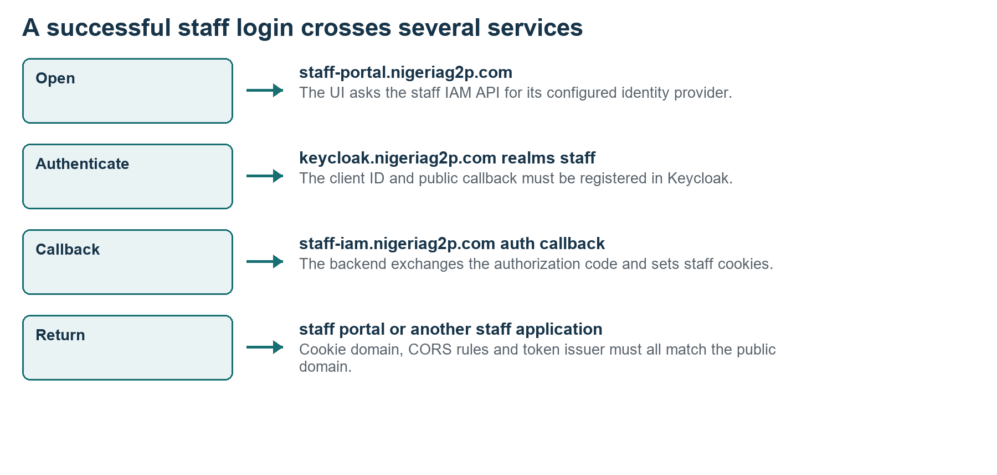
Figure 7 The public staff login flow depends on consistent URLs
Configuration | Change made in the lab
Hostname routing | Added public VirtualService and Gateway hosts; kept local hosts
Browser configuration | Updated application URLs, cookie domains and CORS origins
Identity service | Changed KC_HOSTNAME and added public client redirect URIs
Stored authentication | Updated IAM provider endpoints and callback URLs in its database
Beneficiary authentication | Updated auth.oauth.provider URLs in portalpbmsdb
Odoo | Set each web.base.url to its public host and froze it
Superset | Updated its Secret-backed OIDC configuration and restarted it

Usernames, passwords and existing Odoo login email addresses were retained. URL migration is not account renaming. Review each application’s configuration source; an environment variable update does not change values stored in a database.

14 Step 10 Add public Istio routes
Use both gateway layers in this installation. Applications use Gateway internal; Keycloak has a separate commons-keycloak Gateway.

Ubuntu root Bash inspection
kubectl -n nigeria get gateway -o yaml
kubectl -n nigeria get virtualservice -o yaml
kubectl -n nigeria edit gateway internal
Keep the existing internal Gateway hosts and append *.nigeriag2p.com and nigeriag2p.com where appropriate. In the Keycloak Gateway, add keycloak.nigeriag2p.com alongside its existing local host. Replace these with your new domain if reproducing elsewhere.
kubectl -n nigeria edit gateway commons-keycloak
kubectl -n nigeria edit virtualservice pbms-openg2p-pbms
For every published VirtualService, add its corresponding public hostname to spec.hosts. Example for PBMS:
hosts:
- pbms.openg2p.localhost
- pbms.nigeriag2p.com
1. Repeat for the registry, staff, beneficiary and supporting API routes. Preserve the existing paths and destination service names.
2. Remove hardcoded x-forwarded-host values that force the old local hostname. Nginx forwards the actual public hostname.
3. For a 404 on every public application except Keycloak, check that Gateway internal was updated; updating only the Keycloak Gateway is insufficient.

Expected result
Istio recognizes the public hostname and can route it to the existing Kubernetes Service. Confirm this at the loopback origin after Nginx is configured. [S7]

15 Step 11 Update runtime and identity settings
Use the recorded migration as an inventory, then apply changes to the configuration sources used by your matching application versions.

Ubuntu root Bash examples
kubectl -n nigeria set env statefulset/commons-keycloak \
KC_HOSTNAME=keycloak.nigeriag2p.com
kubectl -n nigeria set env deployment/commons-services-staff-portal-ui \
COOKIE_DOMAIN=.nigeriag2p.com \
IAM_URL=https://staff-iam.nigeriag2p.com
kubectl -n nigeria edit deployment/commons-services-iam-staff-portal-api
For the staff IAM API, update IAM_STAFF_AUTH_COOKIE_DOMAIN, IAM_STAFF_CORS_ALLOW_ORIGINS and IAM_STAFF_DATA_APPLICATION_URLS entries. Apply the matching cookie and IAM settings to the modern registry, master data and other staff UIs. Public token issuers must match the issuer generated by Keycloak.
1. In local Keycloak administration, open the staff and beneficiary realms and each relevant client.
2. Retain the original local redirect URI and add its public equivalent. Example: https://staff-iam.nigeriag2p.com/auth/callback.
3. Update client web origins and URL fields as needed. Set the realm frontend URL to https://keycloak.nigeriag2p.com for this version of the lab.
4. Update application ConfigMaps with public URLs and restart workloads that read configuration only at startup.
5. For Superset, update commons-services-superset-config and restart both its web and worker Deployments. For ODK, update DOMAIN and validate its callback.
This lab uses Keycloak 24.0.5. Current Keycloak hostname v2 documentation explains URL and proxy concepts but can use settings that differ from this installed version. Do not copy a current server option into an older image without checking support. [S6]

16 Step 12 Update stored login and Odoo URLs
The staff portal initially rendered without reaching sign-in because its login provider still held the old domain in the database. Updating those stored endpoints completed the public flow.
Database | Relevant table or setting
iam | login_providers endpoint, metadata, callback and redirect URL columns
iam | staff_portal_applications application_url and api_url
portalpbmsdb | auth.oauth.provider endpoint, validation and callback fields
pbmsdb | ir.config_parameter web.base.url and web.base.url.freeze
socialregistrydb | Same Odoo base URL settings
portalpbmsdb | Same Odoo base URL settings for portal admin

1. Inspect the actual stored provider settings through the application administration UI or an authenticated database connection.
2. Change the local hostnames to their public equivalents, preserving client IDs, secrets and account identities.
3. For each Odoo workspace, enable developer mode, open Technical then Parameters then System Parameters, and set web.base.url to the corresponding public HTTPS URL.
4. Set web.base.url.freeze to True so a later local visit does not overwrite the canonical public URL.
5. Update the staff application links: master-data must open master-data-ui; Identity and Access Management must open iam-staff-ui. Deactivate Keycloak administration and MinIO console tiles in the staff launcher.

Recorded Odoo base URLs
pbmsdb https://pbms.nigeriag2p.com
socialregistrydb https://registry.nigeriag2p.com
portalpbmsdb https://portal-admin.nigeriag2p.com
Changing the domain did not change admin@nigeria.openg2p.localhost as the Odoo login email. Keep the existing credentials reference separately. A new-domain migration has to update both UI configuration and stored identity-provider records.

17 Step 13 Preserve internal HTTPS and DNS
Pods also call services using HTTPS hostnames. They must be able to resolve and trust the new names even before the public tunnel routes are published.
1. Add the public service names to Pod hostAliases and the CoreDNS NodeHosts mapping, using the current WSL host IP for the internal Nginx path.
2. Retain local hostnames for existing local routes. Keep the mappings compatible with WSL IP changes after a restart.
3. Add the public domain and wildcard to the existing local server certificate SANs, signed by the lab CA. Keep the existing localhost SANs.
4. Extend the internal port 443 Nginx server names to include the public domain, and reload Nginx.
5. Update repair-local-network.py so boot-time repair preserves public VirtualService hosts and reconstructs both local and public hostname mappings.

Ubuntu root Bash inspection
hostname -I
kubectl -n nigeria get deployment register-staff-portal-api -o yaml
kubectl -n kube-system get configmap coredns -o yaml
openssl x509 -in /opt/openg2p-lab/tls/server.crt \
-noout -ext subjectAltName
nginx -t
The internal certificate includes nigeriag2p.com and *.nigeriag2p.com in addition to the original local names. It is trusted by the lab Pods through lab-trust. Public visitors use Cloudflare’s public TLS certificate, not the local CA.
The public cloudflared origin is loopback HTTP on port 18080, so no origin TLS bypass such as noTLSVerify was required. The tunnel remains encrypted between Cloudflare and the connector. Keep the public origin bound to 127.0.0.1.

18 Step 14 Create the public Nginx origin
The public origin is separate from the internal TLS listener. It has a default deny server, a static homepage server and an allowlist of application hosts.

Ubuntu root Bash
mkdir -p /opt/openg2p-lab/public-home
nano /etc/nginx/sites-available/iqs-public
Create a simple homepage in public-home/index.html with HTTPS links to the selected services. In this project it was copied from the IQS local launcher, changed to public URLs and stripped of private infrastructure links.
server {
listen 127.0.0.1:18080 default_server;
server_name _;
return 404;
}
server {
listen 127.0.0.1:18080;
server_name nigeriag2p.com www.nigeriag2p.com;
root /opt/openg2p-lab/public-home;
index index.html;
location / { try_files $uri $uri/ =404; }
}
Add the application server on the next page to the same file. Add the existing /etc/nginx/snippets/iqs-brand.conf include to each selected server if reusing this IQS lab’s installed branding. A generic server without that file should omit the include.

Expected result
The root domain serves the launcher from public-home, and an unrecognized Host value returns 404. Nothing is listening on an external interface for port 18080.

19 Step 15 Forward allowed applications
This sample shows the public proxy behavior used by the lab. Fill server_name with every intended application and supporting API hostname from the earlier inventory.
server {
listen 127.0.0.1:18080;
server_name pbms.nigeriag2p.com registry.nigeriag2p.com
staff-portal.nigeriag2p.com register.nigeriag2p.com
beneficiary.nigeriag2p.com keycloak.nigeriag2p.com;
client_max_body_size 100m;
large_client_header_buffers 4 32k;
location ~ ^/(admin|realms/master)(/|$) {
if ($host = keycloak.nigeriag2p.com) { return 404; }
proxy_pass http://127.0.0.1:30080;
proxy_set_header Host $host;
}
location ^~ /web/database/ { return 404; }
location / {
proxy_pass http://127.0.0.1:30080;
proxy_http_version 1.1;
proxy_set_header Host $host;
proxy_set_header Accept-Encoding "";
proxy_set_header X-Forwarded-Proto https;
proxy_set_header X-Forwarded-Host $host;
proxy_set_header X-Forwarded-For $proxy_add_x_forwarded_for;
proxy_set_header Upgrade $http_upgrade;
proxy_set_header Connection "upgrade";
proxy_buffer_size 32k;
proxy_buffers 8 32k;
proxy_redirect http:// https://;
proxy_read_timeout 300s;
}
}
The six hostnames above are a compact example, not the complete deployed allowlist. Add AWE, partner management, master data, consent, ODK, analytics, portal admin and the supporting API hosts before publishing those services.

20 Step 16 Validate the origin before publication
Test the hostname directly against loopback Nginx. This isolates application routing from public DNS and Cloudflare.

Ubuntu root Bash
ln -s /etc/nginx/sites-available/iqs-public \
/etc/nginx/sites-enabled/iqs-public
nginx -t
systemctl reload nginx
curl -I -H 'Host: nigeriag2p.com' http://127.0.0.1:18080/
curl -I -H 'Host: pbms.nigeriag2p.com' \
http://127.0.0.1:18080/web/login
curl -H 'Host: keycloak.nigeriag2p.com' \
http://127.0.0.1:18080/realms/staff/.well-known/openid-configuration
1. Create the symbolic link once. If it already exists, inspect it instead of recreating it.
2. Require a successful nginx -t before reload.
3. Confirm the homepage and Odoo login return usable responses. A 301, 302, 303 or 307 can be a normal redirect if its target is correct.
4. Confirm the staff issuer and authorization endpoint use https://keycloak.nigeriag2p.com.
5. Check that a public application Host is in the Nginx server names, the Gateway and the corresponding VirtualService.

Expected result
The application routes work at 127.0.0.1:18080. Redirects do not point to localhost or the previous domain. A failing local origin should be corrected before creating public DNS records.

21 Step 17 Write the connector configuration
Create /etc/cloudflared/config.yml with the new tunnel UUID and one explicit ingress entry per selected public hostname.

Ubuntu root Bash
mkdir -p /etc/cloudflared
chmod 700 /etc/cloudflared
nano /etc/cloudflared/config.yml

YAML configuration example
tunnel: YOUR_NEW_TUNNEL_UUID
credentials-file: /root/.cloudflared/YOUR_NEW_TUNNEL_UUID.json
ingress:
- hostname: nigeriag2p.com
service: http://127.0.0.1:18080
- hostname: www.nigeriag2p.com
service: http://127.0.0.1:18080
- hostname: pbms.nigeriag2p.com
service: http://127.0.0.1:18080
- hostname: staff-portal.nigeriag2p.com
service: http://127.0.0.1:18080
- service: http_status:404
1. Replace both UUID placeholders with the new UUID. The JSON file must exist at the stated path.
2. Add an entry with the same origin for each remaining public application and API host. Do not rely on the four example names as a full configuration.
3. Keep the final catch-all http_status:404 rule last. It rejects hostnames not explicitly allowed by this connector.
4. Save the file, restrict permissions and validate the ingress rules.
chmod 600 /etc/cloudflared/config.yml
cloudflared tunnel --config /etc/cloudflared/config.yml ingress validate
Reference Locally managed configuration and ordered ingress rules [S3].

22 Step 18 Start the tunnel as a service
The connector was installed as a Linux systemd service inside WSL. An explicit config path avoids dependence on the invoking user’s home directory.

Ubuntu root Bash
cloudflared --config /etc/cloudflared/config.yml service install
systemctl start cloudflared
systemctl is-active cloudflared
systemctl is-enabled cloudflared
cloudflared tunnel info iqs-nigeria-sandbox
journalctl -u cloudflared -n 30 --no-pager
1. Run service install once for this Linux service. If it already exists, inspect the existing unit and configuration first.
2. Start the service and require active status.
3. Check that it is enabled; if it is not, run systemctl enable cloudflared.
4. Inspect tunnel info for active connector connections. This proves the tunnel is connected but does not prove every application route or login works.
5. After changing config.yml, restart cloudflared to load the new ingress rules.
systemctl restart cloudflared
Enabled means the service starts when WSL’s systemd starts. It does not by itself launch WSL at Windows sign-in. In this setup the public BAT launcher starts WSL and the platform after a Windows restart. [S4]

Expected result
cloudflared is active and enabled, and tunnel info reports a connected connector. The public origin remains http://127.0.0.1:18080.

23 Step 19 Publish the DNS routes
Each selected hostname becomes a proxied CNAME pointing to the tunnel. Publish only after the origin and application settings pass their local checks.

Ubuntu root Bash examples
cloudflared tunnel route dns "$TUNNEL" "$DOMAIN"
cloudflared tunnel route dns "$TUNNEL" "www.$DOMAIN"
cloudflared tunnel route dns "$TUNNEL" "pbms.$DOMAIN"
cloudflared tunnel route dns "$TUNNEL" "staff-portal.$DOMAIN"
cloudflared tunnel route dns "$TUNNEL" "keycloak.$DOMAIN"
Repeat for the full application and API inventory. The resulting target is YOUR_NEW_TUNNEL_UUID.cfargotunnel.com. Cloudflare proxying must be enabled for these tunnel routes.

When a placeholder record already exists
cloudflared tunnel route dns --overwrite-dns "$TUNNEL" "$DOMAIN"
We used --overwrite-dns because this new domain had matching placeholder A records. It replaces conflicting records for the named hostname. Do not apply it to a domain or hostname that already serves another website unless replacement is intended.

Wildcard record in the completed setup
cloudflared tunnel route dns --overwrite-dns "$TUNNEL" "*.$DOMAIN"
The original wildcard 127.0.0.1 placeholder was also replaced. A wildcard DNS record does not automatically expose every local service: this connector still has explicit hostname rules and a final 404 rule, and Nginx also has a default deny server.

Expected result
Cloudflare DNS shows the selected proxied CNAME records. Existing unrelated domains and hosting are unchanged. [S2, S3]

24 Step 20 Check public HTTPS and logins
Use the public domain and a browser session through Cloudflare. A direct loopback check cannot validate the public certificate or complete browser authentication.

Ubuntu Bash or an external client
curl -I https://nigeriag2p.com/
curl -I https://pbms.nigeriag2p.com/web/login
curl https://keycloak.nigeriag2p.com/realms/staff/.well-known/openid-configuration
1. Open the public homepage. Verify HTTPS without a certificate warning and follow its service links.
2. Sign in to programme management with the existing Odoo login. Confirm you reach the programme workspace.
3. Open the staff portal, complete Keycloak sign-in and confirm the public callback returns to the staff portal.
4. Open modern registry and confirm the synthetic registrant and household counts. Test partner management, AWE, master data and consent using the staff session.
5. Open beneficiary login, select SIGN IN TO LOCAL DEMO and sign in with the existing beneficiary demo account.
6. Test ODK Continue and Superset Sign in with Keycloak. Verify that no step returns to a localhost URL.
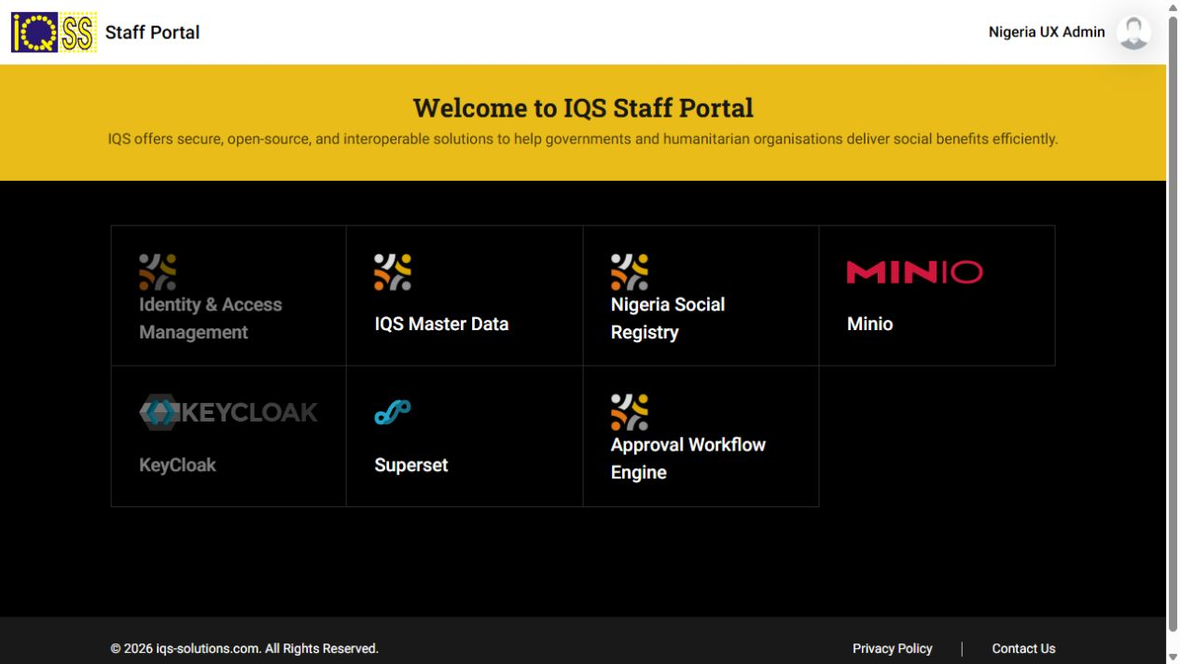
Figure 8 Staff SSO completed through the public domain
All 68 Deployment and StatefulSet workloads were ready at the end of migration. Browser and authenticated HTTPS checks passed for the main application services. Every possible business transaction was not replayed; the platform’s earlier synthetic workflow limits still apply.

25 Step 21 Confirm the public boundaries
Anyone with the link can reach the application login pages, as requested. The application’s own credentials and permissions control access after sign-in.

Public boundary checks
curl -I https://keycloak.nigeriag2p.com/admin/
curl -I https://keycloak.nigeriag2p.com/realms/master/
curl -I https://pbms.nigeriag2p.com/web/database/manager
curl -I https://kafka.nigeriag2p.com/

Expected result
The blocked administration and unmatched infrastructure routes return 404 through the public tunnel. Staff and beneficiary login endpoints still function. A 404 at an API root can also be normal, so inspect a documented API path before diagnosing it.
The published MinIO API supports authenticated application storage operations; the MinIO console is not published. Keycloak administration remains on the local path. Cloudflare email invitations and Access policies were not enabled for this sandbox.
During setup we briefly inspected the optional Zero Trust Free onboarding path, which presented a billing and terms form. That checkout was exited. The completed public tunnel uses the CLI authorization and does not rely on completing that optional Access subscription setup.

Record the result
1. Keep a private list of the intended public hostnames and blocked administration paths.
2. Give testers the public homepage and their application credentials directly.
3. Use synthetic data for this demonstration environment. Introducing real beneficiary records or live financial integrations requires a separate deployment and access review.

26 Step 22 Start after a Windows restart
Run only Start-IQS-Public-Sandbox.bat. It calls the existing platform startup script, waits for readiness, starts the connector and opens the public home page.
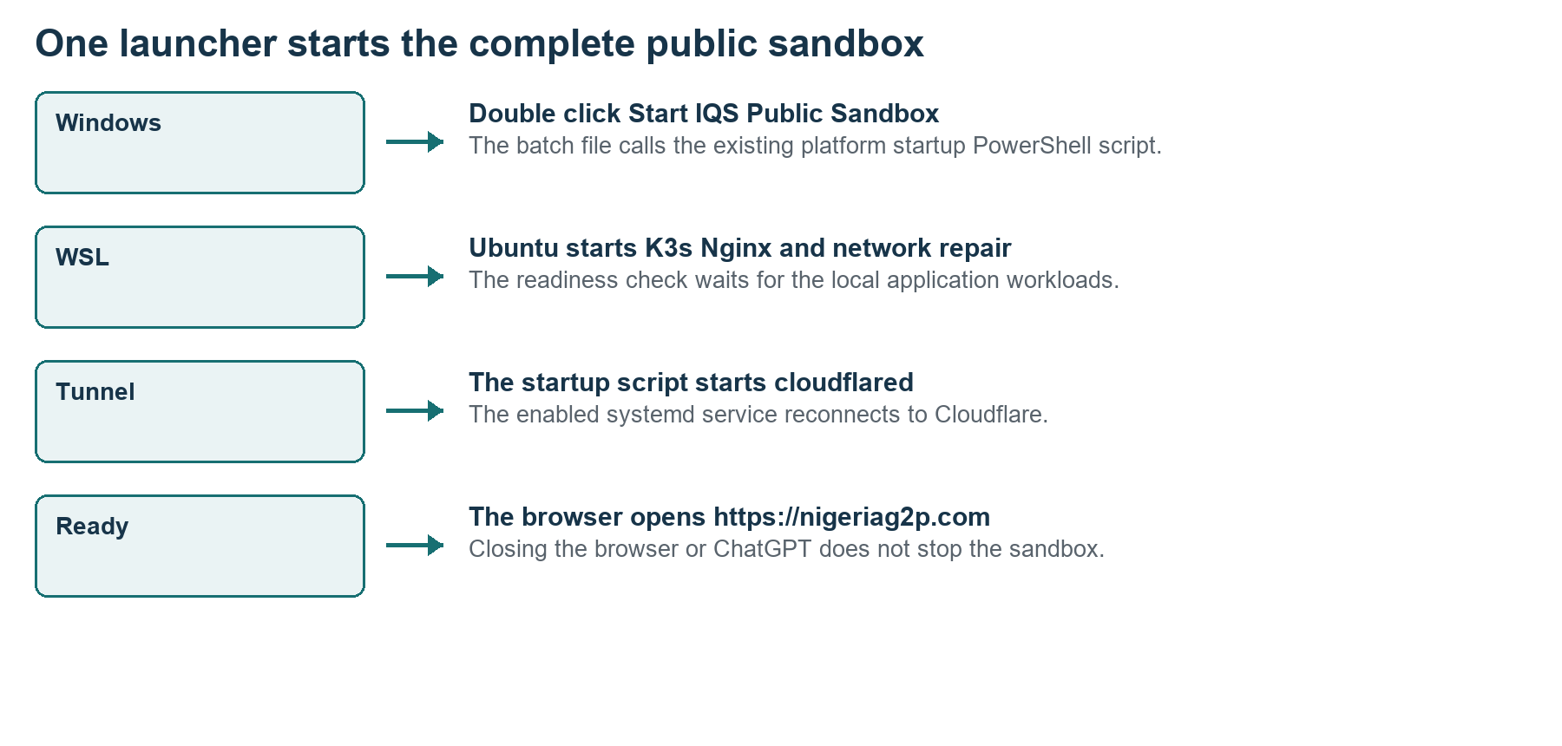
Figure 9 The public launcher includes the local platform startup
1. Double-click Start-IQS-Public-Sandbox.bat on the desktop.
2. Allow the startup window to finish its readiness checks; a restart can require several minutes.
3. Wait for https://nigeriag2p.com to open. Sign in to the selected service.
4. Keep Windows awake and online while external testers use the sandbox. You may close ChatGPT, Codex and the browser.
Do not run Start-IQS-Nigeria.bat first. Running the public launcher is sufficient. The earlier local launcher also starts the connector in this configured machine, but opens the local homepage.

Launch from Windows PowerShell
& 'H:\Nigeria_Mosip\codex\openg2p-lab\Start-IQS-Public-Sandbox.bat'
This installation does not automatically start WSL at Windows sign-in. Enabled cloudflared starts with WSL, and the launcher explicitly starts it again after platform readiness. On native Ubuntu, enabled services start with Linux; there is no BAT step.

27 Step 23 Recreate the public launcher
The public BAT file uses the existing PowerShell startup procedure, with a public homepage parameter. It does not create a second application installation.

BAT file in the lab folder
@echo off
title Start IQS Nigeria Public Sandbox
powershell.exe -NoProfile -ExecutionPolicy Bypass -File "%~dp0Start-IQS-Lab.ps1" -HomeUrl "https://nigeriag2p.com/"
if errorlevel 1 pause
Save as Start-IQS-Public-Sandbox.bat beside Start-IQS-Lab.ps1. The PowerShell script was amended to accept HomeUrl at its beginning:
param([string]$HomeUrl = 'https://openg2p.localhost/')
After the existing K3s and Nginx startup and readiness check, it now starts cloudflared and opens the requested URL:
& wsl.exe -d Ubuntu-22.04 -u root -- systemctl start cloudflared
if ($LASTEXITCODE -ne 0) { throw 'The Cloudflare connector could not start.' }
Start-Process $HomeUrl
Reuse the existing startup script rather than substituting these three lines for its whole content. It also launches WSL in the background, keeps the distribution running, waits for the lab and records startup logs.

Desktop wrapper example
@echo off
call "H:\Nigeria_Mosip\codex\openg2p-lab\Start-IQS-Public-Sandbox.bat"
On another machine change the drive path, WSL distribution name and HomeUrl to the actual installation. Do not hardcode the original H drive if it does not exist.

28 Step 24 Stop resume and preserve the setup
You can pause public access without stopping local work. Stopping WSL stops both the platform and its tunnel.

Windows PowerShell
# Pause public access only
wsl -d Ubuntu-22.04 -u root -- systemctl stop cloudflared
# Resume public access
wsl -d Ubuntu-22.04 -u root -- systemctl start cloudflared
# Check the connector
wsl -d Ubuntu-22.04 -u root -- systemctl is-active cloudflared
A later launcher run or WSL restart starts the enabled connector again. If you intend to keep public access off across boots, disable the service and adjust the launcher’s explicit cloudflared start; changing only systemd enablement is insufficient.

Create a private backup in this lab
python3 /mnt/h/Nigeria_Mosip/codex/openg2p-lab/backup-lab.py
Preserve privately | Purpose
/etc/cloudflared and /root/.cloudflared | Ingress configuration and connector management credentials
/etc/nginx/sites-available/iqs-public | Public origin and blocked routes
/opt/openg2p-lab/public-home | Public launcher assets and links
/opt/openg2p-lab/backups | Database dumps and private configuration archive
Public domain scripts and repair-local-network.py | Domain changes and persistent WSL network repair

The backup script was extended to include the public origin and private tunnel configuration. The post-setup backup recorded was 20261003-203141. A full clean restore of this public configuration has not been tested.

29 Troubleshoot in dependency order
Identify which layer fails before changing application credentials or repeating installation commands.
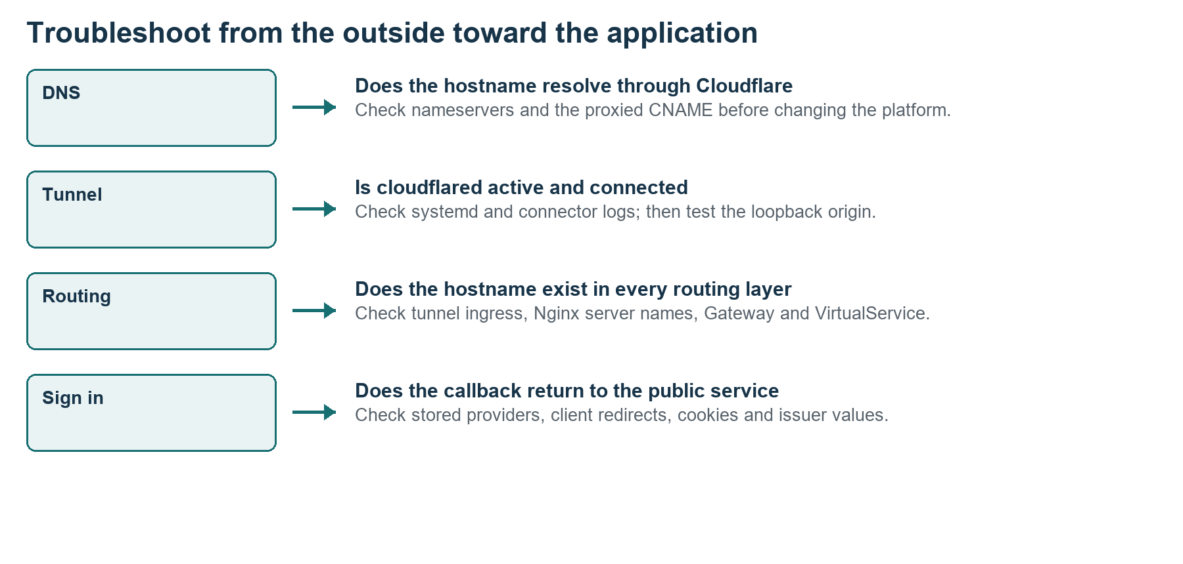
Figure 10 A four layer troubleshooting sequence
Symptom | First check | Next action
Name does not resolve | Registrar delegation and Cloudflare DNS | Compare nameserver pair and proxied CNAME
Tunnel unavailable | PC awake, WSL and cloudflared status | Read connector logs and restore outbound network
502 or origin error | Loopback Nginx and port 18080 | Check listener and origin response
404 for an app | Ingress, Nginx and both Istio Gateways | Add the missing hostname to the correct layer
Blank staff page | Stored IAM login provider URLs | Update endpoints and callback, then reload
Login loop or token 401 | Issuer, client redirect, cookie domain | Use a fresh session and compare all public URLs
Callback goes to localhost | Database provider or configuration cache | Update stored URL and restart affected service
Changes fail after reboot | WSL IP and network repair script | Preserve public hosts in the startup repair

30 Diagnostic commands and acceptance checklist
These inspection commands help you compare a new setup with the recorded working configuration.

Ubuntu root Bash
systemctl is-active k3s nginx cloudflared
systemctl is-enabled cloudflared
nginx -t
cloudflared tunnel --config /etc/cloudflared/config.yml ingress validate
cloudflared tunnel info iqs-nigeria-sandbox
journalctl -u cloudflared -n 30 --no-pager
kubectl -n nigeria get deploy,sts
kubectl -n nigeria get gateway,virtualservice

Acceptance checklist
1. Nameservers resolve to the assigned Cloudflare pair and the domain is Active.
2. The tunnel is connected, the config is valid and public HTTPS loads without certificate exceptions.
3. Homepage links use public domains and all required application and API hosts are routed.
4. Staff and beneficiary logins complete their callbacks. Odoo and the other service logins pass.
5. Blocked infrastructure and database administration paths return 404 through the tunnel.
6. The single public BAT launcher starts the platform and connector after a restart.
7. Private backups include database state, tunnel credentials and the public Nginx origin.
8. The reproduction host and any differences are recorded. Test a reboot on that machine before handing it over.
The public launcher’s syntax, enabled connector service and active connections were checked in this project. A new full Windows restart using the public launcher was not performed as part of publication, so include that test in the next planned restart.

31 Project scripts and reuse on another machine
The public setup required version-specific changes to the installed platform. Preserve the source scripts alongside the installation records, and adapt them deliberately for a new domain.
Script | Recorded responsibility
configure-public-domain.py | Runtime URL conversion, gateways, certificate, Pod aliases, Nginx and homepage
update-public-logins.py | Keycloak client redirects, realm frontend URLs and Odoo base URLs
update-public-database-urls.py | URL columns in IAM and portal databases without account renaming
finish-public-access.py | Staff launcher links, authenticated storage and partner API routes
verify-public-sandbox.py | Authenticated Odoo HTTPS and blocked administration checks
repair-local-network.py | WSL IP repair that now preserves both local and public names
backup-lab.py | Private database and configuration backups including connector state

Original source directory: H:\Nigeria_Mosip\codex\openg2p-lab. These public setup scripts were added after the earlier Installation Kit ZIP was created; they are not automatically present in that earlier archive.
1. Install and verify the matching platform first. Copy and inspect the public setup source if you plan to reuse its automation.
2. Replace hardcoded domain values and /mnt/h source paths. Generate a new tunnel UUID and credential JSON file.
3. Compare chart releases, database names, service names, cookie settings and identity provider schemas before running migrations.
4. Do not replay every source script over this already configured machine. Review current values, back up and change only what is needed.
5. Use the earlier manual installation steps when automating against a different OpenG2P release is not appropriate.
A separate clean-machine replay of these public configuration scripts has not been completed. The document records the working installation and explains the adaptation checkpoints rather than certifying an unchanged copy on every host.

32 The completed public sandbox
The final homepage provides the public application entry points. The application records and operational limits remain those of the synthetic Nigeria lab.
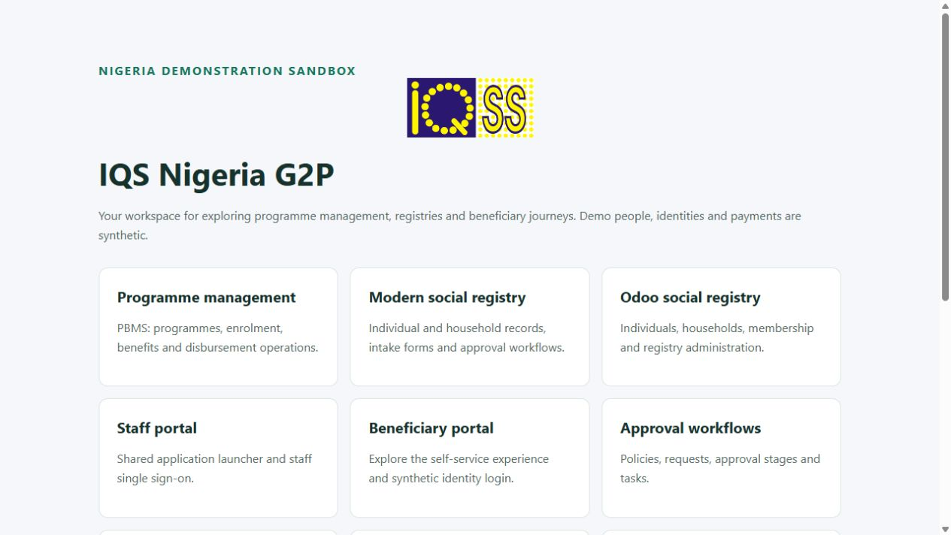
Figure 11 The verified public IQS home page at nigeriag2p.com
Recorded checks: authenticated programme management, Odoo registry and portal administration; staff and beneficiary browser sign-in; modern registry, partner management, AWE, master data, consent, ODK and Superset access; active tunnel connections; and blocked identity administration and Odoo database manager paths.
Cloudflare provides the public access layer. The workstation still hosts all databases and Pods. Sleep, shutdown, WSL shutdown or internet loss stops availability. Closing ChatGPT or the browser does not stop the running services.

33 Official references and evidence record
Official references were consulted on 3 October 2026. Use the installed versions and the local configuration as the authority for this lab’s exact commands and names.
S1 Cloudflare full zone and nameserver setup
S2 Create a locally managed tunnel
S3 Locally managed tunnel configuration
S4 Run cloudflared as a Linux service
S5 Cloudflare tunnel firewall requirements
S6 Keycloak hostname concepts
S7 Istio Gateway host routing
S8 Official cloudflared releases
L1 Local evidence: the saved Cloudflare and BigRock screenshots, connector installation output, tunnel UUID and connection checks, /etc/cloudflared/config.yml, /etc/nginx/sites-available/iqs-public, Kubernetes resources, domain migration source scripts, public-verification.json and the public startup launcher.
The previous installation and usage manuals provide the platform version inventory and verified synthetic business journeys. The nameserver and authorization images capture setup screens; the homepage and staff image capture successful public access. Diagrams are original explanations of this implementation.

