

IQS Nigeria OpenG2P
Installation and Reproduction Guide
  - Windows WSL2 and native Ubuntu manual installation
Edition 1 | 3 October 2026
This manual reconstructs the installation used for the Nigeria IQS UX lab. It explains the host prerequisites, pinned infrastructure and application releases, local HTTPS, authentication, compatibility repairs, Nigeria fixtures and verification commands needed to reproduce the environment on another machine.
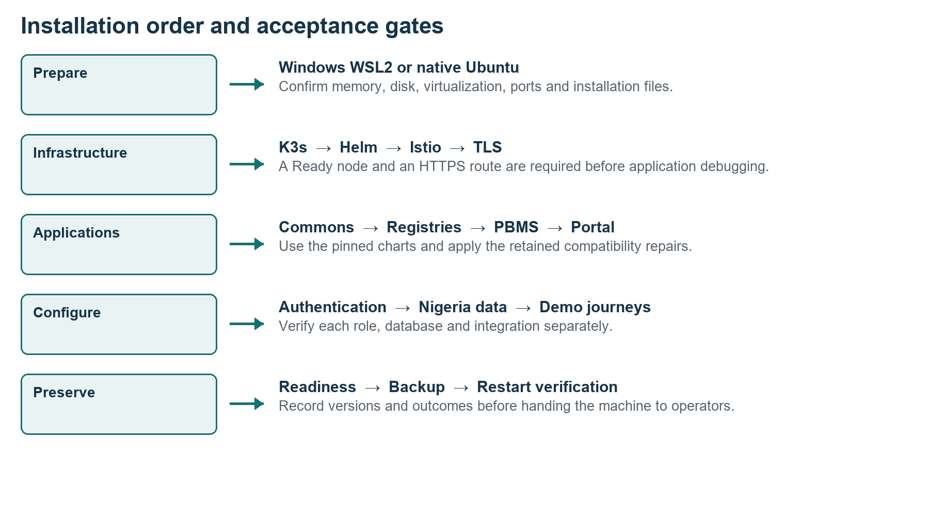
Figure 1 Install in dependency order and verify at every gate
Use the companion IQS Nigeria Installation Kit with this manual. It preserves project specific scripts and charts that are not available from a generic OpenG2P installation command. Generate new credentials and keys on the destination machine.
The original Windows WSL2 lab is operational and has passed a stop and restart test. A clean machine replay of this manual, and the native Ubuntu adaptation, have not yet been executed. Complete the acceptance checklist on the destination before treating it as ready.

01 Scope and reproduction choices
This is a single node local development lab. Select one host path, then follow the shared Linux installation sections.
Path | Use when | Status
Windows WSL2 | Windows workstation with Ubuntu 22.04, systemd and sufficient resources | Original installation path
Native Ubuntu | Dedicated Ubuntu 22.04 x86_64 machine or suitable VM with a local browser | Adapted reference path
Production deployment | Public or government service with real beneficiary and payment data | Separate deployment design required

1. Read the requirements and version inventory. Do not replace the pinned chart versions with latest.
2. Copy the companion kit and verify its file hashes. This kit contains code and chart dependencies, but not downloaded container images.
3. Perform either the Windows or Ubuntu preparation. Use the same Linux directories in both cases.
4. Install infrastructure, then deploy applications in order. Stop at a failed checkpoint instead of moving forward.
5. Apply the retained repairs, initialize accounts and optional synthetic data, and complete browser acceptance tests.
6. Back up and test a stop and restart. Record any differences from the baseline.
The portal uses a separate PBMS 1.3 Odoo backend because its API expects g2p.program; PBMS 3 uses g2p.program.definition. A successful installation does not automatically connect portal applications to PBMS 3. The Example Bank is a simulator, and no live Nigerian identity, bank, SMS or email integration is configured.
Reference Original lab README and scripts; OpenG2P PBMS version compatibility [S1].

02 Contents
Use the clickable contents or Word Navigation Pane to locate a stage. Every command block names its intended shell in the surrounding instructions.
01 Scope and reproduction choices
03 System requirements
04 Version inventory and dependency map
05 Installation kit and working directories
06 Windows preflight and WSL2 installation
07 Enable systemd and allocate WSL resources
08 Native Ubuntu preparation
09 Linux tools and integrity checks
10 Install K3s and check the node
11 Install pinned Helm and Istio
12 Generate fresh configuration and secrets
13 Install Commons Base and Commons Services
14 Create the local HTTPS gateway
15 Build container CA trust and local DNS
16 Install both registries and PBMS
17 Install SPAR Bridge and the bank simulator
18 Install the beneficiary portal and compatible backend
19 Apply the retained compatibility repairs
20 Initialize Odoo and staff authentication
21 Configure beneficiary login forms and cookie isolation
22 Configure the home page and startup service
23 Trust HTTPS on Windows and Ubuntu
24 Seed Nigeria reference data and original fixtures
25 Configure and verify signed demonstration journeys
26 Run fixture eligibility and entitlement calculation
27 Optional larger synthetic batch
28 Apply IQS branding and create the Windows launcher
29 Installation acceptance checklist
30 Backup restart and installation handover
31 Troubleshoot installation failures
32 Manual configuration and upgrade boundaries
33 Official references and source record

03 System requirements
The following planning sizes are engineering recommendations for this full lab, based on its observed footprint. They are not OpenG2P vendor minimums or a production capacity estimate.
Resource | Windows WSL2 full lab | Native Ubuntu full lab
CPU architecture | x86_64 with hardware virtualization enabled | x86_64
CPU planning | At least 12 logical processors; 16 or more preferred | At least 12 logical processors; 16 or more preferred
Physical RAM | 64 GB practical starting point; 96 to 128 GB preferred | 48 GB practical starting point; 64 GB or more preferred
Linux allocation | 48 GB RAM plus 16 GB swap; 64 GB allocation on a 128 GB host | At least 40 to 48 GB usable RAM; swap as an emergency buffer
Disk planning | SSD with at least 150 GB free on the WSL disk location | SSD with at least 150 GB free for Linux and lab growth
OS | Current supported Windows 11 and WSL2; Ubuntu 22.04 distribution | Ubuntu 22.04 LTS with systemd
Permissions | Windows administrator for initial WSL and CA trust; Linux root for setup | sudo or root for setup
Network | Internet access to Ubuntu mirrors, GitHub and image/chart registries | Same outbound access

Original host: 128 GB RAM and 24 logical processors. WSL had approximately 62 GiB RAM and 16 GiB swap. The running lab used about 29 GiB RAM and 53 GB disk at the recorded inspection. Reserve additional headroom for parallel workloads, image downloads, backups and UI builds. A smaller machine can run selected modules, but this full 68 workload configuration has not been qualified on it.
K3s alone lists a much smaller server baseline of 2 cores and 2 GB RAM. That excludes application workloads and cannot size this complete stack. SSD storage is preferable for its databases. [S2]
Windows 10 version 2004 build 19041 or later supports the simple WSL installation commands; prefer a currently supported Windows release for a new machine. WSL2 needs virtualization support. Full Hyper V management tools and Docker Desktop are not required for this K3s path. [S3]

04 Version inventory and dependency map
Preserve the original release names, namespace nigeria and domains for the first reproduction. Renaming them requires changes across scripts, roles, database references and routing.
Component | Pinned version | Purpose
K3s | v1.36.5+k3s1 | Single node Kubernetes and containerd
Helm | v3.22.0 | Chart installation
Istio charts | 1.30.5 | Base CRDs, control plane and ingress
Commons Base | 2.3.3 | Shared databases, storage and identity foundation
Commons Services | 2.3.3 | AWE, partner management, IAM and supporting services
Social Registry | 2.0.8 | Odoo registry
Modern Registry | 1.2.1 | New registry and staff UI
PBMS | 3.0.0 | Programme and beneficiary management
SPAR | 1.1.0 | Financial address mapper
G2P Bridge | 3.0.0 | Disbursement instruction handling
Beneficiary Portal | 2.0.2 | Self service portal
Portal backend | Odoo chart 26.2.9; PBMS core image 1.3.0 | Compatible legacy programme database
Example Bank | 1.1 | Local bank simulator

Chart versions and application image versions are different identifiers. installed-versions.json in the kit records individual images, digests and source commits. Some original tags are latest; use recorded digests when preserving their exact content. Changing Kubernetes, Istio or application versions creates a new compatibility exercise.
Reference Local installed versions and current read only infrastructure inventory; official PBMS versions [S1].

05 Installation kit and working directories
Copy IQS-Nigeria-Installation-Kit.zip from the Documentation folder together with this Word manual. Keep them together when transferring to another machine.
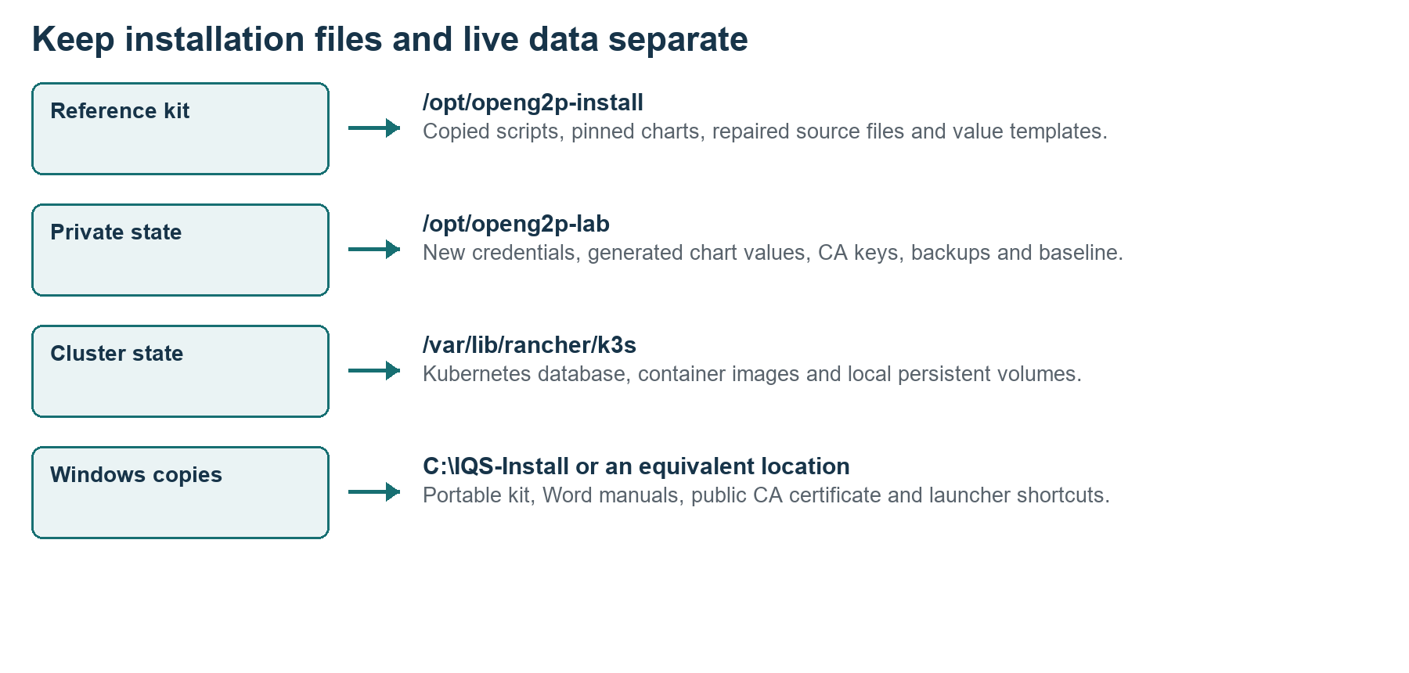
Figure 2 Reference files are separate from private runtime state
On Windows, extract to C:\IQS-Install. The result must contain C:\IQS-Install\IQS-Installation-Kit\lab and charts. In administrator or normal PowerShell as appropriate:
New-Item -ItemType Directory -Force C:\IQS-Install
Expand-Archive -LiteralPath .\IQS-Nigeria-Installation-Kit.zip `
-DestinationPath C:\IQS-Install
wsl -d Ubuntu-22.04 -u root
After Ubuntu is available, use its root Bash shell to copy the extracted kit:
mkdir -p /opt/openg2p-install /opt/openg2p-lab
cp -a /mnt/c/IQS-Install/IQS-Installation-Kit/. /opt/openg2p-install/
chmod 700 /opt/openg2p-lab
export KIT=/opt/openg2p-install
export LAB=/opt/openg2p-lab
For native Ubuntu, extract the ZIP with unzip into a temporary folder and copy the same IQS-Installation-Kit contents to /opt/openg2p-install. The lab scripts in this kit have been adapted from the original H: source path to this Linux path. Do not use the original unadapted scripts on another machine.

06 Windows preflight and WSL2 installation
Run the inspection commands in PowerShell before changing the host. Preserve existing WSL distributions and Hyper V virtual machines.
Get-CimInstance Win32_ComputerSystem |
Select-Object TotalPhysicalMemory,NumberOfLogicalProcessors
Get-CimInstance Win32_Processor |
Select-Object Name,VirtualizationFirmwareEnabled
Get-Volume | Select-Object DriveLetter,SizeRemaining,Size
wsl --version
wsl --list --verbose
Get-NetTCPConnection -LocalPort 443 -ErrorAction SilentlyContinue
1. Confirm sufficient RAM and SSD capacity. The WSL virtual disk consumes space on its own storage drive, regardless of where you save source files.
2. Enable CPU virtualization in firmware if disabled. Reboot as required by the hardware configuration.
3. Open PowerShell as Administrator. If WSL is absent, install Ubuntu 22.04 with the command below and restart Windows when requested.
4. Launch Ubuntu and finish its first run Linux username and password prompts. These are separate from the application accounts.
5. If Ubuntu 22.04 already exists, inspect it first. Install only into a dedicated clean destination or preserve a backup before reusing it.
wsl --install -d Ubuntu-22.04
wsl --update
wsl --set-default-version 2
wsl --list --verbose
If the existing Ubuntu 22.04 distribution reports version 1, convert it only after backing it up:
wsl --set-version Ubuntu-22.04 2

Expected result
Ubuntu-22.04 appears with VERSION 2. Port 443 has no conflicting listener. WSL commands work without deleting or modifying the existing MOSIP VM.
Reference Microsoft WSL installation and basic commands [S3, S4].

07 Enable systemd and allocate WSL resources
WSL must run systemd because K3s, Nginx and the network refresh are managed as Linux services. Run Linux commands in the Ubuntu terminal.
1. Open /etc/wsl.conf with sudo nano. Merge the boot setting into any existing configuration; retain the existing user and mount settings.
2. Save the file. In Windows PowerShell, stop WSL when no distribution has unsaved work, then reopen Ubuntu.
3. Check the systemd PID and service manager. Do not continue if PID 1 is not systemd.
4. For a 128 GB host, consider the resource example below. On a 64 GB host, use memory=48GB and a CPU count that leaves Windows responsive.
sudo nano /etc/wsl.conf
# Required file content under the boot section
[boot]
systemd=true
Windows PowerShell, after saving Linux configuration:
notepad "$env:USERPROFILE\.wslconfig"
# Merge this example into that Windows file
[wsl2]
memory=64GB
processors=16
swap=16GB
localhostForwarding=true
wsl --shutdown
wsl -d Ubuntu-22.04
# Run the following inside Ubuntu
ps -p 1 -o comm=
systemctl is-system-running
free -h
df -h /
The .wslconfig limits apply to the WSL2 VM, potentially affecting other distributions. wsl --shutdown stops all WSL distributions. systemd may report degraded for an unrelated unit; inspect failed services instead of treating that word as proof that K3s cannot work.
Reference Microsoft systemd and WSL settings [S5, S6].

08 Native Ubuntu preparation
Use a dedicated Ubuntu 22.04 x86_64 installation or VM. This is an adaptation of the WSL lab, with the same Linux services and application versions.
1. Install Ubuntu 22.04 using its official installer and create a sudo capable user. Use an SSD and the planning resources stated earlier.
2. Check architecture, memory, disk and systemd. Confirm port 443 is available.
3. Apply normal OS updates and reboot if a kernel update requires it.
4. Install prerequisites, extract the kit and switch to a root Bash session. Native Ubuntu requires no .wslconfig or Windows launcher.
uname -m
lsb_release -ds
free -h
df -h /
ps -p 1 -o comm=
sudo ss -ltnp '( sport = :443 )'
sudo apt-get update
sudo apt-get upgrade
sudo apt-get install -y unzip
unzip IQS-Nigeria-Installation-Kit.zip -d "$PWD/install-files"
sudo mkdir -p /opt/openg2p-install /opt/openg2p-lab
sudo cp -a install-files/IQS-Installation-Kit/. /opt/openg2p-install/
sudo chmod 700 /opt/openg2p-lab
sudo -i
export KIT=/opt/openg2p-install
export LAB=/opt/openg2p-lab
For the first native test, use a browser on that Ubuntu machine. A browser on another computer resolves .localhost to its own machine; remote access requires a deliberately different DNS and TLS design, not simply reusing these URLs.
Review the existing firewall and network routes. K3s uses 10.42.0.0/16 for pods and 10.43.0.0/16 for services by default; resolve VPN or network conflicts before installing. Do not expose the Kubernetes API or overlay ports to public networks.
Reference Ubuntu Server installation [S7]; K3s requirements [S2].

09 Linux tools and integrity checks
All shared Linux installation commands from this point run in a root Bash shell. Reexport KIT, LAB and KUBECONFIG whenever starting a new shell.
apt-get update
apt-get install -y ca-certificates curl wget git jq gettext-base \
openssl nginx python3 python3-pip python3-yaml python3-requests \
python3-cryptography default-jre-headless unzip
export KIT=/opt/openg2p-install
export LAB=/opt/openg2p-lab
export KUBECONFIG=/etc/rancher/k3s/k3s.yaml
python3 --version
python3 -c "import yaml,requests,cryptography; print('Dependencies OK')"
Verify the transferred kit before installation. This detects transfer corruption; compare the ZIP checksum through a trusted project handoff if source authenticity is required.
python3 - <<'PY'
from pathlib import Path
import hashlib,json
root=Path('/opt/openg2p-install')
manifest=json.loads((root/'SHA256SUMS.json').read_text())
for name,expected in manifest.items():
actual=hashlib.sha256((root/name).read_bytes()).hexdigest()
assert actual==expected, name
print('All installation kit file hashes match')
PY
The kit has the original scripts with the source path adapted, additional value templates, extracted chart dependencies, retained repair source ConfigMaps and package audit files. It excludes live credentials, private CA keys, Kubernetes Secrets and database backups. Scripts named test, inspect, resume or finalize are not blanket installation commands; use only the specifically documented operations.

10 Install K3s and check the node
This reproduces the recorded single node server flags: disable Traefik and ServiceLB, and protect the kubeconfig with mode 600.
curl -fsSL https://get.k3s.io -o /tmp/install-k3s.sh
# Review the downloaded installer before running it
less /tmp/install-k3s.sh
INSTALL_K3S_VERSION='v1.36.5+k3s1' \
sh /tmp/install-k3s.sh server \
--disable traefik --disable servicelb \
--write-kubeconfig-mode 600
export KUBECONFIG=/etc/rancher/k3s/k3s.yaml
kubectl wait --for=condition=Ready node --all --timeout=180s
kubectl get nodes -o wide
kubectl get storageclass
k3s --version
1. Confirm the node is Ready and the default local-path storage class exists.
2. If it fails, inspect journalctl -u k3s and systemctl status k3s before installing any applications.
3. Retain the default cluster CIDRs only if they do not conflict with your VPN or host network.
4. Keep Kubernetes installation and local volumes inside the Linux filesystem. Do not place /var/lib/rancher/k3s on a Windows mounted directory.
systemctl --no-pager status k3s
journalctl -u k3s --no-pager -n 60
kubectl get pods -A

Expected result
The server reports v1.36.5+k3s1. CoreDNS and local storage support are running. Docker Desktop is not needed because K3s supplies containerd.
Reference K3s quick start and requirements [S2, S8].

11 Install pinned Helm and Istio
Helm 3 is used because the retained project charts and workflow were installed with Helm 3. Confirm the download checksums before executing downloaded binaries.
cd /tmp
curl -fLO https://get.helm.sh/helm-v3.22.0-linux-amd64.tar.gz
curl -fLO https://get.helm.sh/helm-v3.22.0-linux-amd64.tar.gz.sha256sum
sha256sum -c helm-v3.22.0-linux-amd64.tar.gz.sha256sum
tar -xzf helm-v3.22.0-linux-amd64.tar.gz
install -m 0755 linux-amd64/helm /usr/local/bin/helm
helm version --short
helm repo add istio https://istio-release.storage.googleapis.com/charts
helm repo add openg2p https://openg2p.github.io/openg2p-helm
helm repo update
kubectl create namespace istio-system
helm install istio-base istio/base -n istio-system --version 1.30.5
helm install istiod istio/istiod -n istio-system \
--version 1.30.5 --wait --timeout 10m
helm install istio-ingressgateway istio/gateway -n istio-system \
--version 1.30.5 --set service.type=NodePort \
--set 'service.ports[0].name=status-port' \
--set 'service.ports[0].port=15021' \
--set 'service.ports[0].targetPort=15021' \
--set 'service.ports[1].name=http2' \
--set 'service.ports[1].port=80' \
--set 'service.ports[1].targetPort=8080' \
--set 'service.ports[1].nodePort=30080' \
--wait --timeout 10m
kubectl create namespace nigeria
kubectl -n istio-system get pods,svc
The ingress chart uses gateway injection from istiod. Inspect the actual Pod image if the Deployment template shows image auto. Nginx terminates HTTPS, so this local ingress forwards HTTP through port 30080. The node, Istio and application namespaces must be ready before proceeding.
Reference Helm installation [S9]; Istio Helm installation [S10]; local release inventory.

12 Generate fresh configuration and secrets
Run the retained configuration generator on the destination. It creates a new random lab password if credentials.yaml does not already exist, then creates Commons, Registry and PBMS values.
python3 "$KIT/lab/configure-lab.py"
python3 "$KIT/generate-extra-values.py"
cp -a "$KIT/charts" "$LAB/"
cp -a "$KIT/package-audit" "$LAB/"
cp "$KIT/lab/nigeria-fixtures.json" "$LAB/nigeria-fixtures.json"
chmod +x "$KIT/lab/post-render.py"
chmod 600 "$LAB/"*.yaml
ls -l "$LAB/credentials.yaml"
File | What it controls
commons-base.yaml | Shared credentials, storage classes and foundation volumes
commons-services.yaml | Common domains, Keycloak and service URLs
registry.yaml | Odoo registry and disabled duplicate shared components
pbms.yaml | PBMS Odoo, PostgreSQL and background tasks
register.yaml | Modern registry, AWE callback and sample/template seed flags
spar.yaml and bridge.yaml | Mapper and Bridge endpoints and database links
beneficiary.yaml | Initial portal hostname and backend reference

The kit generator inserts the new password into modern registry approver configuration. Do not copy original credentials.yaml or private chart values from the old machine. The supplied scripts deliberately use a shared demonstration credential; production user and service credentials require separate design.
Inspect chart values for remaining public default credentials, especially supporting components. sync-supporting-db-passwords.py subsequently aligns configured database passwords with actual cluster Secrets. The new password is viewed locally through the credential script; it is not printed in this manual.

Expected result
Values files exist under /opt/openg2p-lab with restrictive permissions. No old machine password or private CA key is required.

13 Install Commons Base and Commons Services
Deploy shared services first. The post renderer removes duplicate resources in the original chart set and changes database initialization hooks so they can run with their prerequisites available.
helm install commons "$LAB/charts/openg2p-commons-base" \
-n nigeria -f "$LAB/commons-base.yaml" \
--post-renderer "$KIT/lab/post-render.py" --timeout 30m
kubectl -n nigeria get pods
kubectl -n nigeria rollout status sts/commons-postgresql --timeout=600s
kubectl -n nigeria rollout status sts/commons-keycloak --timeout=600s
helm install commons-services "$LAB/charts/openg2p-commons-services" \
-n nigeria -f "$LAB/commons-services.yaml" \
--post-renderer "$KIT/lab/post-render.py" --timeout 30m
kubectl -n nigeria get jobs,pods
python3 "$KIT/lab/sync-supporting-db-passwords.py"
Installation is staged without a universal --wait gate because some application initialization, local DNS and authentication require the later repair stages. A Helm deployed status alone does not prove operational readiness. Inspect failures and confirm the shared PostgreSQL, Keycloak, Redis, MinIO and Kafka foundation before adding dependent applications.
kubectl -n nigeria get events --sort-by=.lastTimestamp
kubectl -n nigeria logs sts/commons-postgresql --tail=40
helm -n nigeria status commons
helm -n nigeria status commons-services
Do not delete persistent volumes to fix an initialization password mismatch. On a fresh machine, correct values and database initialization consistently. On an existing cluster, preserve a backup and distinguish the PostgreSQL superuser password from application database user passwords.
Reference Local configure lab, post renderer and supporting password synchronization scripts.

14 Create the local HTTPS gateway
Generate a fresh CA and server certificate on the new machine. The retained bootstrap creates Nginx TLS termination and the Istio internal Gateway.

bash "$KIT/lab/bootstrap-access.sh"
nginx -t
systemctl is-active nginx
kubectl -n nigeria get gateway internal
openssl x509 -in "$LAB/tls/server.crt" -noout \
-subject -issuer -dates -ext subjectAltName
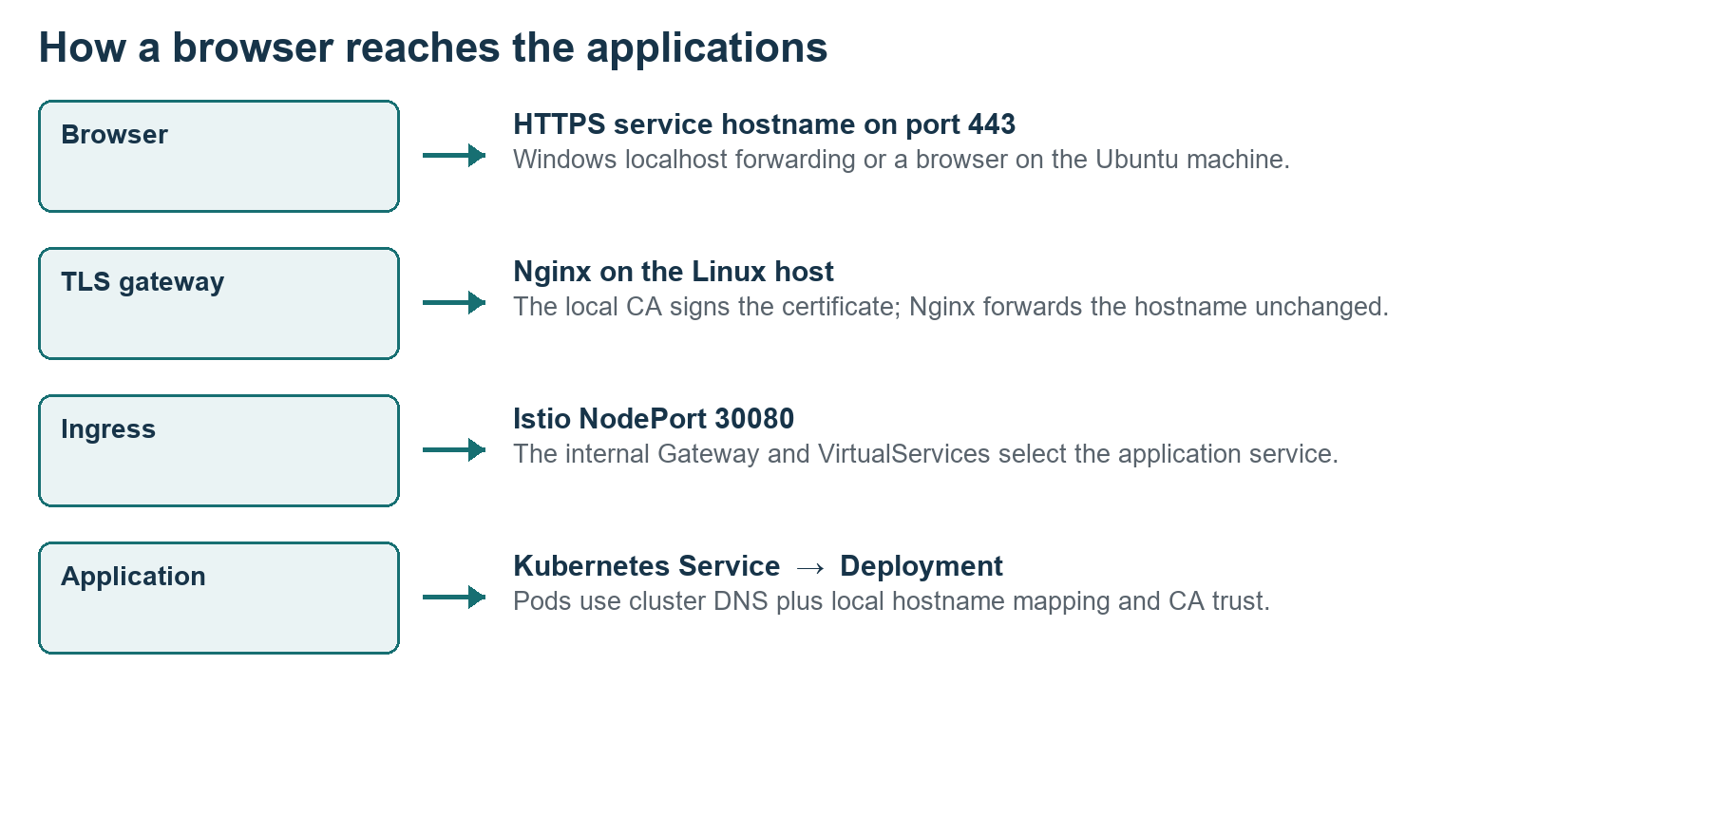
Figure 3 Nginx terminates TLS and Istio routes by hostname
The initial certificate covers openg2p.localhost and its subdomains. The later beneficiary isolation stage reissues it with beneficiary.openg2p-ux.localhost included. Do not reuse the original machine private keys. Server keys remain in /opt/openg2p-lab/tls, readable only by the installation administrator.
bootstrap-access.sh copies the public CA to the kit lab directory and trusts it in Ubuntu. Application containers require additional CA trust, covered in the next section. The bootstrap script creates the route; application readiness still depends on later stages.

15 Build container CA trust and local DNS
Applications need to resolve the local HTTPS names back to the Linux host, rather than treating .localhost as a Pod loopback address. They also need to trust the generated CA.
cat /etc/ssl/certs/ca-certificates.crt "$LAB/tls/ca.crt" \
> "$LAB/tls/ca-bundle.crt"
cp /etc/ssl/certs/java/cacerts "$LAB/tls/java-cacerts"
keytool -importcert -noprompt -alias openg2p-lab \
-file "$LAB/tls/ca.crt" -keystore "$LAB/tls/java-cacerts" \
-storepass changeit
kubectl -n nigeria create configmap lab-trust \
--from-file=ca-bundle.crt="$LAB/tls/ca-bundle.crt" \
--from-file=java-cacerts="$LAB/tls/java-cacerts" \
--dry-run=client -o yaml | kubectl apply -f -
python3 "$KIT/lab/repair-local-network.py"
1. The ConfigMap contains public trust material, not the CA signing key.
2. The repair script localizes VirtualService hosts and environment URLs, injects hostAliases and CA mounts, and updates CoreDNS NodeHosts.
3. Run the network repair again after installing additional charts, because newly created workloads are not patched by an earlier run.
4. The startup service refreshes the mappings after the WSL IP changes. Native Ubuntu can use the same refresh with a stable machine IP.
5. Check DNS, CA validation and routing separately. Do not permanently disable TLS verification to resolve a certificate error.
curl --cacert "$LAB/tls/ca.crt" \
--resolve keycloak.openg2p.localhost:443:127.0.0.1 \
https://keycloak.openg2p.localhost/realms/master/.well-known/openid-configuration

Expected result
The OIDC discovery document is returned with trusted HTTPS. If not, inspect Nginx, Istio routes and shared Keycloak readiness before debugging logins.

16 Install both registries and PBMS
Shared infrastructure is reused. The Social Registry values disable duplicate Kafka, MinIO, reporting, identity and other shared components to avoid deploying competing copies.
helm install registry "$LAB/charts/openg2p-social-registry" \
-n nigeria -f "$LAB/registry.yaml" --timeout 30m
helm install pbms "$LAB/charts/openg2p-pbms" \
-n nigeria -f "$LAB/pbms.yaml" --timeout 30m
helm install register "$LAB/charts/openg2p-registry" \
-n nigeria -f "$LAB/register.yaml" --timeout 30m
python3 "$KIT/lab/sync-supporting-db-passwords.py"
python3 "$KIT/lab/tune-resources.py"
python3 "$KIT/lab/tune-pbms-workers.py"
python3 "$KIT/lab/repair-local-network.py"
kubectl -n nigeria get deploy,sts,pods
Odoo Social Registry and the modern registry are separate applications and databases. PBMS 3 has its own Odoo database and background services. A data record appearing in one registry is not proof of automatic synchronization with the other.
Release | Initial database | Expected host
registry | socialregistrydb | registry.openg2p.localhost
pbms | pbmsdb | pbms.openg2p.localhost
register | Modern registry database in Commons | register.openg2p.localhost

The original registry image had missing imports and session initialization defects. Its API may not become healthy until the retained repairs are applied. The modern registry dbSeed configuration loads templates without sample people or images; Nigeria fixture seeding is a later explicit step.

Expected result
Odoo database servers are running; the registry and PBMS workloads exist. Record any still failing Pods and compare them with the known repair list rather than assuming the whole install has failed.

17 Install SPAR Bridge and the bank simulator
These services enable local mapper and disbursement demonstrations. They do not establish a live bank payment connection.
helm install spar "$LAB/charts/openg2p-spar" \
-n nigeria -f "$LAB/spar.yaml" --timeout 30m
helm install bridge "$LAB/charts/openg2p-g2p-bridge" \
-n nigeria -f "$LAB/bridge.yaml" --timeout 30m
helm install example-bank "$LAB/charts/openg2p-example-bank" \
-n nigeria --timeout 30m
python3 "$KIT/lab/sync-supporting-db-passwords.py"
python3 "$KIT/lab/tune-resources.py"
python3 "$KIT/lab/repair-api-routes.py"
python3 "$KIT/lab/repair-local-network.py"
kubectl -n nigeria get deploy,sts,pods
The original Example Bank chart supplies simulator defaults. Keep it local and inspect its database Secret and deployment configuration before using the demonstration. Its initial Helm revision was later adjusted while repairing credentials and access; this manual uses the retained scripts and baseline charts rather than presenting that revision history as a clean installer.

Roles of the payment services
- PBMS selects fixture beneficiaries and calculates entitlements.
- Key manager and partner verification keys support signed requests.
- Bridge accepts and routes instructions; SPAR resolves synthetic financial addresses.
- Example Bank simulates a bank endpoint. Funding, settlement and reconciliation remain separate implementation work.
The original Bridge mapper URL and root API routes required corrections. repair-api-routes.py adds the expected routes; repair-bridge-mapper.py later configures the signed SPAR endpoint. Keep request signature verification enabled.
Reference OpenG2P Bridge and SPAR product documentation [S11, S12]; local mapper and route repairs.

18 Install the beneficiary portal and compatible backend
The published Portal 2.0.2 is incompatible with the PBMS 3 programme ORM. Install its separate legacy Odoo backend instead of pointing it at pbmsdb.
helm install pbms-beneficiary-portal \
"$LAB/charts/openg2p-pbms-beneficiary-portal" \
-n nigeria -f "$LAB/beneficiary.yaml" --timeout 30m
python3 "$KIT/lab/install-legacy-portal-backend.py"
python3 "$KIT/lab/connect-portal.py"
python3 "$KIT/lab/repair-local-network.py"
kubectl -n nigeria rollout status deploy/portal-backend-odoo \
--timeout=600s
Item | Required configuration
Backend image | openg2p/openg2p-pbms-core:1.3.0
Database | portalpbmsdb on portal-backend-postgresql
Database user | portaluser with password from the generated local credentials
Administration UI | portal-admin.openg2p.localhost/web
Portal authentication | Beneficiary realm, separate cookies and local demo OIDC provider

The installation kit already contains the extracted legacy Odoo chart under charts/legacy. Its adapted installer no longer depends on the original H: upstream Helm checkout. It produces portal-backend.yaml with the new machine password and installs release portal-backend.
The initial portal UI may still fail until ORM column naming, modules, login provider and isolated beneficiary hostname are repaired. Do not interpret a portal failure as a reason to replace the PBMS 3 database.

19 Apply the retained compatibility repairs
The kit preserves the actual repaired source files from the running baseline as ConfigMap data, plus their deployment mount locations. They are tied to the recorded image versions.
python3 "$KIT/apply-retained-patches.py"
python3 "$KIT/lab/repair-metadata.py"
python3 "$KIT/lab/repair-keycloak.py"
python3 "$KIT/lab/finish-access.py"
python3 "$KIT/configure-awe-admin.py"
python3 "$KIT/lab/register-iam-app.py"
python3 "$KIT/lab/fix-partner-login.py"
python3 "$KIT/lab/repair-local-network.py"
Repair | Why it was needed
registry-package-repair | Unused missing imports and registry session initialization
awe-quorum-repair | Ignore reassigned approver tasks during quorum calculation
portal-schema-repair | Map the portal form builder relation to its installed Odoo column
bridge-api-repair | Initialize the Bridge signing helper for the local key manager
bridge-mapper-repair | Initialize the SPAR signing helper in the Bridge worker
pbms-bridge-helper-repair | Align PBMS request and response wire format and JSON signing
Partner issuer configuration | Match the staff realm public HTTPS issuer while retaining validation

repair-metadata.py uses preserved package audit files to mount the complete registry session repairs and registers the generated callback HMAC from the new cluster Secret. The kit does not contain the original callback secret. finish-access.py grants broad local administrator roles; this is a deliberate lab convenience.
Before applying these repairs to another image release, compare the affected source module and its import path. The original repair scripts often read files from running Pods, and some inspection scripts reference temporary Pods or old artifact IDs. The retained source and mount method avoids those temporary extraction prerequisites for this reproduction.

20 Initialize Odoo and staff authentication
Wait for Odoo and Keycloak to accept connections before running module and user initialization. These commands are installation tasks, not daily startup actions.
kubectl -n nigeria rollout status deploy/registry-odoo --timeout=600s
kubectl -n nigeria rollout status deploy/pbms-odoo --timeout=600s
python3 "$KIT/lab/bootstrap-odoo.py"
python3 "$KIT/lab/install-odoo-modules.py"
python3 "$KIT/lab/bootstrap-odk-admin.py"
python3 "$KIT/lab/finish-access.py"
python3 "$KIT/lab/check-staff-login.py"
1. For the Odoo applications, use admin@nigeria.openg2p.localhost and the newly generated local password.
2. For staff SSO, enter admin, including when the login field is labelled Email.
3. Check the staff realm clients and application roles after IAM registration. A valid login can still receive a 403 if the client role is missing.
4. Check Keycloak redirect URLs against the public HTTPS hostnames. Internal service URLs and public token issuer URLs serve different purposes.
5. Open ODK through its Continue action and Superset through Sign in with Keycloak. Confirm an appropriate workspace or administrator account exists.
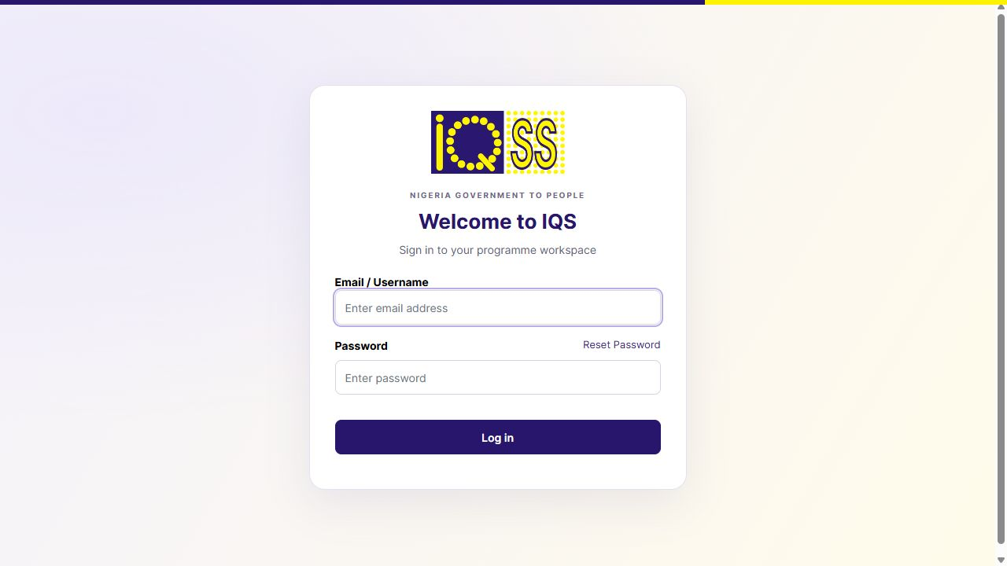
Figure 4 Example IQS Odoo login screen from the original installation
bootstrap-odoo.py records its internal initialization output in private /tmp logs. Check its printed completion flags. Do not print bearer tokens, client secrets or database connection strings into an installation handoff document.
Reference Keycloak administration [S13]; local IAM and Odoo bootstrap scripts.

21 Configure beneficiary login forms and cookie isolation
Initialize the compatible Odoo programme modules, create the local demo provider and then isolate the beneficiary hostname from staff cookies.
python3 "$KIT/lab/bootstrap-portal.py"
python3 "$KIT/lab/seed-portal.py"
python3 "$KIT/lab/repair-portal-schema.py"
python3 "$KIT/lab/seed-portal-form.py"
python3 "$KIT/lab/isolate-beneficiary-domain.py"
python3 "$KIT/lab/extend-demo-session.py"
python3 "$KIT/lab/repair-local-network.py"
nginx -t
1. Inspect the beneficiary Keycloak realm and nigeria-beneficiary-portal client. The demo identity is fatima.
2. Confirm the Odoo provider named Local UX Demo Login and the programme portal form are configured.
3. Check the final client redirect URLs and web origins use https://beneficiary.openg2p-ux.localhost.
4. Confirm the server certificate SAN includes beneficiary.openg2p-ux.localhost and Nginx forwards that host.
5. Open the beneficiary portal, choose SIGN IN TO LOCAL DEMO and use the new password. Submit a new synthetic application only once and retain its generated ID.
The token extension configures a one hour local demo lifetime. It does not make sessions permanent. Do not copy the original application ID or assume it will be generated on a new machine. The original Form.io submission and linked Odoo application were both checked during acceptance.

Expected result
The portal works on its separate domain, and its programme administration workspace uses portalpbmsdb. Staff sessions remain independent.

22 Configure the home page and startup service
Install the application launcher and systemd network refresh after the final hostnames are known.
mkdir -p "$LAB/home"
cp "$KIT/lab/lab-home.html" "$LAB/home/index.html"
python3 "$KIT/lab/install-home.py"
python3 "$KIT/lab/install-startup.py"
cp "$KIT/lab/start-lab-host.sh" "$LAB/start-lab-host.sh"
cp "$KIT/lab/wait-lab-ready.py" "$LAB/wait-lab-ready.py"
chmod 755 "$LAB/start-lab-host.sh"
systemctl daemon-reload
systemctl enable k3s nginx openg2p-lab-network
systemctl restart openg2p-lab-network
nginx -t
python3 "$KIT/lab/smoke-check.py"
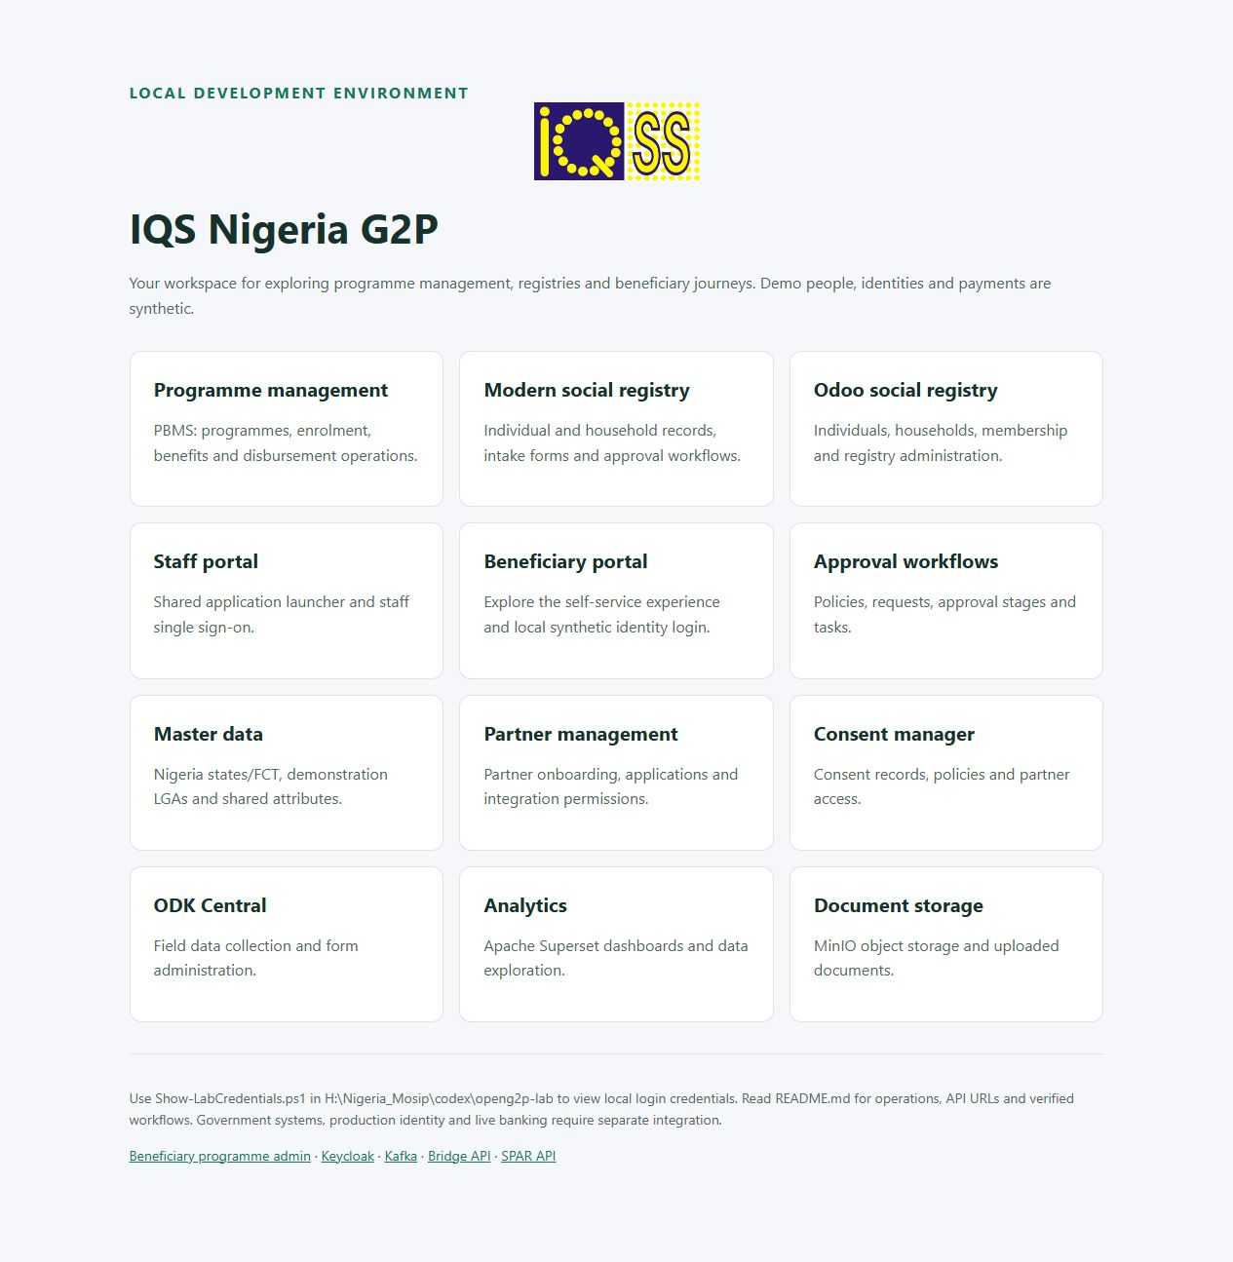
Figure 5 Original installation service launcher used for browser acceptance
The network unit waits for K3s, refreshes local hostname mapping and aligns supporting database credentials. The Windows BAT uses Start-IQS-Lab.ps1, starts a hidden WSL keepalive process, waits up to 20 minutes for readiness and then opens the home page. Native Ubuntu normally keeps these systemd services running without a Windows keepalive process.

23 Trust HTTPS on Windows and Ubuntu
Only the public CA certificate is transferred to the browser machine. Verify that it is the CA generated for this destination lab.
Windows PowerShell: copy the new CA out of WSL, then run certutil in an elevated PowerShell window to trust it in the local machine root store.
wsl -d Ubuntu-22.04 -u root -- cp `
/opt/openg2p-lab/tls/ca.crt /mnt/c/IQS-Install/iqs-lab-ca.crt
certutil -addstore -f Root C:\IQS-Install\iqs-lab-ca.crt
curl.exe -I https://openg2p.localhost/
Start-Process https://openg2p.localhost/
The backtick continues the first PowerShell command onto the next line. The CA trust action is specific to this local lab.
Native Ubuntu root Bash: the bootstrap already installs the CA into the OS store. Recheck it and configure browser specific trust if that browser uses an independent certificate store.
cp "$LAB/tls/ca.crt" \
/usr/local/share/ca-certificates/openg2p-lab.crt
update-ca-certificates
curl --cacert "$LAB/tls/ca.crt" \
--resolve openg2p.localhost:443:127.0.0.1 \
-I https://openg2p.localhost/
1. Open the home page and a login screen without bypassing a certificate warning.
2. Check both a staff host and the separate beneficiary host.
3. If WSL localhost forwarding does not reach Nginx, inspect the WSL IP, listener and forwarding configuration before editing DNS.
4. Retain CA private keys only inside the protected lab directory. Trusting a certificate does not resolve a wrong DNS name or absent SAN.

24 Seed Nigeria reference data and original fixtures
Synthetic fixture loading is optional for an empty installation, but required to reproduce the original UX lab records. Run it only on the clean destination after core applications are healthy.
python3 "$KIT/lab/seed-nigeria-master.py"
python3 "$KIT/lab/finish-seeding.py"
kubectl -n nigeria wait --for=condition=complete \
job/nigeria-register-seed job/nigeria-identity-seed --timeout=600s
python3 "$KIT/lab/seed-odoo-nigeria.py"
python3 "$KIT/lab/seed-modern-nigeria.py"
python3 "$KIT/lab/localize-registry.py"
python3 "$KIT/lab/localize-approval-policies.py"
python3 "$KIT/lab/repair-seed-status.py"
python3 "$KIT/lab/check-demo-flows.py"
Seed area | Original expected content
Master geography | Nigeria, 36 states plus FCT, six demonstration LGAs
Modern registry | 12 synthetic individuals and six households
Odoo Social Registry | Separate copies of the original synthetic records
Mock identity | 12 local mock identities
PBMS fixture | Farmer sample adapter, eligibility and NGN demonstration setup

NG01 through NG37 are lab codes, not official administrative P codes. The six demonstration LGAs do not form a complete Nigeria geography dataset. LAB IDs and mock foundational IDs must never be represented as genuine NINs.
Some seeding scripts write directly to database tables. That was acceptable for the controlled initial lab fixtures; it is not the normal operational intake or approval procedure. Do not run them over a populated project without a backup and review of replacement or upsert behavior.

Expected result
Searchable synthetic records appear in their intended databases. Verify list counts and record details rather than relying on dashboard widgets alone.

25 Configure and verify signed demonstration journeys
These are deliberate integration tests that mutate synthetic state. Execute only once per intended new test and inspect generated IDs before advancing.
python3 "$KIT/lab/connect-pbms-bridge.py"
python3 "$KIT/lab/repair-bridge-mapper.py"
python3 "$KIT/lab/repair-pbms-bridge-helper.py"
python3 "$KIT/lab/test-signed-mapper.py"
python3 "$KIT/lab/seed-all-demo-accounts.py"
python3 "$KIT/lab/test-bridge-mapper.py"
These commands create local signing certificates and synthetic mapper links, configure the Bridge helper and test signed resolution. Local key manager client authentication is relaxed by the original helper configuration inside the lab; transaction request signature checks remain enabled. Do not carry that setting into production without a separate security design.

Registry approval acceptance
1. Open a synthetic person in the modern registry. Submit a small demographic edit through the UI.
2. Record its new change request ID. Complete the configured approval stages through the eligible reviewer.
3. Inspect AWE Webhook Deliveries and reopen the registry record. Verify the approved value and version history.
4. Do not run resume-approved-task.py on a new machine: it references the original request and task IDs.

PBMS calculation and dispatch acceptance
The next section gives the deliberate PBMS fixture test commands. They resolve programme and cycle records by mnemonic but retain fixed October 2026 dates and directly set lab approval flags. These fixture scripts are separate from the normal reviewer procedure. A complete PBMS batch proves Bridge acceptance, not bank settlement.

26 Run fixture eligibility and entitlement calculation
Use only on the clean synthetic destination after Nigeria data and signing configuration are ready. This reproduces the original controlled demonstration, including direct lab approval flags.
1. Inspect NG_LAB_FARMER, benefit NG_LAB_CASH and its enrollment cycle. Confirm six original farmer fixture rows have link_registry_id beginning NG-LAB-.
2. Review the fixed October 2026 dates in the three scripts. Change them consistently if the destination rehearsal requires another test period.
3. Prepare eligibility with test-pbms-enrollment.py once. It sets cycle approval and a fixture only domain; wait for worker completion.
4. Poll with inspect-pbms-flow.py. Confirm complete and six registrants before proceeding. Do not rerun preparation to poll: it resets pending status.
5. Run test-pbms-entitlements.py once. It asserts completed eligibility, creates the demonstration disbursement cycle and prepares entitlement processing.
6. Wait for eligibility_process_status and entitlement_process_status to become complete. Review six NGN 25,000 entitlements and the NGN 150,000 total.
7. For the intended synthetic dispatch, run approve-demo-disbursement.py once. It authorizes the list and cycle for the lab worker.
8. Inspect PBMS and Bridge status and retain the generated batch identifiers. Do not replay approval to recover an uncertain result.
# Stage 1 prepare once
python3 "$KIT/lab/test-pbms-enrollment.py"
# Read only polling and worker diagnosis
python3 "$KIT/lab/inspect-pbms-flow.py"
kubectl -n nigeria logs deploy/pbms-celery-worker --tail=40
# Stage 2 only after eligibility is complete
python3 "$KIT/lab/test-pbms-entitlements.py"
python3 "$KIT/lab/inspect-pbms-flow.py"
# Stage 3 only after calculation and manual review
python3 "$KIT/lab/approve-demo-disbursement.py"
python3 "$KIT/lab/inspect-pbms-flow.py"
These commands change synthetic state and can initiate signed instructions. They do not fund or settle a bank payment. Keep the fixture restriction and use the operations manual for normal approval and review behavior.

27 Optional larger synthetic batch
The later UX batch was added after the base platform worked. It is not required to install OpenG2P or validate initial authentication.
python3 "$KIT/lab/seed-platform-batch.py"
python3 "$KIT/lab/finish-platform-batch.py"
python3 "$KIT/lab/link-batch-applications.py"
python3 "$KIT/lab/verify-platform-batch.py"
Read the scripts before use: they seed several databases and synthetic policies. Some original batch helpers assume prior fixture IDs or record shapes. If the verifier reports a mismatch, inspect the destination IDs and relations rather than silently changing records to make counts pass.
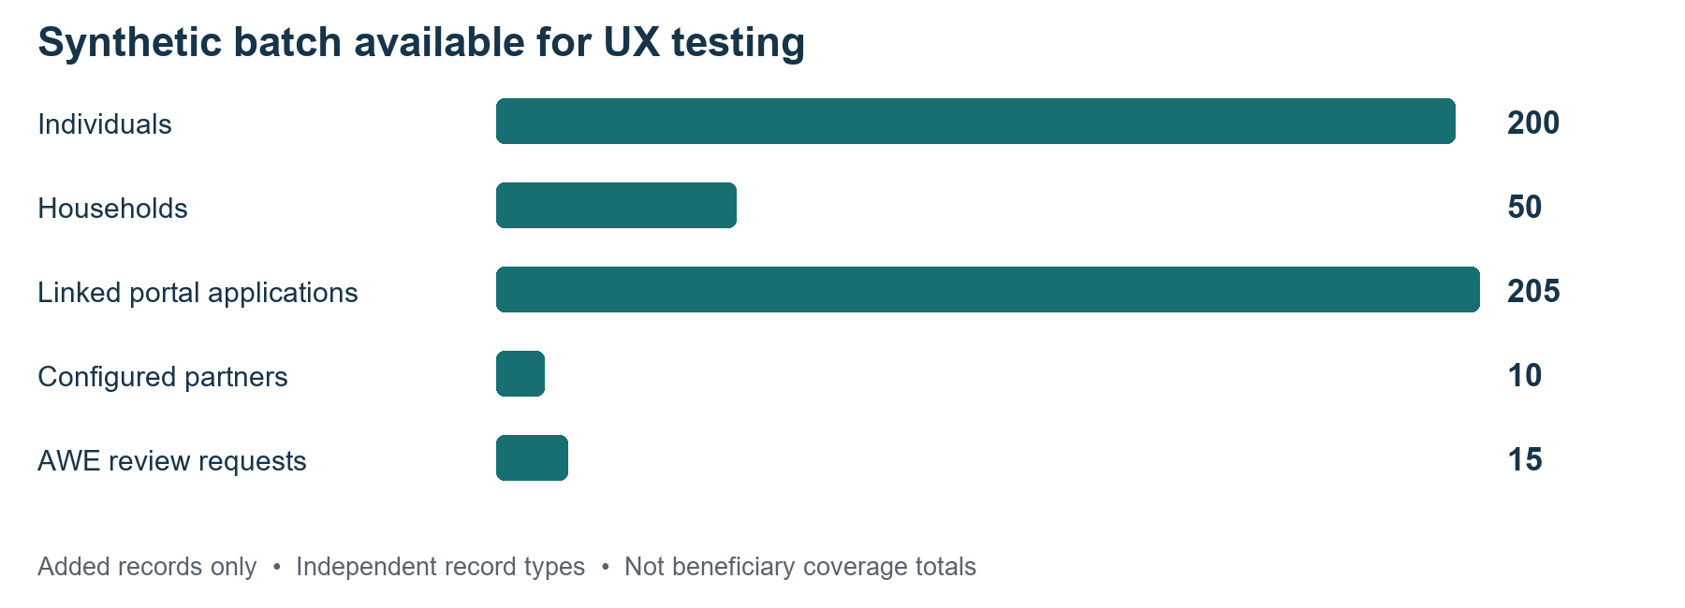
Figure 6 Optional additional UX records from the original lab
The original added batch has 200 individuals, 50 households, five additional programmes, ten configured partners plus six review placeholders, fifteen independent AWE requests and 205 linked portal applications. The completed modern and Odoo registry totals were 212 people and 56 households. Standalone AWE fixtures do not have a registry callback. Additional programmes use the Farmer fixture adapter even where their label says Household Cash Support.
The portal application list requires linked application records and numeric application identifiers; Form.io submissions alone are insufficient. The link batch helper implements this local relation. New batch records do not automatically create PBMS 3 entitlements or a disbursement batch.

28 Apply IQS branding and create the Windows launcher
Branding was applied after functional verification. The logo and CSS JavaScript presentation assets are included in the kit with their source notes.
python3 "$KIT/lab/apply-iqs-branding.py"
python3 "$KIT/lab/brand-native-apps.py"
python3 "$KIT/lab/verify-iqs-branding.py"
nginx -t
The gateway serves same origin branding assets and injects presentation changes. Native Odoo company settings and Keycloak themes are also adjusted. Original server and launcher files are preserved in branding-backup. Service URLs and database model names remain the technical identifiers used by the installation.
Windows PowerShell, after copying the kit and configuring the Linux startup files:
$kitLab = 'C:\IQS-Install\IQS-Installation-Kit\lab'
Copy-Item -LiteralPath "$kitLab\Start-IQS-Lab.bat" `
-Destination "$kitLab\Start-IQS-Nigeria.bat"
# Double click Start-IQS-Nigeria.bat in the kitLab folder
& "$kitLab\Start-IQS-Lab.ps1"
A Desktop shortcut can target this BAT in its folder. Copying only the BAT to the Desktop would break its relative reference to the PS1 script. The backtick continues the PowerShell command onto the next line.
The launcher is manual, not a scheduled Windows task. Its default distribution name is Ubuntu-22.04. If using a differently named imported distribution, change that name consistently in all supplied Windows launcher, status, stop, backup and credential scripts before testing.

29 Installation acceptance checklist
Do not hand over the new machine solely because the Helm releases say deployed. Record the result of every check below.
Check | Expected result | Evidence to retain
Infrastructure | Ready node, active K3s and Nginx, Istio ready | Versions and workload output
Workloads | Baseline target 68 ready Deployments or StatefulSets | smoke check report
HTTPS | Baseline target 18 launcher entry points respond | URL status report
Odoo login | Correct email works in PBMS, registry and portal admin | Login and menu screenshot
Staff login | admin reaches modern registry, AWE and partner management | Fresh session screenshot
Beneficiary login | fatima reaches local demo on isolated hostname | Application list screenshot
Registry edit | Approval stages finish and callback updates the record | Request ID and changed value
Mapper | Signed SPAR link and resolution succeed | Test output without keys
Disbursement | Reviewed sample batch accepted by Bridge | Batch IDs and acceptance state
Data | Intended synthetic record counts and relations | List totals and verifier report
Recovery | Stop and start restores access and saved records | Readiness and record recheck

export KUBECONFIG=/etc/rancher/k3s/k3s.yaml
python3 "$KIT/lab/smoke-check.py"
kubectl -n nigeria get deploy,sts
helm list -n nigeria
python3 "$KIT/lab/validate-handover.py"
The 68 and 18 figures belong to this pinned full configuration. A deliberate module change changes them. Review validators that expect original artifact IDs before using them on a fresh machine. Independent UI and workflow evidence takes precedence over a checker with stale identifiers.

30 Backup restart and installation handover
Create a destination specific backup after acceptance. Do not copy the old lab password, live database dumps or private key material into the public installation kit.
python3 "$KIT/lab/backup-lab.py"
python3 "$KIT/lab/save-baseline.py"
systemctl stop nginx openg2p-lab-network
/usr/local/bin/k3s-killall.sh
systemctl start k3s nginx openg2p-lab-network
python3 "$KIT/lab/wait-lab-ready.py"
save-baseline.py records version and source information and private Kubernetes configuration. On another machine the optional source checkout directories may be absent; inspect its path assumptions and store the resulting inventory in the new project handover folder. Never publish baseline Secrets or backup archives.
1. Recheck an Odoo record, a modern registry approval and a beneficiary application after restart.
2. Record destination host details, WSL distribution name if applicable, RAM allocation, disk location, chart releases, image digests and applied repairs.
3. Give operators the usage manual, launcher location and a separate secure credentials reference.
4. Preserve the logical backup location and test restore into a separate clean environment before relying on disaster recovery.
5. For WSL, a stopped distribution export provides a whole distribution copy; ensure the destination file is on a drive with adequate free space.
Windows PowerShell example, after stopping work and checking disk capacity:
wsl --export Ubuntu-22.04 D:\IQS-Backups\ubuntu-iqs-lab.tar
The original lab passed stop and restart testing; full clean restore was not tested. The native Ubuntu reproduction and this installation kit require their own acceptance records.

31 Troubleshoot installation failures
Investigate the first failed dependency. Keep logs private because upstream services can log tokens or connection strings.
Symptom | Inspect first | Action
kubectl uses localhost 8080 | KUBECONFIG environment variable | Export /etc/rancher/k3s/k3s.yaml
Node not Ready | K3s journal and network CIDRs | Resolve service or CNI problem
ImagePullBackOff | Image name, digest and registry access | Check network and retained tag availability
Pending Pod | PVC, resources and events | Resolve storage or memory shortage
Database authentication failure | Secret and actual database user password | Run the documented synchronization and recheck
HTTPS failure | Nginx listener, SAN, CA and NodePort | Correct that layer before login testing
Login loops or 401 | Issuer, cookies, redirects and host mapping | Recheck public issuer and fresh session
Login 403 | Staff client role and IAM registration | Repair the intended client role
Registry API crash | Pinned image imports and session repairs | Apply retained matching ConfigMaps
Portal missing programme | portalpbmsdb and installed portal modules | Keep legacy backend separate from PBMS 3
PBMS worker exhausts DB | PostgreSQL memory and Celery concurrency | Apply resource and worker tuning
Changes lost after Helm upgrade | Mounted repair ConfigMaps and live workload specs | Review baseline and upgrade plan

kubectl -n nigeria describe pod <pod-name>
kubectl -n nigeria logs <pod-name> --tail=60
kubectl -n nigeria get events --sort-by=.lastTimestamp
journalctl -u k3s -u nginx --no-pager -n 60
Replace <pod-name> with the actual Pod. Do not rerun every seed or bootstrap script as a repair technique, delete PVCs to retry, or run a plain Helm upgrade over the local fixes.

32 Manual configuration and upgrade boundaries
The commands deliberately invoke retained installation scripts where the original work required substantial code or API configuration. Their source is included in the companion kit for inspection and manual execution.
Area | Where to inspect the exact implementation
Chart overrides | lab/configure-lab.py and value-templates.json
Duplicate resources | lab/post-render.py
Nginx and certificates | lab/bootstrap-access.sh and lab/install-home.py
Container trust and DNS | lab/repair-local-network.py
Database users | lab/sync-supporting-db-passwords.py
IAM and roles | lab/repair-keycloak.py, finish-access.py and register-iam-app.py
Registry callback | lab/repair-metadata.py and lab/labdb.py
Version specific code patches | retained-patches.json and apply-retained-patches.py
Portal connection and login | lab/connect-portal.py, seed-portal.py and isolate-beneficiary-domain.py
Synthetic data | lab/seed files and optional batch helpers
Startup and backup | lab/install-startup.py, startup scripts and backup-lab.py

This is a reconstructed manual procedure with the original repair code preserved. It is not a tested unattended installer. New image tags, changed schema versions, a different namespace, different domains or remote access require review of the scripts and a fresh acceptance run.
reconcile-helm.py preserves current workload specifications and compatibility fixes. It is a baseline preservation helper, not a general software upgrade solution. For an upgrade, compare the new chart and source with retained patches, build maintained images where appropriate, back up, test separately and verify the same workflows before changing the working environment.

33 Official references and source record
References were consulted on 3 October 2026. Current upstream pages can describe releases newer than the pinned lab; keep the installed version inventory with this manual.
S1 OpenG2P PBMS versions
S2 K3s requirements
S3 Microsoft WSL installation
S4 Microsoft WSL basic commands
S5 Microsoft systemd in WSL
S6 Microsoft WSL settings
S7 Ubuntu Server installation
S8 K3s quick start
S9 Helm installation
S10 Istio Helm installation
S11 OpenG2P Bridge
S12 OpenG2P SPAR
S13 Keycloak administration
Local evidence: openg2p-lab/README.md, installed-versions.json, configuration generators, repair scripts, the retained extracted charts and the current read only K3s Helm Istio inventory. The companion kit records SHA256 hashes of its files. Screenshots show the original lab; graphics are original explanations of its architecture and installation stages.
Companion archive: IQS-Nigeria-Installation-Kit.zip. Keep it beside this document when transferring the installation procedure. The previous IQS Nigeria Platform Usage and Operations Guide covers normal application use after acceptance.

