

IQS Nigeria Platform
Usage and Operations Guide
  - Step by step procedures for the local OpenG2P environment
Edition 1 | 3 October 2026
Use this manual to start the platform, choose the correct service, work with synthetic records, follow approval and payment demonstrations, and preserve the local environment. It is written for project operators, programme administrators and the team improving the Nigeria user experience.
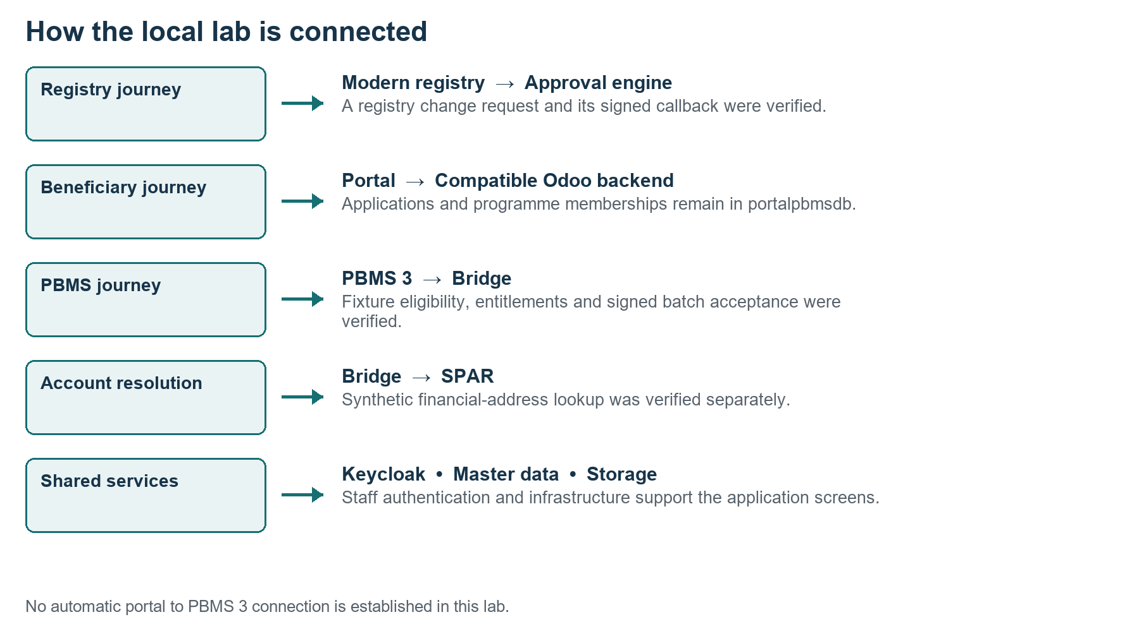
Figure 1 Verified local journeys and their integration boundaries
The installed lab provides working application screens and several verified journeys. It is not yet one fully integrated production delivery system. Procedures marked “reference procedure” describe configuration or testing still required before that capability can be treated as operational.
Passwords remain in the separate local credentials file. This guide contains login identifiers and access routes, without passwords or private keys.

01 Using this guide
Follow the numbered steps in order. Each procedure identifies the service, the expected result and the practical limits of the local implementation.

Three levels of evidence
Label | Meaning
Verified locally | The screen, dataset or journey was inspected or exercised in this installation.
Reference procedure | Official product guidance adapted for this lab; full completion has not been verified here.
Implementation required | A connector, policy, mapping or production service must be configured before the outcome is available.

Recommended first session
1. Start the lab and open the service home page. Read Startup and shutdown before using administration tools.
2. Choose the login family from Service access and sign in. Explore existing synthetic records before creating more.
3. Browse a registrant, a household, a PBMS programme, a beneficiary application and an approval request.
4. Use the troubleshooting section when a screen and its underlying data disagree. Do not interpret empty widgets as proof that all records are missing.
5. Back up before configuration changes. Record the identifiers of any new practice records you create.

Scope and version fit
Local screen labels take precedence over older OpenG2P user guides. Archived Odoo procedures are relevant to Social Registry and the compatible portal backend; legacy manager screens must not be assumed to exist in PBMS 3. The upstream documentation evolves independently of the installed image versions.
All data examples in this manual are synthetic. Geography codes NG01 to NG37 are lab codes. Government identity, live banking, public notifications and full disaster recovery are separate implementation work.
Reference Local README and installed versions [L1]; official module overview [S1].

02 Contents
Use Word’s Navigation Pane for all section headings. The links below jump to procedures in this document.
01 Using this guide
03 Service access
04 Logins and roles
05 Startup and readiness
06 Shutdown and daily checks
07 Data and verified journeys
08 Modern registry browsing
09 Registry changes and approvals
10 Create an Odoo individual
11 Create a household and link members
12 Import and export registry data
13 Programme definitions in PBMS 3
14 Benefit codes and programme amounts
15 Eligibility enrollment and cycles
16 Disbursement and reconciliation
17 Beneficiary applications
18 Portal forms and programme administration
19 Approval engine operations
20 Configure and maintain approval policies
21 Partner onboarding and lifecycle
22 Master data and geography
23 Consent management operations
24 ODK field collection
25 Analytics and reporting
26 Document storage and attachments
27 Identity administration and event tools
28 Technical health and diagnosis
29 Backup and restore
30 Troubleshooting application screens
31 UX testing and operational rehearsal
32 Operator checklist and glossary
33 Official documentation references
34 Additional references and local evidence

03 Service access
Start from https://openg2p.localhost/. The service home page is a launcher; it does not provide one shared database or one login for every application.
Service | Local address | Login family
PBMS 3 | pbms.openg2p.localhost/web | Odoo administrator
Modern registry | register.openg2p.localhost | Staff SSO
Odoo registry | registry.openg2p.localhost/web | Odoo administrator
Staff portal | staff-portal.openg2p.localhost | Staff SSO
Beneficiary portal | beneficiary.openg2p-ux.localhost/selfservice | Beneficiary demo
Portal programme admin | portal-admin.openg2p.localhost/web | Odoo administrator
Approval workflows | awe.openg2p.localhost | Staff SSO
Partner management | partner-management.openg2p.localhost | Staff SSO
Master data | master-data-ui.openg2p.localhost | Staff SSO
Consent manager | consent-manager.openg2p.localhost | Staff SSO
ODK Central | odk.openg2p.localhost | Continue then staff SSO
Superset | superset.openg2p.localhost | Sign in with Keycloak
MinIO | minio.openg2p.localhost | Storage credentials
Keycloak admin | keycloak.openg2p.localhost/admin | Master realm admin
Kafka console | kafka.openg2p.localhost | Staff SSO
Bridge API docs | bridge.openg2p.localhost/docs | Signed transaction APIs
SPAR API docs | spar.openg2p.localhost/docs | Signed mapper APIs

Use HTTPS for every address in the table. The OpenG2P hostnames are retained even though the visible interfaces use IQS branding. API documentation is not a payment administration dashboard.
Reference Local service inventory and current launcher [L1].

04 Logins and roles
The same person can use several services, but the authentication route and permissions depend on the application.
Access type | Identifier | Where it applies
Odoo administrator | admin@nigeria.openg2p.localhost | PBMS 3, Odoo registry and portal programme admin
Staff identity | admin | Staff SSO services and modern registry
Beneficiary identity | fatima | Local demo sign in on the beneficiary portal
Keycloak administrator | admin in master realm | Identity administration only

1. Open the selected service from the home page. Confirm its hostname before entering credentials.
2. For Odoo, enter the full administrator email shown above. For staff SSO, enter admin even if the field is labelled Email.
3. For the beneficiary portal, choose SIGN IN TO LOCAL DEMO first, then use fatima. The initial email or phone form is a different login path.
4. Retrieve the password from your separate IQS Nigeria Service Credentials text file or run Show-LabCredentials.ps1 from the lab folder. Do not place passwords in training slides or screenshots.
5. After expiry, sign in again through the intended service. Keep beneficiary and staff sessions on their separate hostnames.
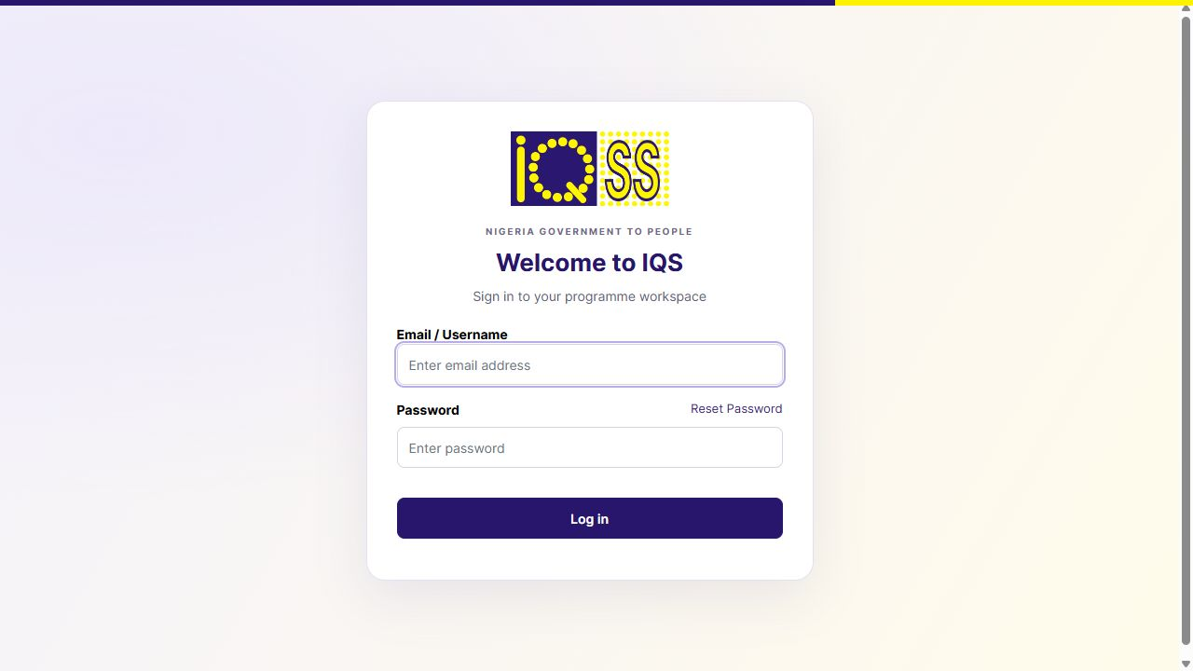
Figure 2 Actual IQS login screen with credential fields empty
Suggested operational roles are registrar, reviewer, programme manager, payment reviewer and technical administrator. The current lab administrator has broad access for exploration; production roles need separate design and validation.
Reference Local credentials routes [L1]; realms, users and client roles [S10].

05 Startup and readiness
Verified locally. Closing ChatGPT does not stop this platform. A Windows restart or WSL shutdown does require the manual launcher again.
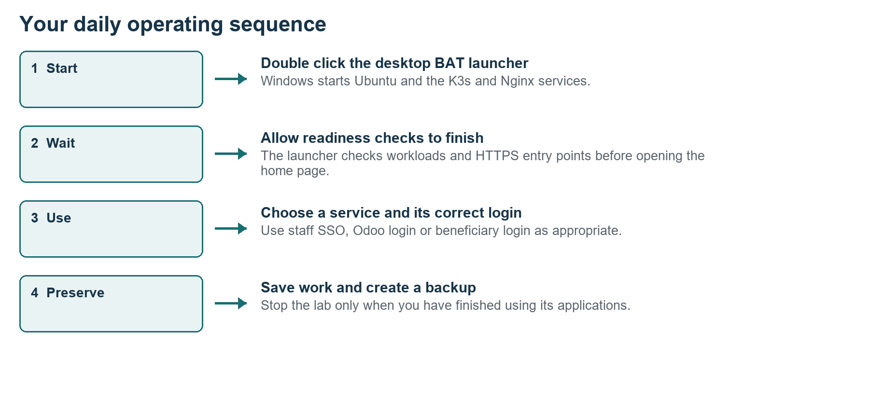
Figure 3 Daily start use and preserve sequence
1. After Windows starts, double click Start-IQS-Nigeria.bat on the Desktop. Alternatively use Start-IQS-Lab.bat in H:\Nigeria_Mosip\codex\openg2p-lab.
2. Leave the launcher window open. It starts Ubuntu-22.04, the local services and network mapping repair, then waits for readiness.
3. Allow several minutes. The current launcher waits up to twenty minutes before reporting a failure with diagnostics.
4. When the launcher reports ready, it opens the home page. Check that the chosen service loads before starting work.
5. If readiness fails, use Status-Lab.ps1 and the health command below. Preserve the startup logs; do not rerun installation scripts.
wsl -d Ubuntu-22.04 -u root -- python3
/mnt/h/Nigeria_Mosip/codex/openg2p-lab/smoke-check.py
The command above is one command; join the displayed lines with a space. The current healthy baseline is 68 ready Deployments or StatefulSets and 18 HTTPS entry points. Counts may change after deliberate upgrades.
Reference Start-IQS-Lab.ps1, wait script and smoke checks [L2].

06 Shutdown and daily checks
Save application work before stopping. Stop and backup scripts operate on this local lab; they do not stop the existing Hyper V MOSIP virtual machine.

Daily checks
1. Open the launcher and verify the home page plus the service you plan to use.
2. Sign in and confirm one expected record or programme is visible. Check pending tasks before modifying the same artifact.
3. If you are changing configuration or loading data, create a backup first. Record the backup folder and the planned change.
4. Monitor free space on C: as well as H:. The WSL virtual disk is backed by C:, while project sources and this manual are on H:.

Normal shutdown
1. Finish any application edits and allow background eligibility or batch jobs to finish.
2. Open PowerShell, set the working folder, then run Stop-Lab.ps1. This stops the lab containers and Nginx while retaining data volumes.
3. Close browser tabs when finished. Start the lab again with the BAT launcher when needed.
Set-Location H:\Nigeria_Mosip\codex\openg2p-lab
.\Status-Lab.ps1
.\Stop-Lab.ps1
Run each PowerShell line separately. Avoid wsl --shutdown during active lab work: it stops all WSL distributions. Do not delete Kubernetes volumes, uninstall Helm releases or remove the Ubuntu distribution as a routine shutdown method.

End of session record
Record the operator, date, procedure, affected identifiers, observed result and any unresolved error. A screenshot should show the status and context without passwords, private keys or unrelated desktop activity.
Reference Local start stop status scripts and machine footprint [L1, L2].

07 Data and verified journeys
The October batch is available for browsing and UX testing. Registry copies and programme backend copies were loaded deliberately; they are not evidence of automatic synchronisation.
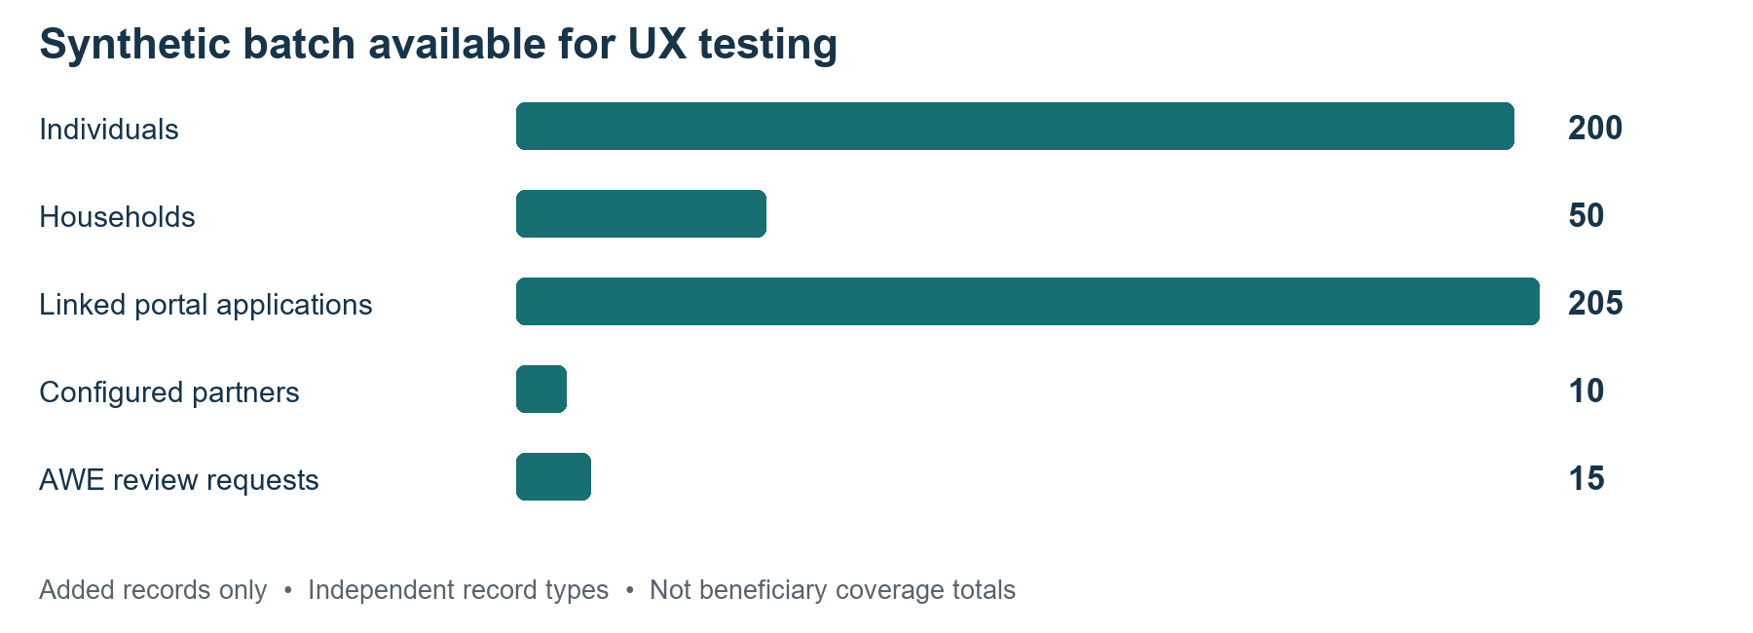
Figure 4 Additional synthetic records by independent record type
Area | Current example | Operational meaning
Modern registry | 212 people and 56 households | Original 12 and 6 plus the new 200 and 50
Odoo registry | 212 people and 56 households | Separate local registry copy
PBMS 3 | 7 programme definitions and 206 farmer fixtures | 2 original programmes plus 5 additional examples
Portal batch | 205 linked applications | 200 people plus 5 applications for Fatima
Partners batch | 8 active and 2 disabled | 6 review placeholders appear separately
AWE batch | 5 in review, 5 approved, 5 rejected | Independent synthetic policy examples

Find the added records using IQS-SYN-20261003 or names containing Demo. LAB-ID identifiers are fake lab IDs, not Nigerian NINs. Reference dates and incomes support test cases; they are not policy assessments.
Verified original journeys include registry edit approval with callback, one submitted beneficiary application, signed SPAR resolution and six PBMS entitlements accepted as a Bridge batch. Some summary widgets still show blanks or incomplete counters; use the record list and workflow history when checking evidence.
Reference Synthetic summary, verification output and original lab handover [L1, L3].

08 Modern registry browsing
Verified locally. Open Modern social registry and sign in with the staff account. The current home page identifies two registers and their record totals.
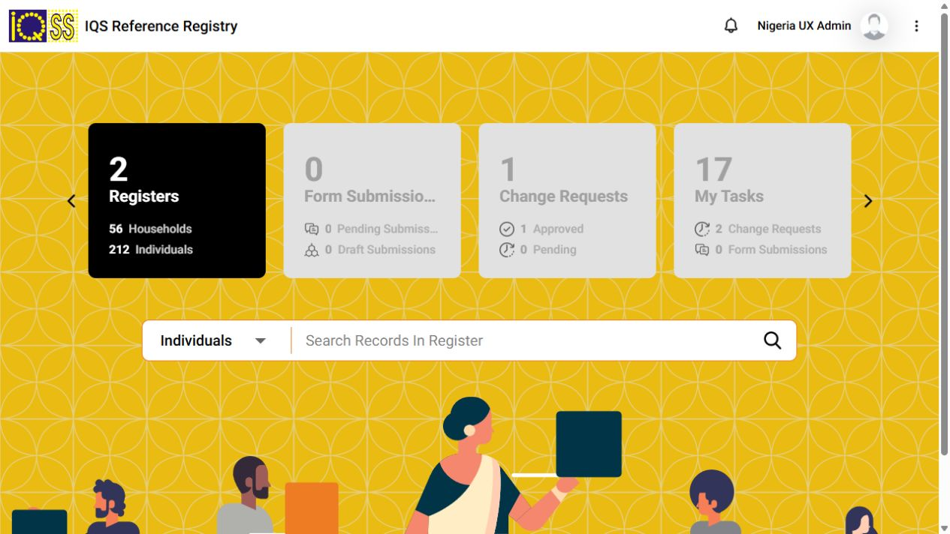
Figure 5 Modern registry dashboard showing 212 individuals and 56 households
1. Choose Individuals from the registry home page, or click the Individuals count.
2. Use the search field for a known synthetic name or reference. Apply Filters when checking a subset; clear them before interpreting totals.
3. Open one record card. Confirm its functional record ID and status before inspecting further.
4. Use Individual Info, Household, Livelihood, Vulnerability and Programs tabs. Blank fields mean that this fixture or metadata mapping does not display a value.
5. Review the Change Request and Version History panels before editing. A seeded ACTIVE record does not mean a government decision has been made.
For a predictable example, find IQS-SYN-20261003-I-0050, Emeka Adeyemi Demo 050. Its demographic fields and fake lab identity are visible. Some State or LGA display fields and completion scores may be blank or zero in the new fixtures despite underlying seeded data.

Expected result
The list shows existing records and the detail page shows the chosen ID. Browse Households in the same way. If a search returns nothing, clear filters, check the register type and inspect the next page before concluding that data was lost.
Reference Current UI and local registry records [L1, L3]; registry change management [S2].

09 Registry changes and approvals
Verified original journey. Edit Details creates a reviewable change request; final approval must also reach the registry through its callback before the new value is authoritative.
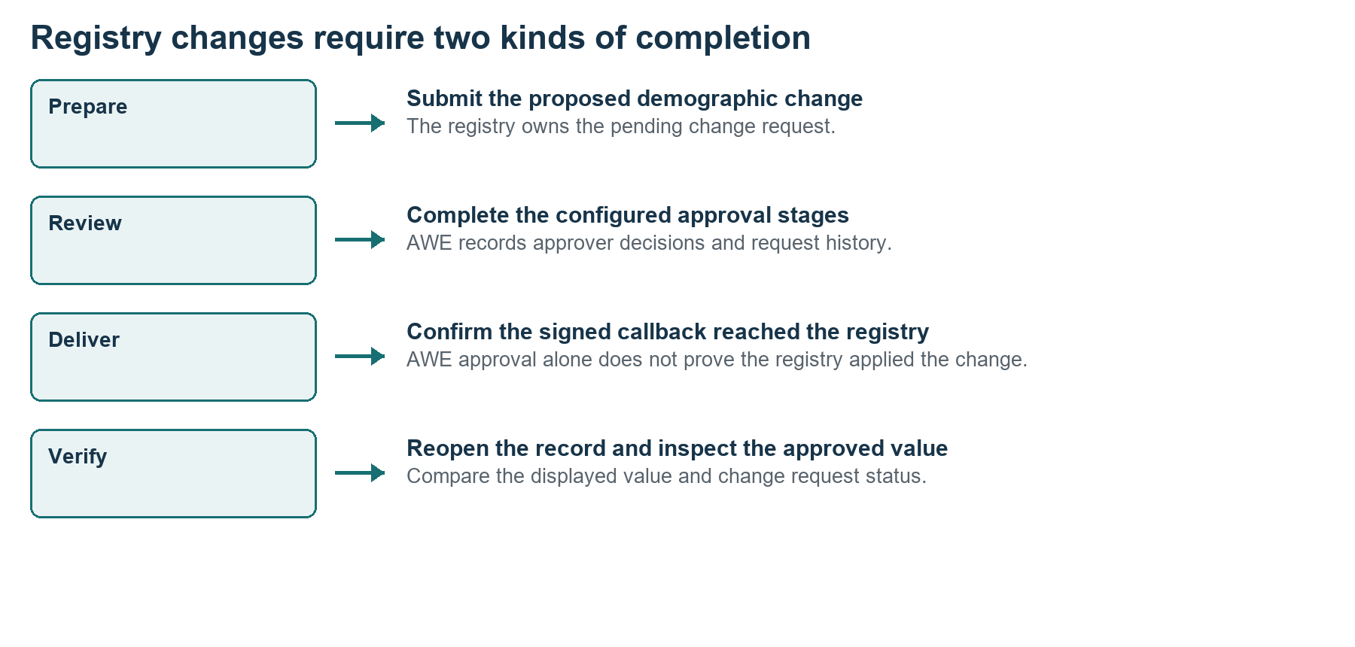
Figure 6 Submission review callback and applied value are separate checkpoints
1. Open an existing synthetic individual and record its functional ID and current value.
2. Choose Edit Details for the section you want to change, such as Demographic Details. Use a small test value and a clear reason.
3. Review the proposed values and submit through the form’s change request action. Do not edit directly in the database for an operational demonstration.
4. Find the request in the registry change request or My Tasks view. Review the proposed difference, not only the person’s name.
5. Complete each configured stage through the eligible reviewer’s task. The original local policy used two stages; do not assume one click completes every request.
6. Inspect the corresponding AWE request and Webhook Deliveries if the registry remains pending.
7. Reopen the individual and verify the approved value, change request status and version history.
The original Fatima record has an approved middle name value UX Demo from the verified journey. The new standalone AWE fixtures have no registry callback. Approving those fixtures changes the approval service record only.
Reference Registry change feature [S2]; AWE responsibilities [S5]; verified local callback [L1].

10 Create an Odoo individual
Reference procedure matched to current fields. Use Odoo social registry for direct administrative creation. The modern registry has a separate intake and change request design.
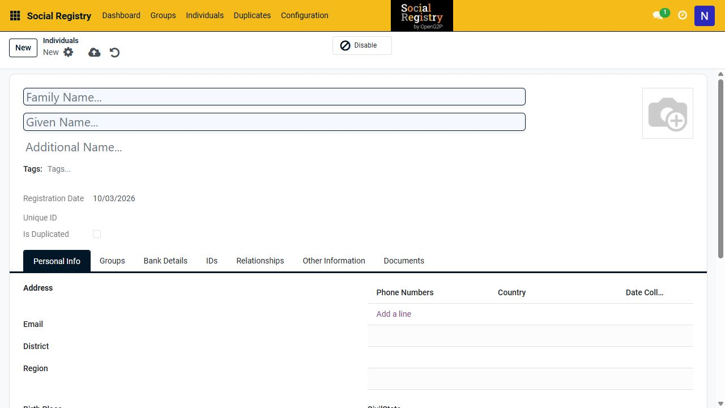
Figure 7 Current Odoo individual form and its tabs
1. Open Odoo social registry and sign in with the Odoo administrator email. Select Social Registry if an app menu is shown.
2. Choose Individuals, search for the intended person and check for duplicates before creating a record.
3. Click New. Enter Family Name and Given Name; add Additional Name only when needed. Use a clearly marked synthetic name for practice.
4. In Personal Info, enter the sample address, email, birth date or approximate birth date, gender, occupation and income where relevant.
5. Use IDs only for a declared lab identifier. Do not label a fake number as a verified NIN. Use the other tabs for supported relationships or documents.
6. Click Save manually. Return to Individuals and search for the new name. Reopen it to confirm the fields persisted.
Practice value: Family Name DemoPractice, Given Name Amina, email amina.practice@example.invalid. Leave optional phone and bank fields empty unless testing those fields explicitly. The actual form uses District and Region labels; these are not automatically the modern registry State and LGA codes.
Expected result: the new row appears in Individuals and its detail page opens. If you only intended to inspect the form, click Discard changes instead of saving.
Reference Archived Odoo individual guide [S3]; inspected local form [L4].

11 Create a household and link members
Reference procedure. In the Odoo registry, household records are groups and member links connect existing individuals to a group.
1. Create or locate the individual members first. Record their identifiers so you select the correct people.
2. Select Social Registry > Groups. Search for the household before creating a new one.
3. Click New. Give the group a unique synthetic name such as IQS DemoPractice Household. Select a household group type if configured.
4. Complete the available address and group information. Treat the displayed mandatory fields as the required input for this installed version.
5. Open the Members or membership area and use Add a line to select each individual. Assign a membership kind or relationship when the form provides it.
6. Save the group, reopen it and check the member list. Open one member and confirm the group link is also visible.
7. For the modern registry, browse the corresponding Household register separately. Creation in Odoo does not automatically create a modern registry record.

Verification checklist
- The household is a group record, not an individual with a household name.
- Every member link points to the intended individual; a repeated member is not an additional person.
- A household head or relationship field is recorded only when supported and intentionally configured.
- The sample batch has 50 additional households with four members each; this is a test structure, not an assumption about Nigerian household size.
Membership and programme enrollment have different meanings. Adding someone to a household does not enroll them in a programme or create a payment entitlement.
Reference Archived group creation guide [S4]; local batch membership setup [L3].

12 Import and export registry data
Reference procedure. Use a small trial import and a backup before a large batch. The supplied individuals.csv is a data export, not a universal upload template for every service.
1. Create a backup, decide which registry owns the import and choose a unique external identifier scheme.
2. Export a small sample from that service where available. Use its fields and required types as the mapping reference.
3. Prepare five synthetic test rows with distinct IDs. Check date formats, enumerations, geography relationships and household member references.
4. In an Odoo list, open the action or list menu and choose Import records if available. Upload the file and map each source column to the intended field.
5. Use Test or Validate if offered. Resolve unmapped columns and required field errors before importing.
6. Import the small trial, then search for each row and verify household relationships separately.
7. Only then process the remaining rows. Repeating an import requires stable identifiers and the correct update mapping; otherwise it can create duplicates.

Export for review
Filter the list first, select the relevant records and choose Export if your role permits it. Include the functional or external ID with names and statuses. Check the export row count and filters before using it as a report. Keep identity or financial exports private.

Modern registry intake
Do not assume the Odoo import button exists in the modern registry. Its ingestion and intake services need register metadata, validation and workflow mappings. Loading a database fixture bypasses those operational intake steps.
Reference Archived registry CSV guide [S11]; local fixture exporters [L3].

13 Programme definitions in PBMS 3
Verified screen and reference creation procedure. Open Programme management > PBMS > Programs. The list currently contains two original and five additional synthetic programmes.
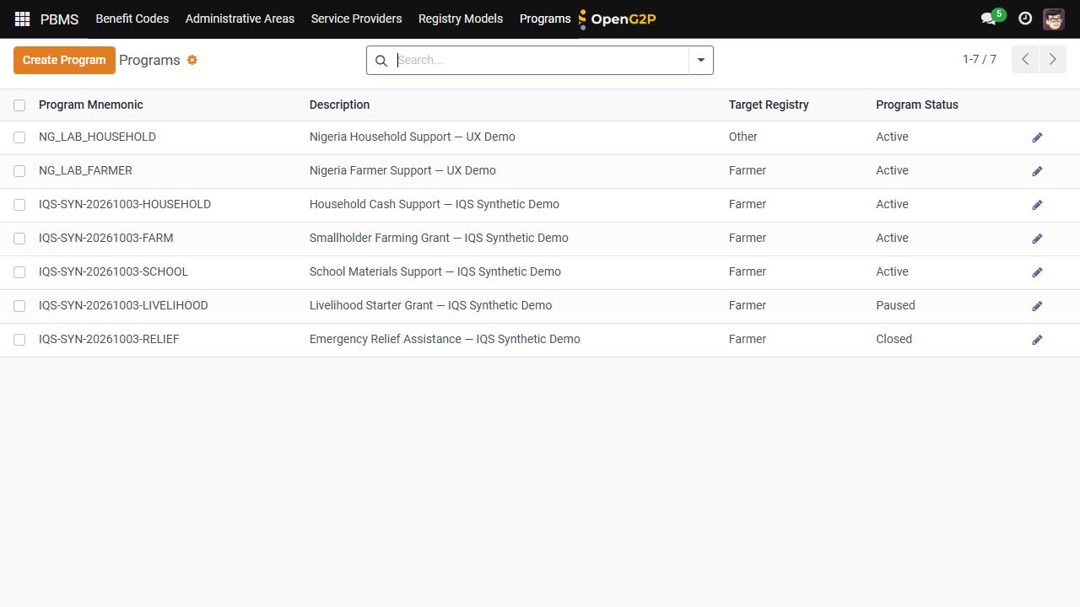
Figure 8 PBMS 3 programme list including active paused and closed examples
1. Open Programs and choose an existing synthetic programme to learn its structure.
2. Review Program Mnemonic, Description, Program Status and Base Registry. The base registry determines which adapter provides candidate data.
3. For a new practice programme, click Create Program and use a unique mnemonic. Make the description explicitly synthetic.
4. Choose the available base registry only after confirming that its adapter is installed. Farmer is the working fixture adapter; Other does not establish household connectivity.
5. Set enrollment and disbursement frequency. Use OnDemand for a controlled local test and keep automatic approval disabled until rules and reviewers are validated.
6. Review Program Benefit Codes, Eligibility Rules, Entitlement Rules, Enrollment Cycles and Disbursement Cycles.
7. Save and reopen the programme. Confirm its status and configuration before creating any job or cycle.
All five additional programmes use the farmer adapter for UI fixtures, including the example labelled Household Cash Support. That label does not mean a working household eligibility connector exists. The original NG_LAB_HOUSEHOLD also needs a household adapter.
Reference PBMS overview [S6]; inspected PBMS 3 screen and fixture adapter [L1, L4].

14 Benefit codes and programme amounts
Verified local values. A benefit code declares a type and unit. Its association with a programme and the entitlement rule determine how the value is used.
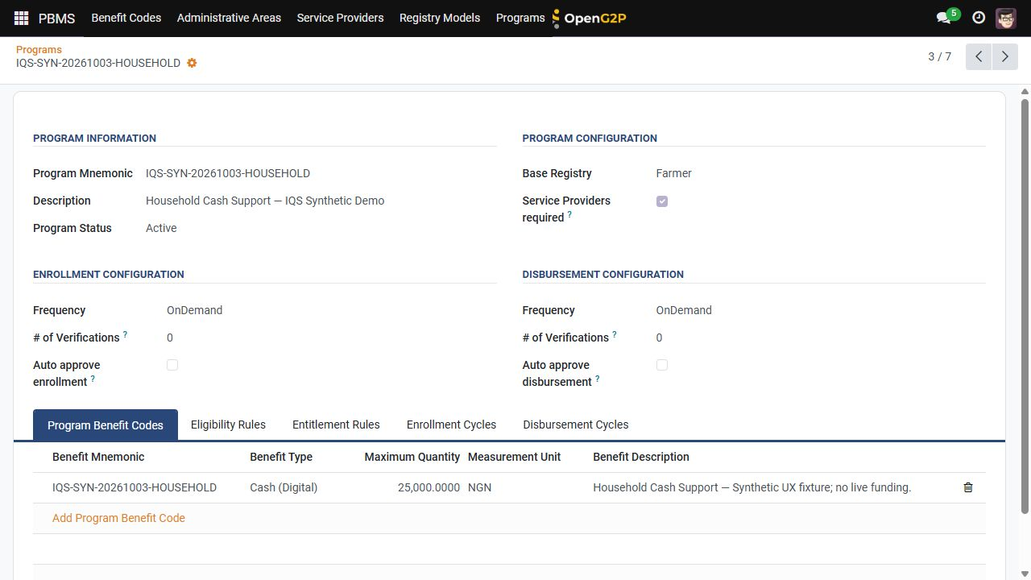
Figure 9 Programme configuration and the NGN benefit association
1. In PBMS, open Benefit Codes. Inspect NG_LAB_CASH or one of the IQS-SYN examples.
2. For a new local example, choose Create Code. Enter a unique benefit mnemonic and a description identifying it as synthetic.
3. Select the available benefit type and measurement unit. The existing examples are Cash Digital and NGN.
4. Save the code, open the target programme and choose Program Benefit Codes.
5. Use Add Program Benefit Code to associate the code. Review Maximum Quantity and Measurement Unit.
6. Configure a matching entitlement rule before calculating benefits. A maximum quantity field alone does not prove that every beneficiary receives that amount.
Additional programme | Sample amount | PBMS status
Household Cash Support | NGN 25,000 | Active
Smallholder Farming Grant | NGN 40,000 | Active
School Materials Support | NGN 15,000 | Active
Livelihood Starter Grant | NGN 50,000 | Paused
Emergency Relief Assistance | NGN 30,000 | Closed

These amounts are fixtures for interface design. Do not present them as Nigerian government policy. The compatible portal backend keeps its own programme records and statuses; changes here do not automatically update portal display.
Reference Local programme and benefit fixtures [L3, L4]; PBMS overview [S6].

15 Eligibility enrollment and cycles
Reference procedure for PBMS 3 with an existing verified fixture calculation. A programme definition must be followed by valid rules, cycle approval and a beneficiary list job.
1. Open the programme and inspect Eligibility Rules. Confirm that the rule targets the intended adapter and includes only synthetic IDs.
2. Inspect Entitlement Rules separately. Confirm the associated benefit code, quantity and selection domain.
3. Open Enrollment Cycles and inspect the cycle number and date windows. If the tab is empty despite a seeded cycle, check its relation and view filters with the technical administrator.
4. Create a new cycle through Create New Enrollment Cycle only for a new controlled test. Review enrollment and disbursement start and end dates.
5. Use the configured enrollment approval process. Do not treat creating a cycle as approval.
6. Open the relevant beneficiary list or enrollment operation provided by the cycle. Start a single calculation and wait for the background status to finish.
7. Compare number of registrants, eligibility process status, entitlement process status and error fields. A running or pending job is not complete.
8. Review the selected IDs and amounts before authorising any disbursement stage.
The original fixture rule selects link_registry_id values beginning NG-LAB-. It produced six eligible records and six NGN 25,000 entitlements. Expanding that rule to the additional 200 fixtures requires deliberate configuration; it has not happened automatically.

Stop condition
If the UI lacks the expected action, ask the technical administrator to inspect the installed model and matching view. Do not substitute a legacy Eligibility Manager instruction or edit approval flags in the database. The earlier lab bootstrap scripts are implementation fixtures, not routine operator actions.
Reference Original eligibility test and PBMS model setup [L5]; installed version boundary [L1].

16 Disbursement and reconciliation
Verified batch acceptance; full bank settlement is implementation required. Inspect existing evidence before running another batch.
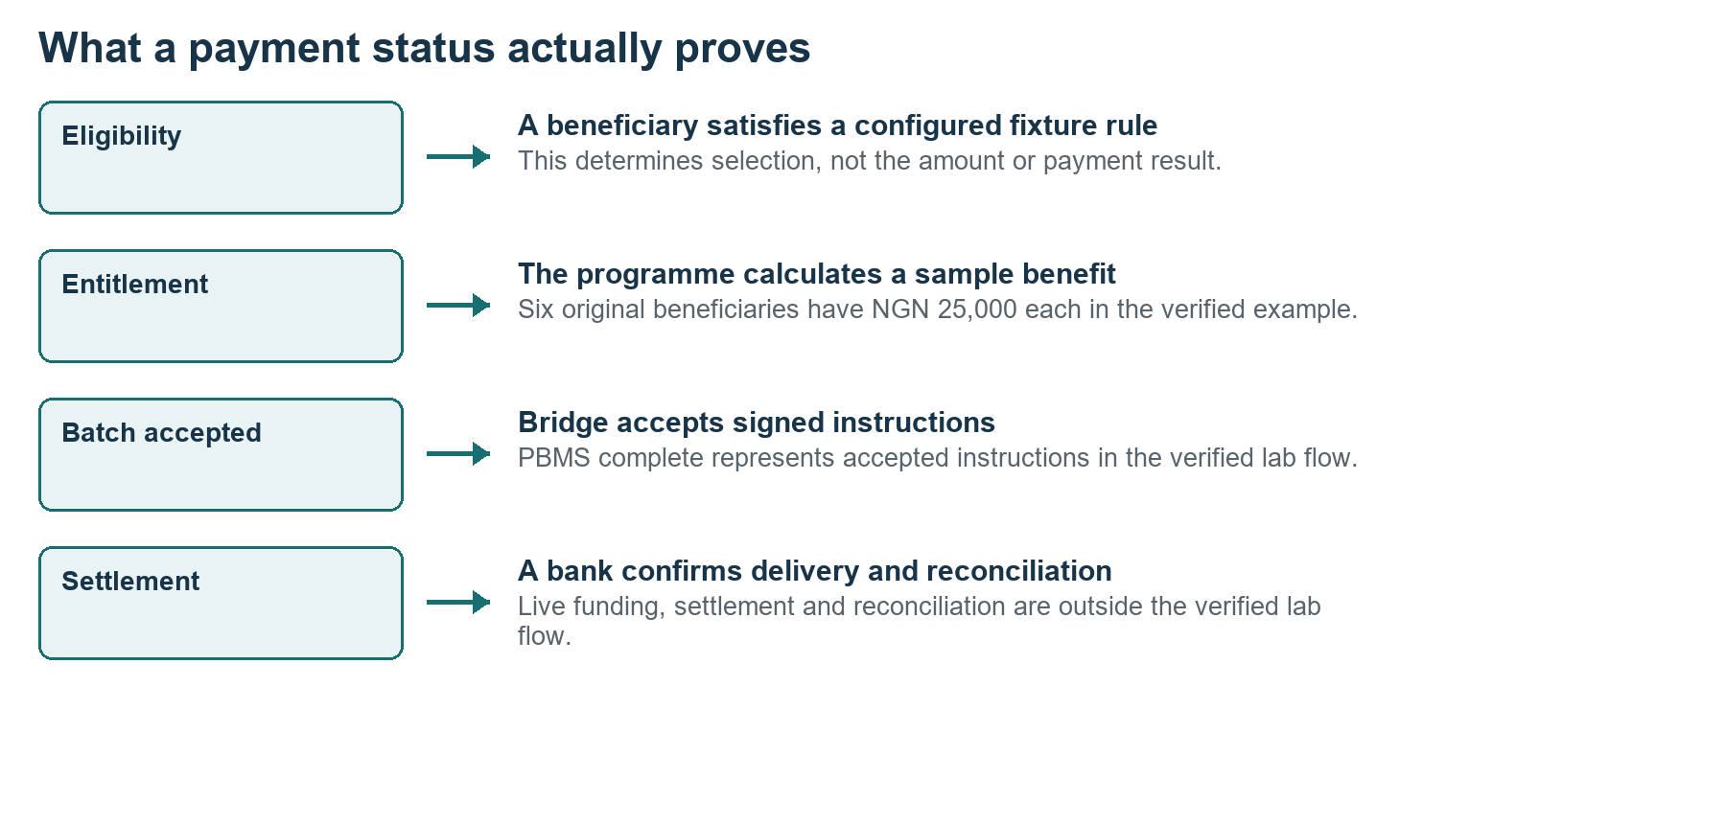
Figure 10 Eligibility entitlement acceptance and settlement are different outcomes
1. Locate the original programme NG_LAB_FARMER and the verified beneficiary list NG_LAB_ENTITLEMENT_TEST through its configured administrative view.
2. Review the six entitlement records and their amounts. The original total is NGN 150,000.
3. Inspect the disbursement cycle NG_LAB_DISBURSEMENT_001 and its approval state. Capture its ID and the related batch ID.
4. Inspect the PBMS background status and the Bridge record. The original PBMS batch was complete after the signed instructions were accepted.
5. For any new test, have the programme and payment reviewers verify beneficiary IDs, amounts, cycle scope and duplicate protection before approving dispatch.
6. Track the external bank response and reconciliation result only when that integration has been configured and tested. Do not label an accepted batch as paid.
The original Bridge batch contains six demonstration instructions. The additional synthetic batch created no new payment instructions. Replaying approve-demo-disbursement.py can create duplicate instructions; do not run it as a normal training step.
Bridge and SPAR API documentation are useful for developers. Transaction endpoints require signed requests and the configured partner keys. The example bank is a simulator; treasury funding, live rails and settlement are not certified in this lab.
Reference Bridge [S7], SPAR [S8] and original batch evidence [L1, L5].

17 Beneficiary applications
Verified local login and original submission. Open the separate beneficiary hostname to keep its cookies distinct from staff sessions.
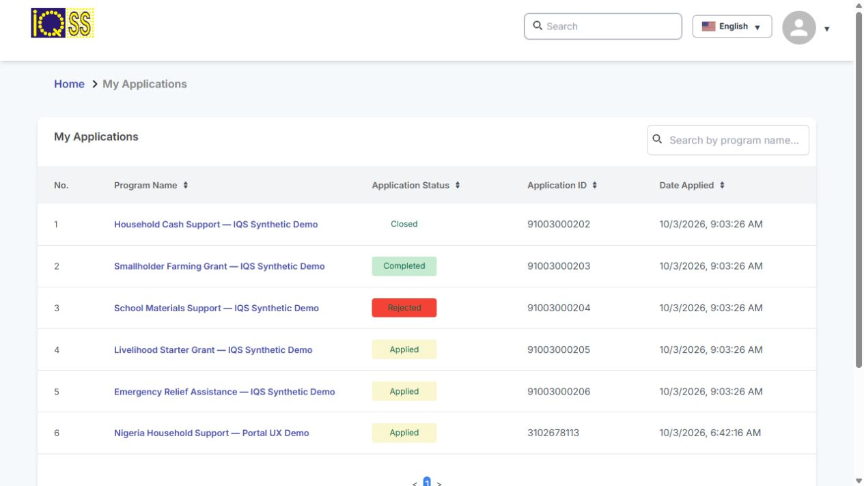
Figure 11 Fatima application list after the batch with the original record retained
1. Open Beneficiary portal from the service home page. Choose SIGN IN TO LOCAL DEMO.
2. Sign in as fatima with the separate credentials reference. Use the programme discovery or home navigation to locate an available programme.
3. Open the programme description and choose its application action. Read the local demo notice.
4. Complete the displayed form using synthetic values. In the sample support form, use a demo contact name, support request and demo confirmation.
5. Review the form before submitting. Submit once and retain the confirmation and application ID.
6. Open My Applications. Confirm the programme name, status, application ID and date. A lack of confirmation should be investigated before submitting again.
7. Sign in again when the beneficiary token expires; the local token lifetime is one hour.
Fatima has the original application ID 3102678113 plus five additional linked examples. Other batch records supply 200 more linked applications. Their fixture statuses are examples rather than actual eligibility outcomes. Applications stay in the compatible portal database; PBMS 3 requires a connector or API migration to consume them.
Reference Local portal login and verified submission [L1, L3]; archived portal guidance [S12].

18 Portal forms and programme administration
Reference procedure using the separate portal programme admin workspace. Do not try to map this legacy portal form in the PBMS 3 programme definition.
1. Open Beneficiary programme admin from the service home page and sign in with the Odoo administrator email.
2. Choose the Forms application or Forms menu. Inspect the existing IQS Synthetic Support Application builder before creating a new one.
3. Create a new Form Builder with a unique name. Select an existing formio.js version. Use the installed version rather than downloading an arbitrary new runtime.
4. Open Form Builder and add the required fields. Give each input a stable key, a clear label and validation appropriate to the sample.
5. Include a Submit button. Test required fields, long text, error messages and keyboard navigation in preview.
6. Set the builder to the current published state and enable portal use through the available builder settings.
7. Open Programs in this workspace, choose the target programme and select the builder in the Portal Form section.
8. Save, reopen the programme in the beneficiary portal and test with a new synthetic application. Confirm a linked application record appears, not only a Formio submission.

Important data distinction
A Formio form, a programme membership and a linked application are different records. My Applications depends on the portal application relation. During this batch, linked records were added to g2p.program.registrant_info so the fixtures appeared in the beneficiary interface. Application identifiers must satisfy the API’s numeric format; arbitrary text can make the application list fail.
Form changes do not automatically rewrite past submissions. Version new builders and retain the earlier schema needed to interpret historical data.
Reference Form builder and programme mapping guide [S13]; inspected local portal model [L3, L6].

19 Approval engine operations
Verified current navigation. The AWE administration interface provides Policies, Requests, Delegations, Webhook Deliveries and Audit Log.
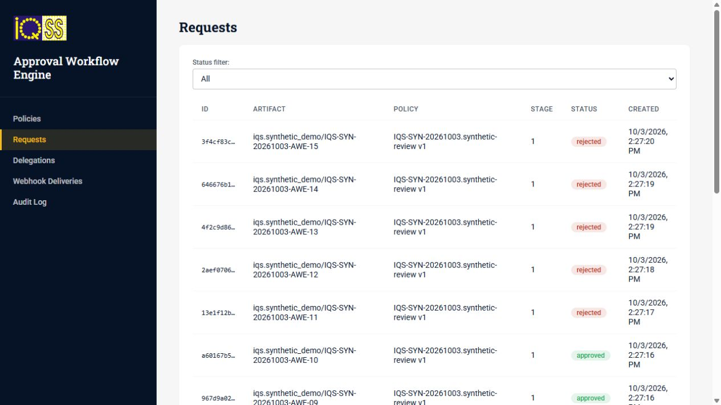
Figure 12 AWE request list with independent approved rejected and in review examples
1. Open Approval workflows through staff SSO. Confirm your administrator identity and the selected environment.
2. Open Requests. Use Status filter to select in_review, approved or rejected; capture the artifact identifier with the status.
3. Open a request and inspect its policy key, version, stage, context and decision history.
4. Review a pending task through the configured approver view in the caller application or the available task action. Only the assigned eligible approver should act.
5. Open Webhook Deliveries for caller-linked requests. Check delivery outcome and retries if the source application has not updated.
6. Use Audit Log to inspect transitions and actors. Keep the request ID when escalating a stuck stage.
The batch policy IQS-SYN-20261003.synthetic-review has fifteen fixtures: five in_review, five approved and five rejected. Its artifact type is iqs.synthetic_demo and it has no registry callback. In contrast, the original registry change request has two approval stages and a callback to apply the change.
AWE determines approval outcomes for caller-owned artifacts. It does not automatically enroll people, transfer funds or synchronise programme databases. A policy edit creates a draft version; activating it governs future requests while existing requests remain tied to their original version.
Reference AWE overview and specifications [S5, S14]; local fixture policy [L3].

20 Configure and maintain approval policies
Reference procedure. Use a new test policy rather than changing the policy that owns an in flight demonstration.
1. Open Policies and inspect the existing stage definitions, decision mode and approver rules.
2. Choose New policy for a separate synthetic test. Define a stable policy key, name and artifact type.
3. Add the required stages in order. Choose the rule that identifies the intended users, roles or groups.
4. Select an appropriate mode such as all or a configured quorum. Confirm the rule actually resolves to an eligible user.
5. Save the draft and inspect it. Activate only after a test request proves that tasks reach the intended reviewer.
6. Record the activated version and create a new synthetic request through the caller integration. Do not assume old requests switch to that version.
7. For absence or stuck tasks, use Delegations or the request’s available reassignment action according to the team’s review procedure.
8. Inspect the audit history after every administrative change. Verify the caller’s result after terminal approval or rejection.

How to investigate a stuck review
Record request ID, policy version, stage and expected approver. Check whether the task is open, whether the user’s client role is available, and whether another reviewer already satisfied the stage. For a completed request with an unchanged source artifact, inspect callback delivery rather than changing policy thresholds.
Treat SLA, delegation, self approval rules and quorum as a deliberate operational design. They should represent the Nigeria project’s approved review responsibilities. Broad administrator privileges in the local lab are a convenience and do not establish a production separation of duties.
Reference AWE stage rules and policy versions [S14]; local AWE screens [L4].

21 Partner onboarding and lifecycle
Verified local UI and fixture statuses. Partner Management controls verification keys for integrations; an approved partner is not a beneficiary.
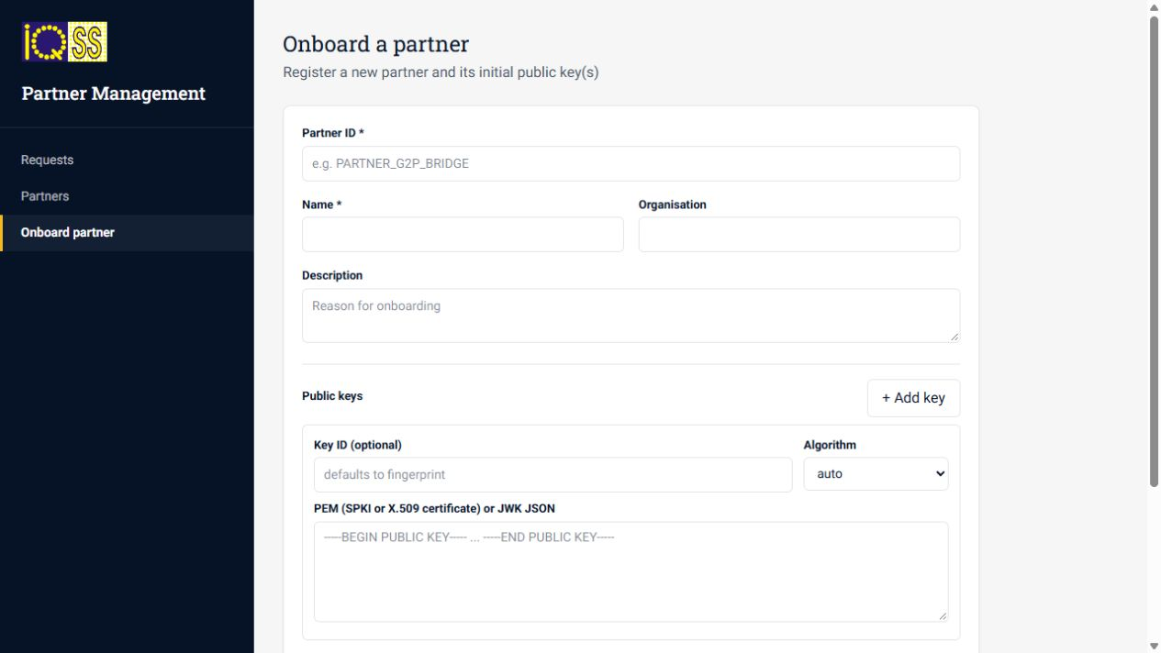
Figure 13 Onboarding form with partner identity public keys and optional JWKS import
1. Open Partner management through staff SSO. Use Partners to inspect existing IDs and avoid collisions.
2. Choose Onboard partner. Enter a unique Partner ID, Name, Organisation and a descriptive local test purpose.
3. Add at least one valid public key. Supply PEM or JWK and a matching algorithm. Do not paste a private key.
4. If using a JWKS URL, verify the endpoint and the import option. It imports keys once; it does not continuously poll the endpoint.
5. Submit request. Open Requests and inspect the created request and proposed keys.
6. An authorised reviewer approves or rejects the request with review notes. Confirm the request outcome and the partner’s status separately.
7. For an approved partner, use View in Partners to inspect active keys. Disable only a deliberately selected test integration; later enable it when the integration is ready.
The batch contains ten configured partners plus six review requests. Rejected onboarding can leave a Created placeholder partner; that is distinct from an Active partner. Active keys are served only for active partners and valid keys. Key rotation requires a key update request and a planned overlap or revocation.
Reference Partner functional specification [S15]; local onboarding screen and fixtures [L3, L4].

22 Master data and geography
Reference procedure with verified Nigeria seed inventory. Master data supplies shared reference values; it is not the register of people or households.
1. Open Master data using staff SSO. Identify the country and geography dataset you are viewing.
2. Inspect the Country value for Nigeria and the State or FCT entries before creating new values.
3. Search for a state or code used by your fixture. Confirm the parent relationship and level.
4. For a new test LGA or reference value, use a distinct demo code, a descriptive label and the correct parent. Do not reuse an existing code with a different meaning.
5. Save through the available management form, then verify that the target application can resolve the value.
6. If a dropdown remains blank, inspect its metadata mapping, expected code field and cache or refresh behaviour. Recreating the same value is not a safe first fix.

Local geography limits
The lab contains Nigeria, all 36 states plus FCT, and six demonstration LGAs. Codes NG01 through NG37 are local seed codes, not official administrative codes. The installation does not contain a complete set of 774 LGAs. New batch household locations cycle across the 37 state and FCT entries.

Maintain a reference dictionary
For each value retain its code, label, parent, level, source, effective dates and active state where supported. Keep a versioned mapping between official project codes and lab codes. Avoid changing an identifier already referenced by records without a migration plan.
The modern registry uses State or FCT and Local Government Area labels; the Odoo form currently uses District and Region. UI labels and underlying IDs must be mapped deliberately during integration.
Reference Master Data Service [S16]; local Nigeria seed and inspected display [L1, L3, L4].

23 Consent management operations
Reference procedure. The consent service is installed, but the full subject authentication, receipt and registry enforcement journey has not been certified in this environment.
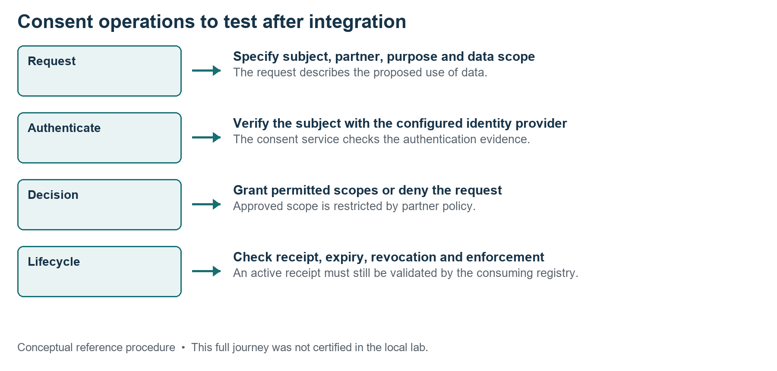
Figure 14 Consent request authentication decision and lifecycle
1. Open Consent manager and inspect the available partner, policy and consent views.
2. Before creating a request, identify the synthetic subject, active partner, data controller, allowed fields and declared purpose.
3. Verify that the partner policy allows the requested scopes. A staff login by itself does not prove the subject gave consent.
4. Use the integrated subject flow to authenticate the subject and grant or deny the request. If this flow is absent, stop at configuration review.
5. On approval, inspect the consent identifier, permitted scopes, receipt and validity period. Denial should not create an active consent artifact.
6. Test expiry and revocation through the configured API or interface, then verify that the consuming registry enforces the result.
Consent status and access enforcement are different checkpoints. A saved receipt does not prove that every registry endpoint checks it. Current upstream documentation also distinguishes originated consent from partner-signed consent used by registry validation. Align the installed API contract before treating these routes as interchangeable.
Use synthetic data for these tests. Production purpose wording, controller responsibility, lawful use and user consent experience require a separate project review; this procedure is a software operating reference.
Reference Consent lifecycle and enforcement reference [S17]; local service boundary [L1].

24 ODK field collection
Reference procedure. Staff SSO reaches ODK Central, but a live field form and an automatic registry ingestion mapping still need configuration.
1. Open ODK Central, choose Continue where shown, and sign in through staff SSO.
2. Create or select a clearly named demonstration project. Inspect its staff and app user permissions.
3. Prepare an XLSForm or XForm with a stable form ID, explicit version, synthetic identifiers and validation rules.
4. Within the project’s Forms area, choose New and upload the definition. Resolve validation warnings before continuing.
5. Test the draft using preview or a test client. Exercise required fields, branching, repeat groups and invalid responses.
6. Publish the draft only after testing. Configure Form Access for the intended test collectors.
7. Submit one synthetic record and inspect it in Submissions. Export a small sample and check identifiers and timestamps.
8. Configure the registry importer or ingestion connector separately, map the source fields, import the small sample and verify the target record.

What draft publishing changes
ODK Central separates test drafts from published forms. Draft submissions can be cleared when the draft is published or replaced. Preserve test findings and confirm the current version before preparing a field collection session.

Expected result
A form submission appears in ODK and the mapped registry record appears only after a configured import. A successful ODK upload alone is not evidence that the beneficiary has entered a registry, a programme or an approval queue.
Reference ODK form administration [S9]; local ODK access [L1].

25 Analytics and reporting
Reference procedure. Superset is accessible through Keycloak; Nigeria programme dashboards and dataset joins require explicit configuration.
1. Open Analytics and choose Sign in with Keycloak. Confirm the workspace is the local lab.
2. Inspect existing datasets before building a chart. Identify the source database, dataset grain and refresh mechanism.
3. For a new demonstration dataset, have the administrator configure an appropriate read only database connection or approved data extract.
4. Select a dataset and create a chart for a defined question, such as application count by status. Define the metric and grouping explicitly.
5. Save the chart with a clear name and add it to a new demonstration dashboard.
6. Add filters for programme, date and relevant geography only when the fields and relationships exist.
7. Compare a chart total with the underlying filtered list or query. Record the refresh time and the definition of the metric.
8. Test dashboard access using the intended role before sharing it.

Avoid misleading totals
Individuals, households, applications, partners and requests are different record grains. Do not add them into a population coverage total. The portal and PBMS programme records are separate; a join needs an agreed cross system identifier. Registry dashboard approval counters and independent AWE task counts may legitimately measure different objects.
The chart in this guide describes the size of the synthetic batch, not operational programme performance. When designing production dashboards, distinguish submitted, approved, enrolled, entitlement calculated, batch accepted and bank settled counts.
Reference Superset dashboard workflow [S18]; local record counts and integration boundaries [L1, L3].

26 Document storage and attachments
Reference procedure. MinIO is the object storage administration console; application attachment metadata belongs to the relevant registry or portal.
1. Open Document storage and sign in using the separate storage credentials reference.
2. Inspect existing buckets and folder conventions. Avoid changing application bucket settings during routine browsing.
3. For a test upload, use the attachment action in the owning application first. Select a harmless synthetic document with a descriptive filename.
4. Save the attachment and reopen the application record. Confirm that the file can be downloaded by an authorised user.
5. If troubleshooting, inspect the corresponding object in MinIO and compare the stored object key with application metadata.
6. Keep an inventory of bucket, object key, record ID, upload date and content type when investigating a missing attachment.
An object uploaded directly to MinIO does not automatically appear on an individual or application. Application metadata and permissions are needed to connect the object to the record. Conversely, a visible attachment row does not prove that its object can still be fetched.

Preserve file evidence
Do not rename, overwrite or delete an object referenced by an application without a documented repair procedure and a backup. Use a distinct test bucket only when your project administrator has approved that storage convention. For real identity or supporting documents, apply the project’s access and retention design before loading them.
The logical backup includes non database file volumes, but online copies do not provide a coordinated whole environment recovery point. See Backup and restore for the separate database and file recovery requirements.
Reference Local MinIO and attachment service inventory [L1]; backup implementation [L7].

27 Identity administration and event tools
Reference procedure. Keycloak governs authentication and client roles; Kafka supports events and integrations. These are technical administration tools rather than routine beneficiary screens.

Keycloak inspection
1. Open Keycloak administration and sign in to the master realm with the administrator account.
2. Select staff before inspecting staff users or client roles; select beneficiary for the fatima demonstration identity.
3. Inspect the intended user, enabled state, client role mappings and current sessions. Record the client ID when diagnosing an access denial.
4. For project users, create distinct accounts and least privilege role assignments through a deliberate access procedure. Do not use the shared lab administrator as the production account model.
A staff login can succeed while a service returns 403 because its client role is absent. Partner Management needs its relevant partner manager role, while AWE has its own client scoped roles. Do not disable token validation as a troubleshooting shortcut.

Kafka inspection
1. Open Kafka console through staff SSO. Identify the expected topic and consumer group for the integration you are checking.
2. Inspect message timestamps, keys, partition offsets and consumer lag. Correlate with the source artifact ID.
3. Do not publish, replay or delete events during a read only diagnosis. Replay requires an agreed duplicate handling and idempotency design.
eSignet, mock identity, Inji and key management are installed supporting services. Mock identities do not connect to Nigeria NIN or NIMC, and identity issuance or wallet journeys require their own configuration.
Reference Keycloak user roles and realms [S10]; local supporting service inventory [L1].

28 Technical health and diagnosis
Verified read only commands. Run these in Windows PowerShell. Keep logs private because some upstream services may print connection strings or tokens.
Set-Location H:\Nigeria_Mosip\codex\openg2p-lab
.\Status-Lab.ps1
1. Check k3s and nginx are active and compare ready replicas with desired replicas. Completed installation jobs are not running services.
2. Run the detailed health check and review both workload readiness and HTTPS results.
3. For a failing service, identify its pod and inspect a small recent log window. Capture the actual error and artifact ID.
4. Check whether the problem is login, role permission, API validation, background processing or a frontend display mapping before changing infrastructure.
wsl -d Ubuntu-22.04 -u root -- kubectl -n nigeria get pods
wsl -d Ubuntu-22.04 -u root -- kubectl -n nigeria get deploy,sts
wsl -d Ubuntu-22.04 -u root -- kubectl -n nigeria logs
deploy/pbms-celery-worker --tail=40
The last log command wraps across two display lines; join them with a space. Use the actual deployment name from the inventory for another service.

Interpret common results
Result | Likely investigation
401 | Expired session or issuer and token validation
403 | Client role or resource permission
422 | Request fields do not match the API schema
500 | Inspect server error and compatibility mapping
Pending job | Worker health queue and latest job error
Empty UI | Filters backend association and metadata mapping

Reference Local status scripts and repaired compatibility boundaries [L1, L2].

29 Backup and restore
Verified backup creation; restoration into a separate clean environment has not been tested. Keep backup material private because it includes credentials and keys.

Create a routine backup
1. Save application work and record any background jobs still running.
2. In PowerShell, set the lab folder and run Backup-Lab.ps1.
3. Confirm the reported timestamped folder under /opt/openg2p-lab/backups. Check that the process completed without an error.
4. Record the timestamp, reason and intended retention. Keep another protected copy outside the WSL virtual disk if this is your recovery plan.
Set-Location H:\Nigeria_Mosip\codex\openg2p-lab
.\Backup-Lab.ps1
The backup includes exports from five PostgreSQL servers, Kubernetes configuration and Secrets, non database volume files, chart values, credentials and TLS material. Database consistency is per database; file volumes are copied online. It is not one coordinated distributed transaction snapshot.

Restore planning procedure
1. Preserve a new backup of the current lab before attempting any restore.
2. Use a separate clean recovery environment with the recorded image versions. Do not overwrite the only working lab as the first recovery test.
3. Restore matching database exports, file volumes, credentials and TLS, then apply the retained baseline configuration and refresh network mappings.
4. Run readiness checks and verify saved registry records, an approval callback, a portal application and the original Bridge batch.
5. Document the result before treating the backup as a proven disaster recovery method.
For a stopped whole environment recovery point, export Ubuntu-22.04 with wsl --export to a protected backup path after stopping the lab. This includes other contents of that distribution and requires sufficient free disk space.
Reference backup-lab.py, logical backup inspection and local recovery notes [L7, L1].

30 Troubleshooting application screens
Use the service and artifact ID to diagnose a problem. Avoid reseeding data or reinstalling the platform merely because a login or widget fails.
Symptom | First action | Then check
Home page unavailable | Run the BAT launcher | Readiness output and startup logs
Staff admin rejected | Use staff SSO and admin | Session expiry and staff realm
Odoo admin rejected | Use full admin email | Correct service and database
Fatima login fails | Choose local demo login | Beneficiary hostname and session
Partner page flickers | Sign out and sign in fresh | 401 issuer or 403 client role
Odoo dashboard says zero | Open Individuals and Groups | List totals and dashboard mapping
Modern field blank | Inspect record and metadata | Fixture field mapping and choices
Cycle tab empty | Check programme association | Seed relation and view domain
My Applications fails | Inspect portal API logs | Linked records and numeric IDs
AWE approved registry pending | Inspect Webhook Deliveries | Signed callback and caller errors
PBMS batch complete | Inspect Bridge acceptance | Do not infer bank settlement
Changes absent after source edit | Check deployed image | Build and deployment still required

Escalation evidence
Record the service URL, user login family, exact time, artifact ID, expected result, actual result and a minimal screenshot. Include the latest relevant status and log error. Remove credentials and tokens from any shared diagnostic material.
The Partner Management issuer repair is retained in the local configuration. A plain Helm upgrade can remove compatibility patches. Review the baseline and targeted fixes before any software upgrade.
Reference Observed screens, repaired authentication and local patch inventory [L1, L4].

31 UX testing and operational rehearsal
Use this procedure to review the interface before recording training videos or redesigning screens. Existing fixtures provide several states without new payment activity.
1. Select one persona and objective: registrar searching a person, reviewer handling a change, programme manager inspecting a cycle, or beneficiary checking an application.
2. Write a starting condition and expected endpoint. Choose the correct service and existing synthetic artifact ID.
3. Follow the documented path without changing production style configuration. Note unclear labels, hidden actions, empty fields and duplicate status meanings.
4. Check keyboard access, focus visibility, readable errors, table pagination and whether instructions remain understandable at browser zoom.
5. Check Nigerian terminology, State or FCT and LGA labels, NGN display and consistent date interpretation. Some upstream placeholder dollar labels may remain.
6. Record the exact step where the experience fails. Separate a UI issue from a missing connector or backend validation error.
7. Save a short screen capture of the relevant service window with credentials hidden. Add narration after capture.
8. Retest the same artifact and path after the change, including an error or empty state.

Editing and deployment
registry-ui-source and beneficiary-ui-source are reference checkouts. Editing them does not alter a running container. Match the installed release, create a distinct custom image tag, preserve local fixes, deploy to the intended workload and verify the browser journey. Keep the previous configuration for rollback.

Complete rehearsal
Start the lab, browse one person and household, inspect a PBMS programme, open Fatima’s application list, inspect an AWE request and partner review, then create a backup. Treat these as linked training topics, not one automatically connected financial transaction.
Reference Local UI source and image inventory notes [L1]; Camtasia capture script [L8].

32 Operator checklist and glossary
Use this checklist to make each operating session repeatable. The suggested responsibilities below are a project operating model, not preconfigured production permission assignments.
When | Check | Evidence
Before work | Launcher readiness and correct login | Service opens and expected record loads
Before import | Backup stable identifiers trial rows | Backup timestamp and validated sample
Before approval | Artifact difference policy and assignee | Request ID and reviewer note
Before dispatch | Selected IDs amounts and duplicate control | Cycle and list approval evidence
After approval | Caller result and callback delivery | Applied field and history
After payment test | Accepted versus settled status | Bridge and bank evidence separately
Before closing | Saved work jobs and backup | Session log and backup folder

Term | Meaning in this environment
PBMS | Program and Beneficiary Management System; the main installation uses version 3.
Register | A defined dataset such as individuals or households within the modern registry.
Membership | A relation to a household or programme; its meaning depends on the model.
Eligibility | Rule evaluation that selects candidate beneficiaries.
Entitlement | Calculated benefit quantity or amount for a beneficiary.
AWE | Approval Workflow Engine for policies tasks decisions and callbacks.
SPAR | Social Payments Account Registry mapping an ID to a financial address.
Bridge | Service that receives and routes disbursement instructions.
SSO | Single sign on through the configured identity provider.
Fixture | A synthetic record created to support demonstration and testing.

Reference Official module terminology [S1, S5, S6, S7, S8] and local model boundaries [L1].

33 Official documentation references
Sources were consulted on 3 October 2026. Current official documentation may describe newer capabilities than the installed images. Archived guides are explicitly identified below.
S1 OpenG2P module overview
S2 Registry change management and approval workflow
S3 Create an individual registrant archived Odoo guide
S4 Create a group and add individual registrants archived guide
S5 Approval Workflow Engine overview
S6 PBMS product overview
S7 G2P Bridge product overview
S8 SPAR product overview
S9 ODK Central managing forms
S10 Keycloak Server Administration Guide
All illustrations in this guide are original explanatory graphics. Application screenshots were captured from the local IQS lab. They are examples of the screens at capture time, not screenshots of live Nigerian government operations.

34 Additional references and local evidence
Use these sources when the procedure calls for configuration or when investigating a difference between the guide and a later version.
S11 Registry CSV import archived guide
S12 Beneficiary self registration archived guide
S13 Create Formio form and map with programme archived guide
S14 AWE functional specifications
S15 Partner Management functional specifications
S16 Master Data Service
S17 Consent lifecycle
S18 Apache Superset first dashboard

Local evidence index
L1 openg2p-lab/README.md and installed-versions.json document installed versions and verified boundaries.
L2 Start-IQS-Lab.ps1, Status-Lab.ps1, Stop-Lab.ps1 and smoke-check.py document startup and checks.
L3 synthetic-data/summary.json, verification.json and batch scripts document the additional records.
L4 Browser inspection on 3 October 2026 supplies menu names screenshots and observed display limitations.
L5 test-pbms-enrollment.py and original disbursement evidence explain fixture processing; these scripts are not routine operator controls.
L6 link-batch-applications.py and the installed portal API schema identify linked application records.
L7 backup-lab.py and backups/20261003-143601 identify the post batch private backup.
L8 recordings/English-Walkthrough-Script.txt provides the planned short training clips.
Local relative paths above are under H:\Nigeria_Mosip\codex\openg2p-lab, except private backups which are inside WSL at /opt/openg2p-lab. The latest baseline health check reported 68 of 68 workloads and 18 of 18 HTTPS entry points ready.

