IQS Nigeria User Experience Improvement Plan
  - Recommendations for the OpenG2P sandbox and phased delivery
Prepared for the Nigeria government to people project | 3 October 2026
Build one coherent service around the tasks people need to complete. Begin with household registration through programme enrollment, then reuse the proven design across other workflows.
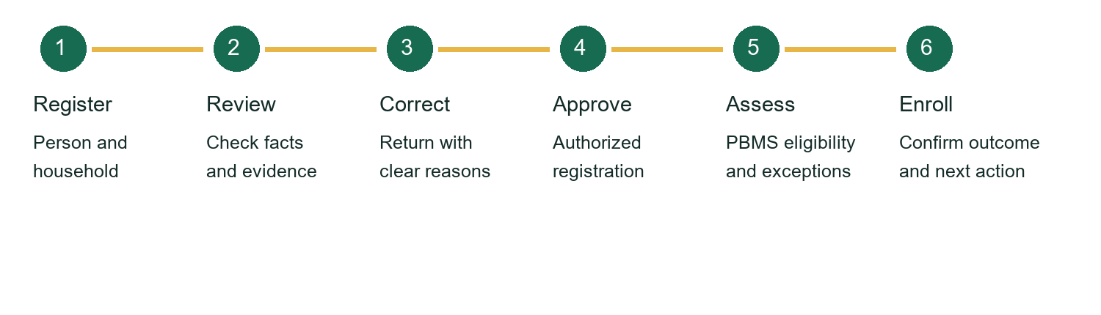

Purpose and scope
This document translates the submitted SOW, UX delivery SOP and back office delivery framework into practical UX recommendations. It combines journey design, screen concepts, engineering dependencies and release evidence.
The framework prioritizes government staff in Phase 1. Public registration can support sandbox prototyping; its production rollout needs its own agreed scope. The illustrations show proposed designs and are not screenshots of implemented features.

Document guide
2 Experience priorities 3 Registration journey 4 Staff workspace
5 Architecture and trust 6 Delivery and acceptance 7 First release and references

Experience priorities
The existing registration integration provides a functional foundation. The next release should reduce uncertainty, repeated entry and switching between services. Usability and accessibility still require dedicated validation.
Area | Recommended experience | Expected benefit
Homepage | Role-based tasks and a clear starting point | Less uncertainty about which service to open
Registration | Guided sections, drafts and check answers | Fewer mistakes and lost sessions
Status | Plain language, timestamp and next action | Users understand progress and responsibility
Staff review | My Work and a unified case workspace | Less searching and switching
Login | Consistent presentation and role context | Clearer access and session recovery
Errors | Preserved answers and field-linked guidance | Faster correction and safer retry
Help | Approved task-specific SOP guidance | Consistent decisions and escalation

Design for the actual users
Clerks need fast capture and correction. Reviewers need evidence and reasons. Approvers need the authority and context to decide. Finance officers need exception ownership and payment state clarity. Auditors need controlled history. Beneficiaries need understandable progress and practical help.

Separate operational tasks from technical tools
Use tasks as the primary navigation. Retain the service catalogue for administrators and advanced users. Show programme and geography context consistently so staff can see which records and decisions they are working with.

Registration and progress
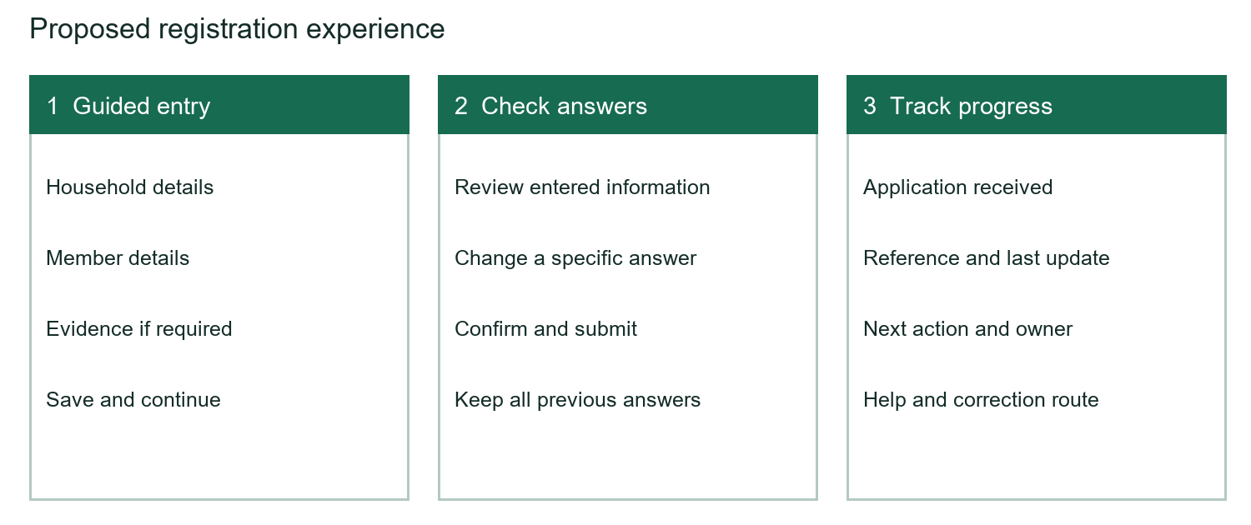

Make entry manageable
Group related questions into meaningful sections. Explain why sensitive information is required. Keep household member controls easy to add, review and correct. Test the number of steps with users rather than imposing a long wizard.

Preserve work and prevent avoidable mistakes
Save drafts on the server, display their saved state and provide a resume route. Keep answers when validation fails. Show a summary linked to each invalid field and explain how to fix it. Draft retention and deletion rules must be agreed before production use.

Confirm before submitting
Provide a check answers page with direct Change links. After submission, show a reference, receipt time, current status and next action. Safe repeat submission must not create duplicate records.

Make recovery part of the journey
A connection failure should show whether submission was confirmed. Provide safe retry or status checking. A correction request should identify the information needed and preserve unaffected answers. Explain session expiry and reauthentication clearly.
Reference patterns: GOV.UK question pages, check answers and validation [4–6]. These patterns should be tested with the Nigeria project audience.

Staff workspace and case review
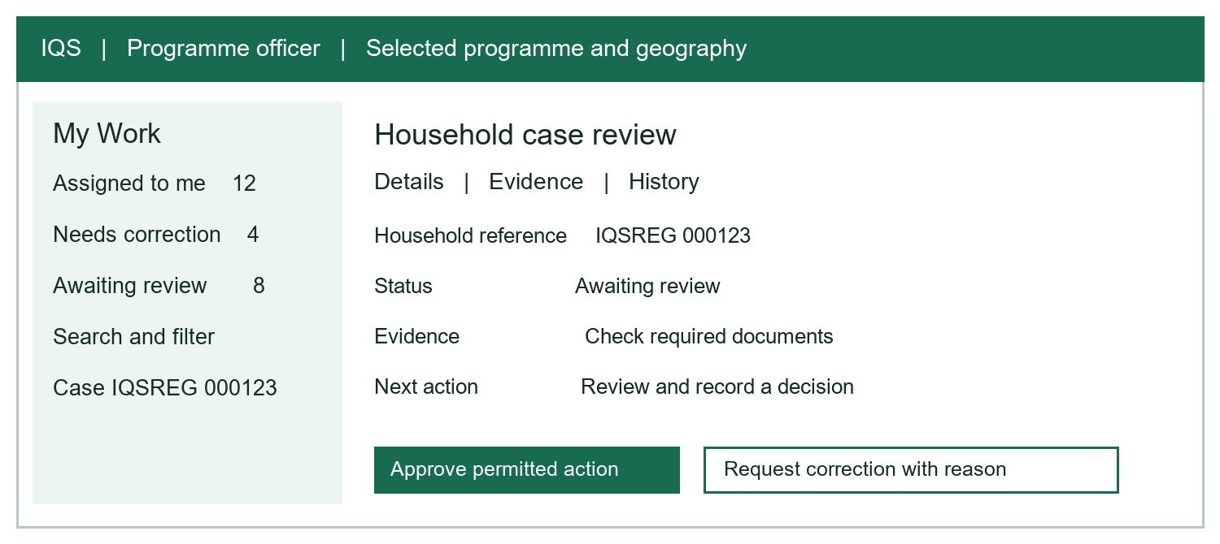
Illustrative concept with fictional counts and references. Actual fields, actions and permissions depend on the agreed workflow and supported platform contracts.

Start with My Work
Show assigned cases, review queues, filters, search and ownership. Include last refresh time and an indication when data may be stale. Agree priority rules with programme owners before displaying priority labels.

Bring the decision context together
Keep the household reference and status visible. Present facts, evidence, validation results, previous observations and authorized history together. Replace raw integration mappings with meaningful user information; keep technical diagnostics in an administrative view.

Support clear and accountable decisions
Require structured reasons for corrections or rejection where policy requires them. Explain what each action will do before confirmation. Record the actor, time and resulting state. If another staff member changes the case, refresh the facts before allowing a conflicting decision.

Enforce separation of duties
Define capture, verification, approval, finance, audit and administration permissions. Enforce them on the server, including programme and geography restrictions. The current sandbox reviewer access needs further role configuration before it represents this operating model.

Architecture accessibility and trust
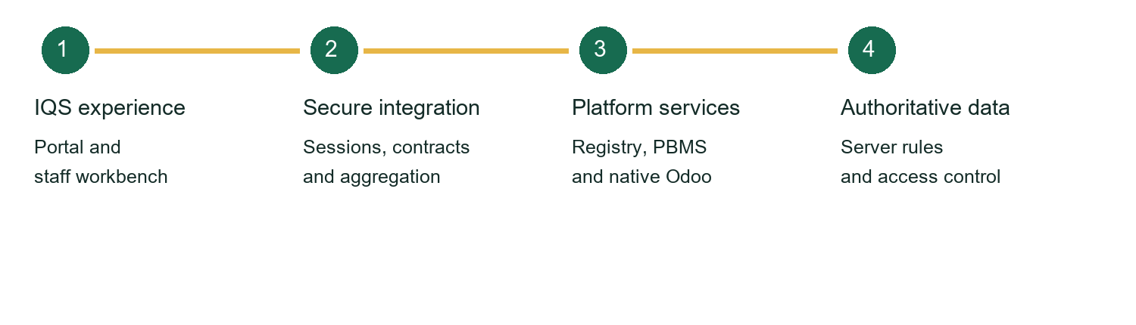

Use a hybrid implementation
Extend native Odoo screens when their models, record rules and actions are essential. Build a custom staff workbench for cross-system tasks where stable APIs exist. Classify each operation as supported API, supported extension, new API required or deferred before engineering starts.
Keep eligibility rules and decisions on the server. Integration services may manage sessions and aggregate information, while preserving the platform as the authoritative source of business decisions.
Quality area | Implementation requirement
Accessibility | Target WCAG 2.2 AA; test keyboard access, focus, labels, contrast, touch targets and authentication.
Status integrity | Distinguish received, reviewed, eligible, enrolled and paid. Display genuine pending and failure states.
Privacy | Mask sensitive identifiers where appropriate; restrict access and avoid personal data in analytics.
Connectivity | Test slower networks, interrupted requests, safe retries and smaller screens.
Help governance | Show approved content with owner, version and review date; provide a functioning escalation route.
Accessibility reference: W3C WCAG 2.2 guidance [7]. Compliance is a verification outcome, not a consequence of adopting a component library.

Delivery and acceptance
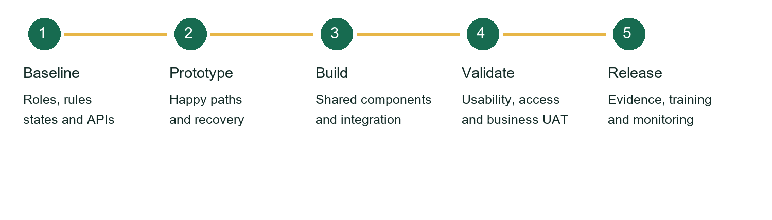
Stage | Outputs and acceptance evidence | Lead responsibility
Baseline | Roles, rules, states, API capability map and pilot boundary | Agency owner with PMO and technical lead
Prototype | Journeys, screen states, copy and user test findings | UX team with representative users
Build | Shared components, supported integration and engineering tests | Frontend team with platform engineers
Validate | Usability, accessibility, recovery tests and business UAT | QA and agency UAT owners
Release | Approved evidence, training, operations guide and monitoring | Technical release owner and business owner

Measure outcomes rather than appearance
Establish a baseline for task completion, time to complete, correction rates, abandonment and support requests. Agree measurable targets after observing representative users. Any thresholds remain proposed until accepted by the project owners.

Test the full journey
Include a successful case, missing information, correction, duplicate submission, ineligible household, permission denial, expired session, backend timeout and conflicting staff edits. Test approved browsers, devices and assistive technologies.

Keep traceability throughout delivery
Link each feature to its SOW requirement, journey, design, implemented change, test evidence and UAT decision. Keep technical acceptance separate from business acceptance. The reviewed source documents are submitted proposals; production baselines and commitments depend on their agreed approval status.

First release and reference material

Recommended first implementation
Deliver a role-based homepage, guided registration with draft saving and check answers, an application timeline, and a My Work case-review workspace. Validate this single workflow before extending the design to additional modules.
Priority | Deliverable | Key dependency
1 | Role-based entry and common navigation | Agreed roles and access context
2 | Drafts, preserved errors and check answers | Server storage and retention policy
3 | Progress timeline and recovery | Authoritative state and retry contracts
4 | Staff queues and case decisions | Assignment, concurrency and permissions
5 | Contextual help and release evidence | Approved SOP content and UAT owners

Source documents
[1] Unified NSIPA G2P UIUX Frontend KMS SOW v4.0. Workspace copy in redrafted_issue_package.
[2] NSIPA G2P UIUX Frontend Delivery SOP v1.0. Workspace copy in redrafted_issue_package.
[3] OpenG2P PBMS BackOffice UX Frontend Astra Delivery Framework v1.0. Workspace copy in redrafted_issue_package.

Official design and accessibility references
[4] GOV.UK question pages
https://design-system.service.gov.uk/patterns/question-pages/
[5] GOV.UK check answers
https://design-system.service.gov.uk/patterns/check-answers/
[6] GOV.UK validation
https://design-system.service.gov.uk/patterns/validation/
[7] W3C new guidance in WCAG 2.2
https://www.w3.org/WAI/standards-guidelines/wcag/new-in-22/

