# Clean code (beautifier)

It is decided to use style tooling for formatting the C++ code. This is chosen so that developers don't need to worry about style issues during code reviews.

## Implementation Clang-Format in the pipeline

TODO!

## Implement for your IDE

### A) Plugin in Qt Creator

1. Open Qt Creator, go to **Help**, and select **About Plugins...**

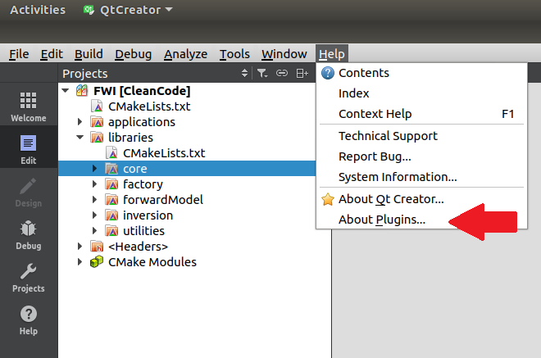

1. Select **Beautifier (experimental)** under C++, and **close** Qt Creator.

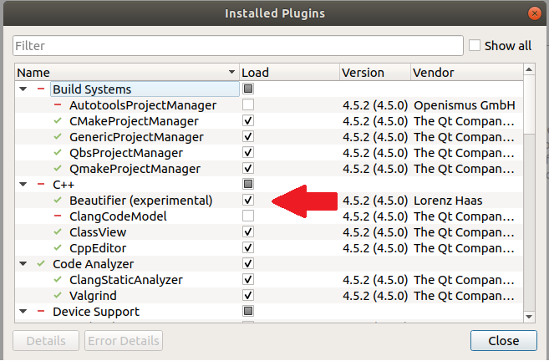

1. Open Qt Creator, go to **Tools**, and select **Options...**

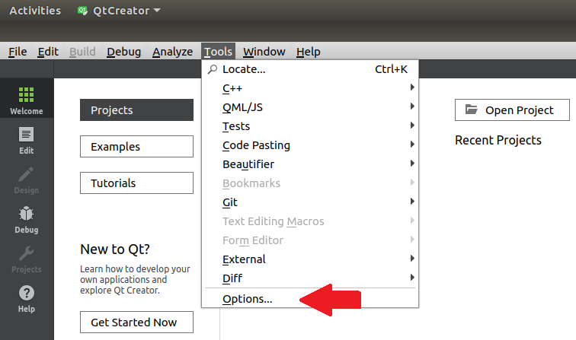

1. In **Options** select **Beautifier** (1). In the **General** tab, check **Enable auto format on File Save** (2), select **ClangFomat** (3), and check **Restrict to files contained in the current poject** (4).

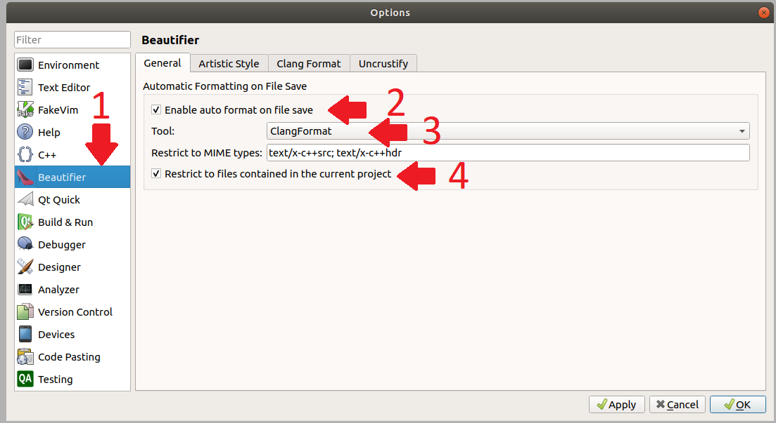

1. In this window select tab **Clang Format** (1). Verify if **Clang Format command** (2) is correctly filled in. Select option **File** in **Use predefined style** (3) and select **None** as **Fallback style** (4). Note: Clang-Format automatically searches for the .clang-format file in the (parent) directory.

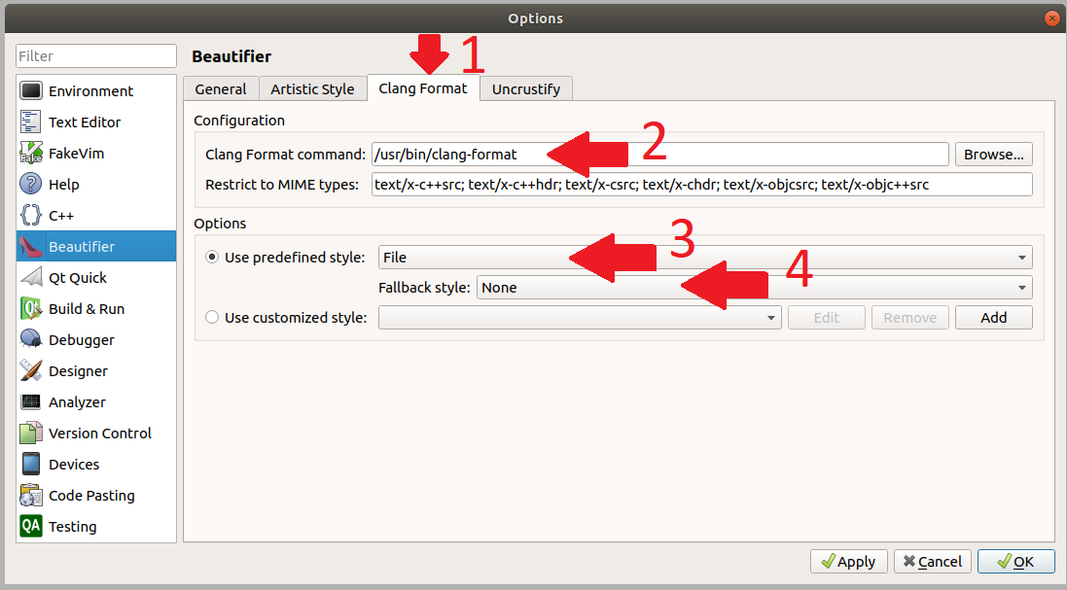

### B) Clang Format in other IDE’s

In most IDE’s a Clang-format plugin is available that works in a similar way as described above. It is important to **select predefined style by file**. Clang-Format will than automatically search the style format file.

## Change the style format

The style used by Clang-Format is implemented in the .clang-format file in the parallelized-fwi. This file has no name, and is thus simply called .clang-format. In Ubuntu it is a hidden file, but it can be shown by clicking Crtl + H. Note: the version of Clang-Format is decisive for commands that can be used. Unfortunately, I had to remove some commands for this reason.