# Clean code (beautifier)

It is decided to use style tooling for formatting the C++ code. This is chosen so that developers don't need to worry about style issues during code reviews.

## Implementation Clang-Format in the pipeline

TODO!

## Install Clang-Format

In Linux open your **terminal**, and type in: sudo apt install clang-format .

## Implement for your IDE

### A) Plugin in Qt Creator

1. Open Qt Creator, go to **Help**, and select **About Plugins...**

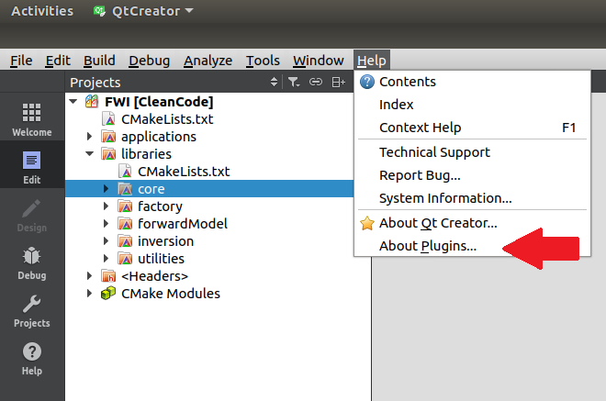

1. Select **Beautifier (experimental)** under C++, and **close** Qt Creator.

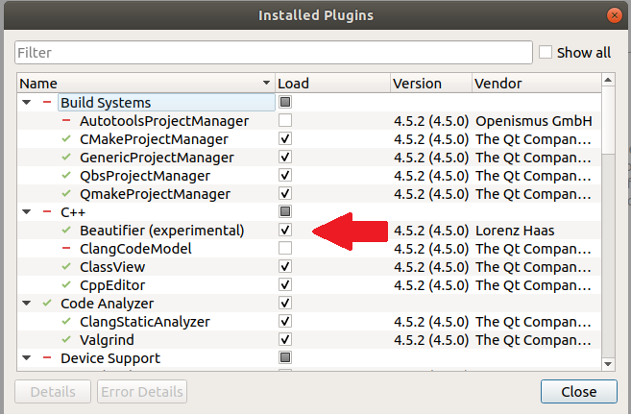

1. Open Qt Creator, go to **Tools**, and select **Options...**

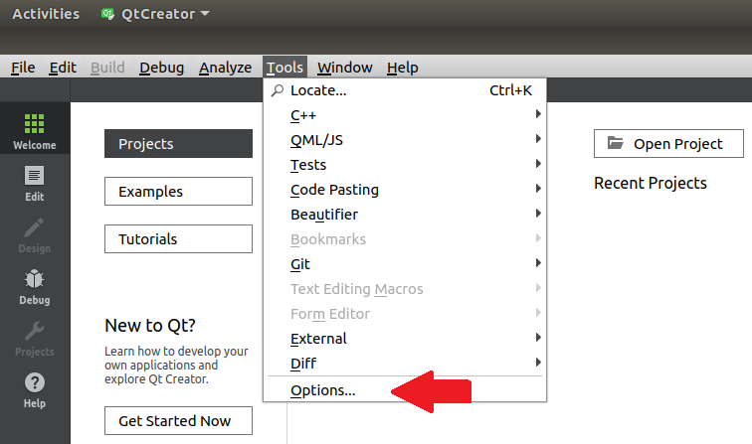

1. In **Options** select **Beautifier** (1). In the **General** tab, check **Enable auto format on File Save** (2), select **ClangFomat** (3), and check **Restrict to files contained in the current poject** (4).

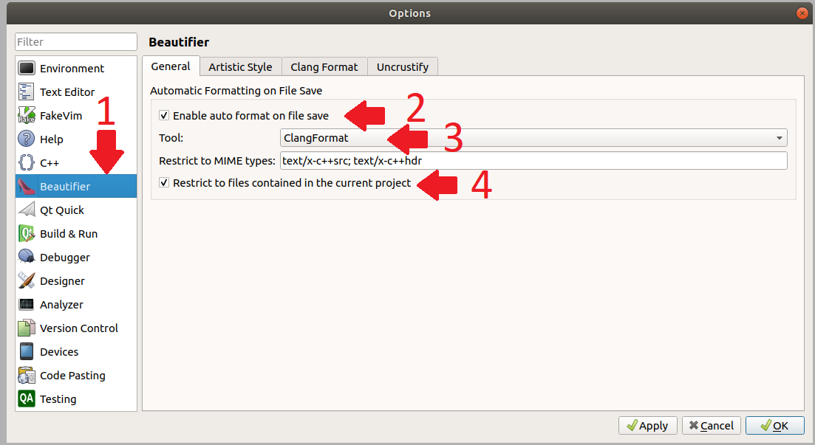

1. In this window select tab **Clang Format** (1). Verify if **Clang Format command** (2) is correctly filled in. Select option **File** in **Use predefined style** (3) and select **None** as **Fallback style** (4). Note: Clang-Format automatically searches for the .clang-format file in the (parent) directory.

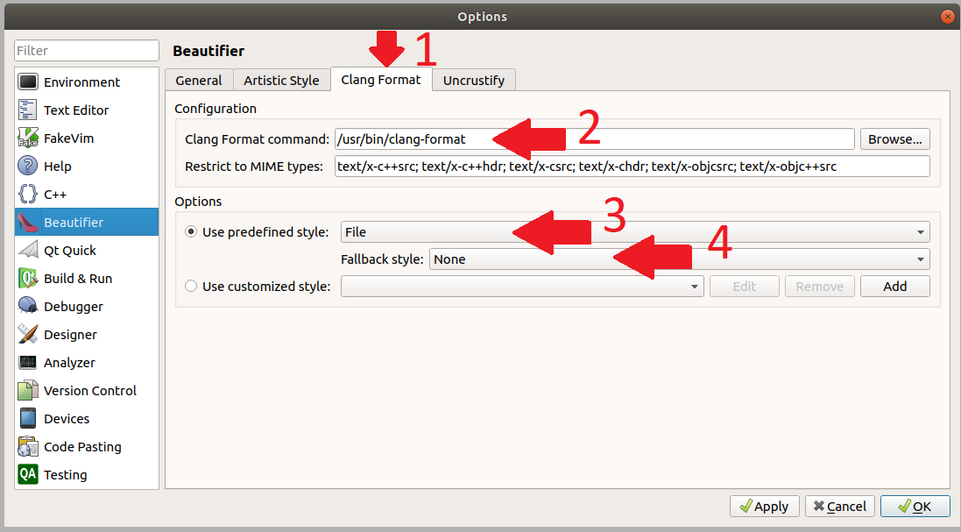

### B) Clang Format in other IDE’s

In most IDE’s a Clang-format plugin is available that works in a similar way as described above. It is important to **select predefined style by file**. Clang-Format will than automatically search the style format file.

## Change the style format

The style used by Clang-Format is implemented in the .clang-format file in the parallelized-fwi. This file has no name, and is thus simply called .clang-format. In Ubuntu it is a hidden file, but it can be shown by clicking Crtl + H. Note: the version of Clang-Format is decisive for commands that can be used. Unfortunately, I had to remove some commands for this reason.

# Code-standards (Naming & Good practice)

For the enforcing of code standards, clang-tidy is used, which gives IDE warnings when code-standard criteria are not met. These standards themselves are described in the CodeStandards documentation in this project.

## Install clang-tidy

Run the following command in your Linux terminal: sudo apt install clang-tidy

## Implementation for your IDE

### A) Plugin in QT-Creator

1. To enable the clang-tidy plugin into the QT-Creator IDE, first go to **Help About Plugins…**

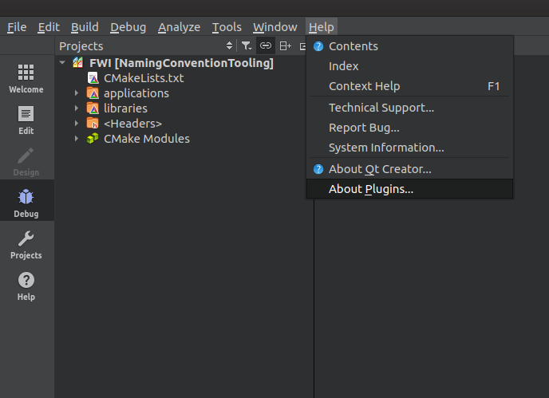

2. Tick the box next to the ClangCodeModel if this was not already the case.

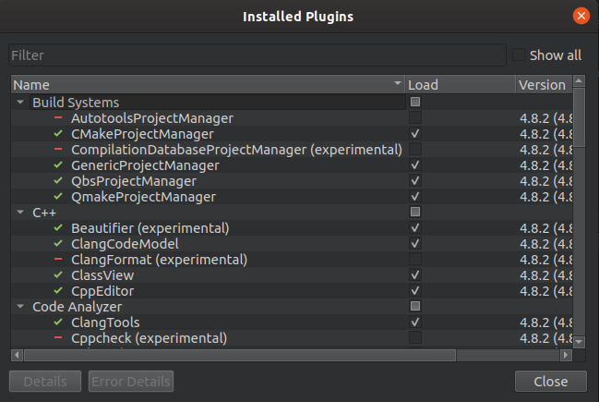

3. Having done this, go to **Tools Options**

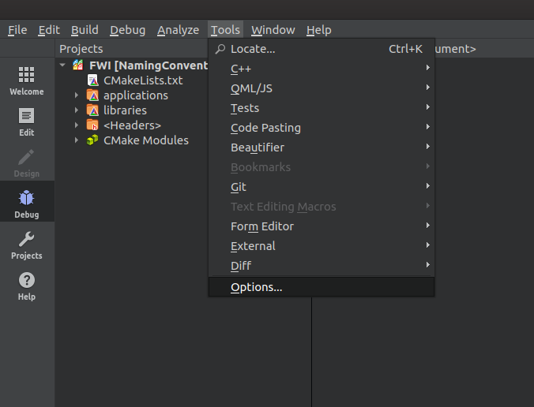

4. In the options, go to **C++** and go to the tab ‘**Code Model**’. Next click on **Manage** next to the Diagnostic Configuration

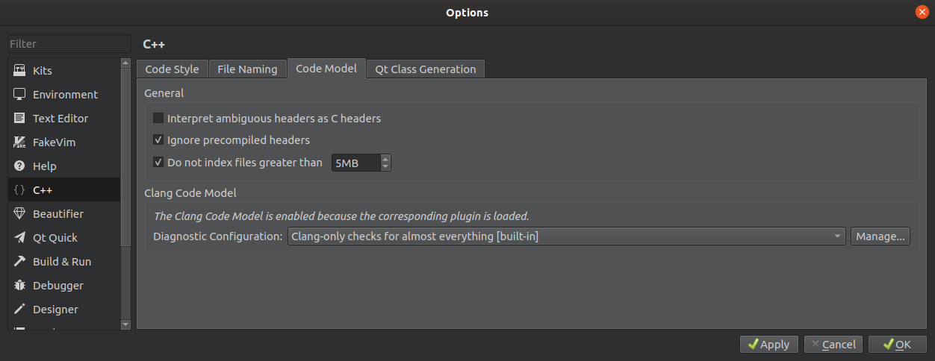

5. Select **Clang-only checks for almost everything [built-in]** and press **Copy** to be able to customize it and give it a suitable name

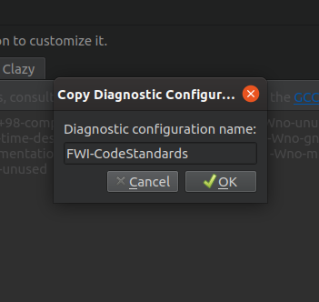

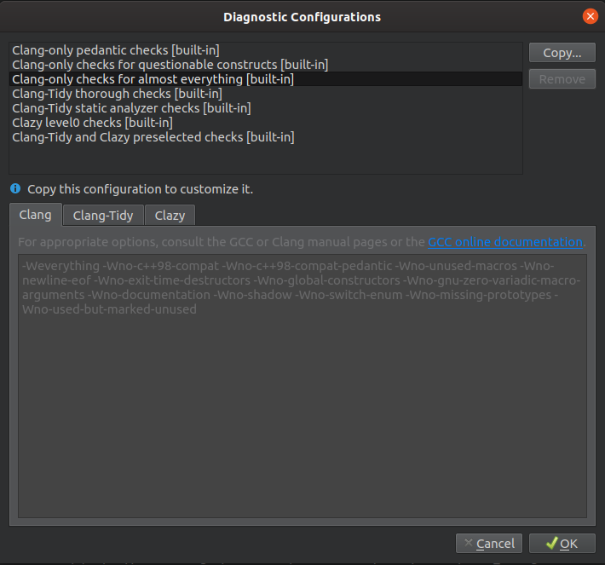

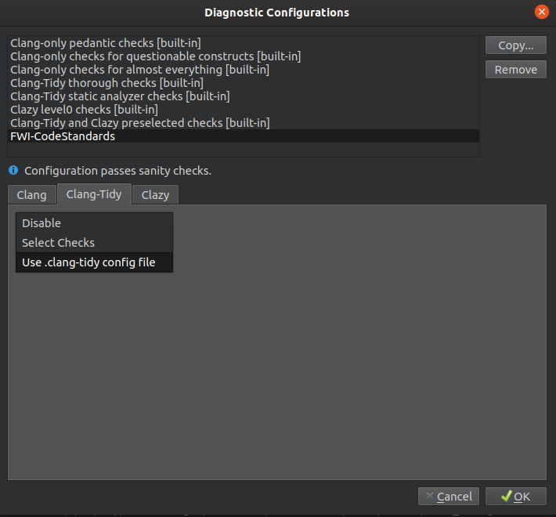6. Select your own Diagnostic Configuration, go to the tab **Clang-Tidy**, select **Use .clang-tidy config file** in the drop-down and click **OK**

7. Lastly, select the newly created Diagnostic Configuration in the dropdown and click **OK.** Since the .clang-tidy file is already set up in the git-folder, the IDE should start giving warnings when naming conventions are not adhered to.

**Note:** It could take a while before the clang-tidy has parsed the project and starts giving warnings.

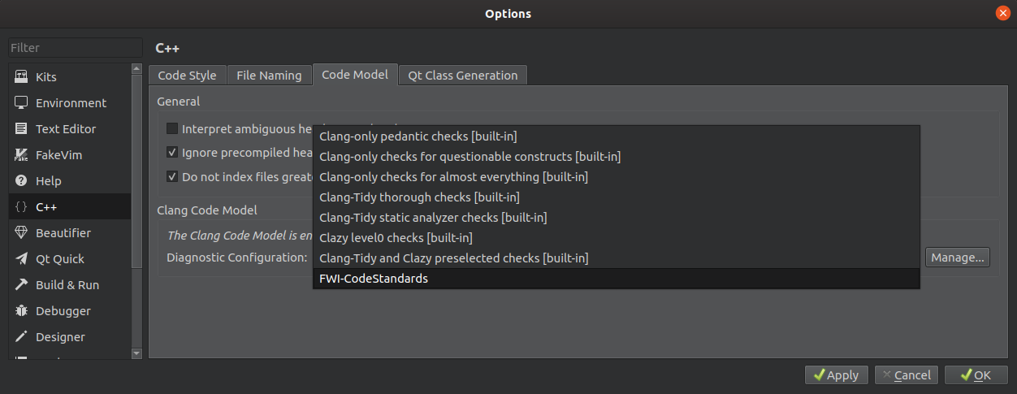

### B) Clang-tidy in other IDE’s

In other IDE’s these checks can be implemented in a similar fashion, by using the .clang-tidy configuration file.

## Change the code-standards format

The style used by Clang-Format is implemented in the .clang-tidy file in the parallelized-fwi. This file has no name, and is thus simply called .clang-tidy. In Ubuntu it is a hidden file, but it can be shown by clicking Crtl + H.