**MODEL QUERIES**

Query 1: Show the appointments for a doctor for tomorrow.

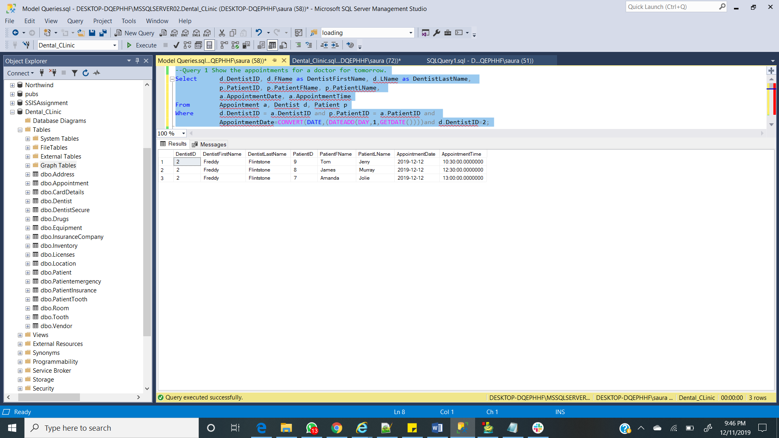

Query 2: Show me a patients next appointment.

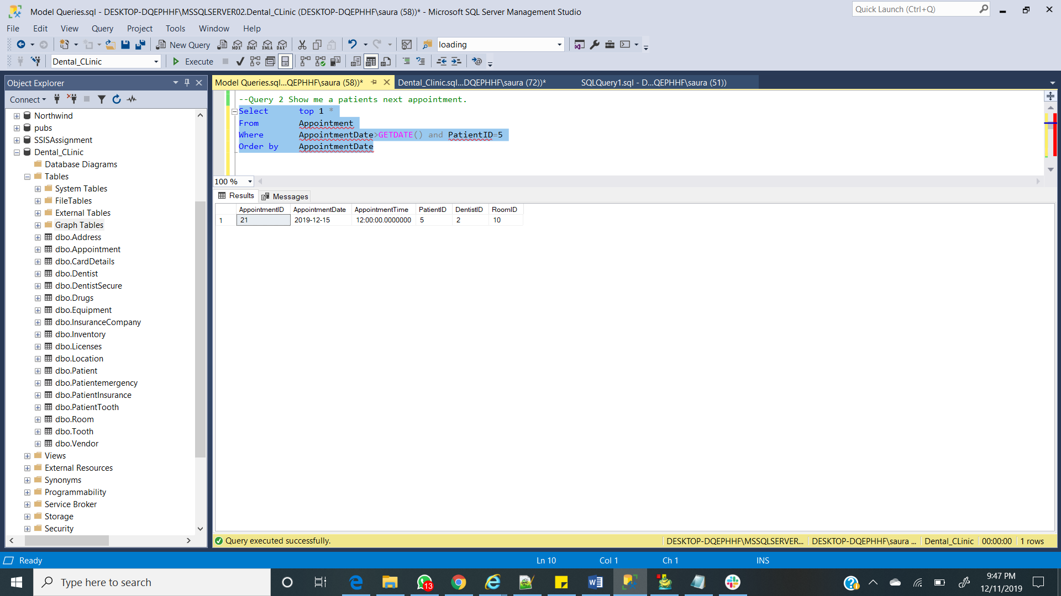

Query 3: How many teeth does a patient have

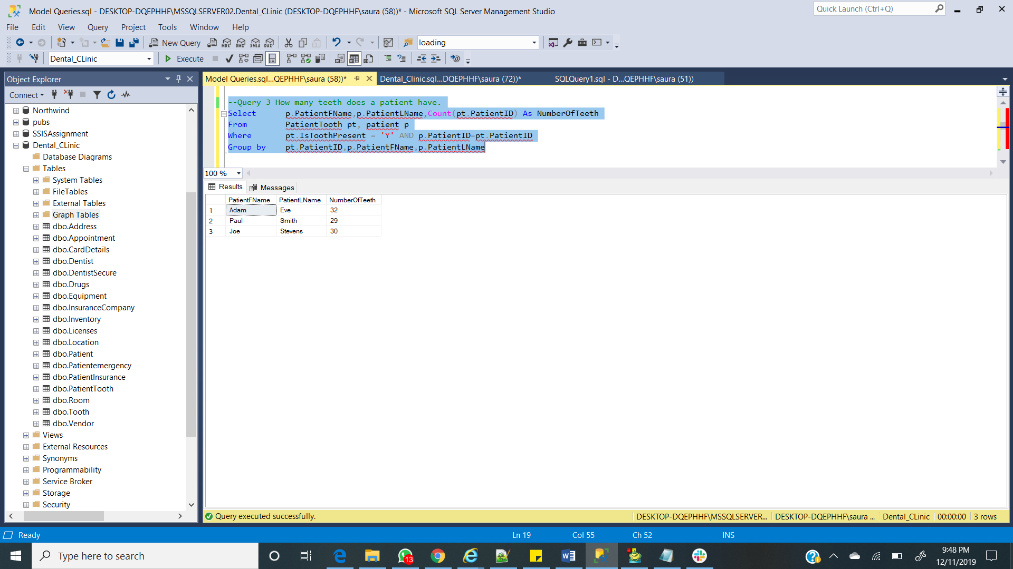

Query 4: Show the treatments associated with an appointment

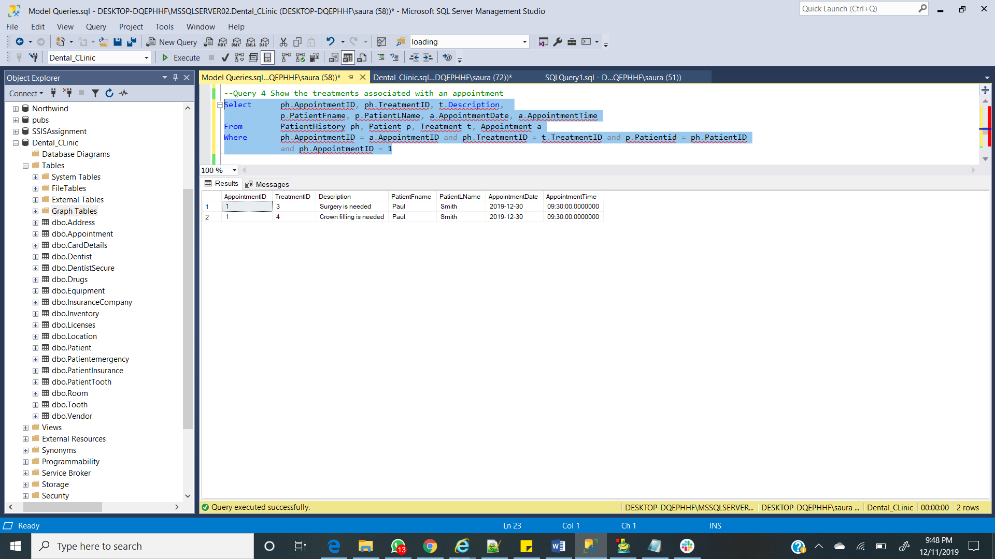

Query 5: Show an invoice

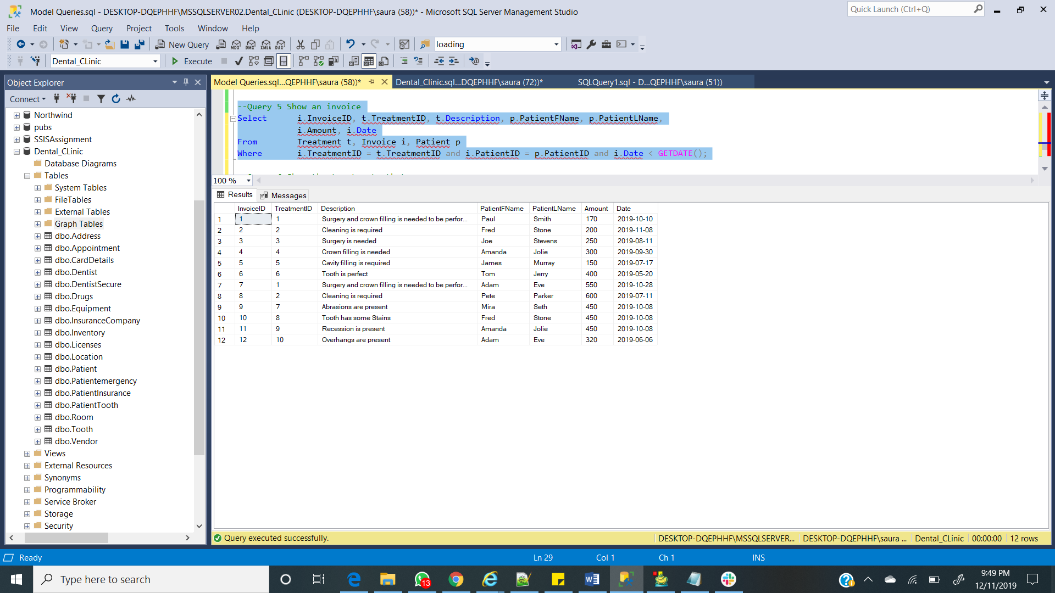

Query 6: Show the treatments that make up an invoice

