**Лабораторная работ 2. Airflow and docker.**

**Грибанов Данил, 6233**

**Ход работы**

**Все файлы (dockerfile, docker-compose и прочее) находятся в папке airflow (так же dags и скрипты для запуска соотв. частей).**

**Перед запуском самой системы (докера airflow) следует подготовить следующее:**

Создадим хранилище с данными для запуска и обучения всех систем:

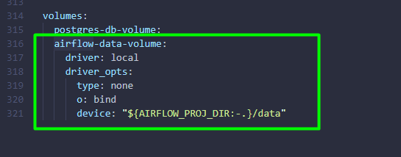

И добавим данное хранилище с папкой докер-файлов нужных в dind:

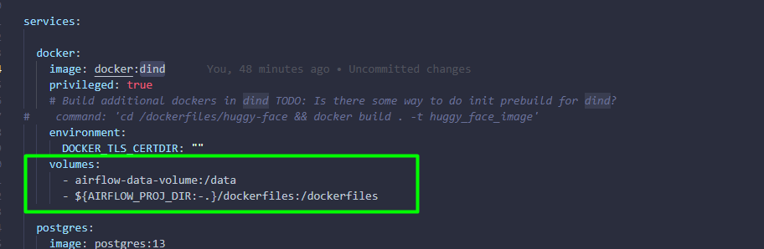

Запустим docker-compose.yaml для сборки airflow и нужного:

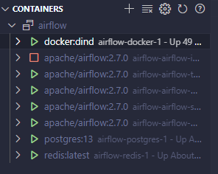

Дождемся инициализации (пару минут), и зайдем в docker:dind:

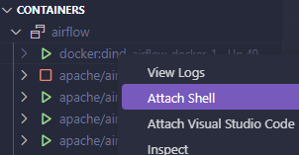

Теперь подготовим здесь докер для использования нейронных сетей:

cd /dockerfiles/huggy-face && docker build . -t huggy_face_image

Дождемся сборки (до 10 минут). Теперь мы готовы к запуску основных DAG разработанных для лабораторных работ. Код DAG к соотв. пунктам задания имеет комментарии и пояснения.

*Видео в краткий пересказ*

Airflow/dags/airflow_lab2.py

1. **import** os
2. **from** datetime **import** datetime
3. **from** airflow **import** DAG
4. **from** airflow.providers.docker.operators.docker **import** DockerOperator
5. **from** airflow.sensors.filesystem **import** FileSensor
7. **from** docker.types **import** Mount
9. default_args **=** {
10. 'owner': 'airflow',
11. 'start_date': datetime(2023, 1, 1),
12. 'retries': 1,
13. }

16. dag **=** DAG(
17. 'audio_to_text_to_summary_to_pdf',
18. default_args**=**default_args,
19. description**=**'DAG for extracting audio, transforming to text, summarizing, and saving as PDF',
20. schedule_interval**=**None,
21. )
23. # TODO: Connection could be done via PythonAPI - but I didnt found HOW - so, do this in Web instead...
24. #file_connection = Connection(
25. #    conn_id="file_connection",
26. #    conn_type="fs",
27. #    description="Connection to file-path",
28. #)
30. wait_for_new_file **=** FileSensor(
31. task_id**=**'wait_for_new_file',
32. poke_interval**=**10,  # Interval to check for new files (in seconds)
33. filepath**=**'/opt/airflow/data/lab2',  # Target folder to monitor
34. fs_conn_id**=**'file_connection',
35. dag**=**dag,
36. )
38. extract_audio **=** DockerOperator(
39. task_id**=**'extract_audio',
40. image**=**'jrottenberg/ffmpeg',
41. docker_url**=**"tcp://docker:2375", # For Dind usage case
42. mount_tmp_dir**=**False,
43. network_mode**=**'bridge',
44. entrypoint**=**'bash',
45. command**=**['-c', 'cd /data/lab2 && for single_video in ./*.mp4; do ffmpeg -y -i "${single_video}" -ss 1 -to 5 -vn "./../lab2_output/${single_video}.wav"; done'],
46. mounts**=**[
47. Mount(source**=**'/data', target**=**'/data', type**=**'bind'),
48. ],
49. dag**=**dag,
50. )
52. audo2text **=** DockerOperator(
53. task_id**=**'audio2text',
54. image**=**'huggy_face_image',
55. docker_url**=**"tcp://docker:2375", # For Dind usage case
56. mount_tmp_dir**=**False,
57. network_mode**=**'bridge',
58. entrypoint**=**'bash',
59. command**=**['-c', "python /data/audio2text.py"],
60. mounts**=**[
61. Mount(source**=**'/data', target**=**'/data', type**=**'bind'),
62. ],
63. dag**=**dag,
64. )
66. text2summary **=** DockerOperator(
67. task_id**=**'text2summary',
68. image**=**'huggy_face_image',
69. docker_url**=**"tcp://docker:2375", # For Dind usage case
70. mount_tmp_dir**=**False,
71. network_mode**=**'bridge',
72. entrypoint**=**'bash',
73. command**=**['-c', "python /data/text2summary.py"],
74. mounts**=**[
75. Mount(source**=**'/data', target**=**'/data', type**=**'bind'),
76. ],
77. dag**=**dag,
78. )
80. wait_for_new_file >> extract_audio >> audo2text >> text2summary

*Код audio2text:*

1. **from** transformers **import** pipeline
2. **import** glob
3. **import** os
5. **for** audio_file_path **in** glob.glob('/data/lab2_output/*.wav'):
6. _, filename **=** os.path.split(audio_file_path)
7. output_txt_file_path **=** f'/data/lab2_output/text/{filename}.txt'
8. **if** os.path.isfile(output_txt_file_path):
9. **continue** # skip, already exist
11. pipe **=** pipeline("automatic-speech-recognition", "openai/whisper-tiny")
12. res **=** pipe(audio_file_path)
14. with open(output_txt_file_path, "w") as text_file:
15. text_file.write(res['text'])

*Код text2summary:*

1. **from** transformers **import** pipeline
2. **import** glob
3. **import** os
5. **for** txt_file_path **in** glob.glob('/data/lab2_output/text/*.txt'):
6. _, filename **=** os.path.split(txt_file_path)
7. output_summary_file_path **=** f'/data/lab2_output/summary/{filename}'
8. **if** os.path.isfile(output_summary_file_path):
9. **continue** # skip, already exist
11. with open(txt_file_path, 'r') as fr:
12. text **=** fr.read()
14. summarizer **=** pipeline("summarization", max_length**=**9) # Since our input small
15. text_summ **=** summarizer(text)
17. with open(output_summary_file_path, "w") as text_file:
18. text_file.write(text_summ[0]['summary_text'])

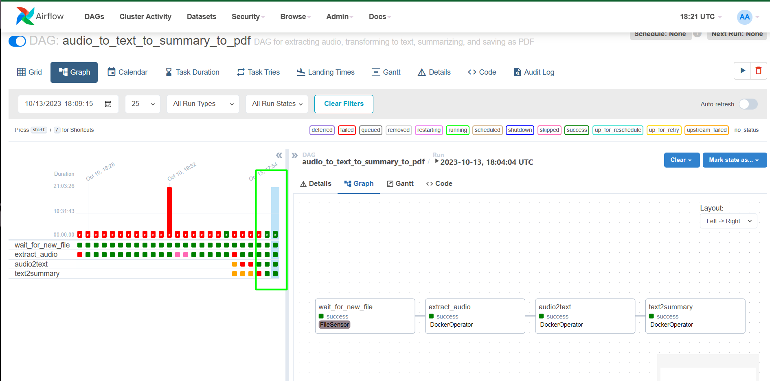

*Обучение сети при обнаружении нового файла на примере MNIST*

Для тестирования такой ситуации, я разбил обучающую выборку MNIST на 10 случайных частей. В папке airflow/data/lab2_nn_train/full_data – полные файлы данных, сама загрузка и слежка идет за папкой airflow/data/lab2_nn_train/data, куда можно закидывать или удалять файла для тестирования.

В качестве обучения взят набор данных MNIST и пару легких сверточных сетей.

Airflow/dags/airflow_train_lab2.py

1. **import** os
2. **from** datetime **import** datetime
3. **from** airflow **import** DAG
4. **from** airflow.providers.docker.operators.docker **import** DockerOperator
5. **from** airflow.sensors.filesystem **import** FileSensor
7. **from** docker.types **import** Mount
9. default_args **=** {
10. 'owner': 'airflow',
11. 'start_date': datetime(2023, 1, 1),
12. 'retries': 1,
13. }

16. dag **=** DAG(
17. 'train_nn',
18. default_args**=**default_args,
19. description**=**'DAG train NN',
20. schedule_interval**=**None,
21. )
23. wait_for_new_file **=** FileSensor(
24. task_id**=**'wait_for_new_train_file',
25. poke_interval**=**10,  # Interval to check for new files (in seconds)
26. filepath**=**'/opt/airflow/data/lab2_nn_train/data',  # Target folder to monitor
27. fs_conn_id**=**'file_train_connection',
28. dag**=**dag,
29. )
31. train_nn **=** DockerOperator(
32. task_id**=**'train_nn_on_updated_data',
33. image**=**'huggy_face_image',
34. docker_url**=**"tcp://docker:2375", # For Dind usage case
35. mount_tmp_dir**=**False,
36. network_mode**=**'bridge',
37. entrypoint**=**'bash',
38. command**=**['-c', "python /data/lab2_nn_train/train_nn_mnist.py"],
39. mounts**=**[
40. Mount(source**=**'/data', target**=**'/data', type**=**'bind'),
41. ],
42. dag**=**dag,
43. )

46. wait_for_new_file >> train_nn

Код обучения:

1. **import** argparse
2. **import** torch
3. **import** torch.nn as nn
4. **import** torch.nn.functional as F
5. **import** torch.optim as optim
6. **from** torch.utils.data **import** Dataset
7. **from** torchvision **import** transforms
8. **from** torch.optim.lr_scheduler **import** StepLR
10. **import** numpy as np
11. **import** glob
12. **import** os
13. **import** sys
14. **from** datetime **import** datetime
16. SAVE_MODEL_PATH **=** '/data/lab2_nn_train/models'
17. DATA_PATH **=** '/data/lab2_nn_train/data'
18. TEST_FILENAME **=** 'test_data.npz'
19. TRAIN_PREFIX **=** 'train_'

22. BATCH_SIZE **=** 32
23. EPOCHS **=** 15
24. LR **=** 1e**-**4
25. LR_STEP **=** 0.7
26. CUDA **=** False
27. SEED **=** 2023
28. LOG_INTERVAL **=** 10
29. SAVE_MODEL **=** True

32. **class** MnistDataset(Dataset):
34. **def** __init__(self, x, y, transform**=**None):
35. **assert** len(x) **==** len(y)
36. self.x **=** x
37. self.y **=** y
38. self.transform **=** transform
40. **def** __len__(self):
41. **return** len(self.x)
43. **def** __getitem__(self, idx):
44. x_sample **=** self.x[idx]
46. **if** self.transform:
47. x_sample **=** self.transform(x_sample)
49. **return** x_sample, self.y[idx]

52. **class** Net(nn.Module):
53. **def** __init__(self):
54. super(Net, self).__init__()
55. self.conv1 **=** nn.Conv2d(1, 32, 3, 1)
56. self.conv2 **=** nn.Conv2d(32, 64, 3, 1)
57. self.dropout1 **=** nn.Dropout(0.25)
58. self.dropout2 **=** nn.Dropout(0.5)
59. self.fc1 **=** nn.Linear(9216, 128)
60. self.fc2 **=** nn.Linear(128, 10)
62. **def** forward(self, x):
63. x **=** self.conv1(x)
64. x **=** F.relu(x)
65. x **=** self.conv2(x)
66. x **=** F.relu(x)
67. x **=** F.max_pool2d(x, 2)
68. x **=** self.dropout1(x)
69. x **=** torch.flatten(x, 1)
70. x **=** self.fc1(x)
71. x **=** F.relu(x)
72. x **=** self.dropout2(x)
73. x **=** self.fc2(x)
74. output **=** F.log_softmax(x, dim**=**1)
75. **return** output

78. **def** train(model, device, train_loader, optimizer, epoch):
79. model.train()
80. **for** batch_idx, (data, target) **in** enumerate(train_loader):
81. data, target **=** data.to(device), target.to(device)
82. optimizer.zero_grad()
83. output **=** model(data)
84. loss **=** F.nll_loss(output, target)
85. loss.backward()
86. optimizer.step()
87. **if** batch_idx **%** LOG_INTERVAL **==** 0:
88. print('Train Epoch: {} [{}/{} ({:.0f}%)]\tLoss: {:.6f}'.format(
89. epoch, batch_idx **\*** len(data), len(train_loader.dataset),
90. 100. **\*** batch_idx **/** len(train_loader), loss.item()))

93. **def** test(model, device, test_loader):
94. model.eval()
95. test_loss **=** 0
96. correct **=** 0
97. with torch.no_grad():
98. **for** data, target **in** test_loader:
99. data, target **=** data.to(device), target.to(device)
100. output **=** model(data)
101. test_loss **+=** F.nll_loss(output, target, reduction**=**'sum').item()  # sum up batch loss
102. pred **=** output.argmax(dim**=**1, keepdim**=**True)  # get the index of the max log-probability
103. correct **+=** pred.eq(target.view_as(pred)).sum().item()
105. test_loss **/=** len(test_loader.dataset)
107. print('\nTest set: Average loss: {:.4f}, Accuracy: {}/{} ({:.0f}%)\n'.format(
108. test_loss, correct, len(test_loader.dataset),
109. 100. **\*** correct **/** len(test_loader.dataset)))

112. **def** main():
113. use_cuda **=** CUDA **and** torch.cuda.is_available()
115. torch.manual_seed(SEED)
116. exp_folder_path **=** os.path.join('/data/lab2_nn_train/res', str(datetime.now()))
117. os.makedirs(exp_folder_path, exist_ok**=**True)
118. sys.stdout **=** open(os.path.join(exp_folder_path, "print.log"), 'w')
120. **if** use_cuda:
121. device **=** torch.device("cuda")
122. **else**:
123. device **=** torch.device("cpu")
125. train_kwargs **=** {'batch_size': BATCH_SIZE}
126. test_kwargs **=** {'batch_size': BATCH_SIZE}
127. **if** use_cuda:
128. cuda_kwargs **=** {'num_workers': 1,
129. 'pin_memory': True,
130. 'shuffle': True}
131. train_kwargs.update(cuda_kwargs)
132. test_kwargs.update(cuda_kwargs)
134. transform**=**transforms.Compose([
135. transforms.ToTensor(),
136. transforms.Normalize((0.1307,), (0.3081,))
137. ])
138. x_train_list **=** []
139. y_train_list **=** []
141. **for** single_train_file **in** glob.glob(os.path.join(DATA_PATH, f'{TRAIN_PREFIX}*.npz')):
142. single_train_loaded **=** np.load(single_train_file)
143. x_train_list.append(single_train_loaded['x_train'])
144. y_train_list.append(single_train_loaded['y_train'])
146. x_train_np **=** np.concatenate(x_train_list, axis**=**0)
147. y_train_np **=** np.concatenate(y_train_list, axis**=**0)
148. dataset_train **=** MnistDataset(
149. x**=**x_train_np, y**=**y_train_np,
150. transform**=**transform
151. )
153. test_loaded **=** np.load(os.path.join(DATA_PATH, TEST_FILENAME))
154. dataset_test **=** MnistDataset(
155. x**=**test_loaded['x_test'], y**=**test_loaded['y_test'],
156. transform**=**transform
157. )
158. train_loader **=** torch.utils.data.DataLoader(dataset_train,**\*\***train_kwargs)
159. test_loader **=** torch.utils.data.DataLoader(dataset_test, **\*\***test_kwargs)
161. model **=** Net().to(device)
162. optimizer **=** optim.Adadelta(model.parameters(), lr**=**LR)
164. scheduler **=** StepLR(optimizer, step_size**=**1, gamma**=**LR_STEP)
165. **for** epoch **in** range(1, EPOCHS **+** 1):
166. train(model, device, train_loader, optimizer, epoch)
167. test(model, device, test_loader)
168. scheduler.step()
170. **if** SAVE_MODEL:
171. torch.save(model.state_dict(), os.path.join(exp_folder_path, 'mnist_cnn.pt'))

174. **if** __name__ **==** '__main__':
175. main()

