### NLP Tutor

***NLP Mini-Project report submitted to Visvesvaraya National Institute of Technology, Nagpur in fulfillment of requirement for the award of the degree of***

### Masters of Technology in

**Applied AI**

***by***

### SAURABH SHARMA (MT23AAI018)

### &

### SADASHIV NAYAK A (MT23AAI039)

***under the guidance of***

### Dr. Saugata Sinha



**Department of Electronics and Communication Engineering Visvesvaraya National Institute of Technology, Nagpur Nagpur 440010 (India)**

**22th June, 2025**

Copyright © Visvesvaraya National Institute of Technology, Nagpur(VNIT), 2025

# Mini Project Report: NLP TutorBot

## Introduction

This report provides an in-depth analysis of the NLP TutorBot, an AI-powered tool designed to simplify and optimize interaction with PDF documents. It facilitates querying, extraction, summarization, and contextual responses, enhanced with a user-friendly Streamlit interface and YouTube video suggestions.

## Objective

The primary goals of NLP Tutor are:

* Enable querying of user-uploaded PDF content.
* Simplify extraction and summarization of document information.
* Offer an accessible, intuitive interface for enhanced usability.

## System Overview

The architecture includes:

* **Input**: PDF uploads processed via Streamlit.
* **Processing**: Text extraction, chunking, embedding, summarization, and RAG-based querying.
* **Output**: Contextual answers and YouTube links displayed in the UI.

## Task Ownership

1. Saurabh Sharma – Front End + Testing
2. Sadashiv Nayak A – Backend + Testing

## Code Details and Structure

The project is structured with the following Python files, each contributing to its functionality:

* **functions.py**: Contains core logic for PDF processing and conversation.
  + get_pdf_content: Extracts text from PDFs using PyPDF2, iterating over pages to build raw text.
  + get_chunks: Splits text into 1000-character chunks with 200-character overlap using CharacterTextSplitter.
  + get_vectorstore: Generates embeddings with HuggingFaceEmbeddings (all-MiniLM-L6-v2) and stores them in FAISS (Facebook AI – Similarity search uses Nearest neighbor), including error handling for invalid chunks.
  + conversation_chain: Implements LangChain’s RAG pipeline with a history-aware retriever, using LLaMA3 via Groq API to generate responses, yielding chunks for streaming output.
* **app.py**: Manages the Streamlit UI and backend processing.
  + Initializes Streamlit with custom CSS from html_template.py and handles file uploads with hash_files for unique identification.
  + async_process_files: Processes PDFs asynchronously using threading, updating progress and ETA in session state.
  + get_youtube_videos: Fetches top 3 videos using yt-dlp based on user queries.
  + save_vectorstore_to_disk and load_cached_files: Manages caching with pickle in the cache/ directory.
  + Includes UI elements like chat input, progress bars, and app management buttons (e.g., CLEAR CACHE, RESTART APP).
* **models.py**: Configures the language model.
  + Loads environment variables (e.g., API key) from config/.env using dotenv.
  + Initializes ChatGroq with LLaMA3-70b-8192, setting parameters like temperature (0.7) and max_tokens (8192) for optimal performance.
* **html_template.py**: Defines UI styling and templates.
  + css: Styles chat messages with Tailwind-inspired classes, setting background colors and layouts.
  + ai_template and human_template: HTML templates for bot and user messages, embedding avatar images (e.g., ai_profile_photo.png at 120x120 pixels).
  + hide_st_style: Hides Streamlit’s default menu and footer for a cleaner look.

## Architecture Explanation

The NLP Tutor architecture is a sophisticated, RAG-driven system optimized for document interaction:

* **Input Layer**: Streamlit accepts PDF uploads, hashing files with hash_files in app.py for caching in cache/. The UI provides options to load cached sessions or process new files.
* **Preprocessing Layer**: get_pdf_content in functions.py uses PyPDF2 to extract text, while get_chunks splits it into manageable chunks. This layer ensures scalability for large documents.
* **Embedding Layer**: get_vectorstore employs HuggingFaceEmbeddings to create vector representations, stored in FAISS for efficient retrieval. Caching with pickle allows merging of multiple vectorstores.
* **Summarization Layer**: Although not fully implemented, the design reserves space for facebook/bart-large-cnn to summarize sections, enhancing content overview.
* **Retrieval and QA Layer**: conversation_chain leverages LangChain’s history-aware retriever to contextualize queries, using RAG to fetch relevant chunks. The LLaMA3-70b-8192 model (via Groq API) generates responses, with deepset/roberta-base-squad2 as a fallback. Optional LangSmith integration tracks quality.
* **Output Layer**: app.py renders responses in the Streamlit chat interface using templates from html_template.py. get_youtube_videos integrates yt-dlp to suggest videos, enhancing educational value.
* **Async Processing**: async_process_files uses threading to handle background tasks, updating st.session_state with progress and ETA for a responsive user experience.

## Workflow

The process flows as follows:

1. Users upload PDFs via Streamlit, triggering async_process_files.
2. Text is extracted and chunked, then embedded and stored in FAISS.
3. Queries are processed by conversation_chain, retrieving relevant content.
4. Responses are generated and displayed, with YouTube links fetched concurrently.

## Features

Key functionalities include:

* **PDF Interaction**: Guides users in querying content.
* **Dynamic Data Querying**: RAG ensures contextual accuracy.
* **User-Friendly Interface**: Streamlit with custom styling offers seamless navigation.

## Challenges and Solutions

Development challenges addressed:

* **Challenge**: Long processing times for large PDFs.
* **Solution**: Asynchronous processing with progress tracking.
* **Challenge**: Context accuracy in queries.
* **Solution**: History-aware retriever with RAG.

## Technologies Used

The project utilizes:

* **Python**: Core language.
* **LangChain**: Drives RAG and conversational logic.
* **Hugging Face Embeddings and FAISS**: Enables efficient storage and retrieval.
* **Streamlit**: Powers the UI.
* **Groq API and LLaMA3-70b-8192**: Handles high-performance NLP.
* **LangSmith (Optional)**: Evaluates conversation quality.
* **yt-dlp**: Fetches YouTube videos.

## Project Structure

Directory layout:

* cache/: Stores vectorstores and processed PDFs.
* config/: Holds .env for API keys.
* docs/: Test PDFs.
* prints/: Screenshots.
* src/: Source code.
* README.txt: Project overview.
* requirements.txt: Dependencies.

## App Snippet for Output

Sample UI interaction:

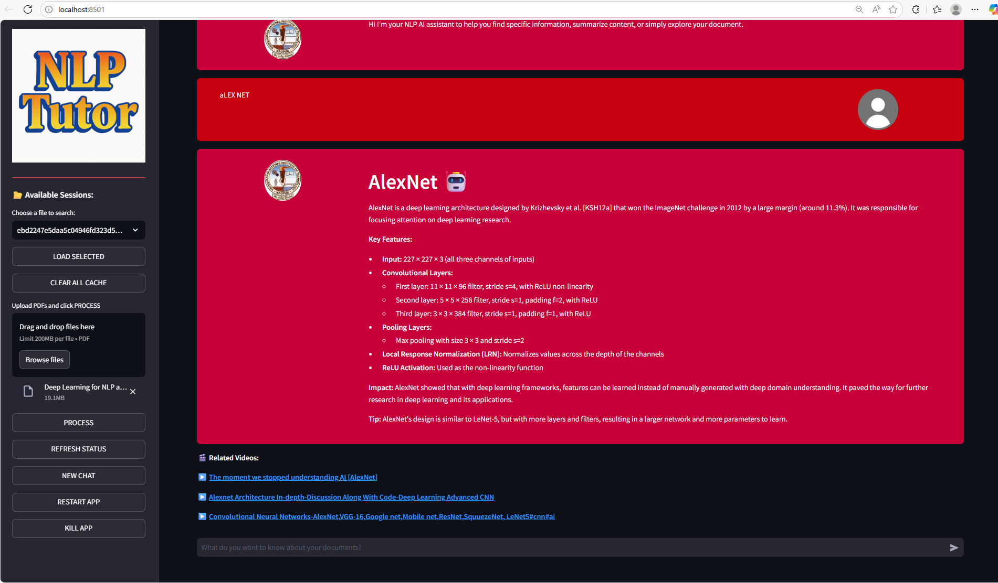

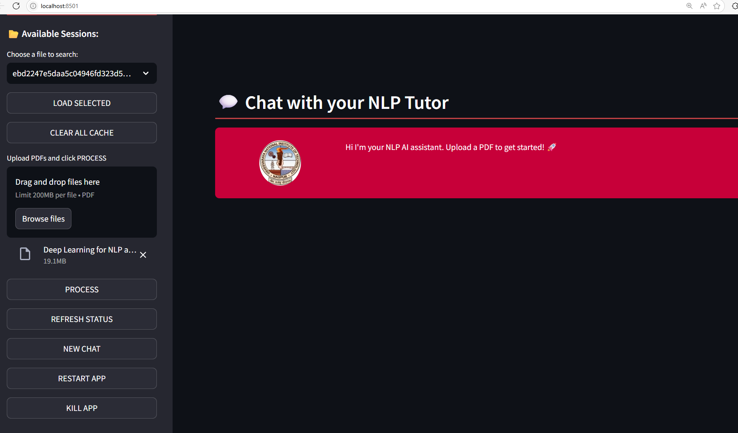

## Future Enhancements

Proposed upgrades:

* Multi-language support with Noto Serif fonts.
* Advanced summarization with google/flan-t5-large.
* Cloud deployment for scalability.

## Conclusion

NLP TutorBot integrates advanced NLP and RAG(Retrieval Augmented Generation) with a responsive UI, offering a robust platform for document interaction with significant potential for future growth.