**Input image for Prediction POST Api Call –**

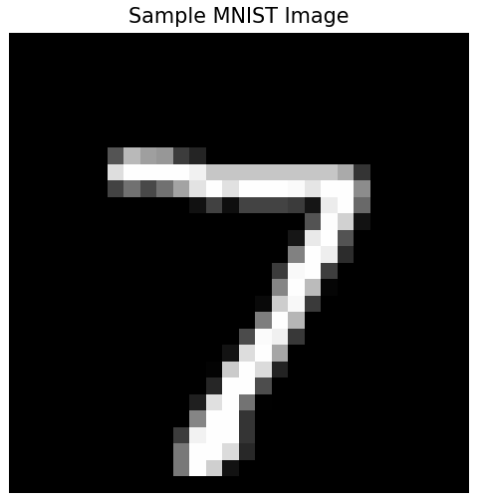

{

    "features": [

        [0.00,0.00,0.00,0.00,0.00,0.00,0.00,0.00,0.00,0.00,0.00,0.00,0.00,0.00,0.00,0.00,0.00,0.00,0.00,0.00,0.00,0.00,0.00,0.00,0.00,0.00,0.00,0.00,0.00,0.00,0.00,0.00,0.00,0.00,0.00,0.00,0.00,0.00,0.00,0.00,0.00,0.00,0.00,0.00,0.00,0.00,0.00,0.00,0.00,0.00,0.00,0.00,0.00,0.00,0.00,0.00,0.00,0.00,0.00,0.00,0.00,0.00,0.00,0.00,0.00,0.00,0.00,0.00,0.00,0.00,0.00,0.00,0.00,0.00,0.00,0.00,0.00,0.00,0.00,0.00,0.00,0.00,0.00,0.00,0.00,0.00,0.00,0.00,0.00,0.00,0.00,0.00,0.00,0.00,0.00,0.00,0.00,0.00,0.00,0.00,0.00,0.00,0.00,0.00,0.00,0.00,0.00,0.00,0.00,0.00,0.00,0.00,0.00,0.00,0.00,0.00,0.00,0.00,0.00,0.00,0.00,0.00,0.00,0.00,0.00,0.00,0.00,0.00,0.00,0.00,0.00,0.00,0.00,0.00,0.00,0.00,0.00,0.00,0.00,0.00,0.00,0.00,0.00,0.00,0.00,0.00,0.00,0.00,0.00,0.00,0.00,0.00,0.00,0.00,0.00,0.00,0.00,0.00,0.00,0.00,0.00,0.00,0.00,0.00,0.00,0.00,0.00,0.00,0.00,0.00,0.00,0.00,0.00,0.00,0.00,0.00,0.00,0.00,0.00,0.00,0.00,0.00,0.00,0.00,0.00,0.00,0.00,0.00,0.00,0.00,0.00,0.00,0.00,0.00,0.00,0.00,0.00,0.00,0.00,0.00,0.00,0.00,0.33,0.73,0.62,0.59,0.24,0.14,0.00,0.00,0.00,0.00,0.00,0.00,0.00,0.00,0.00,0.00,0.00,0.00,0.00,0.00,0.00,0.00,0.00,0.00,0.00,0.00,0.00,0.00,0.87,1.00,1.00,1.00,1.00,0.95,0.78,0.78,0.78,0.78,0.78,0.78,0.78,0.78,0.67,0.20,0.00,0.00,0.00,0.00,0.00,0.00,0.00,0.00,0.00,0.00,0.00,0.00,0.26,0.45,0.28,0.45,0.64,0.89,1.00,0.88,1.00,1.00,1.00,0.98,0.90,1.00,1.00,0.55,0.00,0.00,0.00,0.00,0.00,0.00,0.00,0.00,0.00,0.00,0.00,0.00,0.00,0.00,0.00,0.00,0.00,0.07,0.26,0.05,0.26,0.26,0.26,0.23,0.08,0.93,1.00,0.42,0.00,0.00,0.00,0.00,0.00,0.00,0.00,0.00,0.00,0.00,0.00,0.00,0.00,0.00,0.00,0.00,0.00,0.00,0.00,0.00,0.00,0.00,0.00,0.00,0.33,0.99,0.82,0.07,0.00,0.00,0.00,0.00,0.00,0.00,0.00,0.00,0.00,0.00,0.00,0.00,0.00,0.00,0.00,0.00,0.00,0.00,0.00,0.00,0.00,0.00,0.00,0.09,0.91,1.00,0.33,0.00,0.00,0.00,0.00,0.00,0.00,0.00,0.00,0.00,0.00,0.00,0.00,0.00,0.00,0.00,0.00,0.00,0.00,0.00,0.00,0.00,0.00,0.00,0.00,0.51,1.00,0.93,0.17,0.00,0.00,0.00,0.00,0.00,0.00,0.00,0.00,0.00,0.00,0.00,0.00,0.00,0.00,0.00,0.00,0.00,0.00,0.00,0.00,0.00,0.00,0.00,0.23,0.98,1.00,0.24,0.00,0.00,0.00,0.00,0.00,0.00,0.00,0.00,0.00,0.00,0.00,0.00,0.00,0.00,0.00,0.00,0.00,0.00,0.00,0.00,0.00,0.00,0.00,0.00,0.52,1.00,0.73,0.02,0.00,0.00,0.00,0.00,0.00,0.00,0.00,0.00,0.00,0.00,0.00,0.00,0.00,0.00,0.00,0.00,0.00,0.00,0.00,0.00,0.00,0.00,0.00,0.04,0.80,0.97,0.23,0.00,0.00,0.00,0.00,0.00,0.00,0.00,0.00,0.00,0.00,0.00,0.00,0.00,0.00,0.00,0.00,0.00,0.00,0.00,0.00,0.00,0.00,0.00,0.00,0.49,1.00,0.71,0.00,0.00,0.00,0.00,0.00,0.00,0.00,0.00,0.00,0.00,0.00,0.00,0.00,0.00,0.00,0.00,0.00,0.00,0.00,0.00,0.00,0.00,0.00,0.00,0.29,0.98,0.94,0.22,0.00,0.00,0.00,0.00,0.00,0.00,0.00,0.00,0.00,0.00,0.00,0.00,0.00,0.00,0.00,0.00,0.00,0.00,0.00,0.00,0.00,0.00,0.00,0.07,0.87,1.00,0.65,0.00,0.00,0.00,0.00,0.00,0.00,0.00,0.00,0.00,0.00,0.00,0.00,0.00,0.00,0.00,0.00,0.00,0.00,0.00,0.00,0.00,0.00,0.00,0.01,0.80,1.00,0.86,0.14,0.00,0.00,0.00,0.00,0.00,0.00,0.00,0.00,0.00,0.00,0.00,0.00,0.00,0.00,0.00,0.00,0.00,0.00,0.00,0.00,0.00,0.00,0.00,0.15,1.00,1.00,0.30,0.00,0.00,0.00,0.00,0.00,0.00,0.00,0.00,0.00,0.00,0.00,0.00,0.00,0.00,0.00,0.00,0.00,0.00,0.00,0.00,0.00,0.00,0.00,0.12,0.88,1.00,0.45,0.00,0.00,0.00,0.00,0.00,0.00,0.00,0.00,0.00,0.00,0.00,0.00,0.00,0.00,0.00,0.00,0.00,0.00,0.00,0.00,0.00,0.00,0.00,0.00,0.52,1.00,1.00,0.20,0.00,0.00,0.00,0.00,0.00,0.00,0.00,0.00,0.00,0.00,0.00,0.00,0.00,0.00,0.00,0.00,0.00,0.00,0.00,0.00,0.00,0.00,0.00,0.24,0.95,1.00,1.00,0.20,0.00,0.00,0.00,0.00,0.00,0.00,0.00,0.00,0.00,0.00,0.00,0.00,0.00,0.00,0.00,0.00,0.00,0.00,0.00,0.00,0.00,0.00,0.00,0.47,1.00,1.00,0.86,0.16,0.00,0.00,0.00,0.00,0.00,0.00,0.00,0.00,0.00,0.00,0.00,0.00,0.00,0.00,0.00,0.00,0.00,0.00,0.00,0.00,0.00,0.00,0.00,0.47,1.00,0.81,0.07,0.00,0.00,0.00,0.00,0.00,0.00,0.00,0.00,0.00,0.00,0.00,0.00,0.00,0.00,0.00,0.00,0.00,0.00,0.00,0.00,0.00,0.00,0.00,0.00,0.00,0.00,0.00,0.00,0.00,0.00,0.00,0.00,0.00,0.00,0.00,0.00,0.00,0.00,0.00,0.00,0.00,0.00]

    ]

}

**Response –**

{ "predictions": [7] }

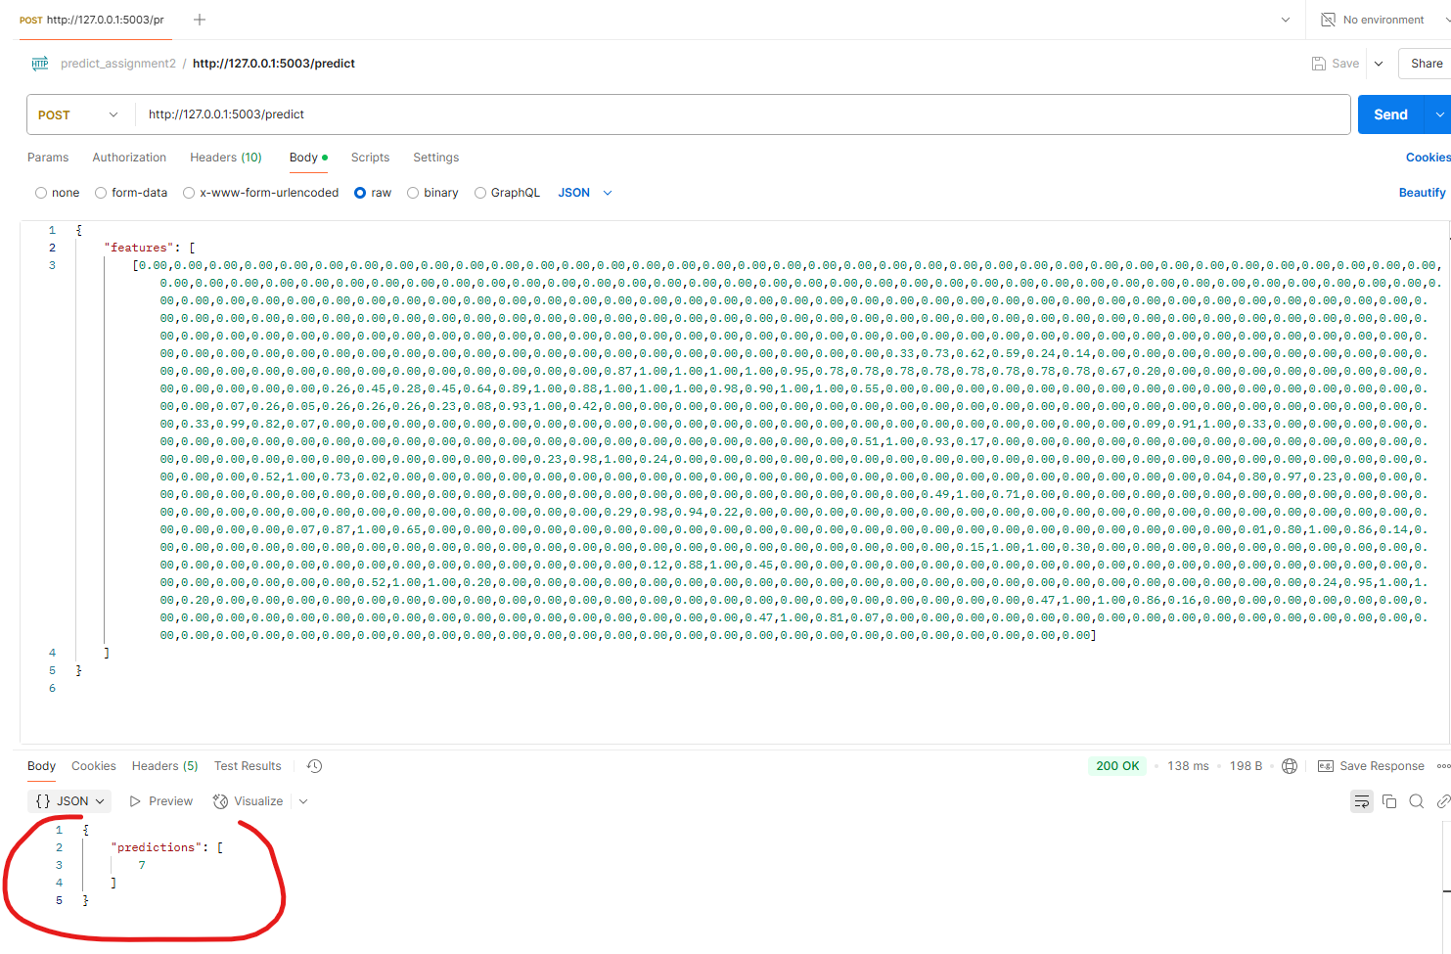

**Input for Training POST API call –**

{

    "features": [

        [0.00,0.00,0.00,0.00,0.00,0.00,0.00,0.00,0.00,0.00,0.00,0.00,0.00,0.00,0.00,0.00,0.00,0.00,0.00,0.00,0.00,0.00,0.00,0.00,0.00,0.00,0.00,0.00,0.00,0.00,0.00,0.00,0.00,0.00,0.00,0.00,0.00,0.00,0.00,0.00,0.00,0.00,0.00,0.00,0.00,0.00,0.00,0.00,0.00,0.00,0.00,0.00,0.00,0.00,0.00,0.00,0.00,0.00,0.00,0.00,0.00,0.00,0.00,0.00,0.00,0.00,0.00,0.00,0.00,0.00,0.00,0.00,0.00,0.00,0.00,0.00,0.00,0.00,0.00,0.00,0.00,0.00,0.00,0.00,0.00,0.00,0.00,0.00,0.00,0.00,0.00,0.00,0.00,0.00,0.00,0.00,0.00,0.00,0.00,0.00,0.00,0.00,0.00,0.00,0.00,0.00,0.00,0.00,0.00,0.00,0.00,0.00,0.00,0.00,0.00,0.00,0.00,0.00,0.00,0.00,0.00,0.00,0.00,0.00,0.00,0.00,0.00,0.00,0.00,0.00,0.00,0.00,0.00,0.00,0.00,0.00,0.00,0.00,0.00,0.00,0.00,0.00,0.00,0.00,0.00,0.00,0.00,0.00,0.00,0.00,0.00,0.00,0.00,0.00,0.00,0.00,0.00,0.00,0.00,0.00,0.00,0.00,0.00,0.00,0.00,0.00,0.00,0.00,0.00,0.00,0.00,0.00,0.00,0.00,0.00,0.00,0.00,0.00,0.00,0.00,0.00,0.00,0.00,0.00,0.00,0.00,0.00,0.00,0.00,0.00,0.00,0.00,0.00,0.00,0.00,0.00,0.00,0.00,0.00,0.00,0.00,0.00,0.33,0.73,0.62,0.59,0.24,0.14,0.00,0.00,0.00,0.00,0.00,0.00,0.00,0.00,0.00,0.00,0.00,0.00,0.00,0.00,0.00,0.00,0.00,0.00,0.00,0.00,0.00,0.00,0.87,1.00,1.00,1.00,1.00,0.95,0.78,0.78,0.78,0.78,0.78,0.78,0.78,0.78,0.67,0.20,0.00,0.00,0.00,0.00,0.00,0.00,0.00,0.00,0.00,0.00,0.00,0.00,0.26,0.45,0.28,0.45,0.64,0.89,1.00,0.88,1.00,1.00,1.00,0.98,0.90,1.00,1.00,0.55,0.00,0.00,0.00,0.00,0.00,0.00,0.00,0.00,0.00,0.00,0.00,0.00,0.00,0.00,0.00,0.00,0.00,0.07,0.26,0.05,0.26,0.26,0.26,0.23,0.08,0.93,1.00,0.42,0.00,0.00,0.00,0.00,0.00,0.00,0.00,0.00,0.00,0.00,0.00,0.00,0.00,0.00,0.00,0.00,0.00,0.00,0.00,0.00,0.00,0.00,0.00,0.00,0.33,0.99,0.82,0.07,0.00,0.00,0.00,0.00,0.00,0.00,0.00,0.00,0.00,0.00,0.00,0.00,0.00,0.00,0.00,0.00,0.00,0.00,0.00,0.00,0.00,0.00,0.00,0.09,0.91,1.00,0.33,0.00,0.00,0.00,0.00,0.00,0.00,0.00,0.00,0.00,0.00,0.00,0.00,0.00,0.00,0.00,0.00,0.00,0.00,0.00,0.00,0.00,0.00,0.00,0.00,0.51,1.00,0.93,0.17,0.00,0.00,0.00,0.00,0.00,0.00,0.00,0.00,0.00,0.00,0.00,0.00,0.00,0.00,0.00,0.00,0.00,0.00,0.00,0.00,0.00,0.00,0.00,0.23,0.98,1.00,0.24,0.00,0.00,0.00,0.00,0.00,0.00,0.00,0.00,0.00,0.00,0.00,0.00,0.00,0.00,0.00,0.00,0.00,0.00,0.00,0.00,0.00,0.00,0.00,0.00,0.52,1.00,0.73,0.02,0.00,0.00,0.00,0.00,0.00,0.00,0.00,0.00,0.00,0.00,0.00,0.00,0.00,0.00,0.00,0.00,0.00,0.00,0.00,0.00,0.00,0.00,0.00,0.04,0.80,0.97,0.23,0.00,0.00,0.00,0.00,0.00,0.00,0.00,0.00,0.00,0.00,0.00,0.00,0.00,0.00,0.00,0.00,0.00,0.00,0.00,0.00,0.00,0.00,0.00,0.00,0.49,1.00,0.71,0.00,0.00,0.00,0.00,0.00,0.00,0.00,0.00,0.00,0.00,0.00,0.00,0.00,0.00,0.00,0.00,0.00,0.00,0.00,0.00,0.00,0.00,0.00,0.00,0.29,0.98,0.94,0.22,0.00,0.00,0.00,0.00,0.00,0.00,0.00,0.00,0.00,0.00,0.00,0.00,0.00,0.00,0.00,0.00,0.00,0.00,0.00,0.00,0.00,0.00,0.00,0.07,0.87,1.00,0.65,0.00,0.00,0.00,0.00,0.00,0.00,0.00,0.00,0.00,0.00,0.00,0.00,0.00,0.00,0.00,0.00,0.00,0.00,0.00,0.00,0.00,0.00,0.00,0.01,0.80,1.00,0.86,0.14,0.00,0.00,0.00,0.00,0.00,0.00,0.00,0.00,0.00,0.00,0.00,0.00,0.00,0.00,0.00,0.00,0.00,0.00,0.00,0.00,0.00,0.00,0.00,0.15,1.00,1.00,0.30,0.00,0.00,0.00,0.00,0.00,0.00,0.00,0.00,0.00,0.00,0.00,0.00,0.00,0.00,0.00,0.00,0.00,0.00,0.00,0.00,0.00,0.00,0.00,0.12,0.88,1.00,0.45,0.00,0.00,0.00,0.00,0.00,0.00,0.00,0.00,0.00,0.00,0.00,0.00,0.00,0.00,0.00,0.00,0.00,0.00,0.00,0.00,0.00,0.00,0.00,0.00,0.52,1.00,1.00,0.20,0.00,0.00,0.00,0.00,0.00,0.00,0.00,0.00,0.00,0.00,0.00,0.00,0.00,0.00,0.00,0.00,0.00,0.00,0.00,0.00,0.00,0.00,0.00,0.24,0.95,1.00,1.00,0.20,0.00,0.00,0.00,0.00,0.00,0.00,0.00,0.00,0.00,0.00,0.00,0.00,0.00,0.00,0.00,0.00,0.00,0.00,0.00,0.00,0.00,0.00,0.00,0.47,1.00,1.00,0.86,0.16,0.00,0.00,0.00,0.00,0.00,0.00,0.00,0.00,0.00,0.00,0.00,0.00,0.00,0.00,0.00,0.00,0.00,0.00,0.00,0.00,0.00,0.00,0.00,0.47,1.00,0.81,0.07,0.00,0.00,0.00,0.00,0.00,0.00,0.00,0.00,0.00,0.00,0.00,0.00,0.00,0.00,0.00,0.00,0.00,0.00,0.00,0.00,0.00,0.00,0.00,0.00,0.00,0.00,0.00,0.00,0.00,0.00,0.00,0.00,0.00,0.00,0.00,0.00,0.00,0.00,0.00,0.00,0.00,0.00],

        [1.00,1.00,1.00,1.00,1.00,1.00,1.00,1.00,1.00,1.00,1.00,1.00,1.00,1.00,1.00,1.00,1.00,1.00,1.00,1.00,1.00,1.00,1.00,1.00,1.00,1.00,1.00,1.00,1.00,1.00,1.00,1.00,1.00,1.00,1.00,1.00,1.00,1.00,1.00,1.00,1.00,1.00,1.00,1.00,1.00,1.00,1.00,1.00,1.00,1.00,1.00,1.00,1.00,1.00,1.00,1.00,1.00,1.00,1.00,1.00,1.00,1.00,1.00,1.00,1.00,0.94,0.88,0.96,1.00,1.00,1.00,1.00,1.00,1.00,1.00,1.00,1.00,1.00,1.00,1.00,1.00,1.00,1.00,1.00,1.00,1.00,1.00,1.00,1.00,1.00,0.96,0.63,0.36,0.29,0.31,0.29,0.67,1.00,1.00,1.00,1.00,1.00,1.00,1.00,1.00,1.00,1.00,1.00,1.00,1.00,1.00,1.00,1.00,1.00,1.00,1.00,1.00,0.92,0.33,0.45,0.78,0.94,1.00,0.86,0.32,0.62,1.00,1.00,1.00,1.00,1.00,1.00,1.00,1.00,1.00,1.00,1.00,1.00,1.00,1.00,1.00,1.00,1.00,1.00,1.00,0.60,0.55,1.00,1.00,1.00,1.00,1.00,0.93,0.32,0.96,1.00,1.00,1.00,1.00,1.00,1.00,1.00,1.00,1.00,1.00,1.00,1.00,1.00,1.00,1.00,1.00,1.00,1.00,0.60,0.65,1.00,1.00,1.00,1.00,1.00,1.00,0.50,0.69,1.00,1.00,1.00,1.00,1.00,1.00,1.00,1.00,1.00,1.00,1.00,1.00,1.00,1.00,1.00,1.00,1.00,1.00,0.73,0.50,1.00,1.00,1.00,1.00,1.00,1.00,0.79,0.45,1.00,1.00,1.00,1.00,1.00,1.00,1.00,1.00,1.00,1.00,1.00,1.00,1.00,1.00,1.00,1.00,1.00,1.00,0.91,0.34,0.97,1.00,1.00,1.00,1.00,1.00,0.93,0.38,0.99,1.00,1.00,1.00,1.00,1.00,1.00,1.00,1.00,1.00,1.00,1.00,1.00,1.00,1.00,1.00,1.00,1.00,1.00,0.44,0.79,1.00,1.00,1.00,1.00,1.00,1.00,0.38,0.93,1.00,1.00,1.00,1.00,1.00,1.00,1.00,1.00,1.00,1.00,1.00,1.00,1.00,1.00,1.00,1.00,1.00,1.00,0.67,0.54,1.00,1.00,1.00,1.00,1.00,1.00,0.42,0.85,1.00,1.00,1.00,1.00,1.00,1.00,1.00,1.00,1.00,1.00,1.00,1.00,1.00,1.00,1.00,1.00,1.00,1.00,0.92,0.31,0.90,1.00,1.00,1.00,1.00,1.00,0.46,0.81,1.00,1.00,1.00,1.00,1.00,1.00,1.00,1.00,1.00,1.00,1.00,1.00,1.00,1.00,1.00,1.00,1.00,1.00,1.00,0.63,0.55,1.00,1.00,1.00,1.00,1.00,0.44,0.84,1.00,1.00,1.00,1.00,1.00,1.00,1.00,1.00,1.00,1.00,1.00,1.00,1.00,1.00,1.00,1.00,1.00,1.00,1.00,1.00,0.96,1.00,1.00,1.00,1.00,0.99,0.38,0.93,1.00,1.00,1.00,1.00,1.00,1.00,1.00,1.00,1.00,1.00,1.00,1.00,1.00,1.00,1.00,1.00,1.00,1.00,1.00,1.00,1.00,1.00,1.00,1.00,1.00,0.92,0.37,0.99,1.00,1.00,1.00,1.00,1.00,1.00,1.00,1.00,1.00,1.00,1.00,1.00,1.00,1.00,1.00,1.00,1.00,1.00,1.00,1.00,1.00,1.00,1.00,1.00,1.00,0.69,0.49,1.00,1.00,1.00,1.00,1.00,1.00,1.00,1.00,1.00,1.00,1.00,1.00,1.00,1.00,1.00,1.00,1.00,1.00,1.00,1.00,1.00,1.00,1.00,1.00,1.00,1.00,0.41,0.80,1.00,1.00,1.00,1.00,1.00,1.00,1.00,1.00,1.00,1.00,1.00,1.00,1.00,1.00,1.00,1.00,1.00,1.00,1.00,1.00,1.00,1.00,1.00,1.00,1.00,0.90,0.34,0.98,1.00,1.00,1.00,1.00,1.00,1.00,1.00,1.00,1.00,1.00,1.00,1.00,1.00,1.00,1.00,1.00,1.00,1.00,1.00,1.00,1.00,0.98,0.98,1.00,1.00,0.47,0.63,1.00,1.00,1.00,1.00,1.00,1.00,1.00,1.00,1.00,1.00,1.00,1.00,1.00,1.00,1.00,1.00,1.00,1.00,1.00,1.00,0.70,0.35,0.29,0.29,0.35,0.46,0.39,1.00,1.00,1.00,1.00,1.00,1.00,1.00,0.98,1.00,1.00,1.00,1.00,1.00,1.00,1.00,1.00,1.00,1.00,1.00,1.00,0.67,0.31,0.79,0.93,0.95,0.64,0.07,0.31,0.86,1.00,1.00,1.00,1.00,1.00,0.76,0.57,1.00,1.00,1.00,1.00,1.00,1.00,1.00,1.00,1.00,1.00,1.00,1.00,0.42,0.81,1.00,0.90,0.51,0.29,0.82,0.73,0.26,0.58,0.87,0.99,1.00,0.97,0.34,0.72,1.00,1.00,1.00,1.00,1.00,1.00,1.00,1.00,1.00,1.00,1.00,1.00,0.61,0.36,0.45,0.28,0.55,0.95,1.00,1.00,0.90,0.50,0.29,0.30,0.31,0.28,0.50,1.00,1.00,1.00,1.00,1.00,1.00,1.00,1.00,1.00,1.00,1.00,1.00,1.00,0.97,0.60,0.63,0.94,1.00,1.00,1.00,1.00,1.00,1.00,0.97,0.89,0.87,0.89,1.00,1.00,1.00,1.00,1.00,1.00,1.00,1.00,1.00,1.00,1.00,1.00,1.00,1.00,1.00,1.00,1.00,1.00,1.00,1.00,1.00,1.00,1.00,1.00,1.00,1.00,1.00,1.00,1.00,1.00,1.00,1.00,1.00,1.00,1.00,1.00,1.00,1.00,1.00,1.00,1.00,1.00,1.00,1.00,1.00,1.00,1.00,1.00,1.00,1.00,1.00,1.00,1.00,1.00,1.00,1.00,1.00,1.00,1.00,1.00,1.00,1.00,1.00,1.00,1.00,1.00,1.00,1.00,1.00,1.00,1.00,1.00,1.00,1.00,1.00,1.00,1.00,1.00,1.00,1.00,1.00,1.00,1.00,1.00,1.00,1.00,1.00,1.00,1.00,1.00,1.00,1.00,1.00,1.00,1.00,1.00,1.00,1.00,1.00,1.00,1.00,1.00,1.00,1.00,1.00,1.00,1.00,1.00,1.00,1.00,1.00,1.00,1.00,1.00,1.00,1.00,1.00,1.00,1.00,1.00,1.00]

    ],

    "labels": [7, 2]

}

