**Magnitude Work Progress**

**Day 1 Work Status 03-10-2018**

**@First Half 10:00AM to 1:00 PM**

1.Reported Magnitude Office at 9.30

2.Meet Sarvana Bhavan and Collected Details about product

3.Explained Overview of Agility multichannel product

4.Share Document for bit understanding

5.Showing office and Cafeteria

6.Shared our Details name and email to create access

7.Introduced Sankalp Saxena

--We Are in Waiting Room because systems are not ready.

**@Second Half 2:00PM to 6:00PM**

1.Sankalp Explained about product functionality

2.Explained Structure of cypress

3.Collected Information about requirement

4.Collected Structure of Automation and Magnitude Expectations

5.Explained Formation Folder structure and Code in cypress format

6.Shared util functions and Existing Code

7.Created Git HUB Access

End of the day machines are ready, but Access is pending, Access will be created by tomorrow as per information from saxena.

By Tomorrow Morning 10:00AM If Everything is Ready We Will Start Working with Them

**Note:** If Set up and Access not ready that means still it’s in processing, we will be in Waiting Room

**Day 2 Work Status 03-10-2018**

**@First Half 10:00AM to 1:00 PM**

**@Saravana Bhavan**

1.System and Access configuration is done

2.Created Cypress Framework and Setup

3.Created magnitude Email id’s

4.Created Test link Server Id and passwords

5.Shared Documents Through magnitude mail Id

6.Shared recorded videos

7.Explained functionality based on recorded videos

**@Sankalp Saxena**

1.Shared Agility Multichannel(AMI) link

2.Invited GIT HUB Access

3.Shared the Code and Util functions

4.Explained Structure

5.Shared 100 Testcases need to Automate

**Cypress:**  
 Cypress is a next generation front end testing tool built for the modern web. We address the key pain point’s developers and QA engineers face when testing modern applications.

**Installation process:**

Step1: Before Cypress Install NodeJs

Visit [**https://nodejs.org/en/**](https://nodejs.org/en/)

Install NodeJS

Step2: Set Nodejs Path as Environment variable

Step3: Open command Prompt and run npm -v to check version and installed node js

Properly or not

**Installation process 2:**

Step1: Run command **npm init** for creating package.json fill the details as and save

{

"name": "agilitycypress",

"version": "1.0.0",

"description": "AgilityMultichannelTesting Cypress",

"main": "index.js",

"scripts": {

"test": "echo \"Error: no test specified\" && exit 1",

"cypress": "cypress open"

},

"author": "ravi",

"license": "ISC",

"dependencies": {

"cypress": "^3.1.0"

}

}

Step3: Visit <https://www.cypress.io/>

Run Command **npm install cypress**

Step4: After installation Cypress Successfully Run command

**/node_modules/.bin/cypress**

Cypress installed successfully, and it will show Folder Structure and example Files

**After Installation (Recommended):**

Step1: Install Visual Studio Code

After Install Visual Studio Code Open Project in Visual Studio code and Run Cypress in Terminal

Step2: Create tsconfig file to load cypress command default in entire project.

{

"compilerOptions": {

"allowJs": true,

"baseUrl" : "../node_modules",

"types" :[

"cypress"

]

},

"include" : [

"**/*.*"

]

}

Save this file in Cypress folder

**Cypress.json**

Once Installation Process finished, Add Configuration as per requirement for cypress.json file

{

"baseUrl": “http://10.54.3.39/AMI”,

"video": false,

"defaultCommandTimeout": 20000,

"pageLoadTimeout": 900000,

"chromeWebSecurity": true,

"integrationFolder": "cypress/integration",

"pluginsFile": "cypress/plugins",

"fixturesFolder": "cypress/fixtures",

"supportFile": "cypress/support",

"screenshotsFolder": "cypress/screenshots",

"viewportHeight": 960,

"viewportWidth": 1400,

"waitForAnimations": true,

}

**@Second Half 2:00PM to 6:30 PM**

**@Ravindra, @Bharath**

1.Undersatd the Requirement

2.Created and Designed Cypress Setup

3.Downloaded Existing code and Util Functions from GIT HUB

4.Custamized Existing code

5.Created **amiDataValue.Json** File and Attached loginUtil Source code

6.Writen one sample Script and checking with Execution

7.Written Assertion for each line of code

End of the Day We showed Sample Script to Sankalp Saxena and We reached his Expectation.

Tomorrow We Will Start Writing Test Scripts for Based on Test Cases. Hope Everything Works Best.

**Cypress Framework Setup is Ready.**

**Day 3 Work Status 05-10-2018**

**@Ravindra**

1.Understanding Execution Flow

2.Written Scripts Tag Relation Gadget for 3 Test Cases

3.Customize the code and Added Assertions

4.Draga and Drop Action is pending in Test Case 1

5.While Execution Getting Error

**1098: Error from Agility Server: Invalid session id. You must re-bind to this provider**

6.Because of Above error Test Scripts are not running

7.Out of 3 Test Cases 2 Test Cases Scripts Execution is Pending

**@Saravan Bhavan**

1.I check with 1098 Error with Saravana

2.Today This Issue Occur he Will restarting Server on Monday

3. I check with him Working on Saturday & Sunday, Saravana told they won't Allow, so he will create VPN Access for work from home

**Day 4 Work Status 08-10-2018**

**@Ravindra**

1.Finished 12 Test Cases Scripts

2.Execution is pending Because of 1098 error

3.I check With Saravana Bhavan they are debugging issue

4.Meet @Radha Jayaraman

5.Showed error Screen Shot to @Radha Jayaraman and shared to @ Saravana Bhavan

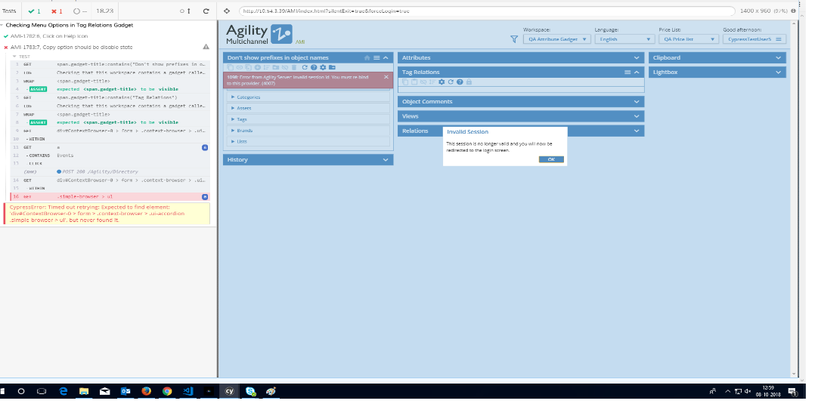

**@Bharath**

1.Written test case for tag relation attribute (no of test case 1).

2. Written 5 test case for Check Action Menu options

3. Did research on drag and drop in cypress

**Day 5 Work Status 09-10-2018**

**@Ravindra**

1.Code Formation is completed for 12 Scripts

2.Executed First 4 Test Scripts with number of iterations.

3.Executed Successfully without any Error

4. Explained Util functions usage to Bharath

5.Code review Done by for Bharath Test Scripts

6.Finished 1 Test Script

**@Bharat**

1.Finished 2 Test Scripts

2.Code Review with Ravindra

**Day 6 Work Status 10-10-2018**

**@Ravindra**

1.Code Formation is completed for 23 Scripts

2.Executed All Test Scripts with number of iterations.

3.Executed Successfully without any Error

4.Code review Done by for Bharath Test Scripts

**@Bharat**

1. Code formation completed for 7 Test Scripts.

2. Code review and formatting done with Ravi.

**Day 7 Work Status 11-10-2018**

Day 7 work Status 11-10-2018

1.Completed 11 scripts

2.Executed All Test Scripts with number of iterations.

3.Executed Successfully without any Error

4.Code Review Meeting done with Magnitude Team

5.Explained project structure and code formation

6.Scripts ran in meeting successfully

7.Got Feed Back

        a. Separation of test data, considering multiple data-sets and ids in different files.

        b. More console logging to indicate where the script is.

8.As per Feedback scripts are implemented and changed

9.After Scripts Changes Ran all 34 Scripts. Scripts Run Successfully with Out any error

**Day 8 Work Status 12-10-2018**

1.Completed Tag Relation Gadget First Set of Scripts 39

2.Executed all Scripts without any error

3.Finished 6 Scripts in working List GUI

4.Executed scripts with number of iterations result success

5.Provided VPN Access

**Day 9 Work Status 13-10-2018**

1.Connected Magnitude Servers Through VPN Access

2.Finished 5 Scripts in Working List Gadget

3.Got Some Internet Issues from my side

4.Execution is pending because of low internet

5.Planning for execution tomorrow

**Day 10 Work Status 14-10-2018**

1.Connected Magnitude Servers Through VPN Access

2.Finished 21 Scripts in Working List Gadget

3. Execution is pending for 10 Scripts because of low internet

4.Planning for execution tomorrow and code formation

**Day 11 Work Status 14-10-2018**

1.Finished 37 Scripts in Working List gadget

2.Code Formation is completed Successfully

3.Ran 37 Scripts with Number of Iterations Successfully

4.Added two user defined commands for log generation

5.Added plugin for failure Test Scripts

6.Log generation Completed

**Day 12 Work Status 16-10-2018**

1.Working on log generation for scripts

2.Code formation and re testing all

3.Generated automatic logs

**Day 13 work status 17-10-2018**

1.Finished log generation for 71 scripts

2.Working on drag and drop

3.cross checking code formation and indentation

4. Till now total 71 scripts are finished reaming test cases are old test cases those test cases I didn’t understand I check with @saravana Bhavan he his modifiing scripts we will do work on tomorrow for reaming test case

**Day 14 Work Status 18-10-2018**

1.Retesting 71 Scripts

2.Generated Logs Having Start Execution and finished execution log report,

3.Uploaded code in GITHUB with help of @Sankalp Saxena

Attended Review meeting with Magnitude team

      @MOM

1. Resolved previous feedback and explained how logs are working
2. Explained Log Util functions and commands
3. Showed Log generation report
4. Showed File separation of Values and DOM files
5. Explained structure of json

       @Feedback and comment

1. In between start and finish log report add assertions logs

4.Assertion logs are finished as per the feed back

5.Now logs are generated automatically without creating file manually

6.Took Help of @Saravan Bhavan

7.Finished 10 scripts and successfully running with number of iterations

**Day 15 Work Status 18-10-2018**

1. 85 Test Scripts are Finished now

2. Generated Logs for Every test Script

3. Re tested all Scripts with number of iterations

4. Working on Documentation