Datapath

By Sidhardh Burre

CS/ECE 2330 Digital Logic Design

April 19, 2021

Table of Contents

Contents

1 Problem Statement 2

2 Analytical Design 3

3 Numerical Verification 4

4 Summary 5

Table of Figures

Figure 1: Simple CPU Datapath 2

Figure 2: Circuits for Datapath 3

Figure 3: Circuits for ALU 4

Figure 4: Test Program 4

Figure 5: Final State of Test Program 5

Table of Tables

Table 1: Arithmetic Functions Defined by F0 and F1 2

# 1 Problem Statement

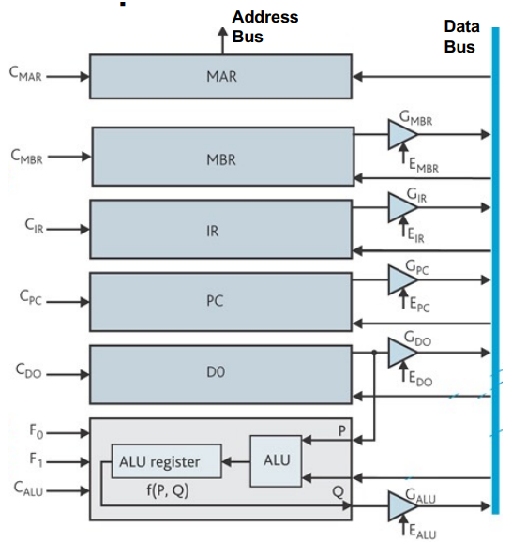Design the datapath as shown in Figure 1, which will complete the Central Processing Unit (CPU) design.

**Figure 1: Simple CPU Datapath**

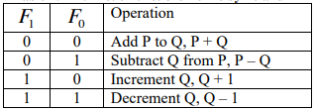The function of the datapath is to store all the information that is used to define the state of the CPU at any given time. This information is stored in the Memory Address Register (MAR), the Memory Buffer Register (MBR), the Instruction Register (IR), the Program Counter (PC), and Data register 0 (D0). In addition, the datapath contains an Arithmetic and Logic Unit (ALU) that is used to perform the 4 arithmetic operations shown in Table 1. Finally, note that there is an additional ALU register used to store the result of the arithmetic operation defined by F1 and F0.

**Table 1: Arithmetic Functions Defined by F0 and F1**

# 2 Analytical Design

Employing the datapath diagram displayed in Figure 1, a datapath was designed that allowed for the proper registers to be activated. The resulting circuit schematic is shown below in Figures 2 and 3.

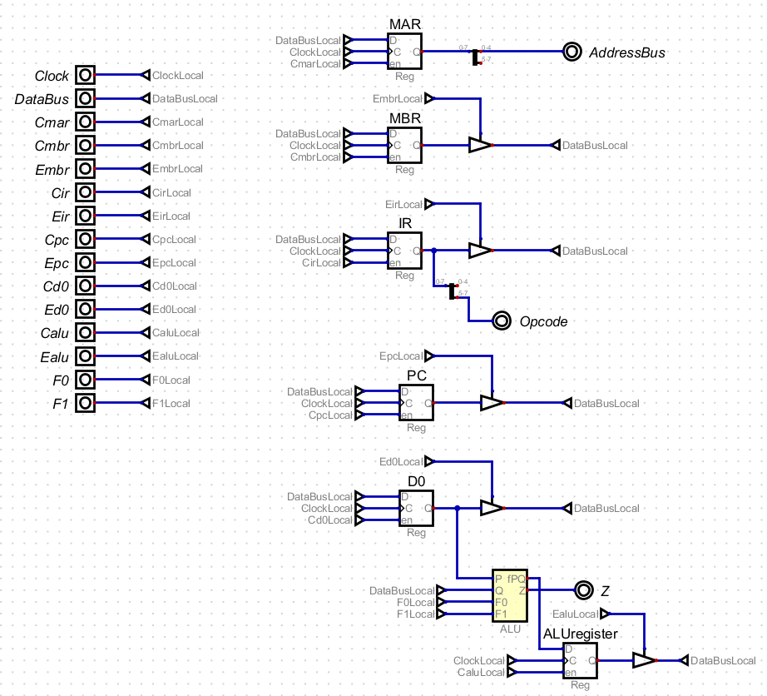

**Figure 2: Circuits for Datapath**

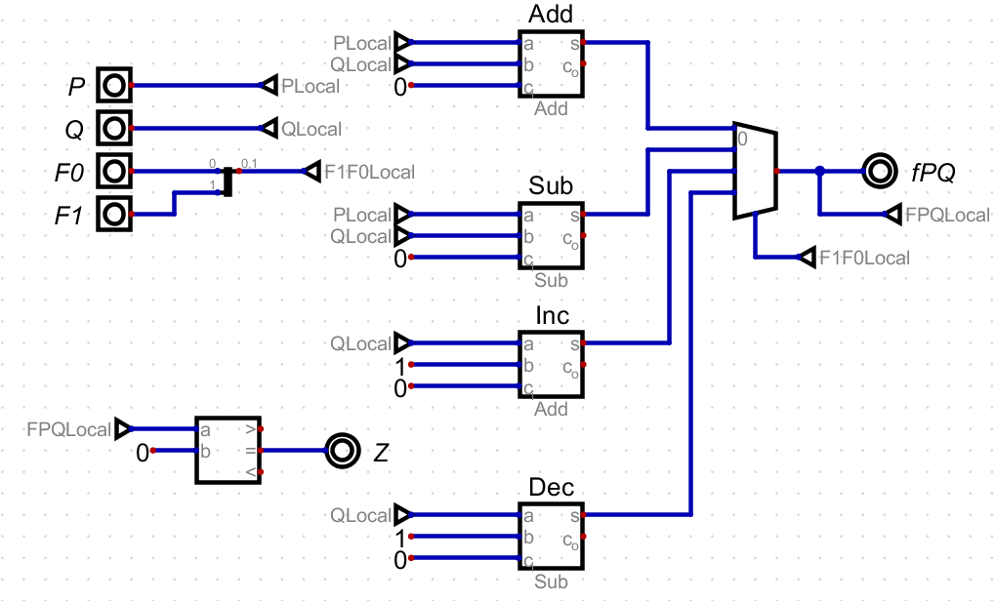

**Figure 3: Circuits for ALU**

# 3 Numerical Verification

The simplest way to test this circuit would be to run a program that exercises all the commands. To do so, a program that incorporates all these commands, shown in Figure 4, was executed. In a convoluted mode, this program counts down from the input value halting when it completes counting down to 0.

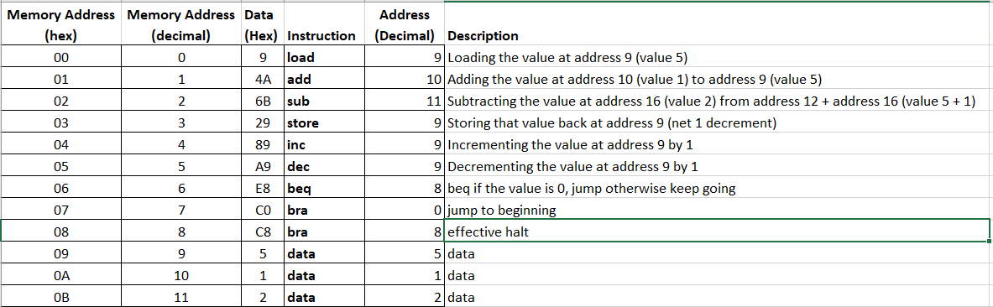

**Figure 4: Test Program**

Shown in Figure 5 is the final state of the program data memory (with the initial state being displayed in Figure 4).

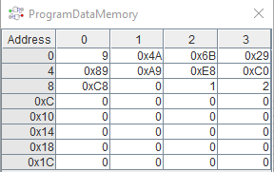

**Figure 5: Final State of Test Program**

# 4 Summary

The problem requirement for this assignment was to design a Datapath circuit to define the state of the CPU at any time, effectively completing the CPU design. This includes the management of the program management registers including the MAR, MBR, IR, PC, D0, and ALU.

By employing the Datapath diagram displayed in Figure 1, a Datapath circuit was created. The circuit was tested with a countdown program that counts down from the inputted value, memory address 0x09 Figure 4, to 0. As the final state of the program has that address value in Figure 5, 0x09 as zero, this suggests that the design can accomplish the programmed function, exercising all its registers and functions. Therefore, the specified digital circuit design solution satisfies the problem requirements.