Assignment 11 : Introduction to Physical Design Flow & Input files
- What is Physical Design in VLSI, and why is it needed after synthesis?

The Physical Design is a step in the ASIC flow once after synthesis we place the actual logic on the Silicon Core area (logic part), the real placement of the blocks, macros, interconnecting the blocks, clock routing, PnR flow, STA and Physical verification and at the end ECO also.

- List the steps in the Physical Design flow in order (Floorplanning to Power Analysis).
In General, the Physical Design flow follows the following order :
- Netlist + Libraries + Constraints
- Floorplanning
- Power Planning
- Placement
- CTS : Clock Tree Synthesis
- Routing : PnR Flow
- Physical Verification PV (DRC/LVS)
- GDSII Tape-out
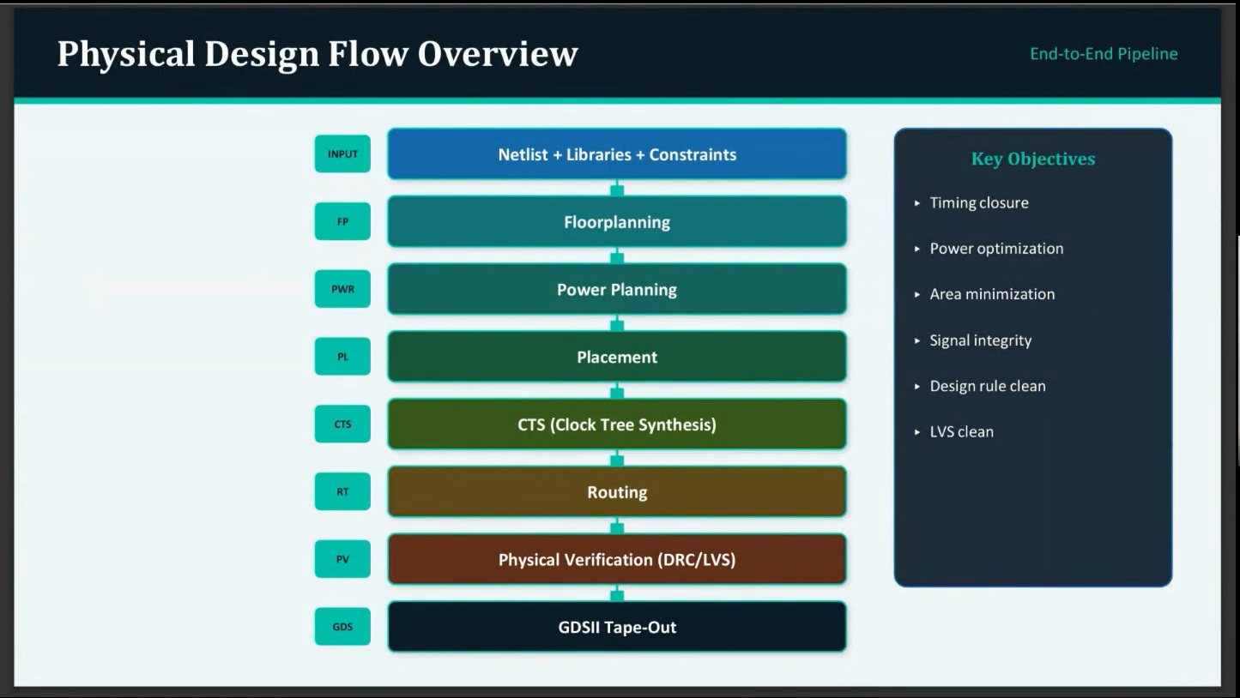

- What are the constraints (timing, power, design) that must be met during Physical Design?
The Timing closure, Power and Area constraints has to be met during the Physical Design. For paths or blocks or subsystem level we set some values for the Timing, Power and Area also.

- Define the following terminologies used in PD: Component, Module, Block, Standard cell, Macro.

Component :

Module : The term is used for the subunit level like a group of logic (standard cell) forms a Module. In the RTL module syntax used or the logic present inside these things forms a module. These are kind of Leaf hierarchies Level 3 or Level 4 logic.

Block : A group of modules form Block or kind of Level 2 logic.

Standard Cell : The basic unit of realization of the whole block or logic is in terms of these like AOI22, NAND, NOR, OAI22, RAM, ALU, core, XOR, XNOR, ADDER, Comparators. These when reused saves time, money and reduce risk by using a predesigned, pretested and precharacterized.

Macro : These are basic gates, Flip-Flops, Memory etc., These are placed in the rows in the Channelled Gate array.

- Differentiate between a Standard cell and a Macro, with examples of each.

Standard Cell :
- Group of primitive cells which are used to build larger circuits.
- Cell library consider them as unit level cells used or logic realized and stuff. In general, the standard cell library are NAND, NOR, XOR, XNOR, FF, Adder, Comparators, ALU, up, core, RAM and ROM like these.
- Designers define only placement of standard cells and interconnects.
- In general, it saves time, money and reduce risk by using a predesigned, pretested and precharacterized.
Macro :
- Basic gates, Flip-Flop and Memory.
- Channelled Gate array, Channel less Gate array and Structured Gate array.

- What is a Netlist? What format is it typically represented in, and what information does it contain?

Netlist is a kind of output where the RTL logic is realized in terms of basic standard cells or macros which are directly mapped by the synthesizer tool and stuff. This file has the logic connectivity of the design.

The netlist file format is in the verilog (.v) only.
- What is an SDC (Synopsys Design Constraints) file? List any three types of constraints typically specified in it.

An SDC (Synopsys Design Constraints) file is a constraint file defined to describe delays available for the i/p path, o/p path, Reg-2-Reg paths, false paths, multicycle paths and clock groups. The design rule checks, defining clock, period, latency and Uncertainty. Define the design environments, design constraints.
It’s a language or methodology or file format understood by the Synopsys tool for setting constraints in the PD stage.

- What is a LIB (Liberty) file? What kind of information does it provide about standard cells?

LIB Liberty File : This file gives a detail information about the standard cells it contains detail information about capacitance, transition time like tr (rise) and tf(fall) time, power characterization data.

In general, like these :
- Cell Delay : Propagation time delay.
- Transition Delay : Signal rise time or fall time.
- Setup Time : A certain amount of time for which data must be stable before the clock edge.
- Hold Time : A certain amount of time for which data must be stable after the clock edge.
- Leakage Power : Static Power consumption.
- Dynamic Power : Switching activity power.

- What is a LEF (Layout Exchange Format) file? What physical information does it contain about cells, macros, and pad cells?

A LEF file contains the Physical information about the cells, macros and pad cells. The LEF files are of two types like Technology LEF and Cell LEF.

Technology LEF :
- LEF Version
- Manufacturing Grid
- Routing layers
- Via definitions
- Width and Spacing Rules
- Pitch and Direction

Cell LEF :
- Cell Size & Boundary.
- Cell Origin
- Pin Locations
- Metal shapes
- Direction (I/O)

- Briefly explain the role of the Technology file in Physical Design.

The Technology file in the Physical design is the (.tf) file. It contains foundry process rules.
The Metal Stack layers are like M1, M2, M3, M4, M5 and M6. The metal layers are alternative Vertical and Horizontal layers.

