Assignment No. 12: Physical Design Flow – Floorplanning & Power Planning

- What are the goals of a good floorplan? List any four.

Goals of Floorplan :
- Minimized total area of chip
- Routability of the design.
- Minimal congestion.
- Low power consumption.

- List the inputs required for floorplanning and briefly explain any two of them.
The inputs required for floorplanning are :
- Netlist : The Logical connectivity of the blocks and interconnection is present. It is verilog or VHDL format.
- Timing Constraints : Input and Output delay of the cell and clock definitions, exceptions.
- Physical Libraries : Layout Exchange Format (LEF) containing the physical information of std cells, macros and pad cells.
- Logic Libraries : Timing and Functionality of cells and hard macros.
- Power Requirements : Power and GND nets.

- Explain Aspect Ratio and Core Utilization. How does each affect the shape and density of the floorplan?

Aspect Ratio (AR) = Width to the height of the chip. (W/H)

If AR = 1 the shape of the Block is Square.
If AR < 1 the shape of the Block is Vertical more.
If AR > 1 the shape of the Block is Horizontal more.

Core Utilization = (Standard cell + Macro area) / ( Total core area ).

- What are blockages in floorplanning? Differentiate between Placement Blockage, Routing Blockage, and Hard vs. Soft blockage.

The blockages in floorplanning are area where the standard cells are not meant to be placed or something.

Placement Blockages :
It prevents the placement of the standard cells, buffers and inverters. Placement blockages must be used in thin spaces between macros.

Routing Blockages : This prevents routing of metal layers in the blocked region.

Hard Blockages : Standard cells and buffers cannot be placed in this area.

Soft Blockages : No standard cells but buffers can be placed in this area.

- Explain the purpose of any four physical cells used in floorplanning: Well tap, End cap, Filler cell, Tie cell, and Decap cell (choose any four).

- Well Tap : These are inserted in the design to prevent the latch-ups. The gate is connected to the VDD or GND are connected to substrate ad n-wells. Reduce the resistance between the power and ground connections to wells of the substrate.
- End Cap : These are placed at every edge of every standard cell row. These are non-functional cells connected to the VDD or Ground rails.
- Filler Cell : Used as continuity of the N well and implant layers in the standard cell rows. These are placed in the empty spaces between the cells and continue of power and found exists between the cells.
- Tie Cell : They are special purpose cells used to connect the gate of transistor to either Power or Ground. The inputs which are needed to connect to Vdd connect to tie High cells. The inputs which are needed to connect to Vss connect to tie Low cells.
- Decap Cell : These cells are placed as charge reservoir when there is sudden power drop these decap cells act as power source for that transient time of supply.

- What are the goals of powerplanning? Why is meeting the IR drop budget important?

Goals of Powerplanning
- To make sure that power mesh is properly created.
- All the standard cells and macros should get the required power supply.
Meeting IR drop budget : The reason is along the trace of wire there is voltage drop so by the time let’s say it has to power up some block and there is ground bounce or High Voltage then the connected supply blocks might not powerup or function properly.

- List the key components of a powerplan (e.g., block ring, core ring, stripes) and explain any three.

The key components of powerplan :
- Block ring.
- Core ring.
- Routing standard cell pins.
- Adding VDD and GND stripes in the core area.
- Connecting PAD pins.
- Connecting block pins.
- Global Net connections.

- Explain the difference between Block Power Rings and Horizontal/Vertical Power Stripes.

Block power rings :
These are power stripes around the macros. The width of the power stripe and spacing between the power stripes are calculated by the designer.

Horizontal/Vertical Power Stripes :
The VDD and GND power stripes run the over the entire section of the die. The block rings, the standard cell power rails are connected to the power pads through the VDD and GND power stripes. These power stripes use the widest and highest routing layer.

- What is a Power Domain, and when is it required in a design?
A power domain is like same like logic partitioning instead we group the modules and give a same supply voltage kind of thing in the design.

In the below diagram wise if we observe Static Power domain is like fixed voltage for the blocks and stuff. There is DVFS mechanism also based on the Frequency corner or something the Voltage gets more or less or something.

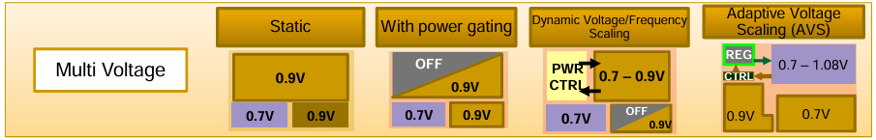

- Explain the role of Standard Cell Rails and follow pins in delivering power to standard cells.

The standard cell rails :
- Used to supply power to the standard cells.
- The cells are connected to the rails through the follow pins. These are connected to Metal Layers M1 or M2.
- The row orientation of alternate standard cell rows is flipped, so that standard cells are connected to both VDD and GND accordingly.

