Assignment 8 : Microwatt SoC
Links :
- GitHub : https://github.com/ssbagi/IBM_OpenPOWER_and_SoC_Design
- Assignment 8 : https://github.com/ssbagi/IBM_OpenPOWER_and_SoC_Design/blob/main/DAY5/Day5_Assignment_8.pdf

- What is the role of the core entity within the SoC? Name the three main interfaces it connects to (Wishbone, interrupts, DMI).

The core is CPU Pipeline (5 stage in-order pipeline) which does the main execution of the program.

The Core entity is connected to the Wishbone interface, Receives Interrupts and communicates via DMI.

- Explain the role of the syscon (System Controller) module. What kind of information/registers does it provide?

System Controller (syscon) :
- Provides SoC configurations/status registers.
- Includes SoC version, reset control, clock config etc.

- What is the purpose of wishbone_bram_wrapper? What happens if MEMORY_SIZE = 0?

Wishbone Wrapper : Block BRAM
- Instantiates internal BRAM as a memory-mapped Wishbone slave.

MEMORY_SIZE = 0 then a dummy memory interface is generated that ACKs with all 1s. For booting from external flash memory not from the internal BRAM one.

- Trace the debug access path from JTAG to the core/fabric — explain the roles of dmi_dtm and wishbone_debug_master.

JTAG : Debug Interface
- 5 Signals : TCK, TDI, TDO, TMS and TRST.

dmi_dtm : Debug Transport Module (DTM)
- JTAG interface bridge to DMI bus.
- Converts JTAG signals to DMI protocol.
- Inputs : JTAG TAP, clock, reset.
- Outputs : DMI transaction signals (dmi_addr, dmi_req and dmi_wr).

wishbone_debug_master :
- Converts DMI requests into Wishbone transactions.
- Connected to wishbone master port, used for debug access to any mapped peripherals.

- List the SoC peripherals connected as Wishbone slaves. Briefly explain the purpose of pp_soc_uart and spi_flash_ctrl.

The SoC peripherals connected to Wishbone interfaces are :
- UART0 / UART1 : pp_soc_uart0, pp_soc_uart1
- SPI : spi_flash_ctrl
- GPIO
- Wishbone BRAM Wrapper
- Interrupts : xics_icp
- Syscon : System Controller
pp_soc_uart :
- Serial communication.
- UART0 typically used for console or debug.
spi_flash_ctrl :
- External SPI flash memory access via Wishbone.

- Explain how interrupts are handled in the Microwatt SoC — describe the roles of xics_ics and xics_icp and how int_level_in feeds into them.

From the soc.vhdl file the block diagram wise the connection is as follows :
-- XICS signals:
signal wb_xics_icp_in : wb_io_master_out;
signal wb_xics_icp_out : wb_io_slave_out;
signal wb_xics_ics_in : wb_io_master_out;
signal wb_xics_ics_out : wb_io_slave_out;
signal int_level_in : std_ulogic_vector(15 downto 0);
signal ics_to_icp : ics_to_icp_t;
signal core_ext_irq : std_ulogic_vector(NCPUS-1 downto 0) := (others => '0');

The xics_ics and xics_icp are External interrupt handler signals.

The module xics_ics the pin int_level_in is connected to the pin int_level_in. The ranges acceptable is from 0 TO 15. The int_level_in from the below diagram is the Source ID for the interrupts from the Peripherals UART, SPI, GPIO and Other sources.

The int_level_in mapping explained in below section like the xcs_ics_entity use the inputs with different master with Source ID numbers and stuff. The xics_ics Entity selects one of them and schedules to the ICP.

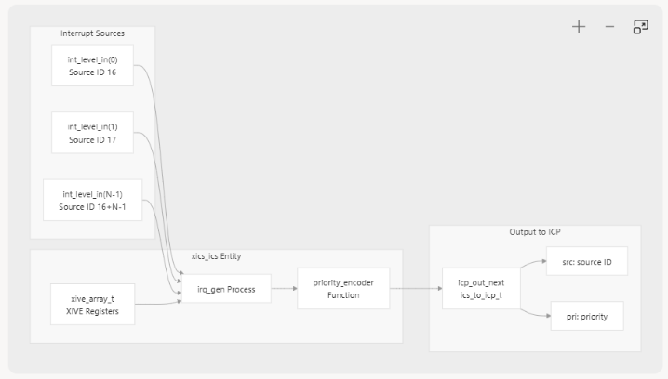

The xics_ics is Interrupt Control Source :
- The xics_ics entity manages interrupt sources and their associated priorities and routing information.
- Each interrupt source has a XIVE (External Interrupt Vector Entry) register that controls its behavior.

The xics_icp is Interrupt Control Presenter :
- The xics_icp entity presents interrupts to CPU cores based on their current priority levels.
- It maintains presentation state for each CPU and implements the XICS presentation protocol.
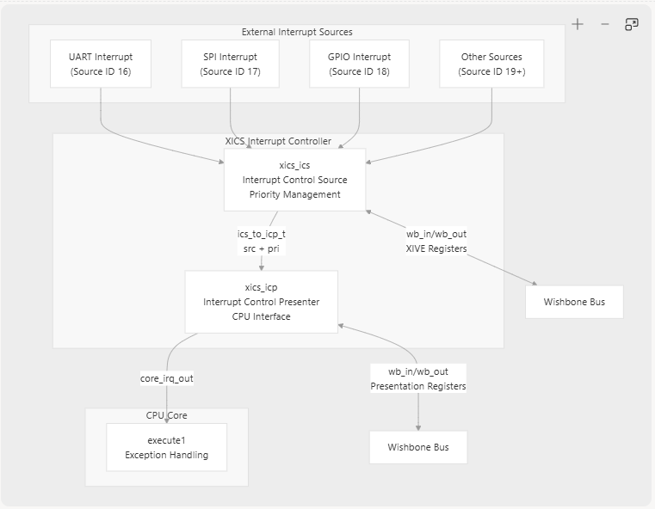

Working Mechanism :

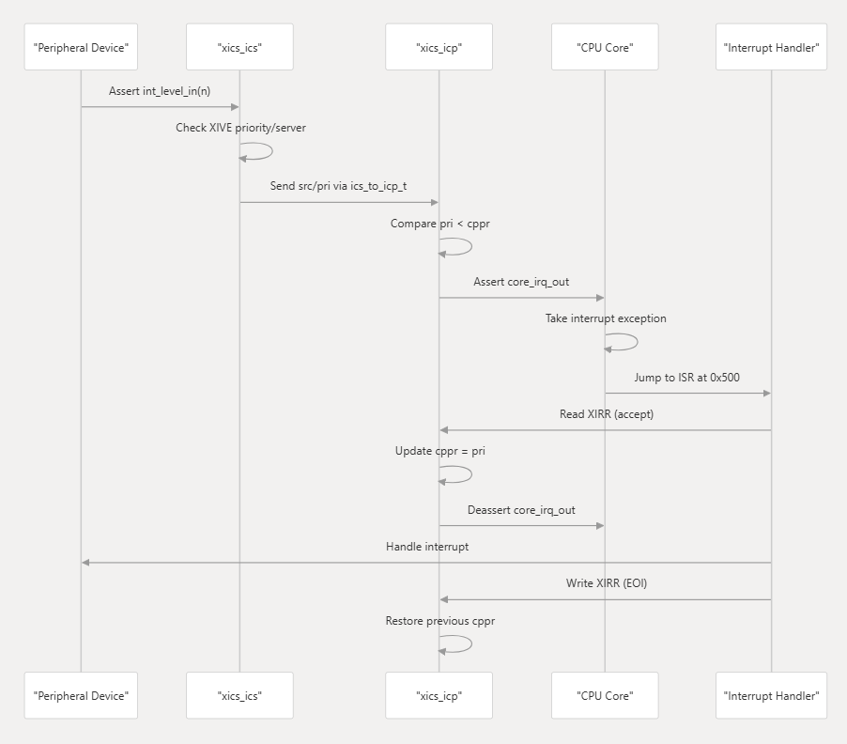

- What is the role of the gpio module in the SoC?

The GPIO are general purpose Input and Output pins which are connected to the Wishbone Wrapper internally then to the CPU. These pins are external world interfaces to the Chip for communication of the CPU or any internal block.

- Describe the Wishbone bus fabric — how does it connect the core (as master) to the various peripherals (as slaves)?

The Wishbone bus fabric connects :
- Master : Core
- Slaves
  - pp_soc_uart0, pp_soc_uart1
  - spi_flash_ctrl
  - gpio
  - xics_icp
  - syscon
  - wishbone_bram_wrapper
One Master Multiple Slave connection. The Arbitration is based on the address generated from the Core block.
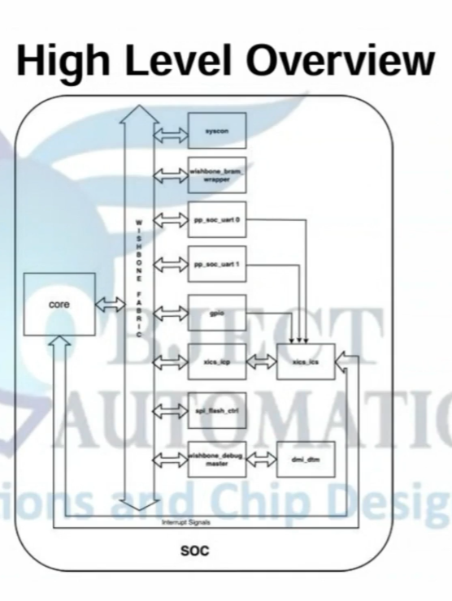

- Describe the power-up and reset sequence of the Microwatt SoC — from reset assertion to “SoC Ready for Full Operation.”

Power-Up and Reset :
- The FPGA powers on, and all logic is initialized to default states.
- A reset signal is asserted to ensure all components start clearly.
- This reset is propagated to all components: core, BRAM, wishbone fabric, peripherals, interrupt controller and DMI etc.
Clock and Reset Distribution :
- system_clk is distributed across all the modules.
- rst_*signals are derived form the soc_reset and connected to the corresponding components.
  - rst_bram : Reset signal for the BRAM module.
  - rst_dtm : Reset signal for the DTM moule.

- What happens when SIM is true and a special DMI write is made to address “11111111”? Why is this feature useful?

SIM = True and Special DMI write for addr = 0x1111_1111.

DMI Interface: Debug Module Interface for external debugger connection

In soc.vhdl dmi_intercon process, after the normal address decode (Wishbone at 0x00–0x03, core debug at 0x10+), there is

Special Case: when SIM is set, any write (dmi_wr = '1') to dmi_addr = "11111111" calls stop, halting the simulation.

SoC : Address Mapping

