# 

**Count of Actor Activities (num_activities) over time from 2015 - present 2**

Overview 2

My Analysis 2

**PullRequestEvent-Closed (num_dist_pullreqclosed) over time from 2015- present 3**

Overview 3

My Analysis: 3

**IssuesEvent-Closed (num_dist_issuesclosed) over time from 2015 - present 4**

Overview 4

My Analysis 4

**ReleaseEvents: (num_releases) over time from 2015 - present 5**

Overview 5

My Analysis 5

**My Observations 6**

# 

# 

# Count of Actor Activities (num_activities) over time from 2015 - present

## Overview

The Github event “**Count Of Actor Activities (num_activities)”** indicates the number of developers contributing to the repository over this time.

This is graphed from the beginning of the PyTorch project (2016) till 2024

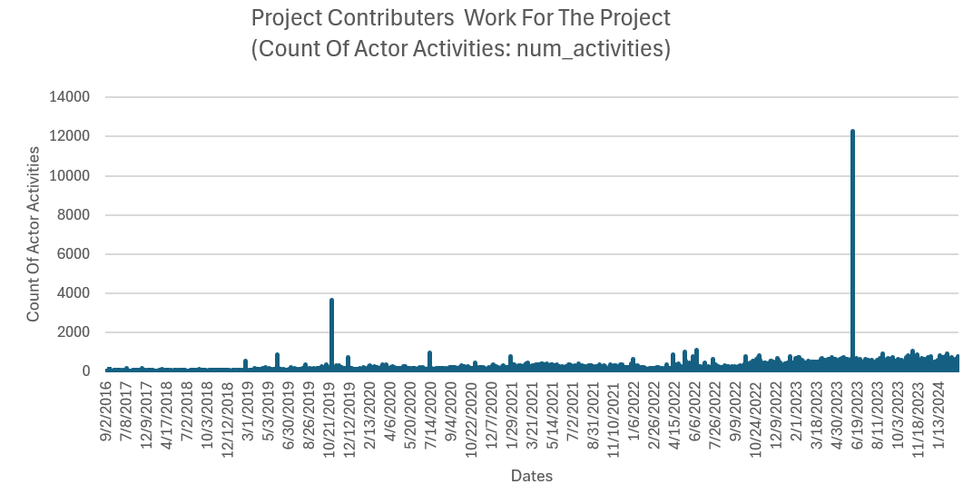

## My Analysis

Looking at the graphs, we can conclude that there was a spike in interest for deep learning in October 2019 as well as in Mid 2023.

# PullRequestEvent-Closed (num_dist_pullreqclosed) over time from 2015- present

## Overview

The Github event “**PullRequestEvent-Closed (num_dist_pullreqclosed)”** indicates that a pull request has been accepted, and a change has been made in the code.

This is graphed from the beginning of the PyTorch project (2016) till 2024

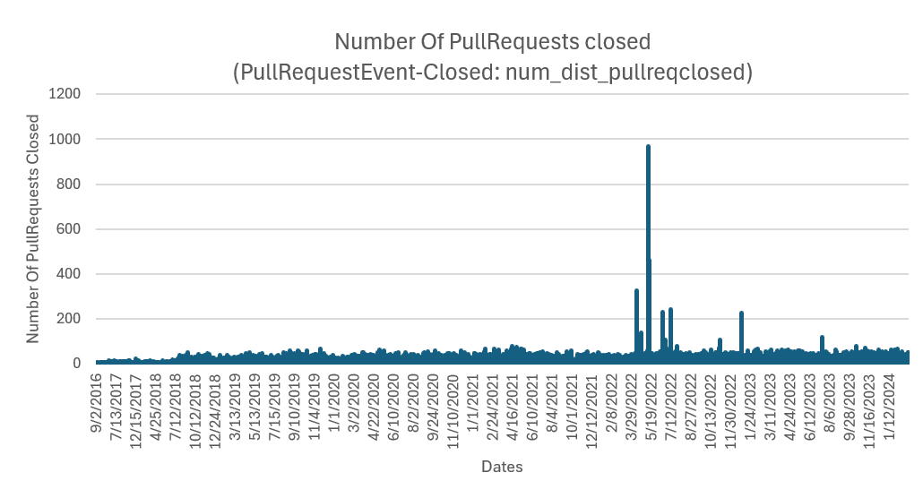

## My Analysis:

We can see that there are many small spikes in the number of pull requests, and that there is a large spike in 2022.

# 

# IssuesEvent-Closed (num_dist_issuesclosed) over time from 2015 - present

## Overview

The Github event “**IssuesEvents (num_dist_issuesclosed)”** indicates that there were problems in the code, and that the bugs were fixed.

This is graphed from the beginning of the PyTorch project (2016) till 2024

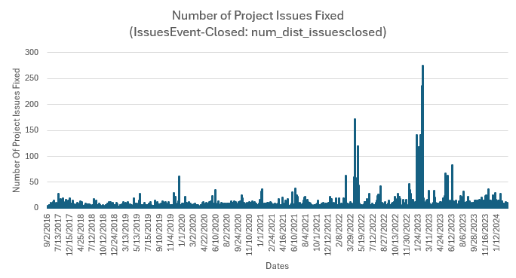

## My Analysis

We can see that the number of issues being fixed increased in 2022, and peaked in 2023. However, the graph is consistent, suggesting constant development to the repository

# ReleaseEvents: (num_releases) over time from 2015 - present

## Overview

The Github event “**ReleaseEvents (num_releases)”** indicates that a new version of PyTorch has been released.

This is graphed from the beginning of the PyTorch project (2016) till 2024

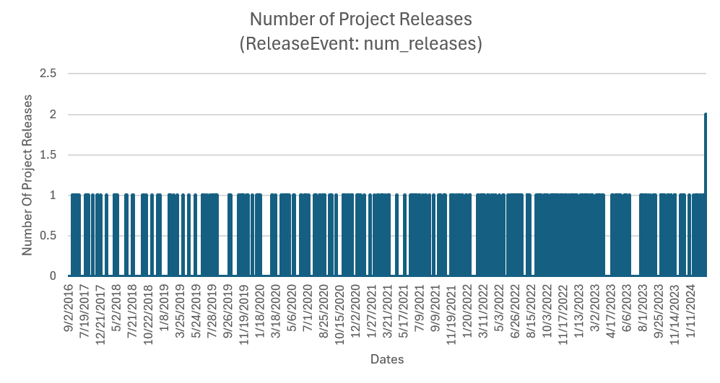

## My Analysis

The frequency of releases really picked up after 2022, and peaked in 2023.

# 

# My Observations

When we superimpose these graphs on top of each other, we get the following:  
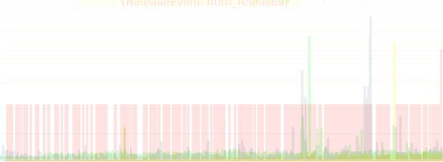

When we analyze this graph, we can see that spikes happen around the time of major events and innovations in AI. For example, we can see the releases of various GPT versions by OpenAI.

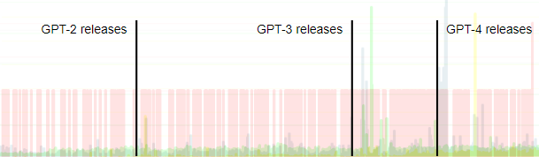

The reasons for the spikes seen in contributions to PyTorch can be attributed to the fact that it is a creation of Facebook’s AI division, and the increases are most likely attempts to either implement data gained from the GPT variants or to help Facebook compete with OpenAI in the field of AI development.