**Individual project case: Kwetter**

Author: Nico Kuijpers

Date: November 21, 2019

Kwetter is a social platform with main purpose to exchange text-based messages of at most 140 characters. Below, the functionality is described for the profile page and the start page.

**Profile page:**

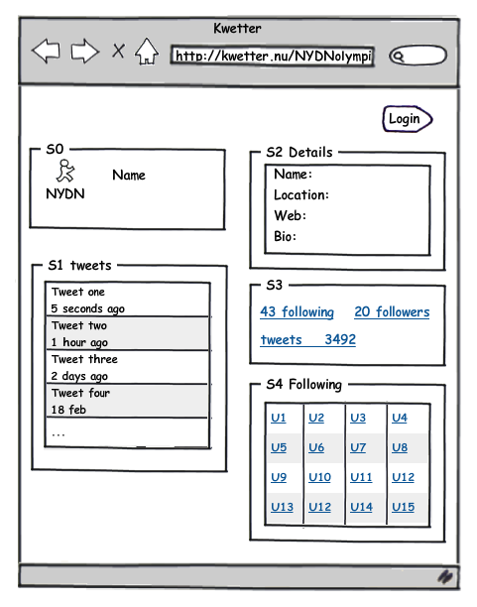

|  |  |  |
| --- | --- | --- |
| Function | Description |  |
| Profile picture profile name | Profile picture and name of the user |  |
| Profile details | User details: bio, location, website  Bio is limited to 160 characters |  |
| Own tweets | 10 most recent tweets by this user |  |
| Followers | Other users following this user.  By clicking followers in S3, a list of followers appears in S1 |  |
| Following | Other users followed by this user.  After clicking one of the links in S4, information of that user wil appear in S4 |  |
| Heart | Users can add a heart symbol to the tweet of another user. A user can give at most one heart symbol to each tweet. | Optioneel |

**Start page:**

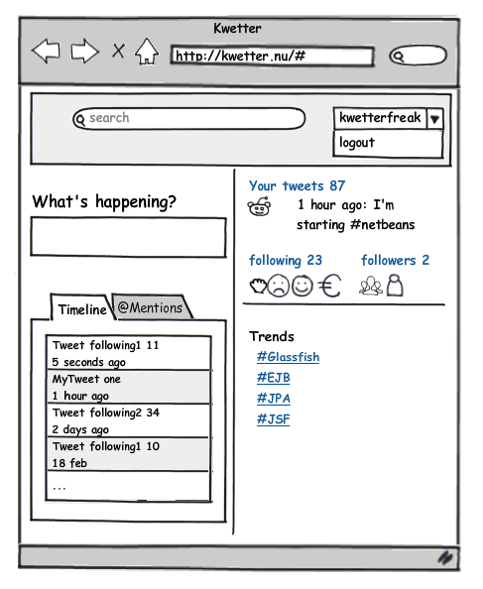

This personalized page appears after logging in.

|  |  |  |
| --- | --- | --- |
| Function | Description |  |
| Search | Search within all tweets. Results will be shown in the timeline tab. |  |
| What’s happening? | Textbox to enter your tweet with a maximum of 140 characters. The tweet will be shown immediately under 'Your tweets'. |  |
| Timeline | Timeline of tweets from the user and from other users being followed. |  |
| @Mentions | Tweets mentioning the user appear in this tab. It is possible to mention another user by adding @username in the tweet. |  |
| Following/ followers | After clicking on either the following or followers link, the profile page appears. |  |
| Trends | Clicking on one of the trends results in list of tweets in the timeline tab. These tweets are at most one week old and contain a hashtag followed by the selected trend. |  |
| Logout | After clicking logout the profile page appears. It is then possible to login as a different user. |  |
| Login | After clicking login and providing credentials, the starting page appears filled with tweets and other information for the user that is logged in. |  |

Registration:

Create a registration form for new users.

Moderation:

Create a page for users with the role of moderator. Moderators can see a list of users and their roles. They can remove users who spread insulting tweets or use swear words. In addition, moderators can change the role of other users to moderator.

Administration:

An administrator can add or remove accounts of other users and may change the roles of other users.