Conformance Pack Partitioning — Proposed Solution
This document describes the proposed approach for routing per-account guardrail evaluation through the partitioned Lambda clones introduced in RESOURCE_POLICY_FIX.md. It is a companion to that broader fix.

Context
In the original Resource Policy Fix design document, the goal was to have a CloudFormation Custom Resource (i.e. aws_account_partitioner) output an Account → Partition mapping that could be fed downstream to ConformancePack.yaml to look up the Lambda partition to use for each account based on the AWS::AccountId parameter. However, CloudFormation doesn’t support passing Mappings as a template parameter (only defined in the template), and there don’t seem to be any suitable alternatives to derive an account’s partition within ConformancePack.yaml solely using input parameter values.
Therefore, we are left with the question: how does ConformancePack.yaml route each account’s Config rules to the correct partition’s Lambda clone?
The approach below answers this by deploying up to three Organization Conformance Packs — one per non-empty partition — each running the same 37-rule template but parameterised to invoke a different Lambda clone set. ExcludedAccounts on each pack ensures every org account receives exactly one pack: the one matching the partition it has been assigned to in DynamoDB.

How it would work
- aws_account_partitioner (Custom Resource Lambda) would run early in main.yaml. It lists all org accounts, assigns each to a partition (≤ 70 accounts each, up to 3 partitions), and returns the per-partition account lists as comma-separated strings (AccountsInP1 / AccountsInP2 / AccountsInP3).
- A nested CloudFormation stack would receive those three lists and create up to three AWS::Config::OrganizationConformancePack resources, each guarded by a Condition that checks whether its account list is non-empty.
- Each pack would set a different PartitionSuffix input parameter on the same shared ConformancePack.yaml template in S3, so its 37 Config rules invoke the matching guardrail-Lambda clone set (<org>gcXX_… / <org>gcXX_…_p2 / <org>gcXX_…_p3).
- Each pack’s ExcludedAccounts would list every account in the other partitions, so the org-wide deployment targets each account from exactly one pack.

Flow diagram
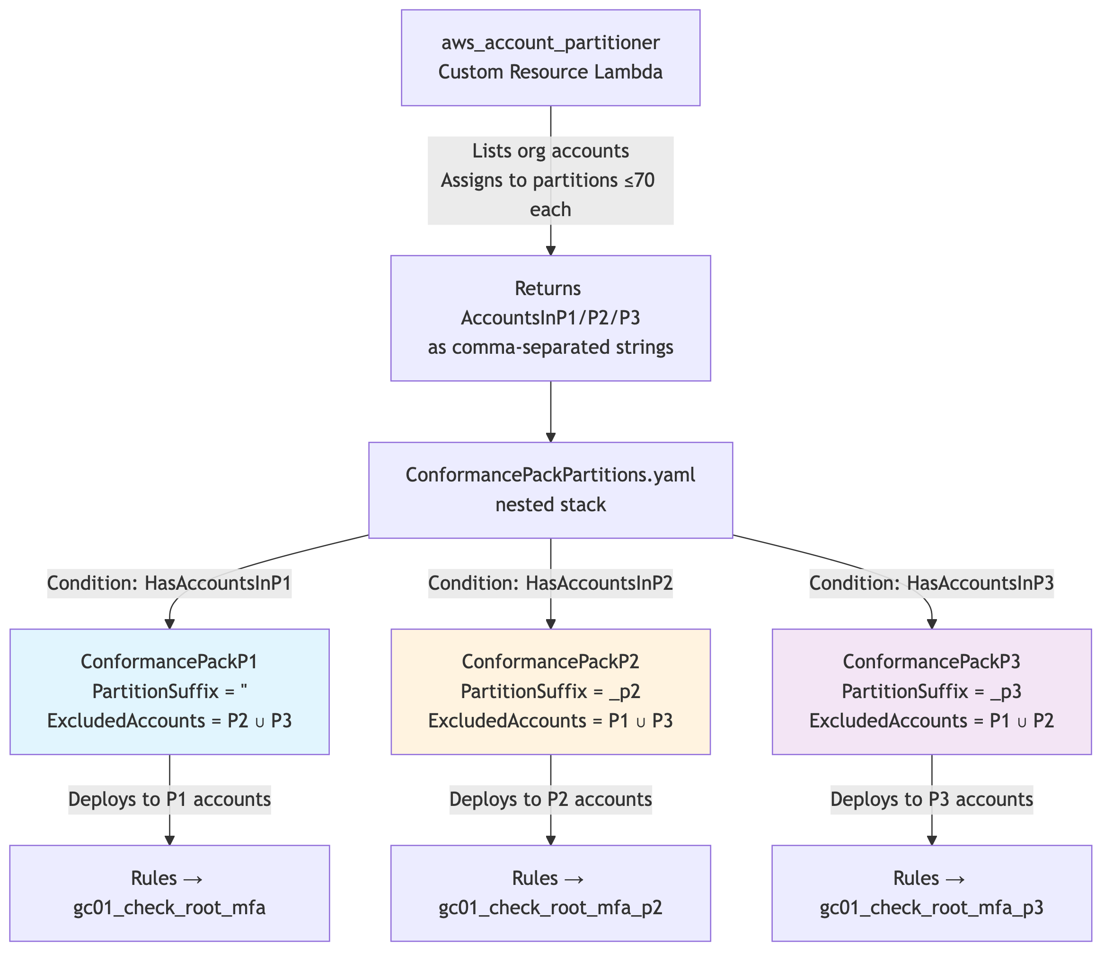
Diagram

Component-by-component

1. ConformancePack.yaml — parameterised rule routing
A new top-level parameter would be added:
PartitionSuffix:
Type: String
Default: ""
AllowedValues: ["", "_p2", "_p3"]
and appended to every ConfigRuleName and to the Lambda function-name portion of every SourceIdentifier. There are 37 substitutions of each. Example:
# Before
ConfigRuleName: gc01_check_root_mfa
Source:
Owner: CUSTOM_LAMBDA
SourceIdentifier:
Fn::Join:
- ""
- - "arn:aws:lambda:ca-central-1:"
- Ref: AuditAccountID
- !Sub ":function:${OrganizationName}gc01_check_root_mfa"
# After
ConfigRuleName: !Sub "gc01_check_root_mfa${PartitionSuffix}"
Source:
Owner: CUSTOM_LAMBDA
SourceIdentifier:
Fn::Join:
- ""
- - "arn:aws:lambda:ca-central-1:"
- Ref: AuditAccountID
- !Sub ":function:${OrganizationName}gc01_check_root_mfa${PartitionSuffix}"
So when the P2 pack passes PartitionSuffix: "_p2", the deployed rule name becomes gc01_check_root_mfa_p2 and it targets the <org>gc01_check_root_mfa_p2 Lambda clone.

2. ConformancePackPartitions.yaml — the nested stack
The single inline AWS::Config::OrganizationConformancePack in main.yaml would be replaced by a nested CloudFormation stack containing up to three of them. The reason for using a nested stack rather than declaring three packs directly in main.yaml is that CloudFormation Conditions cannot reference !GetAtt from a Custom Resource — they are evaluated at template-processing time, before any resources (or custom resources) have run. By passing the per-partition account lists into a nested stack as regular parameters, the nested stack can use them in Conditions.
Inputs to the nested stack:
Parameter | Source | Purpose
AccountsInP1 / AccountsInP2 / AccountsInP3 | !GetAtt InvokeAccountPartitioner.AccountsInPx | Comma-separated lists of account IDs. Empty string when a partition has no accounts. Drives both the per-pack Condition and the per-pack ExcludedAccounts.
GC03AlarmList | (default) | Comma-separated CloudWatch alarm names forwarded to every pack as the GC03AlarmList input parameter. Has a hard-coded default so callers never need to set it.
PipelineBucket, DeployVersion | Parent | Resolve s3://…/ConformancePack.yaml.
InvokeUpdate | Parent | Forwarded as UpdateTriggerVersion.
OrganizationName, AccelRolePrefix, AuditAccountID, BGA1-4, LogArchiveAccountName, ClientEvidenceBucket, GC04EnterpriseMonitoring… | Parent | Forwarded into the ConformancePackInputParameters of each pack.
Conditions:
HasAccountsInP1: !Not [!Equals [!Ref AccountsInP1, ""]]
HasAccountsInP2: !Not [!Equals [!Ref AccountsInP2, ""]]
HasAccountsInP3: !Not [!Equals [!Ref AccountsInP3, ""]]
# AND combinations used by ExcludedAccounts !If ladders:
HasAccountsInP2AndP3: !And [!Condition HasAccountsInP2, !Condition HasAccountsInP3]
HasAccountsInP1AndP3: !And [!Condition HasAccountsInP1, !Condition HasAccountsInP3]
HasAccountsInP1AndP2: !And [!Condition HasAccountsInP1, !Condition HasAccountsInP2]
Resources:
Resource | Condition | PartitionSuffix | ExcludedAccounts
ConformancePackP1 | HasAccountsInP1 | "" | Nested !If over (HasAccountsInP2, HasAccountsInP3): union of whichever of P2/P3 is non-empty, or !Ref AWS::NoValue if both empty.
ConformancePackP2 | HasAccountsInP2 | "_p2" | Nested !If over (HasAccountsInP1, HasAccountsInP3): union of whichever of P1/P3 is non-empty, or !Ref AWS::NoValue if both empty.
ConformancePackP3 | HasAccountsInP3 | "_p3" | Nested !If over (HasAccountsInP1, HasAccountsInP2): union of whichever of P1/P2 is non-empty, or !Ref AWS::NoValue if both empty.
Pack names:
${OrganizationName}-GC-CP-Guardrails ← when AccountsInP1 is non-empty (always, in practice)
${OrganizationName}-GC-CP-Guardrails-P2 ← when AccountsInP2 is non-empty
${OrganizationName}-GC-CP-Guardrails-P3 ← when AccountsInP3 is non-empty
For organizations with ≤ 70 active accounts the behaviour is indistinguishable from the pre-fix deployment: one pack, same name, no exclusions, base gc* Lambda set only. This is intentional — the upgrade path for existing customers requires no manual configuration.
Each pack’s ExcludedAccounts is built with a nested !If ladder so empty AccountsInP* strings are never !Split/!Join’d into the list (which would produce trailing empty elements failing Config’s ^\d{12}$ validation). Worked example for ConformancePackP1:
ConformancePackP1:
Type: AWS::Config::OrganizationConformancePack
Condition: HasAccountsInP1
Properties:
OrganizationConformancePackName: !Sub "${OrganizationName}-GC-CP-Guardrails"
TemplateS3Uri: !Sub "s3://${PipelineBucket}/${DeployVersion}/ConformancePack.yaml"
ExcludedAccounts: !If
- HasAccountsInP2AndP3
- !Split [",", !Join [",", [!Ref AccountsInP2, !Ref AccountsInP3]]]
- !If
- HasAccountsInP2
- !Split [",", !Ref AccountsInP2]
- !If
- HasAccountsInP3
- !Split [",", !Ref AccountsInP3]
- !Ref AWS::NoValue
ConformancePackInputParameters:
- ParameterName: PartitionSuffix
ParameterValue: ""
- ParameterName: UpdateTriggerVersion
ParameterValue: !Ref InvokeUpdate
- ParameterName: OrganizationName
ParameterValue: !Ref OrganizationName
- ParameterName: AuditAccountID
ParameterValue: !Ref AuditAccountID
- ParameterName: GC03AlarmList
ParameterValue: !Ref GC03AlarmList
# … remaining input parameters (BGA1-4, S3*Path, etc.)
ConformancePackP2:
Type: AWS::Config::OrganizationConformancePack
Condition: HasAccountsInP2
Properties:
OrganizationConformancePackName: !Sub "${OrganizationName}-GC-CP-Guardrails-P2"
TemplateS3Uri: !Sub "s3://${PipelineBucket}/${DeployVersion}/ConformancePack.yaml"
ExcludedAccounts: !If
- HasAccountsInP1AndP3
- !Split [",", !Join [",", [!Ref AccountsInP1, !Ref AccountsInP3]]]
- !If
- HasAccountsInP1
- !Split [",", !Ref AccountsInP1]
- !If
- HasAccountsInP3
- !Split [",", !Ref AccountsInP3]
- !Ref AWS::NoValue
ConformancePackInputParameters:
- ParameterName: PartitionSuffix
ParameterValue: "_p2"
# … same set of input parameters as P1
ConformancePackP3:
Type: AWS::Config::OrganizationConformancePack
Condition: HasAccountsInP3
Properties:
OrganizationConformancePackName: !Sub "${OrganizationName}-GC-CP-Guardrails-P3"
TemplateS3Uri: !Sub "s3://${PipelineBucket}/${DeployVersion}/ConformancePack.yaml"
ExcludedAccounts: !If
- HasAccountsInP1AndP2
- !Split [",", !Join [",", [!Ref AccountsInP1, !Ref AccountsInP2]]]
- !If
- HasAccountsInP1
- !Split [",", !Ref AccountsInP1]
- !If
- HasAccountsInP2
- !Split [",", !Ref AccountsInP2]
- !Ref AWS::NoValue
ConformancePackInputParameters:
- ParameterName: PartitionSuffix
ParameterValue: "_p3"
# … same set of input parameters as P1

ExcludedAccounts service-limit headroom
The AWS Config API caps ExcludedAccounts at 1000 entries per organization conformance pack, substantially more than required for this solution. (AWS Config API reference — “Array Members: Minimum number of 0 items. Maximum number of 1000 items. Pattern: \d{12}”).

3. main.yaml — nested-stack invocation
The existing inline AWS::Config::OrganizationConformancePack resource would be replaced by an AWS::CloudFormation::Stack resource that delegates to ConformancePackPartitions.yaml. Critically the logical name ConformancePack would be preserved, so the existing AuditAccountAuditManager DependsOn: ConformancePack reference still resolves without modification.
The nested stack receives only the per-partition account-list !GetAtts from the partitioner; whether each pack is created is driven entirely by emptiness of those account lists.

4. aws_account_partitioner/app.py — per-partition account lists
Two additions:
- New build_partition_account_lists helper. Returns a dict mapping every partition slot 1…MAX_PARTITIONS to a sorted list of account IDs, with empty lists for slots above the current partitionCount.
- AccountsInP1 / AccountsInP2 / AccountsInP3 in the Custom Resource response. Each is a comma-separated string of 12-digit account IDs (empty string when its partition has no accounts). The shape is the same in both invocation contexts (CloudFormation Custom Resource and Step Function step), produced by a shared _build_cfn_response_data helper.
The assignment algorithm itself is unchanged from the pre-fix design: new accounts are sorted, then placed greedily into the lowest-numbered partition with capacity, opening new partitions as needed up to MAX_PARTITIONS.
If a previously-populated trailing partition becomes empty (every account in it gets disabled / removed) the partitioner reduces partitionCount to the highest occupied partition — so a 3-partition org that loses all of P3 will report partitionCount=2 on the next run, and ConformancePackP3 will be deleted on the resulting stack update. Non-trailing partitions are not collapsed (P2 emptying with P3 still occupied leaves partitionCount=3 and only suppresses the P2 pack via its emptiness condition).

CloudFormation 4 KB response-body cap
The CloudFormation Custom Resource response body is capped at 4096 bytes. With MAX_ACCOUNTS_PER_PARTITION × MAX_PARTITIONS = 70 × 3 = 210 account IDs at ~14 bytes each (12-digit + comma), the combined AccountsInPx payload tops out at ~2.7 KB plus envelope, which fits comfortably. Measured body sizes:
Active accounts | count | Body size
1 | 1 | 419 B
70 | 1 | ~1.4 KB
140 | 2 | ~2.0 KB
200 | 3 | 3.2 KB
210 (max) | 3 | ~3.4 KB

5. audit_manager_custom_framework.py — 3 controlMappingSources per control
Each Audit Manager custom control’s controlMappingSources list would be expanded from one entry to three — one per partition variant — so Audit Manager finds evaluation results regardless of which partition’s Config rule produced them. For example:
# Before
"controlMappingSources": [
{
"sourceName": "RootMFA-check",
"sourceSetUpOption": "System_Controls_Mapping",
"sourceType": "AWS_Config",
"sourceKeyword": {
"keywordInputType": "SELECT_FROM_LIST",
"keywordValue": "Custom_gc01_check_root_mfa-conformance-pack",
},
},
],
# After
"controlMappingSources": [
{ # partition 1 — base
"sourceName": "RootMFA-check",
...
"keywordValue": "Custom_gc01_check_root_mfa-conformance-pack",
},
{ # partition 2
"sourceName": "RootMFA-check-p2",
...
"keywordValue": "Custom_gc01_check_root_mfa_p2-conformance-pack",
},
{ # partition 3
"sourceName": "RootMFA-check-p3",
...
"keywordValue": "Custom_gc01_check_root_mfa_p3-conformance-pack",
},
],
sourceName values are suffixed to keep them unique (Audit Manager requires uniqueness within a control). The transformation applies to 37 of 38 controls; gc01_check_attestation_letter is left at one mapping because no Config rule by that name exists in ConformancePack.yaml (this control is documentation-only and produces no Config evaluation evidence).
Audit Manager’s limit of 5 controlMappingSources per control is well above the 3 we use.

Behaviour when a referenced Config rule doesn’t exist
Audit Manager’s CreateControl / UpdateControl API does not validate that referenced Config rules actually exist — the keywordValue is a soft string reference, not a foreign-key check. So in a 1-partition (≤ 70 account) deployment where only the base gc01_check_root_mfa Config rule is created, the control still ships with all three mapping sources; the _p2 and _p3 sources simply return zero evidence at collection time and contribute nothing to the merged control. This is exactly how gc01_check_attestation_letter has always behaved (it points at a non-existent rule and silently collects no AWS Config evidence).
A welcome side-effect of this property is that the framework is forward-compatible with org growth: when the organisation later scales past 70 (or 140) accounts and ConformancePackP2 (or P3) gets deployed, the previously-empty sources start returning real evaluations on the next collection cycle — no framework redeploy, no manual reconciliation, no control rename.

How it would behave at each scale
Active accounts | Partitions | Packs deployed | Behaviour
1–70 | 1 | …-GC-CP-Guardrails only | Identical to pre-fix deployment. No ExcludedAccounts. Every account targets base <org>gc* Lambdas.
71–140 | 2 | … + …-P2 | Each pack lists the other partition’s accounts in ExcludedAccounts, so every account receives exactly one pack. P1 accounts target base Lambdas; P2 accounts target _p2 clones.
141–210 | 3 | … + …-P2 + …-P3 | Each pack excludes the union of the other two partitions’ accounts. Three sets of Lambda clones, three packs, every account in exactly one of them.
>210 | — | (failure) | Partitioner raises and the Custom Resource fails. Manual intervention required (raise MaxAccountsPerPartition, MaxPartitions, or both).
The assignment of any specific account to a specific partition is stable once made: existing rows in the gc-guardrails-partition-state DynamoDB table are never reassigned by the partitioner — only new accounts are placed.

Audit Manager evidence routing
Because the three partition variants of each rule share the same Audit Manager control (just with three controlMappingSources instead of one), evidence aggregation in the assessment is automatic:
AWS Config (partition 1 accounts) ──┐
evaluating gc01_check_root_mfa │
▼
AWS Config (partition 2 accounts) ──┤ Audit Manager
evaluating gc01_check_root_mfa_p2 ├──> control:
│ "gc01_check_root_mfa"
AWS Config (partition 3 accounts) ──┘ (single control, evidence
evaluating gc01_check_root_mfa_p3 from all 3 sources merged)
aws_compile_audit_report consumes Audit Manager evidence folders keyed by control name, not Config rule name. The control names are unchanged by this work, so the CSV report rows continue to be grouped by the original 38 guardrail control names regardless of how many partitions are in play.

